Appendix:
Artwork | Title | Description
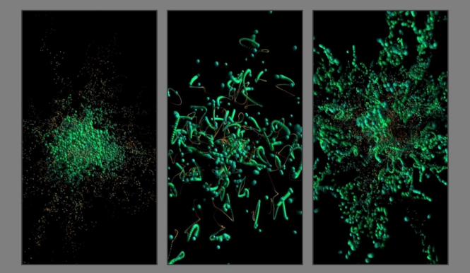  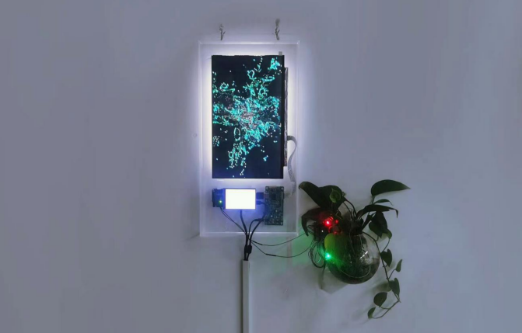 | Botanical Whimsy by  WEN Minjie | "Botanical Whimsy" explores interactive behaviors in generating organic life systems within virtual digital environments. In this study, artificial life forms are regarded as practical and creative vessels for future embodiment and potential life systems, establishing a simulated environment conducive to the growth of organisms. Through algorithms and the mutual generation of novel life forms, the artificial life forms on the screen represent extensions of organisms and humans in the digital realm while visually presenting data on the life phenomena of organic entities and artificial interventions. The primary aim of this research is to investigate how the visualization forms and technological framework of life phenomena data can collaboratively function within a wet media context, thereby exploring how the "life phenomena" of organisms can become a novel pathway for information transmission, fostering a fresh realm of communication between humans and living beings.
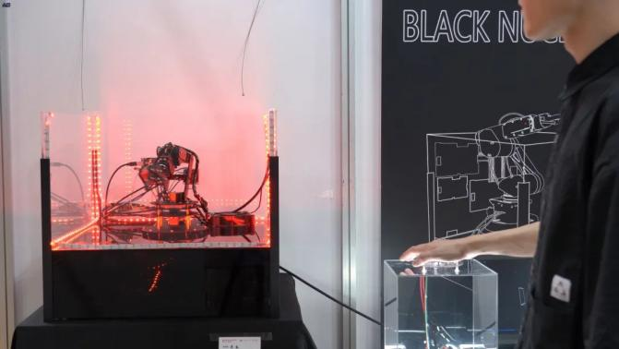  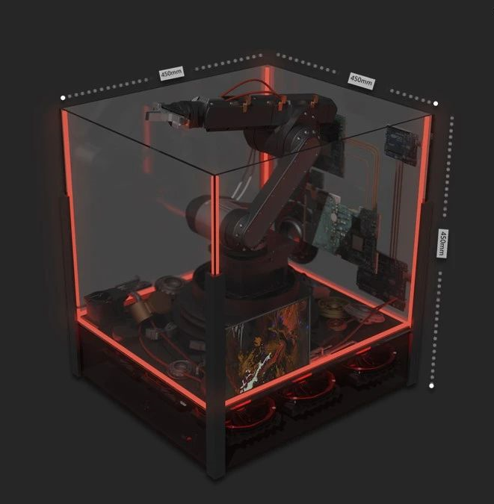 | Black Nuclear by CHEN Aowen | The inspiration for the work "Black Nuclear" derives from the classic movie "The Matrix." In the future, human cognition regarding other life forms transcends mere imagination and virtual constructs. Through the convergence of digital and biological technologies, artificial life forms are actively reshaping the natural biological forms and life systems while also endeavoring to generate novel "potential life" forms. However, the core aim of "Black Box" is to explore a philosophical proposition: as biological functions are supplanted by technological creations and computational processes replace biological activities, the "life" we create symbolizes either hope or destruction. This work profoundly reflects on the essence of life, ethical considerations, and the impact of technological advancements on the relationship between humanity and nature.
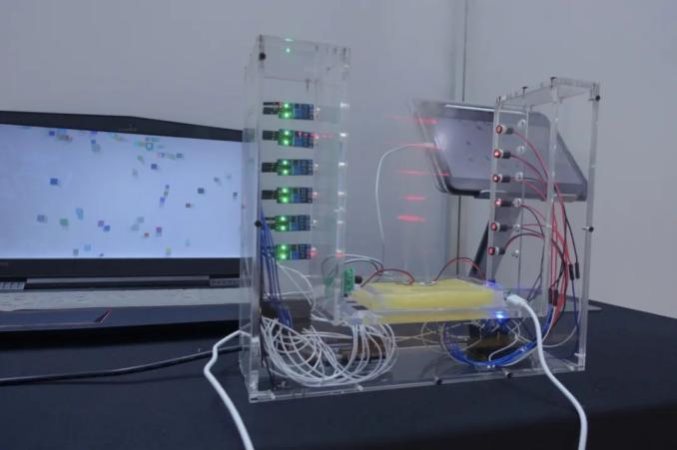  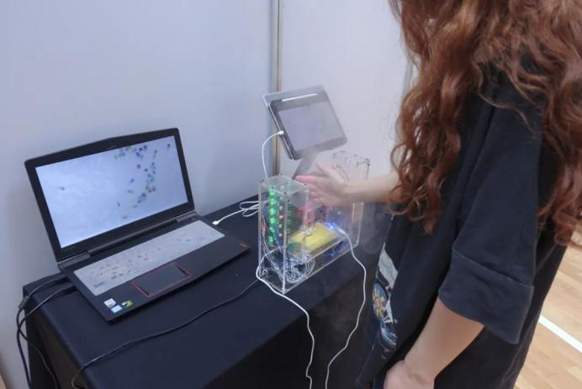 | Artificial Specimen:The Null by ZENG Sixi & PENG Cao xi | Novel digital and biotechnologies fundamentally reshape our conceptual understanding of life and humanity. The anthropomorphization of machines and the mechanization of life represent critical trends for the future. Alongside technological and media innovations, networks and programs gradually acquire lifelike characteristics. As humans use these technologies as tools, can we perceive them as 'quasi-biological' entities? When the logic of programs replaces the natural laws of biology, computers become the electronic realm of life. The convergence of life's principles, manifested through programs, with the consciousness and emotions of human creators catalyzes the evolution of artificial life systems.
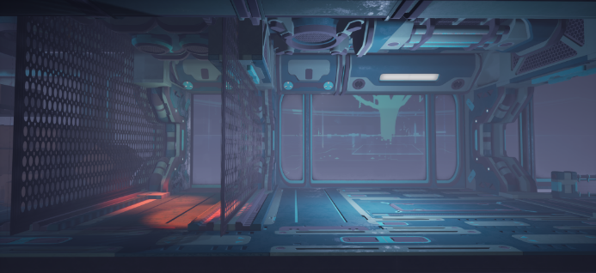  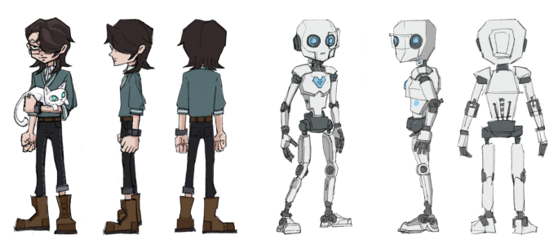  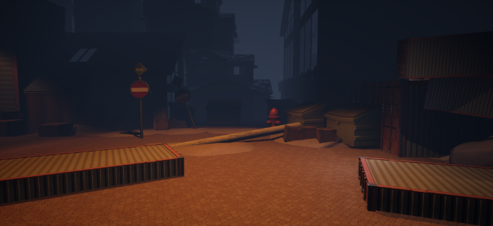  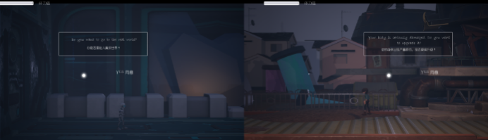 | ROBERT  / ROBOT by JIANG Yuwei & XU Xinxin | "ROBERT/ROBOT" is a 2.5D hand-drawn RPG-style game designed for cooperative play by two players. Like a parallel universe, the game allows each player to assume the roles of a human and an artificial life form, embarking on thrilling adventures together. The game is developed for the PC platform and utilizes the Oculus Quest headset and controllers for interaction.  The game's narrative explores the relationship between humans and artificial life forms from a dualistic perspective. Humans seek perfection and rationality through constant self-improvement and mechanical modifications, evolving into more "perfect" beings. Conversely, artificial life forms aspire to possess human emotions and evolve into "emotional" beings akin to humans. At the climax of this parallel world, what forms will humans and artificial life forms evolve into? Perhaps at the nexus of the mirrored worlds, when humans and artificial intelligence finally meet after completing their respective evolutions, they find themselves transitioning into each other's mirrored reality.  The game delves into the themes of "growth" and "evolution" using RPG side-scrolling mechanics as a medium, all while exploring the fundamental question of whether "harmonious coexistence between humans and artificial life forms" is achievable.
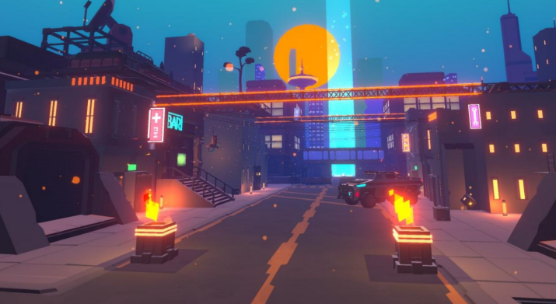 | Zero Point Project by ZHOU Ruijie | "Zero Point Project" is a first-person VR shooting online game developed based on the Unity 3D engine. Players will play the role of a special forces member to annihilate the out-of-control artificial intelligence life forms in the future city. Players will experience an immersive shooting experience through the Oculus Quest 2 headset. At the same time, as the number of kills increases, the number of enemies will gradually increase, and the difficulty of the game will increase step by step, so that players can have a stronger flow experience. On the basis of ensuring the basic VR functions and game experience, a more suitable operation mode for VR is added, a range of splash damage is added, and the importance of aiming is weakened, so that players can have a more comfortable game experience; at the same time, light, smoke and sound effects are added to give people a stronger interactive feeling and sensory stimulation; finally, open exploration content such as finding hidden weapons is added to the game to make the game more playable.
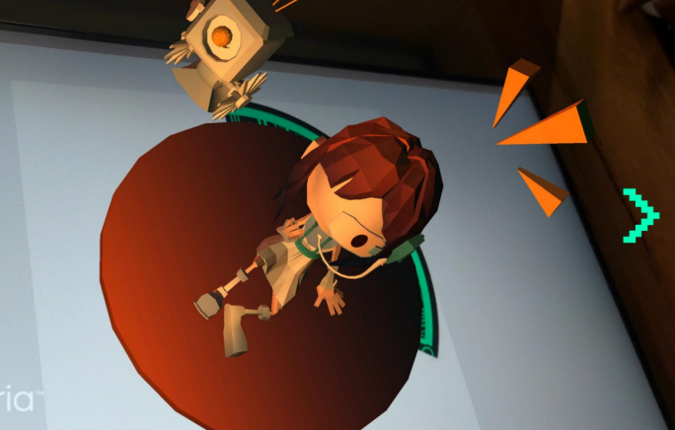  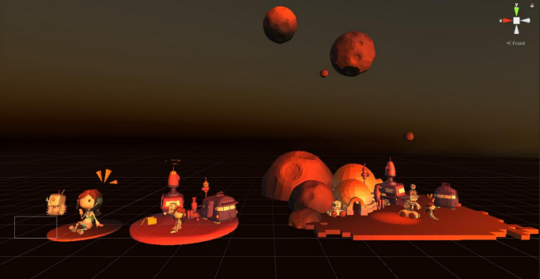  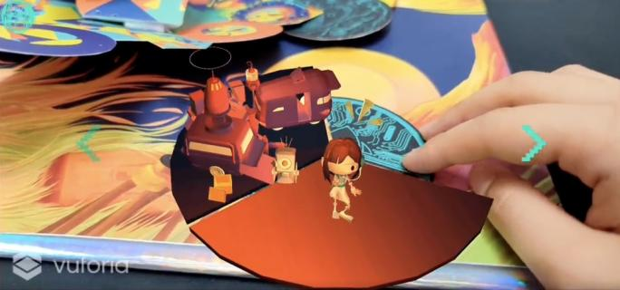  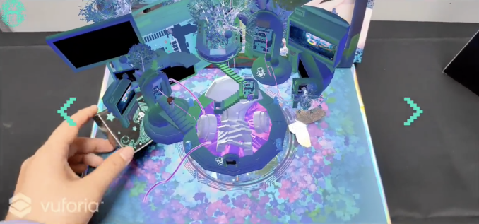 | Black Casket by YE Qianqian | The "Black Casket" seeks to explore the self-evolution of human-machine hybrid organisms in the post-human era. With the aid of computers, these hybrids split, replicate, and simulate evolution at high speed. Beneath their shells, they each conceal their own unique "data universe." As humans strive to create artificial life, the question arises: how will artificial life understand humans? How should the two coexist? The design centers its exploration of artificial life around the concept of the "Black Casket," which serves as the entity for storing artificial life’s data. When the experiencer discovers this black casket, it prompts curiosity and an attempt to decipher its contents. Using a head-mounted device(Oculus Quest 2), the experiencer can have a real-time mixed reality experience, revealing the complete memories of the artificial life before it is fully destroyed. This enables a communication channel to be formed between the experiencer and artificial life, transcending time and space. This work is a vision of the future symbiotic relationship between artificial life and humans, intended to provoke thought about how humans and artificial life may coexist in times to come.

