ZHANG Wenhan *
School of Arts and Design, Yancheng Institute of Technology , Yancheng 224051, China
First author: Wenhan Zhang, E-mail:glorianzhang@gmail.com
Funding:none
Author biography
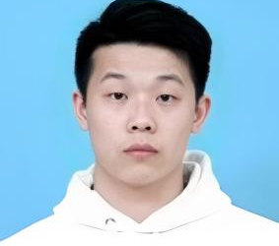
ZHANG Wenhan obtained his Bachelor’s degree in environment design from Hubei Institute of Fine Arts. Then he obtained his Master’s degree in the same field and PhD in design theory majoring in information and interaction design from Wuhan University of Technology. Now, he is a lecturer at the School of Arts and Design, Yancheng Institute of Technology. His current research interests include design philosophy, design ethics, new media technologies, interactive art and artificial intelligence.

WEN Minjie
Faculty of Engineering, Queensland University of Technology,Brisbane 4001,Australia
Corresponding &Second author:WEN Minjie, E-mail: minjie.wen@hdr.qut.edu.au
Funding:"Research and Practice of Plant Intelligence Design in Wet Media Context", funded by Fundamental Research Funds for the Central Universitie, Project No.: 2023CXZZ115.

Author biography


WEN Minjie obtained her Bachelor's degree in Digital Media Arts from Central China Normal University in 2022. Then she obtained her Master's degree in Intelligent Design from Central China Normal University in 2025. Meanwhile, She also completed an exchange program at State University of New York at Oswego. Currently, she is a PhD candidate at the Faculty of Engineering, Queensland University of Technology. Her specializations include Design and Sustainability, Cross-media Interaction Design, and Plant-Human Interaction. Her current research interests are Plant Intelligence Design, Sustainable Design Practices, Interactive Media Design, Health and Wellbeing Design, Human-Plant Collaborative Systems, and Ecological Interactive Installations.

FANG Xing
School of Art and Design, Wuhan University of Technology, Wuhan 430070，China
Third author:FANG Xing, E-mail:428037@qq.com

Author biography
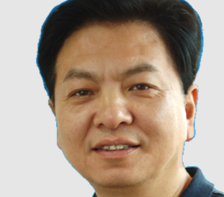
Fang Xing, professor and doctoral supervisor at the School of Art and Design, Wuhan University of Technology, Party General Branch Secretary and Dean of the Media and Art Design College at Wuhan Donghu College. Chief collaborative expert for the Digital Communication Engineering "Double First-Class" Improvement Plan Project at Wuhan University of Technology, "Product Design Professional Responsibility Professor", Associate Editor of Design Art Research Journal, Collaborative Professor at Seoul National University of Education and Korea National University. Executive Director of the Information and Interaction Design Committee of the China Industrial Design Association, President of the Industrial Design Branch of Hubei Mechanical Engineering Society, Vice Secretary-General of Hubei Science and Technology Art Association, Director of the Industrial Design Professional Committee of Hubei Engineering Graphics Society, with research focusing on digital art design theory and application, virtual innovative design theory and application, and interaction design research.

ZHENG Da
School of Fine Arts，Central China Normal University，Wuhan 430070，China
Fourth author:ZHENG Da, E-mail:742872@qq.com

Author biography
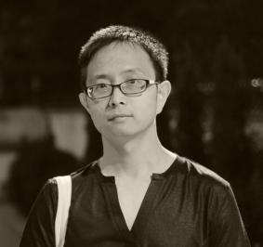
ZHENG Da is the Dean of the School of Fine Arts at Central China Normal University, a professor, and a master’s supervisor. He is currently serving in the Digital Media Art program at the School of Fine Arts.A cross-media artist and founder of the Low Tech Art Lab, his works have received the Interactive Art Award at the 2017 Lumen Prize in the UK and the Art Prize at the 3rd Wang Shikuo Award in 2018. He has also been a visiting scholar at the University of British Columbia (UBC) Art Department and a researcher at CPI in Seoul, South Korea. His artistic work focuses on cross-media interactive art at the intersection of art and science, exploring and practicing where the real and virtual worlds intersect. His creations include game art, interactive art, mechanical installations, and media theater. The Low Tech Art Lab, which he founded, is dedicated to the integration of contemporary media culture and interdisciplinary approaches, conducting art experiments based on electronic virtual environments, exploring the interaction of light and motion, the algorithmic aesthetics of machine vision systems, and the perceptual systems of computational media installation art.

