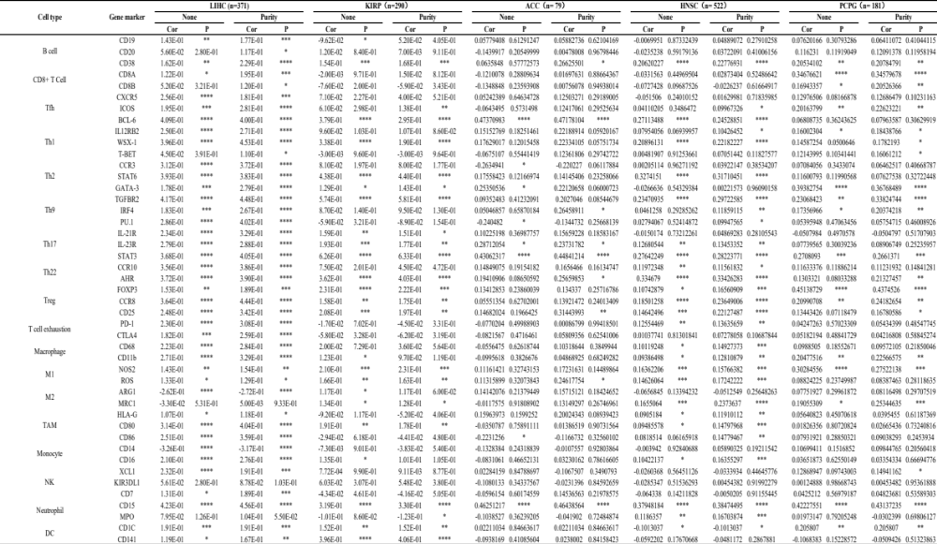
Table 1. Correlation analysis between NAT10 and related genes and markers of immune cells in TIMER. Tfh, follicular helper T cell; Th, T helper cell; Treg, regulatory T cell; TAM, tumor-associated-macrophage; NK, natural killer cell; DC, dendritic cell; None, correlation without adjustment; Purity, correlation adjusted for tumor purity; Cor, R value of Spearman’s correlation. *P < 0.05, **P < 0.01, ***P < 0.001, ****P < 0.0001.

