Supplemental material for

High prevalence of carbapenem-resistant and even convergent Klebsiella pneumoniae among black-headed gulls at the Black Sea coast of Georgia
Pontus Wennesjö^{1,2#}, Elias Eger^{3#}, Mariëlle L. van Toor⁴, Hanna Woksepp^{1,5}, Stefan E. Heiden³, Michael Schwabe³, Zura Javakhishvili⁶, Levan Ninua⁶, Sara Skidell⁴, Jonas Waldenström⁴, Katharina Schaufler^{3,7‡}, Jonas Bonnedahl^{1,2‡}*
¹ Department of Biomedical and Clinical Sciences, Linköping University, Linköping, Sweden
² Department of Infectious Diseases, Region Kalmar County, Kalmar, Sweden
³ Department of Epidemiology and Ecology of Antimicrobial Resistance, Helmholtz Institute for One Health, Helmholtz Centre for Infection Research, Greifswald, Germany
⁴ Centre for Ecology and Evolution in Microbial Model Systems, Linnaeus University, Kalmar, Sweden
⁵ Department of Clinical Microbiology, Region Kalmar County, Kalmar, Sweden
⁶ Center for Wildlife Disease Ecology, Ilia State University, Tbilisi, Georgia
⁷ University Medicine Greifswald, Greifswald, Germany
# First authors contributed equally
‡ Senior authors contributed equally
* Correspondence: Jonas Bonnedahl

Sequence assembly and genomic analyses

Short-read genome assembly
Raw paired-end sequencing reads were contaminant-filtered, adapter-trimmed and quality-trimmed using BBDuK from BBMap (v39.23). Quality control of raw and trimmed reads was done with FastQC (v0.12.1). Assemblies were created using shovill (v1.1.0) in combination with SPAdes (v4.1.0) at a maximum sequence coverage of 100x without using the integrated correction step. A manual polishing step was performed by mapping all trimmed paired-end reads to the draft assembly using BWA-MEM2 (v2.2.1) and polishing the assembly with Polypolish (v0.6.0).

Long-read genome assembly
Besides the online basecalling with the high-accuracy (HAC) model, basecalling was performed using standalone Dorado (v1.1.1) with the super-accurate (SUP) model (sup@v5.2.0,5mC_5hmC@v2,6mA@v1; minimum Q score: 10) from POD5 files after the sequencing. Samples were demultiplexed with Dorado and BAM files converted to FASTQ files using SAMtools (v1.19.2).
Raw sequencing data was subsampled to obtain 4 read subsets per sample. These were independently assembled with nine long-read assemblers (Canu [v2.3], Flye [v2.9.6], metaMDBG [v1.2], Miniasm/Minipolish [v0.3/v0.2.0], myloasm [v0.2.0], NECAT [v0.0.1_update20200803], NextDenovo/NextPolish [v2.5.2/v1.4.1], Plassembler [v1.8.1], Raven [v1.8.3]) and a consensus assembly generated from them with Autocycler (v0.5.2). Sequences were reoriented with Dnaapler (v1.3.0) before being long-read polished with Dorado (v1.1.1). A final short-read polishing step used BWA-MEM2 (v2.3) and Polypolish (v0.6.1).

Annotation
All closed genomes from long-read assemblies as well as the ST307 reference sequence (G24-036C2) for the core SNP analysis were annotated using Bakta (v1.11.4) with the full database (v6.0).

Whole-genome analysis (WGA)
Species assignment was performed with logic integrated in Kleborate (v3.2.4) and Multilocus Sequence Typing (MLST) was done with Kleborate and mlst (v2.23.0) using the scheme for the Klebsiella pneumoniae species complex hosted at the BIGSdb-Pasteur website. Antimicrobial resistance genes and virulence features were also predicted with Kleborate. K locus and O locus assignment were performed with Kaptive (v3.1.0). In addition, resistance genes were predicted using AMRFinderPlus v4.0.22 with database v2025-03-25.1.

Tree inference
A phylogenomic tree of the 40 Klebsiella spp. isolates was constructed with JolyTree (v2.1.211019ac) using a k-mer size of 21, a sketch size of 5,000,000 and performing 1,000 steps for the BME tree search.
To contextualize the K. pneumoniae ST307 and ST395 isolates within the global population structure, the latest RefSeq genome assemblies for the genus Klebsiella were downloaded from NCBI (accessed 09-01-2026). In total, 33,905 genomes were retrieved, of which 28,248 were identified as being K. pneumoniae sensu stricto. Among these, 1,088 and 409 genomes were assigned to sequence types (ST) 307 and 395, respectively. After excluding four ST307 genomes and one ST395 genome with contamination levels > 5% as determined by CheckM2 (v1.1.0), and incorporating the eight ST307 and nine ST395 genomes generated in this study, the final dataset comprised 1,092 ST307 and 417 ST395 genomes.
For each sequence type, a whole-genome core single nucleotide polymorphism (SNP) alignment was generated using Snippy (v4.6.0), with isolates G24-036C2 (ST307) and G24-031C3 (ST395) serving as reference genomes. Recombinant regions were identified and removed using Gubbins (v3.4.3), and variable SNP sites were subsequently extracted using SNP-sites (v2.5.1). Prior to maximum-likelihood phylogenetic inference, identical sequences were removed from the core SNP alignments. This resulted in final datasets comprising 926 taxa and 10,405 alignment sites for ST307, and 343 taxa and 3,368 alignment sites for ST395.
Maximum-likelihood phylogenetic trees were inferred using RAxML-NG (v1.2.2) under the General Time Reversible substitution model with gamma-distributed rate heterogeneity among sites (GTR+Γ), applying ascertainment bias correction as described by Stamatakis. Tree searches were initiated from 500 random and 500 parsimony starting trees. Branch support for the best-scoring maximum-likelihood tree was assessed using 1,000 bootstrap replicates, with support values calculated as transfer bootstrap expectation (TBE).
All trees were visualized and annotated with iTOL (v7.5) and the exported SVG files edited manually.

Plasmid analyses
Plasmids carrying ESBL- or carbapenemase-associated resistance genes and/or aerobactin genes were extracted from complete (closed) genomes and compiled into a curated reference set. To place these plasmids into a broader context, closely related sequences were retrieved from the Plasmid database (PLSDB, v2024_05_31_v2) using Mash (distance < 0.0001) and included in downstream analyses. A distance-based tree was generated with mashtree (version1.4.6; 1000 bootstrap repetitions) to infer plasmid relatedness within the plasmid set.
To identify plasmid similarities between the draft and closed genomes, draft genomes were queried against the closed-plasmid reference set using BLASTn (BLAST+ v2.16.0). Draft genomes were assigned to a plasmid cluster if they matched the corresponding plasmids with a minimum coverage of 80% at a minimum nucleotide identity of 90%. BLAST-based similarity and coverage patterns were visualized using BRIG by generating comparative ring plots for selected clusters.
Finally, clinker was used to identify conserved segments and rearranged blocks across plasmids from the dataset and PLSDB entries.
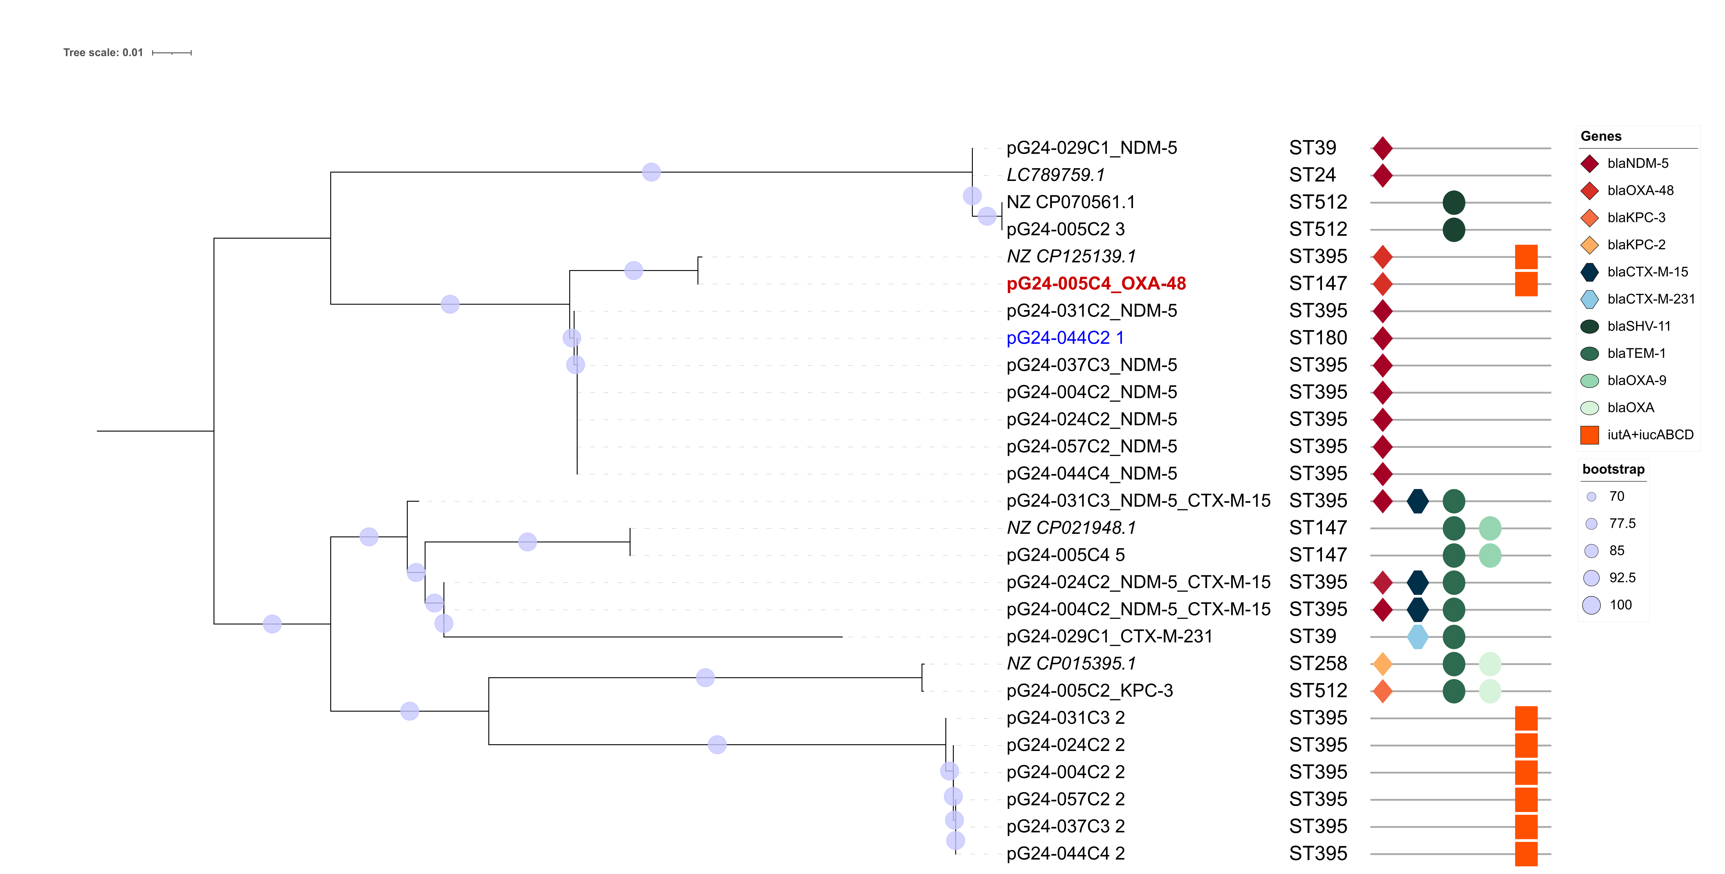
Supplementary Figure S1: Midpoint-rooted Mashtree of plasmids carried by the 11 closed Klebsiella spp. genomes. Shown are all plasmids recovered from closed Klebsiella spp. genomes in the investigated dataset that carry a β-lactamase or the aerobactin locus. In addition, four plasmids retrieved from PLSDB are included (italicized); these had a pairwise mash distance < 0.001 to at least one plasmid from the investigated dataset. Unless otherwise indicated, plasmids derive from K. pneumoniae isolates; the single plasmid originating from a non-K. pneumoniae isolate is highlighted in blue. The mosaic plasmid co-harboring bla_{NDM-5} and the aerobactin locus is emphasized in bold red. For each plasmid, the corresponding sequence type (ST) of the host isolate and the detected β-lactamase gene(s) are indicated.

