Supplementary Material
Supplementary Table S1. ICD-10 Codes Used to Define Comorbidities and Clinical Outcomes
Category | Condition | ICD-10 Codes
Diabetes definition | Type 2 diabetes mellitus | E11.x–E14.x
 | Type 1 diabetes mellitus (exclusion) | E10.x
Cardiovascular outcomes | Atherosclerotic cardiovascular disease (ASCVD) | I20–I25, I63, I65–I66
 | Heart failure | I50.x
Renal outcome | Chronic kidney disease (CKD) | N18.x
 | Kidney event* | N17.x, N18.x, N19
Microvascular complications | Diabetic nephropathy | E11.2
 | Diabetic retinopathy | E11.3, H36.0
 | Diabetic neuropathy | E11.4
 | Peripheral angiopathy/gangrene | E11.5, I70.2, I73.9
Metabolic outcomes | Hypoglycaemia | E16.0–E16.2
 | Diabetic ketoacidosis (DKA) | E11.1
Infectious outcome | Urinary tract infection (UTI) | N39.0
Hospitalisation outcome | Diabetes-related hospitalisation (HOS)** | Admission with primary diagnosis E11.x–E14.x
*Kidney event defined as incident diagnosis of acute kidney injury or advanced CKD during follow-up.
**HOS was analysed regardless of prior history and therefore not restricted to incident events.

Supplementary Table S2. Index Glucose-Lowering Medications and Concomitant Drug Definitions (NHIS Ingredient and ATC Codes)
Drug category | Drug / Class | NHIS ingredient codes
Index drugs | Empagliflozin | 628201ATB, 628202ATB, 649000ATB, 649100ATB, 649200ATB, 649300ATB, 649400ATB, 649500ATB, 696900ATB, 697000ATB
 | Dapagliflozin | 527301ATB, 527302ATB, 639800ATR, 641400ATR, 693201ATB, 693202ATB, 693301ATB, 693302ATB, 693402ATB, 693501ATB, 693502ATB, 702400ATB, 706900ATB, 711300ATB, 712901ATB, 712902ATB, 715300ATR, 715400ATR, 715500ATR, 718300ATR, 718500ATR, 718600ATR, 718800ATR, 718900ATR, 719000ATR, 719100ATR, 719200ATR, 719300ATR, 719400ATR, 719700ATB, 720300ATB, 722200ATR, 722300ATR, 722400ATR, 722500ATR, 723000ATB, 723500ATB, 723900ATB, 724700ATB, 724800ATB, 726800ATR, 726900ATR
 | DPP-4 inhibitors | 624202ATB, 624203ATB, 630500ATB, 630600ATB, 635600ATB, 635700ATB, 675500ATB, 619101ATB, 632000ATR, 645000ATR, 654100ATR, 520500ATB, 520600ATB, 520700ATB, 616401ATB, 613301ATB, 613302ATB, 501101ATB, 501102ATB, 501103ATB, 694201ATB, 694202ATB, 694203ATB, 500801ATB, 685801ATB, 701201ATB
Baseline glucose-lowering covariates | Metformin | 191501ATB, 191502ATB, 191502ATR, 513700ATB, 513700ATR, 518500ATR, 519600ATB, 641800ATR, 672500ATR, 672700ATR, 702500ATB, 704200ATB, 705200ATB, 708400ATR, 709300ATR, 711100ATR, 718700ATR, 191505ATR, 641900ATR, 672600ATR, 672800ATR, 708300ATR, 711000ATR, 718200ATR, 191503ATB, 191503ATR, 498100ATB, 502900ATB, 507000ATB, 702600ATB, 704100ATB, 705300ATB, 191504ATB, 191504ATR, 502300ATB, 502300ATR, 507100ATB, 518600ATR, 524700ATR, 642000ATR, 683300ATR, 683400ATR, 702700ATB, 704300ATB, 705100ATB, 708200ATR, 709400ATR, 709500ATR, 710900ATR, 715200ATR
 | Insulin (all formulations) | 170131BIJ, 170130BIJ, 170431BIJ, 170430BIJ, 441331BIJ, 441330BIJ, 626700BIJ, 441333BIJ, 441332BIJ, 626830BIJ, 488730BIJ, 461831BIJ, 461830BIJ, 666700BIJ, 667000BIJ, 461832BIJ, 484930BIJ, 484931BIJ, 175331BIJ, 175330BIJ, 175333BIJ, 175332BIJ, 693900BIJ
Cardiovascular covariates | RAAS inhibitors (ACEi/ARB) | 104201ATB, 104202ATB, 662403ATB, 673500ATB, 673600ATB, 662402ATB, 122602ATB, 423700ATB, 662000ATB, 673700ATB, 122603ATB, 662100ATB, 122601ATB, 661800ATB, 661900ATB, 122901ATB, 122902ATB, 122903ATB, 133001ATB, 133002ATB, 133003ATB, 151601ATB, 151603ATB, 429201ATB, 460500ATB, 515202ATB, 526800ATB, 515203ATB, 654900ATB, 655000ATB, 515201ATB, 522000ATB, 654700ATB, 654800ATB, 716100ATB, 717500ATB, 177301ATB, 177303ATB, 184501ATB, 185703ATB, 185701ATB, 185702ATB, 468502ATB, 644100ATB, 644200ATB, 468501ATB, 526300ATB, 526400ATB, 526900ATB, 547700ATB, 632800ATB, 468503ATB, 526500ATB, 547600ATB, 632900ATB, 633000ATB, 653200ATB, 501602ATB, 501601ATB, 211301ATB, 211302ATB, 222404ATB, 222401ATB, 222402ATB, 651401ATB, 651402ATB, 651403ATB, 378803ATB, 378801ATB, 378802ATB, 644800ATB, 247102ATB, 247104ATB, 247103ATB, 247101ATB
 | Statins | 111501ATB, 524000ATB, 527100ATB, 614500ATB, 633800ATB, 671800ATR, 673800ATR, 688100ATB, 688200ATB, 694000ACS, 111502ATB, 524100ATB, 527000ATB, 633900ATB, 672000ATR, 688300ATB, 688400ATB, 111503ATB, 634800ATB, 719800ATB, 719900ATB, 711200ACS, 721300ATB, 111504ATB, 634600ATB, 502201ATB, 502202ATB, 502203ATB, 502204ATB, 162403ATR, 185801ATB, 470902ATB, 470901ATB, 634900ATB, 635000ATB, 470903ATB, 635100ATB, 635200ATB, 216601ATB, 216603ATB, 216604ATB, 216602ATB, 454001ATB, 454001ATD, 525000ATB, 525100ATB, 629900ATB, 630100ATB, 454005ATB, 454002ATB, 454002ATD, 525200ATB, 525300ATB, 630000ATB, 630200ATB, 454003ATB, 454003ATD, 629700ATB, 629800ATB, 631600ATB, 631700ATB, 227801ATB, 227801ATR, 227802ATB, 227806ATB
Ingredient codes reflect NHIS active substance codes to ensure consistency across manufacturers and formulations.
Fixed-dose combination products were excluded unless the active ingredient corresponded to the target drug class.

Supplementary Table 3A. Baseline Characteristics Before Propensity Score Matching: Dapagliflozin vs Empagliflozin
Characteristic | DAPA (n=29,434) | EMPA (n=17,050) | P value | SMD
Demographics
Age, y | 39.39 (5.66) | 39.77 (5.62) | < 0.001 | 0.068
Male sex | 20,630 (70.09) | 11,874 (69.64) | 0.311 | 0.010
Income quintile (1=lowest) |  |  | 0.096
└ 1 (lowest) | 4,556 (15.48) | 2,708 (15.88) |  | 0.011
└ 2 | 4,604 (15.64) | 2,615 (15.34) |  | 0.008
└ 3 | 6,625 (22.51) | 3,952 (23.18) |  | 0.016
└ 4 | 8,226 (27.95) | 4,773 (27.99) |  | 0.001
└ 5 (highest) | 5,423 (18.42) | 3,002 (17.61) |  | 0.021
Clinical characteristics
Duration of diabetes, y | 2.11 (2.35) | 2.25 (2.53) | < 0.001 | 0.057
Hypertension | 8,536 (29.00) | 4,943 (28.99) | 0.983 | 0.000
Dyslipidemia | 19,667 (66.82) | 11,371 (66.69) | 0.782 | 0.003
ASCVD | 1,077 (3.66) | 722 (4.23) | 0.002 | 0.030
CKD | 160 (0.54) | 111 (0.65) | 0.143 | 0.014
Chronic diabetic complications† | 3,235 (10.99) | 1,729 (10.14) | 0.004 | 0.028
Hypoglycemia | 115 (0.39) | 20 (0.12) | < 0.001 | 0.054
Diabetic ketoacidosis (DKA) | 133 (0.45) | 59 (0.35) | 0.087 | 0.017
Urinary tract infection (UTI) | 744 (2.53) | 378 (2.22) | 0.035 | 0.020
Health screening parameters
Fasting blood glucose, mg/dL | 137.03 (57.48) | 136.28 (57.56) | 0.174 | 0.013
eGFR, mL/min/1.73m² | 101.03 (27.81) | 101.45 (28.49) | 0.117 | 0.015
BMI, kg/m² | 29.45 (4.62) | 29.45 (4.65) | 0.892 | 0.001
Medication use (baseline)
Metformin use | 20,335 (69.09) | 12,311 (72.21) | < 0.001 | 0.069
Insulin use | 3,205 (10.89) | 2,001 (11.74) | 0.005 | 0.027
RAAS inhibitor use (ACEi/ARB) | 5,752 (19.54) | 3,437 (20.16) | 0.108 | 0.015
Statin use | 12,993 (44.14) | 7,570 (44.40) | 0.592 | 0.005
Calendar period
Index year ≥2019 (post-KDA guideline update)‡ | 20,505 (69.66) | 13,305 (78.04) | < 0.001 | 0.191

Supplementary Table 3B. Baseline characteristics before propensity score Matching: Empagliflozin vs DPP-4 Inhibitors
Characteristic | DPP4i (n=55,854) | EMPA (n=17,050) | P value | SMD
Demographics
Age, y | 39.86 (5.05) | 39.77 (5.62) | 0.058 | 0.017
Male sex | 41,309 (73.96) | 11,874 (69.64) | <0.001 | 0.095
Income quintile (1=lowest) |  |  | 0.024
└ 1 (lowest) | 9,401 (16.83) | 2,708 (15.88) |  | 0.026
└ 2 | 8,461 (15.15) | 2,615 (15.34) |  | 0.005
└ 3 | 12,510 (22.40) | 3,952 (23.18) |  | 0.018
└ 4 | 15,553 (27.85) | 4,773 (27.99) |  | 0.003
└ 5 (highest) | 9,929 (17.78) | 3,002 (17.61) |  |  | 0.004
Clinical characteristics
Duration of diabetes, y | 2.12 (2.18) | 2.25 (2.53) | <0.001 |  | 0.055
Hypertension | 13,549 (24.26) | 4,943 (28.99) | <0.001 |  | 0.107
Dyslipidemia | 35,938 (64.34) | 11,371 (66.69) | <0.001 |  | 0.050
ASCVD | 2,464 (4.41) | 722 (4.23) | 0.323 |  | 0.009
CKD | 415 (0.74) | 111 (0.65) | 0.214 |  | 0.011
Chronic diabetic complications† | 5,702 (10.21) | 1,729 (10.14) | 0.797 |  | 0.002
Hypoglycemia | 81 (0.15) | 20 (0.12) | 0.394 |  | 0.009
Diabetic ketoacidosis (DKA) | 286 (0.51) | 59 (0.35) | 0.006 |  | 0.036
Urinary tract infection (UTI) | 1,427 (2.55) | 378 (2.22) | 0.013 |  | 0.021
Health screening parameters
Fasting blood glucose, mg/dL | 145.52 (61.11) | 136.28 (57.56) | <0.001 |  | 0.156
eGFR, mL/min/1.73m² | 99.37 (27.59) | 101.45 (28.49) | <0.001 |  | 0.075
BMI, kg/m² | 27.60 (4.55) | 29.45 (4.65) | <0.001 |  | 0.402
Medication use (baseline)
Metformin use | 34,462 (61.70) | 12,311 (72.21) | <0.001 |  | 0.225
Insulin use | 5,587 (10.00) | 2,001 (11.74) | <0.001 |  | 0.056
RAAS inhibitor use (ACEi/ARB) | 9,383 (16.80) | 3,437 (20.16) | <0.001 |  | 0.087
Statin use | 23,979 (42.93) | 7,570 (44.40) | 0.001 |  | 0.030
Calendar period
Index year ≥2019 (post-KDA guideline update)‡ | 28,690 (51.37) | 13,305 (78.04) | <0.001 | 0.593
Abbreviations: DAPA, dapagliflozin; DPP4i, dipeptidyl peptidase-4 inhibitor; EMPA, empagliflozin; ASCVD, atherosclerotic cardiovascular disease; CKD, chronic kidney disease; DKA, diabetic ketoacidosis; UTI, urinary tract infection; RAAS, renin–angiotensin–aldosterone system; ACEi, angiotensin-converting enzyme inhibitor; ARB, angiotensin receptor blocker; BMI, body mass index; eGFR, estimated glomerular filtration rate; SMD, standardized mean difference. Values are presented as mean (SD) or n (%).
Standardized mean differences (SMDs) were calculated to assess covariate balance after propensity score matching. An SMD <0.10 was considered indicative of adequate balance.
Chronic diabetic complications included diabetic nephropathy, retinopathy, neuropathy, and peripheral vascular disease/gangrene, which were identified using the ICD-10 codes during the baseline period.
The calendar period variable was defined to account for the 2019 revision of the Korean Diabetes Association (KDA) clinical practice guidelines, which strengthened the recommendations for SGLT2 inhibitors in patients with established ASCVD, heart failure, or chronic kidney disease. This variable was included to mitigate potential calendar-time bias arising from shifts in prescription patterns.

Figure S1A. Distribution of propensity scores before and after matching for the empagliflozin versus dapagliflozin comparison
This figure shows the distribution of propensity scores for patients treated with empagliflozin (EMPA) and dapagliflozin (DAPA) before and after 1:1 propensity score matching. Propensity scores were estimated using logistic regression models based on baseline covariates and the matching procedure was performed using SAS software. The upper panel illustrates the propensity score distribution before matching, and the lower panel shows the distribution after matching. Density histograms and smoothed curves are presented for each treatment group to assess the overlap in propensity score distributions. Improved overlap of the distributions after matching indicates adequate balance of baseline characteristics between the treatment groups.
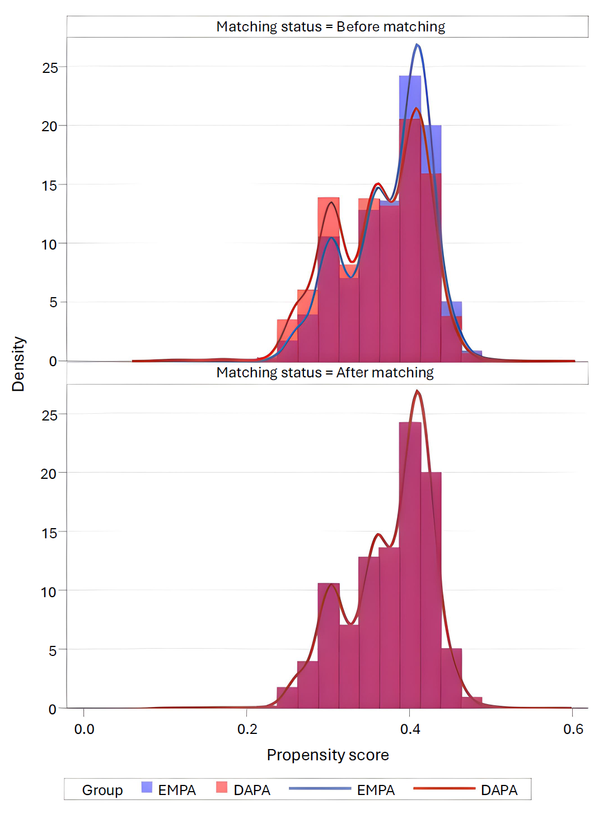
Figure S1B. Distribution of propensity scores before and after matching for the empagliflozin versus DPP-4 inhibitor comparison
This figure shows the distribution of propensity scores for patients treated with empagliflozin (EMPA) and dipeptidyl peptidase-4 inhibitors (DPP-4i) before and after 1:1 propensity score matching. Propensity scores were estimated using logistic regression models based on baseline covariates, and matching was performed using SAS software. The upper panel illustrates the propensity score distribution before matching, and the lower panel shows the distribution after matching. Density histograms and smoothed curves are presented for each treatment group to evaluate the overlap of propensity score distributions. Improved overlap after matching indicates adequate balance of baseline characteristics between the treatment groups.
