Panel A represents western blot analysis shown in Fig 4
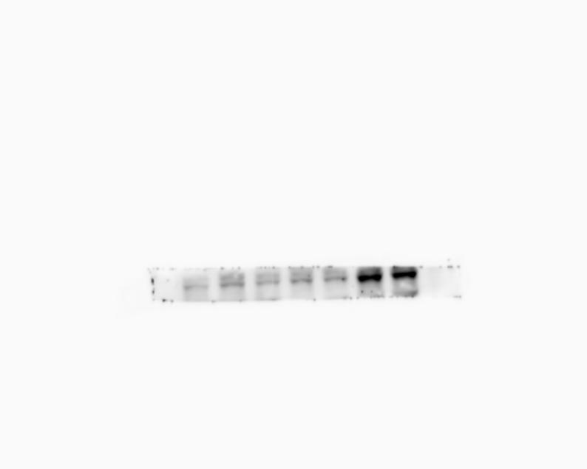
pSmad3 48 kD

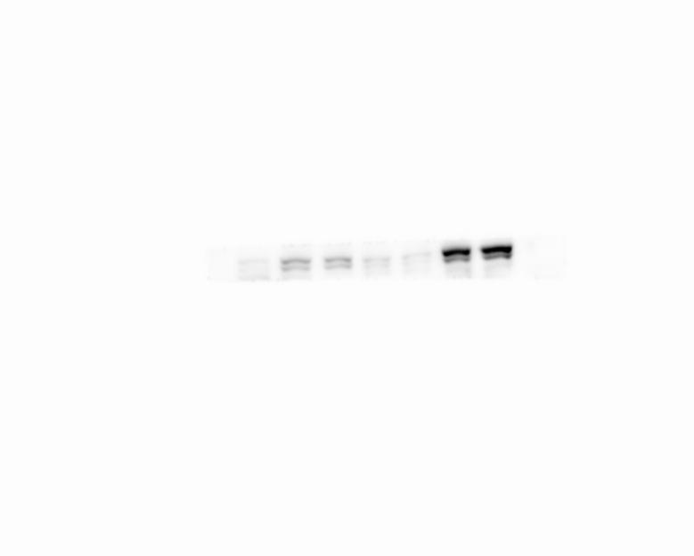
pSTAT3 88 kD


β-Actin 42 kD

