Table S1. Age and sex specific metabolic syndrome scoring equations
Groups | Equations
Male
<60 | −2.9092 + 0.0262*WC + 0.3098*TG-0.944*HDL-C + 0.0097*MAP + 0.0745*FBG
≥60 | −2.3741 + 0.0264*WC + 0.4933*TG-0.999*HDL-C + 0.0054*MAP + 0.0821*FBG
Female
<60 | −2.4981 + 0.0199*WC + 0.5218*TG-0.8616*HDL-C + 0.0110*MAP + 0.1074*FBG
≥60 | −0.5682 + 0.0153*WC + 0.4587*TG-1.3567*HDL-C + 0.0036*MAP + 0.0688*FBG
Abbreviations: FBG, fasting blood glucose (mmol/L); HDL, high-density lipoprotein cholesterol (mmol/L); MAP, mean arterial pressure (mmHg); TG, triglycerides (mmol/L); WC, waist circumference (cm).

Table S2. The characteristics of all study participants for longitudinal analyses of incident asthma.
Variables | Total (n = 8,673 ) | Asthma-free (n = 8,168) | Incident asthma (n = 505) | P
Age (years old) | 58.87 ± 9.13 | 58.73 ± 9.12 | 61.15 ± 8.95 | <0.001
Age group |  |  |  | <0.001
<60 | 4941 (56.97) | 4711 (57.68) | 230 (45.54)
≥60 | 3732 (43.03) | 3457 (42.32) | 275 (54.46)
Gender |  |  |  | 0.087
Male | 3991 (46.02) | 3740 (45.79) | 251 (49.70)
Female | 4682 (53.98) | 4428 (54.21) | 254 (50.30)
Residence |  |  |  | 0.001
Rural | 7196 (83.35) | 6751 (83.03) | 445 (88.65)
Urban | 1437 (16.65) | 1380 (16.97) | 57 (11.35)
Education |  |  |  | 0.001
No formal education | 2547 (29.37) | 2374 (29.06) | 173 (34.26)
<High school | 5258 (60.62) | 4956 (60.68) | 302 (59.80)
High school and above | 868 (10.01) | 838 (10.26) | 30 (5.94)
Marital |  |  |  | 0.043
Married/partnered | 7647 (88.17) | 7216 (88.34) | 431 (85.35)
Never married/widowed/divorced/separated | 1026 (11.83) | 952 (11.66) | 74 (14.65)
Alcohol |  |  |  | 0.127
No | 5306 (61.23) | 5013 (61.43) | 293 (58.02)
Yes | 3360 (38.77) | 3148 (38.57) | 212 (41.98)
Smoke |  |  |  | <0.001
Never | 5321 (61.53) | 5052 (62.00) | 269 (53.80)
Former | 720 (8.33) | 663 (8.14) | 57 (11.40)
Current | 2607 (30.15) | 2433 (29.86) | 174 (34.80)
Physical activity |  |  |  | 0.114
Inactive | 1203 (32.61) | 1117 (32.22) | 86 (38.74)
Moderate | 1110 (30.09) | 1046 (30.17) | 64 (28.83)
Vigorous | 1376 (37.30) | 1304 (37.61) | 72 (32.43)
FBG (mg/dL) | 110.40 ± 36.56 | 110.38 ± 36.41 | 110.76 ± 38.95 | 0.820
HbA1c (%) | 5.27 ± 0.82 | 5.27 ± 0.83 | 5.25 ± 0.73 | 0.610
TG (mg/dL) | 134.71 ± 112.13 | 134.27 ± 107.81 | 141.84 ± 167.10 | 0.141
TC (mg/dL) | 193.96 ± 38.89 | 194.07 ± 38.94 | 192.21 ± 38.13 | 0.298
HDL (mg/dL) | 51.07 ± 15.33 | 51.05 ± 15.23 | 51.42 ± 16.78 | 0.633
LDL (mg/dL) | 116.70 ± 35.10 | 116.89 ± 35.29 | 113.67 ± 31.78 | 0.029
UA (mg/dL) | 4.45 ± 1.25 | 4.44 ± 1.25 | 4.53 ± 1.26 | 0.139
CRP (mg/L) | 2.56 ± 6.88 | 2.50 ± 6.65 | 3.42 ± 9.84 | 0.040
WBC (1000 cells/uL) | 6.23 ± 1.87 | 6.21 ± 1.84 | 6.50 ± 2.21 | 0.004
Height (cm) | 1.58 ± 0.09 | 1.58 ± 0.09 | 1.57 ± 0.10 | 0.005
Weight (kg) | 58.89 ± 11.59 | 58.96 ± 11.53 | 57.75 ± 12.58 | 0.037
WC (cm) | 84.33 ± 12.54 | 84.38 ± 12.34 | 83.60 ± 15.35 | 0.262
BMI (kg/m²) | 23.77 ± 11.17 | 23.72 ± 9.68 | 24.50 ± 25.10 | 0.493
SBP (mm Hg) | 129.50 ± 21.48 | 129.45 ± 21.46 | 130.25 ± 21.91 | 0.417
DBP (mm Hg) | 75.38 ± 12.20 | 75.38 ± 12.15 | 75.32 ± 12.91 | 0.905
Obesity |  |  |  | 0.437
No | 5898 (68.65) | 5566 (68.74) | 332 (67.07)
Yes | 2694 (31.35) | 2531 (31.26) | 163 (32.93)
Abdominal obesity |  |  |  | 0.541
No | 5213 (60.11) | 4916 (60.19) | 297 (58.81)
Yes | 3460 (39.89) | 3252 (39.81) | 208 (41.19)
Hypertension |  |  |  | 0.254
No | 5156 (59.45) | 4868 (59.60) | 288 (57.03)
Yes | 3517 (40.55) | 3300 (40.40) | 217 (42.97)
Heart disease |  |  |  | 0.001
No | 7648 (88.61) | 7226 (88.88) | 422 (84.23)
Yes | 983 (11.39) | 904 (11.12) | 79 (15.77)
Stroke |  |  |  | 0.195
No | 8436 (97.49) | 7951 (97.55) | 485 (96.61)
Yes | 217 (2.51) | 200 (2.45) | 17 (3.39)
Diabetes |  |  |  | 0.575
No | 7206 (83.09) | 6791 (83.14) | 415 (82.18)
Yes | 1467 (16.91) | 1377 (16.86) | 90 (17.82)
MetSS | 1.39 ± 3.40 | 1.39 ± 3.32 | 1.49 ± 4.52 | 0.513
Abbreviations: FBG, fasting blood glucose; HbA1c, glycohemoglobin A1c; TG, triglycerides; TC, total cholesterol; HDL, high density lipoprotein cholesterol; LDL, low density lipoprotein cholesterol; UA, uric acid; CRP, C-reactive protein; WBC, white blood cell; WC, waist circumference; BMI, body mass index; SBP, systolic blood pressure; DBP, diastolic blood pressure; MetSS, metabolic syndrome score. Data are expressed as mean (standard deviation) for continuous variables or count (percent) for categorical variables. P value was calculated by the t-test, Kruskal-Wallis rank-sum test or the χ2 test, where appropriate.

Table S3. The characteristics of all study participants for longitudinal analyses of CLDs.
Variables | Total (n = 8,193 ) | CLDs-free (n = 6,903) | Incident CLDs (n = 1,290) | P
Age (years old) | 58.74 ± 9.11 | 58.54 ± 9.13 | 59.76 ± 8.93 | <0.001
Age group |  |  |  | <0.001
<60 | 4716 (57.56) | 4056 (58.76) | 660 (51.16)
≥60 | 3477 (42.44) | 2847 (41.24) | 630 (48.84)
Gender |  |  |  | <0.001
Male | 3728 (45.50) | 3057 (44.29) | 671 (52.02)
Female | 4465 (54.50) | 3846 (55.71) | 619 (47.98)
Residence |  |  |  | 0.019
Rural | 6789 (83.25) | 5688 (82.83) | 1101 (85.48)
Urban | 1366 (16.75) | 1179 (17.17) | 187 (14.52)
Education |  |  |  | 0.038
No formal education | 2414 (29.46) | 2042 (29.58) | 372 (28.84)
<High school | 4946 (60.37) | 4136 (59.92) | 810 (62.79)
High school and above | 833 (10.17) | 725 (10.50) | 108 (8.37)
Marital |  |  |  | 0.039
Married/partnered | 7227 (88.21) | 6111 (88.53) | 1116 (86.51)
Never married/widowed/divorced/separated | 966 (11.79) | 792 (11.47) | 174 (13.49)
Alcohol |  |  |  | <0.001
No | 5036 (61.52) | 4314 (62.56) | 722 (55.97)
Yes | 3150 (38.48) | 2582 (37.44) | 568 (44.03)
Smoke |  |  |  | <0.001
Never | 5091 (62.28) | 4405 (63.94) | 686 (53.39)
Former | 652 (7.98) | 512 (7.43) | 140 (10.89)
Current | 2431 (29.74) | 1972 (28.63) | 459 (35.72)
Physical activity |  |  |  | 0.409
Inactive | 1143 (32.88) | 970 (33.15) | 173 (31.45)
Moderate | 1043 (30.01) | 884 (30.21) | 159 (28.91)
Vigorous | 1290 (37.11) | 1072 (36.64) | 218 (39.64)
FBG (mg/dL) | 110.49 ± 36.75 | 110.70 ± 36.96 | 109.33 ± 35.58 | 0.218
HbA1c (%) | 5.27 ± 0.83 | 5.27 ± 0.84 | 5.28 ± 0.79 | 0.700
TG (mg/dL) | 134.03 ± 107.09 | 133.83 ± 106.32 | 135.07 ± 111.17 | 0.703
TC (mg/dL) | 194.01 ± 38.84 | 193.97 ± 38.77 | 194.21 ± 39.21 | 0.841
HDL (mg/dL) | 50.95 ± 15.20 | 50.85 ± 14.93 | 51.49 ± 16.55 | 0.191
LDL (mg/dL) | 117.01 ± 35.05 | 117.14 ± 35.06 | 116.29 ± 35.01 | 0.426
UA (mg/dL) | 4.44 ± 1.24 | 4.43 ± 1.25 | 4.53 ± 1.23 | 0.008
CRP (mg/L) | 2.54 ± 6.90 | 2.50 ± 6.82 | 2.78 ± 7.32 | 0.174
WBC (1000 cells/uL) | 6.21 ± 1.86 | 6.18 ± 1.82 | 6.40 ± 2.01 | <0.001
Height (cm) | 1.58 ± 0.09 | 1.58 ± 0.09 | 1.58 ± 0.09 | 0.893
Weight (kg) | 59.07 ± 11.59 | 59.19 ± 11.52 | 58.43 ± 11.94 | 0.030
WC (cm) | 84.42 ± 12.59 | 84.53 ± 12.46 | 83.82 ± 13.25 | 0.062
BMI (kg/m²) | 23.85 ± 11.44 | 23.86 ± 10.40 | 23.78 ± 15.95 | 0.803
SBP (mm Hg) | 129.55 ± 21.50 | 129.54 ± 21.38 | 129.56 ± 22.14 | 0.986
DBP (mm Hg) | 75.46 ± 12.22 | 75.53 ± 12.17 | 75.09 ± 12.52 | 0.235
Obesity |  |  |  | 0.300
No | 5531 (68.15) | 4649 (67.92) | 882 (69.39)
Yes | 2585 (31.85) | 2196 (32.08) | 389 (30.61)
Abdominal obesity |  |  |  | 0.176
No | 4891 (59.70) | 4099 (59.38) | 792 (61.40)
Yes | 3302 (40.30) | 2804 (40.62) | 498 (38.60)
Hypertension |  |  |  | 0.780
No | 4881 (59.58) | 4117 (59.64) | 764 (59.22)
Yes | 3312 (40.42) | 2786 (40.36) | 526 (40.78)
Heart disease |  |  |  | <0.001
No | 7273 (89.04) | 6200 (90.10) | 1073 (83.37)
Yes | 895 (10.96) | 681 (9.90) | 214 (16.63)
Stroke |  |  |  | 0.446
No | 7978 (97.58) | 6727 (97.63) | 1251 (97.28)
Yes | 198 (2.42) | 163 (2.37) | 35 (2.72)
Diabetes |  |  |  | 0.237
No | 6811 (83.13) | 5724 (82.92) | 1087 (84.26)
Yes | 1382 (16.87) | 1179 (17.08) | 203 (15.74)
MetSS | 1.39 ± 3.30 | 1.41 ± 3.27 | 1.29 ± 3.42 | 0.254
Abbreviations: CLDs, chronic lung diseases; FBG, fasting blood glucose; HbA1c, glycohemoglobin A1c; TG, triglycerides; TC, total cholesterol; HDL, high density lipoprotein cholesterol; LDL, low density lipoprotein cholesterol; UA, uric acid; WC, waist circumference; BMI, body mass index; SBP, systolic blood pressure; DBP, diastolic blood pressure; MetSS, metabolic syndrome score. Data are expressed as mean (standard deviation) for continuous variables or count (percent) for categorical variables. P value was calculated by the t-test, Kruskal-Wallis rank-sum test or the χ2 test, where appropriate.

Figure S1. Quantification for missing data of adjustment factors for cross-sectional (A) and longitudinal analyses (B).
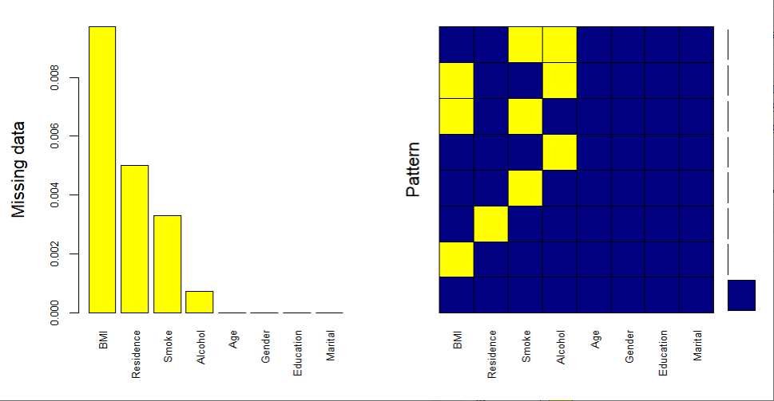A 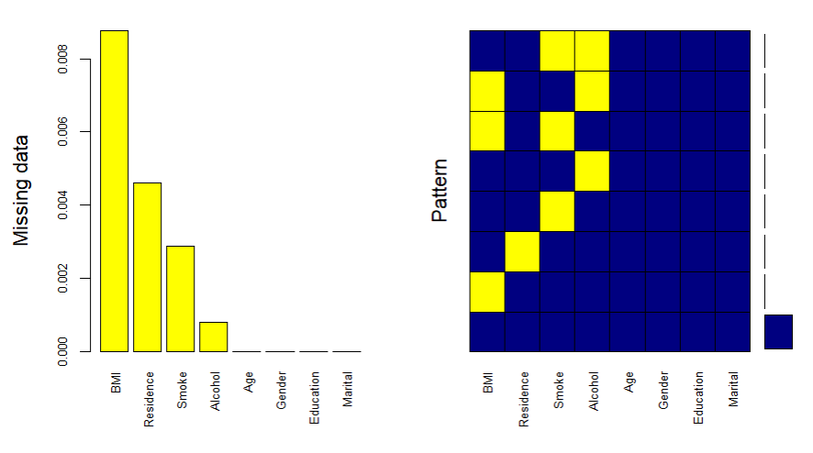B
Abbreviations: BMI, body mass index.

