Osteoclast-derived extracellular miR-106a-5p promotes osteogenic differentiation and facilitates bone defect healing
Yutong Wu ^{1*}, Hongbo Ai ¹, Yuchi Zou ¹ and Jianzhong Xu ^{1*}
^{1.}Department of Orthopedics, Southwest Hospital, Third Military Medical University (Army Medical University), Chongqing 400038, China.

Corresponding author:
Yutong Wu, Department of Orthopedics, Southwest Hospital, Third Military Medical University (Army Medical University), Gaotanyan Street No.30, Chongqing 400038, China. Email: garefieldyutong@gmail.com
Jianzhong Xu, Department of Orthopedics, Southwest Hospital, Third Military Medical University (Army Medical University), Gaotanyan Street No.30, Chongqing 400038, China. Email: xujianzhong1962@163.com

Keywords: Small extracellular vesicles, miRNA, osteogenic differentiation, bone remodeling, intercellular communication

Running title: osteoclast-derived extracellular miR-106a-5p induces osteogenic differentiation

Supplementary Methods and Materials
Western blot analysis
Cells or sEVs were lysed in RIPA lysis buffer mixing with protease phosphatase inhibitor (Beyotime Biotechnology, Jiangsu, China). The lysis system was incubated on ice for 30 mins, and ultrasonic lysed every 10 mins. Subsequently, the supernatant was carefully removed and transferred into a new microfuge tube after centrifugation at 13000 g for 15mins. The BCA protein assay kit (Beyotime Biotechnology, Jiangsu, China) was used to detect the concentration of proteins according manufacturer's instructions. Each sample (50 μg) was diluted in loading buffer (Beyotime Biotechnology, Jiangsu, China) and subjected to a standard SDS-PAGE followed by transferred onto polyvinylidene fluoride membranes (ImmobilonTM-PSQ Membranes, Sigma-Aldrich, China). After blocking in 5% skim milk and washing in Tris Buffered Saline Tween buffer, proteins were detected using the following antibodies: Histone 3 (bs-17422R) at a 1:1000 dilution, CD81 (bs-2489R) at a 1:1000 dilution, TSG101 (bs-1365R) at a 1:1000 dilution, LaminA/C (bs-1839R) at a 1:1000 dilution, and β-actin (bs-0061R) at a 1:2000 dilution. Corresponding secondary antibodies against primary antibodies were used by an hour of incubation (1:2000). Blots against β-actin served as loading control. Super ECL Plus (Bioground, Chongqin, China) and Immun-Star HRP (BioRad) were used to detect chemiluminescent signals.

qPCR analysis
Total RNAs from cells or sEVs were extracted using Trizol reagent (Life Technologies, NY, USA). The ultra-low volume spectrometer (BioDrop µLite, Cambridge, England) was used to measure concentrations and purity of the RNA samples by detecting OD260 and OD280. PrimeScriptTMRT reagent kit (Takara, Nojihigashi, Japan) was used to synthesize cDNA. SYBR Green Supermix (Bio-Rad, Hercules, CA, USA) and specific primers (listed in supplement table 1) were used to further amplification process. Real-time PCR process was carried out on CFX96™ Real-Tim PCR System instrument (Bio-Rad).

Lentivirus construction and transfection
In our study, mimics and inhibitors of miR-106a-5p were purchased from GenePharma (Shanghai, China). The constructed lentivirus vectors which express miR-106a-5p or inhibit miR-106a-5p were obtained from Genechem (Shanghai, China). We logined in the National Center for Biotechnology Information and used BLAST searches (https://blast.ncbi.nlm.nih.gov/Blast.cgi) to ensure inhibitors and products of inhibitory vector only targeted miR-106a-5p. Before transfection, 1 × 106 cells were seeded and cultured in 6-well plates until reaching 70% confluence. Complete medium was replaced to transfection medium containing a-MEM, 10% FBS and lentivirus vectors with 20 MOI (Multiplicity of Infection). After incubation for 48 hours at 37°C, the transfection medium was replaced to selection medium containing a-MEM, 10% FBS and 5 mg/ml puromycin for obtaining stable transduced cells. For rescue experiments, Lipofectamine 2000 Reagent (Thermo Scientific, MA, USA) was used to transfect Fam134a expressing plasmids (GeneCopoeia) to cells which were cultured with miR-106a-5p-sEVs or stably expressed miR-106a-5p. Exo-Fect Exosome Transfection Kit (System Biosciences). was used to load mimics or inhibitors into OC-sEVs,

Statistical analysis
All representative data comes from experiments with similar results which were repeated at least three times and we used means ± standard deviation to present the collected data. Independent unpaired two-tailed Student’s t-tests were used to analyze the difference within the two groups and one-way ANOVA followed by Student-Newman-Keuls post hoc tests were used to detect differences in multiple groups. When p < 0.05, the difference was considered to be statistically significant. * (p < 0.05) or ** (p < 0.01) were used to indicate the significance of the difference within the two groups.

Supplementary Figures
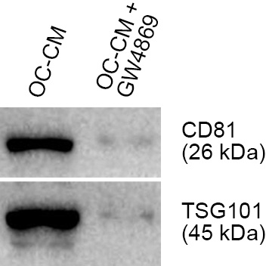
Supplementary Figure 1. OC-sEVs promote osteogenic differentiation of BMSCs
Western blot analysis showed that GW4869 pretreatment significantly inhibited the production of OC-sEVs, which confirmed by the reduced expression of CD81 and TSG101

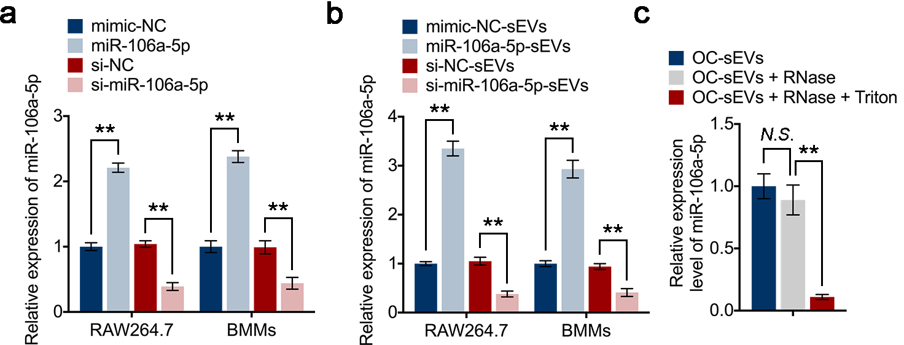
Supplementary Figure 2. miR-106a-5p derived from OC-sEVs can be transferred to BMSCs and induce osteogenic differentiation
(a) Relative expression levels of miR-106a-5p in RAW264.7 cells and BMMs knockdown or overexpressed miR-106a-5p, n = 3.
(b) Relative expression levels of miR-106a-5p in RAW264.7 cells and BMMs cultured with miR-106a-5p-sEVs or si-miR-106a-5p-sEVs, n = 3.
(c) Relative expression levels of miR-106a-5p in OC-sEVs which were treated with the RNase or Triton overnight at 4°C, n = 3.

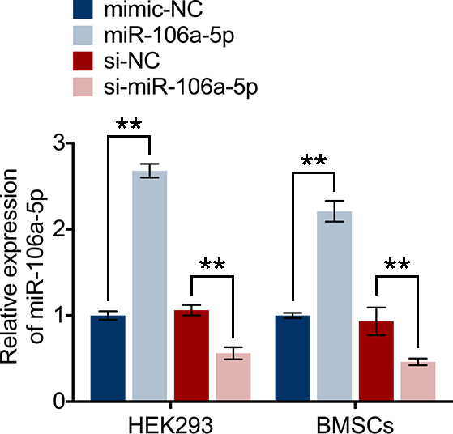
Supplementary Figure 3. Fam134a is a functional target of miR-106a-5p involving in osteogenic differentiation
Relative mRNA expression levels of Alpl, Sp7, Col1a1 and Runx2 in BMSCs knockdown or overexpressed miR-106a-5p, n = 3.

Supplementary Table 1. Primer sequences for qRT-PCR
Genes | Forward | Reverse | Tm (°C)
Alpl | 5'-AATGCCATCCCGTCCAAGACC-3' | 5'-GGTACCCGGAGTCCGTATAGG-3' | 61
Sp7 | 5'-AATCCTAATAGGCCCCAGG-3' | 5'-CCTGGTTACCAACTGGCCTA-3' | 62
Col1a1 | 5'-TTGGTTCGATGCAGCATAGG-3' | 5'-CCGTAATTTTCCCGTATGCA-3' | 60
Runx2 | 5'-CCGTCTCCCTATTATCCTGACAA-3' | 5'-AAGTGCTTCCTGGGAAATGTCAA-3' | 62
miR-106a-5p | 5'-ACTGTGCTAGCATGCTATTTTC-3' | 5'-AGCTAGCTGCCGTGGGCTTAGGC-3' | 60
Fam134a | 5'-AAGTACCTAGGCTGGGGATTCG-3' | 5'-CCCGTAGGATCCCGAGTCGCGGC-3' | 61
Gapdh | 5'-AACGGTCGGAACGATAGCA-3' | 5'-CCTTAAGGCGTAGTTAGGCCC-3' | 62

