Additional Figures for

Reexamination of tsunami source models for the 20th century earthquakes off-Hokkaido and Tohoku along the eastern margin of the Sea of Japan

Satoko Murotani^{1,2}, Kenji Satake², Takeo Ishibe^{2,3}, Tomoya Harada²

¹National Museum of Nature and Science, Ibaraki, Japan.
²Earthquake Research Institute, The University of Tokyo, Tokyo, Japan.
³Association for the Development of Earthquake Prediction, Tokyo, Japan.

Contents of this file: Figures S1 to S2

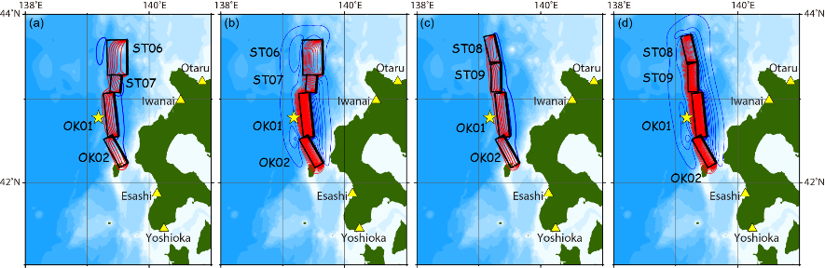

Figure S1. Seafloor displacements for the 1993 off the southwest coast of Hokkaido earthquake (MJMA 7.8) calculated from (a) Model Br, (b) Model Bt, (c) Model Cr, and (d) Model Ct. Counter interval is 20 cm. Red and blue curves show uplift and subsidence, respectively. Star shows the epicenter from the Japan Meteorological Agency (JMA) catalog. Triangles are tide gauge stations.
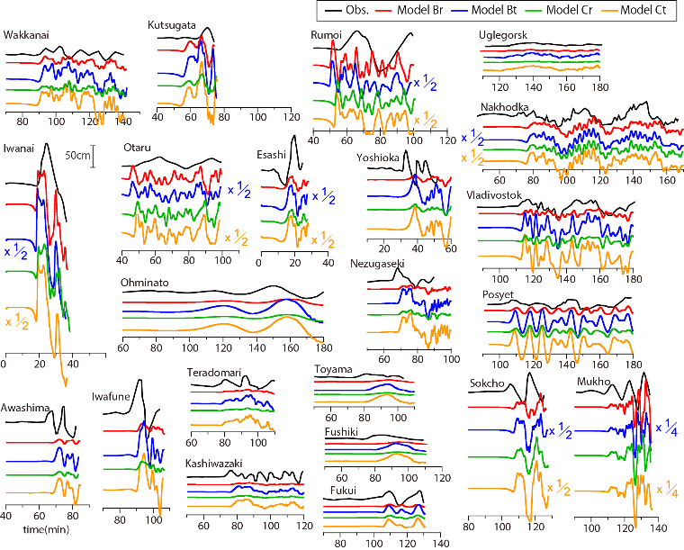
Figure S2. Comparison between the observed and calculated tsunami waveforms for the 1993 off the southwest coast of Hokkaido earthquake.

