Supplementary Figure 1. Expression distribution of MSS constituent genes across glial cell types.
Violin plots depicting the normalized expression (SCTransform) of the nine MSS constituent genes — HK2, LDHA, GYS1, ABCA1, ABCG1, APOE, LPL, PPARG, and ELOVL5 — across microglia (red), astrocytes (green), and oligodendroglia (blue). Internal boxplots indicate median and interquartile range. Expression values represent donor-level pseudobulk means across all nuclei of the respective cell type. APOE showed the highest overall expression and greatest variability across cell types, with particularly elevated levels in astrocytes. LPL expression was largely restricted to microglia. These patterns support the biological relevance of the MSS gene panel for capturing cell-type-specific lipid-metabolic stress.
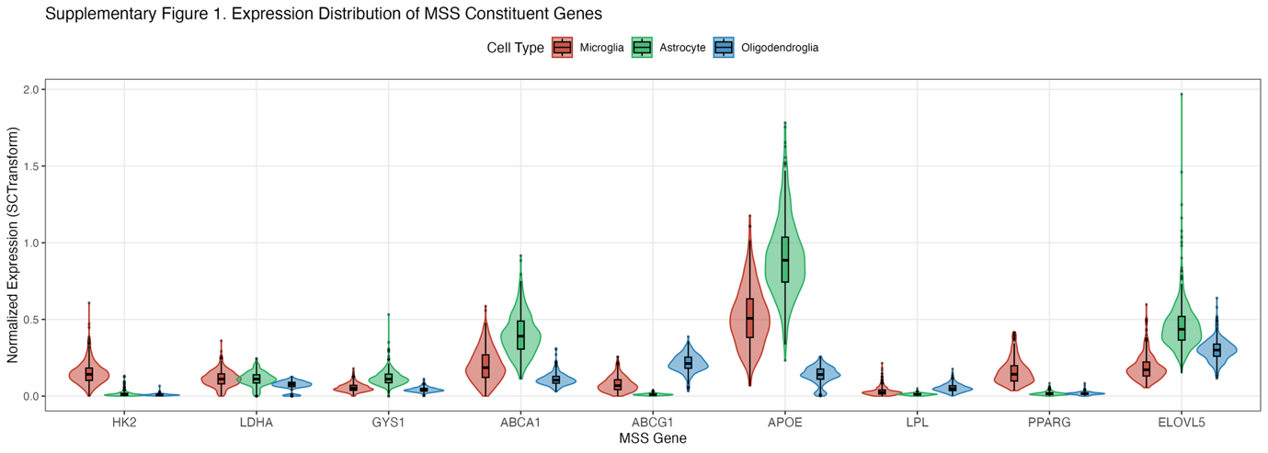
Supplementary Figure 2. Astrocyte reactive state analysis across clinical and pathological measures.
Four-panel figure characterizing reactive astrocyte proportions in relation to tau pathology, cognitive performance, and astrocyte MSS. (A) Reactive astrocyte proportion showed no significant association with Braak stage (β = −0.014, p = 0.245). (B) No significant association was observed with MMSE score (β = +0.002, p = 0.271). (C) Reactive astrocyte proportion showed a trend toward association with astrocyte MSS (β = +0.043, p = 0.077), not reaching statistical significance. (D) Boxplot distribution of reactive astrocyte proportions across Braak stages 0–6, demonstrating no consistent directional change with advancing tau pathology. Together, these findings suggest that astrocyte reactive state transitions in this cohort reflect a disease-independent phenotype, potentially driven by aging-related microglial signaling rather than AD-specific pathological burden. All models adjusted for age at death, sex, and postmortem interval.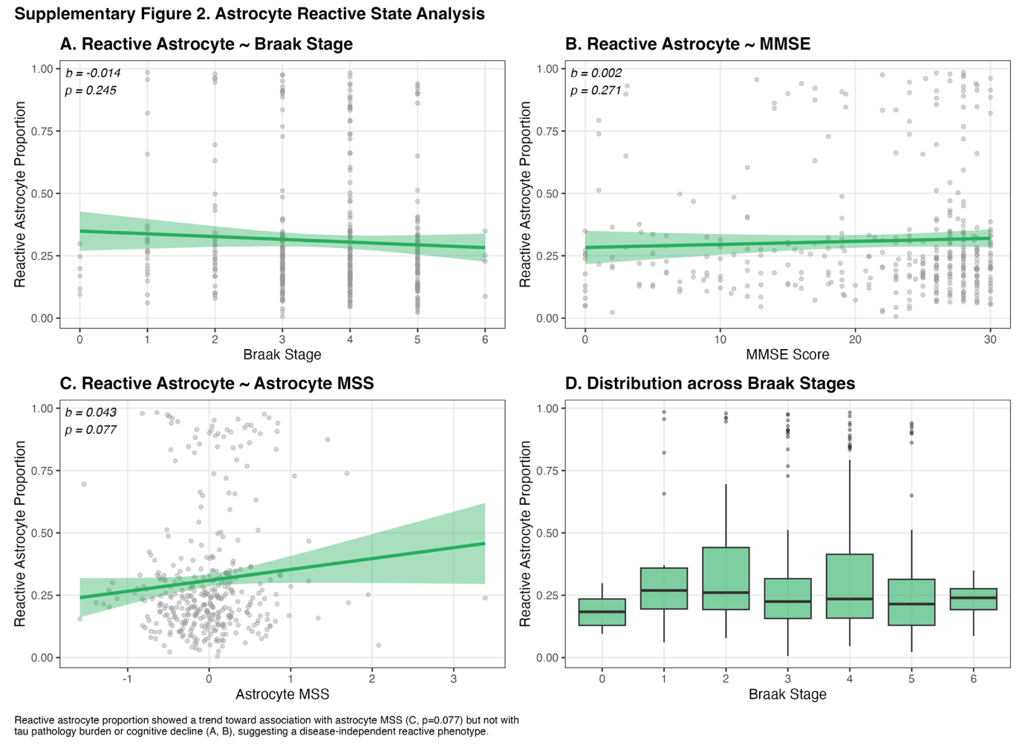

Supplementary Figure 3. APOE ε4-stratified segmented regression of microglial metabolic stress across Braak stages. Segmented regression analysis of microglial MSS across Braak stages, stratified by APOE ε4 carrier status. (A) In APOE ε4 carriers (n = 109), a significant breakpoint was identified at Braak stage 3.18 (95% CI [2.32, 4.03]; Davies test p = 0.008), with a negative slope prior to the breakpoint (slope 1: β = −0.323) and a positive slope thereafter (slope 2: β = +0.226). (B) In APOE ε4 non-carriers (n = 261), no significant breakpoint was detected (Davies test p = 0.113), and a linear model provided adequate fit (slope: β = +0.115). (C) Summary of segmented regression parameters. The breakpoint in APOE ε4 carriers should be interpreted cautiously given limited sample size at early Braak stages (n = 12 for Braak 0–2).
Supplementary Figure 4. Microglial subtype annotation. UMAP visualization of microglial nuclei (n = 82,380) colored by subtype annotation. Five subtypes were identified based on canonical marker gene expression: Homeostatic (P2RY12, TMEM119, CX3CR1), DAM (TREM2, CST7, SPP1), LDAM (LPL, APOE, GPNMB), Inflammatory (IRF7, ISG15, MX1), and Mixed. Macrophages and monocytes were excluded prior to annotation (see Methods 2.2). Marker gene expression profiles for each subtype are detailed in Supplementary Table 3 and Supplementary Figure 6.
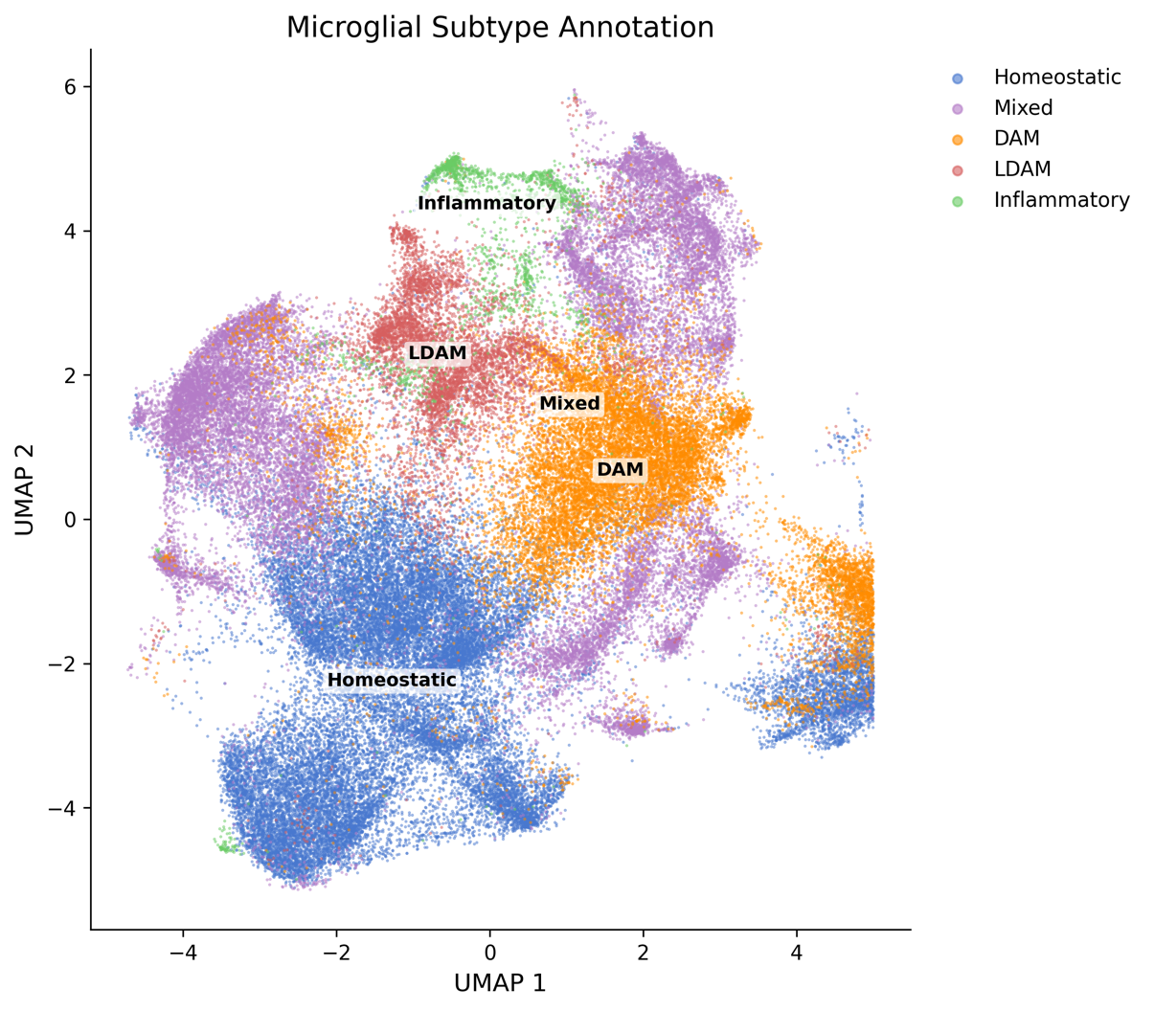
Supplementary Figure 5. Astrocyte and oligodendroglia subtype annotation. UMAP visualizations of astrocyte (left; n = 228,925) and oligodendroglia (right; n = 409,572) nuclei from ROSMAP snRNA-seq data. Astrocyte subclusters (Ast.1–Ast.10) were annotated based on expression of protoplasmic (ALDH1L1, GJA1, AQP4), reactive A1 (GFAP, SERPINA3, CD44), and intermediate markers. Ast.5 was annotated as A1 Reactive. Oligodendroglia were classified as Mature OL (MBP, MOG, MAG), OPC (PDGFRA, CSPG4), and Transitional (BCAS1). Marker expression values are provided in Supplementary Table 3.
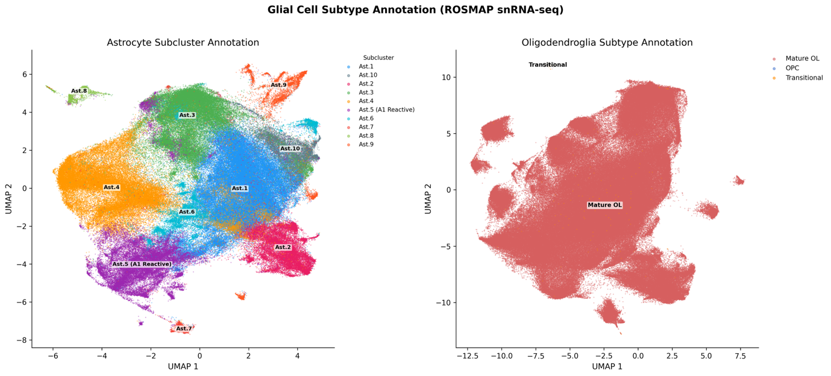
Supplementary Figure 6. Microglial subtype marker gene expression. Dotplot showing average expression (log-normalized; color intensity) and percentage of expressing nuclei (dot size) for selected marker genes across microglial subtypes. Genes are grouped by functional category: homeostatic markers (P2RY12, TMEM119, CX3CR1), DAM markers (TREM2, CST7, SPP1), LDAM markers (LPL, APOE, GPNMB), inflammatory markers (IRF7, ISG15, MX1), and MSS genes (HK2, LDHA). Homeostatic markers showed highest expression in the Homeostatic subtype, while LDAM markers were selectively enriched in the LDAM subtype. SPP1 was broadly expressed across all subtypes.
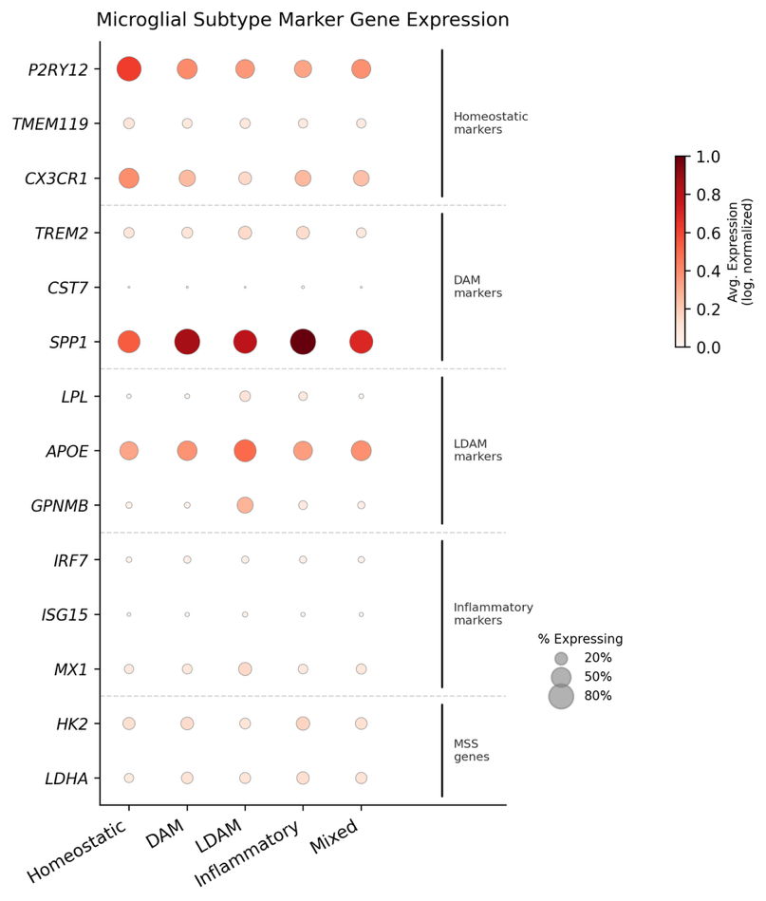

Supplementary Table 1. GSEA Hallmark Pathways — All Cell Types
Cell Type | Pathway | NES | p-value | p.adj | Size
Microglia
 | COMPLEMENT | -2.009 | 1.00e-10 | 5.00e-9 | 134
 | INFLAMMATORY RESPONSE | -1.958 | 5.57e-9 | 1.04e-7 | 108
 | TNFA SIGNALING VIA NFKB | -1.946 | 8.35e-9 | 1.04e-7 | 112
 | INTERFERON GAMMA RESPONSE | -1.898 | 6.50e-9 | 1.04e-7 | 140
 | ALLOGRAFT REJECTION | -1.832 | 9.80e-7 | 9.80e-6 | 109
 | CHOLESTEROL HOMEOSTASIS | -1.697 | 9.39e-4 | 0.006 | 53
 | COAGULATION | -1.694 | 0.002 | 0.009 | 57
 | TGF BETA SIGNALING | -1.671 | 0.005 | 0.022 | 41
 | INTERFERON ALPHA RESPONSE | -1.669 | 5.59e-4 | 0.004 | 72
 | IL2 STAT5 SIGNALING | -1.596 | 5.18e-4 | 0.004 | 123
 | APOPTOSIS | -1.557 | 0.003 | 0.015 | 100
 | KRAS SIGNALING UP | -1.536 | 0.004 | 0.016 | 109
 | PI3K AKT MTOR SIGNALING | -1.522 | 0.007 | 0.028 | 81
 | EPITHELIAL MESENCHYMAL TRANSITION | -1.480 | 0.008 | 0.030 | 85
 | APICAL SURFACE | -1.474 | 0.037 | 0.114 | 21
 | ANGIOGENESIS | -1.441 | 0.050 | 0.126 | 17
 | IL6 JAK STAT3 SIGNALING | -1.405 | 0.049 | 0.126 | 52
 | ANDROGEN RESPONSE | -1.380 | 0.042 | 0.116 | 80
 | HYPOXIA | -1.344 | 0.033 | 0.110 | 120
 | ESTROGEN RESPONSE LATE | -1.333 | 0.054 | 0.128 | 98
 | MITOTIC SPINDLE | -1.306 | 0.039 | 0.114 | 152
 | MTORC1 SIGNALING | -1.276 | 0.057 | 0.130 | 155
 | HEME METABOLISM | -1.248 | 0.083 | 0.181 | 134
 | ADIPOGENESIS | -1.221 | 0.104 | 0.218 | 150
Astrocytes
 | TNFA SIGNALING VIA NFKB | -2.162 | 2.12e-10 | 1.06e-8 | 137
 | MTORC1 SIGNALING | -1.980 | 2.33e-8 | 5.83e-7 | 180
 | UV RESPONSE UP | -1.960 | 4.68e-7 | 5.85e-6 | 127
 | HYPOXIA | -1.897 | 3.78e-7 | 5.85e-6 | 159
 | APOPTOSIS | -1.852 | 2.09e-5 | 2.09e-4 | 119
 | MYC TARGETS V2 | -1.799 | 4.69e-4 | 0.003 | 53
 | P53 PATHWAY | -1.767 | 2.85e-5 | 2.37e-4 | 167
 | UNFOLDED PROTEIN RESPONSE | -1.727 | 6.11e-4 | 0.003 | 103
 | CHOLESTEROL HOMEOSTASIS | -1.712 | 0.001 | 0.007 | 67
 | ESTROGEN RESPONSE EARLY | -1.704 | 2.30e-4 | 0.002 | 146
 | ESTROGEN RESPONSE LATE | -1.628 | 6.30e-4 | 0.003 | 133
 | GLYCOLYSIS | -1.533 | 0.003 | 0.011 | 163
 | IL6 JAK STAT3 SIGNALING | -1.488 | 0.031 | 0.081 | 47
 | NOTCH SIGNALING | -1.475 | 0.052 | 0.108 | 29
 | INTERFERON ALPHA RESPONSE | -1.463 | 0.023 | 0.071 | 79
 | XENOBIOTIC METABOLISM | -1.433 | 0.017 | 0.060 | 137
 | HEME METABOLISM | -1.425 | 0.022 | 0.071 | 160
 | FATTY ACID METABOLISM | -1.418 | 0.017 | 0.060 | 129
 | INFLAMMATORY RESPONSE | -1.397 | 0.031 | 0.081 | 99
 | INTERFERON GAMMA RESPONSE | -1.357 | 0.029 | 0.081 | 138
 | KRAS SIGNALING DN | -1.351 | 0.052 | 0.108 | 95
 | MYOGENESIS | -1.349 | 0.033 | 0.081 | 142
 | COMPLEMENT | -1.347 | 0.035 | 0.081 | 131
 | ANDROGEN RESPONSE | -1.328 | 0.082 | 0.152 | 85
 | ADIPOGENESIS | -1.310 | 0.035 | 0.081 | 181
 | PEROXISOME | -1.307 | 0.101 | 0.180 | 87
 | COAGULATION | -1.262 | 0.127 | 0.211 | 77
 | IL2 STAT5 SIGNALING | -1.221 | 0.113 | 0.195 | 137
 | APICAL JUNCTION | -1.202 | 0.138 | 0.222 | 148
 | KRAS SIGNALING UP | 1.190 | 0.082 | 0.152 | 121
 | PROTEIN SECRETION | 1.271 | 0.068 | 0.136 | 91
Oligodendroglia
 | IL6 JAK STAT3 SIGNALING | -1.683 | 0.005 | 0.075 | 42
 | TNFA SIGNALING VIA NFKB | -1.674 | 3.39e-4 | 0.017 | 135
 | HYPOXIA | -1.514 | 0.002 | 0.047 | 157
 | ANGIOGENESIS | -1.490 | 0.069 | 0.248 | 20
 | IL2 STAT5 SIGNALING | -1.466 | 0.006 | 0.075 | 133
 | APOPTOSIS | -1.449 | 0.008 | 0.075 | 119
 | INTERFERON ALPHA RESPONSE | -1.431 | 0.031 | 0.192 | 71
 | MYC TARGETS V2 | -1.395 | 0.061 | 0.235 | 52
 | INFLAMMATORY RESPONSE | -1.389 | 0.035 | 0.192 | 100
 | XENOBIOTIC METABOLISM | -1.336 | 0.042 | 0.192 | 134
 | ESTROGEN RESPONSE EARLY | -1.335 | 0.042 | 0.192 | 145
 | EPITHELIAL MESENCHYMAL TRANSITION | -1.324 | 0.049 | 0.203 | 143
 | OXIDATIVE PHOSPHORYLATION | -1.306 | 0.032 | 0.192 | 199
 | ESTROGEN RESPONSE LATE | -1.283 | 0.075 | 0.249 | 133
 | PROTEIN SECRETION | 1.354 | 0.035 | 0.192 | 94
NES = Normalized Enrichment Score. Only pathways with p < 0.05 shown. Sorted by NES within each cell type.

Supplementary Table 2. GSEA Reactome Pathways — All Cell Types
Cell Type | Pathway | NES | p-value | p.adj | Size
Microglia
 | EUKARYOTIC TRANSLATION ELONGATION | -2.059 | 2.85e-10 | 6.30e-8 | 89
 | SRP DEPENDENT COTRANSLATIONAL PROTEIN TARGETING TO MEMBRANE | -2.026 | 1.35e-10 | 4.95e-8 | 108
 | RESPONSE OF EIF2AK4 GCN2 TO AMINO ACID DEFICIENCY | -2.003 | 2.36e-9 | 3.26e-7 | 94
 | EUKARYOTIC TRANSLATION INITIATION | -1.995 | 2.01e-10 | 5.57e-8 | 113
 | NONSENSE MEDIATED DECAY NMD | -1.977 | 1.83e-9 | 2.88e-7 | 108
 | SARS COV 2 MODULATES HOST TRANSLATION MACHINERY | -1.958 | 4.04e-6 | 2.23e-4 | 43
 | DAP12 INTERACTIONS | -1.941 | 1.07e-5 | 4.93e-4 | 25
 | SELENOAMINO ACID METABOLISM | -1.928 | 7.05e-8 | 6.00e-6 | 97
 | CELLULAR RESPONSE TO STARVATION | -1.920 | 7.53e-10 | 1.39e-7 | 137
 | ACTIVATION OF THE MRNA UPON BINDING OF THE CAP BINDING COMPLEX AND EIFS AND SUBSEQUENT BINDING TO 43S | -1.901 | 4.23e-6 | 2.23e-4 | 58
 | SARS COV 1 MODULATES HOST TRANSLATION MACHINERY | -1.871 | 4.70e-5 | 0.002 | 36
 | NEUTROPHIL DEGRANULATION | -1.866 | 1.00e-10 | 4.95e-8 | 347
 | REGULATION OF EXPRESSION OF SLITS AND ROBOS | -1.831 | 2.22e-8 | 2.72e-6 | 145
 | SARS COV 1 HOST INTERACTIONS | -1.820 | 3.17e-6 | 1.95e-4 | 87
 | COMPLEMENT CASCADE | -1.789 | 2.64e-4 | 0.009 | 18
 | DAP12 SIGNALING | -1.786 | 4.72e-4 | 0.015 | 22
 | SIGNALING BY ROBO RECEPTORS | -1.757 | 5.00e-8 | 5.02e-6 | 184
 | INTERFERON ALPHA BETA SIGNALING | -1.751 | 3.44e-4 | 0.012 | 45
 | PEPTIDE LIGAND BINDING RECEPTORS | -1.749 | 8.48e-4 | 0.023 | 23
 | ANTIGEN PROCESSING CROSS PRESENTATION | -1.747 | 2.84e-5 | 0.001 | 86
 | IMMUNOREGULATORY INTERACTIONS BETWEEN A LYMPHOID AND A NON LYMPHOID CELL | -1.746 | 2.22e-4 | 0.008 | 52
 | SARS COV 1 INFECTION | -1.744 | 4.89e-6 | 2.45e-4 | 125
 | OTHER SEMAPHORIN INTERACTIONS | -1.744 | 8.38e-4 | 0.023 | 13
 | INTERLEUKIN 10 SIGNALING | -1.740 | 0.001 | 0.028 | 15
 | INFLUENZA INFECTION | -1.732 | 1.63e-6 | 1.11e-4 | 149
 | BASIGIN INTERACTIONS | -1.696 | 0.001 | 0.029 | 19
 | NUCLEAR RECEPTOR TRANSCRIPTION PATHWAY | -1.691 | 0.002 | 0.043 | 29
 | ACTIVATION OF NF KAPPAB IN B CELLS | -1.690 | 0.001 | 0.027 | 51
 | ROS AND RNS PRODUCTION IN PHAGOCYTES | -1.689 | 0.002 | 0.043 | 24
 | SARS COV 2 HOST INTERACTIONS | -1.685 | 1.18e-5 | 5.11e-4 | 162
 | TRANSLATION | -1.682 | 6.48e-8 | 5.97e-6 | 240
 | INTERFERON GAMMA SIGNALING | -1.680 | 8.60e-4 | 0.023 | 65
 | RRNA PROCESSING | -1.675 | 5.37e-6 | 2.58e-4 | 168
 | METABOLISM OF AMINO ACIDS AND DERIVATIVES | -1.671 | 4.03e-7 | 2.97e-5 | 225
 | RHOV GTPASE CYCLE | -1.669 | 0.005 | 0.076 | 27
 | PARASITE INFECTION | -1.662 | 8.37e-4 | 0.023 | 55
 | INTERLEUKIN 17 SIGNALING | -1.660 | 0.001 | 0.027 | 59
 | CELL EXTRACELLULAR MATRIX INTERACTIONS | -1.657 | 0.005 | 0.072 | 13
 | ANTIMICROBIAL PEPTIDES | -1.649 | 0.005 | 0.078 | 13
 | INTERLEUKIN 4 AND INTERLEUKIN 13 SIGNALING | -1.647 | 0.002 | 0.043 | 56
 | EPHB MEDIATED FORWARD SIGNALING | -1.641 | 0.005 | 0.074 | 35
 | TCR SIGNALING | -1.636 | 5.82e-4 | 0.017 | 90
 | SIGNALING BY ALK IN CANCER | -1.634 | 0.001 | 0.029 | 75
 | CD209 DC SIGN SIGNALING | -1.633 | 0.006 | 0.089 | 17
 | GPVI MEDIATED ACTIVATION CASCADE | -1.631 | 0.004 | 0.065 | 26
 | RHO GTPASES ACTIVATE WASPS AND WAVES | -1.630 | 0.007 | 0.098 | 36
 | DOWNSTREAM TCR SIGNALING | -1.629 | 7.34e-4 | 0.021 | 73
 | ACTIVATED TAK1 MEDIATES P38 MAPK ACTIVATION | -1.627 | 0.005 | 0.072 | 22
 | SIGNALING BY INTERLEUKINS | -1.622 | 1.83e-7 | 1.44e-5 | 282
 | STRIATED MUSCLE CONTRACTION | -1.616 | 0.008 | 0.113 | 13
 | ANTIGEN PRESENTATION FOLDING ASSEMBLY AND PEPTIDE LOADING OF CLASS I MHC | -1.611 | 0.012 | 0.144 | 27
 | REGULATION OF T CELL ACTIVATION BY CD28 FAMILY | -1.606 | 0.004 | 0.061 | 53
 | EPH EPHRIN SIGNALING | -1.605 | 0.002 | 0.036 | 68
 | CYTOKINE SIGNALING IN IMMUNE SYSTEM | -1.596 | 1.00e-10 | 4.95e-8 | 493
 | LEISHMANIA INFECTION | -1.594 | 2.84e-4 | 0.010 | 127
 | SARS COV 2 INFECTION | -1.592 | 3.86e-6 | 2.23e-4 | 238
 | INTERLEUKIN 1 SIGNALING | -1.589 | 0.002 | 0.031 | 84
 | TOLL LIKE RECEPTOR TLR1 TLR2 CASCADE | -1.587 | 0.001 | 0.031 | 89
 | P75 NTR RECEPTOR MEDIATED SIGNALLING | -1.586 | 0.002 | 0.031 | 77
 | TAK1 DEPENDENT IKK AND NF KAPPA B ACTIVATION | -1.584 | 0.003 | 0.051 | 34
 | SARS COV 1 ACTIVATES MODULATES INNATE IMMUNE RESPONSES | -1.582 | 0.011 | 0.135 | 35
 | FCERI MEDIATED NF KB ACTIVATION | -1.582 | 0.005 | 0.072 | 64
 | ERYTHROPOIETIN ACTIVATES RAS | -1.579 | 0.009 | 0.115 | 12
 | NR1H3 NR1H2 REGULATE GENE EXPRESSION LINKED TO CHOLESTEROL TRANSPORT AND EFFLUX | -1.576 | 0.009 | 0.115 | 32
 | MAP3K8 TPL2 DEPENDENT MAPK1 3 ACTIVATION | -1.573 | 0.014 | 0.159 | 15
 | P75NTR SIGNALS VIA NF KB | -1.570 | 0.015 | 0.163 | 13
 | OTHER INTERLEUKIN SIGNALING | -1.568 | 0.013 | 0.154 | 17
 | SARS COV 2 ACTIVATES MODULATES INNATE AND ADAPTIVE IMMUNE RESPONSES | -1.565 | 0.002 | 0.043 | 97
 | TOLL LIKE RECEPTOR CASCADES | -1.564 | 5.81e-4 | 0.017 | 132
 | PURINERGIC SIGNALING IN LEISHMANIASIS INFECTION | -1.562 | 0.021 | 0.212 | 21
 | NERVOUS SYSTEM DEVELOPMENT | -1.562 | 3.21e-8 | 3.55e-6 | 412
 | INTERLEUKIN 1 FAMILY SIGNALING | -1.557 | 0.001 | 0.031 | 104
 | SIGNALING BY THE B CELL RECEPTOR BCR | -1.554 | 0.002 | 0.043 | 87
 | MODULATION OF HOST RESPONSES BY IFN STIMULATED GENES | -1.554 | 0.014 | 0.157 | 16
 | TOLL LIKE RECEPTOR 9 TLR9 CASCADE | -1.552 | 0.002 | 0.040 | 91
 | DISEASES ASSOCIATED WITH GLYCOSAMINOGLYCAN METABOLISM | -1.547 | 0.009 | 0.115 | 19
 | AMINO ACID TRANSPORT ACROSS THE PLASMA MEMBRANE | -1.546 | 0.012 | 0.140 | 18
 | CELL CELL COMMUNICATION | -1.545 | 0.006 | 0.088 | 80
 | SIGNALING BY ERYTHROPOIETIN | -1.544 | 0.012 | 0.144 | 23
 | ERYTHROPOIETIN ACTIVATES PHOSPHOINOSITIDE 3 KINASE PI3K | -1.543 | 0.009 | 0.120 | 11
 | MYD88 INDEPENDENT TLR4 CASCADE | -1.537 | 0.004 | 0.061 | 92
 | TICAM1 DEPENDENT ACTIVATION OF IRF3 IRF7 | -1.534 | 0.022 | 0.217 | 13
 | THE ROLE OF NEF IN HIV 1 REPLICATION AND DISEASE PATHOGENESIS | -1.533 | 0.013 | 0.154 | 22
 | PLATELET ACTIVATION SIGNALING AND AGGREGATION | -1.532 | 2.38e-4 | 0.009 | 167
 | CD28 DEPENDENT PI3K AKT SIGNALING | -1.529 | 0.015 | 0.163 | 22
 | REGULATION OF MITF M DEPENDENT GENES INVOLVED IN LYSOSOME BIOGENESIS AND AUTOPHAGY | -1.529 | 0.021 | 0.215 | 17
 | NOTCH3 ACTIVATION AND TRANSMISSION OF SIGNAL TO THE NUCLEUS | -1.528 | 0.019 | 0.202 | 16
 | SARS COV INFECTIONS | -1.528 | 1.70e-6 | 1.11e-4 | 337
 | CLATHRIN MEDIATED ENDOCYTOSIS | -1.525 | 0.001 | 0.029 | 116
 | NR1H2 AND NR1H3 MEDIATED SIGNALING | -1.517 | 0.018 | 0.193 | 37
 | DOWNSTREAM SIGNALING EVENTS OF B CELL RECEPTOR BCR | -1.517 | 0.011 | 0.140 | 65
 | DEATH RECEPTOR SIGNALING | -1.512 | 0.001 | 0.028 | 123
 | PEPTIDE HORMONE METABOLISM | -1.510 | 0.018 | 0.197 | 37
 | RHOU GTPASE CYCLE | -1.508 | 0.007 | 0.099 | 34
 | PLASMA LIPOPROTEIN CLEARANCE | -1.506 | 0.020 | 0.208 | 23
 | CELL DEATH SIGNALLING VIA NRAGE NRIF AND NADE | -1.506 | 0.014 | 0.159 | 59
 | FCGAMMA RECEPTOR FCGR DEPENDENT PHAGOCYTOSIS | -1.501 | 0.008 | 0.107 | 79
 | CELLULAR RESPONSES TO MECHANICAL STIMULI | -1.492 | 0.008 | 0.107 | 77
 | INTERFERON SIGNALING | -1.491 | 5.70e-4 | 0.017 | 195
 | DDX58 IFIH1 MEDIATED INDUCTION OF INTERFERON ALPHA BETA | -1.490 | 0.020 | 0.206 | 56
 | HEMOSTASIS | -1.476 | 1.20e-5 | 5.11e-4 | 361
 | CELL SURFACE INTERACTIONS AT THE VASCULAR WALL | -1.464 | 0.012 | 0.144 | 78
 | NUCLEAR EVENTS MEDIATED BY NFE2L2 | -1.464 | 0.021 | 0.212 | 76
 | TRANSCRIPTIONAL REGULATION OF WHITE ADIPOCYTE DIFFERENTIATION | -1.462 | 0.023 | 0.230 | 63
 | TNFR2 NON CANONICAL NF KB PATHWAY | -1.458 | 0.024 | 0.237 | 63
 | SIGNALING BY GPCR | -1.447 | 8.79e-4 | 0.023 | 253
 | FACTORS INVOLVED IN MEGAKARYOCYTE DEVELOPMENT AND PLATELET PRODUCTION | -1.400 | 0.024 | 0.237 | 92
 | RAC1 GTPASE CYCLE | -1.394 | 0.008 | 0.113 | 147
 | CDC42 GTPASE CYCLE | -1.374 | 0.022 | 0.218 | 122
 | DISEASES OF SIGNAL TRANSDUCTION BY GROWTH FACTOR RECEPTORS AND SECOND MESSENGERS | -1.358 | 0.002 | 0.031 | 335
 | SIGNALING BY RECEPTOR TYROSINE KINASES | -1.332 | 0.003 | 0.056 | 353
 | MEMBRANE TRAFFICKING | -1.280 | 0.004 | 0.065 | 497
 | TRANSPORT OF SMALL MOLECULES | -1.265 | 0.011 | 0.135 | 402
 | RHO GTPASE CYCLE | -1.236 | 0.025 | 0.240 | 349
 | NITRIC OXIDE STIMULATES GUANYLATE CYCLASE | 1.730 | 0.009 | 0.113 | 15
Astrocytes
 | HSF1 DEPENDENT TRANSACTIVATION | -2.125 | 3.24e-6 | 0.002 | 33
 | ATTENUATION PHASE | -2.085 | 1.33e-5 | 0.005 | 23
 | HSF1 ACTIVATION | -2.070 | 4.89e-5 | 0.010 | 26
 | CONSTITUTIVE SIGNALING BY AKT1 E17K IN CANCER | -2.058 | 2.94e-5 | 0.009 | 25
 | CELLULAR RESPONSE TO HEAT STRESS | -1.982 | 1.57e-6 | 0.002 | 95
 | REGULATION OF HSF1 MEDIATED HEAT SHOCK RESPONSE | -1.890 | 4.78e-5 | 0.010 | 76
 | MITOCHONDRIAL UNFOLDED PROTEIN RESPONSE UPRMT | -1.813 | 0.002 | 0.242 | 17
 | NUCLEAR RECEPTOR TRANSCRIPTION PATHWAY | -1.779 | 0.002 | 0.242 | 40
 | GLYCOGEN STORAGE DISEASES | -1.754 | 0.003 | 0.242 | 14
 | INTERFERON ALPHA BETA SIGNALING | -1.728 | 0.002 | 0.242 | 49
 | INTERFERON SIGNALING | -1.534 | 9.96e-4 | 0.172 | 208
 | METABOLISM OF CARBOHYDRATES AND CARBOHYDRATE DERIVATIVES | -1.500 | 0.002 | 0.242 | 236
 | PI METABOLISM | 1.655 | 0.002 | 0.242 | 76
Oligodendroglia
 | TRANSMISSION ACROSS CHEMICAL SYNAPSES | -1.556 | 2.63e-4 | 0.183 | 224
 | NEUROTRANSMITTER RECEPTORS AND POSTSYNAPTIC SIGNAL TRANSMISSION | -1.540 | 0.001 | 0.183 | 169
 | CILIUM ASSEMBLY | -1.523 | 0.002 | 0.208 | 173
 | NEURONAL SYSTEM | -1.426 | 0.001 | 0.183 | 341
 | CLASS I MHC MEDIATED ANTIGEN PROCESSING PRESENTATION | 1.416 | 3.60e-4 | 0.183 | 328
 | ANTIGEN PROCESSING UBIQUITINATION PROTEASOME DEGRADATION | 1.421 | 9.28e-4 | 0.183 | 272
 | NEDDYLATION | 1.432 | 0.001 | 0.183 | 212
 | ATF6 ATF6 ALPHA ACTIVATES CHAPERONE GENES | 1.940 | 0.001 | 0.183 | 10
 | MET RECEPTOR RECYCLING | 1.967 | 7.13e-4 | 0.183 | 10
NES = Normalized Enrichment Score. Only pathways with p < 0.05 shown. Sorted by NES within each cell type.

Supplementary Table 3. Glial Subtype Marker Expression
Microglia
Subtype | Annotation | n (nuclei) | P2RY12 | TMEM119 | CX3CR1 | LPL | TREM2 | APOE | MX1 | SPP1 | CD74
Mic.2 | Homeostatic | 13,720 | 1.052 | 0.117 | 0.566 | 0.017 | 0.104 | 0.447 | 0.080 | 0.763 | 0.877
Mic.3 | Homeostatic | 8,333 | 0.987 | 0.106 | 0.537 | 0.018 | 0.094 | 0.386 | 0.082 | 0.803 | 0.874
Mic.4 | Homeostatic | 4,906 | 1.072 | 0.125 | 0.589 | 0.020 | 0.117 | 0.343 | 0.105 | 0.986 | 0.782
Mic.9 | Homeostatic | 3,538 | 0.849 | 0.133 | 0.472 | 0.021 | 0.146 | 0.605 | 0.101 | 0.909 | 1.004
Mic.7 | DAM | 12,865 | 0.585 | 0.095 | 0.332 | 0.022 | 0.110 | 0.481 | 0.101 | 1.684 | 0.819
Mic.10 | DAM | 3,634 | 0.492 | 0.099 | 0.323 | 0.027 | 0.166 | 0.664 | 0.109 | 1.517 | 0.961
Mic.12 | LDAM | 3,881 | 0.404 | 0.095 | 0.151 | 0.078 | 0.141 | 0.768 | 0.192 | 0.820 | 0.915
Mic.13 | LDAM | 2,683 | 0.624 | 0.114 | 0.231 | 0.225 | 0.236 | 0.726 | 0.174 | 2.353 | 0.750
Mic.15 | Inflammatory | 1,901 | 0.438 | 0.087 | 0.332 | 0.092 | 0.171 | 0.472 | 0.096 | 2.065 | 0.934
Mic.5 | Mixed | 10,465 | 0.717 | 0.100 | 0.399 | 0.025 | 0.097 | 0.519 | 0.090 | 0.977 | 0.782
Mic.6 | Mixed | 7,913 | 0.206 | 0.063 | 0.134 | 0.020 | 0.082 | 0.594 | 0.137 | 1.400 | 0.838
Mic.8 | Mixed | 5,743 | 0.646 | 0.098 | 0.376 | 0.019 | 0.105 | 0.496 | 0.101 | 1.251 | 0.839
Macrophages | Excluded | 2,070 | 0.144 | 0.017 | 0.022 | 0.026 | 0.031 | 0.366 | 0.163 | 0.405 | 0.406
Monocytes | Excluded | 813 | 0.089 | 0.008 | 0.115 | 0.045 | 0.005 | 0.175 | 0.092 | 0.279 | 0.571
Astrocyte
Subtype | Annotation | n (nuclei) | ALDH1L1 | GJA1 | AQP4 | GFAP | VIM | SERPINA3 | CD44 | C3 | SERPING1
Ast.1 | Protoplasmic | 75,124 | 0.752 | 1.693 | 1.497 | 1.113 | 0.300 | 0.090 | 0.069 | 0.016 | 0.080
Ast.2 | Protoplasmic | 19,993 | 0.715 | 1.610 | 1.570 | 1.235 | 0.365 | 0.108 | 0.068 | 0.012 | 0.058
Ast.3 | Fibrous | 36,810 | 0.717 | 1.573 | 1.473 | 1.482 | 0.337 | 0.127 | 0.115 | 0.027 | 0.093
Ast.4 | Reactive (A1) | 42,671 | 0.626 | 1.329 | 1.821 | 1.926 | 0.355 | 0.179 | 0.545 | 0.062 | 0.092
Ast.5 | Reactive (A1) | 27,082 | 1.062 | 1.300 | 1.655 | 1.899 | 0.395 | 0.787 | 0.774 | 0.054 | 0.231
Ast.6 | Intermediate | 8,266 | 0.814 | 1.556 | 1.447 | 1.346 | 0.385 | 0.256 | 0.215 | 0.029 | 0.121
Ast.7 | Intermediate | 1,801 | 0.805 | 1.321 | 1.696 | 1.524 | 0.278 | 0.181 | 0.148 | 0.033 | 0.123
Ast.8 | Stress | 2,249 | 0.995 | 1.367 | 1.432 | 1.259 | 0.311 | 0.115 | 0.097 | 0.020 | 0.065
Ast.9 | Intermediate | 6,499 | 0.729 | 1.578 | 1.529 | 1.050 | 0.416 | 0.144 | 0.255 | 0.020 | 0.078
Ast.10 | Intermediate | 8,430 | 0.809 | 1.735 | 1.587 | 1.138 | 0.404 | 0.109 | 0.141 | 0.027 | 0.064

Oligodendroglia
Subtype | Annotation | n (nuclei) | MBP | MOG | MAG | PDGFRA | CSPG4 | SOX10
Oli.1 | Mature OL | 6,579 | 2.557 | 0.988 | 0.919 | 0.008 | 0.004 | 0.315
Oli.2 | Mature OL | 89,361 | 2.213 | 0.784 | 0.716 | 0.009 | 0.004 | 0.258
Oli.3 | Mature OL | 129,743 | 2.395 | 0.924 | 0.704 | 0.007 | 0.004 | 0.276
Oli.4 | Mature OL | 31,152 | 2.325 | 0.849 | 0.899 | 0.002 | 0.001 | 0.211
Oli.5 | Mature OL | 8,584 | 2.632 | 1.052 | 0.740 | 0.007 | 0.004 | 0.260
Oli.6 | Mature OL | 53,753 | 2.262 | 0.750 | 0.565 | 0.013 | 0.005 | 0.227
Oli.7 | Mature OL | 9,002 | 2.075 | 0.625 | 0.550 | 0.009 | 0.005 | 0.326
Oli.8 | Mature OL | 6,444 | 2.098 | 0.651 | 0.570 | 0.009 | 0.003 | 0.300
Oli.9 | Mature OL | 6,314 | 2.410 | 0.945 | 0.763 | 0.008 | 0.003 | 0.259
Oli.10 | Mature OL | 2,120 | 2.342 | 0.893 | 0.696 | 0.006 | 0.005 | 0.291
Oli.11 | Mature OL | 2,117 | 2.389 | 0.937 | 0.745 | 0.007 | 0.002 | 0.270
Oli.12 | Mature OL | 1,424 | 2.216 | 0.789 | 0.663 | 0.022 | 0.006 | 0.265
MFOL | Transitional | 1,801 | 1.778 | 0.502 | 0.393 | 0.600 | 0.213 | 0.282
COP | Transitional | 556 | 1.778 | 0.474 | 0.225 | 0.203 | 0.250 | 0.701
OPC.1 | OPC | 11,481 | 0.848 | 0.041 | 0.025 | 1.055 | 0.376 | 0.250
OPC.2 | OPC | 42,725 | 0.599 | 0.041 | 0.015 | 1.211 | 0.399 | 0.273
OPC.3 | OPC | 6,416 | 0.553 | 0.050 | 0.014 | 1.075 | 0.435 | 0.247

Values represent mean normalized expression (SCTransform) per subtype. LDAM = Lipid-droplet Associated Microglia; DAM = Disease-Associated Microglia; IFN = Interferon-responsive; OPC = Oligodendrocyte Precursor Cell; MFOL = Myelin-Forming OL; COP = Committed OPC. Macrophages and Monocytes were excluded from downstream analyses. — indicates clusters present in original dataset but not included in primary marker analysis.

Supplementary Table 4. Distribution of APOE ε4 Genotype Groups across Braak Stages

APOE Genotype Group | Braak 0–2 | Braak 3–4 | Braak 5–6 | Total
APOE ε4 Heterozygote (e3/e4) | 12 | 46 | 45 | 103
APOE ε4 Homozygote (e4/e4) | 0 | 3 | 3 | 6
APOE ε4 Non-carrier (e3/e3) | 45 | 172 | 44 | 261
Total | 57 | 221 | 92 | 370

Values represent number of donors. Braak stage groupings: low (0–2), intermediate (3–4), high (5–6). APOE ε2 carriers excluded from all analyses (n=76; see Methods).

