Supplementary Information for:
Higher probability of abrupt shift from drought to heavy rainfall

Content:
Table S1 List of the CMIP5 models used in this study
Fig. S1 Historical trends for scPDSI drought and R99p heavy rainfall, as well as the probability of abrupt shift from drought to R99p heavy rainfall during 1955−2004
Fig. S2 Observed and simulated probabilities of the abrupt shift from drought to heavy rainfall
Fig. S3 Future probability of abrupt shift from drought to R99p heavy rainfall under RCP8.5
Fig. S4 Observed and simulated probability distribution functions (PDFs) of the abrupt shift from drought to heavy rainfall
Fig. S5 Future probability of abrupt shift from drought to R95p heavy rainfall under RCP4.5
Fig. S6 Combined trends of drought, R99p heavy rainfall, and the probability of abrupt shift
Fig. S7 The effect of elevated CO₂ concentration on the potential evapotranspiration (PET) estimation
Fig. S8 The effect of elevated CO₂ concentration on the scPDSI drought calculation
Fig. S9 Same as Fig. S4. The effect of elevated CO₂ concentration is not considered in the scPDSI calculation
Fig. S10 Same as Fig. S5 but under RCP8.5 without considering the effect of elevated CO₂ concentration in the scPDSI calculation
Fig. S11 Same as Fig. S5 but without considering the effect of elevated CO₂ concentration in the scPDSI calculation
Fig. S12 Same as Fig. S5 but for R99p heavy rainfall without considering the effect of elevated CO₂ concentration in the scPDSI calculation
Fig. S13 Same as Fig. S5 but for R99p heavy rainfall under RCP8.5 without considering the effect of elevated CO₂ concentration in the scPDSI calculation
Fig. S14 Same as Fig. S6 but without considering the effect of elevated CO₂ concentration in the scPDSI calculation
Fig. S15 Observed and simulated convective available potential energy (CAPE) and convective inhibition (CIN)
Fig. S16 Observed and simulated vertically integrated moisture flux convergence (VIMFC)
Fig. S17 The significance test for Poisson distributions
Fig. S18 Future probability of abrupt shift from drought to R99p heavy rainfall under RCP4.5

Table S1 List of the CMIP5 models used in this study
Model name | Ensemble runs | Modeling group | Resolution (Longitude× Latitude)
CNRM-CM5 | r1i1p1 | Centre National de Recherches Météorologiques/Centre Européen de Recherche et de Formation Avancée en Calcul Scientifique | 256×128
GFDL-CM3 | r1i1p1 | NOAA Geophysical Fluid Dynamics Laboratory | 144×90
GFDL-ESM2G | r1i1p1 | NOAA Geophysical Fluid Dynamics Laboratory | 180×90
GFDL-ESM2M | r1i1p1 | NOAA Geophysical Fluid Dynamics Laboratory | 144×90
HadGEM2-ES | r1i1p1 | Met Office Hadley Centre | 192×145
HadGEM2-CC | r1i1p1 | Met Office Hadley Centre | 192×145
MIROC5 | r1i1p1, r2i1p1, r3i1p1 | Japan Agency for Marine Marine-Earth Science and Technology, Atmosphere and Ocean Research Institute (The University of Tokyo), and National Institute for Environmental Studies | 256×128
MRI-CGCM3 | r1i1p1 | Meteorological Research Institute | 320×160
CSIRO-Mk3.6.0 | r1i1p1 | Commonwealth Scientific and Industrial Research Organization in collaboration with Queensland Climate Change Centre of Excellence | 192×97
ACCESS1-0 | r1i1p1 | Commonwealth Scientific and Industrial Research Organization (CSIRO) and Bureau of Meteorology (BOM), Australia | 192×145
ACCESS1-3 | r1i1p1 |  | 192×145
IPSL-CM5A-MR | r1i1p1 | Institute Pierre-Simon Laplace | 144×143
INM-CM4 | r1i1p1 | Institute for Numerical Mathematics | 180×120

Fig. S1 Historical abrupt shift from drought to heavy rainfall. Long-term trends from 1955 to 2004 in a calculated scPDSI and b heavy rainfall intensity based on observations. The trend is estimated by calculating Sen’s slope estimator and the corresponding significance is estimated using the Mann-Kendall test. The stippling in a and b indicates the trend is statistically significant at the 5% level. c The probability of abrupt shift from drought (scPDSI below −2) to R99p heavy rainfall for the period 1955−2004. The abrupt shift is defined as the occurrence of R99p heavy rainfall during the month immediately after drought demise. The stippling in c indicates the probability of abrupt shift is statistically significant at the 5% level. d PDF of the land fraction showing the probability of abrupt shift generated from observations and independent sequences of drought and heavy rainfall. The vertical dashed lines represent the mean probability of abrupt shift. The lower and upper bounds of the gray shading refer to 2.5th and 97.5th percentile estimates, respectively, of the probability of abrupt shift generated from 1,000 random independent sequences of drought and heavy rainfall.

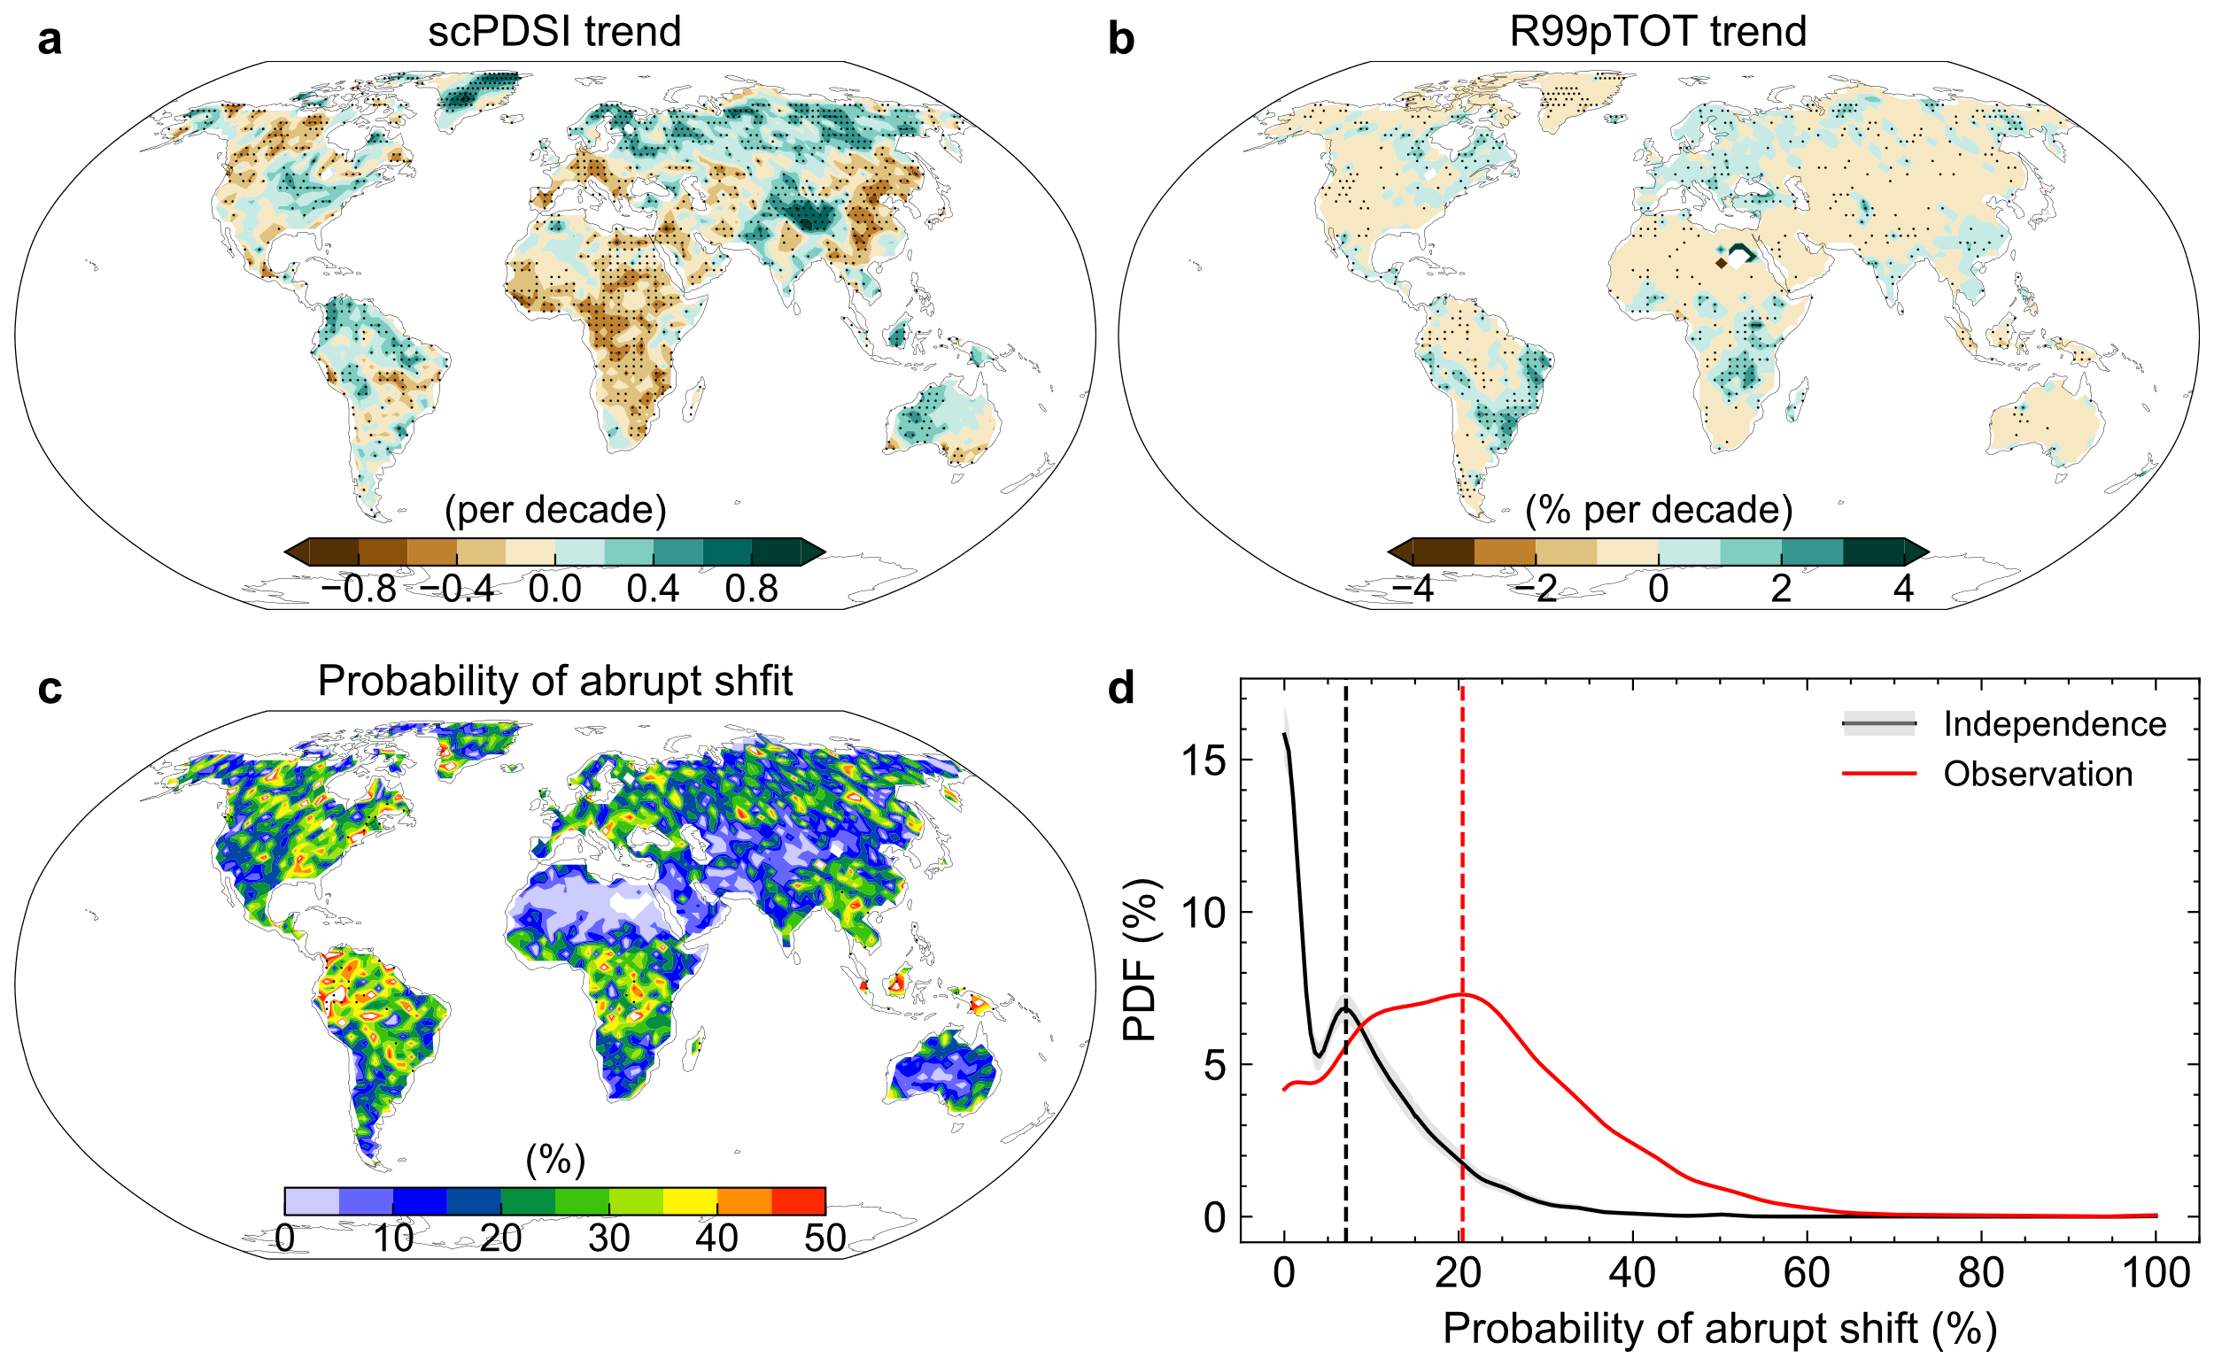

Fig. S2 Observed and simulated probabilities of the abrupt shift from drought to heavy rainfall. a, b The probability of abrupt shift from drought to R95p and R99p heavy rainfall, respectively, for the present climate (1955−2004) calculated based on the REGEN precipitation and CRU potential evapotranspiration datasets. c, d Same as a, b but generated from the ensemble mean of 15 CMIP5 simulations.

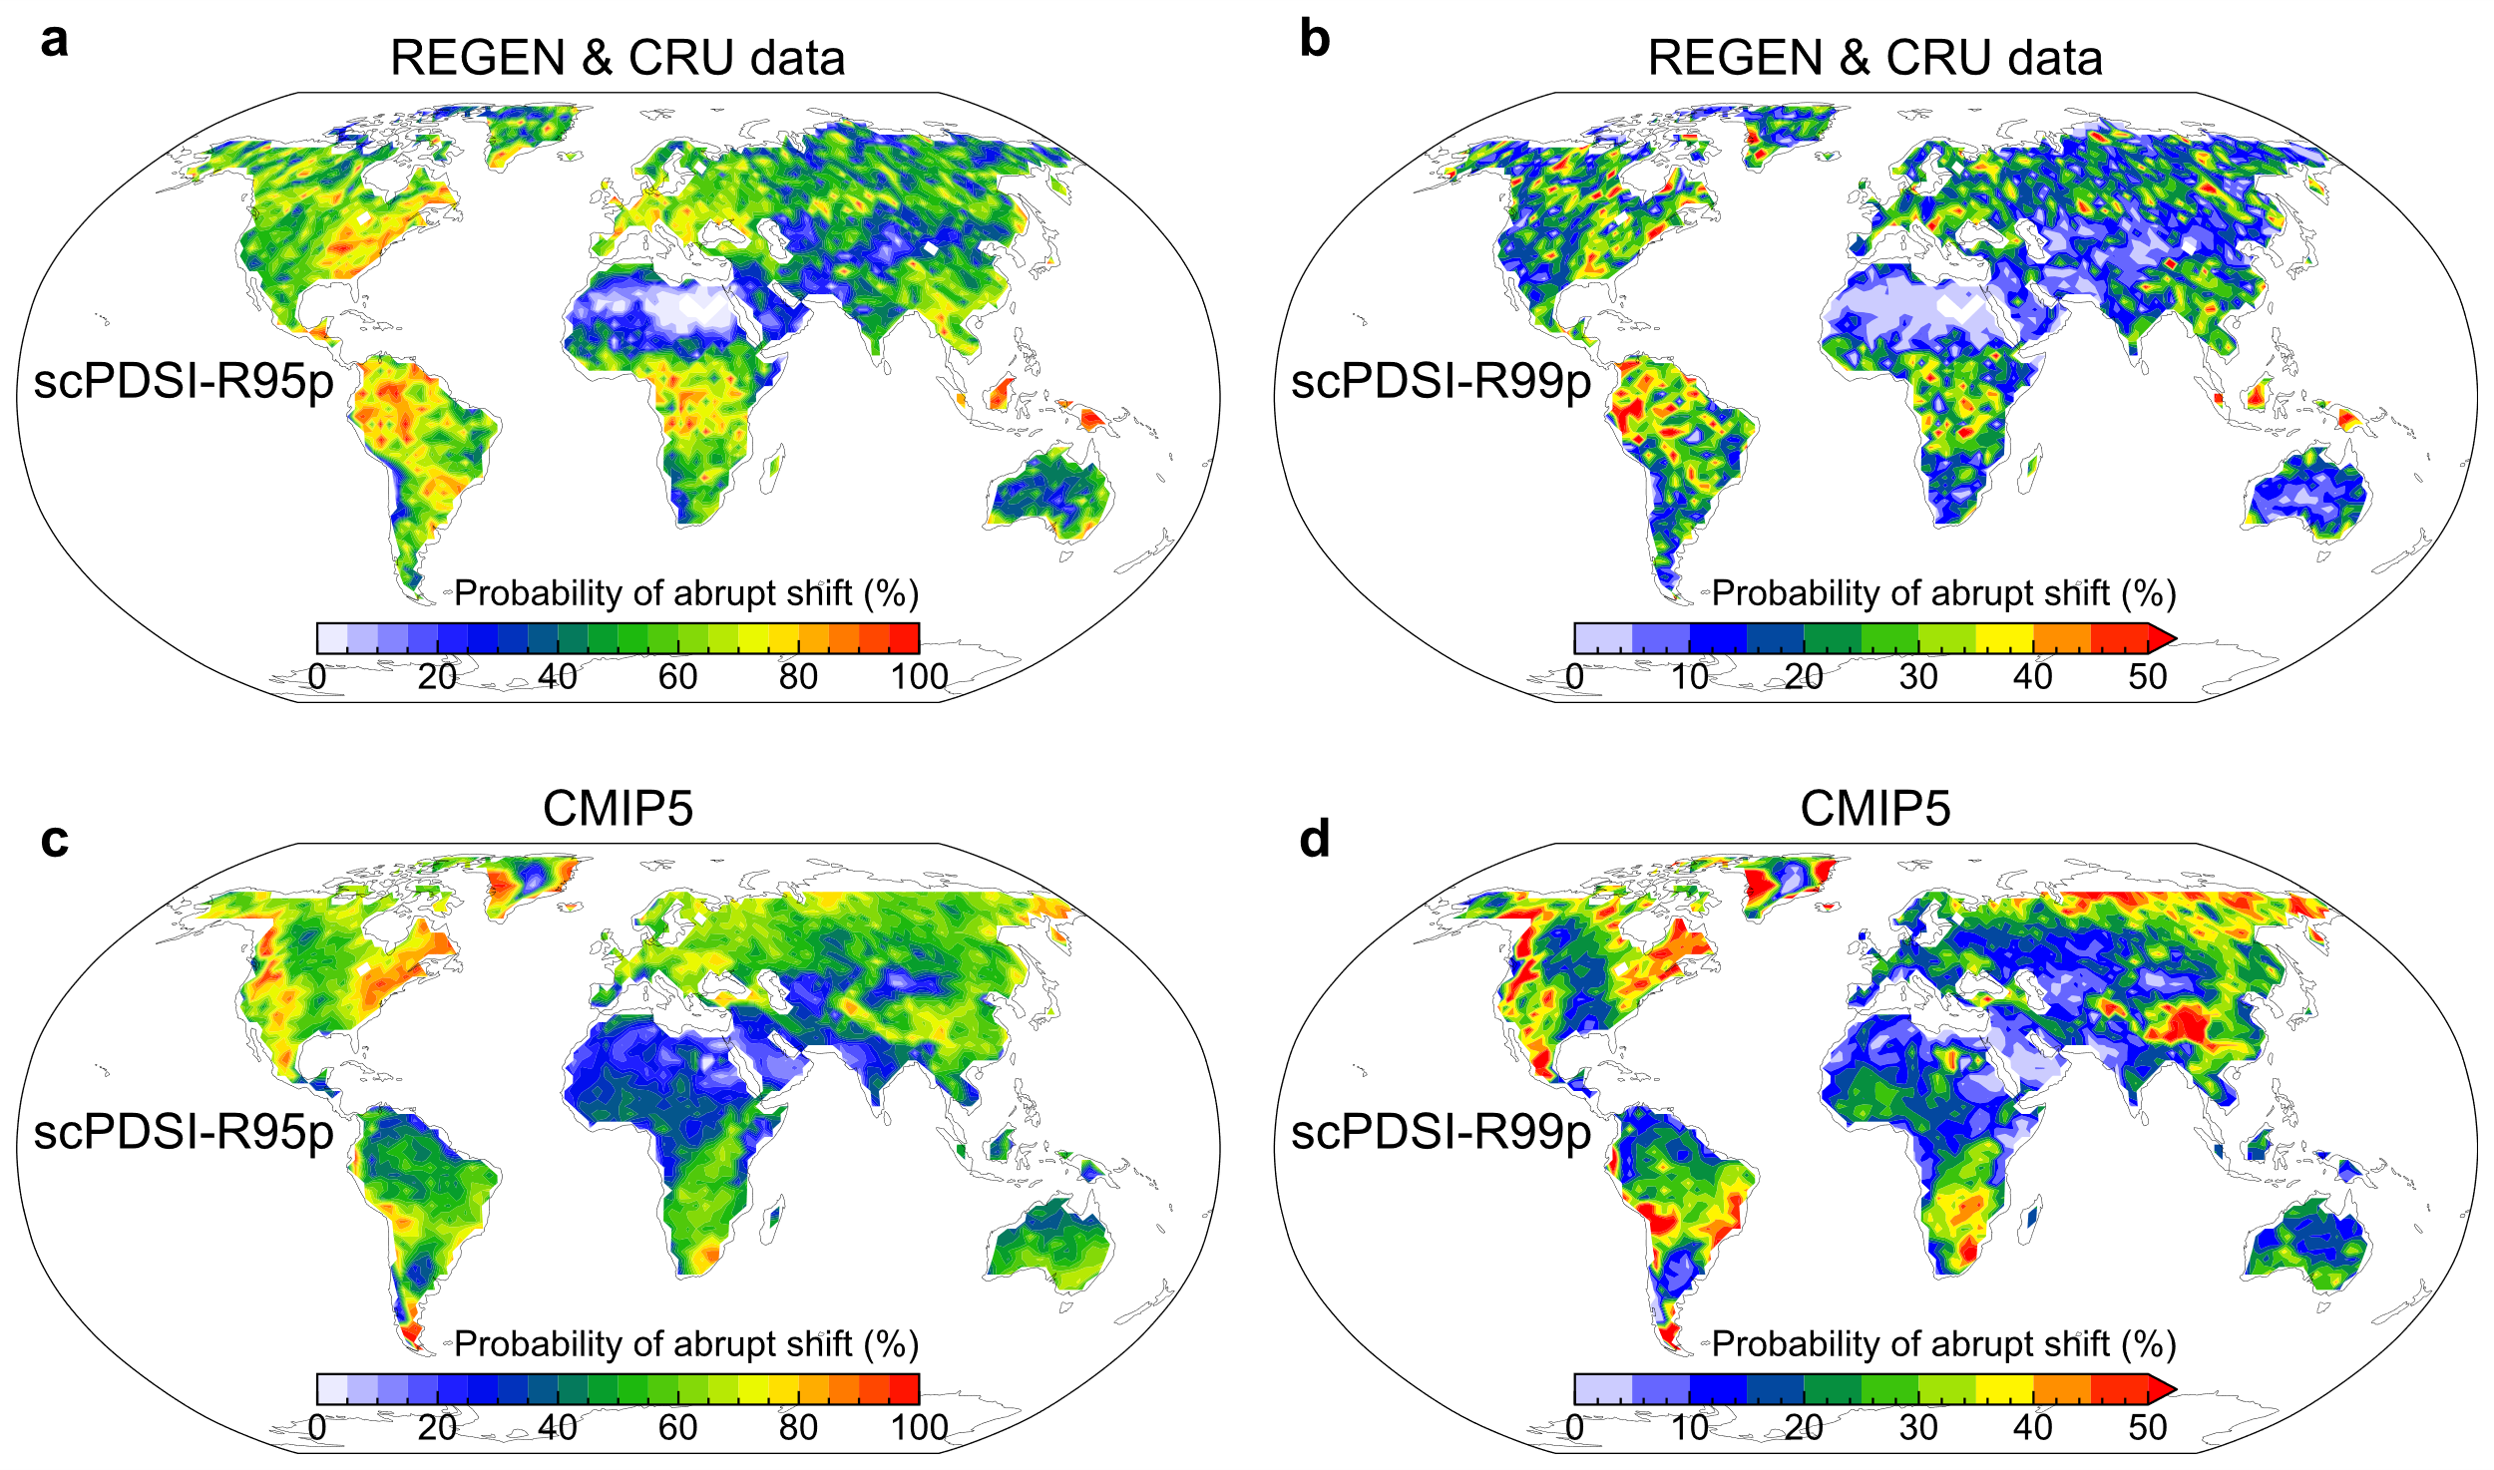

Fig. S3 Future probability of abrupt shift from drought to R99p heavy rainfall under RCP8.5. a Multi-model mean of projected change (%) of the probability of abrupt shift between future (2051−2100) and present (1955−2004) climate. b Future probability of the abrupt shift event (2051−2100). The stippling in a denotes locations for which at least two-thirds of models agree with the sign of multi-model mean results, while the stippling in b denotes locations for which the probability of abrupt shift derived from at least two-thirds of models is significant at the 5% level. c PDF of the land fraction showing a probability of abrupt shift. e Mean value of the probability of abrupt shift over regions defined in d for present (1955−2004) and future (2051−2100) climate, separately for individual models. The gray shading illustrates the uncertainty range of CMIP5 historical simulations.

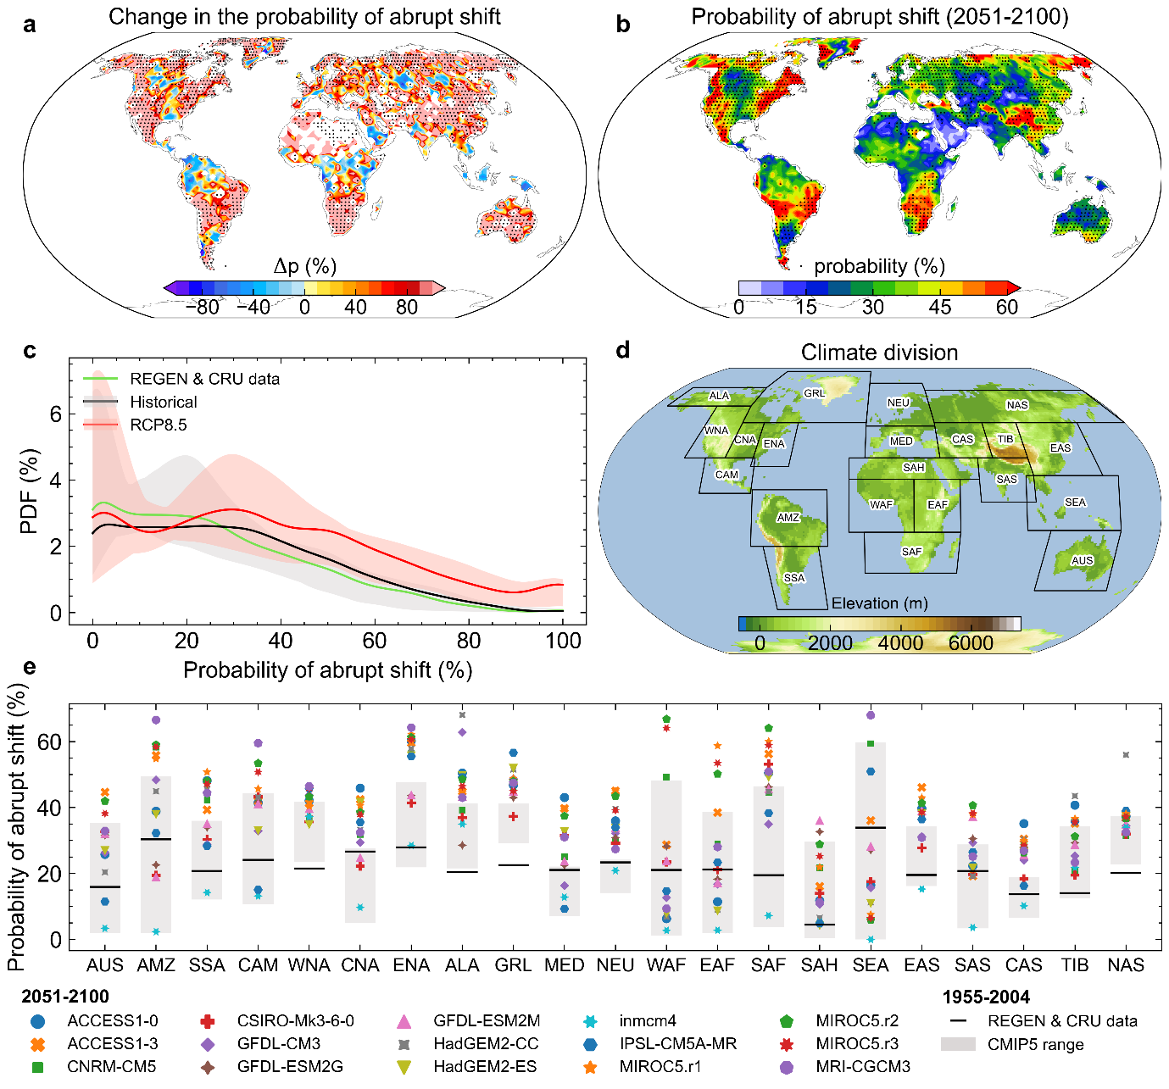

Fig. S4 Observed and simulated probability distribution functions (PDFs) of the abrupt shift from drought to heavy rainfall. a PDF of the land fraction showing the probability of abrupt shift from drought to R95p heavy rainfall for present (1955−2004) and future (2051−2100) climates. b Same as a but for R99p heavy rainfall.
b
a

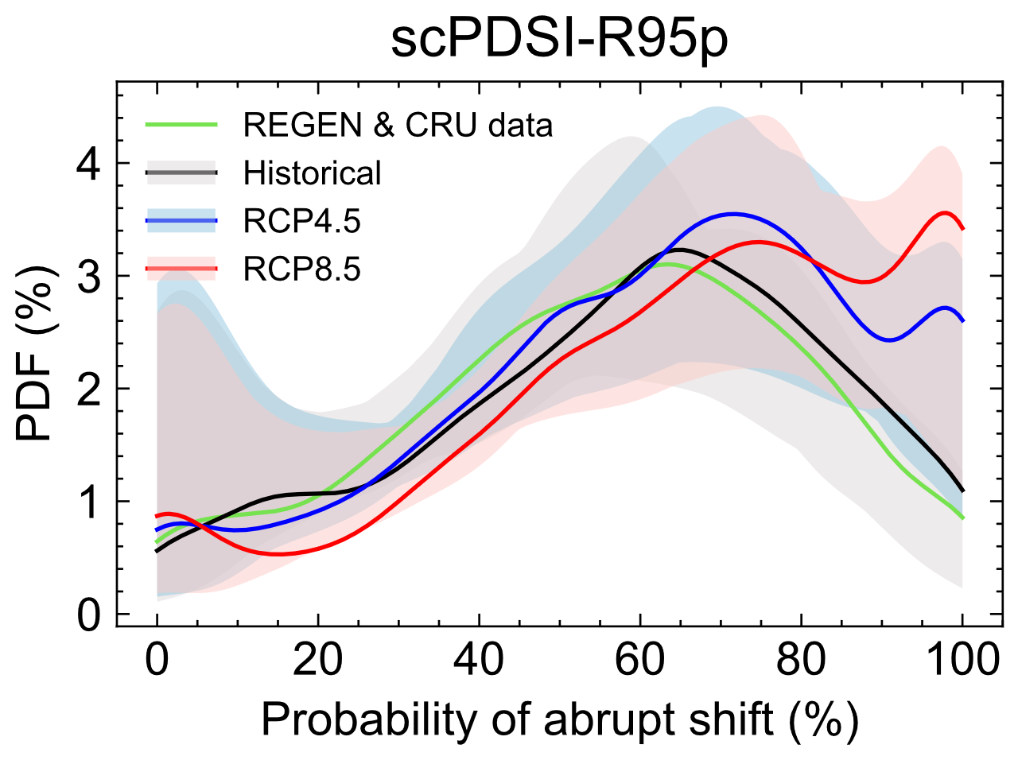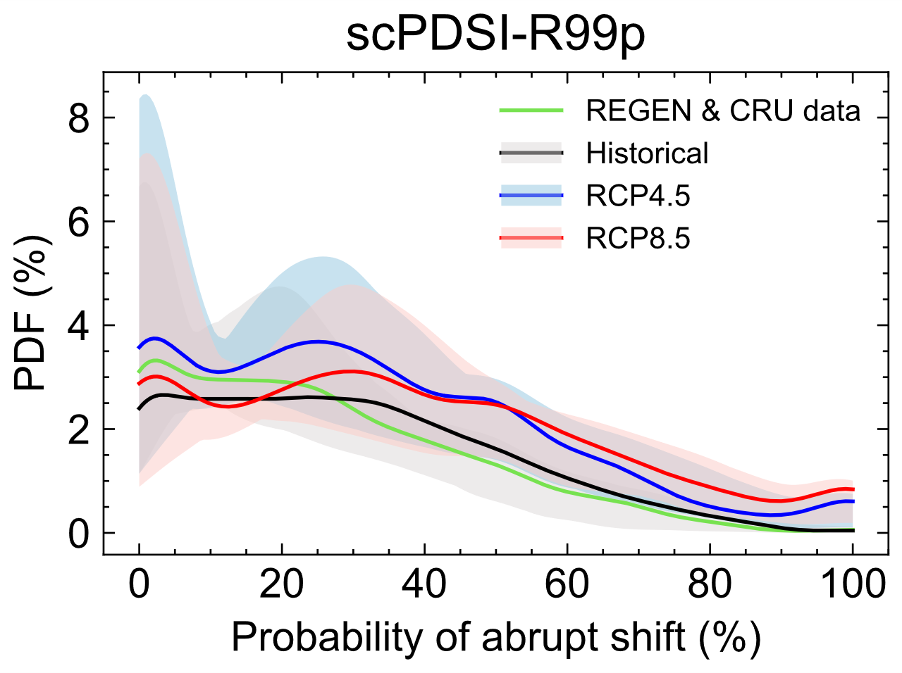

Fig. S5 Future probability of abrupt shift from drought to R95p heavy rainfall under RCP4.5. a Multi-model mean of projected change (%) of the probability of abrupt shift between future (2051−2100) and present (1955−2004) climate. b Future probability of the abrupt shift event (2051−2100). The stippling in a denotes locations for which at least two-thirds of models agree with the sign of multi-model mean results, while the stippling in b denotes locations for which the probability of abrupt shift derived from at least two-thirds of models is significant at the 5% level. c PDF of the land fraction showing a probability of abrupt shift. e Mean value of the probability of abrupt shift over regions defined in d for present (1955−2004) and future (2051−2100) climate, separately for individual models. The gray shading illustrates the uncertainty range of CMIP5 historical simulations.

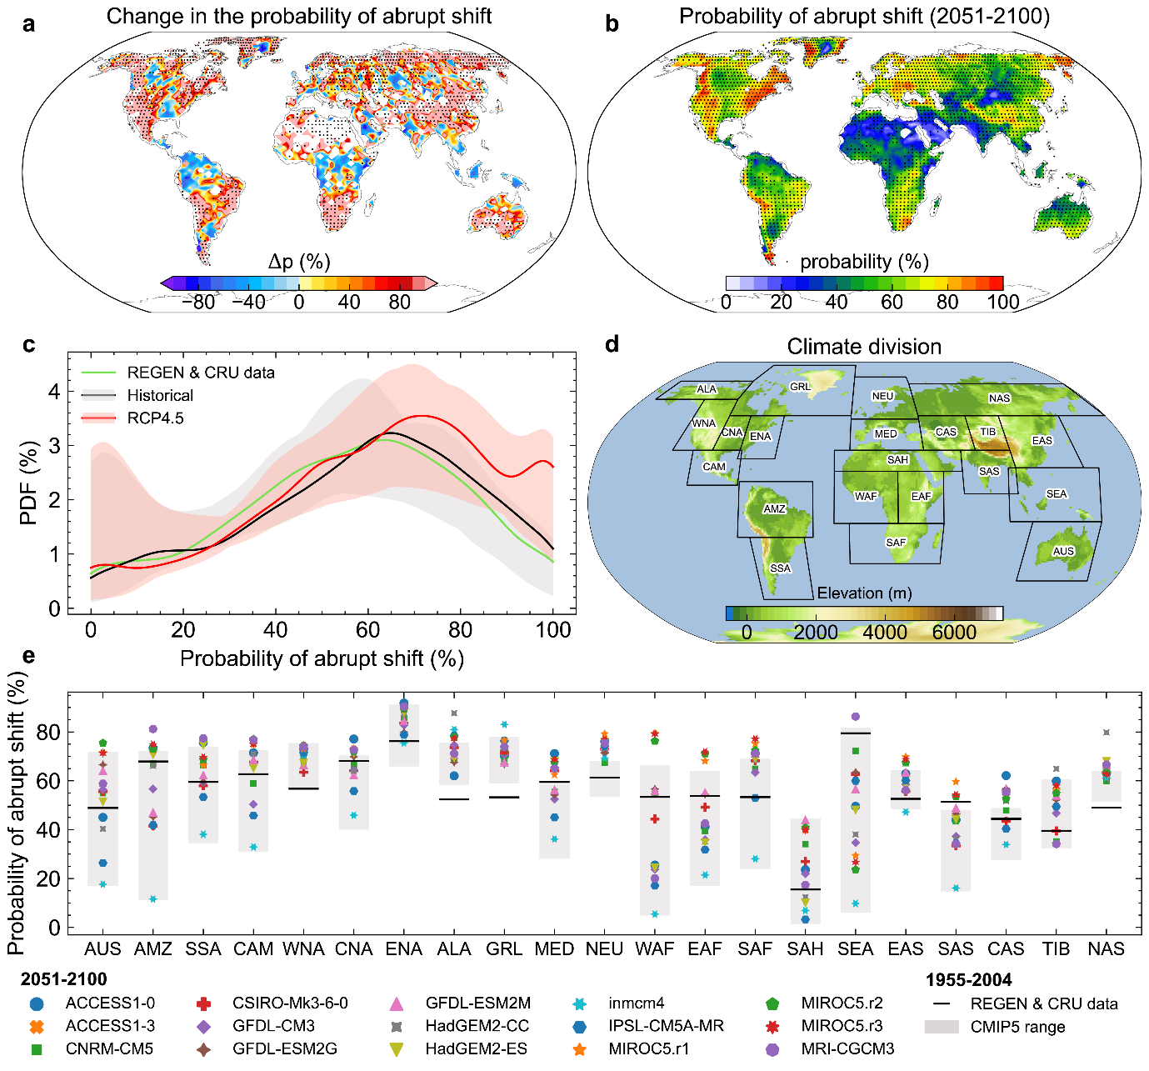

Fig. S6 Combined trends of drought, R99p heavy rainfall, and the probability of abrupt shift. a The combined trend of R99p heavy rainfall and the probability of abrupt shift from drought to R99p heavy rainfall between past and future climates under RCP4.5. b Same as a but for the scPDSI drought and the abrupt shift. c, d Same as a, b but under RCP8.5. Stippling indicates regions where at least two-thirds of models agree with the sign of multi-model mean results.

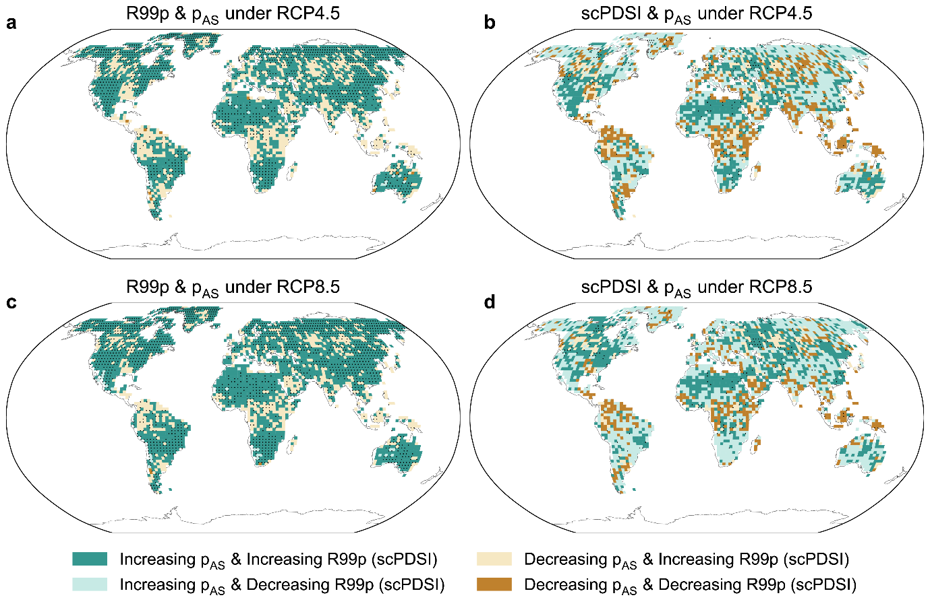

Fig. S7 The effect of elevated CO₂ concentration on the potential evapotranspiration (PET) estimation. Yearly deviations from the 1980–99 global multi-model mean PET for the period 2000-2100 based on the Penman-Monteith parameterization with and without considering the effect of CO₂ on evapotranspiration.
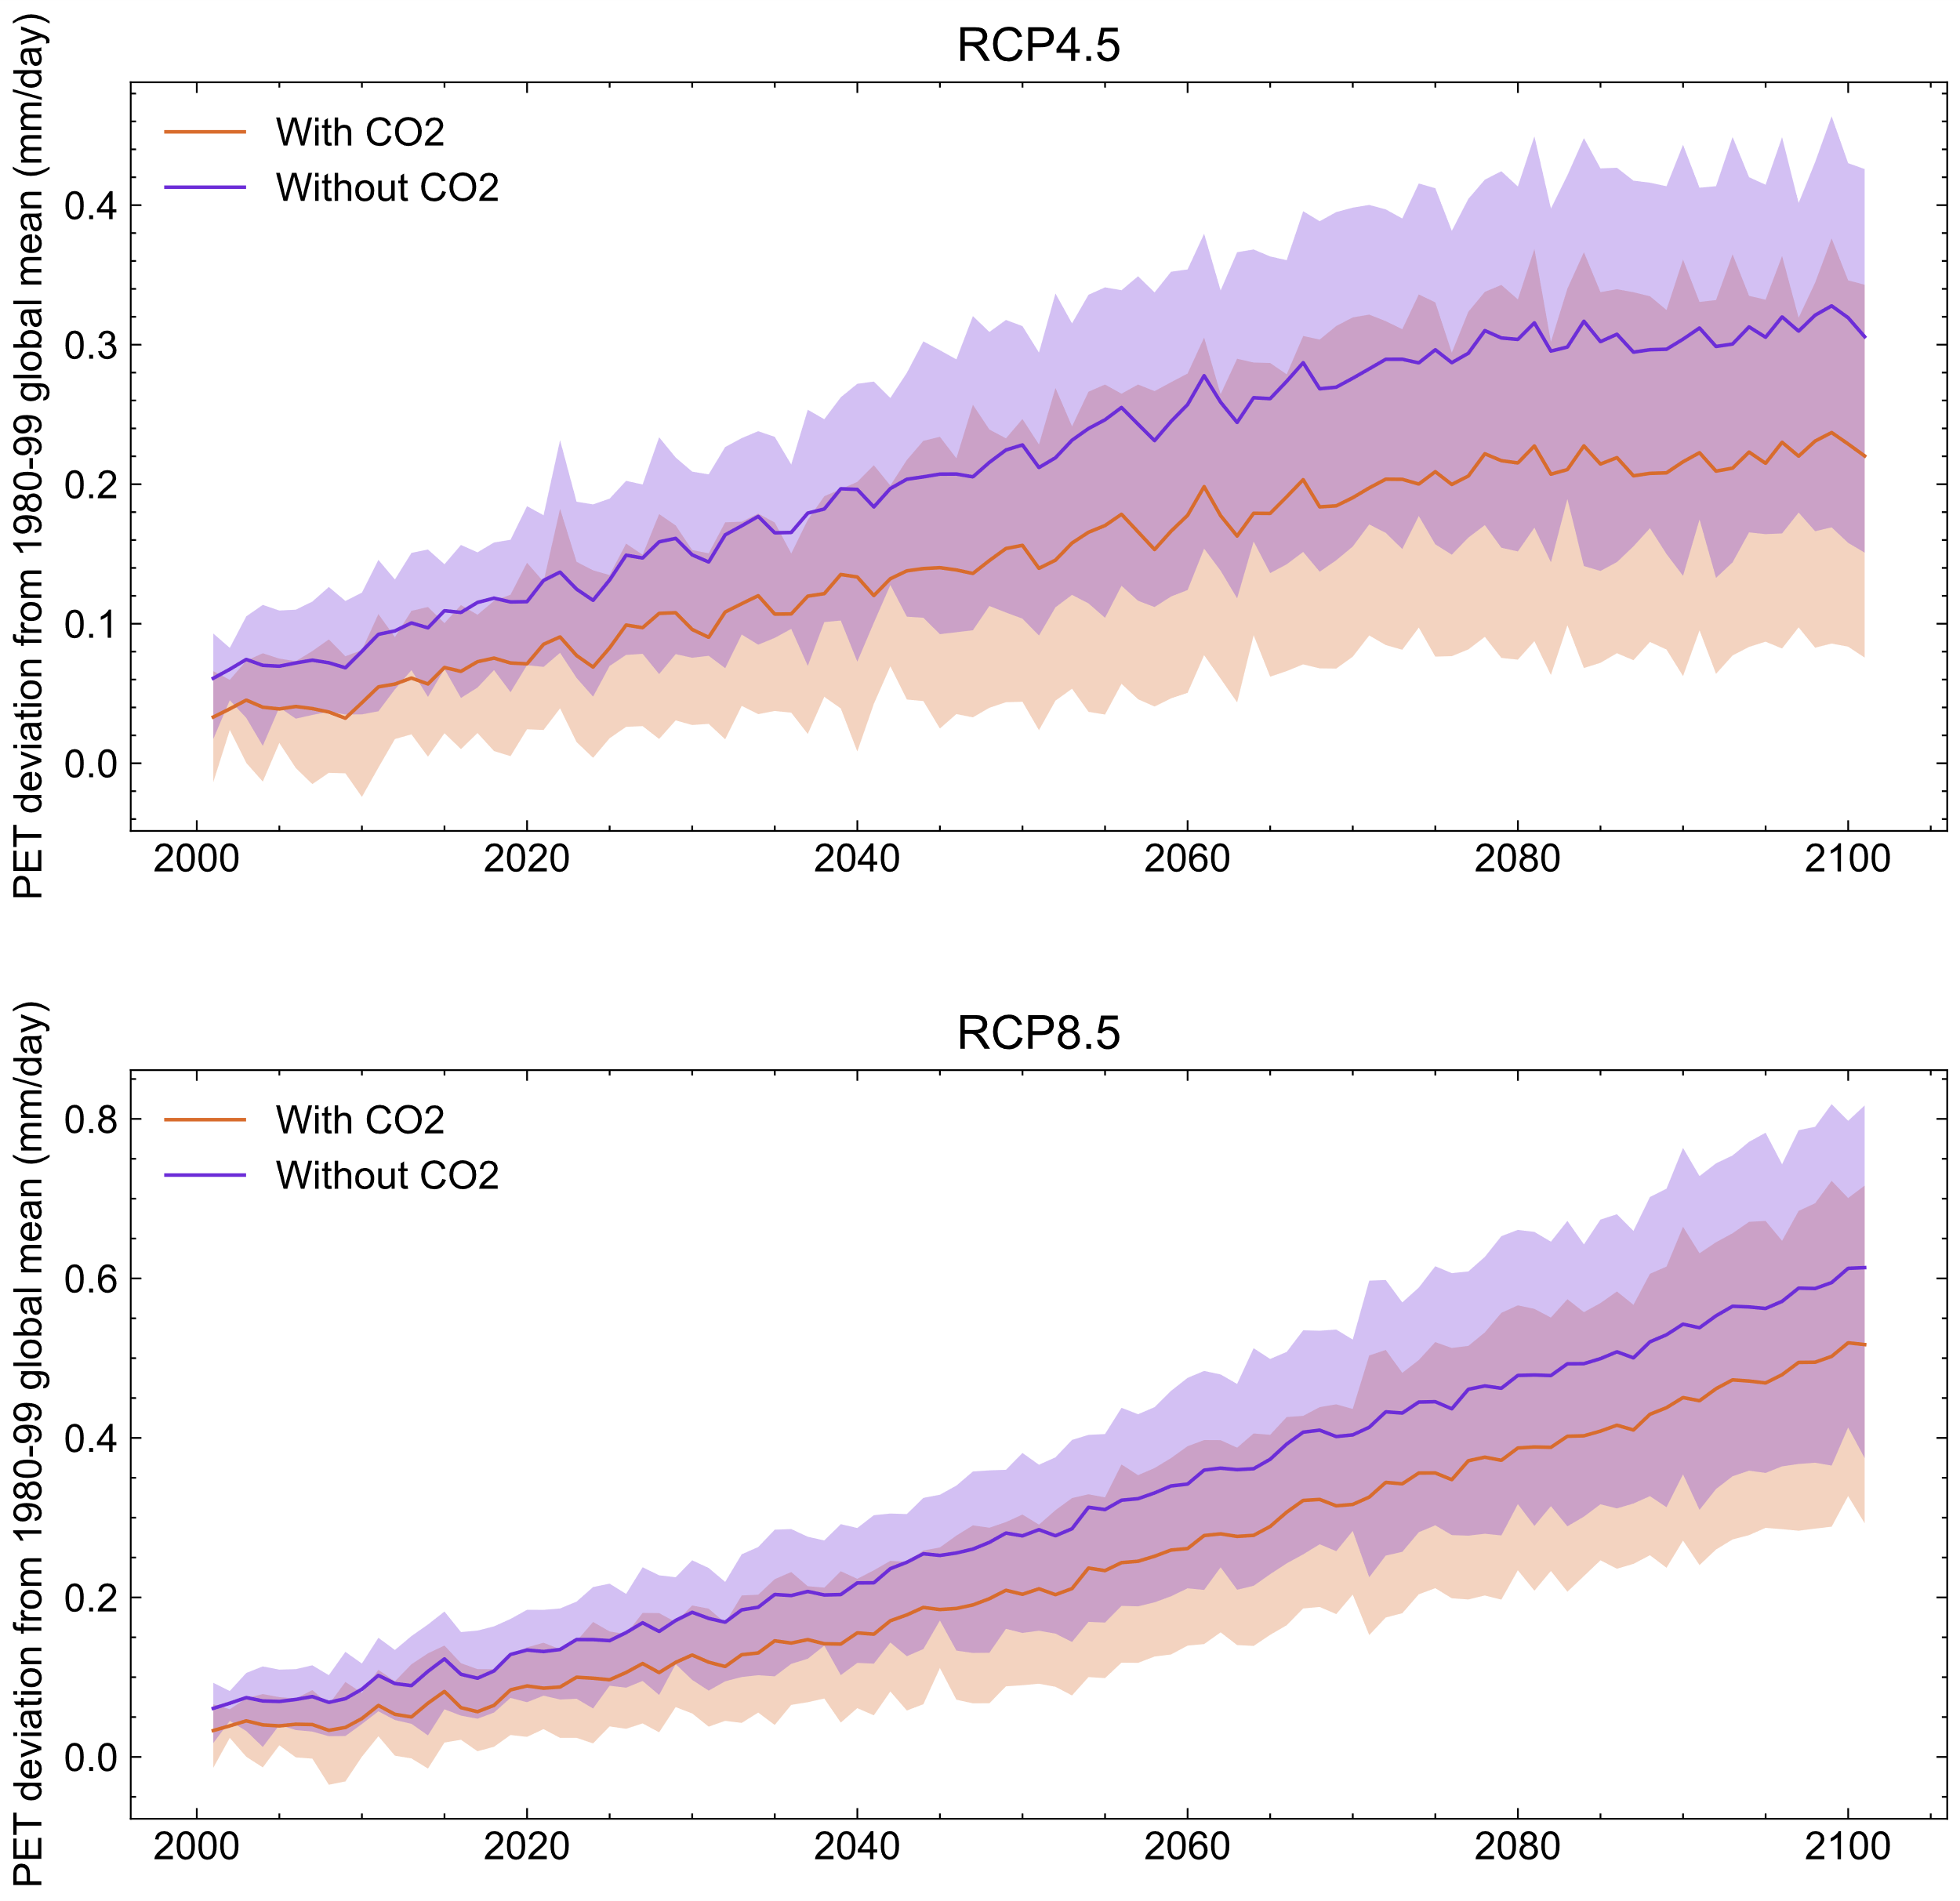

Fig. S8 The effect of elevated CO₂ concentration on the scPDSI drought calculation. Global mean scPDSI from 1955 to 2100 with and without considering the effect of CO₂ on evapotranspiration in the Penman-Monteith parameterization.

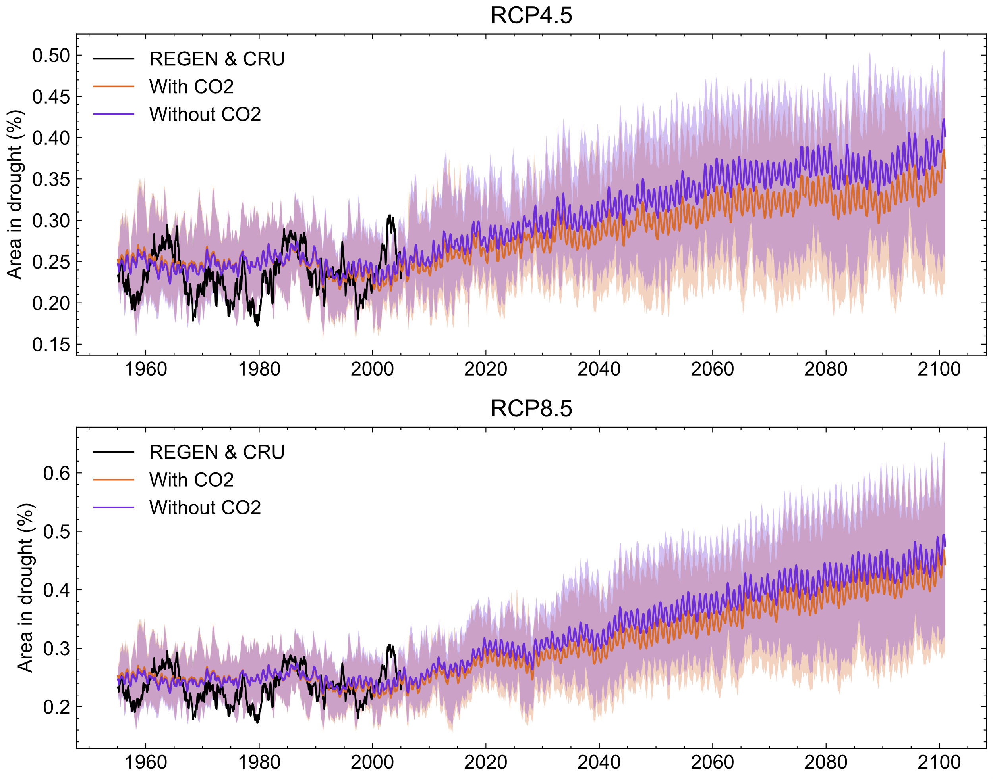

Fig. S9 Same as Fig. S4. The effect of elevated CO₂ concentration is not considered in the scPDSI calculation.
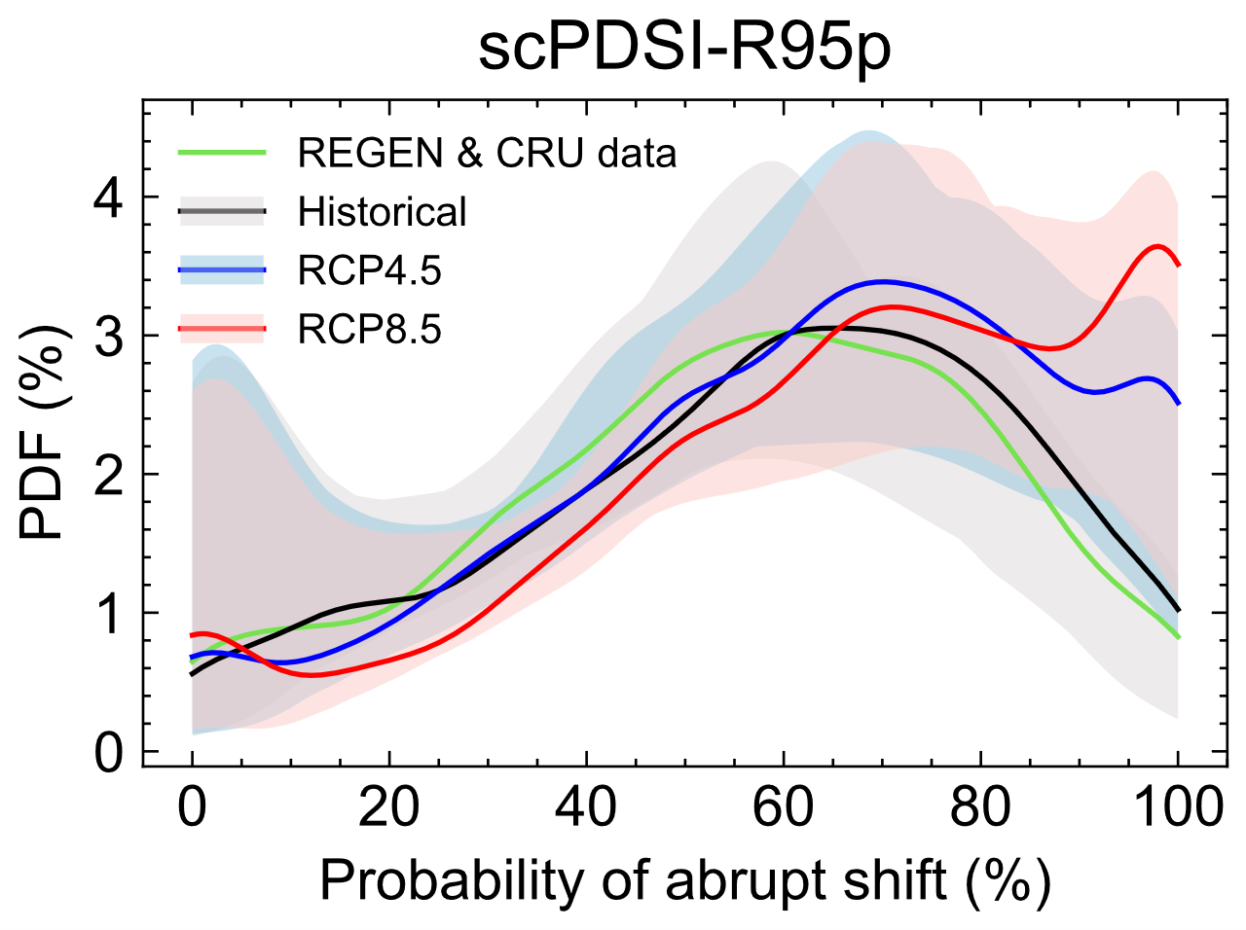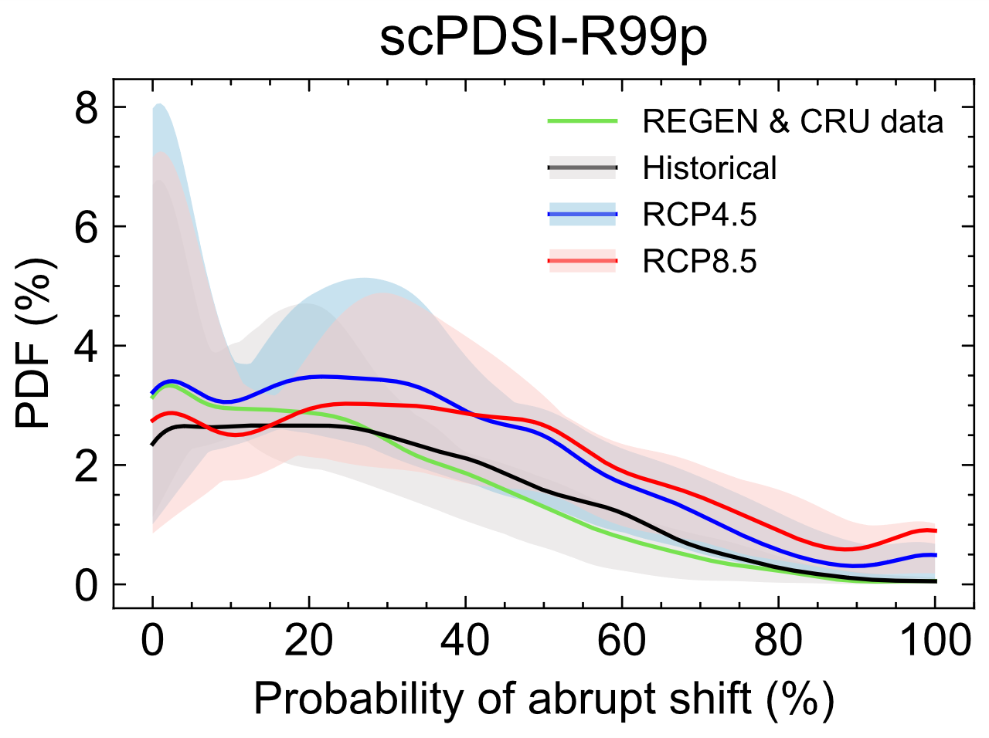

Fig. S10 Same as Fig. S5 but under RCP8.5 without considering the effect of elevated CO₂ concentration in the scPDSI calculation.
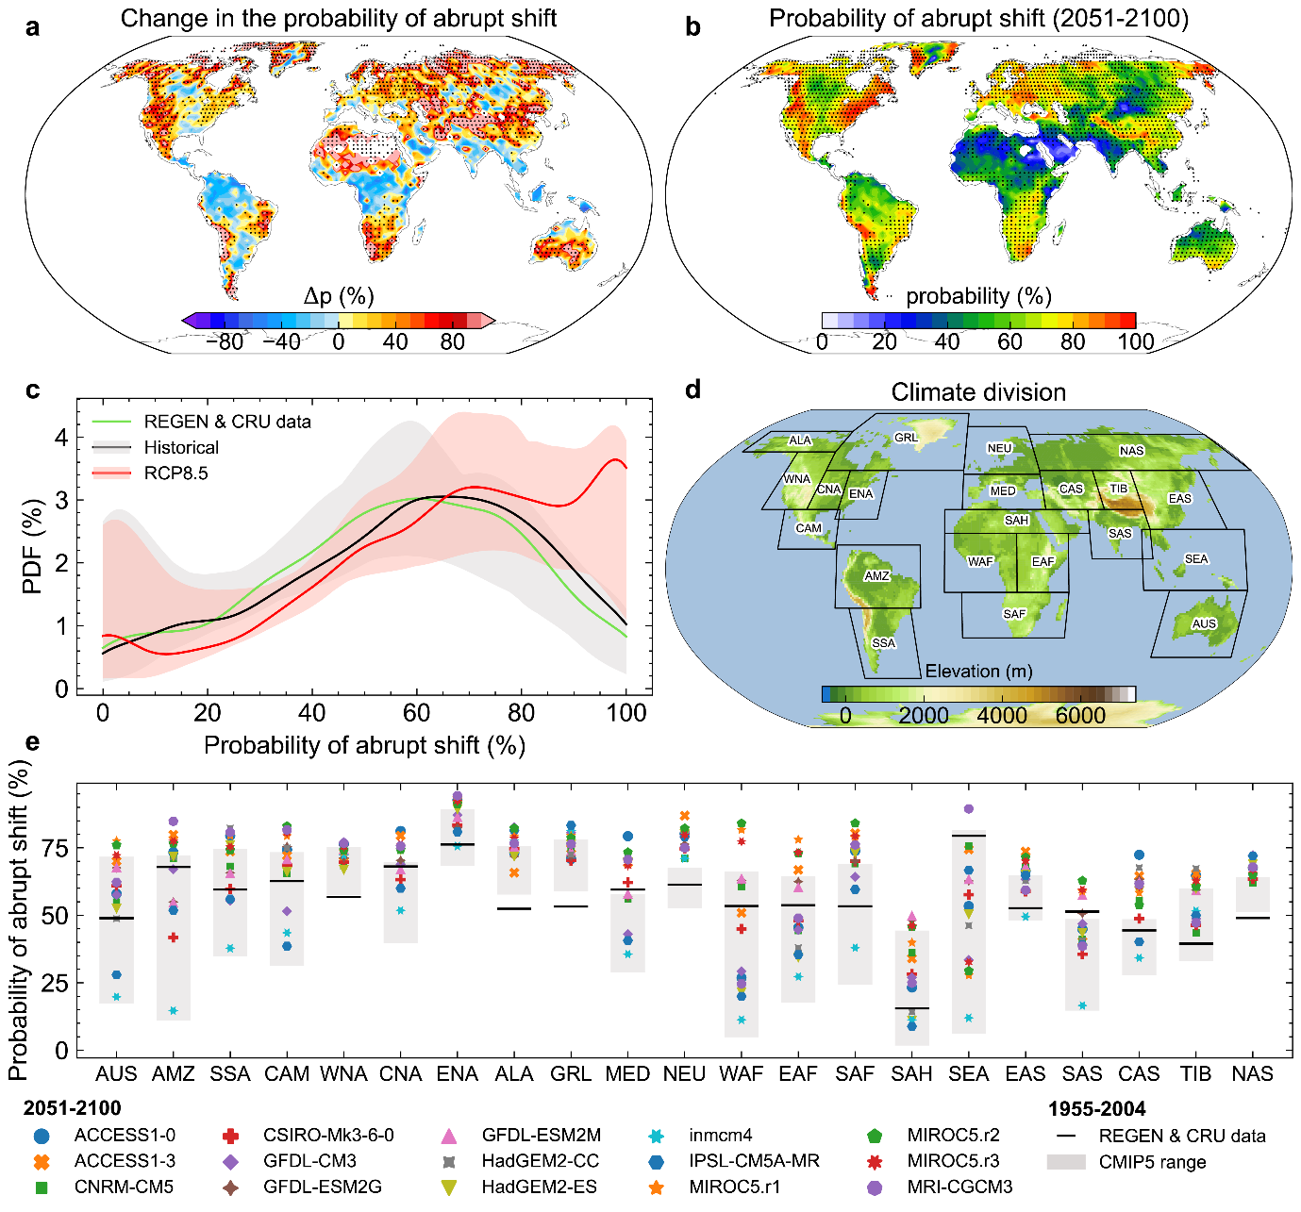

Fig. S11 Same as Fig. S5 but without considering the effect of elevated CO₂ concentration in the scPDSI calculation.
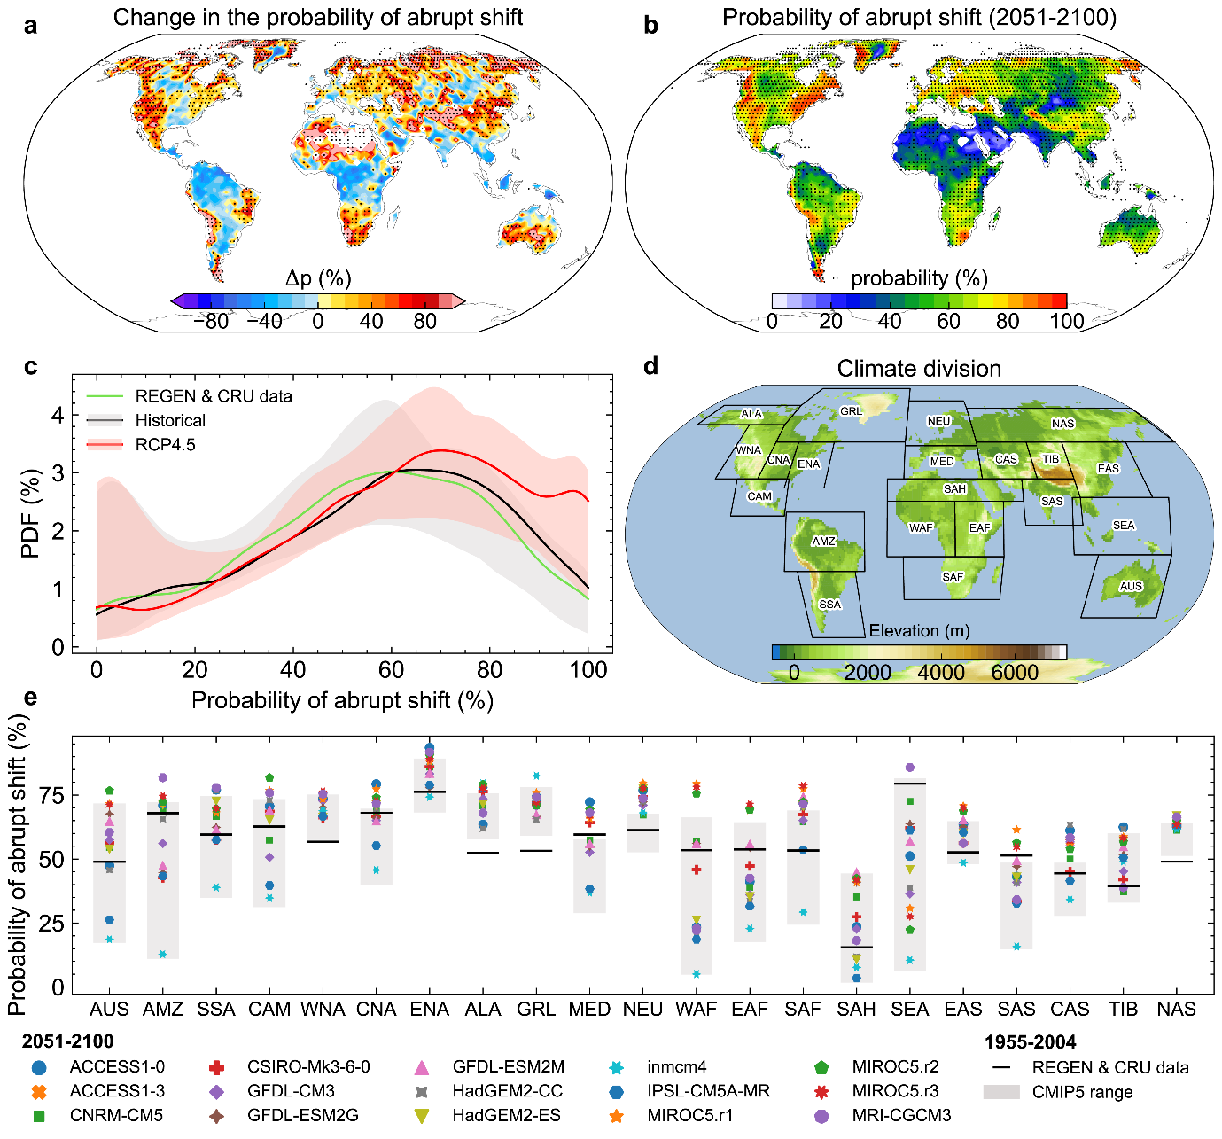

Fig. S12 Same as Fig. S5 but for R99p heavy rainfall without considering the effect of elevated CO₂ concentration in the scPDSI calculation.

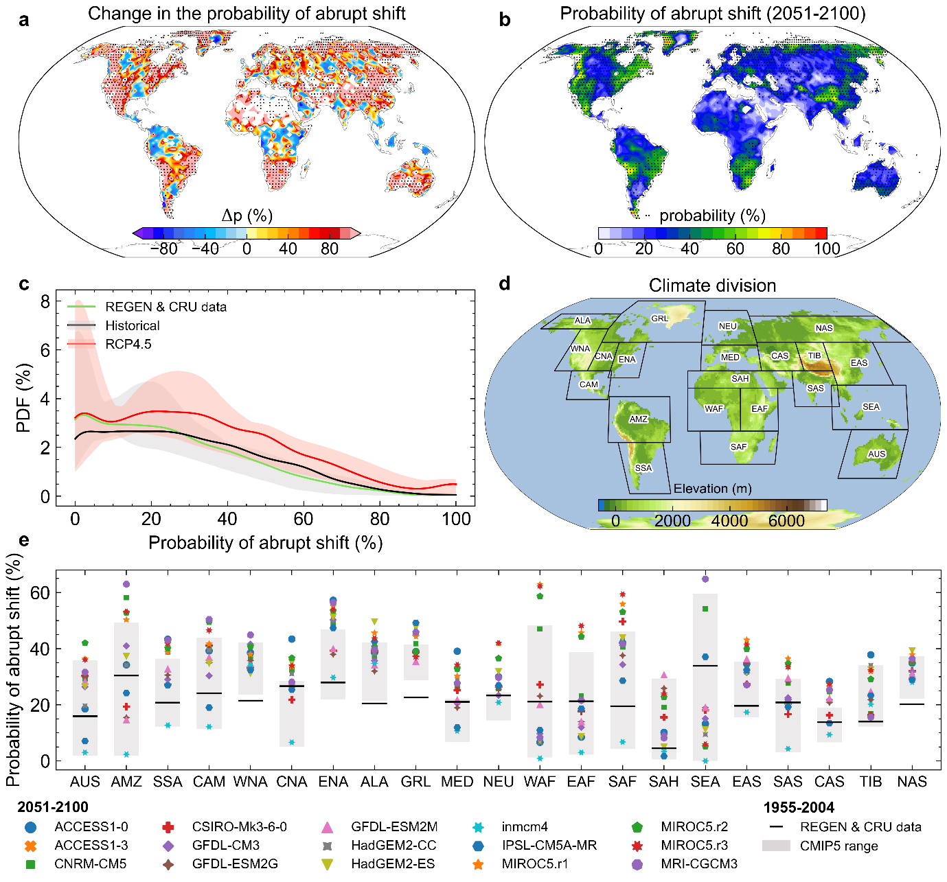

Fig. S13 Same as Fig. S5 but for R99p heavy rainfall under RCP8.5 without considering the effect of elevated CO₂ concentration in the scPDSI calculation.
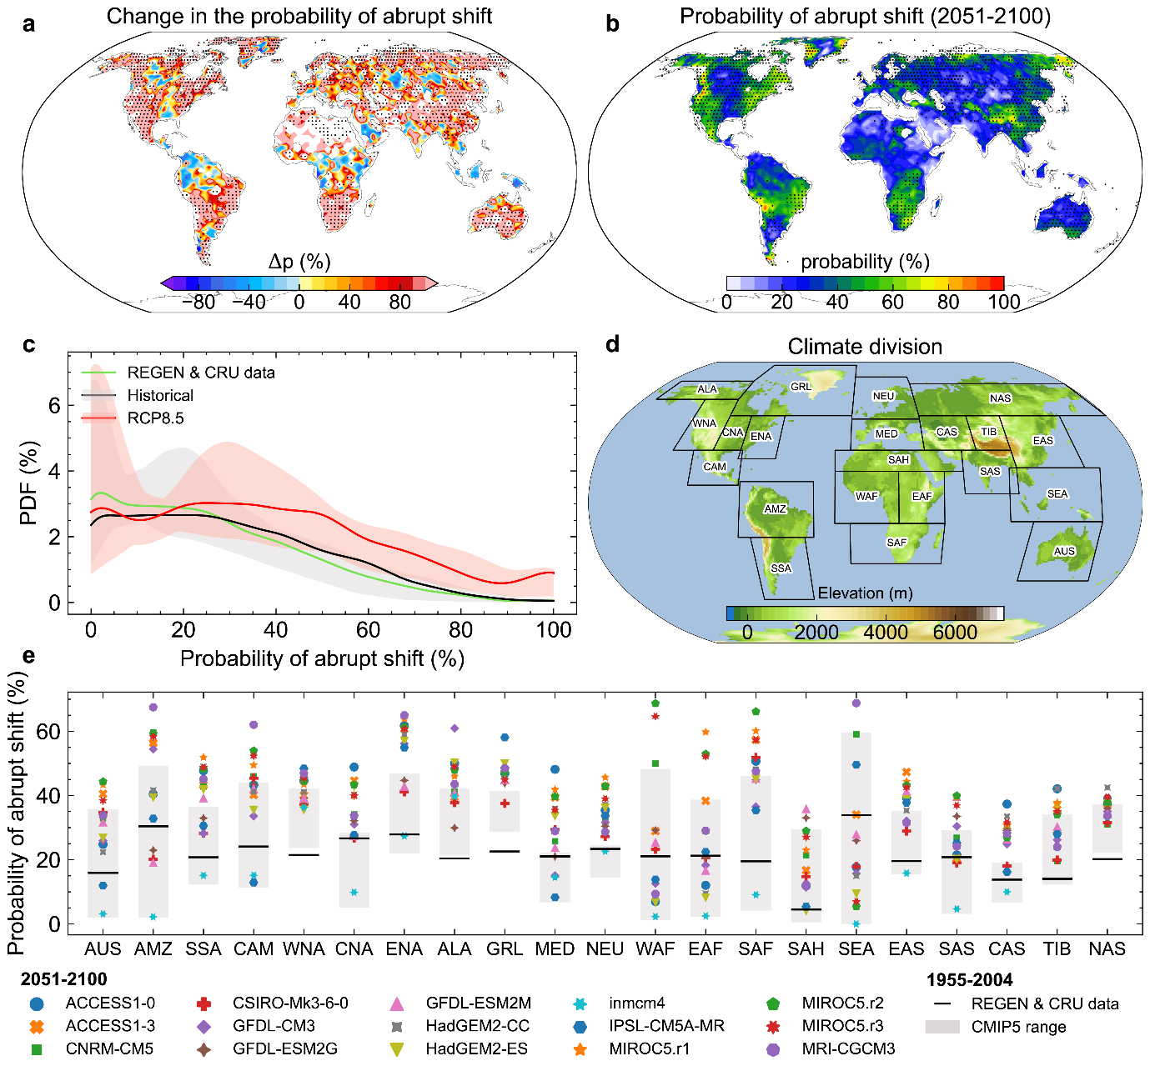

Fig. S14 Same as Fig. S6 but without considering the effect of elevated CO₂ concentration in the scPDSI calculation.
a
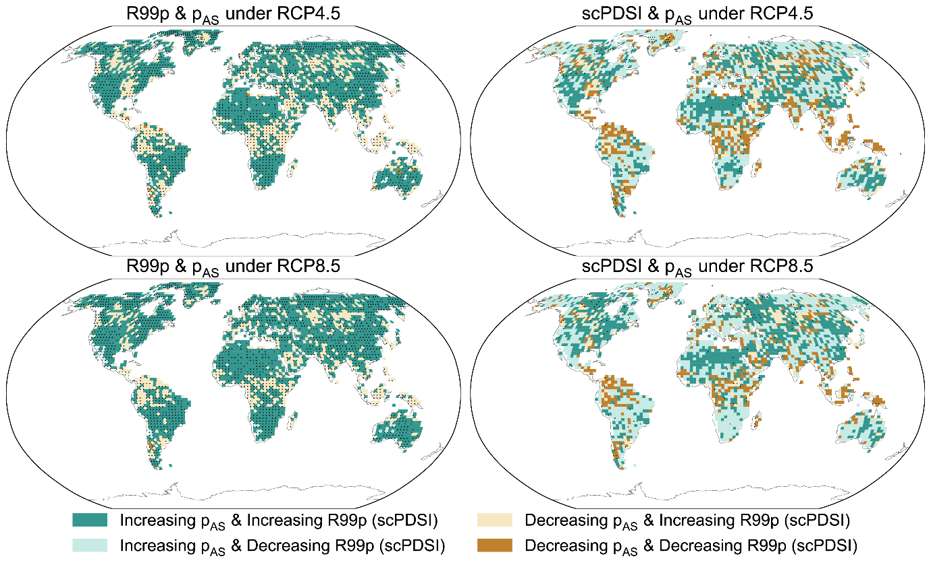
d
c
b

Fig. S15 Observed and simulated convective available potential energy (CAPE) and convective inhibition (CIN). a, b The CAPE and CIN generated from R1 NCAR/NCEP reanalysis during 1955−2004. c, d Same as a, b but generated from the ensemble mean of 15 CMIP5 simulations
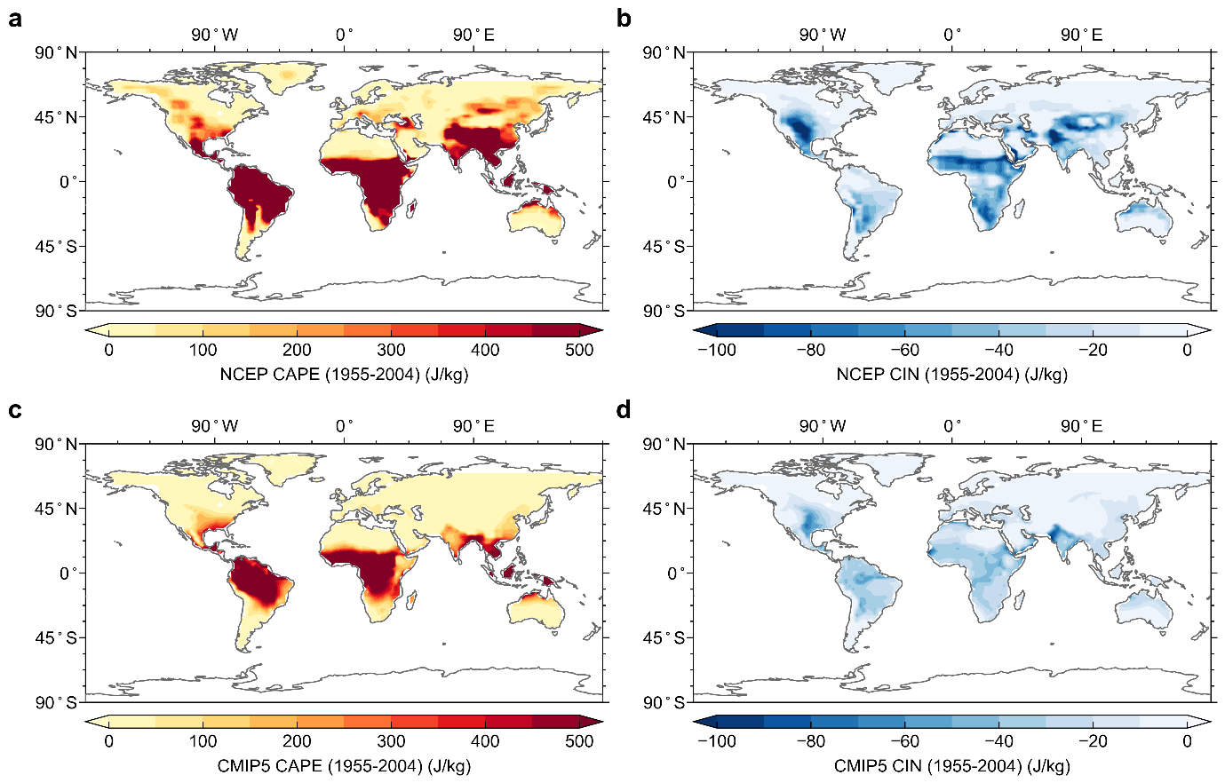

Fig. S16 Observed and simulated vertically integrated moisture flux convergence (VIMFC). a The VIMFC generated from R1 NCAR/NCEP reanalysis during 1955−2004. b Same as a but generated from the ensemble mean of 15 CMIP5 simulations
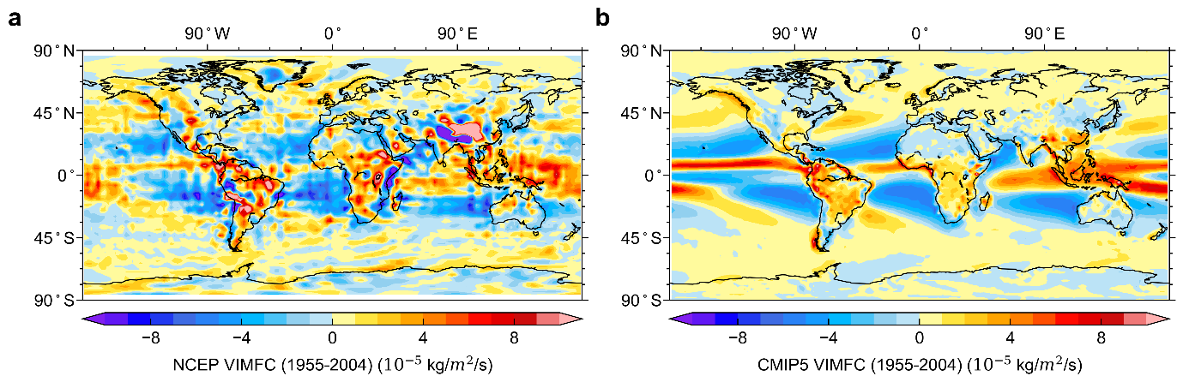

Fig. S17 The significance test for Poisson distributions. a The p-value of the hypothesis test on the Poisson process of scPDSI drought demise during 1955−2004. b, c Same as a but for the R95p and R99p heavy rainfall events. The p-value represents the chance that a process belongs to the Poisson distribution.

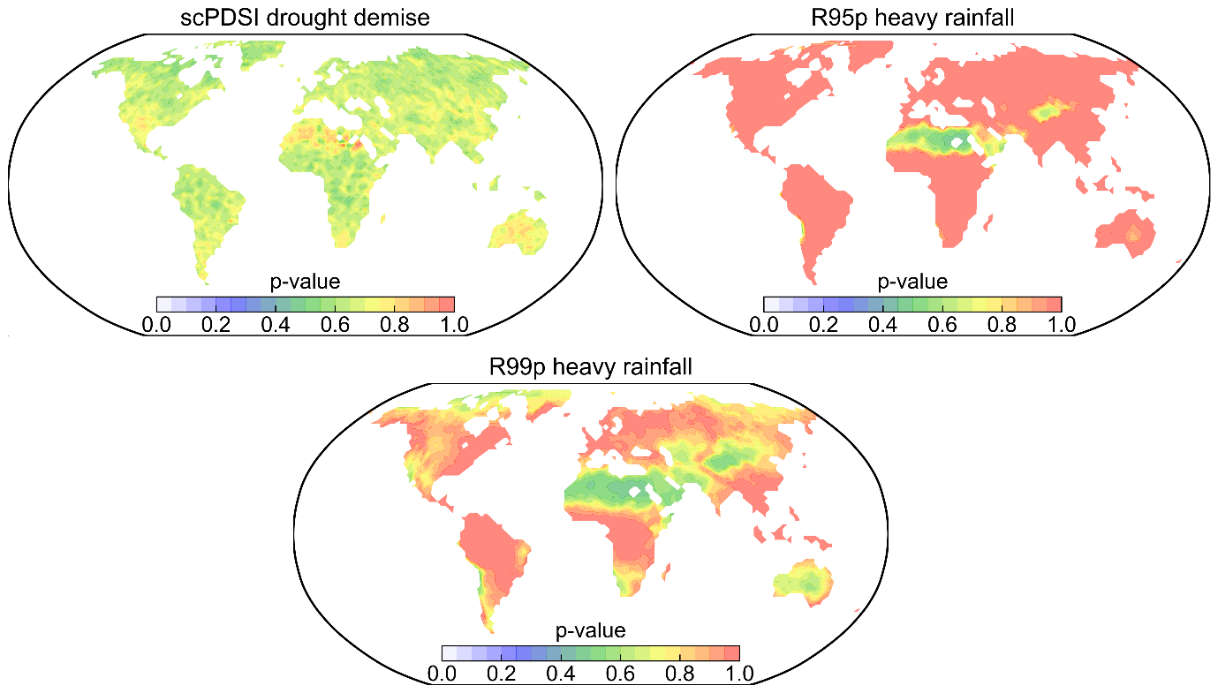
c
b
a

Fig. S18 Future probability of abrupt shift from drought to R99p heavy rainfall under RCP4.5. a Multi-model mean of projected change (%) of the probability of abrupt shift between future (2051−2100) and present (1955−2004) climate. b Future probability of the abrupt shift event (2051−2100). The stippling in a denotes locations for which at least two-thirds of models agree with the sign of multi-model mean results, while the stippling in b denotes locations for which the probability of abrupt shift derived from at least two-thirds of models is significant at the 5% level. c PDF of the land fraction showing a probability of abrupt shift. e Mean value of the probability of abrupt shift over regions defined in d for present (1955−2004) and future (2051−2100) climate, separately for individual models. The gray shading illustrates the uncertainty range of CMIP5 historical simulations.

