Supplementary Material
For the manuscript entitled:
Dynamic Non-HDL-C Exposure and Carotid Plaque Development in a Longitudinal Health-Check Cohort
Contents
- Supplementary Figure S1. Kaplan–Meier curves for incident carotid plaque by baseline Non-HDL-C quartiles
- Supplementary Figure S2. Sequence patterns and their contribution to onset timing categories

- Supplementary Table S1. Incremental value of baseline and cumulative Non-HDL-C beyond the conventional model
- Supplementary Table S2. Distribution of plaque-sequence patterns and onset categories
- Supplementary Table S3. Definitions and derivation of dynamic Non-HDL-C metrics
- Supplementary Table S4. Full quartile-based associations of baseline and cumulative Non-HDL-C with incident carotid plaque
- Supplementary Table S5. Full sensitivity-analysis results in the monotonic-only and complete four-visit subgroups

Supplementary Figure legends
Supplementary Figure S1. Kaplan–Meier curves for incident carotid plaque by baseline Non-HDL-C quartiles
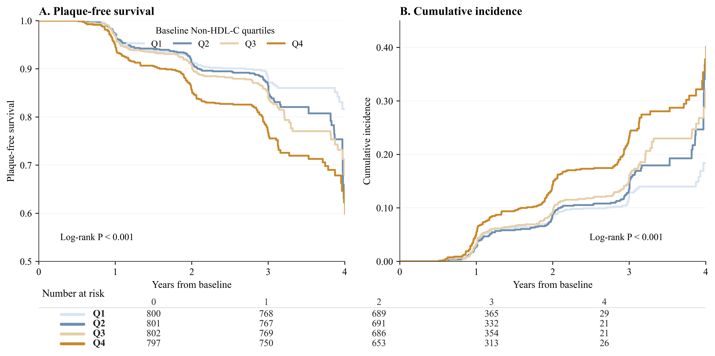
Kaplan–Meier curves showing plaque-free survival and cumulative incidence of incident carotid plaque according to baseline Non-HDL-C quartiles. Quartiles were defined according to the baseline Non-HDL-C distribution in the primary analytic cohort.

Supplementary Figure S2. Sequence patterns and their contribution to onset timing categories
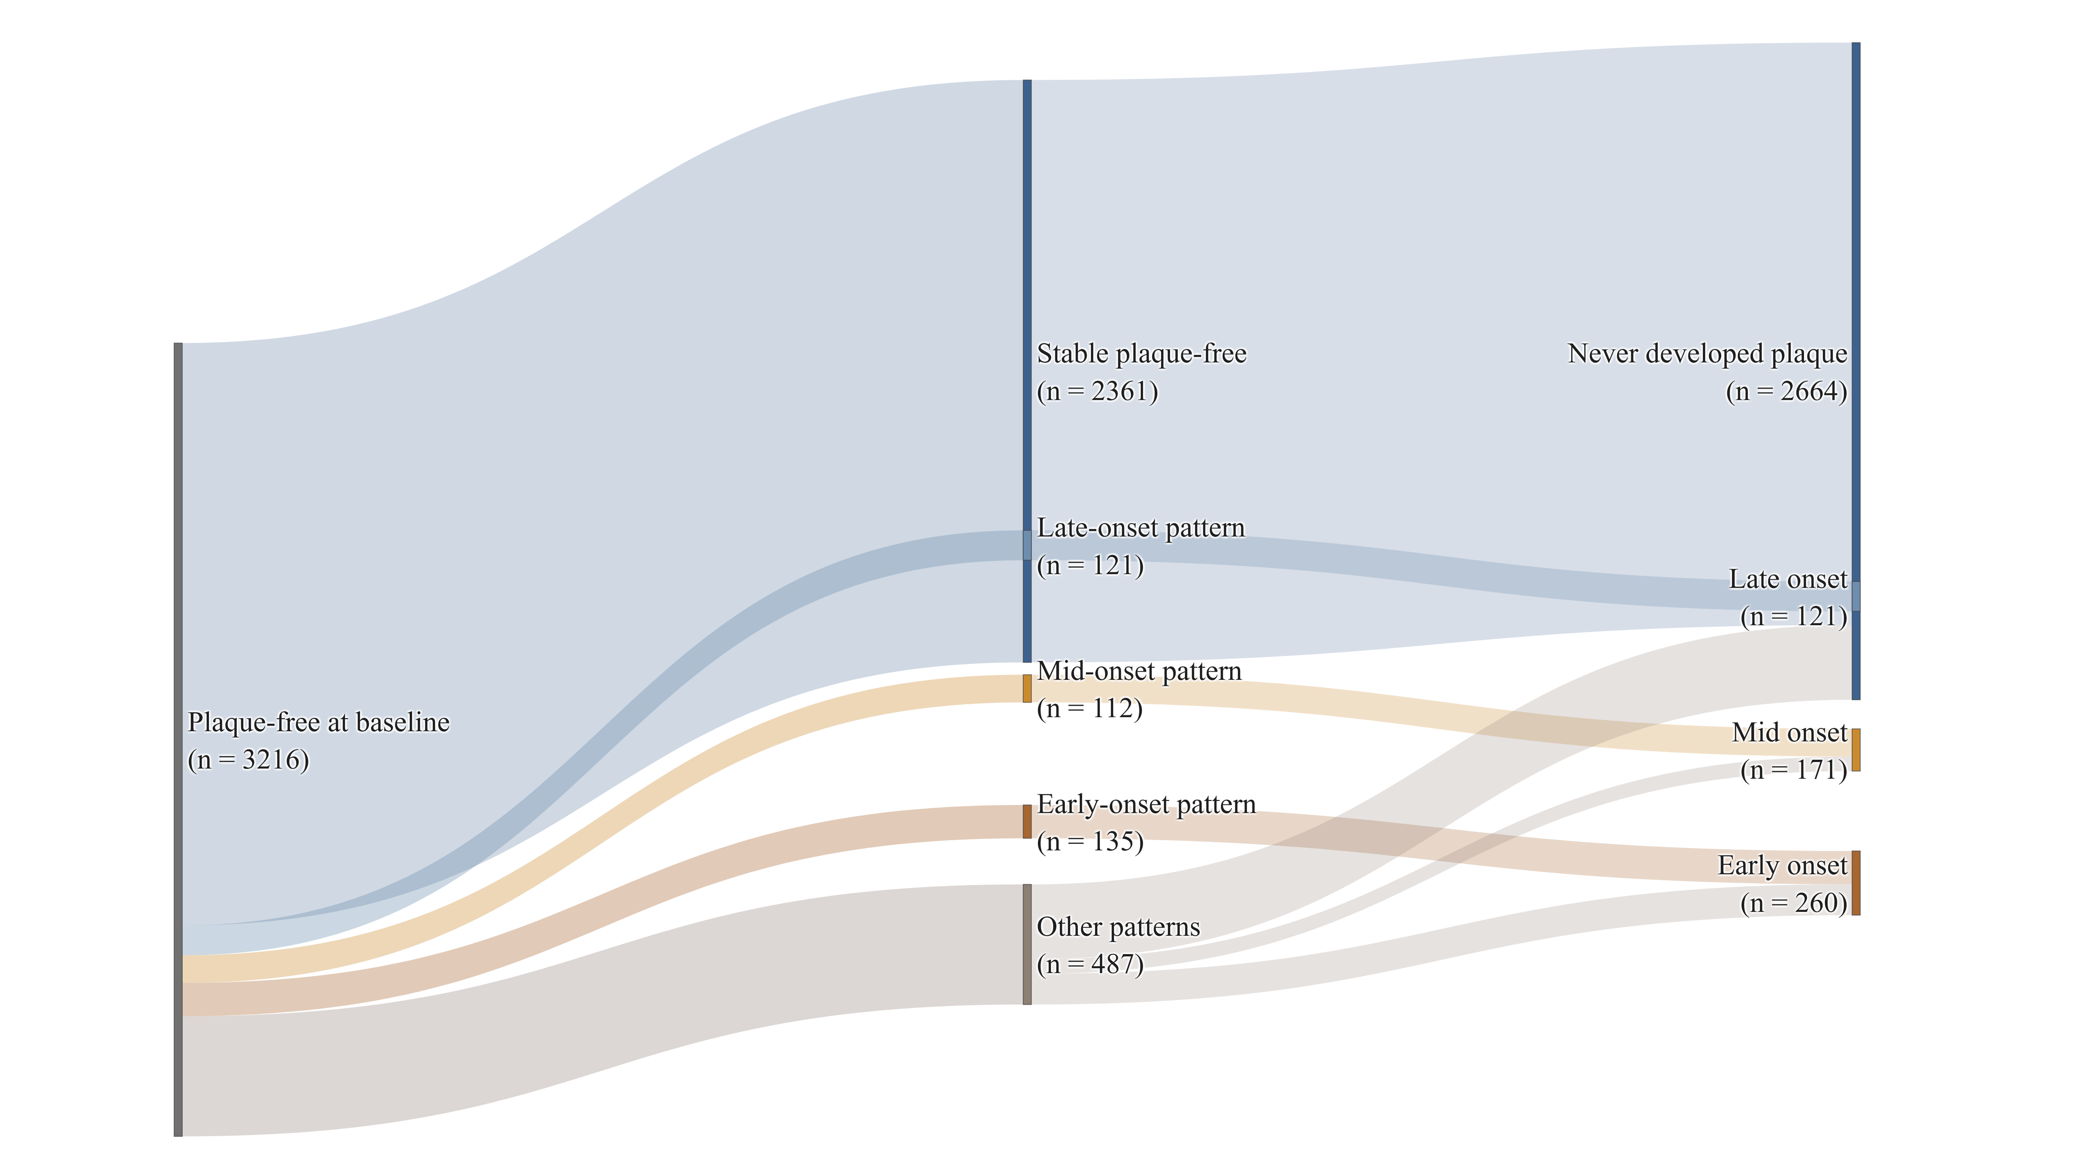
Diagram showing the distribution of longitudinal plaque-sequence patterns and their relation to plaque onset timing categories. Sequence patterns were summarized as 0000, 0001, 0011, 0111, and other patterns. Onset categories were defined as never developed plaque, late-onset plaque, mid-onset plaque, and early-onset plaque.

Supplementary Table S1. Incremental value of baseline and cumulative Non-HDL-C beyond the conventional model
Model / comparison | AUC | DeLong P value | IDI | NRI
Conventional model | 0.7664 | — | — | —
Conventional model + Baseline Non-HDL-C | 0.7729 | 0.037 | 0.0072 | 0.271
Conventional model + Cumulative Non-HDL-C | 0.7724 | 0.122 | 0.0110 | 0.285
Cumulative vs Baseline | 0.7729 vs 0.7724 | 0.737 | 0.0038 | 0.190
Note: The conventional model included age, sex, BMI, SBP, DBP, fasting glucose, and uric acid. AUC denotes the area under the receiver operating characteristic curve. DeLong P values were used to compare AUCs between models. IDI and NRI were used to assess incremental discrimination and reclassification, respectively. BMI, body mass index; SBP, systolic blood pressure; DBP, diastolic blood pressure; IDI, integrated discrimination improvement; NRI, net reclassification improvement. For the comparison between baseline and cumulative Non-HDL-C, IDI and NRI represent the relative improvement of the cumulative model over the baseline model.

Supplementary Table S2. Distribution of plaque-sequence patterns and onset categories
Category | Subgroup | n | %
Sequence patterns | 0000 | 2361 | 73.4
Sequence patterns | 0001 | 121 | 3.8
Sequence patterns | 0011 | 112 | 3.5
Sequence patterns | 0111 | 135 | 4.2
Sequence patterns | Other | 487 | 15.1
Onset categories | Never developed plaque | 2664 | 82.8
Onset categories | Late-onset plaque | 121 | 3.8
Onset categories | Mid-onset plaque | 171 | 5.3
Onset categories | Early-onset plaque | 260 | 8.1
Note: Sequence patterns and onset categories were related but not perfectly equivalent. “Other” included patterns not classified as 0000, 0001, 0011, or 0111. Sequence pattern and onset timing should therefore not be interpreted as strictly one-to-one categories.

Supplementary Table S3. Definitions and derivation of dynamic Non-HDL-C metrics
Metric | Definition | Analytical use
Baseline Non-HDL-C | The baseline value at study entry | Main exposure in the baseline model
Updated Non-HDL-C | The most recent pre-event value | Time-updated exposure metric
Cumulative Non-HDL-C | The time-weighted average exposure derived from repeated Non-HDL-C measurements during follow-up | Main longitudinal burden metric
Slope of Non-HDL-C | The temporal trend over follow-up | Captures direction and rate of change over time
Variability of Non-HDL-C | Within-person fluctuation over time | Captures visit-to-visit instability
Note: Non-HDL-C was calculated as total cholesterol minus HDL-C. Dynamic metrics were derived from repeated health examination measurements collected during follow-up.

Supplementary Table S4. Full quartile-based associations of baseline and cumulative Non-HDL-C with incident carotid plaque
Panel A. Baseline Non-HDL-C
Quartile | n | HR (95% CI) | P value
Q1 | 800 | Reference | —
Q2 | 801 | 1.200 (0.873, 1.649) | 0.261
Q3 | 802 | 1.271 (0.928, 1.742) | 0.135
Q4 | 797 | 2.098 (1.546, 2.846) | <0.001
Panel B. Cumulative Non-HDL-C
Quartile | n | HR (95% CI) | P value
Q1 | 803 | Reference | —
Q2 | 803 | 0.959 (0.698, 1.317) | 0.797
Q3 | 803 | 1.089 (0.798, 1.488) | 0.590
Q4 | 803 | 2.084 (1.549, 2.804) | <0.001
Note: Hazard ratios (HRs) and 95% confidence intervals (CIs) were adjusted for age, sex, BMI, SBP, DBP, fasting glucose, and uric acid. Q1 was used as the reference group. Quartile cutoffs for baseline Non-HDL-C were 0.59–2.88 mmol/L for Q1, >2.88–3.46 mmol/L for Q2, >3.46–4.06 mmol/L for Q3, and >4.06–12.8 mmol/L for Q4. Quartile cutoffs for cumulative Non-HDL-C were 0.704–2.96 mmol/L for Q1, >2.96–3.49 mmol/L for Q2, >3.49–4.03 mmol/L for Q3, and >4.03–7.83 mmol/L for Q4.

Supplementary Table S5. Full sensitivity-analysis results in the monotonic-only and complete four-visit subgroups
Analysis set | N | Exposure | HR (95% CI) | P value
Primary analytic set | 3216 | Baseline Non-HDL-C | 1.210 (1.117, 1.311) | <0.001
Primary analytic set | 3216 | Updated Non-HDL-C | 1.192 (1.094, 1.297) | <0.001
Primary analytic set | 3216 | Cumulative Non-HDL-C | 1.292 (1.185, 1.408) | <0.001
Monotonic-only subgroup | 3082 | Baseline Non-HDL-C | 1.231 (1.125, 1.347) | <0.001
Monotonic-only subgroup | 3082 | Updated Non-HDL-C | 1.222 (1.108, 1.349) | <0.001
Monotonic-only subgroup | 3082 | Cumulative Non-HDL-C | 1.337 (1.210, 1.478) | <0.001
Complete four-visit subgroup | 2858 | Baseline Non-HDL-C | 1.271 (1.157, 1.396) | <0.001
Complete four-visit subgroup | 2858 | Updated Non-HDL-C | 1.188 (1.085, 1.300) | <0.001
Complete four-visit subgroup | 2858 | Cumulative Non-HDL-C | 1.303 (1.187, 1.430) | <0.001
Note: Hazard ratios were adjusted for age, sex, BMI, SBP, DBP, fasting glucose, and uric acid. All effect estimates are presented per 1-standard deviation increase in the corresponding exposure metric. The monotonic-only subgroup was defined as participants without reversal from plaque-positive to plaque-negative status during follow-up.

