Supplementary Appendix
For: Standardizing public annual quality reports to benchmark health vocational education: a retrospective comparative study of two colleges in Jiangsu, China

Supplementary Table S1. Historical summary for Jiangsu College of Nursing, 2015–2025
Indicator year | Source report year | Initial employment (%) | Year-end employment (%) | Monthly income (CNY) | Graduate-degree teachers (%) | Senior-title teachers (%) | Books per student | Equipment value per student (CNY)
2015 | 2017 | 93.40 | NA | 2954 | 51.49 | 29.21 | 140.00 | 16991.42
2016 | 2017 | 93.90 | NA | 3143 | 53.88 | 29.68 | 123.56 | 16844.16
2017 | 2018 | 99.22 | NA | 3290 | 63.03 | 25.21 | 96.35 | 14203.15
2018 | 2019 | 95.10 | NA | 3805 | 69.72 | 25.10 | 73.07 | 11723.81
2019 | 2021 | 86.17 | 95.94 | 3420 | 78.72 | 26.41 | 57.39 | 11920.00
2020 | 2021 | 53.40 | NA | 3560 | 66.37 | 26.55 | NA | 12451.00
2021 | 2022 | 85.42 | NA | 4100 | 78.43 | 27.70 | 57.39 | 11161.00
2022 | 2024 | NA | 95.63 | NA | 84.94 | 25.85 | 60.02 | 10841.27
2023 | 2025 | NA | 93.75 | 4900 | 75.46 | 27.22 | 60.27 | 10839.33
2024 | 2025 | NA | 92.14 | 4910 | 86.01 | 32.15 | 62.44 | 12976.95
2025 | 2025 | 90.45 | 93.86 | NA | 88.05 | 40.84 | 103.95 | 13958.05

Supplementary Table S2. Source discrepancies and analytical choices
Indicator / year | Value(s) reported | Analytical choice | Reason | Effect on conclusions
JCN graduates, 2023 | 3145 in JCN 2024 talent card; 3154 in JCN 2025 retrospective table | 3154 | Later three-year retrospective table aligned with surrounding years. | No substantive change.
JCN outcomes, 2024 | Body text: graduates 2850; year-end employment 94.14%; contract employment 69.16%; progression 11.44%. Later table: graduates 2951; year-end employment 92.14%; contract employment 64.89%; progression 11.39%. | Later retrospective table | Internally consistent three-year summary used for the main panel; alternative values retained in supplement. | Cross-school direction unchanged.
JCN enrollment, 2021 historical appendix | Narrative: 2991/2918/2832. Detailed table: 3099/3026/2901. | Detailed table | More auditable row-wise source. | Historical context only.
SVHC intake wording, 2025 | 3577 newly admitted/recorded entrants, 3509 reporters, 98.10% reporting rate; no separate planned-intake value visible. | planned value left missing; admitted=3577 | Avoided inferring a planned value from an ambiguous scan. | No change in reporting-rate comparison.

Supplementary Figure S1. Historical trends at Jiangsu College of Nursing.
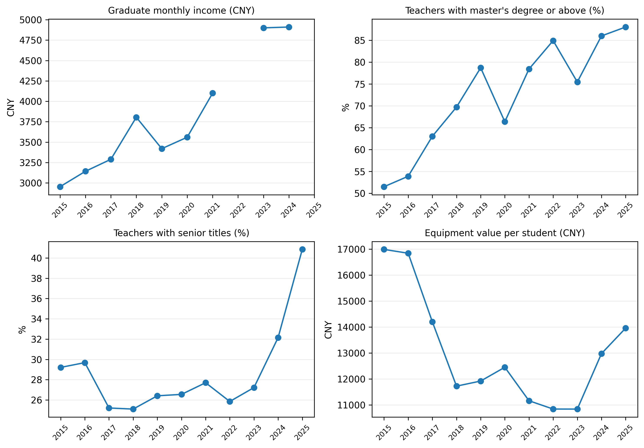
Legend: The supplementary figure displays graduate monthly income, teachers with graduate degrees, teachers with senior titles, and teaching/research equipment value per student across the extractable Jiangsu historical series. Missing points reflect unavailable or non-extractable values in the underlying reports.

