Alanine-specific appetite in slow growing chickens is associated with impaired glucose transport and TCA cycle

Shahram Niknafs¹, Marina R S Fortes², Sungbo Cho¹, John L Black³, Eugeni Roura¹

¹ Centre for Nutrition and Food Sciences, Queensland Alliance for Agriculture and Food Innovation, The University of Queensland, St. Lucia, QLD 4072, Australia; ² School of Chemistry and Molecular Bioscience, The University of Queensland, St Lucia, Qld 4072, Australia; ³ John L Black Consulting, Warrimoo, NSW 2774, Australia

s.niknafs@uq.edu.au
m.fortes@uq.edu.au
blue0555@hotmail.com
jblack@pnc.com.au
e.roura@uq.edu.au

Corresponding Author:
Professor Eugeni Roura, Room S435, Hartley Teakle [#83], The University of Queensland, St Lucia, Brisbane 4072, Australia. Tel: +61 7 3365 2526, E: e.roura@uq.edu.au

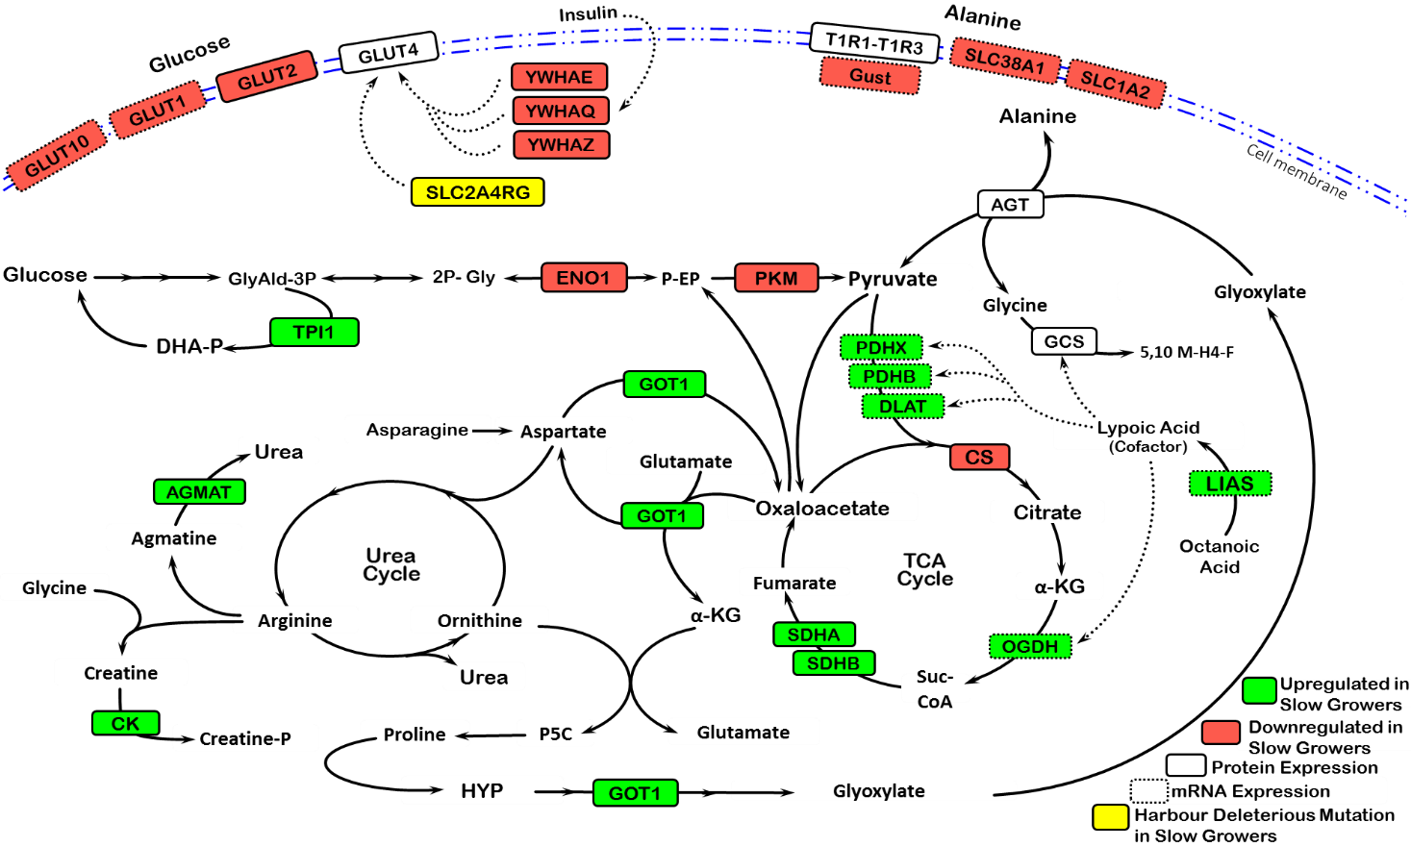

Figure S1. Integrated details of the enriched pathways from transcriptomic, proteomic, and genomic data representing their up/down regulations (P<0.05) in slow-growing chickens (AGMAT: Agmatinase; AGT: Alanine-glyoxylate transaminase; CK: Creatine Kinase; CS: Citrate synthase; DLAT: dihydrolipoamide S-acetyltransferase; ENO1: Enolase 1; GCS: Glycine cleavage system; GLUT1, 2, 4, 10: glucose transporter 1, 2, 4, 10; GOT1: Glutamic-oxaloacetic transaminase 1; Gust: Gustducin; LIAS: Lipoic acid synthetase; OAA: Oxaloacetate; OGDH: oxoglutarate (α-ketoglutarate) dehydrogenase; PDHB: pyruvate dehydrogenase (lipoamide) beta; PDHX: pyruvate dehydrogenase complex component; PKM: Pyruvate Kinase; PRPS2: Phosphoribosyl pyrophosphate synthetase 2; SDHA, B: Succinate dehydrogenase complex flavoprotein subunit A, B; SLC2A4RG: Solute Carrier 2 A4 Regulator; SLC38A1: Solute Carrier 38 A1; SLC1A2: Solute Carrier 1 A2; TPI1: Triosephosphate isomerase 1; T1R1-T1R3: Umami taste receptor; YWHAE, Q, Z: Tyrosine 3-monooxygenase/ tryptophan 5-monooxygenase activation protein epsilon, theta, zeta).

Table S1. Ingredient and nutrient composition of the control¹ and supplemental² diet used in the double-choice experiments.
 | Item | % in different diets
 | Item | Grower | Finisher
Ingredient | Wheat | 30 | 30
Ingredient | Sorghum | 32.7 | 39.5
Ingredient | Soybean Meal | 19.5 | 13
Ingredient | Canola Meal | 7 | 8
Ingredient | Meat Meal | 4.2 | 3.63
Ingredient | Blood Meal | - | -
Ingredient | Poultry Oil (press) | 3.64 | 3.06
Ingredient | Poultry Oil (mixer) | 1.5 | 1.5
Ingredient | Alimet (Met) | 0.33 | 0.25
Ingredient | Lysine | 0.32 | 0.31
Ingredient | Broiler starter premix | 0.33 | 0.33
Ingredient | Sodium Bicarbonate | 0.14 | 0.15
Ingredient | Salt | 0.075 | 0.151
Ingredient | Threonine | 0.089 | 0.070
Ingredient | Choline Chloride | 0.033 | 0.033
Nutrient | Protein | 21.6 | 19.29
Nutrient | Fat | 7.31 | 6.80
Nutrient | Fibre | 3.27 | 3.21
Nutrient | Calcium | 0.87 | 0.78
Nutrient | Available phosphorus | 0.51 | 0.477
Nutrient | Methionine | 0.58 | 0.489
Nutrient | Methionine + Cysteine | 0.94 | 0.828
Nutrient | Lysine | 1.23 | 1.059
Nutrient | Tryptophan | 0.245 | 0.223
Nutrient | Arginine | 1.26 | 1.07
Nutrient | Threonine | 0.82 | 0.721
Nutrient | Isoleucine | 0.83 | 0.736
Nutrient | Valine | 0.97 | 0.866
Nutrient | Leucine | 1.64 | 1.50
Nutrient | Choline (mg/kg) | 1421.2 | 1298.8
Nutrient | Metabolizable Energy (MJ/kg) | 13.2 | 13.3
Nutrient | Phosphorus | 0.66 | 0.613
Nutrient | Digestible Methionine | 0.51 | 0.43
Nutrient | Digestible Met + Cys | 0.83 | 0.733
Nutrient | Digestible Lysine | 1.10 | 0.94
Nutrient | Sodium | 0.16 | 0.16
Nutrient | Potassium | 0.757 | 0.65
Nutrient | Chloride | 0.190 | 0.19
Nutrient | Digestible Threonine | 0.726 | 0.63
Nutrient | Digestible Tryptophan | 0.237 | 0.207
Nutrient | Digestible Isoleucine | 0.764 | 0.669
Nutrient | Digestible Leucine | 1.44 | 1.32
Nutrient | Digestible Arginine | 1.14 | 0.96
Nutrient | Digestible Valine | 0.855 | 0.759
¹The control diet was a standard broiler feed supplied by the Darwalla Group (Esk, QLD, Australia).
²The supplemental feeds consisted of the control diet described in the table supplemented with a mix of three essential (Met, Lys and Thr) or three non-essential (Ala, Asp, and Asn) amino acids. Each amino acid was supplemented to reach 73% excess of the control diet.

Table S2. List of candidate genes that were used for genomic variant calling

Gene | Aliases | Entrez ID | Chr | Gene | Aliases | Entrez ID | Chr
CASR | - | 418266 | 1 | SLC2A2 | GLUT-2 | 396272 | 9
GPRC6A | - | 428620 | 3 | SLC2A14 | GLUT3, SLC2A3 | 396517 | 1
GPR92 | LPAR5 | 418279 | 1 | SLC7A6 | y+ LAT-2 | 415622 | 11
GPR139 | - | 431418 | 14 | SLC7A5 | LAT1 | 415832 | 11
CD36 | - | 417730 | 1 | SLC9A3R2 | - | 416550 | 14
T1R1 | TAS1R1 | 428176 | 21 | SLC2A4 | GLUT4, SLC2A4 | 417384 | 18
T1R3 | TAS1R3 | 428182 | 21 | SLC43A2 | LAT4 | 417557 | 19
SGLT1 | SLC5A1 | 395496 | 15 | SLC38A1 | SNAT1 | 417806 | 1
GPR120 | FFAR4; O3FAR1 | 428963 | 6 | SLC38A2 | SNAT2 | 417807 | 1
GRM1 | mGluRs | 421614 | 3 | SLC16A7 | MCT2 | 417815 | 1
GRM2 | mGluRs | 427575 | 12 | SLC9A2 | NHE2 | 418719 | 1
GRM3 | mGluRs | 418644 | 1 | SLC7A1 | CAT-1 | 418922 | 1
GRM5 | mGluRs | 373933 | 1 | SLC2A5 | GLUT-5 | 419438 | 21
GRM7 | mGluRs | 416112 | 12 | SLC7A7 | y+LAT1 | 420216 | 2
GRM8 | mGluRs | 427853 | 1 | SLC9A3 | NHE3 | 420801 | 2
PKD2L1 | - | 428954 | 6 | SLC9A3R1 | - | 422108 | 18
HCN3 | - | 100859704 | 25 | SLC7A2 | CAT-2 | 422730 | 4
HCN1 | - | 431590 | Z | SLC1A2 | EAAT2 | 423156 | 5
HCN2 | - | 770384/428335 | 28 | SLC1A1 | EAAT-3 | 427352 | Z
HCN4 | - | 427478 | 10 | SLC3A1 | SLC1A5, ASCT2, rBAT | 428569 | 3
AQP7 | aquaporin 7 | 426892 | Z | SLC7A11 | xCT | 428731 | 4
AQP2 | aquaporin 2 | 431304 | 33 | SLC36A1 | PAT1 | 770250 | 13
AQP5 | aquaporin 5 | 431305 | 33 | BSG | CD147 | 770363 | 28
AQP3 | - | 426894 | Z | SLC5A10 | SGLT5 | 770581 | 14
AQP1 | - | 420384 | 2 | SLC6A14 | ATB0,+ | 10085752 | 4
AQP4 | - | 421088 | 2 | SLC16A3 | - | 395383 | 18
AQP8 | - | 416566 | 14 | SLC38A1 | - | 417806 | 1
AQP9 | - | 415402 | 10 | SLC1A2 | - | 423156 | 5
AQP10 | - | 101749384 | 25 | SLC2A4RG | GEF | 100858363 | 20
AQP11 | - | 426725 | 1 | Gust | GNAT3 | 427851 | 1
AQP12A | - | 424861 | 9 | AGXT2 | - | 431666 | Z
T2R1 | TAS2R1; TAS2R40 | 101749182 | 1 | DLAT | - | 419796 | 24
T2R2 | TAS2R2; TAS2R4 | 101747503 | 1 | PDHB | - | 416066 | 12
T2R7 | TAS2R7; TAS2R3 | 771663 | 3 | PDHX | - | 423154 | 5
GNAT3 | Gustducin | 427851 | 1 | SLC2A2 | - | 396272 | 9
 | SCNN1G | 416579 | 14 | GLUT4 | - | 100858363 | 20
ENaC | SCNN1B | 427673 | 14 | YWHAE | - | 417554 | 19
 | SCNN1D | 428184 | 21 | YWHAQ | - | 421932 | 3
 | SCNN1A | 396050 | 1 | YWHAZ | - | 425619 | 2
GPRC5B |  | 101747453 | 14 | ENO1 | - | 396017 | 21
SLC15A1 | PepT-1 | 378789 | 1 | PKM | - | 396456 | 10
SLC2A8 | GLUT8 | 378802 | 17 | ALT | GPT2 | 415746 | 11
SLC16A3 | MCT4 | 395383 | 18 | OGDH | - | 426429 | 22
ANPEP | APN | 395667 | 10 | CS | - | 100858903 | 33
SLC16A8 | MCT3 | 396041 | 1 | LIAS | - | 422791 | 4
SLC2A1 | SLC2A1, GLUT1 | 396130 | 21

Table S3. Performance parameters of broiler chickens in the double choice (DC) experiments of feed vs feed supplemented with amino acid (AA) during d 28-42 (week 5 and 6). FG: fast-growing chickens; SG: slow-growing chickens; T1: control feed; T2: essential amino acid (Met, Lys, Thr); T3: non-essential amino acid (Ala, Asp, Asn); G×T: group × treatment interaction. ^{a, b} means not sharing common letters are significantly different.

DC test | Effect | Body weight (g) |  |  | Weight gain (g) | Feed intake (g) | FCR(g:g)
DC test | Effect | d 28 | d 35 | d 42 | d 28-42 | d 28-42 | d 28-42
Feed vs Feed Supplemented with AA | Main effect
Feed vs Feed Supplemented with AA | Group
Feed vs Feed Supplemented with AA | FG | 1900ª | 2596ª | 3465ª | 1565ª | 3019ª | 1.94
Feed vs Feed Supplemented with AA | SG | 1347^{b} | 1935^{b} | 2664^{b} | 1317^{b} | 2603^{b} | 1.99
Feed vs Feed Supplemented with AA | Treatment
Feed vs Feed Supplemented with AA | T1 | 1645 | 2281 | 3098 | 1453 | 2857 | 1.99
Feed vs Feed Supplemented with AA | T2 | 1584 | 2218 | 2981 | 1399 | 2667 | 1.91
Feed vs Feed Supplemented with AA | T3 | 1641 | 2298 | 3112 | 1471 | 2910 | 1.99
Feed vs Feed Supplemented with AA | P-value
Feed vs Feed Supplemented with AA | Group | <0.001 | <0.001 | <0.001 | <0.001 | <0.001 | NS
Feed vs Feed Supplemented with AA | Treatment | NS | NS | NS | NS | NS | NS
Feed vs Feed Supplemented with AA | G×T | NS | NS | NS | NS | NS | NS

