D1 (forest plot for depression results)
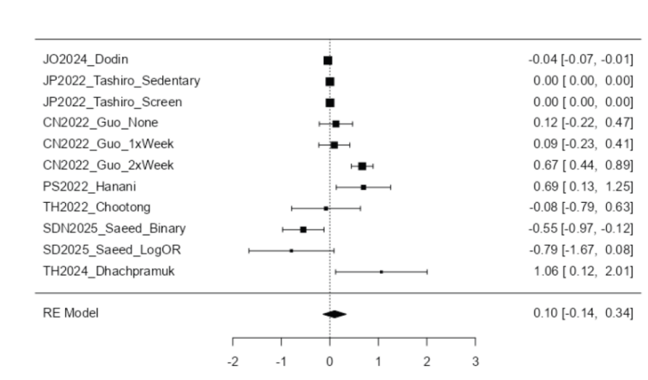

D2 (funnel plot for depression results)
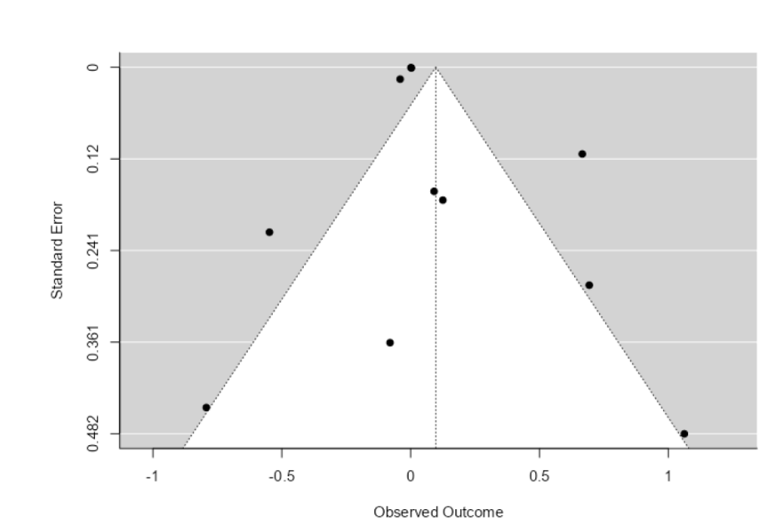

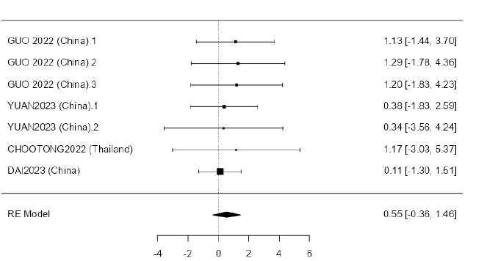
A1 (forest plot for Anxiety results)

A2 (funnel plot for anxiety results)
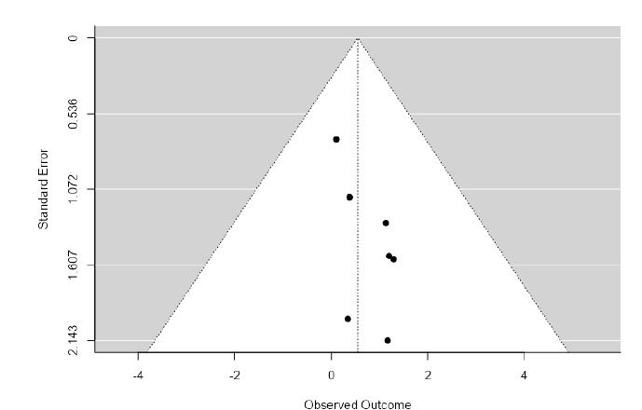

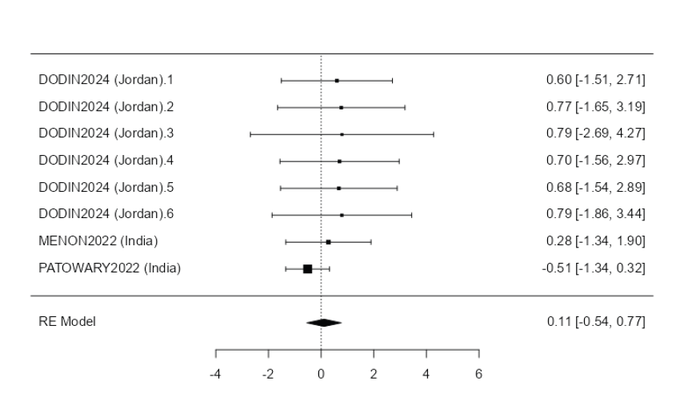
S1 (forest plot for Stress results)

S2 (funnel plot for stress results)
