Supplementary File 1. Full database search strategies and PRISMA-S log
Search execution summary. The final search update was performed on 12 April 2026. Database searching identified 7 PubMed records and 5 Scopus records. After removal of 3 duplicate database records, 9 records were screened at title/abstract level and all 9 were excluded. Twelve manually identified full-text reports were assessed for eligibility; 9 were excluded and 3 were retained in the final review and quantitative synthesis.

PRISMA-S metric | Count
PubMed records | 7
Scopus records | 5
Database duplicates removed | 3
Records screened at title/abstract | 9
Records excluded at title/abstract | 9
Manual full-text reports assessed | 12
Full-text reports excluded | 9
Studies included in review/meta-analysis | 3

Database/source | Run | Query | Date searched | Records retrieved/notes
PubMed | Main search | ("Metabolic Syndrome"[Mesh] OR "metabolic syndrome"[tiab] OR "syndrome X"[tiab] OR "hội chứng chuyển hóa"[tiab] OR "hoi chung chuyen hoa"[tiab])  AND ("Aged"[Mesh] OR "Aged, 80 and over"[Mesh] OR elderly[tiab] OR elder*[tiab] OR geriatric*[tiab] OR "older adult*"[tiab] OR "older people"[tiab] OR "older person*"[tiab] OR "older patient*"[tiab] OR "older outpatient*"[tiab] OR "người cao tuổi"[tiab] OR "nguoi cao tuoi"[tiab])  AND ("Vietnam"[Mesh] OR Vietnam[tiab] OR Vietnamese[tiab] OR "Viet Nam"[tiab] OR "Việt Nam"[tiab])  AND (prevalence[tiab] OR epidemiolog*[tiab] OR "associated factor*"[tiab] OR "risk factor*"[tiab] OR determinant*[tiab] OR correlate*[tiab]) | 2026-04-12 | 7  Primary database search; no date restriction
PubMed | 2026 update | ("Metabolic Syndrome"[Mesh] OR "metabolic syndrome"[tiab] OR "syndrome X"[tiab] OR "hội chứng chuyển hóa"[tiab] OR "hoi chung chuyen hoa"[tiab])  AND ("Aged"[Mesh] OR "Aged, 80 and over"[Mesh] OR elderly[tiab] OR elder*[tiab] OR geriatric*[tiab] OR "older adult*"[tiab] OR "older people"[tiab] OR "older person*"[tiab] OR "older patient*"[tiab] OR "older outpatient*"[tiab] OR "người cao tuổi"[tiab] OR "nguoi cao tuoi"[tiab])  AND ("Vietnam"[Mesh] OR Vietnam[tiab] OR Vietnamese[tiab] OR "Viet Nam"[tiab] OR "Việt Nam"[tiab])  AND (prevalence[tiab] OR epidemiolog*[tiab] OR "associated factor*"[tiab] OR "risk factor*"[tiab] OR determinant*[tiab] OR correlate*[tiab])  AND ("2026/01/01"[dp] : "2026/12/31"[dp]) | 2026-04-12 | 0  No additional elderly-specific report was identified from the update alone
Scopus | Main search | TITLE-ABS-KEY(("metabolic syndrome" OR "syndrome x" OR "hội chứng chuyển hóa" OR "hoi chung chuyen hoa")  AND (elderly OR elder* OR geriatric* OR "older adult*" OR "older people" OR "older person*" OR "older patient*" OR "older outpatient*" OR "người cao tuổi" OR "nguoi cao tuoi")  AND (Vietnam OR Vietnamese OR "Viet Nam" OR "Việt Nam")  AND (prevalence OR epidemiolog* OR "associated factor*" OR "risk factor*" OR determinant* OR correlate*)) | 2026-04-12 | 5  Primary database search; TITLE-ABS-KEY
Scopus | 2026 update | TITLE-ABS-KEY(("metabolic syndrome" OR "syndrome x" OR "hội chứng chuyển hóa" OR "hoi chung chuyen hoa")  AND (elderly OR elder* OR geriatric* OR "older adult*" OR "older people" OR "older person*" OR "older patient*" OR "older outpatient*" OR "người cao tuổi" OR "nguoi cao tuoi")  AND (Vietnam OR Vietnamese OR "Viet Nam" OR "Việt Nam")  AND (prevalence OR epidemiolog* OR "associated factor*" OR "risk factor*" OR determinant* OR correlate*))  AND PUBYEAR = 2026 | 2026-04-12 | 0  No additional elderly-specific included report identified from update alone
Manual journal / repository search | Targeted full-text identification | Vietnamese journals and repositories screened manually: Tạp chí Nghiên cứu Y học; Tạp chí Nội tiết và Đái tháo đường; Tạp chí Dinh dưỡng và Thực phẩm; Y Học TP. Hồ Chí Minh; institutional repositories and grey literature sources. | 2026-04-12 | 12  Twelve full-text reports identified for direct eligibility assessment
Manual full-text identification was essential because the final set of Vietnamese elderly-specific reports was not fully captured by title/abstract screening of the international databases.

Supplementary File 2. Additional exploratory outputs
These outputs were retained as exploratory diagnostics because only three studies were included in the primary pooled analysis. They should therefore be interpreted cautiously.
Primary pooled estimate used for diagnostics: 40.98% (95% CI 30.29%–52.60%), I² = 94.7%, τ² = 0.1623.
Supplementary Figure S2A. Exploratory Baujat-style plot showing each study’s contribution to heterogeneity and its influence on the pooled logit prevalence estimate.
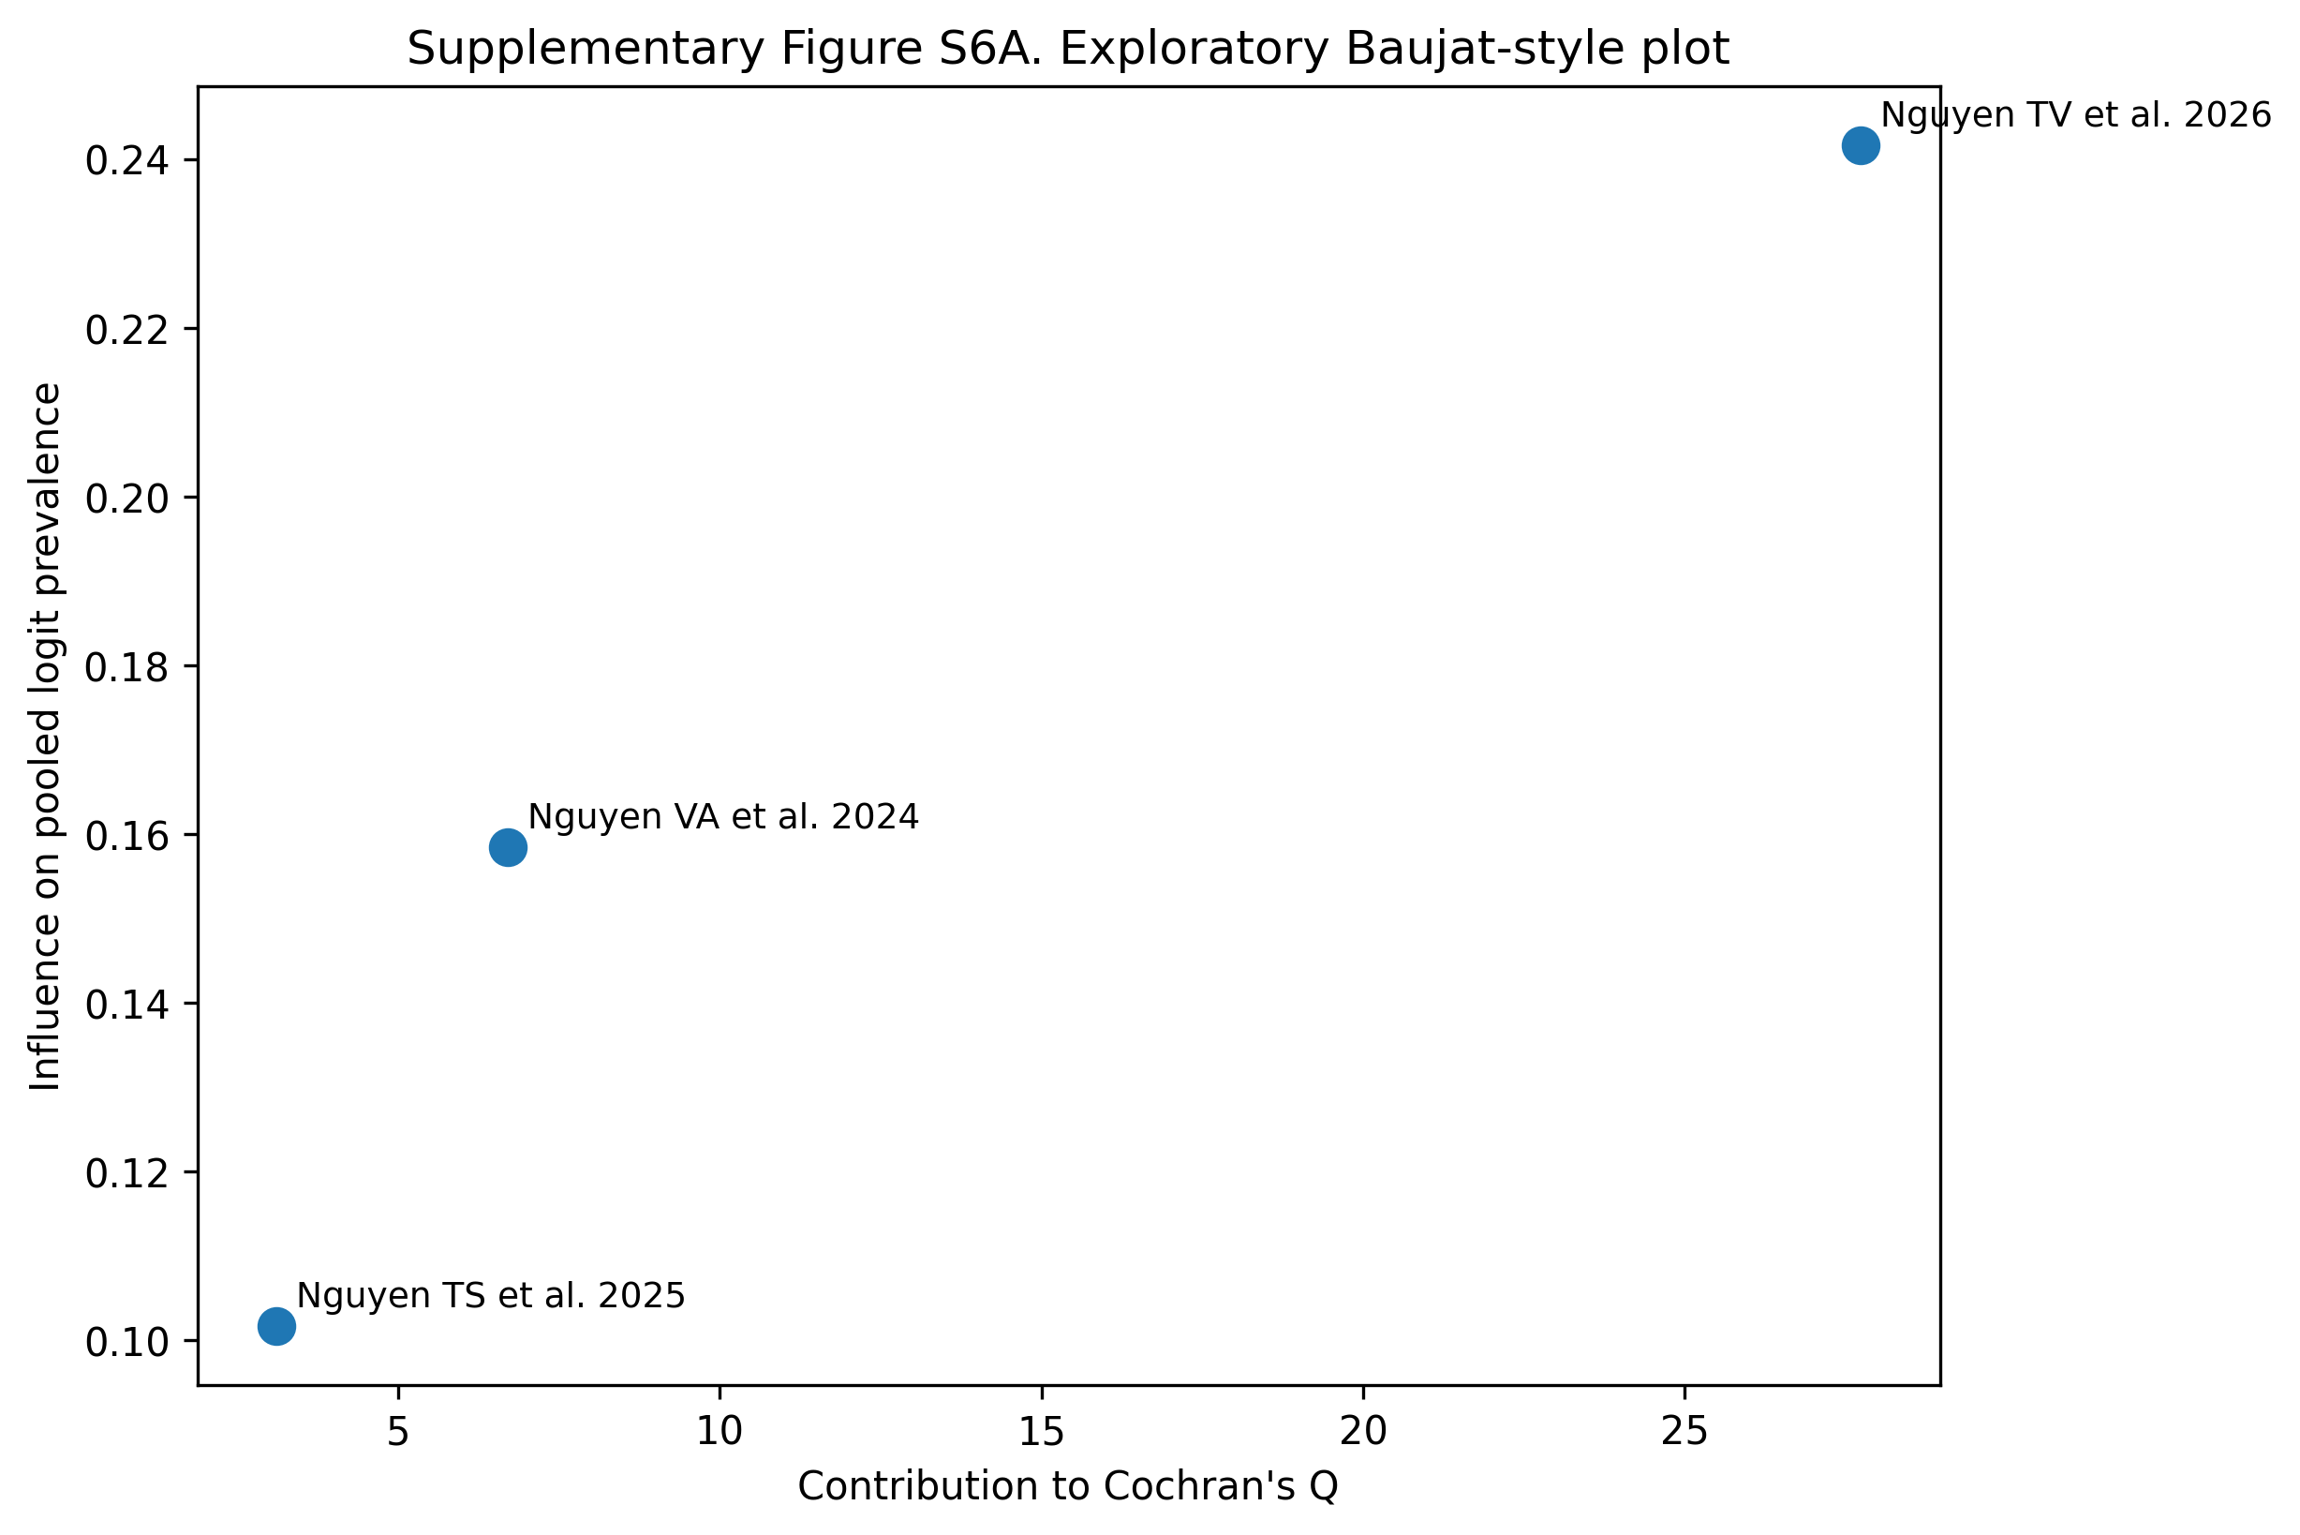

Supplementary Figure S2B. Leave-one-out diagnostics showing how the pooled prevalence changes when each study is omitted in turn.
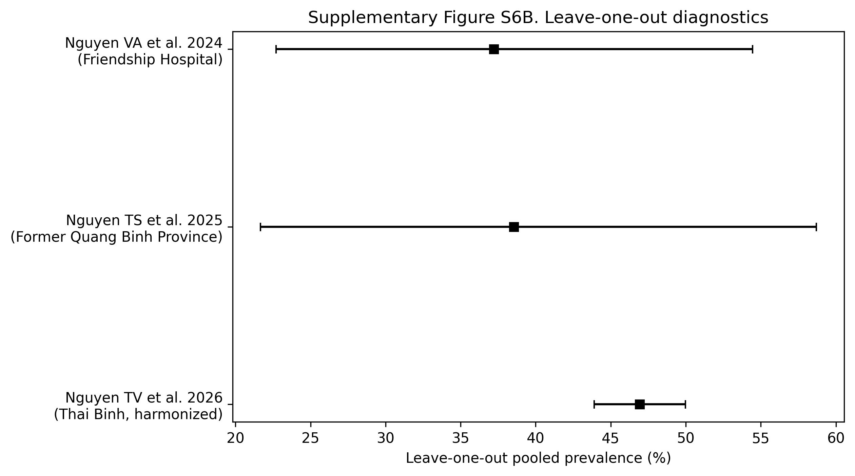

Supplementary Table S3. Leave-one-out meta-analysis results.
Omitted study | Pooled prevalence (%) | 95% CI lower | 95% CI upper | Tau-squared | I-squared (%) | Absolute influence on the pooled logit estimate
Nguyen VA et al. 2024 (Friendship Hospital) | 37.21 | 22.7 | 54.45 | 0.2473 | 96.4 | 0.1585
Nguyen TS et al. 2025 (Former Quang Binh Province) | 38.54 | 21.67 | 58.71 | 0.3379 | 96.9 | 0.1017
Nguyen TV et al. 2026 (Thai Binh, harmonised) | 46.93 | 43.91 | 49.97 | 0.0 | 0.0 | 0.2416
The Baujat-style plot was generated from logit-transformed proportions using DerSimonian–Laird random-effects pooling, and the influence axis shows the absolute change in the pooled logit prevalence when each study is omitted. Because only three studies were available, the figure is descriptive rather than inferential.

