Supplementary information
Table S1 Soil physicochemical properties under different N fertiliser application rates. Mean ± standard deviation of three replicates is presented for soil characteristics. Values in the same column following different letters indicate significant differences (P < 0.05) between the same soil layer (topsoil: 0–25 cm, subsoil: 25–50 cm). N0, N1, N2, and N3: N fertiliser application rates of 0, 120, 360, and 600 kg ha⁻¹ y⁻¹, respectively, for 5 years. SOC, soil organic carbon; TN, total nitrogen; AN, alkali-hydrolysable N; AP, available phosphate; AK, available potassium.
Soil layer | Treatment | pH | SOC | TN | AN | NH₄⁺ | NO₃⁻ | AP | AK | C/N
 |  |  | (g/kg) | (g/kg) | (mg/kg) | (mg/kg) | (mg/kg) | (mg/kg) | (mg/kg)
Topsoil | N0 | 3.82 ± 0.10a | 45.21 ± 1.70a | 3.69 ± 0.29a | 284.67 ± 20.11a | 22.60 ± 0.29ab | 41.57 ± 17.42bc | 574.33 ± 65.92a | 284.00 ± 7.94a | 14.32 ± 1.04a
 | N1 | 3.84 ± 0.02a | 43.03 ± 6.20a | 3.53 ± 0.47a | 283.73 ± 29.38a | 19.65 ± 0.70b | 32.23 ± 2.52c | 479.83 ± 27.58a | 259.00 ± 69.20a | 14.22 ± 0.15a
 | N2 | 3.57 ± 0.05b | 36.26 ± 4.41b | 2.98 ± 0.65ab | 250.13 ± 34.56ab | 21.93 ± 2.03ab | 72.86 ± 27.58a | 578.00 ± 162.89a | 239.67 ± 25.11ab | 14.42 ± 1.61a
 | N3 | 3.54 ± 0.04b | 30.83 ± 3.27b | 2.48 ± 0.26b | 228.20 ± 20.19b | 27.56 ± 5.40a | 61.29 ± 7.07ab | 429.83 ± 60.76a | 167.00 ± 20.52b | 14.52 ± 0.90a
Subsoil | N0 | 3.72 ± 0.05a | 36.07 ± 4.12a | 2.64 ± 0.24a | 224.93 ± 19.11a | 16.79 ± 0.46a | 47.43 ± 20.07a | 503.17 ± 5.48a | 202.33 ± 37.11a | 15.93 ± 1.44a
 | N1 | 3.73 ± 0.03a | 25.97 ± 0.98b | 2.27 ± 0.37ab | 188.53 ± 28.29b | 16.52 ± 0.62a | 34.90 ± 7.05a | 381.67 ± 52.66ab | 189.00 ± 48.54a | 13.54 ± 1.75a
 | N2 | 3.68 ± 0.14a | 22.94 ± 5.39b | 1.93 ± 0.48bc | 159.13 ± 29.71c | 16.91 ± ± 1.00a | 48.15 ± 18.08a | 353.67 ± 112.55b | 176.67 ± 5.86a | 13.86 ± 0.37a
 | N3 | 3.63 ± 0.01a | 22.22 ± 7.01b | 1.70 ± 0.44c | 145.13 ± 29.71c | 19.05 ± 2.57a | 43.28 ± 3.69a | 279.83 ± 15.77b | 111.33 ± 16.17b | 15.09 ± 1.09a

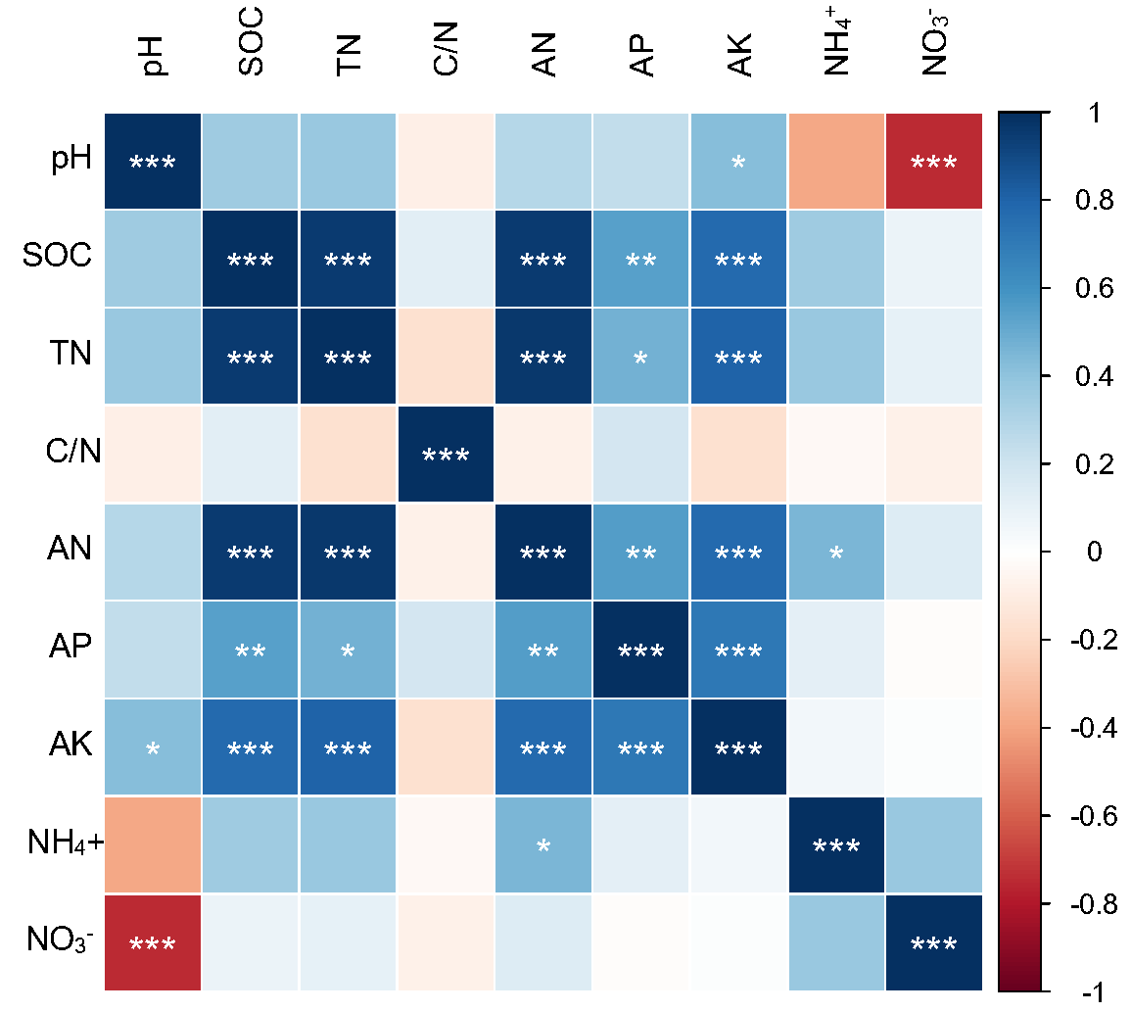

Fig. S1 Pearson’s correlation between soil physicochemical properties. SOC, soil organic carbon; TN, total nitrogen; AN, alkali-hydrolysable N; AP, available phosphate; AK, available potassium. *, **, and *** represent P < 0.05, P < 0.01, and P < 0.001, respectively.

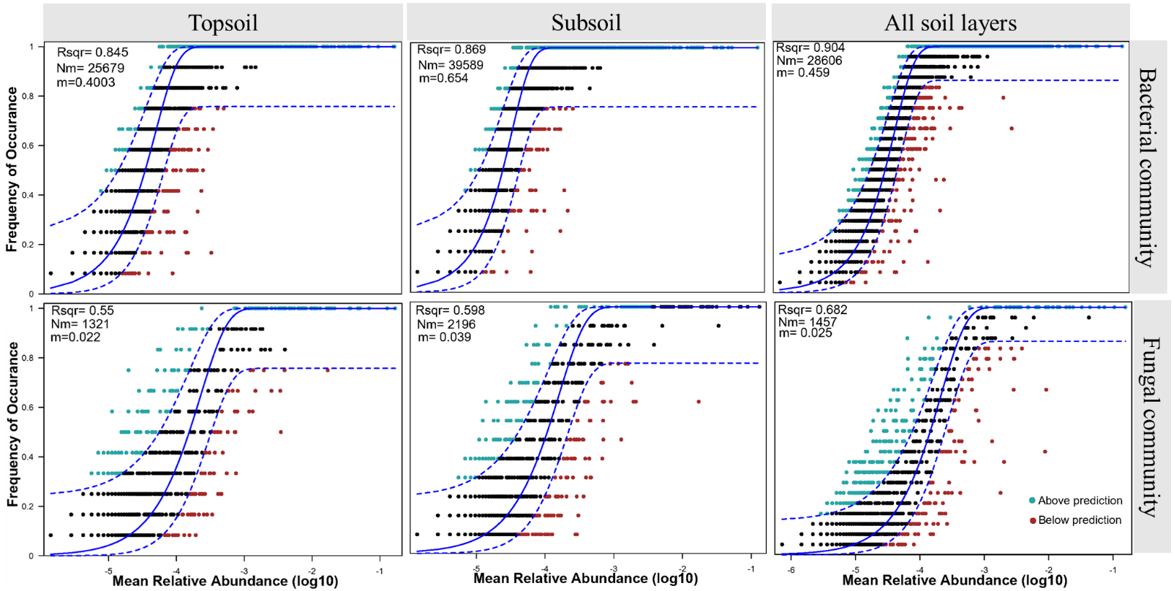
Fig. S2 Fit of the Sloan neutral community model for the assembly of soil bacterial and fungal communities. Topsoil: 0–25 cm, subsoil: 25–50 cm. Blue solid line represents the best fit curve of the model. The range between upper and lower dashed lines indicates 95% confidence interval. Rsqr represents the overall goodness-of-fit of the neutral community model; Nm was calculated by multiplying metacommunity size and migration; m indicates the migration rate.

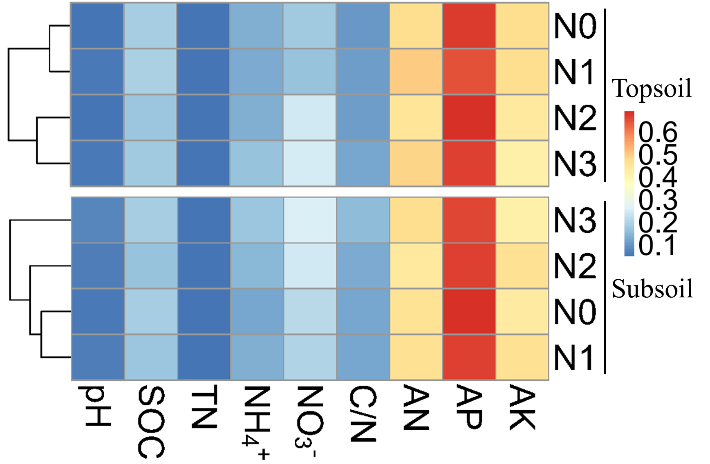
Fig. S3 Cluster analysis of different N fertiliser application rate treatments in the same soil layer (topsoil: 0–25 cm, subsoil: 25–50 cm) and with the same soil physicochemical characteristics. SOC, soil organic carbon; TN, total nitrogen; AN, alkali-hydrolysable N; AP, available phosphate; AK, available potassium. N0, N1, N2, and N3 refer to N fertiliser application rates of 0, 120, 360, and 600 kg ha⁻¹ y⁻¹, respectively, for 5 years.

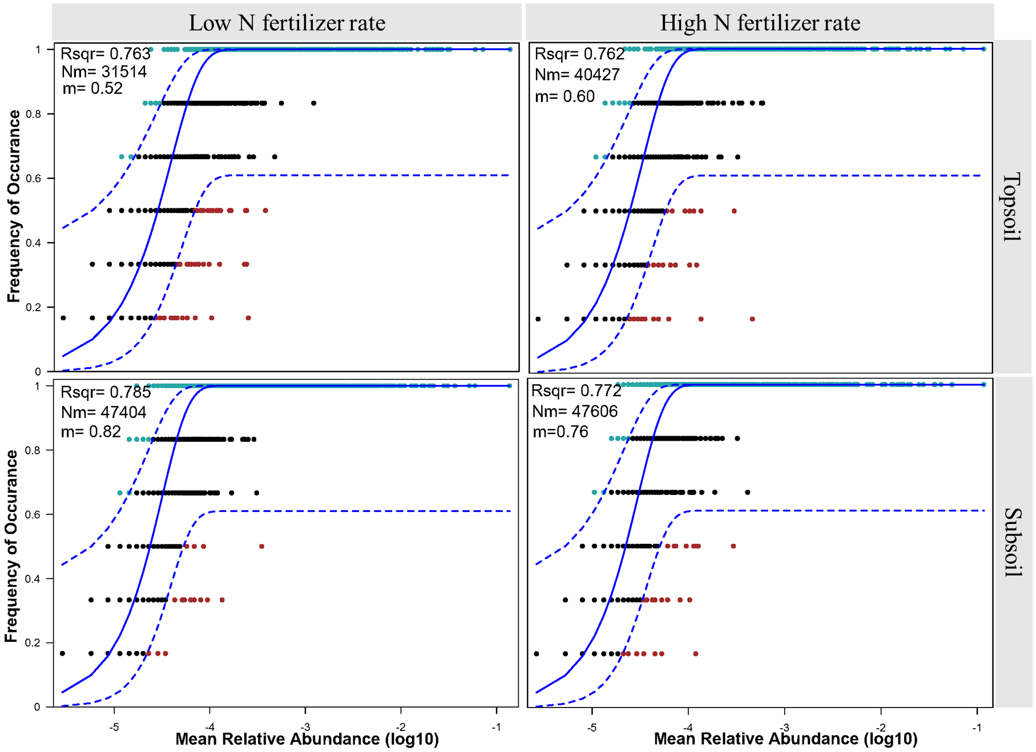

Fig. S4 Fit of the Sloan neutral community model for the assembly of soil bacterial and fungal communities. Topsoil: 0–25 cm, subsoil: 25–50 cm. N fertiliser application rates of 0 and 120 kg ha⁻¹ y⁻¹ were defined as low N fertiliser application rates N fertiliser application rates of 360 and 600 kg ha⁻¹ y⁻¹ were defined as high N fertiliser application rates. The blue solid line represents the best fit curve of the model. The range between the upper and lower dashed lines indicates 95% confidence interval. Rsqr represents overall goodness-of-fit of the neutral community model; Nm was calculated by multiplying metacommunity size and immigration; m indicates the migration rate.

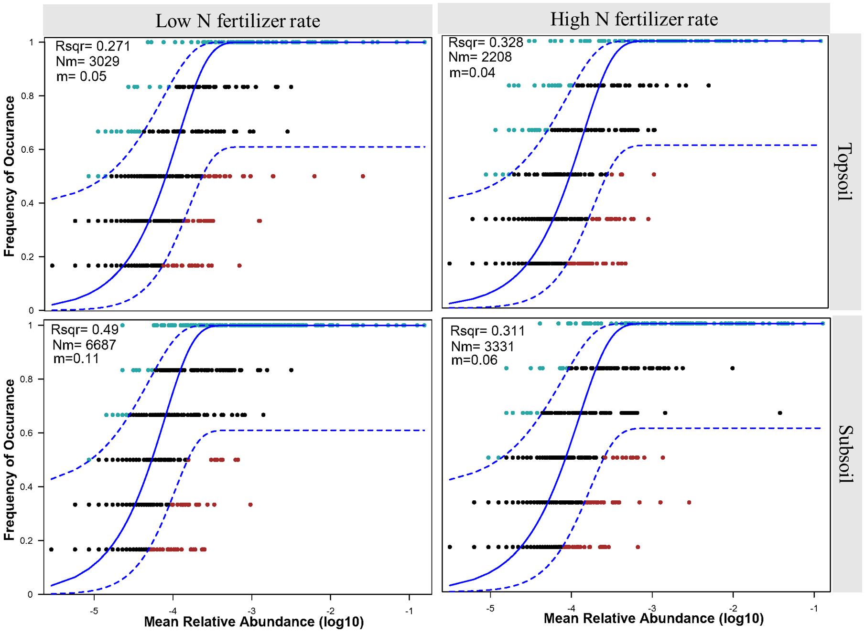

Fig. S5 Fit of the Sloan neutral community model for the assembly of soil bacterial and fungal communities. Topsoil: 0–25 cm, subsoil: 25–50 cm. N fertiliser application rates of 0 and 120 kg ha⁻¹ y⁻¹ were defined as low N fertiliser application rates N fertiliser application rates of 360 and 600 kg ha⁻¹ y⁻¹ were defined as high N fertiliser application rates. The blue solid line represents the best fit curve of the model. The range between the upper and lower dashed lines indicates 95% confidence interval. Rsqr represents the overall goodness-of-fit of the neutral community model; Nm was calculated by multiplying metacommunity size and migration; m indicates the migration rate.

