Supplementary Data
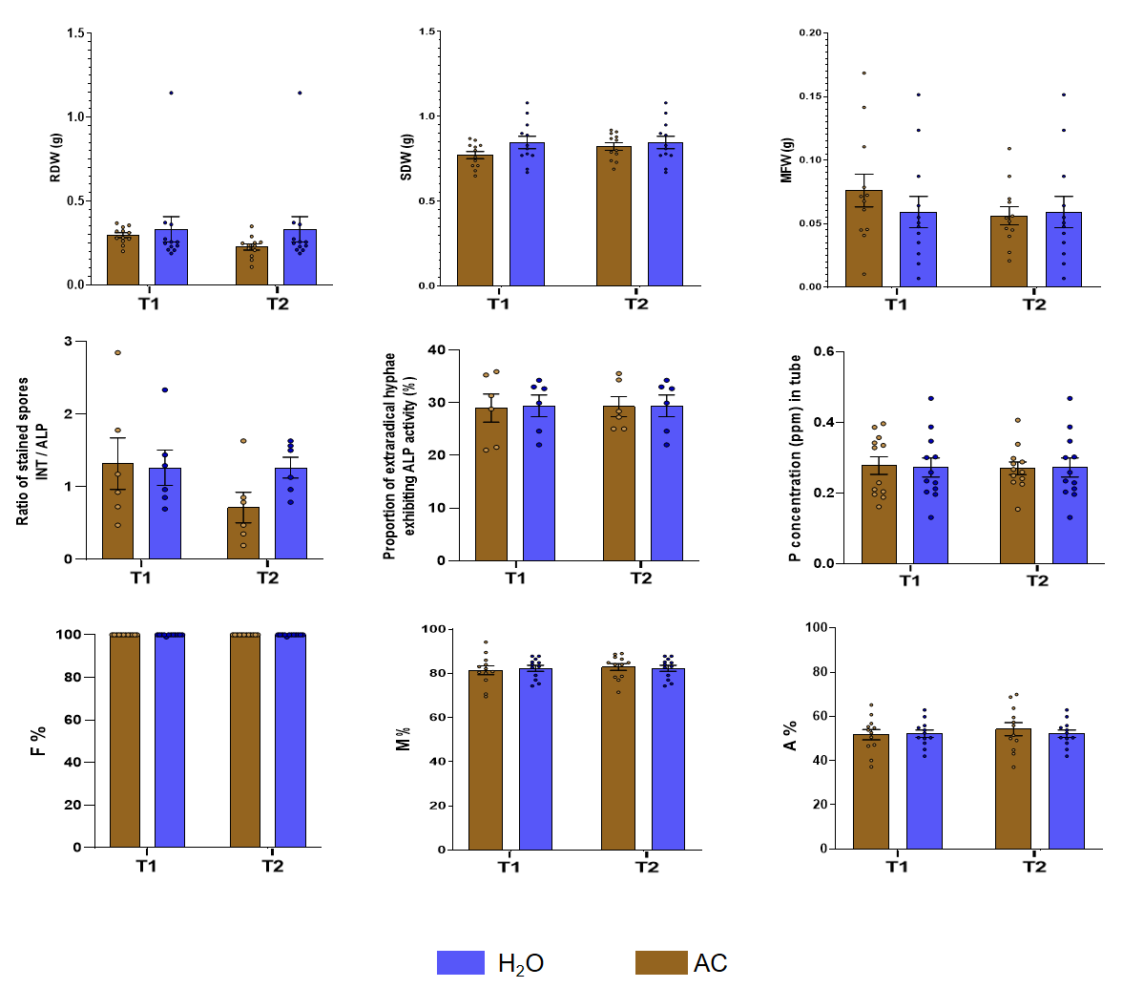
Figure S1. Measured parameters in Medicago truncatula colonized by Rhizophagus intraradices MUCL 49410 comparing the H₂O control and acetone (AC) control treatments. Parameters include root dry weight (RDW) and shoot dry weight (SDW) of plants grown in pots; mycelium fresh weight (MFW) produced within the in-growth tubes; INT/ALP-stained spore ratio reflecting spore metabolic activity; percentage of extraradical hyphae exhibiting alkaline phosphatase (ALP) activity indicating hyphal metabolic activity; and inorganic phosphorus (Pi) concentration remaining in the in-growth tubes; root colonization frequency (F%), colonization intensity (M%), arbuscule abundance (A%), and vesicle/spore abundance (V%) in roots.Data are expressed as means ± standard errors (n = 12). No significant differences were observed between the two control treatments. (one-way ANOVA, P ≤ 0.05).
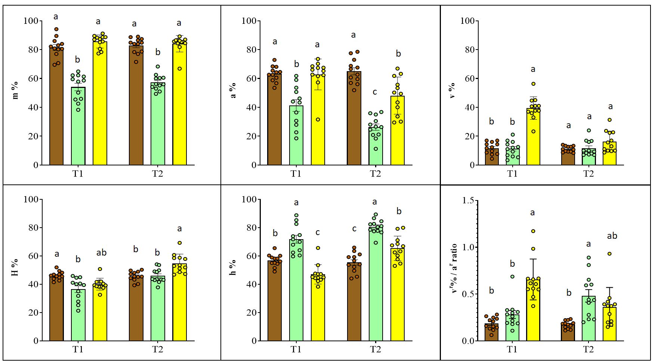
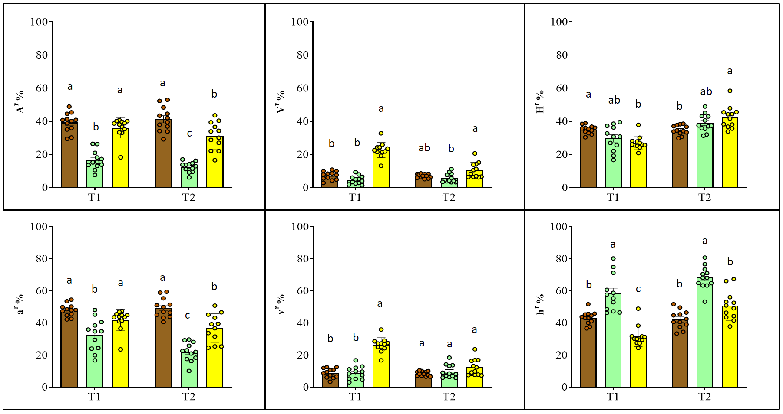
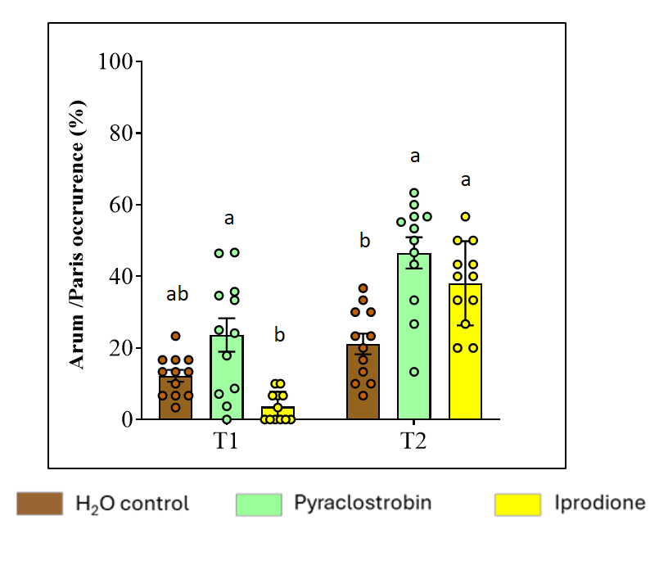
Figure S2. Root colonization parameters, measured at T1 and T2 in the roots of Medicago truncatula colonized by Rhizophagus intraradices MUCL 49410, assessed according to the method of Trouvelot et al. (1986) using the Mycocheck Advanced Excel spreadsheet (Lucic-Mercy et al., 2024). Parameters include mycorrhizal colonization intensity (m%), arbuscule abundance (a%), vesicle/spore abundance (v%) and intraradical hyphal abundance (h%) in colonized root fragments, intraradical hyphal abundance in the root system (H%), vesicle/arbuscule ratio (v%/a%), arbuscule abundance in the root system relative to vesicules and intraradical hyphal abundance (A^{r}%), vesicle abundance in the root system relative to arbuscule and intraradical hyphal abundance (V^{r}%), intraradical hyphal abundance in the root system relative to arbuscule and vesicule abundance (H^{r}%), arbuscule abundance in the intraradical colonization (M%) relative to vesicules and intraradical hyphal abundance (a^{r}%), vesicle abundance in the intraradical colonization (M%) relative to arbuscule and intraradical hyphal abundance (v^{r}%), intraradical hyphal abundance in the intraradical colonization (M%) relative to arbuscule and vesicule abundance (h^{r}%) and arum-type arbuscule occurrence (Arum/Paris occurrence, %). The extraradical mycelium in the in-growth tube developed either in the absence of pesticides (H₂O control) or in the presence of pyraclostrobin and iprodione applied at the recommended pesticide dose. Data are expressed as means ± standard errors (n = 12). Data were arcsine square-root transformed prior to statistical analysis. Different letters indicate significant differences between treatments at T1 and T2 (one-way ANOVA followed by a Tukey multiple comparison test, P ≤ 0.05).

