Supporting Information
Omental Adipocyte-to-Myeloid Reprogramming Drives Effective Skin Flap Regeneration
Chen Zhao¹, Jiaxian Zhang¹, Jianxin Yan¹, Hengyu Du¹, Xuanru Zhu¹, Shuxian Jiang¹, Ruoxi Chen¹, Xiao Jiang¹, Shenghong Li¹, Xuan Liao¹, Xiaofei Zheng³, Taixing Cui^{2,*}, Hongwei Liu^{1,*}
¹Department of Plastic Surgery of the First Affiliated Hospital of Jinan University, Institute of New Technology of Plastic Surgery of Jinan University, Key Laboratory of Regenerative Medicine of Ministry of Education, Jinan University, 510630, Guangzhou, China
²Dalton Cardiovascular Research Center, Department of Medical Pharmacology and Physiology, University of Missouri, School of Medicine, 134 Research Park Dr, Columbia, MO 65211, USA
³Department of Sports Medicine, The First Affiliated Hospital, Guangdong Provincial Key Laboratory of Speed Capability, The Guangzhou Key Laboratory of Precision Orthopedics and Regenerative Medicine, School of Medicine, Jinan University, 510630, Guangzhou, China
*Correspondence author: Hongwei Liu (liuhongwei0521@hotmail.com) and Taixing Cui (taixingcui@health.missouri.edu)

Supplemental Figures：
Figure S1
(A) Schematic diagram of the vascular ligation of greater omental adipose tissue (OmAT), inguinal white adipose tissue (iWAT), and epididymal white adipose tissue (eWAT), with “-” indicating the blockage site. OmAT: blockage of the left gastro-omental artery; iWAT: subcutaneous vessel blockage.
(B) Schematic workflow for the surgical removal of the panniculus carnosus to exclude dermal adipose contribution.
(C) Immunofluorescence staining of the adipocyte marker Perilipin-1 (Plin1) (red) in skin flaps after panniculus removal. Note the absence of Plin1 signal in the dermis.
(D) Histological comparison. H&E stained full-thickness skin sections from the Sham group (Skin) versus the Panniculus-removed group (Flap).
(E) Macroscopic views of short-axis prefabricated skin flaps at days 0, 1, 3, 7, and 14 post-surgery across the three adipose tissue graft groups (OPF, IPF, and EPF). Black dashed lines delineate the boundaries of the flap regions.
Figure S2
(A-B) Pseudotime ordering of GFP+ cells arranges them into a main trajectory. (A) The main trajectory reveals a bifurcation into three distinct differentiation states (State 1 – State 3). (B) Projection of calculated pseudotime values onto the original t-SNE plot, visualizing the developmental progression.
(C) The stacked bar plot displays the relative proportions of adipocyte-lineage/progenitor cells versus myeloid cells across pseudotime (divided into 15 equal bins). The intermediate bins, representing the transition zone, exhibit an overlapping distribution of both lineages, indicative of a hybrid transcriptional state enriched for both dedifferentiation- and myeloid-specific genes.
(D-E) Distribution of cells along the pseudotime axis. (D) Density of cells from OmAT, Sham, and OPF groups plotted along the trajectory. (E) Adipocytes and Myeloid cells mapped onto the pseudotime trajectory. Cells with nUMI counts > 1 are defined as positive.
(F) Expression dynamics of key adipocyte markers and myeloid markers along the pseudotime axis. Figure S3
(A) Quality control metrics for the snRNA-seq data across the three groups. Violin plots display the percentage of mitochondrial genes, Unique Molecular Identifier (UMI) counts, and the number of detected genes per nucleus.
(B) Statistical assessment of differential cell abundance between groups. *p< 0.05, **p < 0.01, ***p < 0.001.

(C-D) Identification of major cell types. Violin plots (C) and Dot plots (D) showing the relative expression levels of canonical marker genes for the eight identified clusters.
(E) Bar charts showing the absolute cell counts and relative proportions of the eight major subpopulations across the three groups.
(F) Bar graph detailing the proportional distribution of the adipocyte subpopulations across the three groups.
(G) Ratio of Observed to Expected (Ro/E) heatmap. Darker colors indicate a higher enrichment of a specific subpopulation within the respective group.
(H) Gene Ontology (GO) pathway enrichment analysis for adipocyte subpopulations A1, A3, A4, A5, and A6.
(I) Immunofluorescence co-staining for markers CD45 (red) and CD29 (red), and GFP (green) from OPF of Adiponectin^{Cre};ROSA26^{mTmG} mice at 1, 3, and 7 days post-surgery.
(J) Immunohistochemical staining for CD34 and CD11b in OmAT, iWAT and eWAT.

Figure S4
(A) The number and relative proportion of nine GFP+ cell subpopulations among the three groups.
(B) Bar graph showing the different proportional distributions of the nine GFP+ cell subpopulations across the three groups.
(C-D) Gene expression profiling. Violin plots (C) and Dot plots (D) display the expression of cluster-specific marker genes for the GFP+ lineage.
(E-F) Spatial exclusion of stromal contaminants. Immunofluorescence staining for the endothelial marker CD31 (red) and the smooth muscle marker SM22 (red) co-localized with GFP (green) in (E) the host tissue surrounding the graft (non-transplant region) and (F) within the transplanted graft (transplant region) of the OPF group at day 7. White dashed lines demarcate the graft boundary.
(G) GO term enrichment for GFP+ subpopulation cells C3, C4, C1, and C8.
(H) Feature plots visualizing the expression of selected cluster-specific genes for subpopulations C1, C3, C4, and C8. Expression levels are color-coded (red = high) and overlaid onto the t-SNE projection.
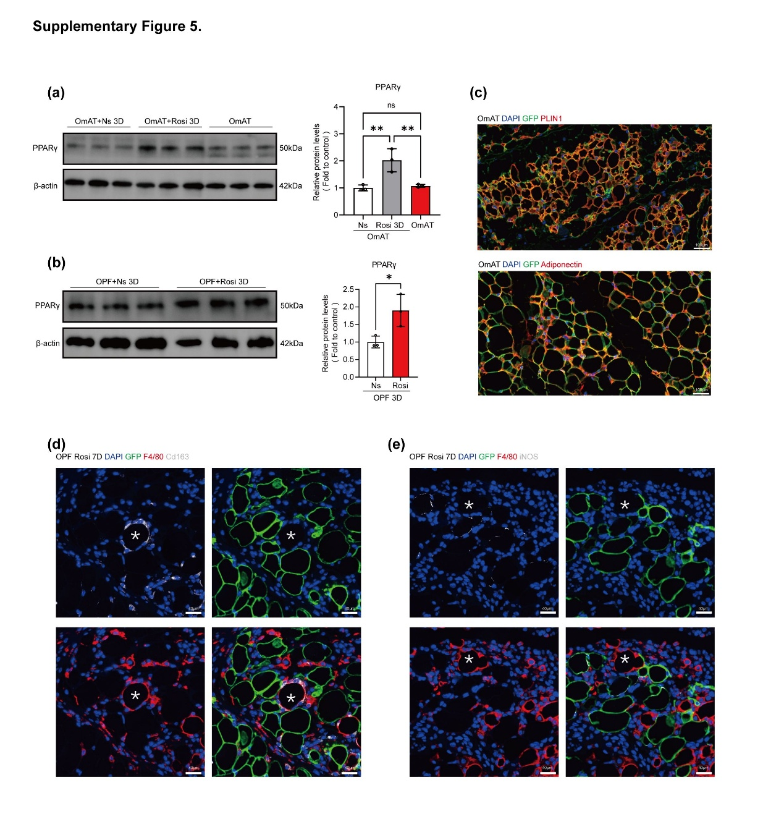 Figure S5
(A-B) Western blot analysis of PPARγ protein levels in native OmAT 3 days after administration of Rosiglitazone (Rosi) or Normal Saline (Ns), compared to untreated baseline.
(C) Representative immunofluorescence co-staining for the adipocyte markers PLIN1 (red) and adiponectin (red) with GFP (green) in OmAT sections from Adiponectin^{Cre};ROSA26^{mTmG} mice following Rosi administration.
(D-E) Immunofluorescence staining of macrophage markers F4/80 (red), CD163 (white), and iNOS (white) co-localized with GFP (green) in the Rosi group at day 7. Asterisks (*) indicate typical crown-like structures where macrophages surround lipid droplets/dead adipocytes, distinct from the reprogrammed hybrid cells.

