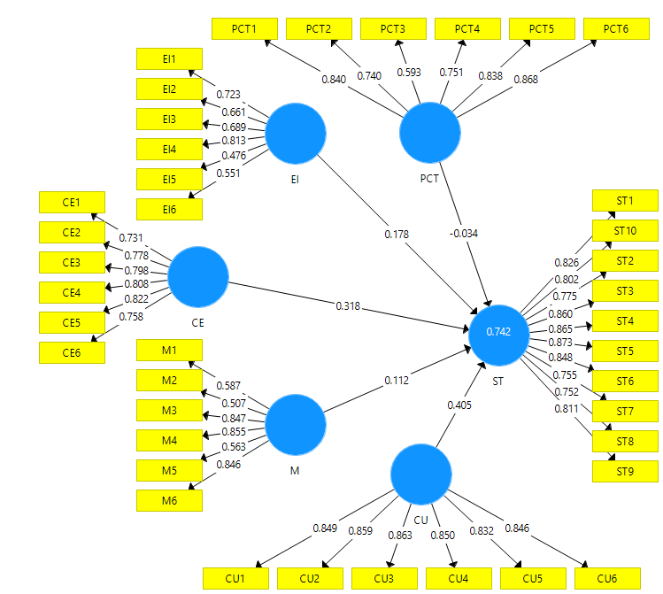

Outer Loading (1)
 | CE | CU | EI | M | PCT | ST
CE1 | 0,731
CE2 | 0,778
CE3 | 0,798
CE4 | 0,808
CE5 | 0,822
CE6 | 0,758
CU1 |  | 0,849
CU2 |  | 0,859
CU3 |  | 0,863
CU4 |  | 0,850
CU5 |  | 0,832
CU6 |  | 0,846
EI1 |  |  | 0,723
EI2 |  |  | 0,661
EI3 |  |  | 0,689
EI4 |  |  | 0,813
EI5 |  |  | 0,476
EI6 |  |  | 0,551
M1 |  |  |  | 0,587
M2 |  |  |  | 0,507
M3 |  |  |  | 0,847
M4 |  |  |  | 0,855
M5 |  |  |  | 0,563
M6 |  |  |  | 0,846
PCT1 |  |  |  |  | 0,840
PCT2 |  |  |  |  | 0,740
PCT3 |  |  |  |  | 0,593
PCT4 |  |  |  |  | 0,751
PCT5 |  |  |  |  | 0,838
PCT6 |  |  |  |  | 0,868
ST1 |  |  |  |  |  | 0,826
ST10 |  |  |  |  |  | 0,802
ST2 |  |  |  |  |  | 0,775
ST3 |  |  |  |  |  | 0,860
ST4 |  |  |  |  |  | 0,865
ST5 |  |  |  |  |  | 0,873
ST6 |  |  |  |  |  | 0,848
ST7 |  |  |  |  |  | 0,755
ST8 |  |  |  |  |  | 0,752
ST9 |  |  |  |  |  | 0,811

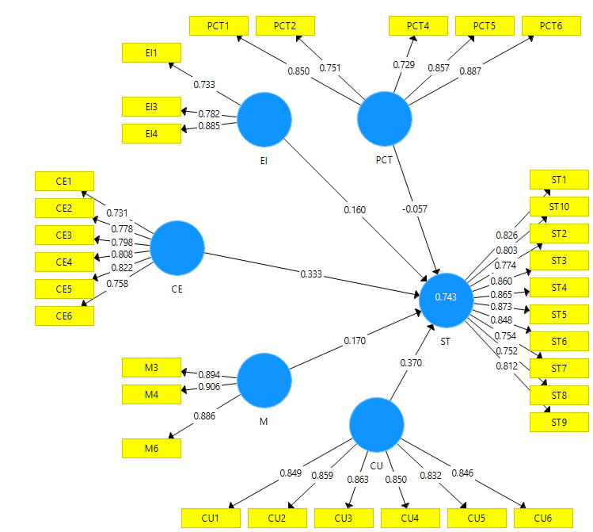
Outer Loading (2)
 | CE | CU | EI | M | PCT | ST
CE1 | 0,731
CE2 | 0,778
CE3 | 0,798
CE4 | 0,808
CE5 | 0,822
CE6 | 0,758
CU1 |  | 0,849
CU2 |  | 0,859
CU3 |  | 0,863
CU4 |  | 0,850
CU5 |  | 0,832
CU6 |  | 0,846
EI1 |  |  | 0,733
EI3 |  |  | 0,782
EI4 |  |  | 0,885
M3 |  |  |  | 0,894
M4 |  |  |  | 0,906
M6 |  |  |  | 0,886
PCT1 |  |  |  |  | 0,850
PCT2 |  |  |  |  | 0,751
PCT4 |  |  |  |  | 0,729
PCT5 |  |  |  |  | 0,857
PCT6 |  |  |  |  | 0,887
ST1 |  |  |  |  |  | 0,826
ST10 |  |  |  |  |  | 0,803
ST2 |  |  |  |  |  | 0,774
ST3 |  |  |  |  |  | 0,860
ST4 |  |  |  |  |  | 0,865
ST5 |  |  |  |  |  | 0,873
ST6 |  |  |  |  |  | 0,848
ST7 |  |  |  |  |  | 0,754
ST8 |  |  |  |  |  | 0,752
ST9 |  |  |  |  |  | 0,812

Construct Reliability and Validity
 | Cronbach's Alpha | rho_A | Composite Reliability | Average Variance Extracted (AVE)
CE | 0,874 | 0,879 | 0,905 | 0,613
CU | 0,923 | 0,923 | 0,940 | 0,722
EI | 0,722 | 0,754 | 0,843 | 0,644
M | 0,876 | 0,879 | 0,924 | 0,802
PCT | 0,875 | 0,898 | 0,909 | 0,668
ST | 0,945 | 0,948 | 0,953 | 0,669

Discriminant Validity
Fornell-Larcker Criterion
 | CE | CU | EI | M | PCT | ST
CE | 0,783
CU | 0,667 | 0,850
EI | 0,541 | 0,633 | 0,802
M | 0,657 | 0,798 | 0,597 | 0,895
PCT | 0,507 | 0,573 | 0,589 | 0,616 | 0,817
ST | 0,749 | 0,796 | 0,642 | 0,744 | 0,523 | 0,818

Collinearity Statistics (VIF)
Outer VIF Values
 | VIF
CE1 | 2,523
CE2 | 2,789
CE3 | 1,938
CE4 | 2,121
CE5 | 2,398
CE6 | 1,820
CU1 | 2,734
CU2 | 2,993
CU3 | 2,875
CU4 | 2,610
CU5 | 2,496
CU6 | 2,742
EI1 | 1,346
EI3 | 1,447
EI4 | 1,705
M3 | 2,521
M4 | 2,576
M6 | 2,163
PCT1 | 2,345
PCT2 | 1,761
PCT4 | 1,627
PCT5 | 2,463
PCT6 | 2,632
ST1 | 2,659
ST10 | 4,067
ST2 | 2,606
ST3 | 4,591
ST4 | 4,387
ST5 | 4,024
ST6 | 3,451
ST7 | 2,524
ST8 | 2,416
ST9 | 4,250

Inner VIF Values
 | CE | CU | EI | M | PCT | ST
CE |  |  |  |  |  | 2,018
CU |  |  |  |  |  | 3,292
EI |  |  |  |  |  | 1,961
M |  |  |  |  |  | 3,253
PCT |  |  |  |  |  | 1,857
ST

R Square
 | R Square | R Square Adjusted
ST | 0,743 | 0,736

F Square
 | CE | CU | EI | M | PCT | ST
CE |  |  |  |  |  | 0,214
CU |  |  |  |  |  | 0,161
EI |  |  |  |  |  | 0,051
M |  |  |  |  |  | 0,034
PCT |  |  |  |  |  | 0,007
ST

Model Fit
Fit Summary
 | Saturated Model | Estimated Model
SRMR | 0,065 | 0,065
d_ULS | 2,340 | 2,340
d_G | 1,250 | 1,250
Chi-Square | 1371,058 | 1371,058
NFI | 0,761 | 0,761

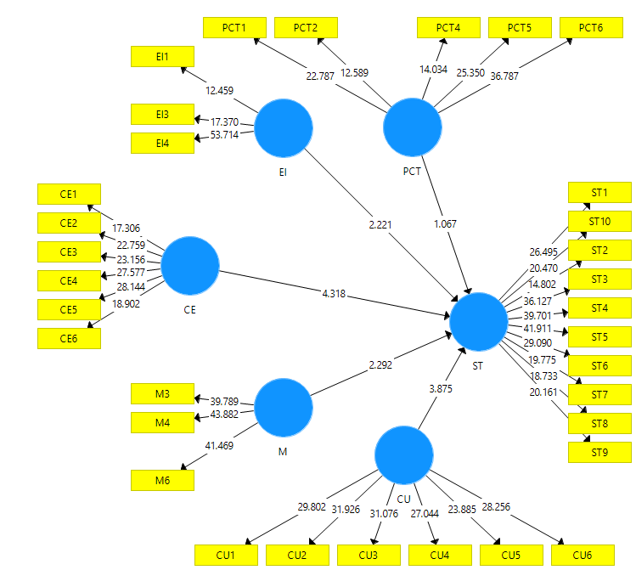

Blindfolding
 | SSO | SSE | Q² (=1-SSE/SSO)
CE | 1200,000 | 1200,000
CU | 1200,000 | 1200,000
EI | 600,000 | 600,000
M | 600,000 | 600,000
PCT | 1000,000 | 1000,000
ST | 2000,000 | 1034,168 | 0,483

Path Coefficient
 | Original Sample (O) | Sample Mean (M) | Standard Deviation (STDEV) | T Statistics (|O/STDEV|) | P Values
CE -> ST | 0,333 | 0,330 | 0,077 | 4,318 | 0,000
CU -> ST | 0,370 | 0,367 | 0,095 | 3,875 | 0,000
EI -> ST | 0,160 | 0,166 | 0,072 | 2,221 | 0,027
M -> ST | 0,170 | 0,172 | 0,074 | 2,292 | 0,022
PCT -> ST | -0,057 | -0,056 | 0,053 | 1,067 | 0,286

