Supplementary Material

Green Synthesis of Primary Nitroalkanes via Oxidation of Small-Molecule Aldoximes Catalyzed by Alkali-Modified TS-1

Yu-Qing Gu · Cong-Xuan Fan · Shi-Feng Xing · Hong-Jun Zhu*

College of Chemistry and Molecular Engineering
Nanjing Tech University, 211816 Nanjing, China

*Corresponding author, e-mail: zhuhj@njtech.edu.cn

1. Catalyst synthesis and characterization 2
2. Preparation of propionaldehyde oxime 5
3. Gas chromatography internal standard method 6
4. Comparison of molecular radius of acetoxime and propionaldehyde oxime 9
5. Verification of reaction mechanism 10

Catalyst synthesis and characterization
To identify the crystalline phase of the TS 1 samples, X ray diffraction (XRD) patterns were recorded on a Bruker D8 ADVANCE diffractometer equipped with Cu-Kα radiation. The morphological features of the catalysts were observed using scanning electron microscopy (SEM, Hitachi Regulus 8100). Transmission electron microscopy (TEM) images were acquired on a FEI Talos F200X G2 instrument. Textural properties including specific surface area and pore structure were analyzed by a Micromeritics ASAP 2460 analyzer. Elemental compositions were determined using a PE NexION 1000G inductively coupled plasma optical emission spectrometer (ICP OES). Fourier transform infrared (FT-IR) spectra were collected on a Thermo Nicolet iS8 spectrometer, while UV-vis diffuse reflectance spectra were measured on a PerkinElmer Lambda 1050+ 2D spectrophotometer.
A certain concentration of alkaline solution was mixed with TS-1 and stirred at 323 K for 4 h. Subsequently, the mixture was sealed and kept at 443 K for 24 h in a 50 mL Teflon-lined autoclave. Following natural cooling to room temperature, the modified sample was rinsed with demineralised water until neutral, dried at 373 K for 12 h, and finally calcined at 823 K for 5 h. The catalyst was named TS-1-x-n (x is the abbreviation for the name of the alkali used, n is the concentration of alkali used (mol/L)) (Table. 1S).
Table 1S Name of study samples
Fig. 1S X-ray diffraction patterns of the different alkali-modified TS-1
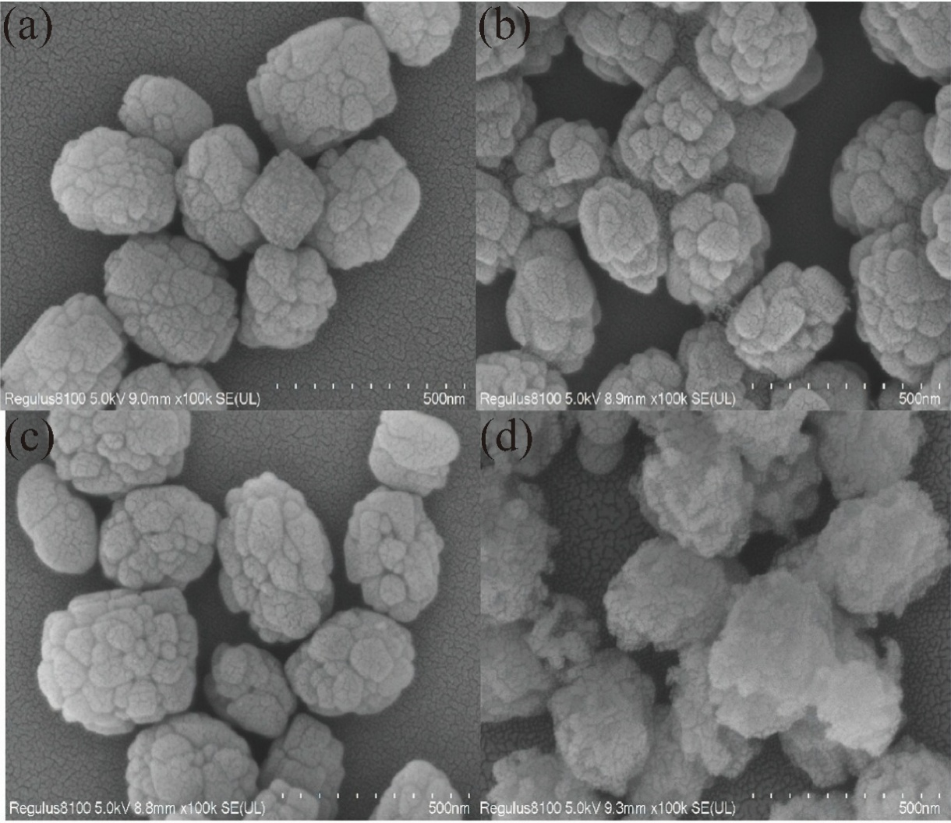
Fig. 2S SEM images of catalyst samples: (A) TS-1, (B) TS-1-EA-0.1, (C) TS-1-TPAOH-0.1, (D)TS-1-Na-0.1

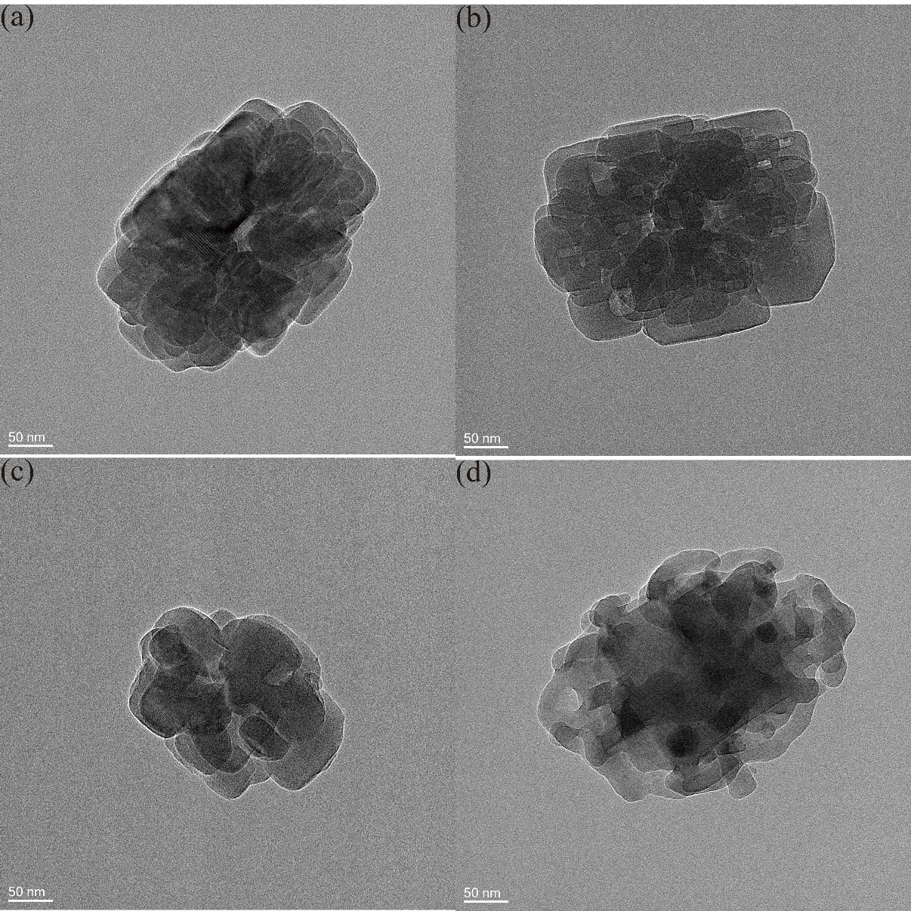
Fig. 3S TEM images of catalyst samples: (A) TS-1, (B) TS-1-EA-0.1, (C) TS-1-TPAOH-0.1, (D) TS-1-Na-0.1

2. Preparation of propionaldehyde oxime
An oven-dried flask was charged with propionaldehyde oxime (0.1 mol), hydroxylamine hydrochloride (8.3 g, 0.12 mol), NaHCO₃ (15 g, 0.18 mol) and then the mixture was heated at 42 °C for 8 h. The mixture was filtered with diethyl ether (3 × 50 mL). The filtrate was washed with saturated sodium bisulfite (3 × 50 mL) and the combined organic layer was dried with anhydrous sodium sulfate. The combined organic layer was concentrated in vacuum to give the propionaldehyde oxime.
¹H NMR was recorded at 400 MHz spectrometer using CDCl₃ as solvent. The following abbreviations are used to describe peak patterns where appropriate: br =broad, s =singlet, d = doublet, t = triplet, q = quartet, m = multiplet. Coupling constants are reported in hertz (Hz). Chemical shifts are reported in ppm relative to the internal standard tetramethylsilane (δ = 0ppm) for ¹H NMR.
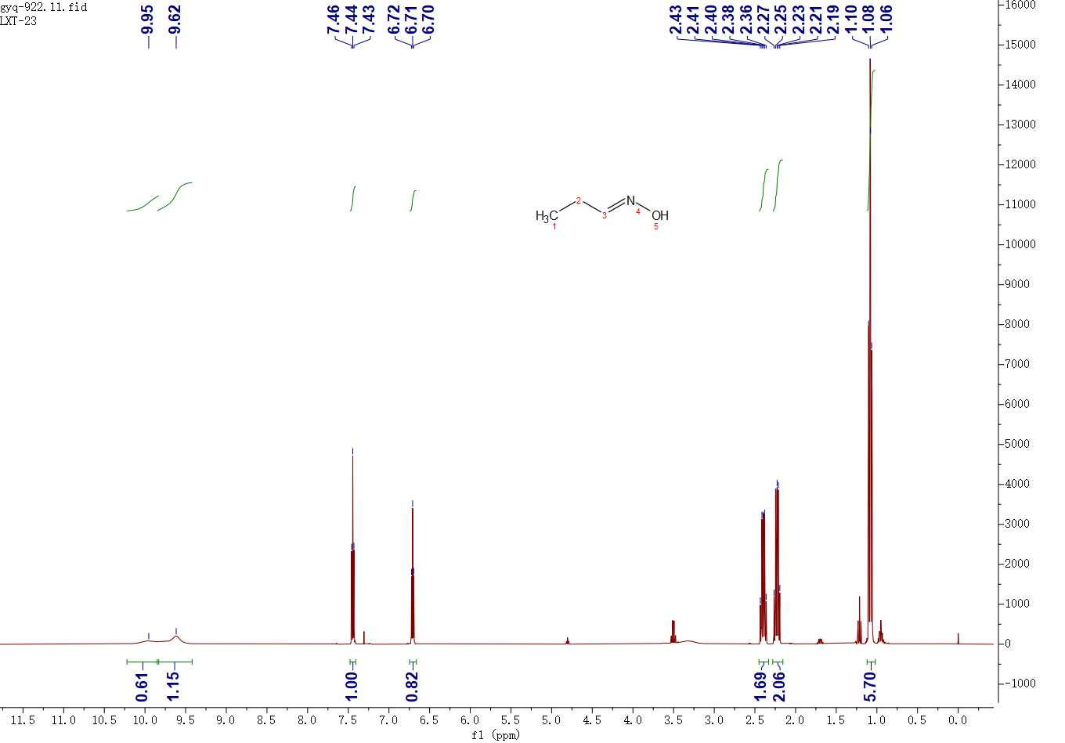
¹H NMR (400 MHz, Chloroform-d) δ 9.93 (s, 1H), 9.59 (s, 1H), 7.42 (t, J = 5.8 Hz, 1H), 6.69 (t, J = 5.4 Hz, 1H), 2.43 – 2.31 (m, 2H), 2.26 – 2.13 (m, 2H), 1.10 – 1.00 (m, 6H).
Fig. 4S ¹H NMR spectrum of propionaldehyde oxime

3. Gas chromatography internal standard method
Preparation of standard mixed reserve solution and internal standard solution: take a certain amount of 1-nitropropane and propionic acid respectively, and accurately record the precise mass of each sample. Dissolve 1-nitropropane and propionic acid with ethyl acetate, and use a volumetric flask to volume to 50mL, that is to get the mixed reserve solution. Weigh a certain amount of dodecane, accurately record its mass, then dissolve with ethyl acetate and fixed volume in a 50 mL volumetric flask to get the internal standard solution. Preparation of series standard mixture: accurately pipette different gradient volume of standard solution,respectively, add containing the same volume of internal standard solution and ethyl acetate to the same volume. The prepared series of standard mixtures were detected on a FL 9790 Plus gas chromatograph, and the standard curve was plotted with the mass ratio of the target substance in the standard compounds to the internal standard as the horizontal coordinate, and the peak area ratio of the standard substance to the internal standard as the vertical coordinate, and linearly fitted. Finally, the linear equations shown in the table were obtained. The reciprocal of the slope of the linear equation is the correction factor (f_{is}).
$$f_{is}=\frac{m_{i}∕A_{i}}{m_{s}∕A_{s}}$$
m_{i}: mass of the target substance;
m_{s}: mass of the internal standard s;
A_{s}: peak area of the internal standard s;
A_{i}: peak area of the corresponding substance in the reaction solution;
Determination of sample content in the reaction mixture: after each reaction, the reaction mixture was centrifuged at 9000 rpm for 2 minutes. The solid was isolated from the reaction mixture. Subsequently, the entire supernatant was taken, and an equal amount of internal standard was added. The mixture was diluted tosame volume with ethyl acetate. Finally, the analysis was performed using an FL 9790 Plus gas chromatograph, and the retention time and peak area were recorded. The formula for calculating the sample content is:
$$w_{i}=\frac{m_{s}A_{i}f_{is}}{mA_{s}}×100\%$$
W_{i}: sample i mass content in the reaction solution;
m: theoretical mass of the sample i in the reaction solution;
m_{s}: mass of internal standard s;
A_{s}: peak area of the internal standard s;
A_{i}: peak area of the corresponding substance i in the reaction solution;
f_{is}: the correction factor is the reciprocal of the slope.
The obtained products were monitored by gas chromatography (FL 9790 plus) equipped with a flame ionization detector (FID) and an MXD-WAX capillary column (30 m × 0.32 mm × 0.5 μm). The yield of 1-nitropropane (Y_{1-np}) and propionic acid (Y_{pa}) were calculated by the internal standard method. The yield of 1-nitropropane (Y_{1-np}) and propionic acid (Y_{pa}) and selectivity of 1-nitropropane (S) were calculated as follows:
- $Y_{1-np}=\frac{n_{1-np'}}{n_{1-np}}×100\%$
- $Y_{pa}=\frac{n_{pa'}}{n_{pa}}×100\%$
- $S=\frac{n_{1-np}}{n_{1-np}+n_{pa}}×100\%$
Y_{1-np} and Y_{pa} are the yield of 1-nitropropane and propionic acid, respectively. S denoted 1-nitropropane selectivity. n_{1-np'} and n_{pa'} (the actual number of moles of 1-nitropropane and propionic acid produced) were calculatedby the internal standard method. n_{1-np} and n_{pa} are the theoretical moles of 1-nitropropane and propionic acid produced, respectively.

Fig. 5S (A) Internal standard calibration curve for nitropropane in gas-phase analysis, (B) internal standard calibration curve for propionic acid in gas-phase analysis

4. Comparison of molecular radius of acetoxime and propionaldehyde oxime
The structures of acetoxime and propionaldehyde oxime were individually optimized by energy minimization using Chem3D. Subsequently, the optimized structures of acetoxime and propionaldehyde oxime were separately imported into Multiwfn to calculate their molecular size. Finally, the molecular structures of acetoxime and propionaldehyde oxime were visualized using VMD (Yoo et al. 2023; Lu et al. 2024).
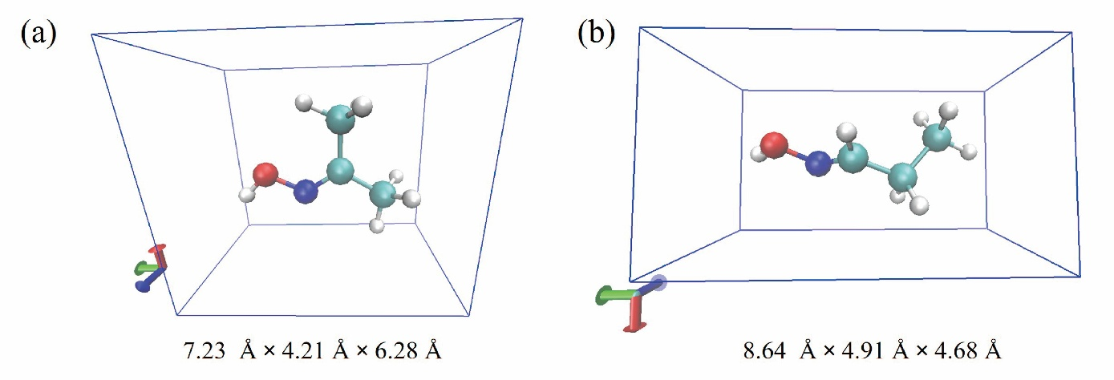
Fig. 6S Comparison of molecular radius of acetone and propionaldehyde oxime: (A) acetoxime, (B) propionaldehyde oxime

5. Verification of reaction mechanism
The catalyst TS-1-EA-0.1 was recovered after catalyzing the oxidative synthesis of 1-nitropropane from propionaldehyde oxime. The recovered TS‑1‑EA‑0.1 was calcined at 623 K for 2 h in air. TS-1-EA-0.1 and the used TS-1-EA-0.1 were characterized by UV-vis, respectively (Lin et al. 2025)

Fig. 7S UV-vis spectra of the used TS-1-EA-0.1(using TS-1 as the reference sample)

Reference

Lu T (2024) A comprehensive electron wavefunction analysis toolbox for chemists, Multiwfn. J Chem Phys 161: 082503. https://doi.org/10.1063/5.0216272
Yoo SH, Lee SC, Jang HY, Kim SB (2023) Characterization of ibuprofen removal by calcined spherical hydrochar through adsorption experiments, molecular modeling, and artificial neural network predictions. Chemosphere 311: 137074. https://doi.org/10.1016/j.chemosphere.2022.137074
Lin D, Zheng X, Zong Z, Xu Y, He Q, Ma Z, Chen D, Yang C, Feng X (2025) Confined water accelerated alkene epoxidation inside channels of Ti-beta zeolite. AlChE J 71: e18726. https://doi.org/10.1002/aic.18726

