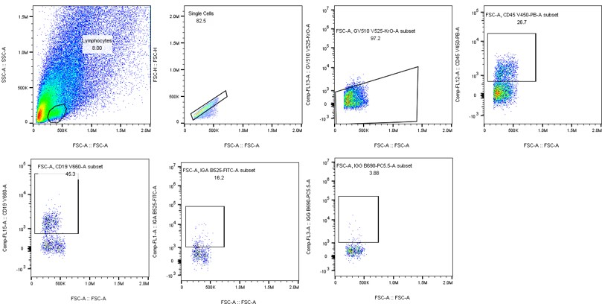
Supplementary Figure 1. The Gating Strategy for Flow Cytometry of IgG and IgA Positive Cells in DSS-induced Mouse Acute Colitis Tissue. Sequential gating on lymphocytes → single cells → live cells → CD45+ leukocytes → CD19+ B cells → IgA+ or IgG+ cells.

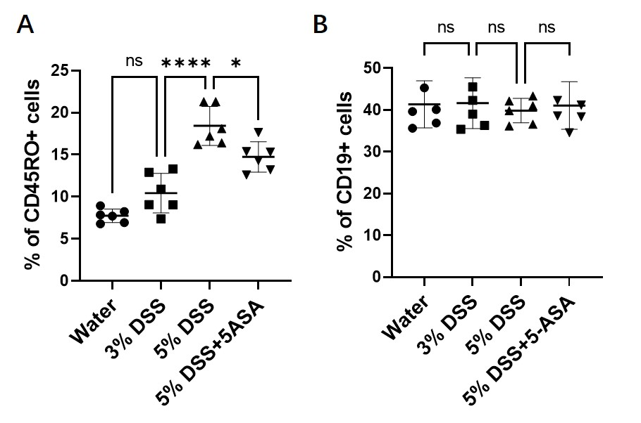
Supplementary Figure 2. CD19+ B cell proportions among lamina propria lymphocytes remain stable across DSS treatment groups. (A) Quantification showing the proportion of CD45+ cells significantly increased in the 5% DSS-induced group, but decreased after treatment with 5-ASA. n = 6 per group. (B) Quantification showing that CD19+ cells had no significant differences among groups. n = 6 per group. Data presented as mean ± SD. *P < 0.05, ****P < 0.0001, ns, not significant by one-way ANOVA with Tukey's post-hoc test.
Supplementary Table 1 Clinicopathological features of UC patients.
Case | Sex/age  (years) | Duration  (months) | 5-ASA treatment | Inflammation Phase  in rectum tissue
1 | M/34 | 6 | No | Active
2 | M/36 | 7 | No | Active
3 | M/28 | 5 | No | Active
4 | M/43 | 12 | No | Active
5 | F/42 | 6 | No | Active
6 | M/38 | 7 | No | Active
7 | M/32 | 4 | No | Chronic
8 | M/43 | 3 | No | Chronic
9 | M/42 | 7 | No | Chronic
10 | M/46 | 6 | No | Chronic
11 | M/32 | 6 | No | Chronic
12 | F/42 | 7 | No | Chronic
13 | F/42 | 37 | Yes | Remission
14 | M/56 | 43 | Yes | Remission
15 | F/45 | 56 | Yes | Remission
16 | M/39 | 38 | Yes | Remission
17 | M/44 | 68 | Yes | Remission
18 | M/53 | 32 | Yes | Remission

