Supplementary Information

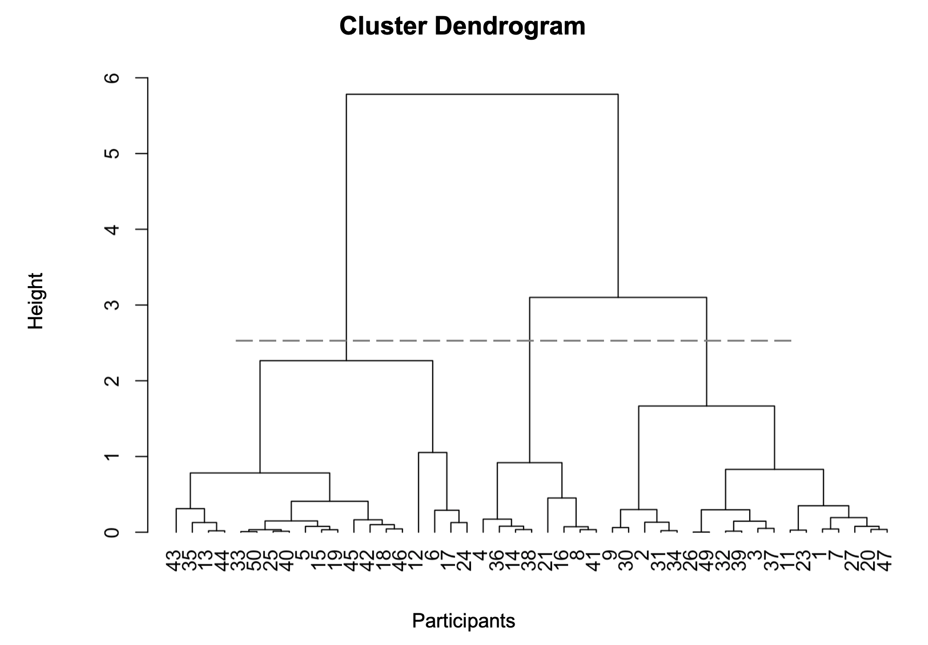
Supplementary Figure 1. Cluster dendrogram illustrating the results of the hierarchical clustering analysis. Dashed line indicates the threshold for three clusters.

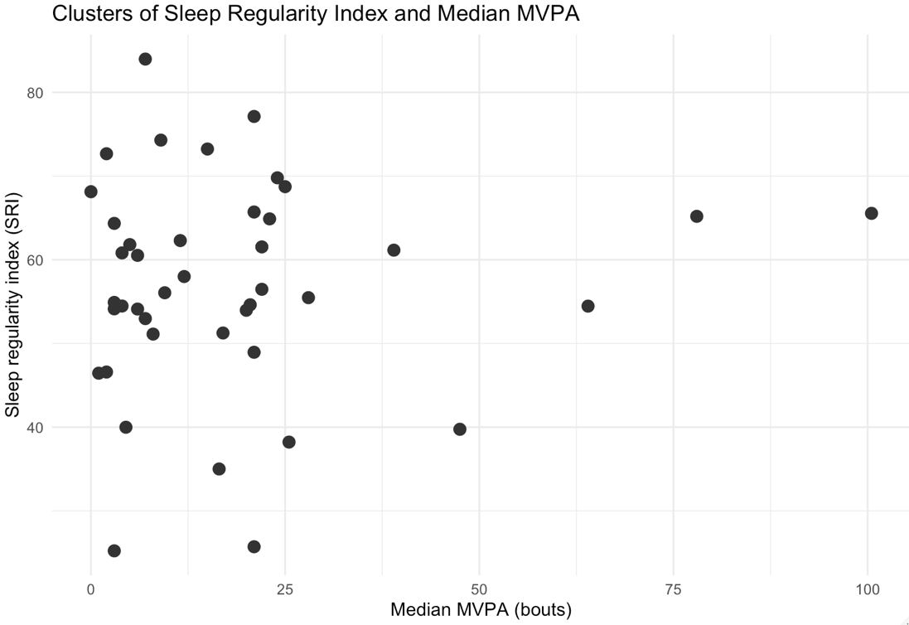

Supplementary Figure 2. Shows the cluster analysis of MVPA compared to SB.
MVPA: moderate to vigorous physical activity in bouts

