Histopathological findings (Slides)
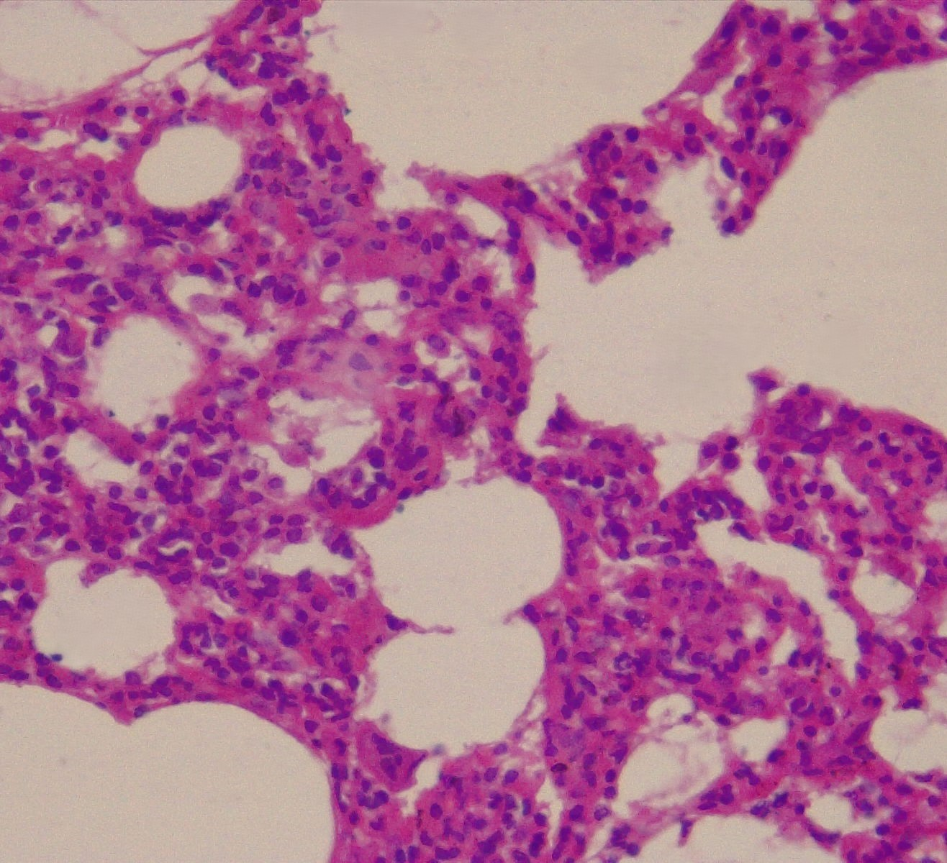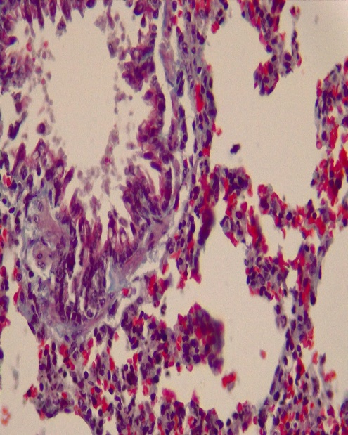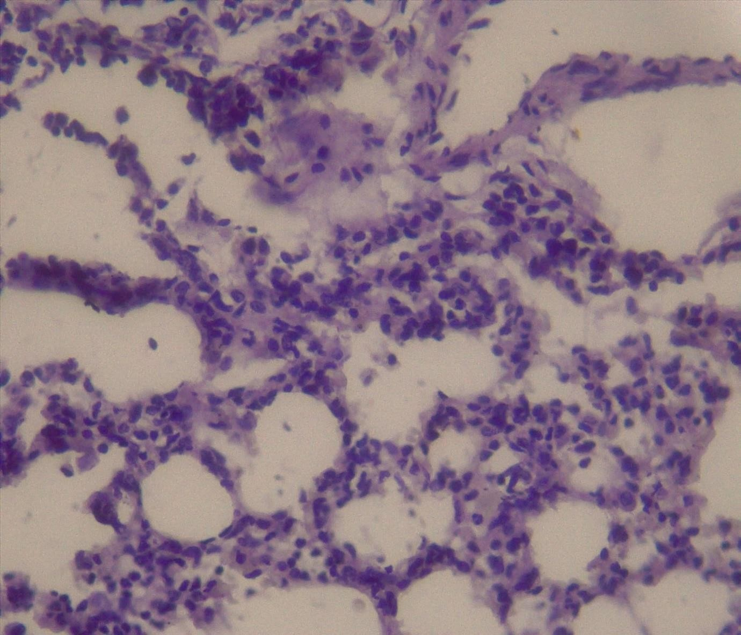
Plates 1,2, 3- Control group X400 slides stained with H&E, Masson trichome and PAS
Sections of the lung shows a normal lung tissue stain (yellow arrow=alveolus, blue arrow=bronchiole, red arrow= alveoli ducts) that are separated by the interstitium.

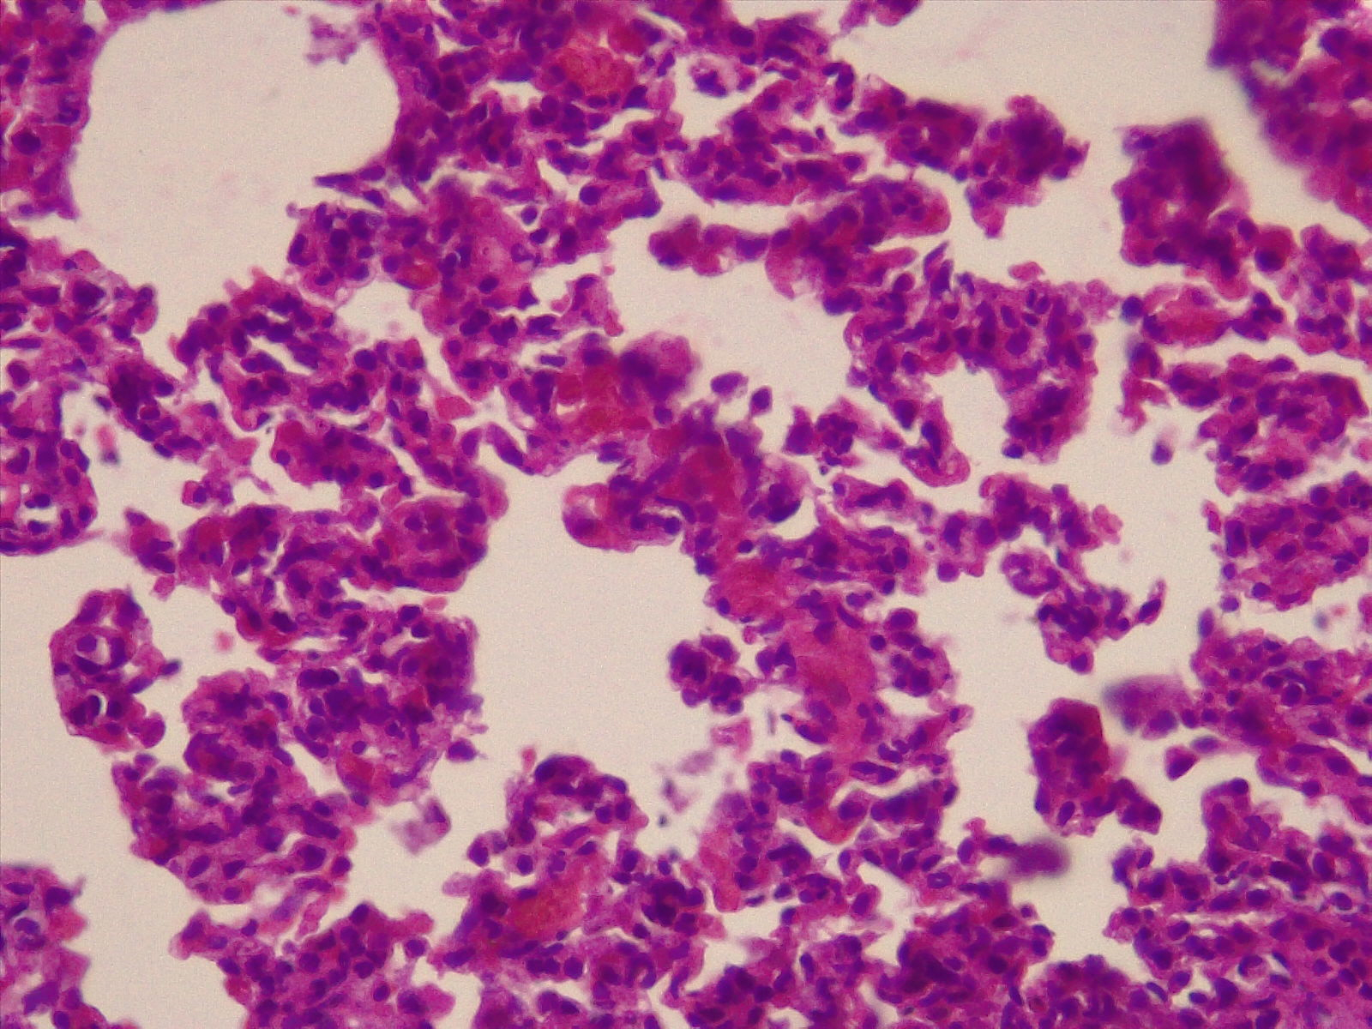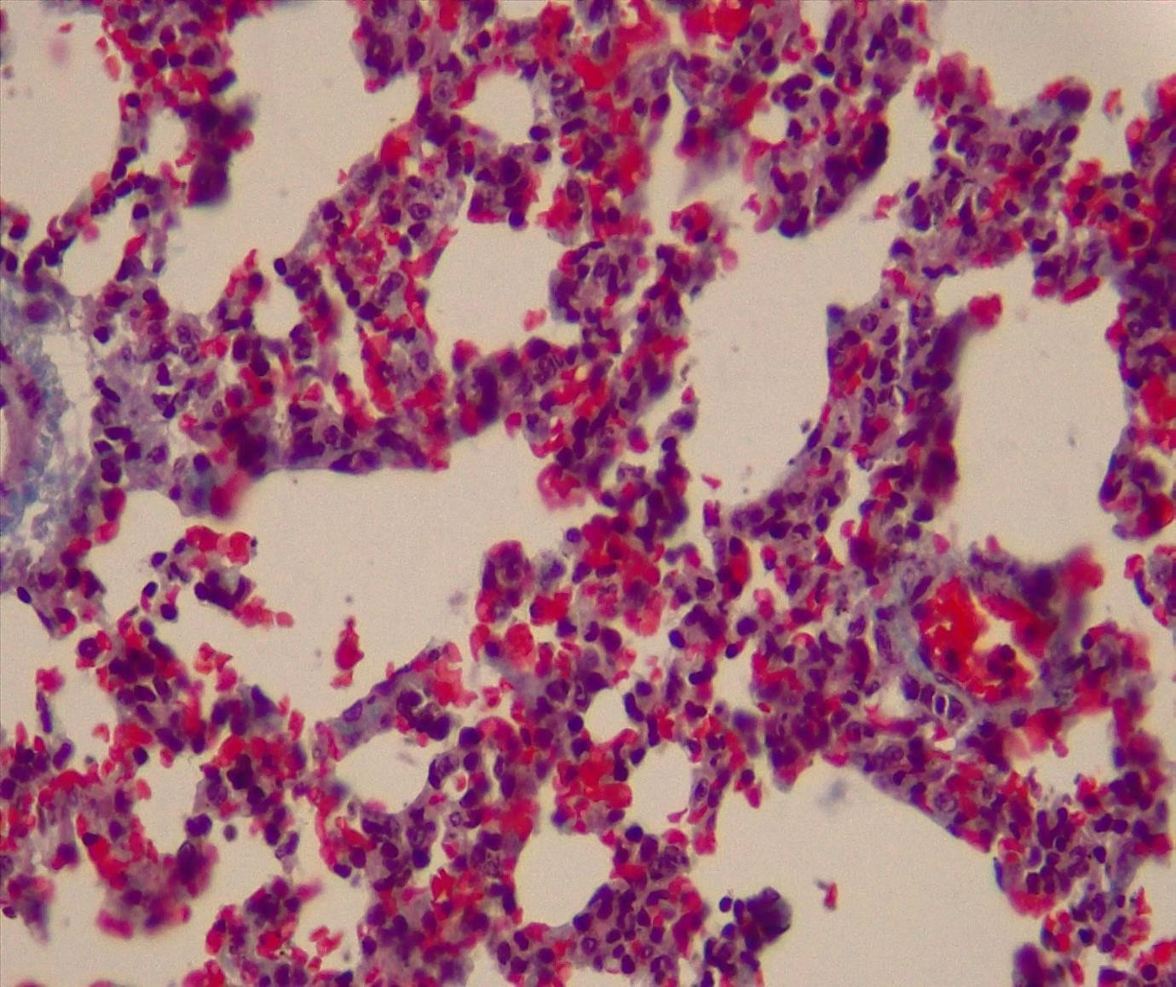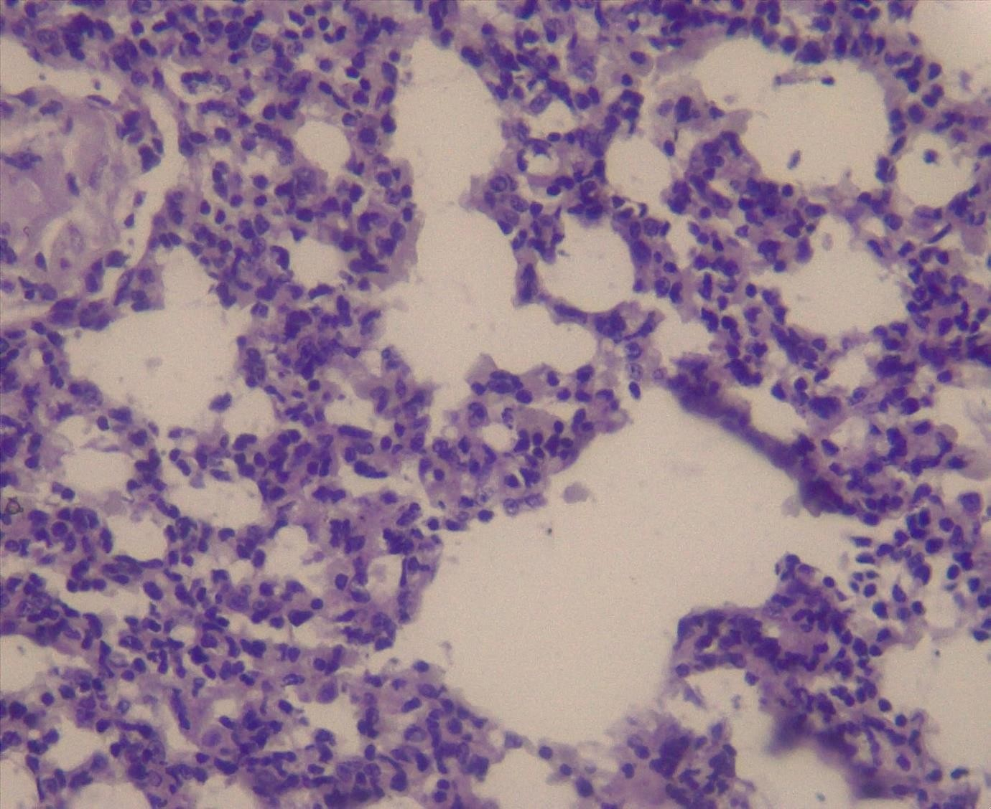

Plates 4,5,6 – Group B (3hrs exposure) X400 slides stained with H&E, Masson trichome and PAS: Sections of the lung shows normal lung tissue stains (yellow arrow=alveolus, black arrow= blood vessel, blue arrow= alveoli sac) that are separated by the interstitium.

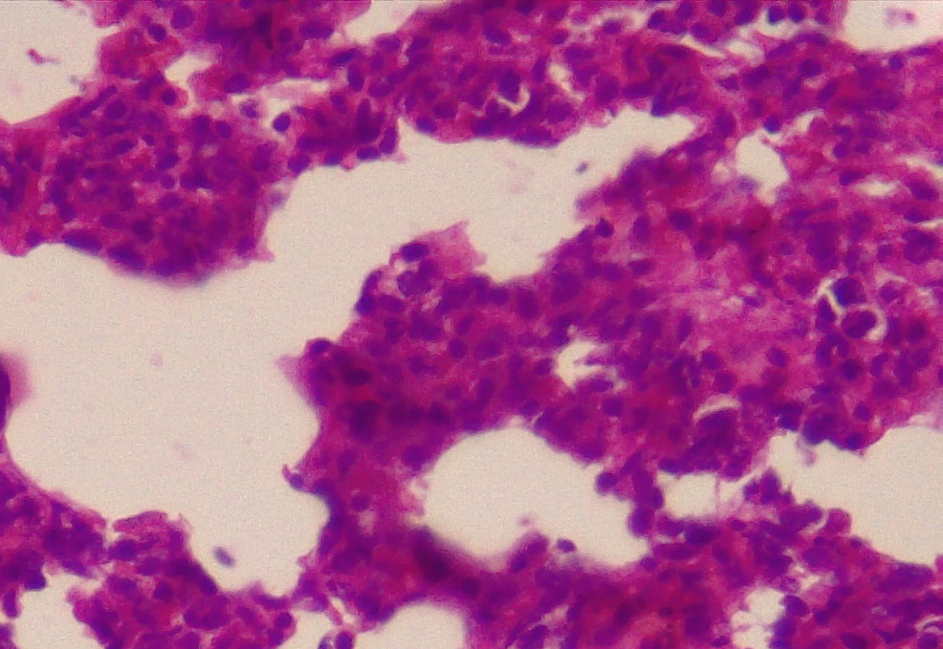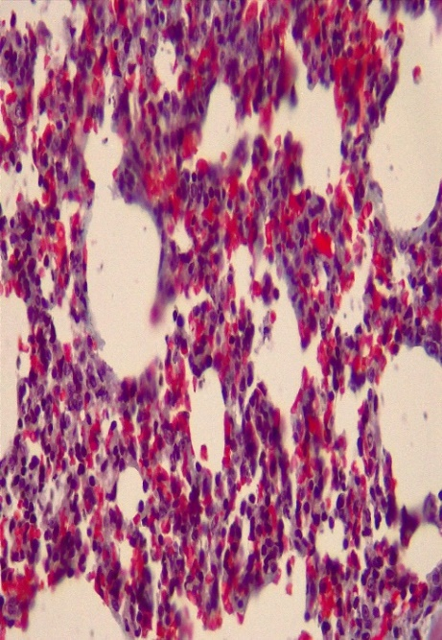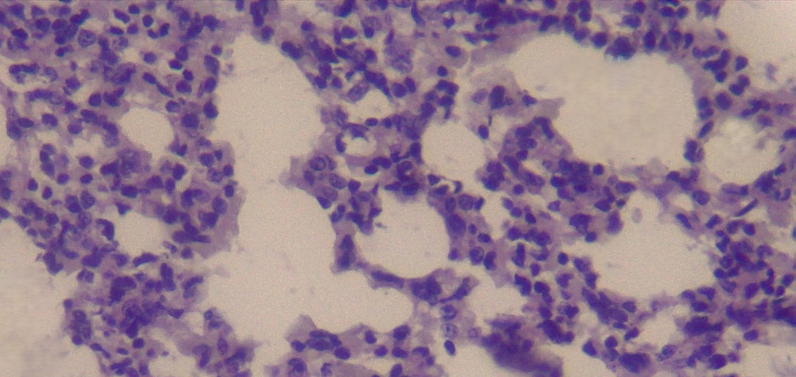
Plates 7,8 9 – Group C (5hrs exposure) X400 slides stained with H&E, Masson trichome and PAS: Sections of the lung shows normal lung tissue stains (red & blue arrow=alveoli duct) that are separated by the interstitium.

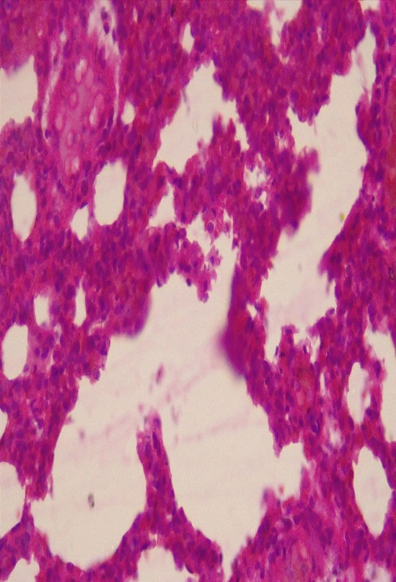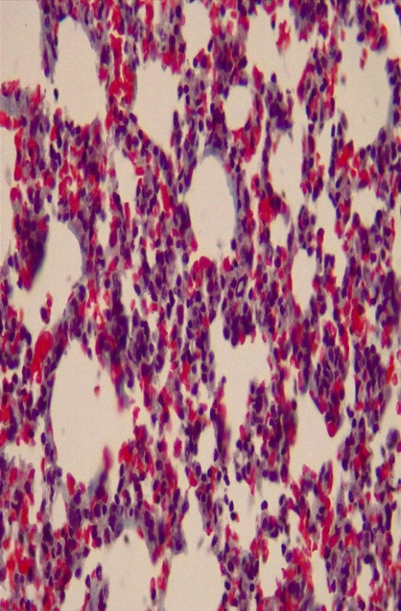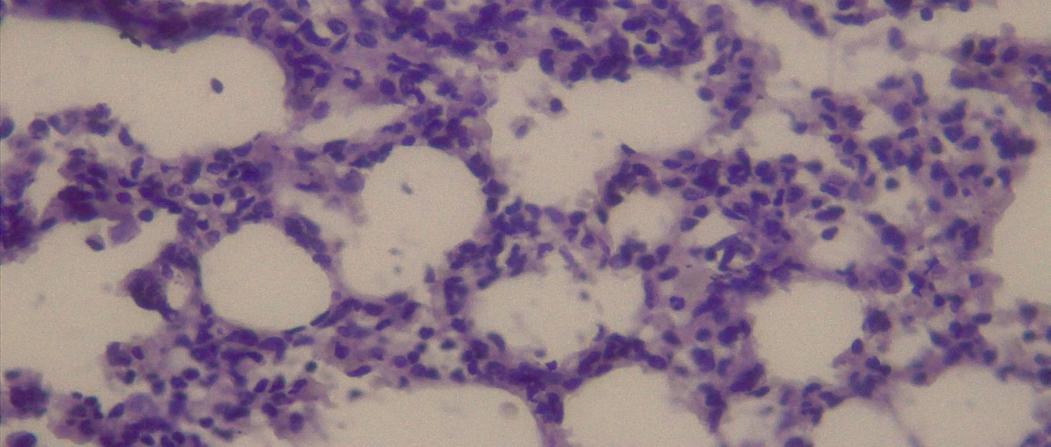

Plates 10,11, 12 – Group D (7hrs exposure) X400 slides stained with H&E, Masson trichrome and PAS: Sections of the lung shows normal lung tissue stains (black arrow= inflammatory infiltrate, blue arrow= alveolus and yellow arrow = alveoli duct) that are separated by the interstitium with increased pneumocytes activities

