Characterizing spatiotemporal infestation cluster dynamics of two-spotted spider mite in sweet pepper screenhouses: implications for precision monitoring
Roni Gafni ^{a, b *}, Yael Edan ^{c}, Liran Shmuel ^{d}, Dana Levanon ^{c}, Svetlana Dobrinin ^{e} and Yafit Cohen ^{d}
a Tel-Hai Academic College, Upper Galilee, Israel
b Northern Agricultural R&D, MIGAL - Galilee Research Institute, Kiryat Shemona, Israel
c Department of Industrial Engineering and Manufacturing, Ben Gurion University of the Negev, Beer Sheva, Israel
d Institute of Agricultural and Biosystems Engineering, Agricultural Research Organization - Volcani Institute, Rishon Lezion, Israel
e Agriculture Extension Service, Ministry of Agriculture and Rural Development, Bet Dagan, Israel
* Corresponding author. Tel.: +972 58323126
E-mail address: roni.ga@migal.org.il (R. Gafni)

Supplementary Material

Table S1. Summary statistics of slope values describing the rate of directional spread of the two-spotted spider mite (Tetranychus urticae, TSSM) infestation clusters. Mean and standard deviation (SD) of slope values are presented for each temporal phase, direction and movement category. Clusters were categorized as advancing (|slope| > 0.1) or static (|slope| ≤ 0.1). Clusters with insufficient consecutive observations were categorized as 'single observation' and excluded from the slope analysis.
Temporal  phase | Direction | Movement category | n  clusters | Mean  slope | SD  slope
Initial | -- | Singe observation | 17 | -- | --
Initial | north | advancing | 10 | -0.387 | 0.328
Initial | north | static | 13 | 0.005 | 0.018
Initial | south | advancing | 18 | -0.333 | 0.202
Initial | south | static | 5 | 0.001 | 0.053
Initial | east | advancing | 4 | -0.259 | 0.067
Initial | east | static | 19 | -0.022 | 0.044
Initial | west | advancing | 2 | -0.330 | 0.036
Initial | west | static | 21 | -0.023 | 0.036
Rising | -- | Singe observation | 39 | -- | --
Rising | north | advancing | 11 | -0.484 | 0.788
Rising | north | static | 30 | -0.002 | 0.011
Rising | south | advancing | 21 | -0.393 | 0.965
Rising | south | static | 20 | -0.007 | 0.022
Rising | east | advancing | 16 | -0.266 | 0.388
Rising | east | static | 25 | -0.006 | 0.019
Rising | west | advancing | 17 | -0.497 | 0.862
Rising | west | static | 24 | -0.001 | 0.031
Decline | -- | Singe observation | 21 | -- | --
Decline | north | advancing | 24 | 0.427 | 0.757
Decline | north | static | 27 | 0.002 | 0.008
Decline | south | advancing | 22 | 0.420 | 0.856
Decline | south | static | 29 | 0.005 | 0.020
Decline | east | advancing | 19 | 0.066 | 0.217
Decline | east | static | 32 | 0.021 | 0.040
Decline | west | advancing | 21 | 0.270 | 0.153
Decline | west | static | 30 | 0.017 | 0.045

Table S2. Average Nearest Neighbor (ANN) index values for each sampling event in each screenhouse across the 2015 and 2016 growing seasons. Values represent the ratio between observed and expected mean nearest-neighbor distances under complete spatial randomness; p-values (in parentheses) indicate the statistical significance of deviation from randomness. ANN values lower than 1 denote aggregated spatial patterns.
Screenhouse |  |  |  | Sampling date | Growing season
M_12 | M_7 | M_11 | M_4 | Sampling date | Growing season
 |  | 0.0469 (<2.2e-16) | 0.0297 (0.0013) | 09 Sep | 2015
 |  | 0.088 (<2.2e-16) | 0.069 (<2.2e-16) | 16 Sep | 2015
 |  | 0.144 (<2.2e-16) | 0.217 (<2.2e-16) | 07 Oct | 2015
 |  | 0.174 (<2.2e-16) | 0.414 (<2.2e-16) | 21 Oct | 2015
 |  | 0.3 (<2.2e-16) | 0.569 (<2.2e-16) | 28 Oct | 2015
 |  | 0.298 (<2.2e-16) | 0.926 (<2.2e-16) | 04 Nov | 2015
 |  | 0.3 (<2.2e-16) | 0.663 (<2.2e-16) | 11 Nov | 2015
 |  | 0.284 (<2.2e-16) | 0.632 (<2.2e-16) | 18 Nov | 2015
 |  | 0.244 (<2.2e-16) | 0.717 (<2.2e-16) | 25 Nov | 2015
 |  | 0.178 (<2.2e-16) | 0.512 (<2.2e-16) | 02 Dec | 2015
 |  | 0.16 (<2.2e-16) | 0.366 (<2.2e-16) | 09 Dec | 2015
 |  | 0.082 (<2.2e-16) | 0.155 (<2.2e-16) | 16 Dec | 2015
 |  | 0.0653 (<2.2e-16) | 0.087 (<2.2e-16) | 23 Dec | 2015
0.25 (<2.2e-16) | 0.16 (<2.2e-16) | 0.0721 (<2.2e-16) |  | 4 Aug | 2016
0.0017 (0.0002) | 0.052 (<2.2e-16) | 0.012 (<2.2e-16) |  | 22 Aug | 2016
0.025 (<2.2e-16) | 0.106 (<2.2e-16) | 0.0268 (<2.2e-16) |  | 31 Aug | 2016
0.037 (<2.2e-16) | 0.146 (<2.2e-16) | 0.037 (<2.2e-16) |  | 04 Sep | 2016
0.048 (<2.2e-16) | 0.1945 (<2.2e-16) | 0.052 (<2.2e-16) |  | 11 Sep | 2016
0.072 (<2.2e-16) | 0.382 (<2.2e-16) | 0.079 (<2.2e-16) |  | 20 Sep | 2016
0.077 (<2.2e-16) | 0.464 (<2.2e-16) | 0.086 (<2.2e-16) |  | 26 Sep | 2016
0.059 (<2.2e-16) | 0.675 (<2.2e-16) | 0.085 (<2.2e-16) |  | 06 Oct | 2016
0.061 (<2.2e-16) | 0.689 (<2.2e-16) | 0.084 (<2.2e-16) |  | 09 Oct | 2016
0.137 (<2.2e-16) | 0.906 (<2.2e-16) | 0.168 (<2.2e-16) |  | 25 Oct | 2016
0.317 (<2.2e-16) | 0.791 (<2.2e-16) | 0.317 (<2.2e-16) |  | 31 Oct | 2016
0.257 (<2.2e-16) | 0.669 (<2.2e-16) | 0.249 (<2.2e-16) |  | 07 Nov | 2016
0.136 (<2.2e-16) | 0.457 (<2.2e-16) | 0.154 (<2.2e-16) |  | 13 Nov | 2016
0.052 (<2.2e-16) | 0.269 (<2.2e-16) | 0.112 (<2.2e-16) |  | 21 Nov | 2016
0.04 (<2.2e-16) | 0.098 (<2.2e-16) | 0.064 (<2.2e-16) |  | 28 Nov | 2016

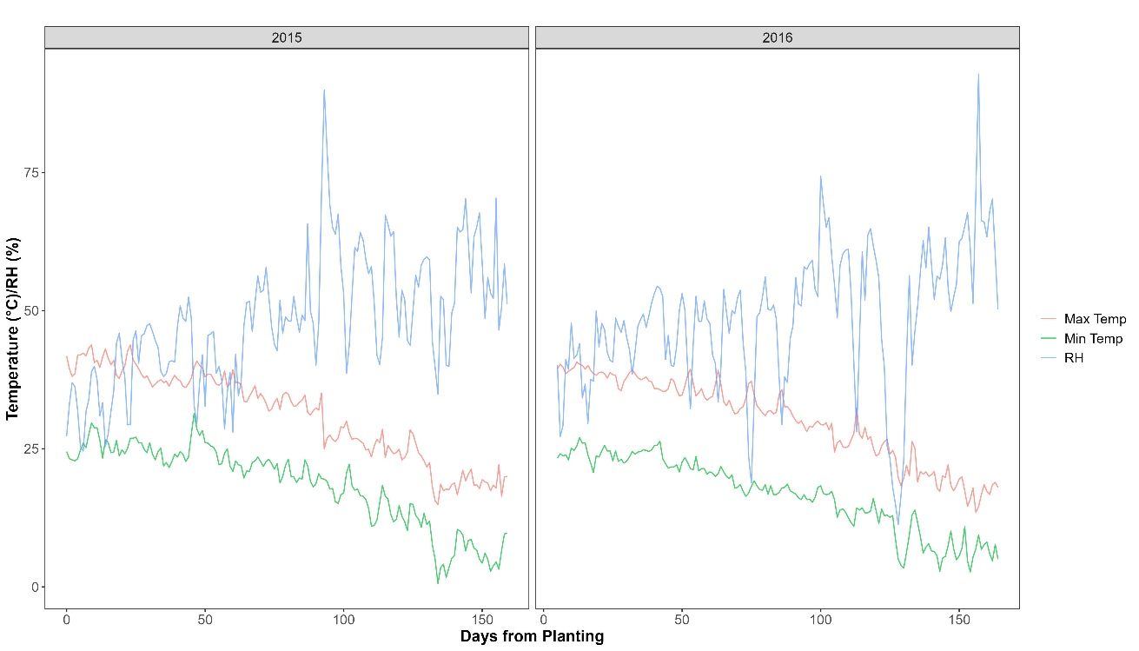
Figure S1. Daily minimum and maximum air temperature (°C) and mean daily relative humidity (RH, %) recorded during the 2015 and 2016 sweet pepper growing seasons. Environmental data were measured at 10-min intervals inside the screenhouses using HOBO U23 Pro v2 data loggers and aggregated to daily values. The x-axis represents days from planting, with planting dates of 25 July and 20 July for the 2015 and 2016 growing seasons, respectively.

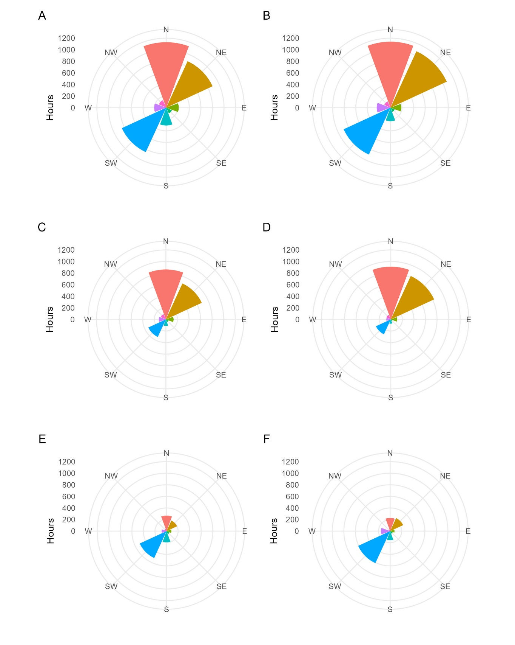
Figure S2. Wind direction frequency (hours) for 2015 (left column) and 2016 (right column). Full time series for the 2015 and 2016 growing seasons (A and B, respectively). Initial and Rising phases - first 100 days of 2015 and 2016 growing season (C and D, respectively), Decline phase - day 101 to end of each measurement period (E and F, respectively). Wind direction indicates the direction from which the wind originated.
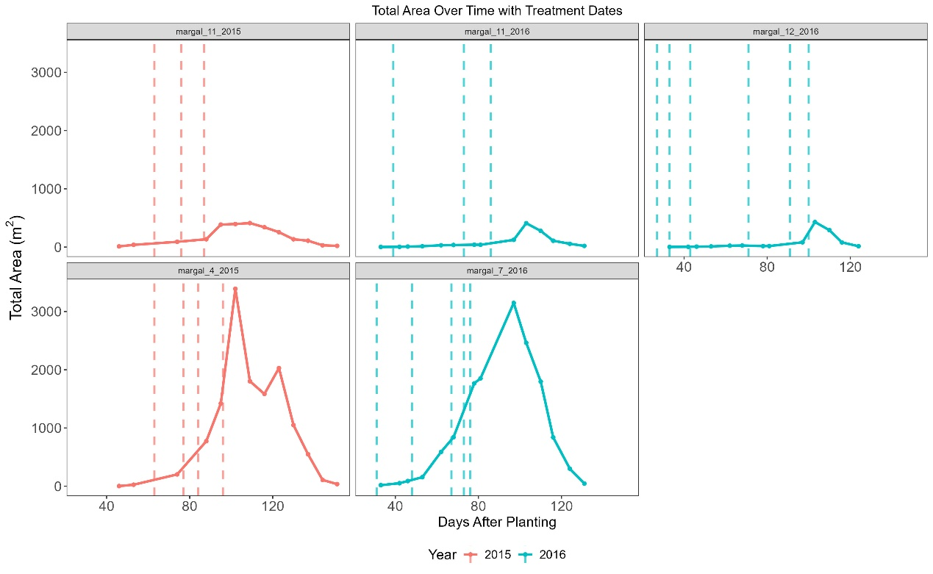
Figure S4. Timing of natural enemy release events in each sampled screenhouse during the 2015 and 2016 growing seasons in relation to TSSM infestation dynamics. Dashed vertical lines indicate dates of natural enemy releases implemented following detection of infestation foci according to the regional scouting protocol. Solid lines represent total TSSM-infested area (m²) over time (days after planting). Colors denote growing season (red – 2015; blue – 2016).

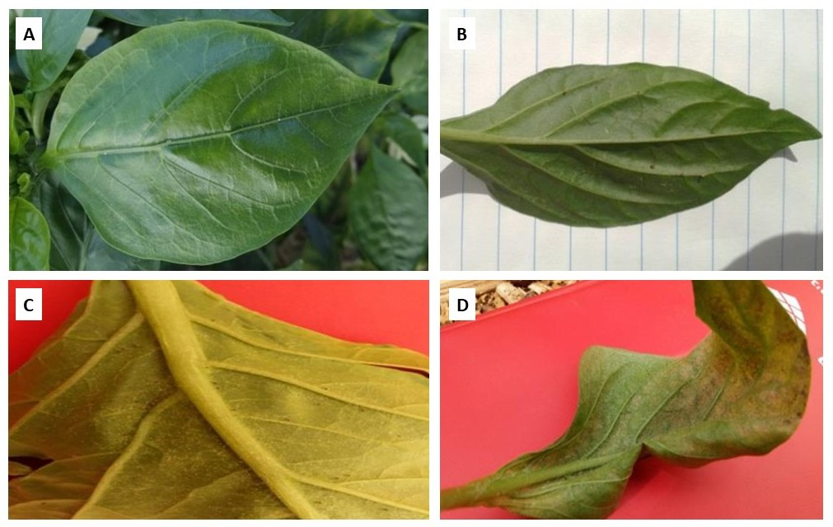
Figure S3. Representative pepper leaves illustrating infestation severity levels of TSSM. Severity levels were determined based on visible leaf damage and extension service guidelines: (A) 0 – no mites (healthy leaf); (B) 1 – <5 mites; (C) 2 – 5–10 mites; and (D) 3 – >10 mites.

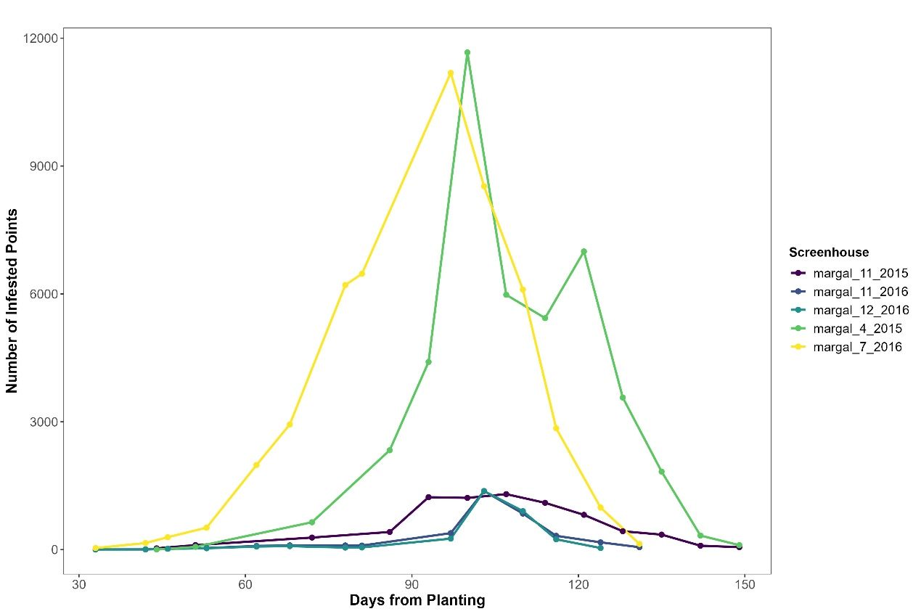
Figure S5. Temporal dynamics of two-spotted spider mite (Tetranychus urticae) infestation in pepper screenhouses during the 2015 and 2016 growing seasons. Each line represents the number of infested sampling points (infestation severity > 0) plotted against days after planting (DAP) for an individual screenhouse.

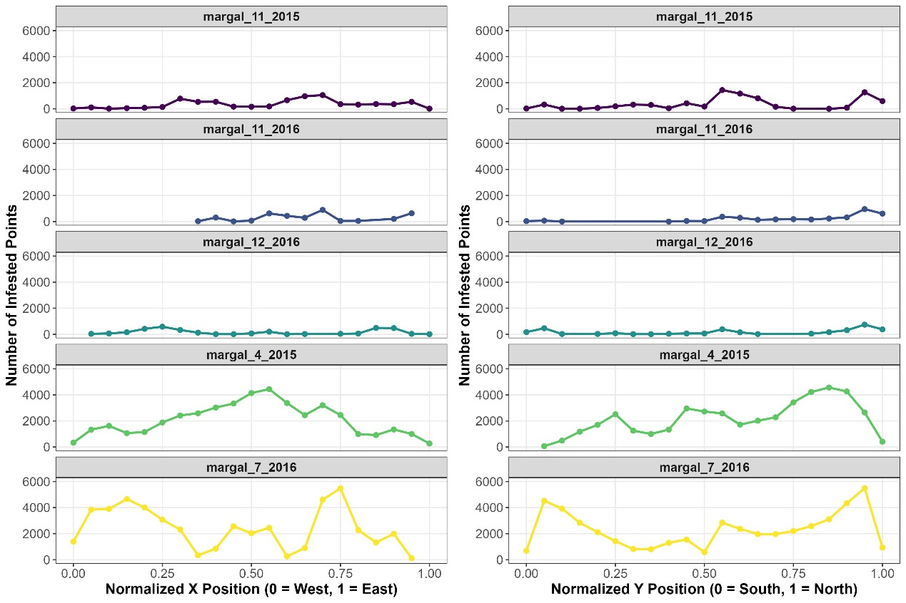
Figure S6. Spatial distribution of infested sampling points within each screenhouse along normalized X (left) and Y (right) coordinates. Coordinates were scaled to a 0–1 range (0 = minimum, 1 = maximum) to enable direct comparison among screenhouses located at different geographical sites.

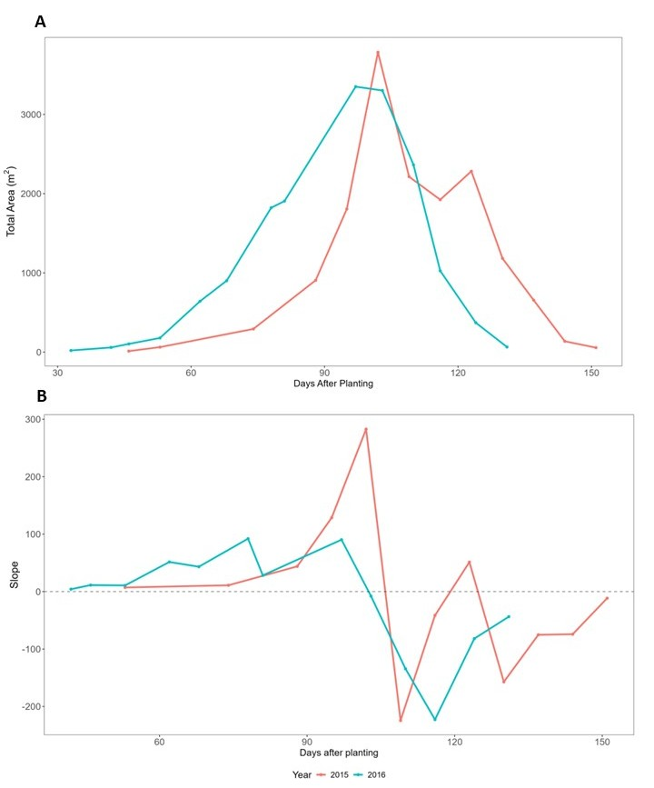
Fig. S7. Temporal dynamics of TSSM infestation aggregated across all sampled screenhouses during the 2015 (red) and 2016 (blue) growing seasons. (A) Total infested area (m²) per day, summed across screenhouses. (B) Daily slope values representing the change in total infested area between consecutive sampling dates. The x-axis represents days after planting.

