Supplementary Figures
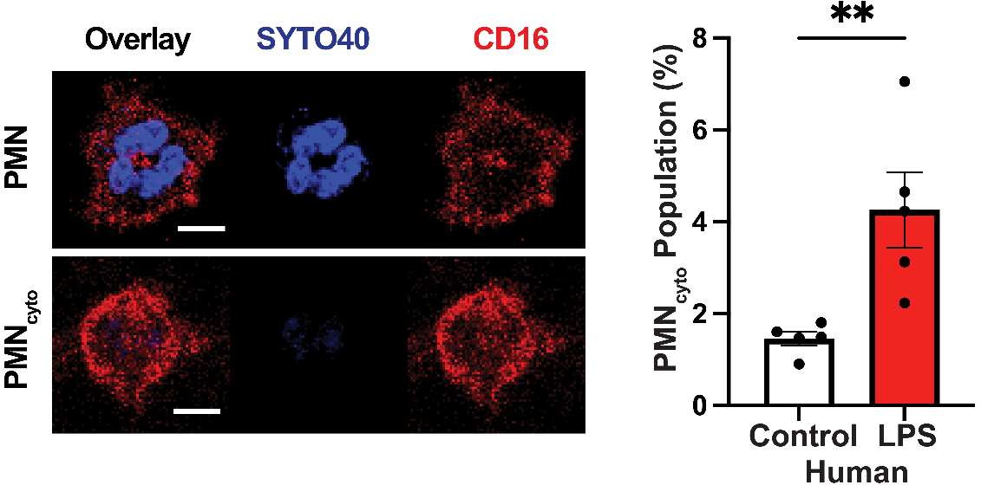

Supplement Figure 1: Evidence for human PMN_{cyto} formation. Human pheripharal blood PMN were challenged with LPS as the same concentrations (100µg/mL) used for mouse PMN experiments (described in Figure 1A,B) 30m. Scale bar 5µm; N = 5; **p<0.01, shown are mean values ± SEM.
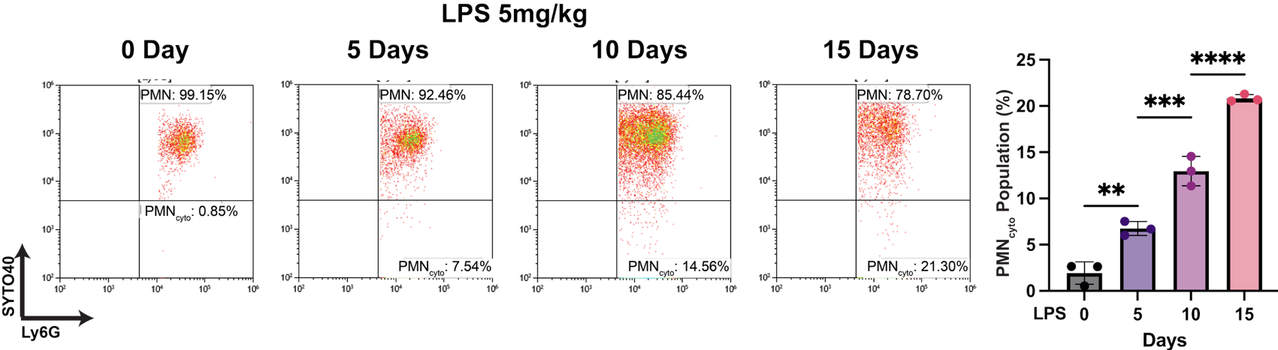

Supplement Figure 2: Time course of PMN_{cyto} generation in lungs after endotoxemia. PMN_{cyto} number was measured after challenging WT mice with LPS (5mg/kg; i.p.) for 0, 5, 10, and 15 days. Post LPS challenge, lungs were harvested, single cell suspensions were prepared, stained with SYTO40 and Ly6G-AF647, and cells were analyzed by flow cytometry. n=3; ns= not significant; *p<0.05; **p<0.01; shown are mean ± SEM.

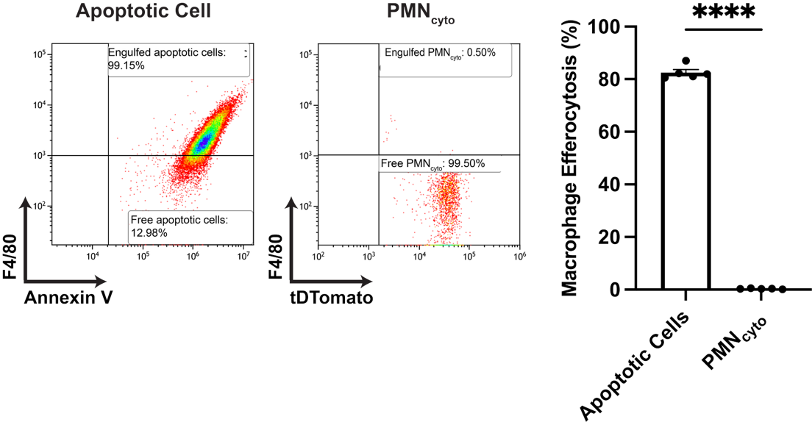

Supplement Figure 3: Macrophages fails to clear PMN_{cyto}. Mouse bone marrow macrophages incubated for 30 min with apoptotic PMN (induced by UV (Nepal et al., 2019)) stained with annexin V (red) or PMN_{cyto} collected from Catchup mice 24h after LPS challenge. Quantitative analysis of macrophage efferocytosis of apoptotic PMN vs. PMN_{cyto} by FACS shows ineffective clearance of PMN_{cyto}. Apoptotic cells stained with Annexin V; PMN_{cyto} (td-Tomato) from Catchup mice; macrophages stained with F4/80. n=5, ****p<0.0001, shown are mean ± SEM.

