Supplemental Figures
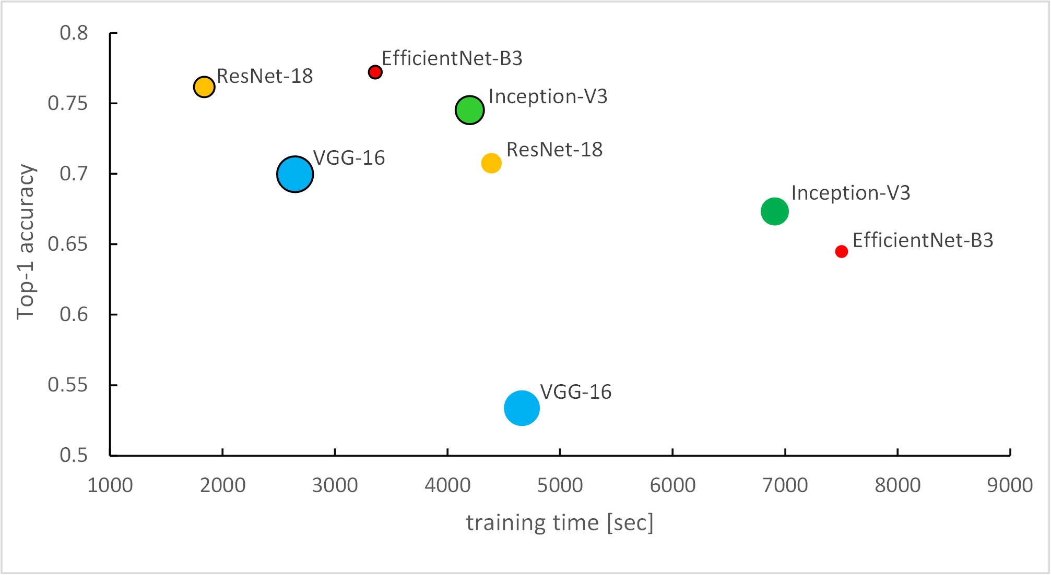
Extended Data Figure 1 | Comparison of 4 deep convolutional neural networks.
We compared the training time, top-1 accuracy, and the number of parameters of 4 convolutional neural networks used for feature extraction from clinical and IHC image modalities. We counted the training time of the first 10 generations of each model to eliminate contingency. In the comparison of the performances of the four models, EfficienNet-B3 had the highest accuracy and the least number of parameters for the IHC image modality (represented by the dots surrounded by black). For clinical images, we chose the ResNet-18 model as the backbone of the network, which makes the network more portable and less prone to overfitting.

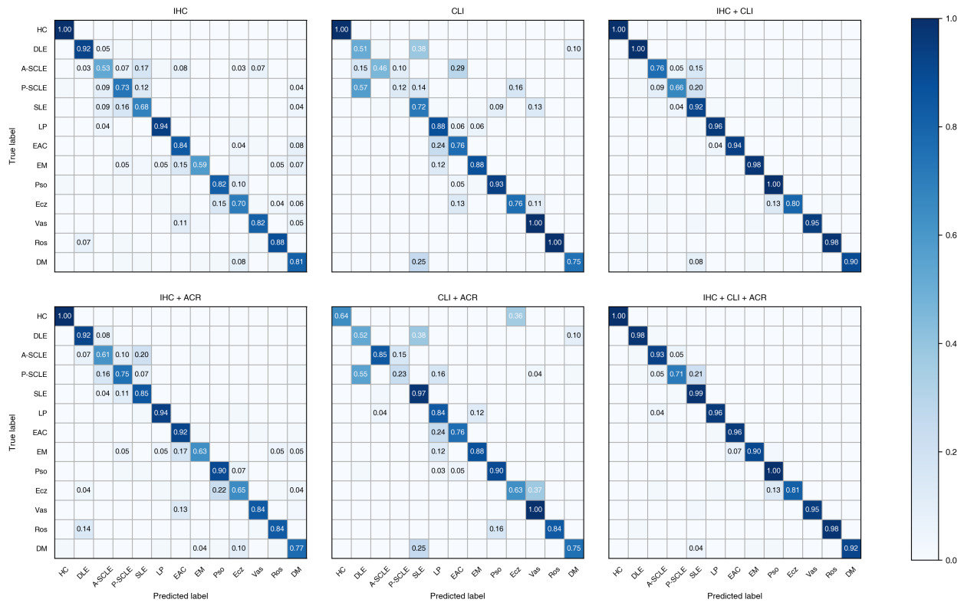
Extended Data Figure 2 | Confusion matrix of different combinations of models for 13 classifications

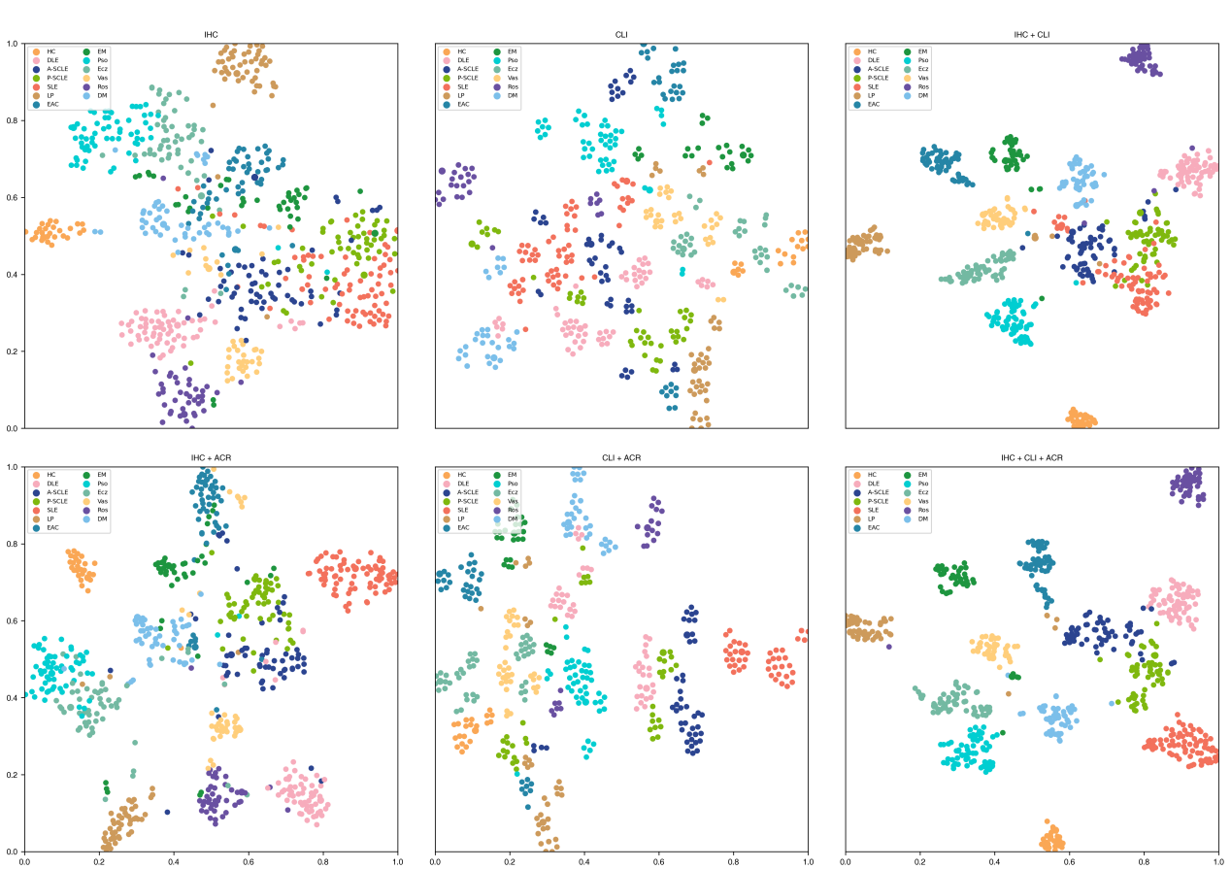
Extended Data Figure 3 | t-SNE visualization of different combinations of models for 13 classifications

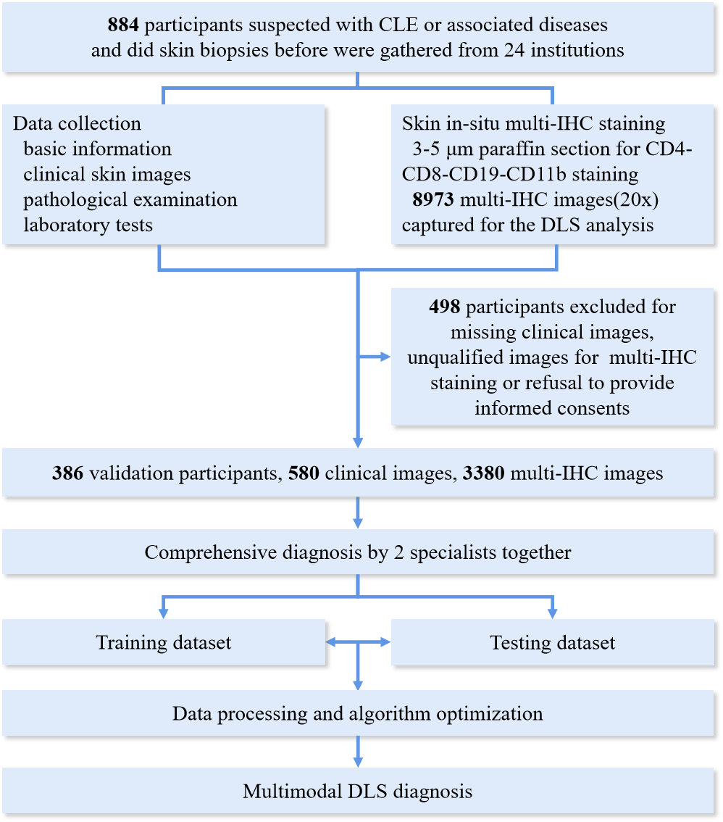
Extended Data Figure 4 | Study design and work flow.

