Supplementary figure 1
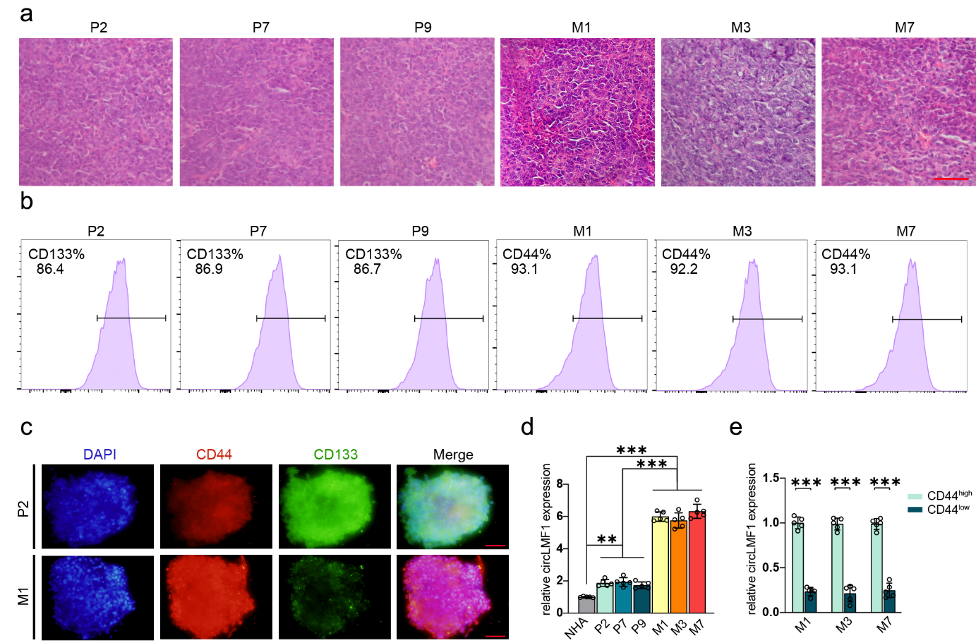
Supplementary figure 1 High expression of circLMF1 in glioma correlates with the MES-type GBM. a Representative H&E-stained images of human GBM tissues classified as PN-type (P2, P7, P9) or MES-type (M1, M3, M7). Scale bar = 50 μm. b Flow cytometry-based expression analysis of CD133 and CD44 proteins in PN-type and MES-type GSC lines. c Immunofluorescence analysis of CD44 and CD133 expression in GSC lines P2 and M1. Scale bar = 50μm. d circLMF1 expression in PN-type GSC lines (P2, P7, P9), MES-type GSC lines (M1, M3, M7), and normal brain tissues. e qPCR analysis of circLMF1 relative expression in CD44^{high} and CD44^{low} subpopulations of MES-type GSCs.

Supplementary figure 2
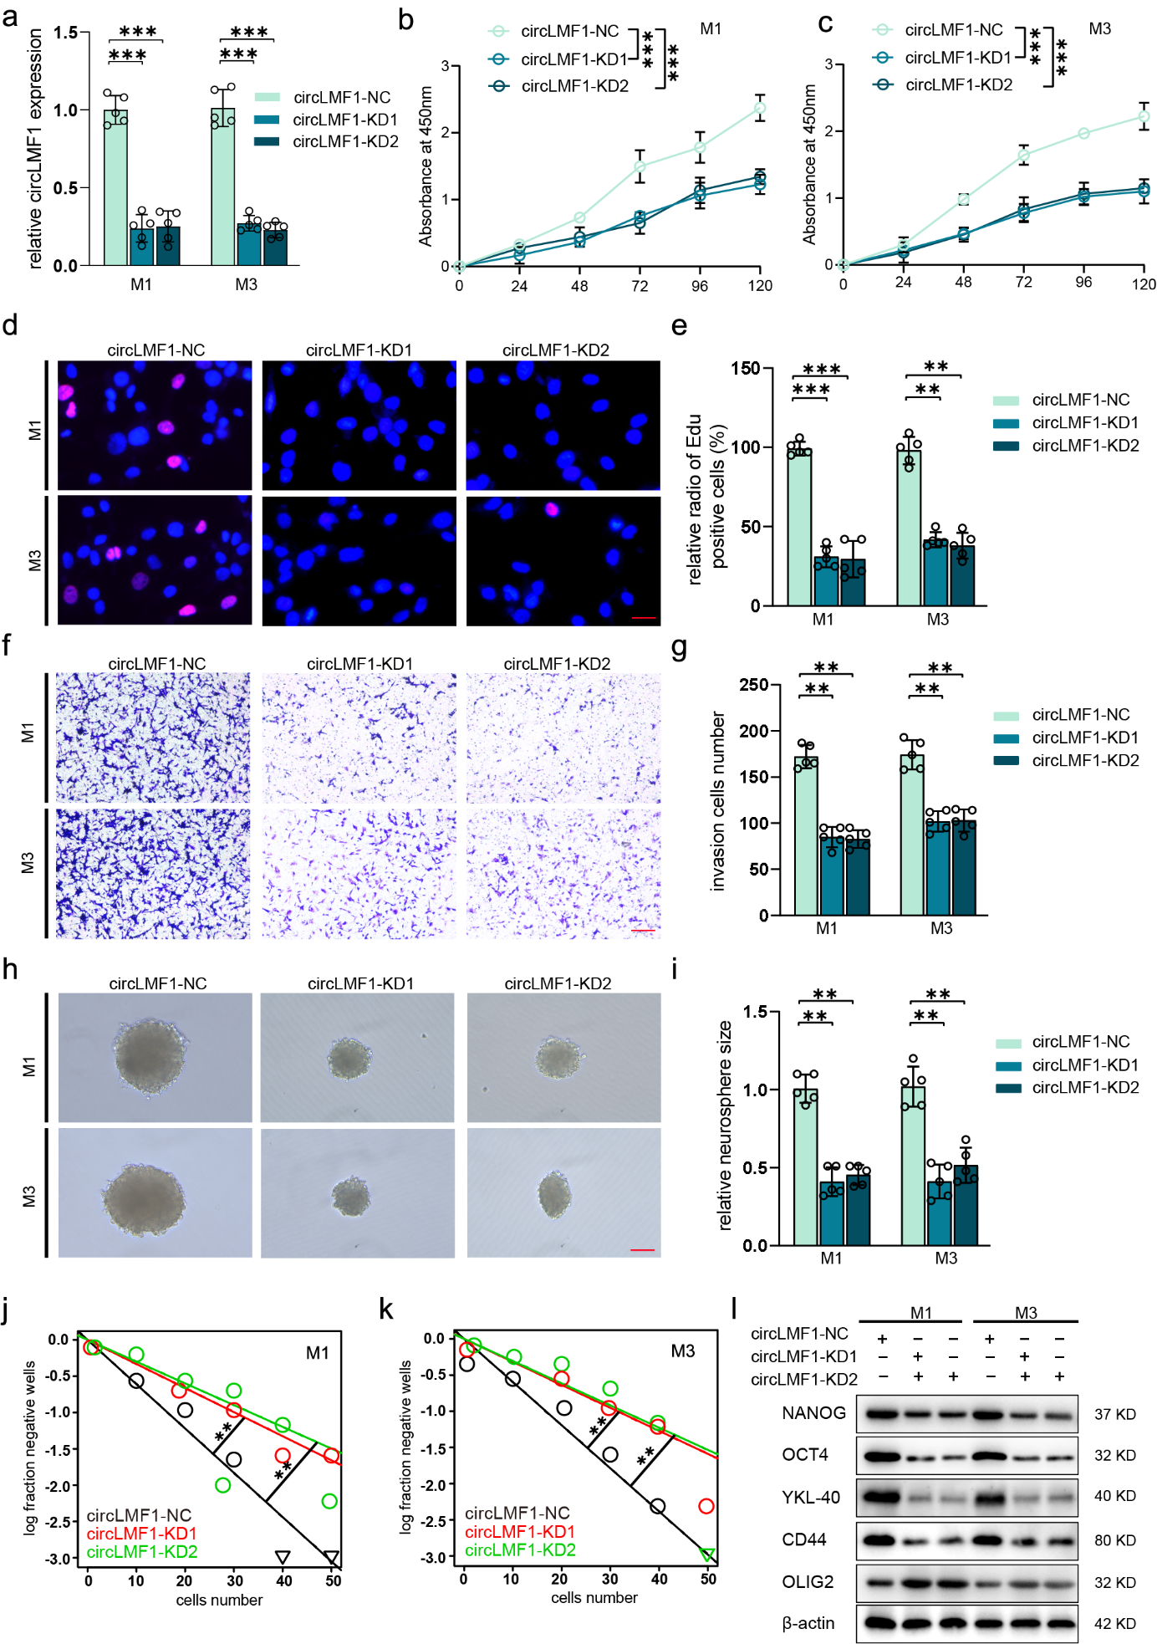
Supplementary figure 2 Regulating circLMF1 impacts proliferation, invasiveness, stemness and PMT of GSCs. a qPCR analysis of circLMF1 expression in M1 and M3 cells transduced with negative control (NC), circLMF1-knockdown vector KD1, or circLMF1-knockdown vector KD2. b, c Cell viability of M1 and M3 cells transduced with NC, circLMF1-KD1 or circLMF1-KD2, assessed by CCK-8 assay at 24, 48, 72, 96, and 120 hours. d, e Representative EdU staining images and corresponding quantitative analysis of M1 and M3 cells transduced with NC, circLMF1-KD1 or circLMF1-KD2. Scale bar = 50μm. f, g Matrigel-coated Transwell invasion assay and corresponding quantitative analysis of M1 and M3 cells transduced with NC, circLMF1-KD1 or circLMF1-KD2. Scale bar = 50μm. h, i Neurosphere formation assay: representative images and size quantification in M1/M3 cells with NC, circLMF1-KD1 or circLMF1-KD2. Scale bar = 50μm. j, k ELDA of neurosphere-forming frequency in M1/M3 cells transduced with NC, circLMF1-KD1 or circLMF1-KD2. l Western blot of stemness, mesenchymal, and proneural markers in M1/M3 cells transduced with NC, circLMF1-KD1 or circLMF1-KD2. All data are shown as the mean ± SD (five independent experiments). *p<0.05; **p<0.01; ***p<0.001; ns, no significance.

Supplementary figure 3
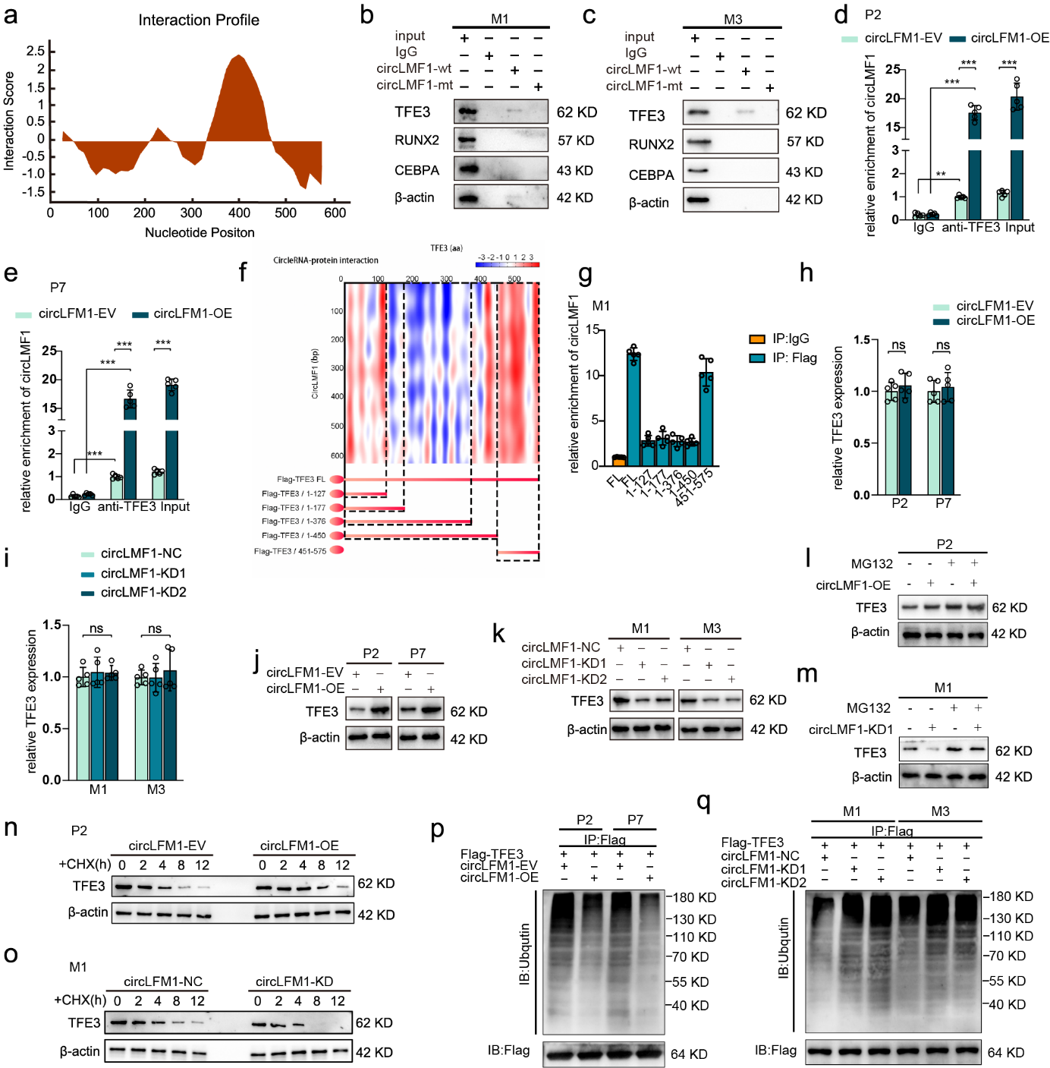
Supplementary figure 3 CircLMF1 binds directly to TFE3 and enhances its protein stability in GSCs. a CircLMF1 binds to TFE3 proteins via CatRAPID prediction. b, c RNA pull-down assay to display the interaction between circLMF1 and TFE3, RUNX2, and CEBPA respectively in M1 and M3. d, e RIP assays showing anti-TFE3 treatment leaded to circLMF1 enrichment in P2 and P7 transduced with EV or circLMF1-OE. f RNA–protein interaction between circLMF1 and TFE3 predicted by the CatRAPID algorithm (top) and the diagrams of Flag-tagged TFE3 truncations (bottom).g RIP assays were performed in M1 transfected with the truncated mutant vectors to validate the binding domain of TFE3. h-k qPCR and western blotting assays showing TFE3 mRNA (h,i) and protein expression (j,k) after circLMF1 overexpression and knockdown. l, m The circLMF1 knockdown or overexpressed GSCs were treated with or without MG132 (50 μM) for 6 hours, and TFE3 expression was detected by Western blotting. n, o The circLMF1 knockdown or overexpressed GSCs were treated with CHX (50μg/ml) at 0, 2, 4, 8, and 12 hours and the expression of TFE3 protein was detected by western blotting. p, q In vivo ubiquitination assays showed TFE3 ubiquitination levels in GSCs with circLMF1 overexpression or knockdown. All data are shown as the mean ± SD (five independent experiments). *p<0.05; **p<0.01; ***p<0.001; ns, no significance.

Supplementary figure 4
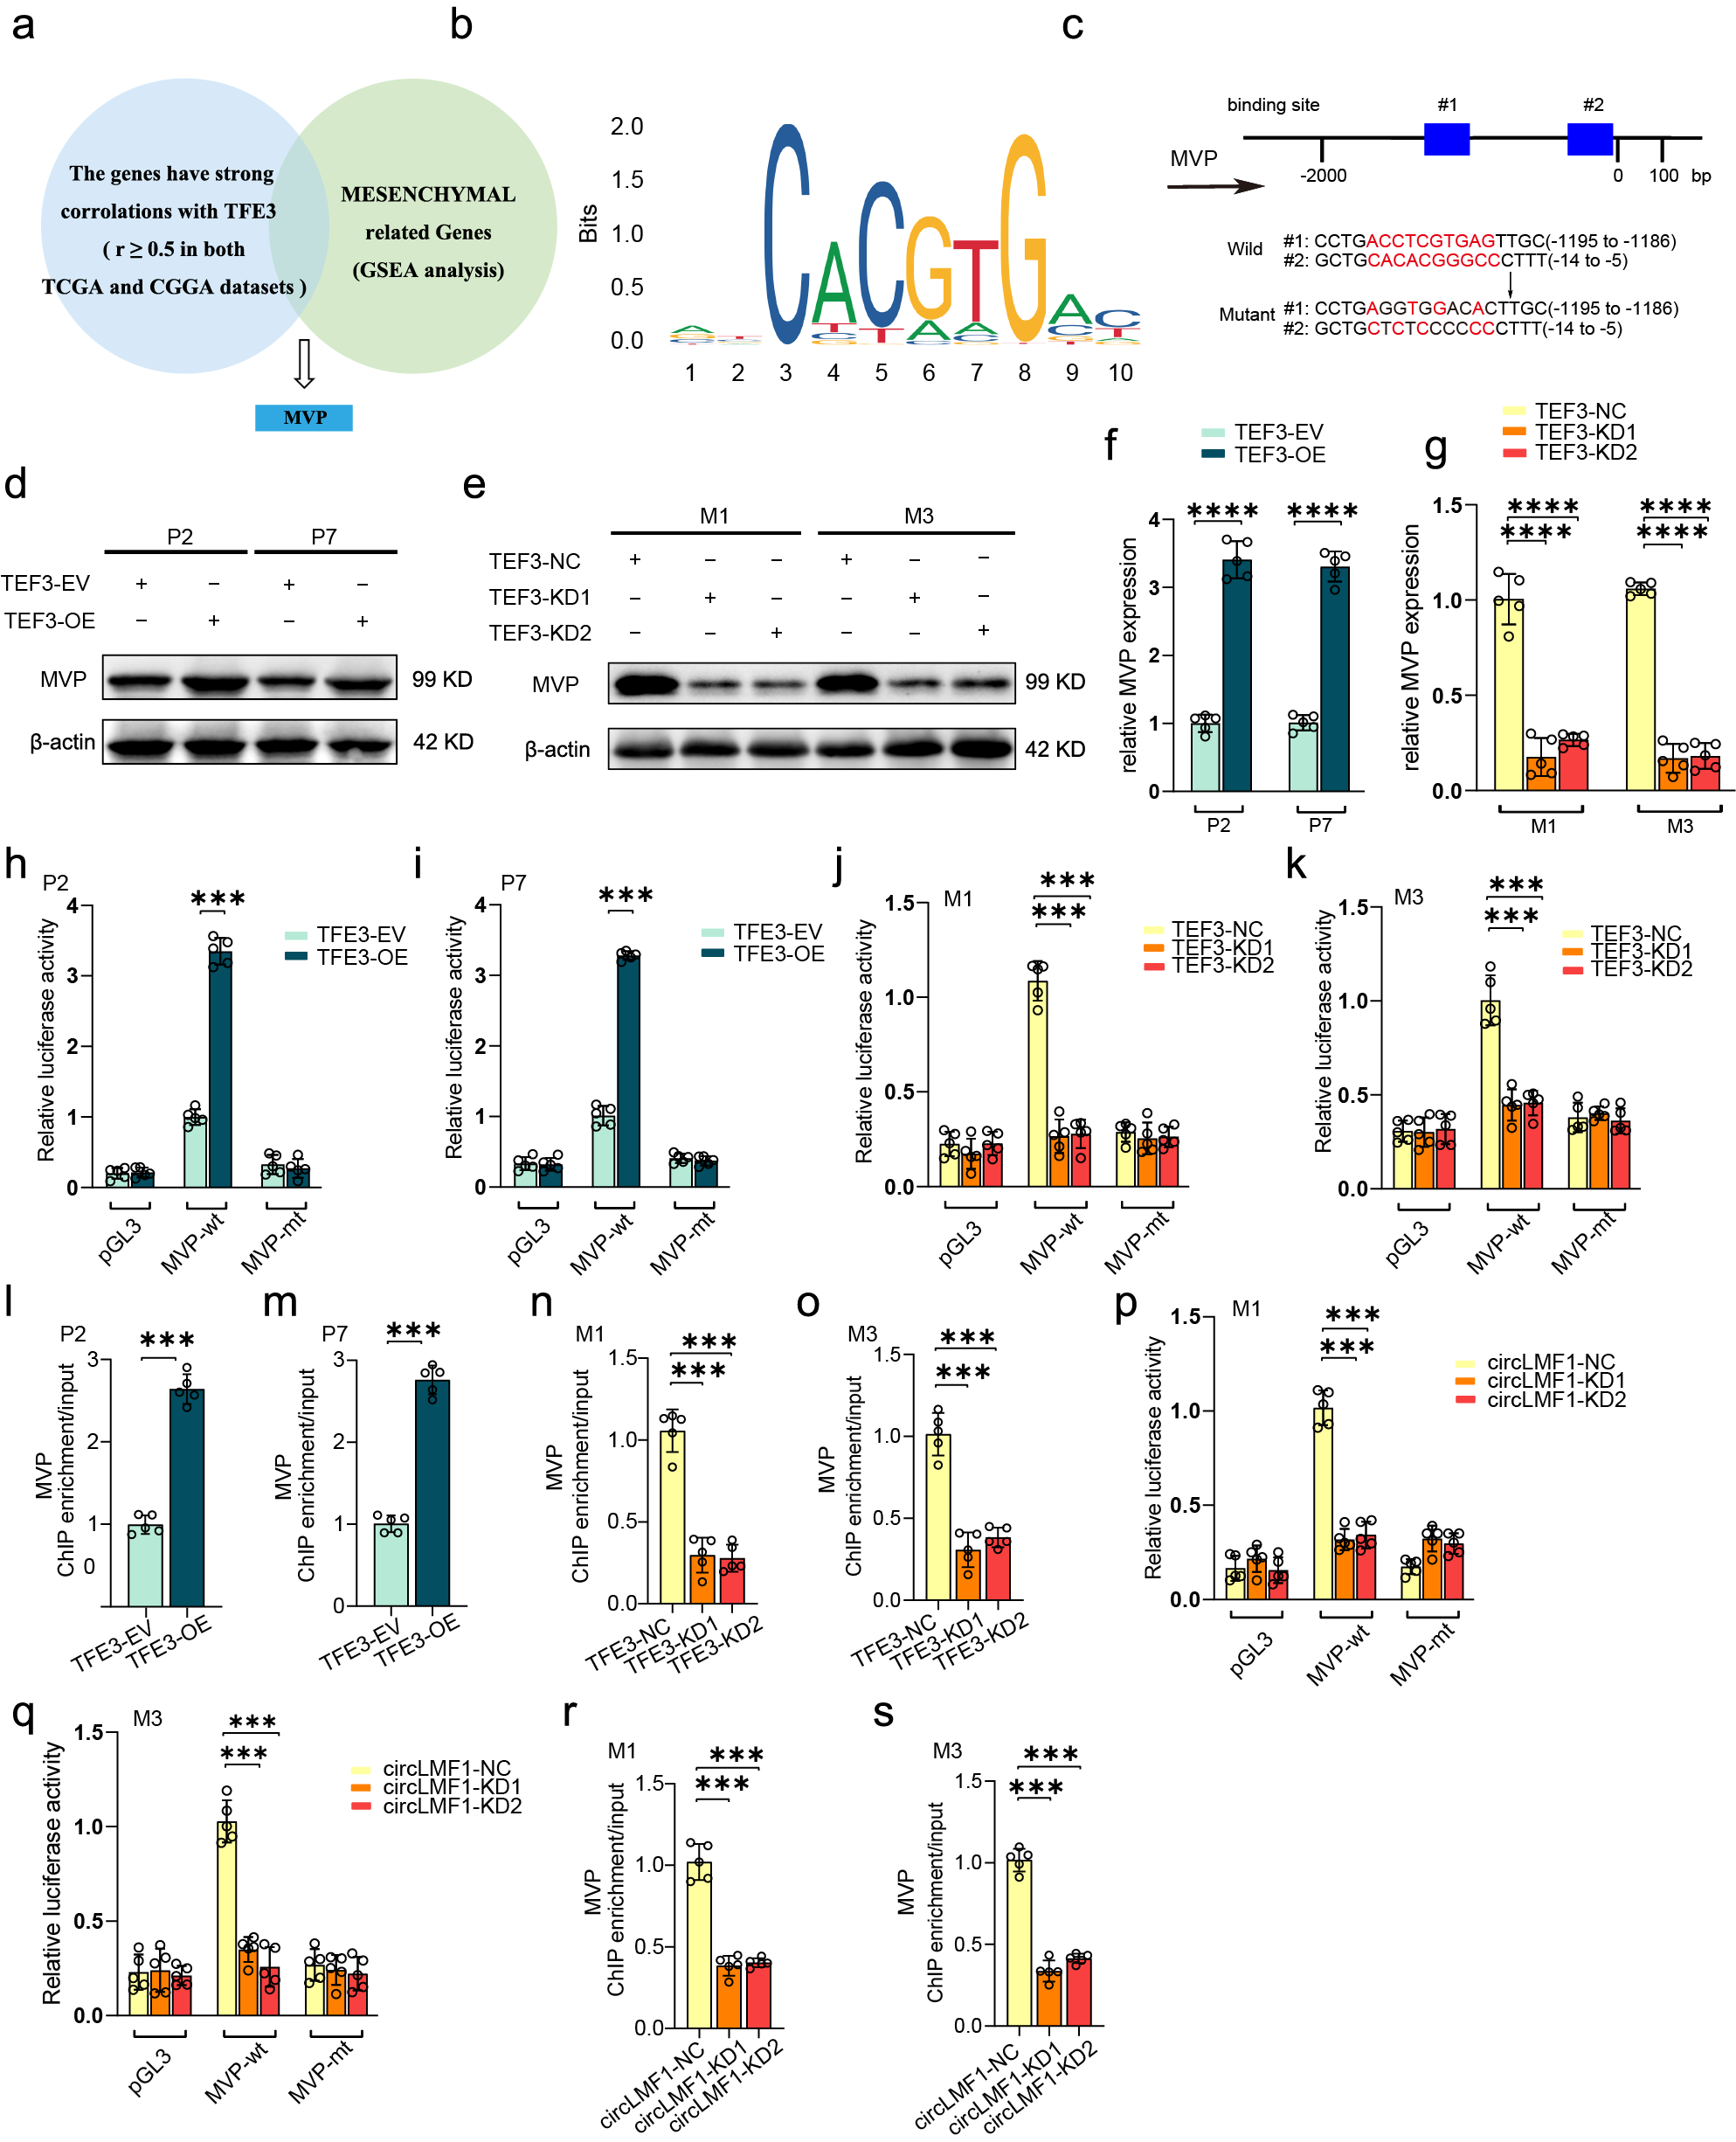
Supplementary figure 4 CircLMF1 promoted the PMT of GSCs via upregulating MVP. a Venn diagram of candidate TFE3 targets associated with PMT. b TFE3 binding motif obtained from the Jaspar database.
c Shows the two putative TFE3 binding sites and matched mutant sequences in the MVP promoter region for luciferase reporter assays. d-g Western blotting and qPCR assays showing MVP protein (d,e) and mRNA expression (f,g) after TFE3 overexpression and knockdown compared to their respective controls. h-k The luciferase reporter assays revealed luciferase activity driven by the MVP promoter in TFE3-overexpressing (h,i) or TFE3-knockdown (j,k) GSCs compared to their respective controls. l-o ChIP-qPCR analysis revealed TFE3-dependent enrichment of the MVP promoter in TFE3-overexpressing (l,m) or TFE3-knockdown (n,o) GSCs compared to their respective controls. p, q The luciferase reporter assay showed MVP promoter activity in circLMF1-knockdown GSCs (j,k) relative to control. r, s ChIP-qPCR analysis showed reduced TFE3 binding to the MVP promoter in circLMF1-knockdown GSCs compared to control. All data are shown as the mean ± SD (five independent experiments). *p<0.05; **p<0.01; ***p<0.001; ns, no significance.

Supplementary figure 5
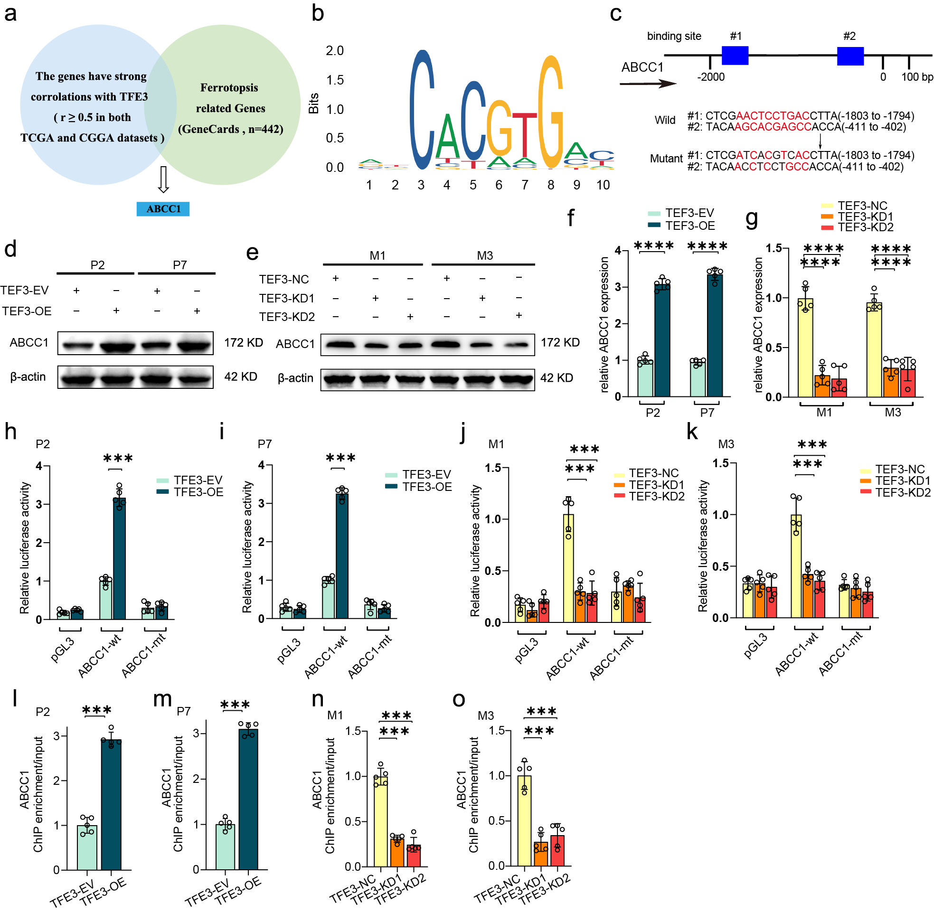
Supplementary figure 5 CircLMF1 enhances the sensitivity of GSCs to ferroptosis by upregulating ABCC1. a Venn diagram of candidate TFE3 targets associated with ferroptosis. b TFE3 binding motif obtained from the Jaspar database. c Shows the two putative TFE3 binding sites and matched mutant sequences in the ABCC1 promoter region for luciferase reporter assays. d-g Western blotting and qPCR assays showing ABCC1 protein (d,e) and mRNA expression (f,g) after TFE3 overexpression and knockdown compared to their respective controls. h-k The luciferase reporter assays revealed luciferase activity driven by the ABCC1 promoter in TFE3-overexpressing (h,i) or TFE3-knockdown (j,k) GSCs compared to their respective controls. l-o ChIP-qPCR analysis revealed TFE3-dependent enrichment of the ABCC1 promoter in TFE3-overexpressing (l,m) or TFE3-knockdown (n,o) GSCs compared to their respective controls. All data are shown as the mean ± SD (five independent experiments). *p<0.05; **p<0.01; ***p<0.001; ns, no significance.

