Supplementary Table 1. Search Strategy.
  - PubMed(Items found:24)
Step | Search Terms
#1 | Pulmonary Disease, Chronic Obstructive[MeSH Terms]
#2 | ((Chronic Obstructive Pulmonary Disease*[Title/Abstract]) OR (COPD[Title/Abstract])) OR (Chronic Obstructive Lung Disease[Title/Abstract])
#3 | #1 OR #2
#4 | (((((unmet need*[Title/Abstract]) OR (health services need*[Title/Abstract])) OR (health services demand[Title/Abstract])) OR (need, health services[Title/Abstract])) OR (unsatisfied demand[Title/Abstract])) OR (outstanding demand[Title/Abstract])
#5 | qualitative research[MeSH Terms]
#6 | (((((((qualitative study[Title/Abstract]) OR (grounded theory[Title/Abstract])) OR (focus group[Title/Abstract])) OR (ethnography[Title/Abstract])) OR (phenomenology[Title/Abstract])) OR (interview[Title/Abstract])) OR (attitude[Title/Abstract])) OR (feeling*[Title/Abstract])
#7 | #5 OR #6
#8 | #3 AND #4 AND #7
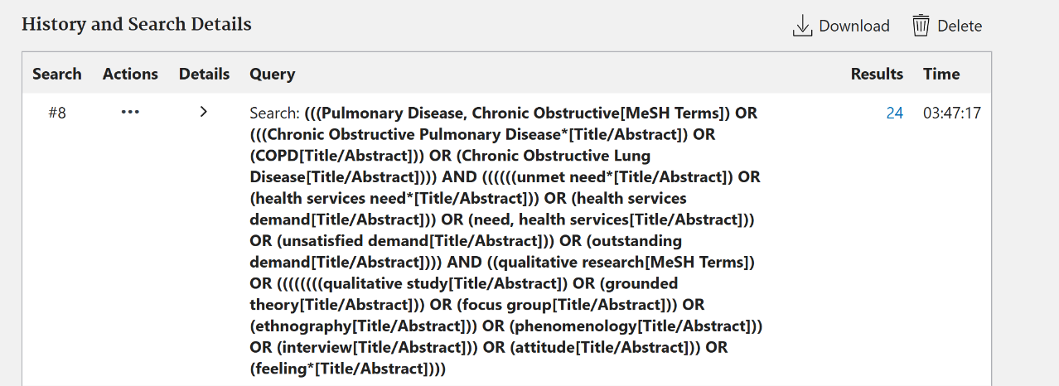

  - Web of Science(Items found:237)
Step | Search Terms
#1 | TS=(‘Pulmonary Disease, Chronic Obstructive’ OR ‘Chronic Obstructive Pulmonary Disease*’ OR ‘COPD’ OR ‘Chronic Obstructive Lung Disease’)
#2 | TS=(‘unmet need*’ OR ‘health services need*’ OR ‘health services demand’ OR ‘need, health services’ OR ‘unsatisfied demand’ OR ‘outstanding demand’)
#3 | TS=(‘qualitative research’ OR ‘grounded theory’ OR ‘focus group’ OR ‘ethnography’ OR ‘phenomenology’ OR ‘interview’ OR ‘attitude’ OR ‘feeling*’)
#4 | #1 AND #2 AND #3
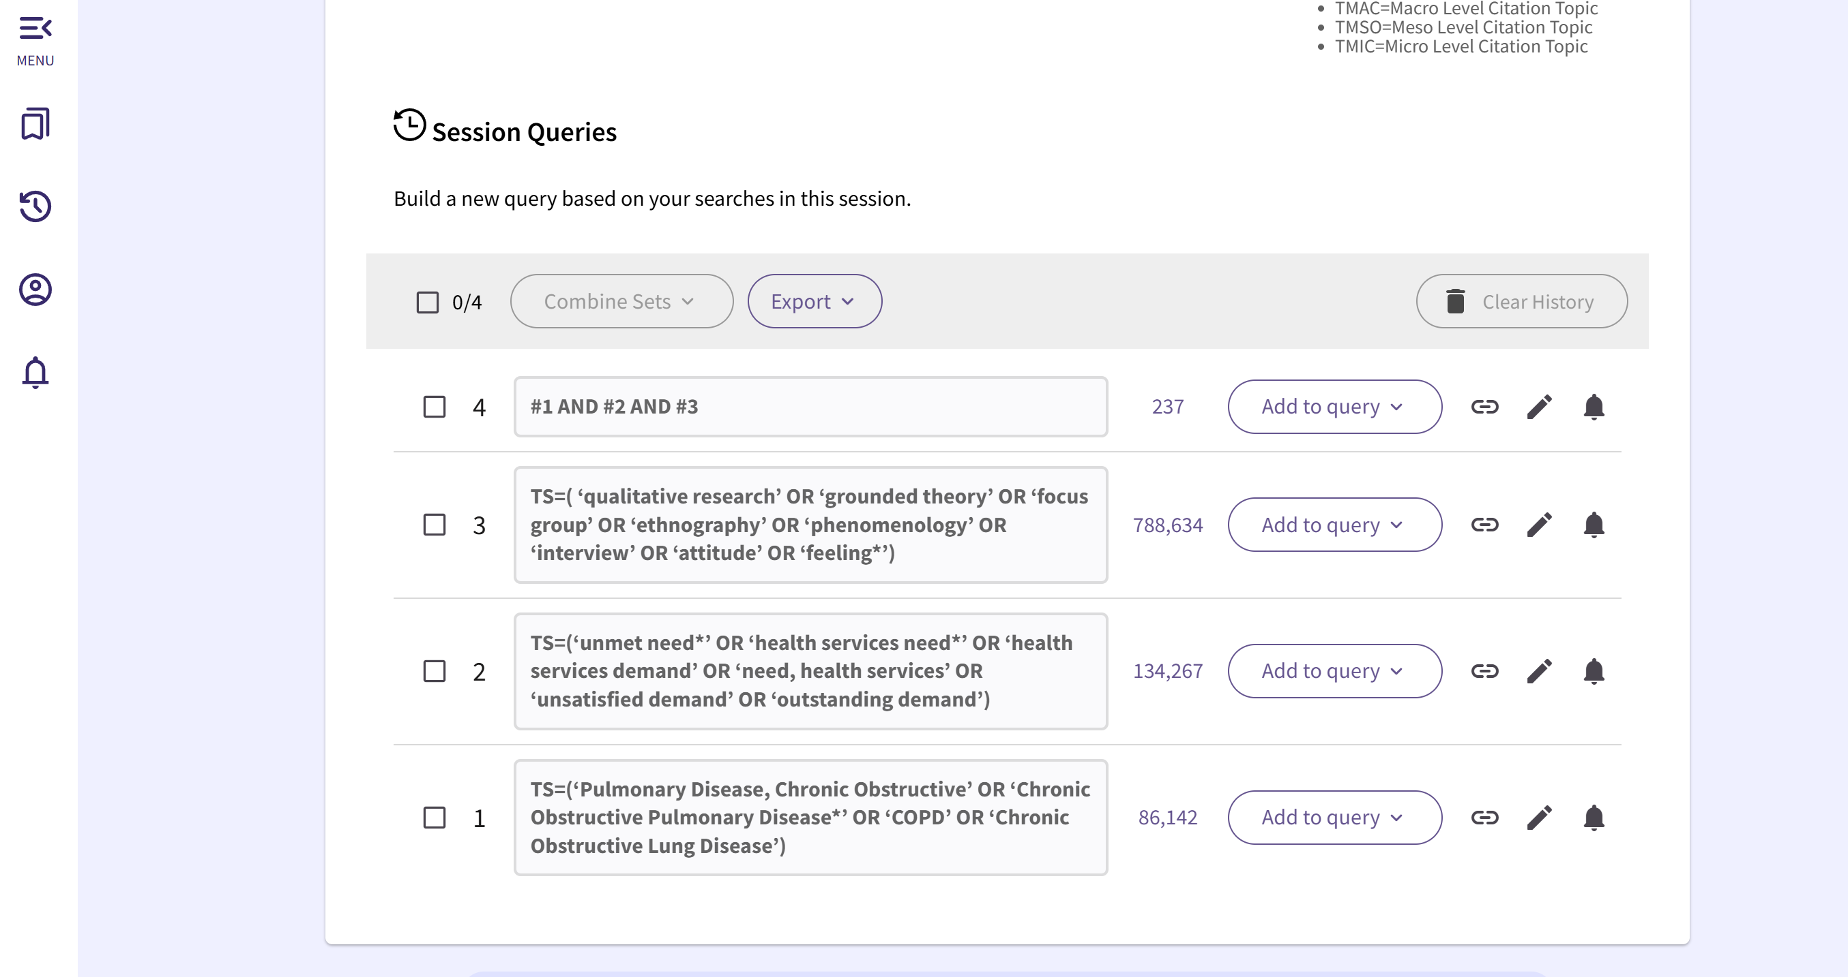
  - The Cochrane Library (Items found:70)
Step | Search Terms
#1 | MeSH descriptor: [Pulmonary Disease, Chronic Obstructive] explode all trees
#2 | ((Chronic Obstructive Pulmonary Disease*) OR (COPD) OR (Chronic Obstructive Lung Disease)):ti,ab,kw
#3 | #1 OR #2
#4 | ((unmet need*) OR (health services need*) OR (health services demand) OR (need, health services) OR (unsatisfied demand) OR (outstanding demand)):ti,ab,kw
#5 | MeSH descriptor: [Qualitative Research] explode all trees
#6 | ((qualitative study) OR (grounded theory) OR (focus group) OR (ethnography) OR (phenomenology) OR (interview) OR (attitude) OR (feeling*)):ti,ab,kw
#7 | #5 OR #6
#8 | #3 AND #4 AND #7
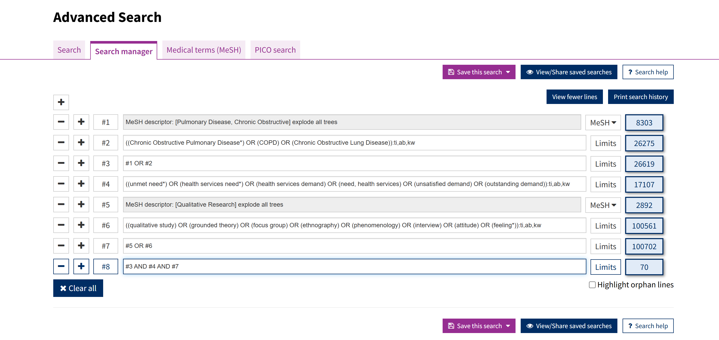

  - CINAHL(Items found:17)
Step | Search Terms
#1 | "Pulmonary Disease, Chronic Obstructive" OR "Chronic Obstructive Pulmonary Disease*" OR "COPD" OR "Chronic Obstructive Lung Disease"
#2 | "unmet need*" OR "health services need*" OR "health services demand" OR "need, health services" OR "unsatisfied demand" OR "outstanding demand"
#3 | "qualitative study" OR "grounded theory" OR "focus group" OR "ethnography" OR "phenomenology" OR "interview" OR "attitude" OR "feeling*"
#4 | #1 AND #2 AND #3
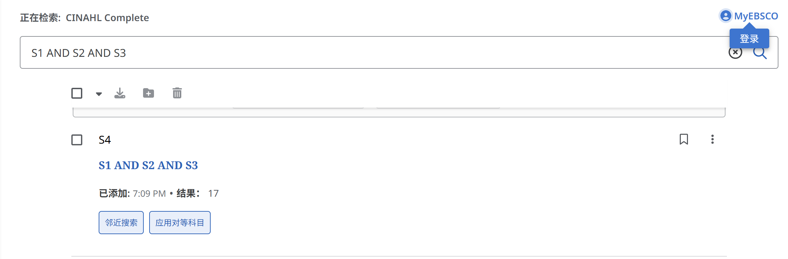

  - Embase (Items found:44)
Step | Search Terms
#1 | 'chronic obstructive lung disease'/exp
#2 | 'chronic obstructive pulmonary disease*':ab,ti OR 'chronic obstructive pulmonary disorder':ab,ti OR copd:ab,ti OR 'chronic pulmonary obstructive disorder':ab,ti
#3 | #1 OR #2
#4 | 'unmet need*':ab,ti OR 'health services need*':ab,ti OR 'health services demand':ab,ti OR 'need, health services':ab,ti OR 'unsatisfied demand':ab,ti OR 'outstanding demand':ab,ti
#5 | 'qualitative research'/exp
#6 | 'qualitative study':ab,ti OR 'grounded theory':ab,ti OR 'focus group':ab,ti OR ethnography:ab,ti OR phenomenology:ab,ti OR interview:ab,ti OR attitude:ab,ti OR feeling*:ab,ti
#7 | #5 OR #6
#8 | #3 AND #4 AND #7
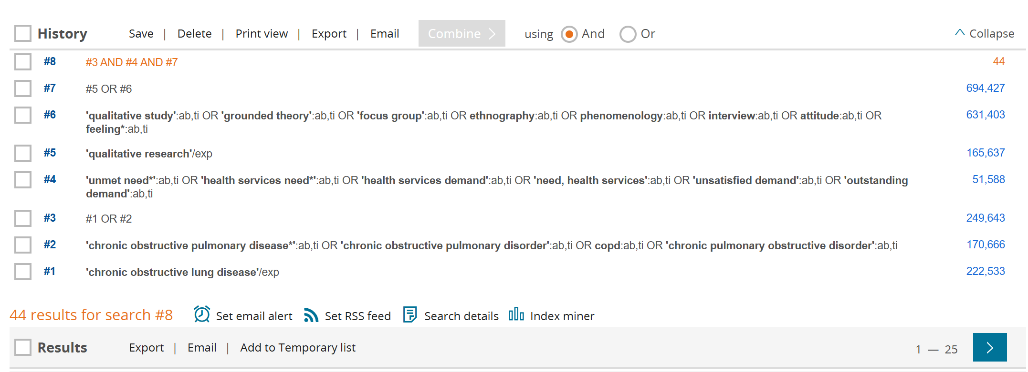

  - PsycINFO (Items found:49)
Step | Search Terms
#1 | mainsubject.Exact("pulmonary disease, chronic obstructive")
#2 | tiab(Chronic Obstructive Pulmonary Disease*) OR tiab(COPD) OR tiab(Chronic Obstructive Lung Disease)
#3 | #1 OR #2
#4 | tiab(unmet need*) OR tiab(health services need*) OR tiab(health services demand) OR tiab(need, health services) OR tiab(unsatisfied demand) OR tiab(outstanding demand)
#5 | mainsubject.Exact("qualitative research")
#6 | tiab(qualitative study) OR tiab(grounded theory) OR tiab(focus group) OR tiab(ethnography) OR tiab(phenomenology) OR tiab(interview) OR tiab(attitude) OR tiab(feeling*)
#7 | #5 OR #6
#8 | #3 AND #4 AND #7
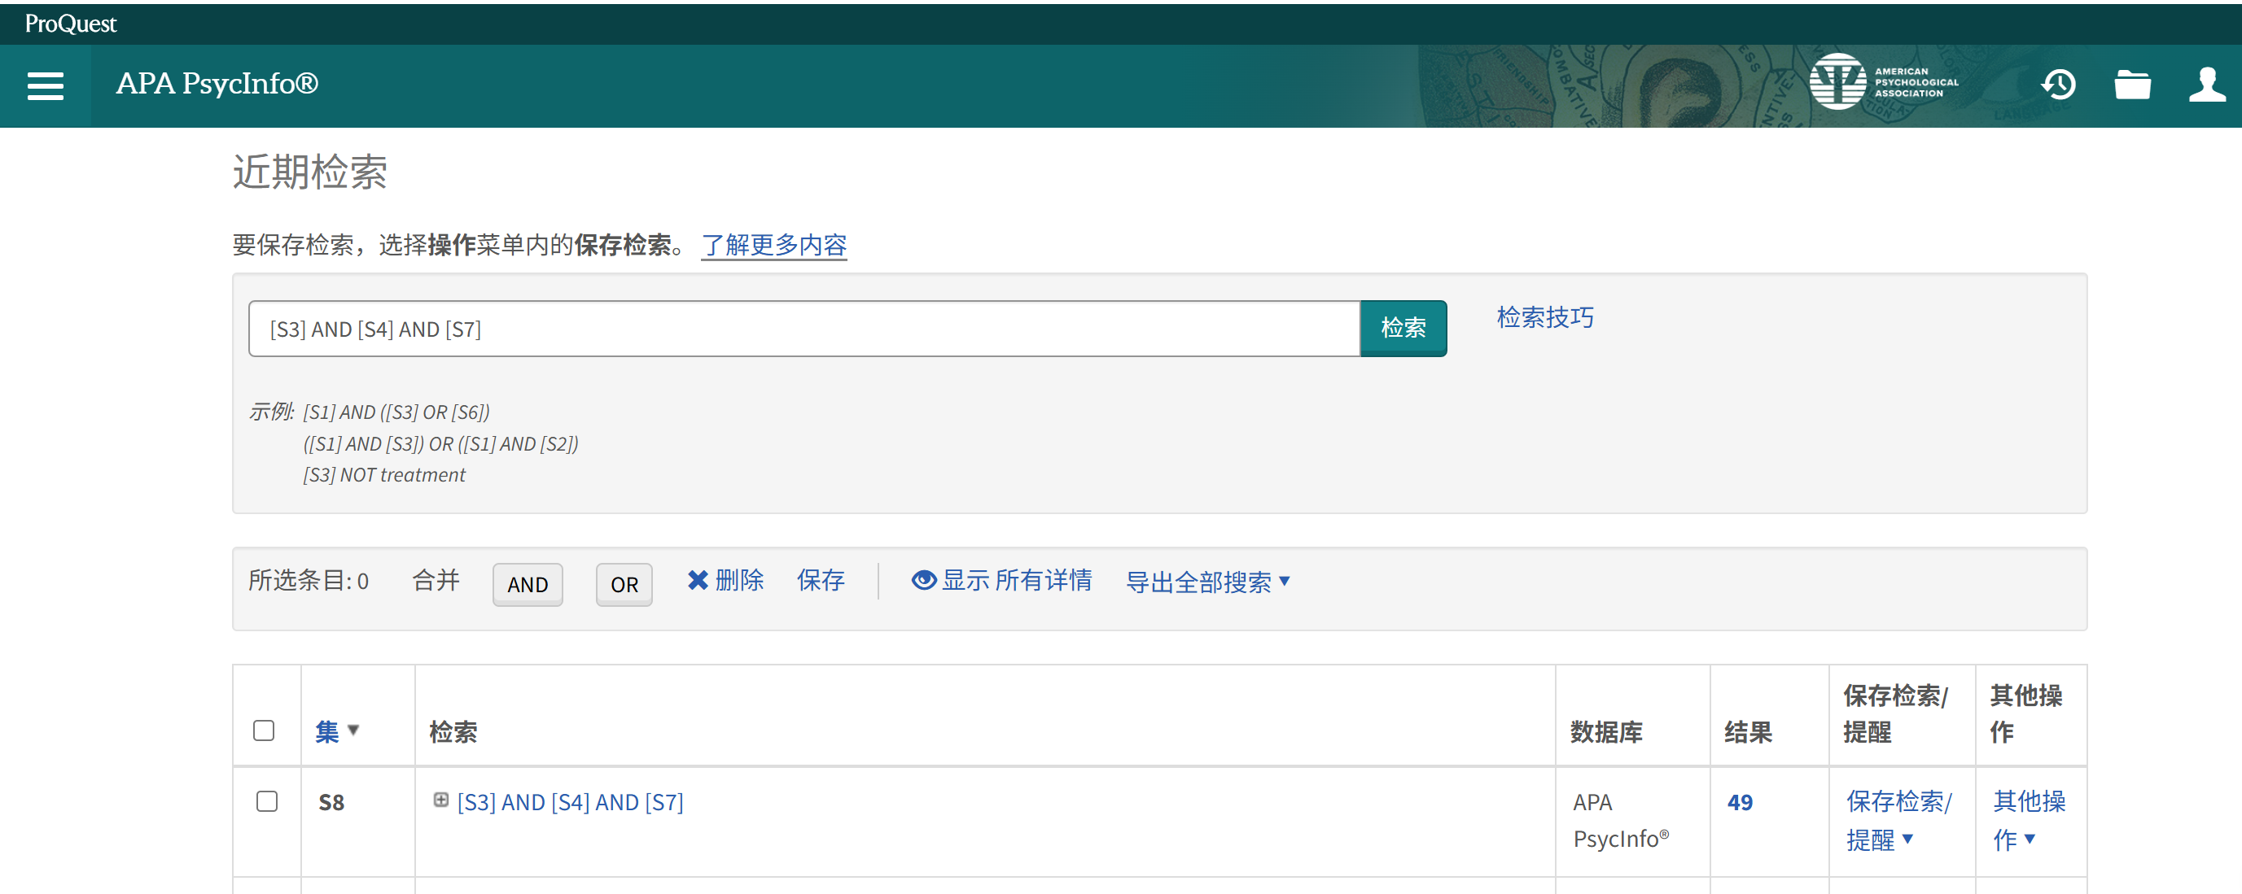
  - MEDLINE(Items found:19)
Step | Search Terms
#1 | "Pulmonary Disease, Chronic Obstructive" OR "Chronic Obstructive Pulmonary Disease*" OR "COPD" OR "Chronic Obstructive Lung Disease"
#2 | "unmet need*" OR "health services need*" OR "health services demand" OR "need, health services" OR "unsatisfied demand" OR "outstanding demand"
#3 | "qualitative study" OR "grounded theory" OR "focus group" OR "ethnography" OR "phenomenology" OR "interview" OR "attitude" OR "feeling*"
#4 | #1 AND #2 AND #3
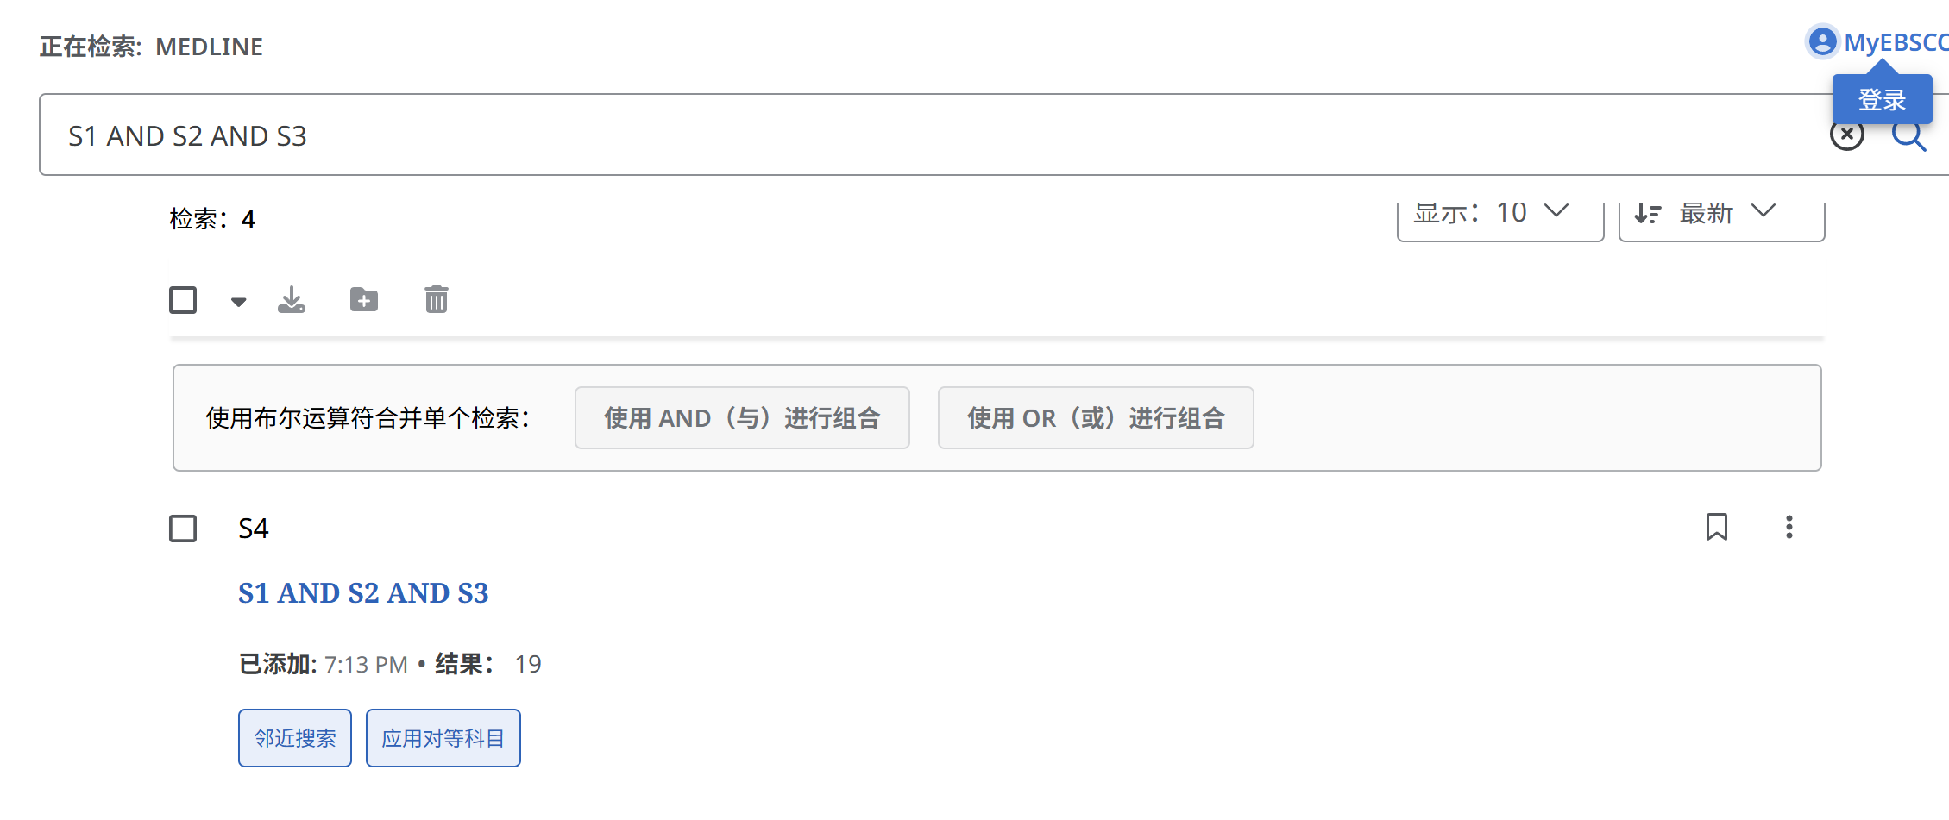
  - Scopus (Items found:118)
Step | Search Terms
#1 | TITLE-ABS-KEY("Pulmonary Disease, Chronic Obstructive" OR "Chronic Obstructive Pulmonary Disease*" OR "COPD" OR "Chronic Obstructive Lung Disease")
#2 | TITLE-ABS-KEY("unmet need*" OR "health services need*" OR "health services demand" OR "need, health services" OR "unsatisfied demand" OR "outstanding demand")
#3 | TITLE-ABS-KEY("qualitative study" OR "grounded theory" OR "focus group" OR "ethnography" OR "phenomenology" OR "interview" OR "attitude" OR "feeling*")
#4 | #1 AND #2 AND #3
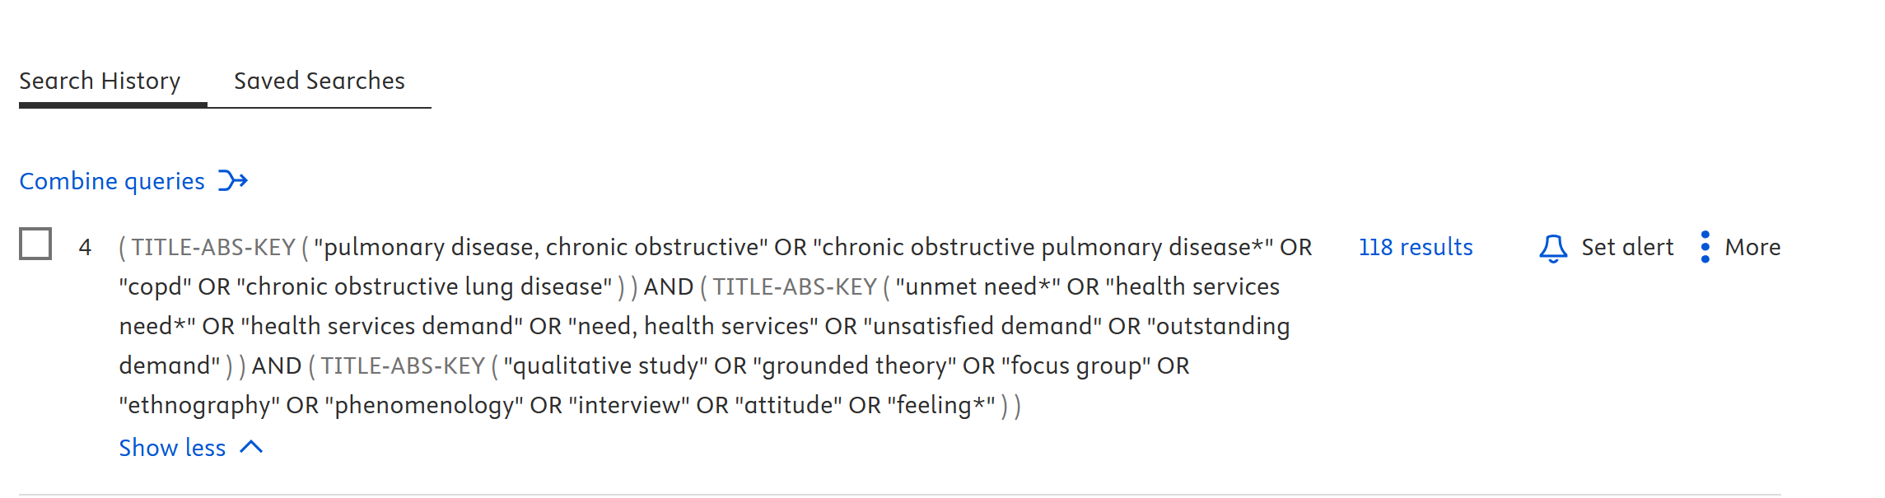

  - CNKI (Items found:4)
Step | Search Terms
#1 | SU=('慢性阻塞性肺疾病' + '慢性阻塞性肺病' + 'COPD' + '慢阻肺')
#2 | SU=('未满足需求' + '支持性照顾需求' + '健康需求' + '需求未满足' + '照护需求')
#3 | SU=('质性研究' + '定性研究' + '现象学研究' + '扎根理论' + '民族志' + '人种学' + '访谈' + '体验' + '感受' + '经历')
#4 | #1 AND #2 AND #3
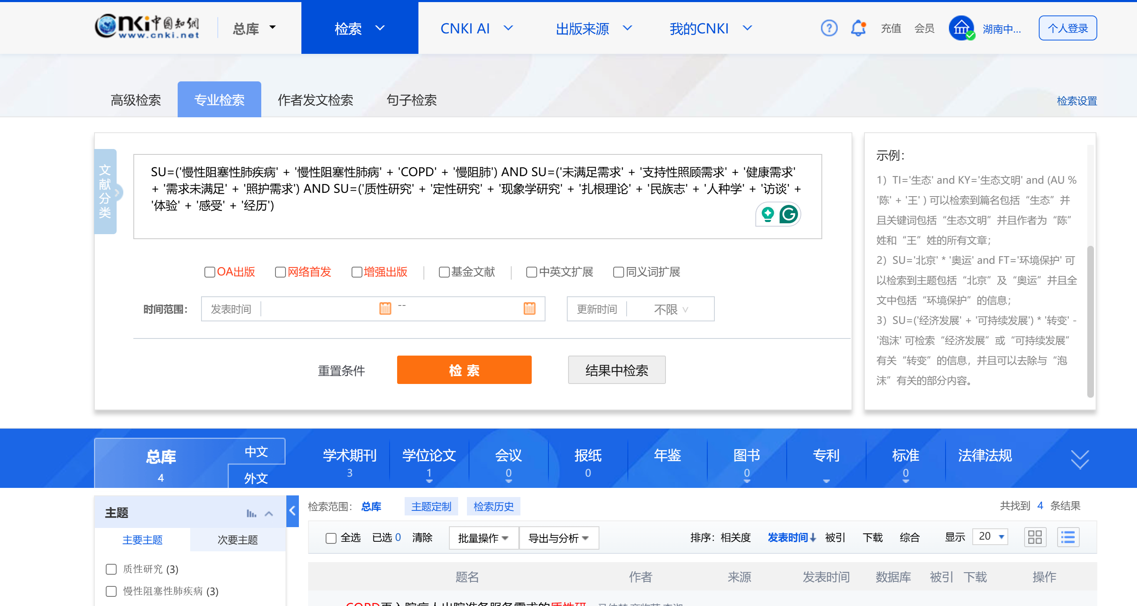

  - Wanfang (Items found:19)
Step | Search Terms
#1 | 主题:(慢性阻塞性肺疾病 OR 慢性阻塞性肺病 OR COPD OR 慢阻肺)
#2 | 主题:(未满足需求 OR 支持性照顾需求 OR 健康需求 OR 需求未满足 OR 照护需求)
#3 | 题名或关键词:(质性研究 OR 定性研究 OR 现象学研究 OR 扎根理论 OR 民族志 OR 人种学 OR 访谈 OR 体验 OR 感受 OR 经历)
#4 | #1 AND #2 AND #3
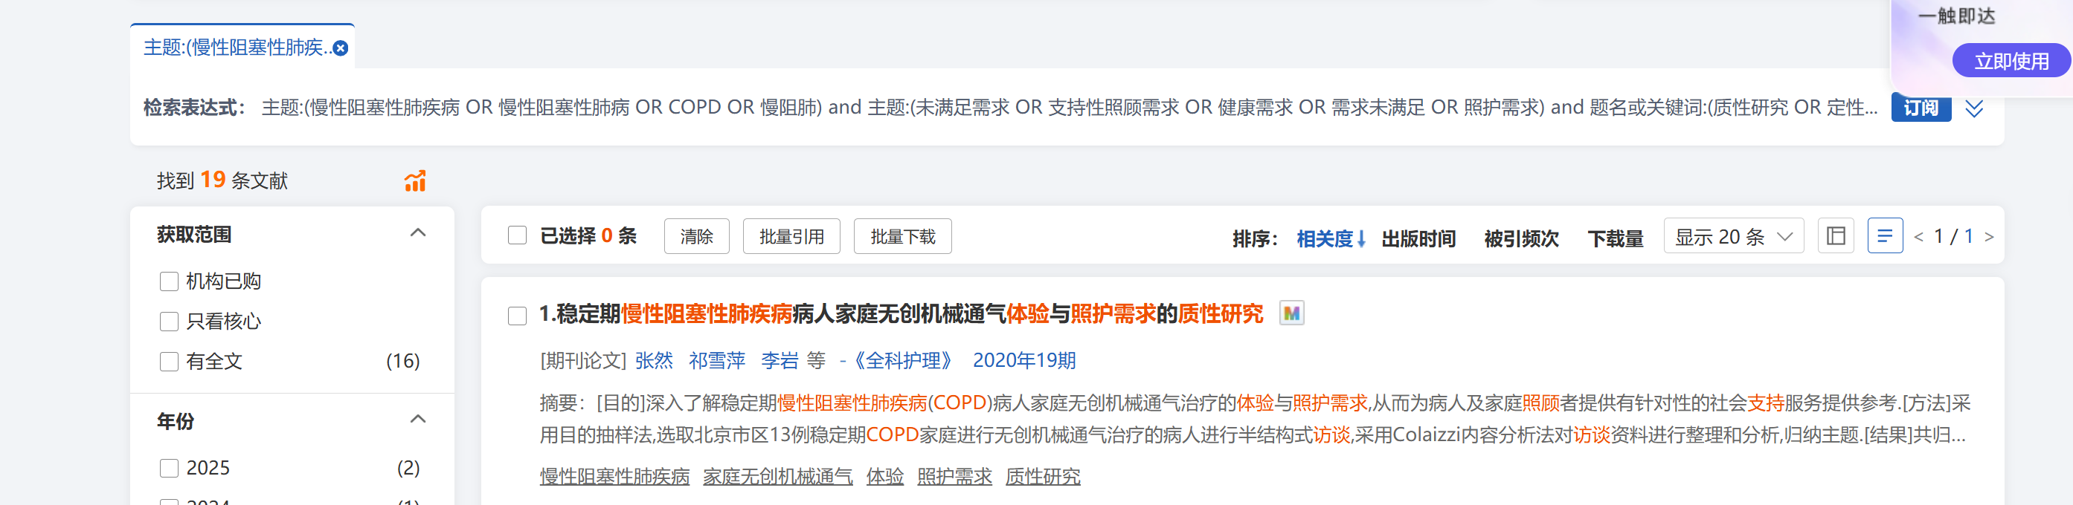

  - VIP (Items found:3)
Step | Search Terms
#1 | M= (慢性阻塞性肺疾病 OR 慢性阻塞性肺病 OR COPD OR 慢阻肺)
#2 | M=(未满足需求 OR 支持性照顾需求 OR 健康需求 OR 需求未满足 OR 照护需求)
#3 | M= (质性研究 OR 定性研究 OR 现象学研究 OR 扎根理论 OR 民族志 OR 人种学 OR 访谈 OR 体验 OR 感受 OR 经历)
#4 | #1 AND #2 AND #3
