Appendix A
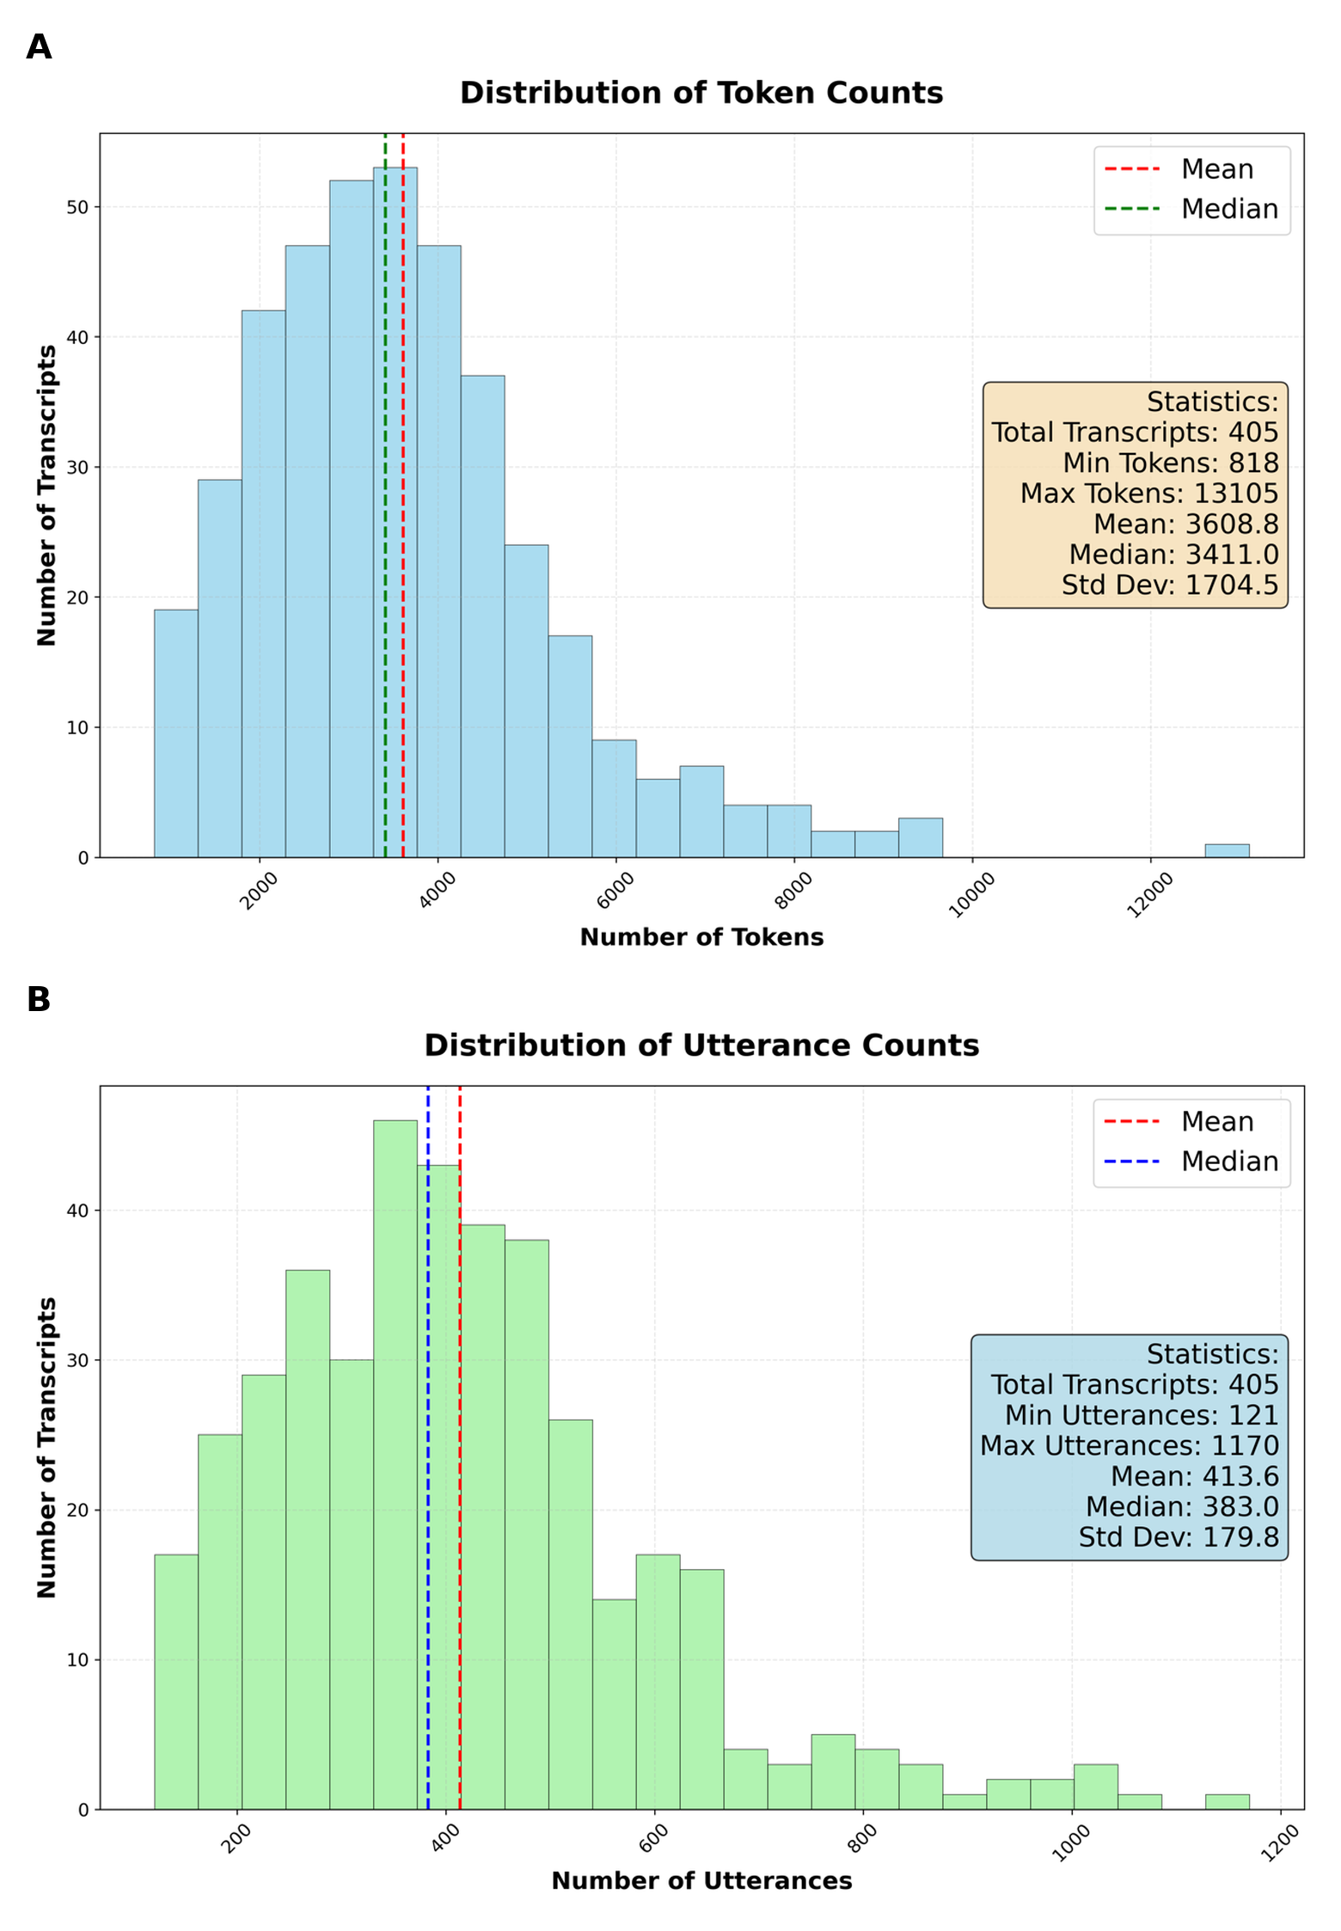
Supplementary Figure S1. Distributions of token counts (panel A) and utterance counts (panel B) across the 405 transcripts in the VHA 4C dataset.

