Identification of an SFRP1 inhibitor as a novel therapeutic strategy for cancers using dry-wet combined drug discovery strategy

Yunlong Zhang ^{1,2} Ruiqi Wei ³, Meihong Pan ³, Nan Qin ^{3,*}, Xiaopeng Wei ^{3,*}, Jun Shen ^{1,*}

1. Tianjin Medical University Cancer Institute and Hospital;National Clinical Research Center for Cancer; Key Laboratory of Cancer Prevention and Therapy; Tianjin’s Clinical Research Center for Cancer; Tianjin 300060，China.
2. Hospital of Stomatology, Tianjin Medical University, Tianjin 300070, China
3 Tianjin Key Laboratory on Technologies Enabling Development of Clinical Therapeutics and Diagnostics, School of Pharmacy, Tianjin Medical University, Tianjin, P. R. China

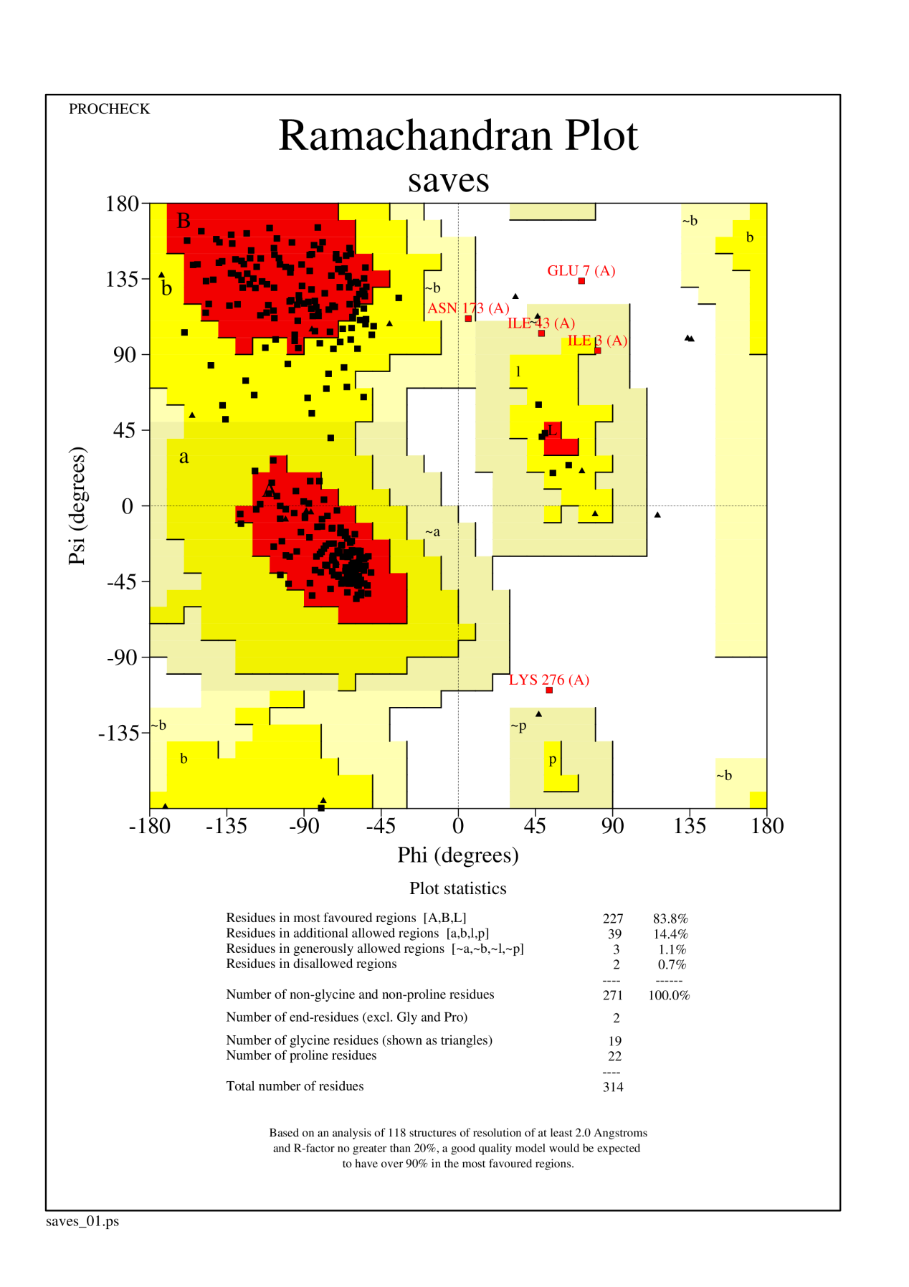
Fig.S1. Ramachandran Plot of the constructed SFRP1 structure

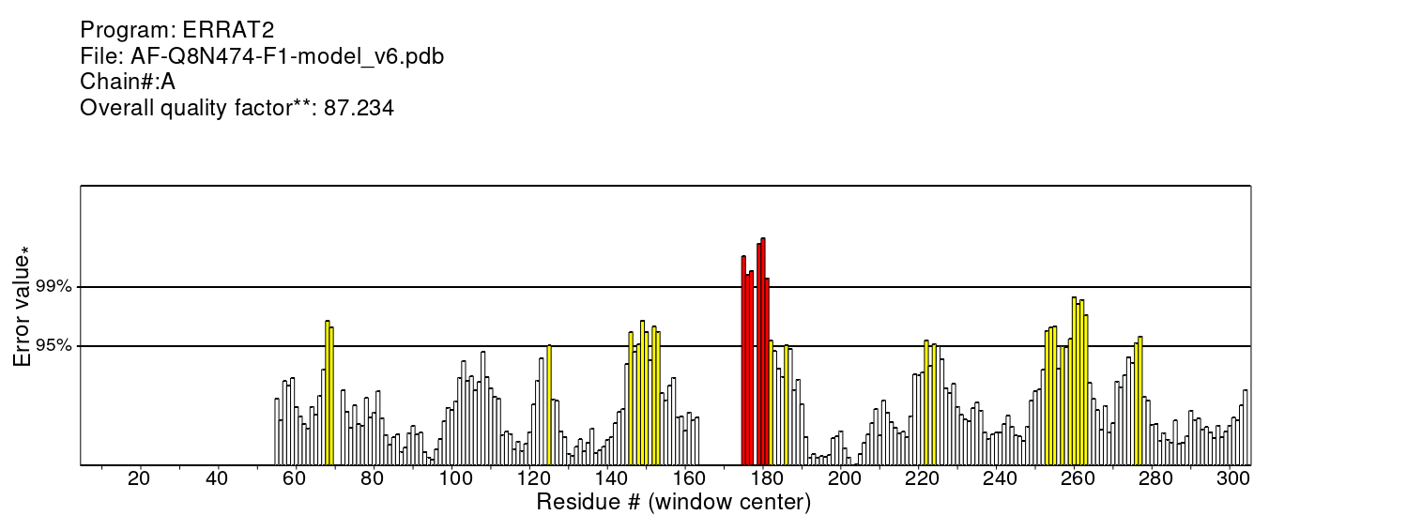

Fig.S2. Assessment by the ERRAT algorithm, which evaluates non-bonded atom interactions, yielded a score of 87.234
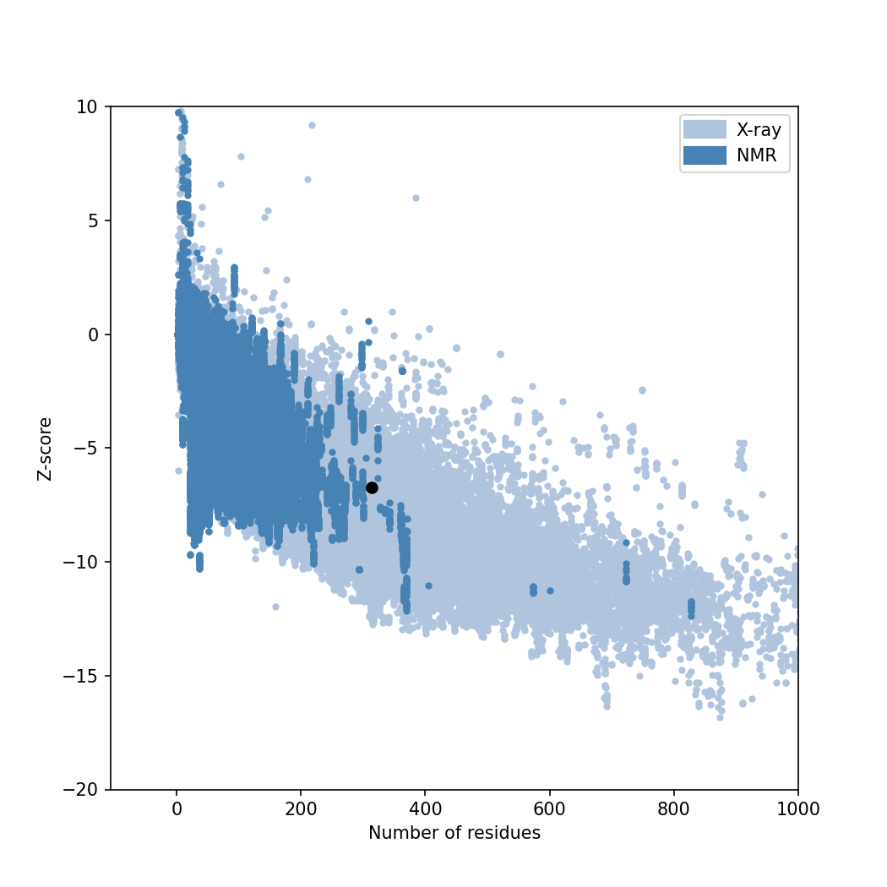
Fig.S3. Z-score of the constructed SFRP1 structure

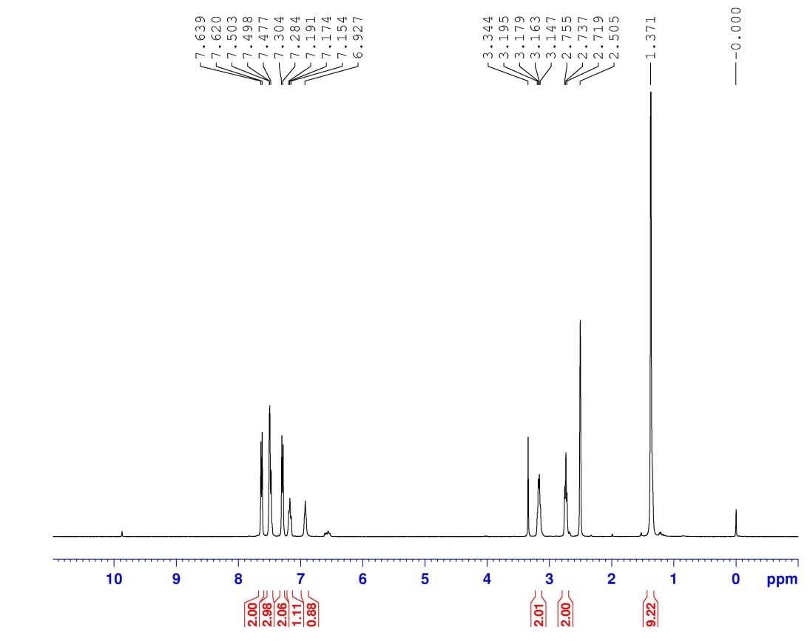
Fig.S4. The ¹H NMR plot of compound S1

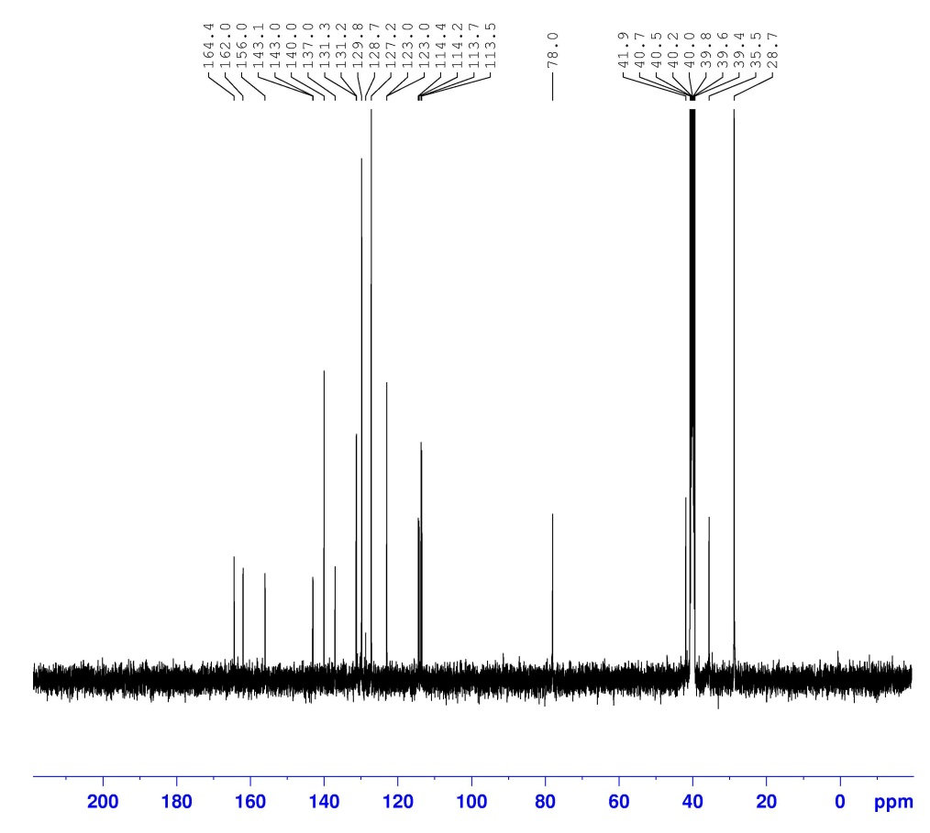
Fig.S5. The ¹³C NMR plot of compound S1

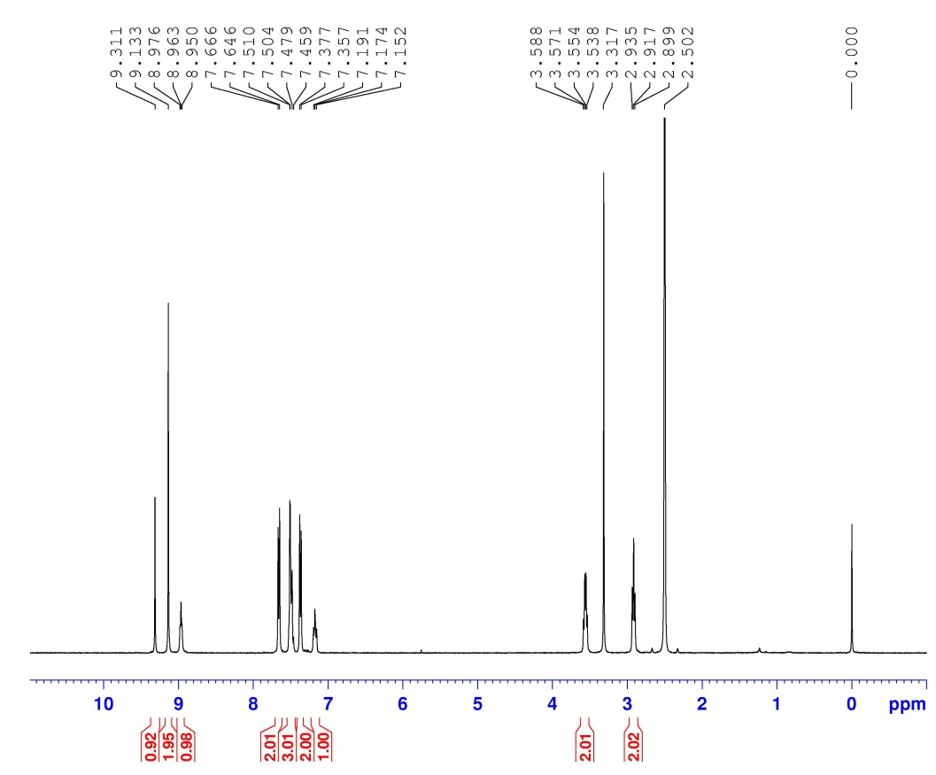
Fig.S6. The ¹H NMR plot of compound L1

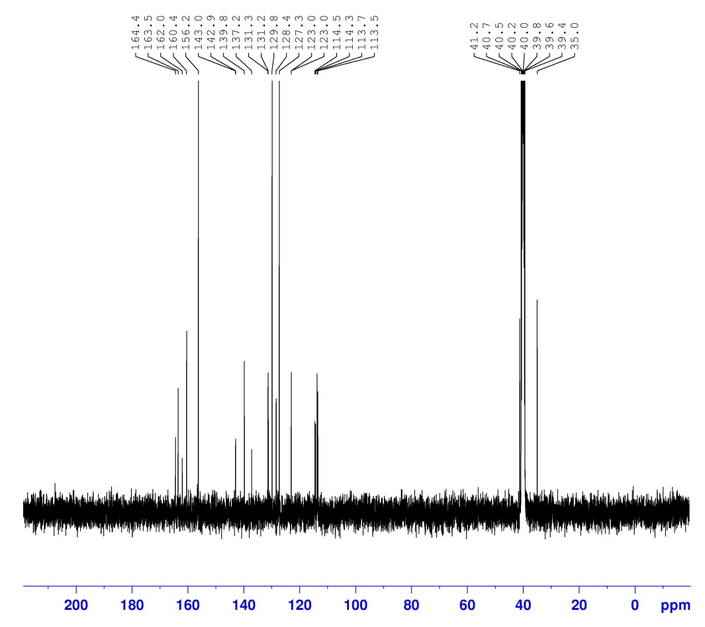
Fig.S7. The ¹³C NMR plot of compound L1

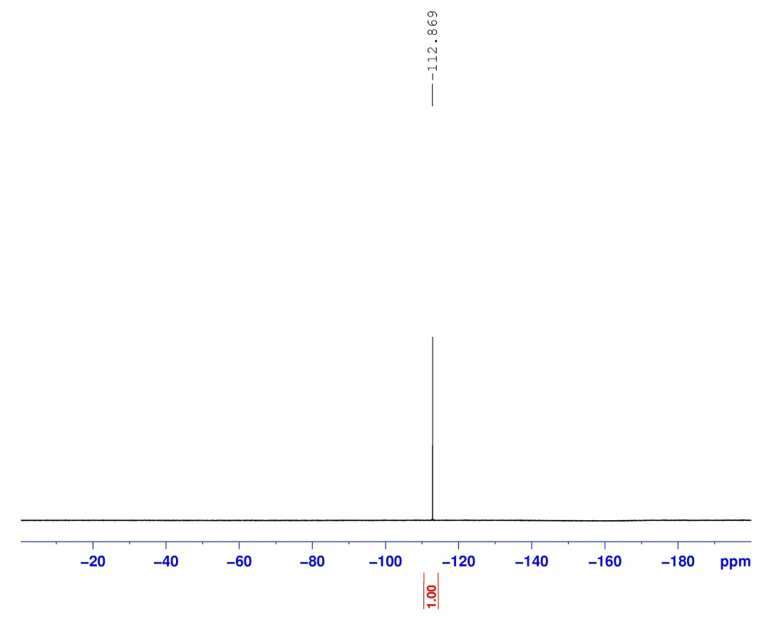
Fig.S8. The ¹⁹F NMR plot of compound L1

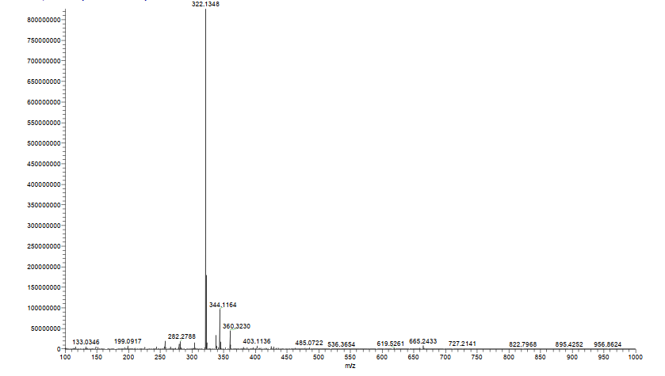
Fig.S9. The ESI-HRMS plot of compound L1

