Graphical Abstract

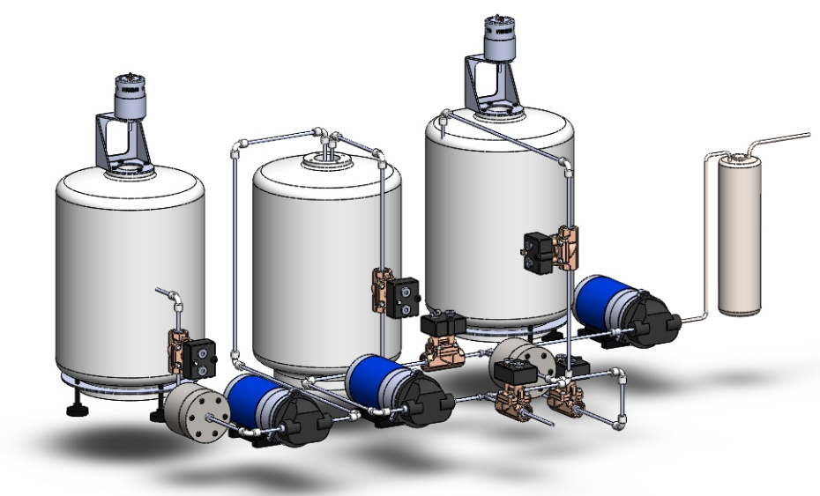
Heavy metals remediation

CSTR
reactor

Time
EDTA Conc.
Carbonation
Mixing tank
Dilution
pH
Mixing tank

Calcination
Drying
Calcium-rich waste
Purified CaCO₃
