Development, Hirshfeld surface analysis, DFT calculations and biological evaluation of neratinib loaded Co-crystals for solubility enhancement.
Scanning Absorbance Maxima
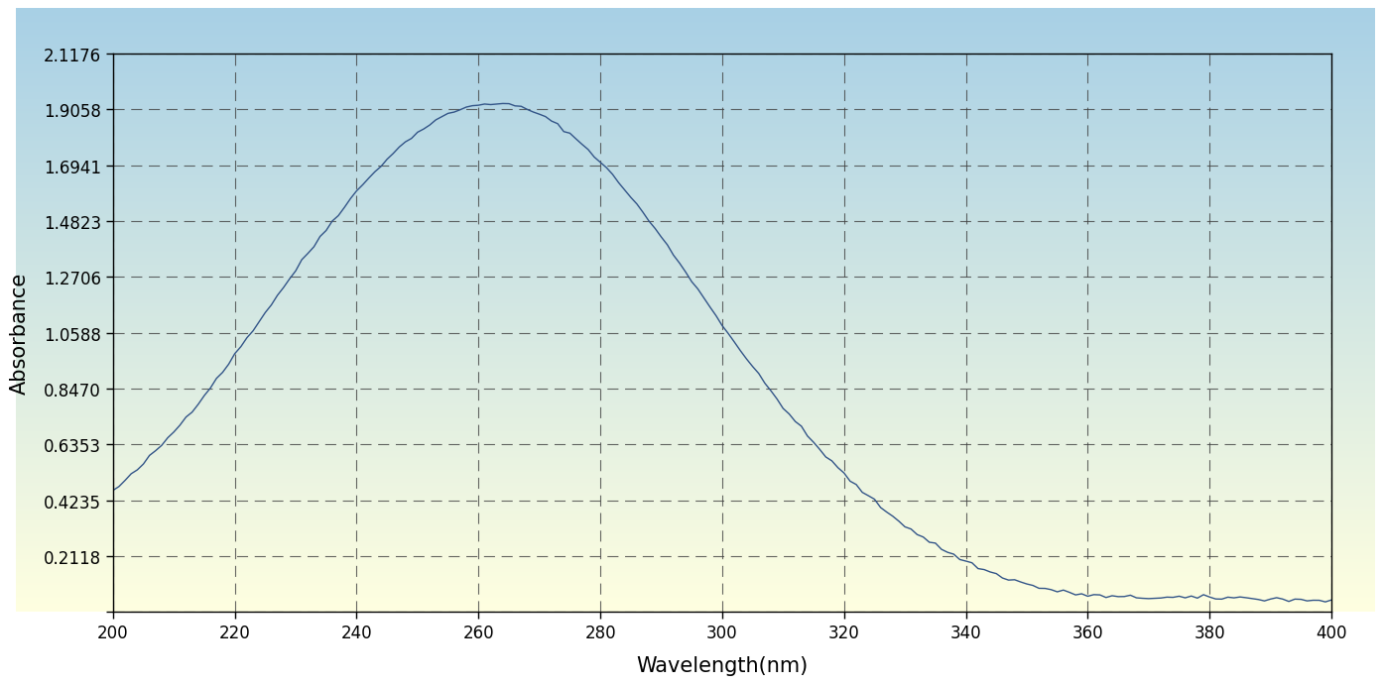
Figure S1: Scanning Absorbance Maxima of Neratinib in Methanol (264 nm)
Calibration Curve Determination
Table 4: Calibration Curve Data of Neratinib in Methanol
Sr. No. | Concentration (μg/mL) | Absorbance
1 | 2 | 0.182
2 | 4 | 0.364
3 | 6 | 0.559
4 | 8 | 0.728
5 | 10 | 0.910
6 | 12 | 1.092
Slope |  | 0.091
Intercept |  | 0.0019
Correlation Coefficient (R²) |  | 0.9998
Absorption Maxima (λ_{max}) |  | 264 nm

Table S1: Cumulative Percentage In Vitro Drug Release (mean ± SD, n = 3) from Neratinib–3-Hydroxybenzoic Acid Cocrystal Batches PF1–PF9 and Pure Neratinib
Time (min) | Pure Neratinib | PF1 | PF2 | PF3 | PF4 | PF5 | PF6 | PF7 | PF8 | PF9
0 | 0.00 ± 0.00 | 0.00 ± 0.00 | 0.00 ± 0.00 | 0.00 ± 0.00 | 0.00 ± 0.00 | 0.00 ± 0.00 | 0.00 ± 0.00 | 0.00 ± 0.00 | 0.00 ± 0.00 | 0.00 ± 0.00
5 | 3.8 ± 0.34 | 6.4 ± 0.48 | 7.9 ± 0.54 | 9.2 ± 0.61 | 10.1 ± 0.68 | 12.8 ± 0.76 | 14.6 ± 0.84 | 11.4 ± 0.72 | 15.8 ± 0.88 | 17.2 ± 0.94
10 | 6.9 ± 0.47 | 11.8 ± 0.66 | 14.2 ± 0.74 | 16.4 ± 0.82 | 17.9 ± 0.86 | 22.4 ± 1.08 | 25.6 ± 1.16 | 20.3 ± 0.98 | 27.8 ± 1.24 | 30.4 ± 1.32
15 | 9.4 ± 0.58 | 16.6 ± 0.82 | 19.8 ± 0.91 | 22.7 ± 0.98 | 25.1 ± 1.12 | 31.6 ± 1.34 | 36.2 ± 1.48 | 28.4 ± 1.22 | 39.4 ± 1.56 | 43.8 ± 1.64
20 | 11.6 ± 0.68 | 20.8 ± 0.96 | 24.9 ± 1.04 | 28.4 ± 1.12 | 31.8 ± 1.28 | 41.2 ± 1.54 | 47.1 ± 1.68 | 36.6 ± 1.38 | 51.2 ± 1.76 | 57.4 ± 1.84
30 | 14.2 ± 0.76 | 26.4 ± 1.14 | 31.6 ± 1.28 | 36.1 ± 1.36 | 40.8 ± 1.48 | 52.4 ± 1.78 | 59.6 ± 1.88 | 46.2 ± 1.62 | 63.8 ± 1.94 | 69.4 ± 2.02
45 | 16.8 ± 0.88 | 32.6 ± 1.38 | 38.4 ± 1.46 | 43.2 ± 1.58 | 48.6 ± 1.72 | 61.4 ± 1.86 | 67.8 ± 1.96 | 54.8 ± 1.84 | 72.6 ± 2.08 | 77.8 ± 2.16
60 | 18.4 ± 1.24 | 38.4 ± 1.74 | 43.6 ± 1.58 | 48.2 ± 1.86 | 54.3 ± 1.94 | 66.8 ± 2.02 | 73.4 ± 1.96 | 61.2 ± 2.08 | 78.4 ± 2.14 | 84.6 ± 1.92

