Supplemental Fig 1
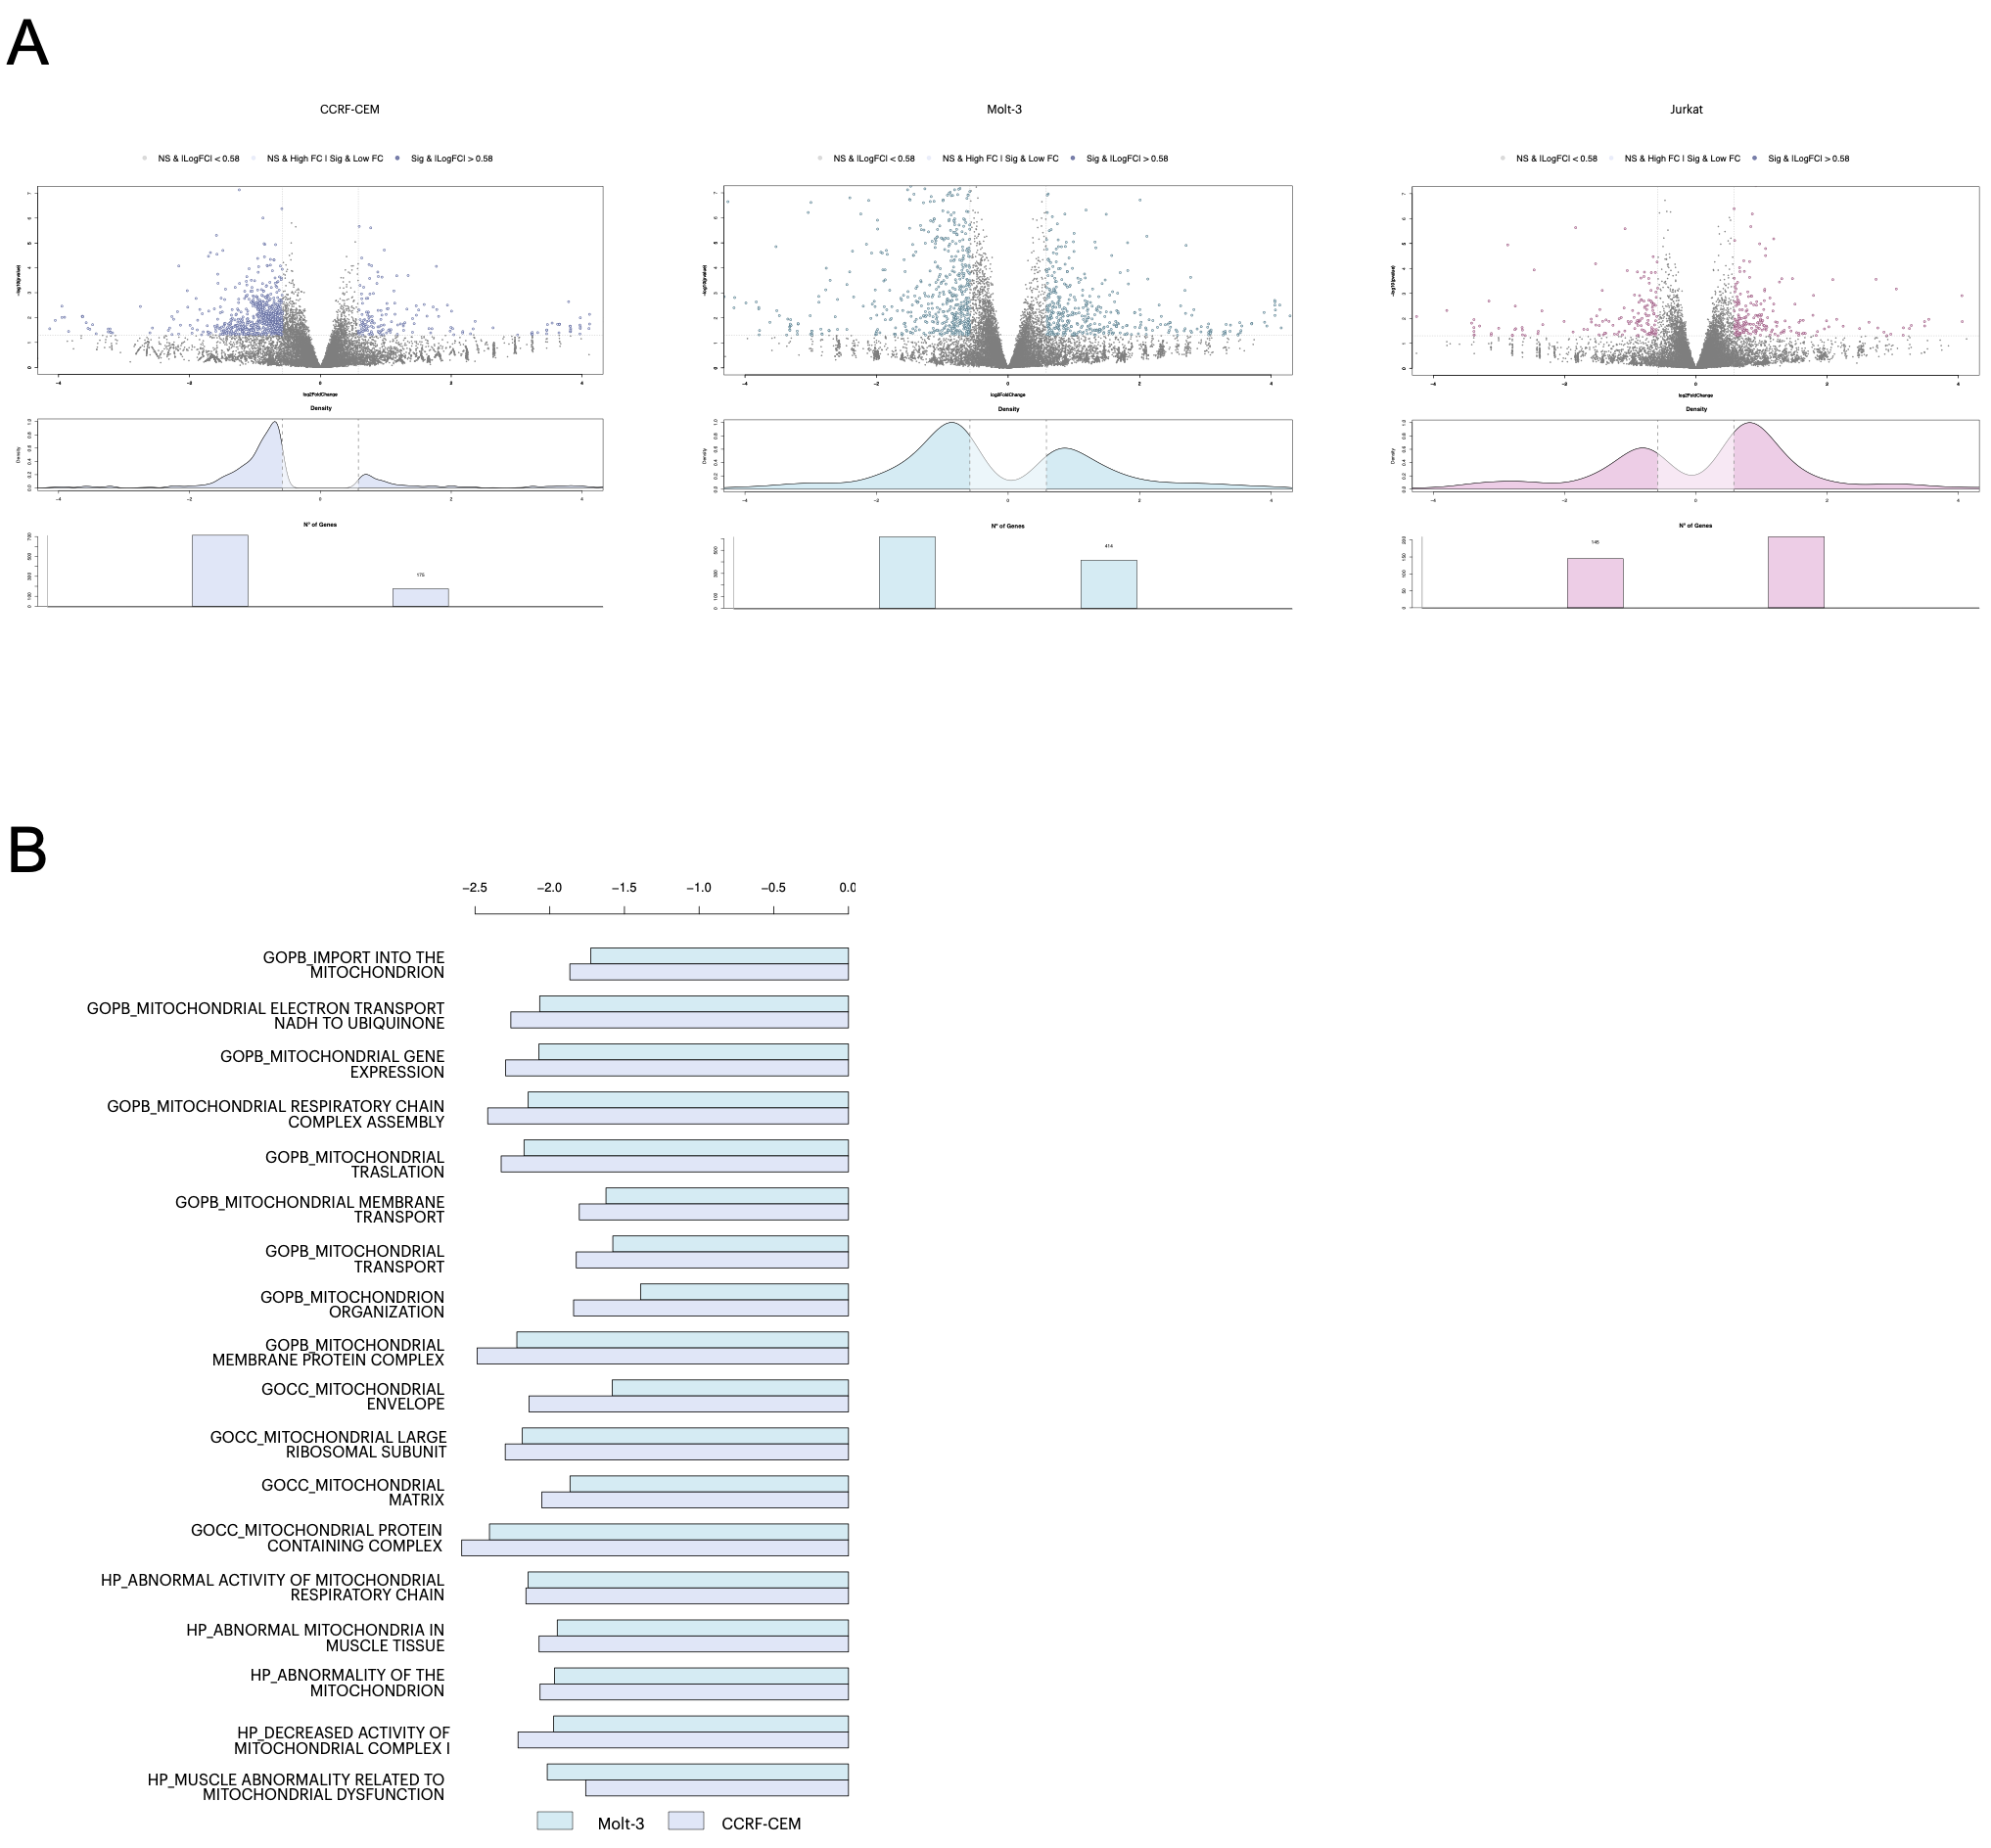

Supplemental Fig 2

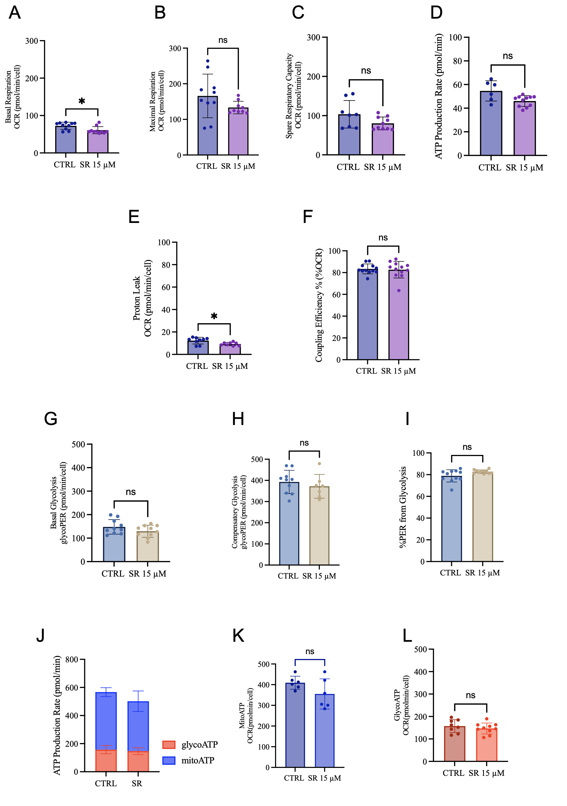

Supplemental Fig 3
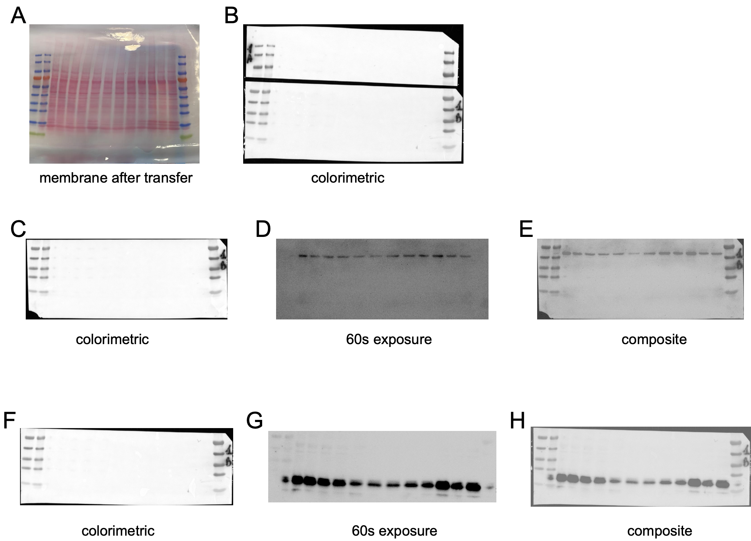

Supplemental Fig 4
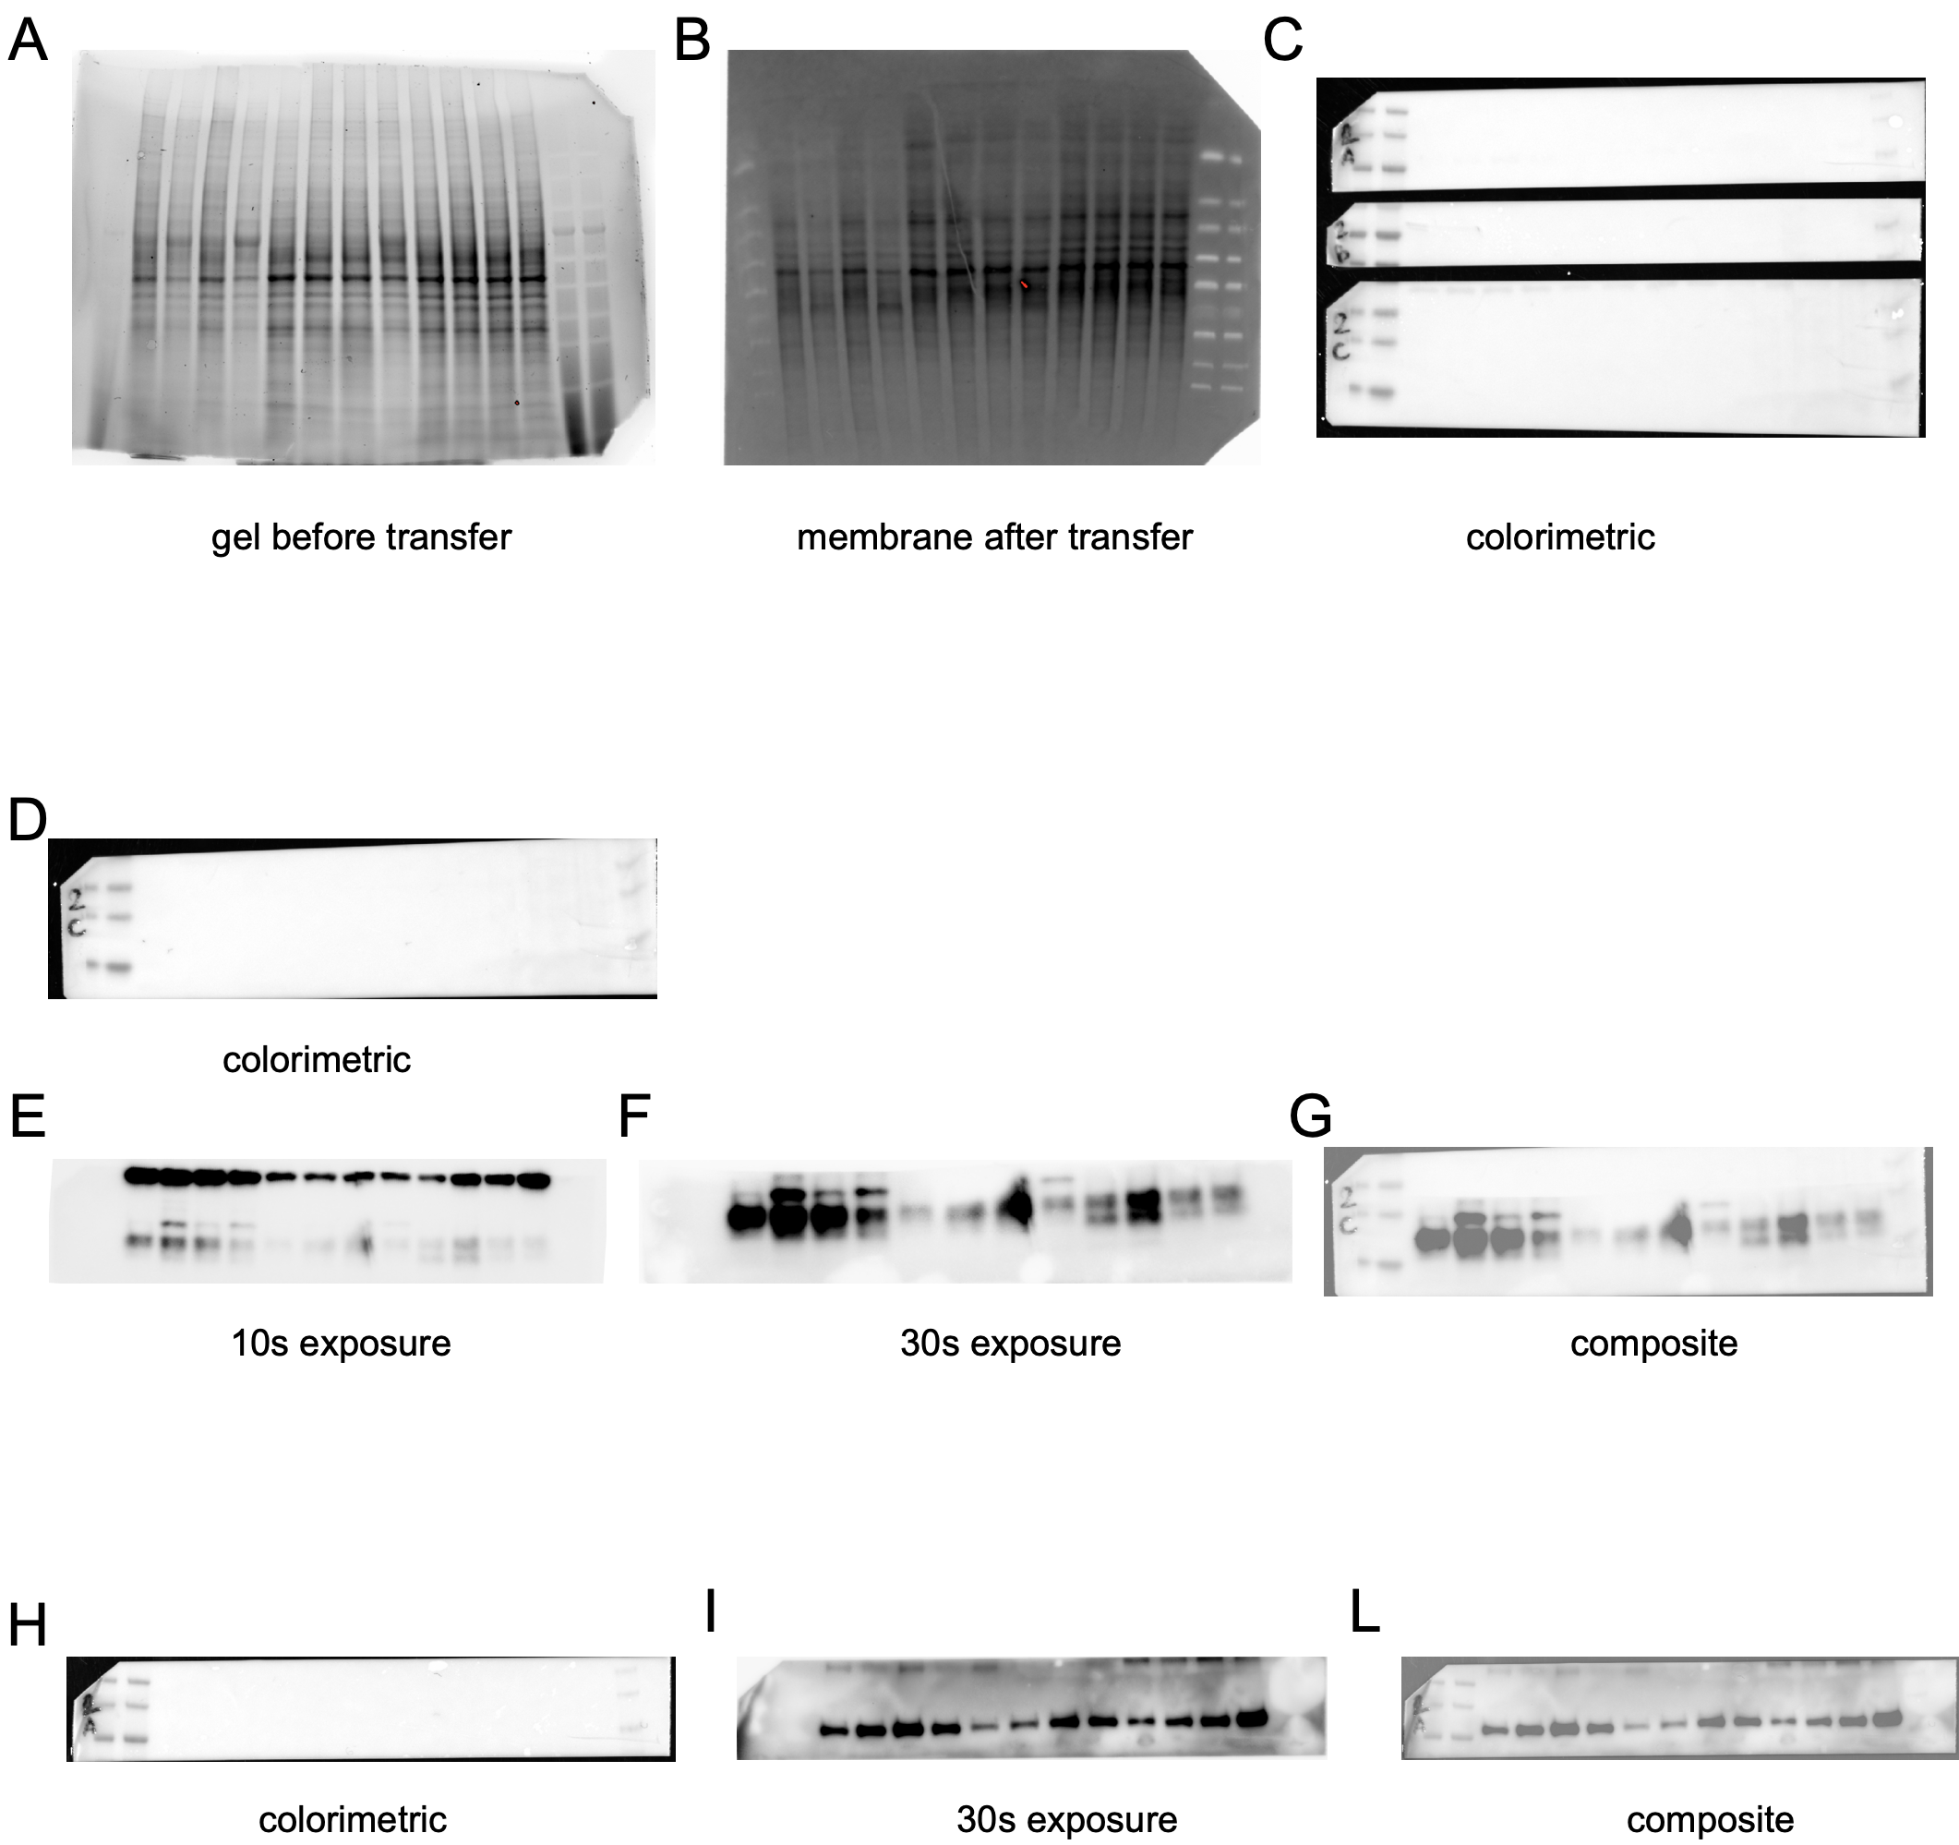

Supplemental Fig 5
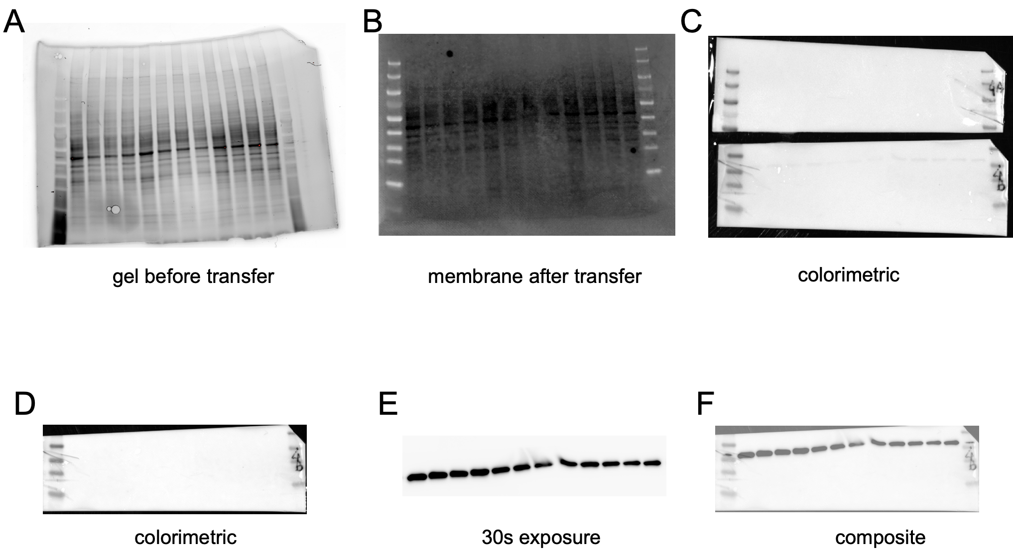

Supplemental Figure Legends

Fig S1) A Volcano plots showing differentially expressed genes (DEGs) in CCRF-CEM, Molt-3 and Jurkat cells after treatment with the β3-AR inhibitor SR. Differential expression analysis was performed using DESeq2. Genes were considered significantly deregulated with p-value < 0.05 and |log2FC| ≥ 0.58. Upper panels show log2 fold change vs significance, middle panels show distribution of fold changes, and lower panels show number of differentially expressed genes. B Gene Ontology (GO) Biological Processes, Cellular Components, and Hallmark pathways related to mitochondrial metabolism in CCRF-CEM and Molt-3 cells. Bar plot displays Normalized Enrichment Scores (NES) obtained from GSEA analysis.

Fig S2) Peripheral blood mononuclear cells (PBMCs) isolated from 10 healthy pediatric donors were treated with SR59230A (15 µM) for 24 hours. Mitochondrial respiration was assessed using the Cell Mito Stress Test, evaluating basal respiration A, maximal respiration B, spare respiratory capacity C, and ATP-linked respiration D. Glycolytic function was analyzed by Glycolytic Rate Assay, measuring basal glycolysis E, compensatory glycolysis F, and percentage of proton efflux rate derived from glycolysis (%PER from glycolysis) G. Total cellular ATP production was determined by ATP Rate Assay, including total ATP production J, mitochondrial ATP production K, and glycolytic ATP production L. Statistical significance was determined using the two-sided nonparametric Mann–Whitney test, as data were not normally distributed. *P ≤ 0.05.

Fig S3) Western-blot analysis of ADRB3 and GPX4 in T-ALL cell lines after 24-48-72h SR 15 µM treatment (Membrane 1), related to Figure 1G and 6K. Representative images from a single membrane are shown: A membrane immediately after transfer (post-transfer total protein check); B colorimetric image acquired on the ChemiDoc system for transfer/loading assessment; C colorimetric image of ADRB3 acquired on the ChemiDoc system after membrane cutting D ADRB3 chemiluminescent (ECL) exposure, short (60 s) highlighting high-abundance bands; E composite overlay of ADRB3 and colorimetric; F colorimetric image of GPX4 acquired on the ChemiDoc system after membrane cutting G GPX4 chemiluminescent (ECL) exposure, short (60 s) highlighting high-abundance bands; H composite overlay of GPX4 and colorimetric. Samples were loaded into gels from right to left, with the protein ladder in the first lane. Band intensities were quantified with ImageJ and normalized to stain-free total protein; quantitative data are reported in Fig. 1G and 6K (main text).

Fig S4) Western-blot analysis of FTH1 and CD71 in T-ALL cell lines after 24-48-72h SR 15 µM treatment (Membrane 1), related to Figure 6D and 6E. Representative images from a single membrane are shown: A stain-free gel image prior to transfer (UV activation for total-protein visualization); B membrane immediately after transfer (post-transfer total protein check); C colorimetric image acquired on the ChemiDoc system for transfer/loading assessment; D colorimetric image of FTH1 acquired on the ChemiDoc system after membrane cutting; E FTH1 chemiluminescent (ECL) exposure, short (30 s) highlighting high-abundance bands; F FTH1 chemiluminescent (ECL) exposure (60 s) highlighting high-abundance bands; G composite overlay of FTH1 and colorimetric; H colorimetric image of CD71 acquired on the ChemiDoc system after membrane cutting I CD71 chemiluminescent (ECL) exposure, short (30 s) highlighting high-abundance bands; L composite overlay of CD71 and colorimetric. Samples were loaded into gels from right to left, with the protein ladder in the first lane. Band intensities were quantified with ImageJ and normalized to stain-free total protein; quantitative data are reported in Fig. 6D and 6E (main text).

Fig S5) Western-blot analysis of LDHA in T-ALL cell lines after 24-48-72h SR 15 µM treatment (Membrane 1), related to Figure 6F. Representative images from a single membrane are shown: A stain-free gel image prior to transfer (UV activation for total-protein visualization); B membrane immediately after transfer (post-transfer total protein check); C colorimetric image acquired on the ChemiDoc system for transfer/loading assessment; D colorimetric image of LDHA acquired on the ChemiDoc system after membrane cutting E LDHA chemiluminescent (ECL) exposure, short (30 s) highlighting high-abundance bands; F composite overlay of LDHA and colorimetric. Band intensities were quantified with ImageJ and normalized to stain-free total protein; quantitative data are reported in Fig. 6F (main text).

Supplemental Methods

Cell line and cell culture
Information on cell line origin, immunophenotype, cytogenetics, and known mutations is provided in Table SM1.

Protein extraction and Western Blot Analysis
Detailed procedures are described below. Cell pellets were resuspended in RIPA lysis buffer (Millipore) supplemented with protease and phosphatase inhibitors (Sigma-Aldrich) and centrifuged at 10,000 × g for 30 min at 4°C. Protein concentration was determined using the Bradford assay (Bio-Rad) at 595 nm. Forty micrograms of total protein were separated on 4–20% SDS-PAGE precast gels and transferred onto PVDF or nitrocellulose membranes using a Trans-Blot Turbo Transfer System (Bio-Rad). Membranes were blocked in EveryBlot Blocking Buffer (Bio-Rad) and incubated overnight at 4°C with primary antibodies listed in supplemental Methods Table 2. After washing, membranes were incubated with HRP-conjugated secondary antibodies and developed using enhanced chemiluminescence reagents (Bio-Rad). Signal acquisition was done with a ChemiDoc imaging system (Bio-Rad). Densitometric analysis was performed using ImageJ (NIH). Protein signals were normalized to total protein per lane, obtained either from stain-free gel activation after transfer or from Ponceau S staining (Thermo Fisher Scientific). Background subtraction was applied uniformly across all lanes. Primary antibodies were diluted at the indicated concentrations (Table SM2) in 5% of Bovine Serum Albumine (BSA) prepared fresh in PBS-Tween20 (PBST) and used immediately for membrane incubation according to standard immunoblotting procedures.

Metabolic Assay
T-ALL cell lines, primary blasts and normal PBMCs were counted on the day of the assay and seeded at the same cell density to minimize OCR and PER variability due to differences in cell number rather than metabolic activity. Cells were washed twice in XF assay medium, plated in poly-L-lysine–coated XFe96 plates, and centrifuged at 1200 rpm for 10 min. Plates were incubated in a CO₂-free incubator at 37 °C according to the manufacturer’s instructions prior to Seahorse measurements. Pretreatment and sequential injections with concentrations are summarized in Table SM3.
Mitochondrial respiration (Mito Stress Test): Oxygen consumption rate (OCR) was measured under basal conditions and following sequential injections of oligomycin (1.5 µM), FCCP (1 µM), and rotenone/antimycin A (0.5 µM). Basal respiration reflects mitochondrial activity at baseline, and maximal respiration was calculated after FCCP injection.
Glycolysis (Glycolytic Rate Assay): Proton efflux rate (PER) was measured following sequential injections of Rot/AA (0.5 µM) and 2-deoxy-D-glucose (2-DG, 50 mM). Glycolytic rate (glycoPER) correlates 1:1 with extracellular lactate accumulation.
ATP production (ATP Rate Assay): ATP production rates (glycoATP, mitoATP, total ATP) and the XF-ATP rate index were determined using the ATP Rate Assay, with sequential injections of oligomycin and Rot/AA.
Substrate Oxidation Stress Test: to evaluated the contribution of three primary mitochondrial fuels (glucose/pyruvate, glutamine, and long-chain fatty acids) to cellular respiration, allowing assessment of how cells shift substrate utilization when alternative pathways are inhibited. Cells were sequentially treated with UK5099 (mitochondrial pyruvate carrier inhibitor), BPTES (glutaminase inhibitor), and Etomoxir (CPT1A inhibitor) according to manufacturer’s instructions.
Palmitate Oxidation Stress Test: Performed to specifically evaluate the effect of SR59230A on long-chain fatty acid oxidation (FAO) by monitoring changes in OCR.
Injection strategies, concentrations, and sources of drugs and compounds used in Seahorse metabolic assays are listed in Supplemental Methods Table 3.

Quantitative Reverse Transcription–Polymerase Chain Reaction (qRT-PCR)
T-ALL cells were seeded in 6-well plates at a density of 5 × 10⁵ cells/mL and treated with 15 µM SR for 24, 48, or 72 h. Following treatment, cells were pelleted, washed with PBS, and lysed in 500 or 1000 µL of TRIzol reagent (Invitrogen) according to pellet size, then stored at at -20C until RNA extraction, according to the manufacturer’s instructions. Reverse transcription was performed using 1 µg of total RNA with a High-Capacity cDNA Reverse Transcription Kit (Applied Biosystems). Quantitative PCR was carried out using 1× SYBR Green Supermix (Bio-Rad) and 300 nM of each primer in a 20 µL reaction volume. Primers (Sigma-Aldrich; Saint Louis, MO, USA) are listed in Table SM4. The relative quantification (RQ) of mRNA expression of GPX4, FSP1, and NRF2 was calculated using the 2^-( ΔΔCt) method (Ct = cycle threshold), sample calculations were
normalized to GAPDH.

RNA sequencing (RNAseq)
Total RNA extraction was performed using the RNeasy Plus Mini kit (Qiagen) according to the manufacturer's protocol. RNA quality and integrity were assessed prior to sequencing. Libraries were prepared using poly(A) selection combined with globin mRNA removal, followed by the generation of strand-specific libraries. Sequencing was carried out on the DNBSEQ platform in paired-end mode, generating approximately 30 million reads per sample.

Data Pre-processing and Alignment
Raw paired-end sequencing reads were initially subjected to quality control assessment using FastQC (v0.11.9). To ensure high-quality data for downstream analysis, adapter sequences and low-quality bases were trimmed using fastp (v0.20.1), applying default parameters for paired-end data. The resulting high-quality clean reads were aligned to the human reference genome (GRCh38.p13, assembly 38) using the splice-aware aligner STAR (v2.7.10a). Alignment was performed utilizing the GeneCounts quant mode to facilitate preliminary inspection, with the Homo_sapiens.GRCh38.113 annotation file guiding the splice junction mapping. Post-alignment processing, including sorting and indexing of BAM files, was managed within the STAR workflow. Gene-level expression quantification was performed using the featureCounts utility from the Rsubread package (v2.14.2). Fragments were counted at the exon level and summarized by gene ID (Ensembl), strictly counting read pairs that mapped to the same gene. Dimensionality reduction was performed using Principal Component Analysis on rlog-transformed data to visualize sample clustering and variance. Statistical analysis of differential gene expression was conducted in the R statistical environment (v4.2.1) using the DESeq2 package (v1.40.1). Prior to analysis, the dataset was filtered to remove one outlier sample identified during quality control checks and low-abundance genes (row sums < 10 reads) to reduce the false discovery rate burden. Raw counts were normalized using the median of ratios method implemented in DESeq2. Differential expression results were annotated by mapping Ensembl IDs to Gene Symbols using the org.Hs.eg.db package. To identify biological pathways modulated by the treatment, Gene Set Enrichment Analysis (GSEA) was performed using the fgsea package (v1.26.0). Enrichment was tested against the Gene Ontology Biological Processes (C5:GOBP) and the Hallmark (H) gene sets obtained from the Molecular Signatures Database (MSigDB). To facilitate high-level biological interpretation, Hallmark gene sets were further aggregated into process categories ("superpathways") following the classification schema described by Liberzon et al¹. Significant pathways were defined using a false discovery rate (FDR) cutoff of < 0.05. To identify robust therapeutic signatures, we prioritized pathways that were concordantly modulated (showing consistent Normalized Enrichment Scores, NES) in the responsive cell lines (CEM and Molt-4) while showing divergent or non-significant regulation in the resistant/distinct line (Jurkat).

Supplemental Tables

 | ªSex | Age at Diagnosis (years) | Protocol | Risk | WBC (x10^3/µL) | RBC (x10^6/µL) | PLT (x10^3/µL) | HCT (%) | HGB (g/dl) | MCV (fl) | MCH (pg) | MCHC (g/dl) | FTH1 (ng/mL) | sTfR (mg/L) | Fe (µg/dL) | CRP (mg/dL) | ALP (U/L) | UA (mg/dL) | HSCT | Conditioning before TCSE | Relapse | Alive at last follow up
T-ALL 4 | M | 6 | AIEOP BFM ALL 2017 | GPR. CNS1. early non-SR. random IB/2 long. HR | 308.1 | 4.05 | 96 | 32 | 14.02 | 79.2 | 35.1 | 44.3 | 409 | 214 | NA | 1.08 | 244 | 14.20 | No |  | Yes | No
Table SM1: Clinical and hematological data from medical records of 1 newly diagnosed patient with T-ALL treated at the Meyer Children’s Hospital IRCCS between December 2019 and December 2023.

Cell line | Origin | Immunology | Cytogenetics | Molec. Genet
CCRF-CEM | established from the peripheral blood of a 3-year-old girl with acute lymphoblastic leukemia (ALL) at relapse (terminal) in 1964 (first continuous human T-ALL cell line). | CD2 -, CD3 +, CD4 +, CD5 +, CD6 +, CD7 +, CD8 -, CD13 -, CD14 -, CD15 +, CD19 -, CD33 -, CD34 -, HLA-DR -, TCRalpha/beta +, TCRgamma/delta - | human near-tetraploid karyotype with extensive subclonal variation - 90(88-101)<4n>XX, -X, -X, +20, +20, t(8;9)(p11;p24)x2, der(9)del(9)(p21-22)del(9)(q11q13-21)x2 - sideline with +5, +21, add(13)(q3?3), del(16)(q12) | expression of NKX2-5 (This gene encodes a homeobox-containing transcription factor)
Molt-3 | established from the peripheral blood of a 19-year-old man with acute lymphoblastic leukemia (ALL) in relapse in 1971 | CD2+, CD3-, CD4(+), CD5+, CD6+, CD7+, CD8+, CD13-, CD19-, CD34(+), TCRalpha/beta-, TCRgamma/delta-, cyCD3+ | human hypertetraploid karyotype - 98(94-101)<4n>XXYY, +6, +7, +8, +8, +17, +20, del(6)(q16)x2, der(7)t(7;7)(p15;q11)x2 - identity confirmed | -
Jurkat | established from the peripheral blood of a 14-year-old boy with acute lymphoblastic leukemia (ALL) at first relapse in 1976 | CD2+, CD3+, CD4-, CD5+, CD6+, CD7+, CD8-, CD13-, CD19-, CD34(+), cyCD3+, TCRalpha/beta+, TCRgamma/delta- | human flat-moded hypotetraploid karyotype with 7.8% polyploidy - 87(78-91)<4n>XX, -Y, -Y, -5, -16, -17, -22, add(2)(p21)/del(2)(p23)x2 - sideline with additional der(5)t(5;10)(q11;p15), del(9)(p11)

Table SM2: Origin, immunophenotype, cytogenetics, and key mutations of the T-ALL cell models used in this study

Antibody | Dilution | Company | Catalog Number
ADRB3 | 1:1000 | Abcam (Cambridge, MA, USA) | ab9406
FTH1 (D1D4) | 1:1000 | Cell Signaling Technology (Danvers, MA, USA) | #4393
CD71 (D7G9X) | 1:1000 | Cell Signaling Technology (Danvers, MA, USA) | #13113
LDHA | 1:1000 | Cell Signaling Technology (Danvers, MA, USA) | #3582
GPX4 | 1:1000 | Cell Signaling Technology (Danvers, MA, USA) | #52455

Table SM3: Primary antibodies used for Western blot analysis, including dilution, supplier, and catalog number.

Test | Injection / Pretreatment | Concentration |  | Source / Company
Mito Stress Test | Oligomycin | 1.5 µM | Sigma-Merck
Mito Stress Test | FCCP | 1 µM | Sigma-Merck
Mito Stress Test | Rotenone/Antimycin A (Rot/AA) | 0.5 µM | Sigma-Merck
Glycolysis Stress Test | Rot/AA | 5 µM | Sigma-Merck
Glycolysis Stress Test | 2-Deoxy-D-glucose (2-DG) | 50 mM | Sigma-Merck
ATP Rate Assay | Oligomycin | 1.5 µM | Sigma-Merck
ATP Rate Assay | Rot/AA | 0.5 µM | Sigma-Merck
Substrate Oxidation Test | UK5099 (MPC inhibitor) | 2 µM | Sigma-Merck
Substrate Oxidation Test | BPTES (GLS1 inhibitor) | 3 µM | Sigma-Merck
Substrate Oxidation Test | Perhexiline maleate salt (CPT1A/2 inhibitor) | 4 µM | Sigma-Merck
Substrate Oxidation Test | Oligomycin | 1.5 µM | Sigma-Merck
Substrate Oxidation Test | FCCP | 1 µM | Sigma-Merck
Substrate Oxidation Test | Rotenone/Antimycin A (Rot/AA) | 0.5 µM | Sigma-Merck
Palmitate Oxidation Stress Test | L-Carnitine hydrochloride | 0.5 mM | Sigma-Merck
Palmitate Oxidation Stress Test | HEPES | 5 mM | Sigma-Merck
Palmitate Oxidation Stress Test | Palmitate-BSA | 100 µM | Sigma-Merck
Palmitate Oxidation Stress Test | BSA control | 100 µM | Sigma-Merck
Palmitate Oxidation Stress Test | Perhexiline maleate salt (CPT1A/2 inhibitor) | 4 µM | Sigma-Merck
Palmitate Oxidation Stress Test | Oligomycin | 3 µM | Sigma-Merck
Palmitate Oxidation Stress Test | FCCP | 2 µM | Sigma-Merck
Palmitate Oxidation Stress Test | Rotenone/Antimycin A (Rot/AA) | 5 µM | Sigma-Merck

Table SM4: Injections, concentrations, and sources of drugs and compounds used in Seahorse metabolic assays

Gene | Forward primer (5’–3’) | Reverse primer (5’–3’)
GPX4 | CCTGGACAAGTACCGGGGCT | AAACCACACTCAGCGTATCG
FPS1 | ACATGGTGAGGCAGGTCCA | GCCACTTGGGAGTGAATGAG
NRF2 | GGCGGGAGGACCTTCTGTATGC | GGCCCAATTTTGTTCCACCTCTCC
GAPDH | TGCACCACCAACTGCTTAGC | GGCATGGACTGTGGTCATGAG

Table SM5: Primers sequences of Real-Time Expression Analysis

Supplemental Methods References

1. Liberzon, A. et al. The Molecular Signatures Database (MSigDB) hallmark gene set collection. Cell Syst. 1, 417–425 (2015).

