TYPICAL CASE
A 59-year-old male patient was admitted with the chief complaints of "15-year history of type 2 diabetes mellitus and recurrent ulceration and infection of the right foot for 7 months." The outpatient diagnosis included: 1. Right diabetic foot (Wagner stage 4); 2. Diabetic peripheral neuropathy; 3. Type 2 diabetes mellitus. The patient underwent surgical treatment of "right foot debridement + transverse tibial bone grafting." Postoperative follow-up at 12 months showed good wound healing of the right foot with no recurrence of ulceration (see Figures a–j).
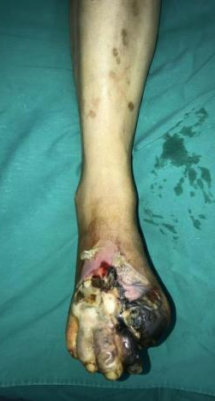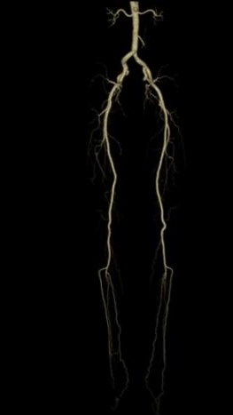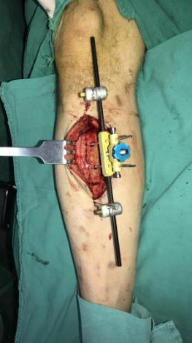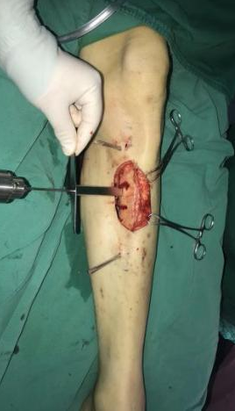
Figure a Figure b Figure c Figure d Figure e

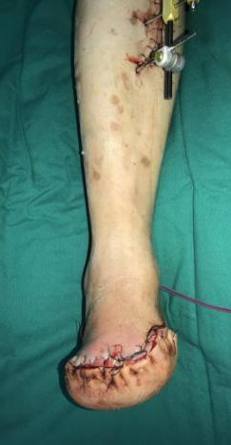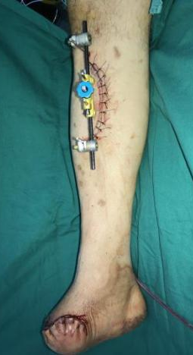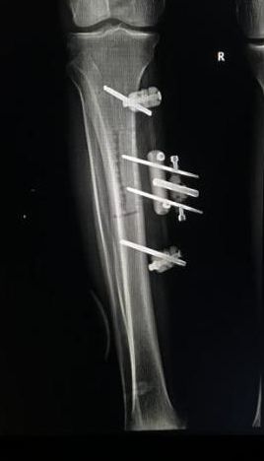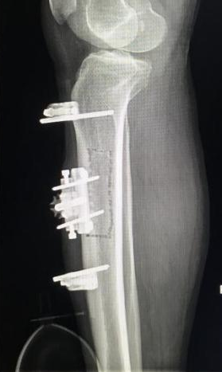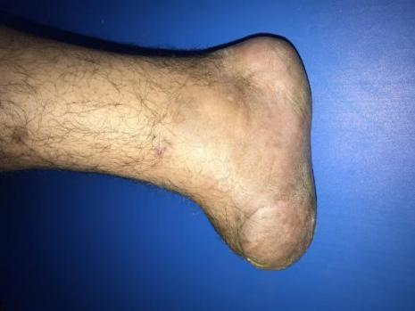
Figure f Figure g Figure h Figure i Figure j

Figure Legends
Figure a: Preoperative photograph showing gangrene and infection involving the dorsum of the right foot and the first to fourth toes.
Figures b–c: Lower limb CTA demonstrating occlusion of the right dorsalis pedis artery.
Figures d–g: Intraoperative views showing completed foot debridement and transverse tibial bone transport (TTT).
Figures h–i: Postoperative radiographs revealing stable fixation of the external fixator and satisfactory alignment of the tibial osteotomy site.
Figure j: Twelve-month postoperative follow-up showing well-healed wounds of the right foot with no recurrence of ulceration.

