Supplementary Figure S1. Full directed CLPN network. All cross-lagged predictive edges from T1 to T2 symptoms are shown (edge weights ≥ 0.05). Arrow thickness represents the strength of prediction.
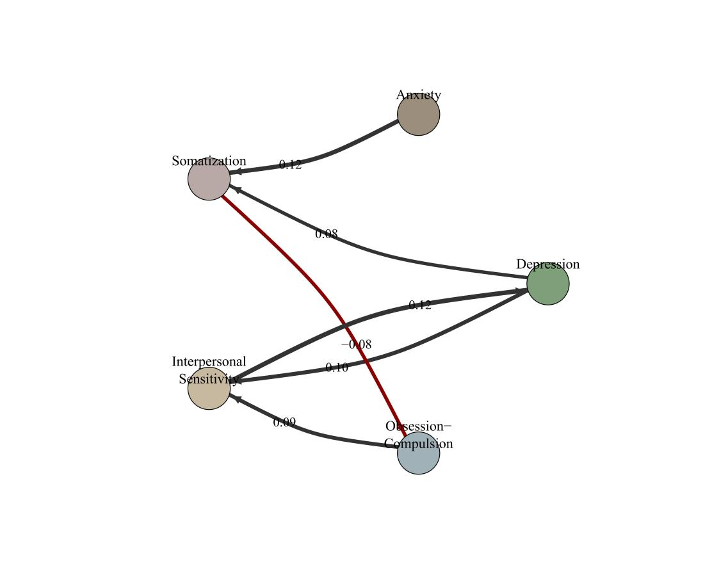
Supplementary Figure S2. Heatmap of the full CLPN coefficient matrix. Darker green indicates stronger positive prediction; darker purple indicates stronger negative prediction. Black numbers indicate significant paths (FDR-corrected p < 0.05).
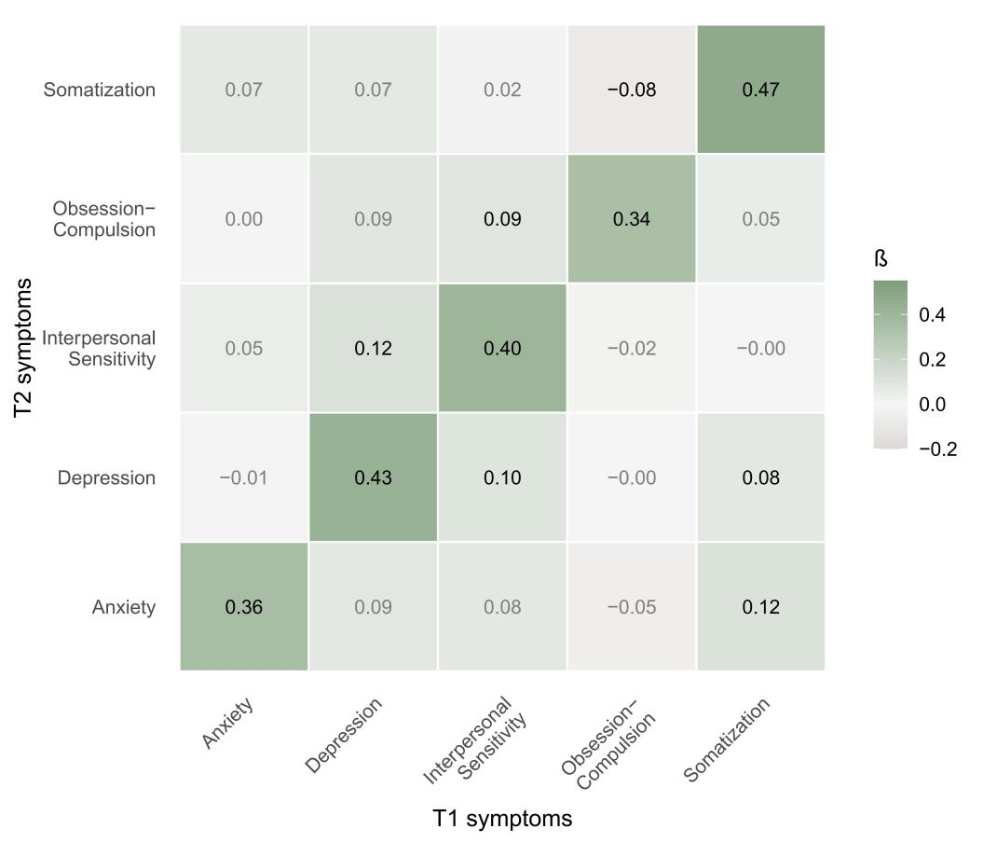
Supplementary Figure S3. Strength centrality of the change-score network. Bar plot showing node strength centrality (sum of absolute edge weights) for each symptom change (Δ). Higher strength indicates greater centrality in the synchronous symptom change network.
