Survey on Pediatric Organ Donation Practices and Barriers in Japanese Intensive Care Units
Study Purpose:
This study aims to identify barriers to pediatric brain-death organ donation in Japan, where donation rates remain substantially lower than in other developed countries. Because institutional protocols for organ donation and donor management vary widely without standardized national guidelines, and because inter-institutional comparative studies are limited, we developed this web-based survey to characterize current practices and epidemiology.

Consent:
☐ I consent to participate in this study

=====================================================================
SECTION 1: Institutional Characteristics
1. Institution Name: ______________________________________

2. Institution Category
- ☐ University Hospital
- ☐ Japanese Association for Acute Medicine (JAAM) Accredited Training Facility
- ☐ Japan Neurosurgical Society (JNS) Core or Affiliated Training Facility
- ☐ Certified Emergency and Critical Care Center
- ☐ Japanese Association of Children's Hospitals and Related Institutions (JACHRI) Member
- ☐ None of the above

3. Respondent Characteristics
Department:
- ☐ Pediatrics
- ☐ Intensive Care Medicine
- ☐ Emergency Medicine
- ☐ Anesthesiology
- ☐ Neurosurgery
- ☐ Other

Position: ______________________________________

Years Since Medical School Graduation:
- ☐ 6–15 years
- ☐ 16–25 years
- ☐ 26–35 years
- ☐ 36–45 years
- ☐ >45 years

4. Number of ICU Beds for pediatric patients at risk of brain death: (________) beds

5. ICU Type
- ☐ Open ICU
- ☐ Semi-closed ICU
- ☐ Closed ICU

6. Primary Department managing potential brain-dead pediatric patients
- ☐ Pediatrics
- ☐ Intensive Care Medicine
- ☐ Emergency Medicine
- ☐ Anesthesiology
- ☐ Neurosurgery
- ☐ Other

7. Pediatric Organ Donation Protocols
- ☐ Established
- ☐ Not established

8. If not established, what infrastructure is needed? (select all that apply)
- ☐ Operating room availability
- ☐ Institutional consensus
- ☐ Ethics committee
- ☐ Organ donation committee
- ☐ Legal brain-death determination system
- ☐ Child abuse evaluation protocol
- ☐ In-hospital donor coordinator
- ☐ Critical-care mediator
- ☐ External transplant team collaboration
- ☐ Staff psychological support system
- ☐ Administrative support
- ☐ Other (specify): ______________________________________

=====================================================================
SECTION 2: Organ Donation Epidemiology
1. Has your institution performed organ donation? (including adult patients)
- ☐ Yes
- ☐ No

2. Has your institution performed organ donation in pediatric patients (<18 years old)?
- ☐ Yes
- ☐ No

For the following questions, please report data for the calendar year 2024 (January 1 – December 31, 2024).

3. Case Numbers at Each Step of the Donation Pathway
A. Total ICU deaths
All deaths in ICU
Number: (________)

B. Patients suspected of brain death
Persistent deep coma with fixed, dilated pupils in the absence of CNS depressants or neuromuscular blockade
Number: (________)

C. Cerebral/brainstem function evaluation NOT performed
Evaluation in accordance with Legal Brain-Death Determination Manual (assessment of deep coma, fixed dilated pupils, absent brainstem reflexes, isoelectric EEG) was not conducted
Number: (________)
Reasons (select all that apply):
- ☐ Anticipated imminent death or hemodynamic instability
- ☐ Institutional policy against routine evaluation
- ☐ Unknown
- ☐ Other

D. Potential organ donors identified
Diagnosed with conditions potentially progressing to brain death (irreversible cessation of all brain function with apnea)
Number: (________)

E. Donation options NOT presented
Organ donation was not discussed with family
Number: (________)
Reasons (select all that apply):
- ☐ Prior family refusal
- ☐ Forensic autopsy required
- ☐ Viral infection (e.g., hepatitis)
- ☐ Active infection
- ☐ Malignancy (excluding primary CNS tumors)
- ☐ Acute intoxication
- ☐ Metabolic/endocrine disorder
- ☐ Suspected child abuse
- ☐ Age <12 weeks
- ☐ Intellectual disability
- ☐ No longer met criteria
- ☐ Hemodynamic instability
- ☐ Unknown
- ☐ Other

F. Donation options presented to families
Organ donation was discussed with family
Number: (________)

G. Legal brain-death determination NOT performed
Did not proceed to legal determination despite discussion
Number: (________)
Reasons (select all that apply):
- ☐ Family declined
- ☐ Forensic autopsy required
- ☐ Viral infection
- ☐ Active infection
- ☐ Malignancy (excluding primary CNS tumors)
- ☐ Acute intoxication
- ☐ Metabolic/endocrine disorder
- ☐ Suspected child abuse
- ☐ Intellectual disability
- ☐ No longer met criteria
- ☐ Clinical deterioration
- ☐ Unknown
- ☐ Other

H. Legal brain-death determination performed
Underwent formal legal determination
Number: (________)

I. Did NOT proceed to organ donation
Did not donate despite determination
Number: (________)
Reasons (select all that apply):
- ☐ Did not meet legal criteria
- ☐ Family withdrew consent
- ☐ Developed active infection
- ☐ Hemodynamic instability
- ☐ Unknown
- ☐ Other

J. Brain-death organ donations completed
Successfully proceeded to organ procurement
Number: (________)

K. Cardiac-death organ donations completed
Donation after cardiac death
Number: (________)

Patients flow through the organ donation pathway in ICU deaths
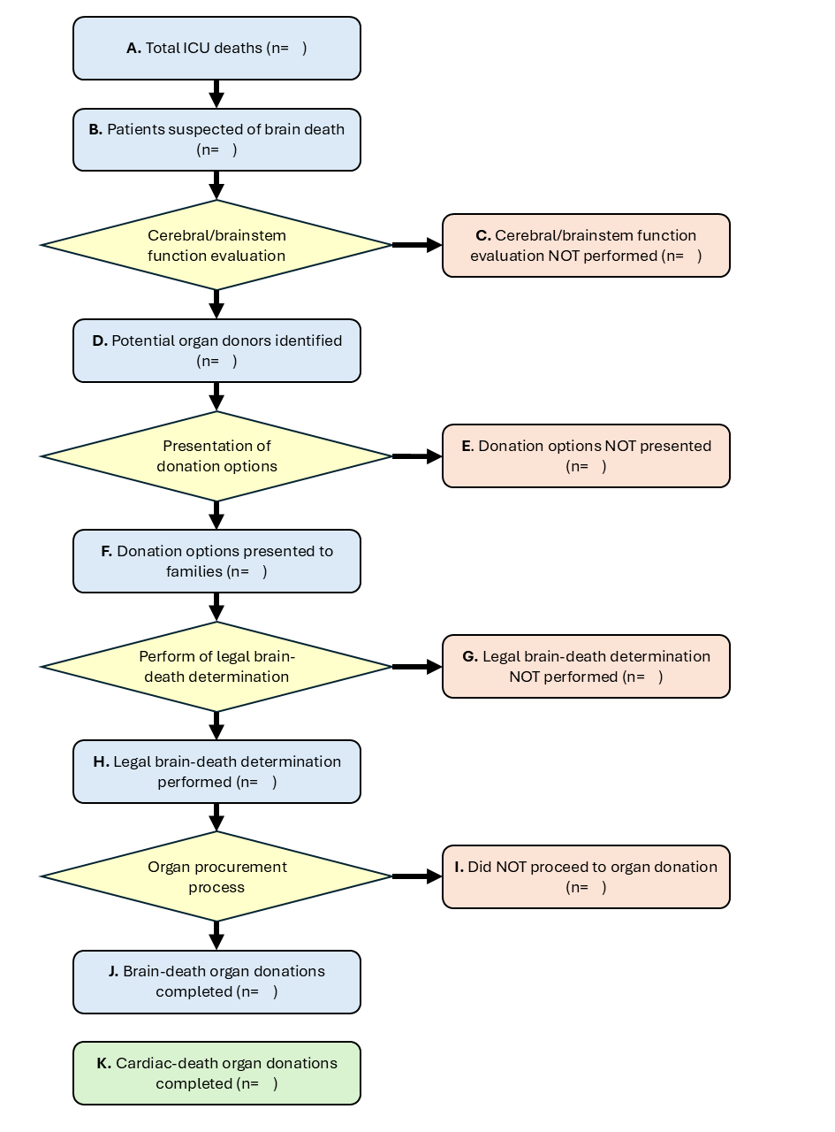
4. Patients Discharged Alive
Number of potential organ donors discharged alive from ICU: (________)

5. Airway Management Status at Discharge
(for patients discharged alive - select all that apply)
- ☐ Tracheostomy newly performed during ICU stay
- ☐ Pre-existing tracheostomy
- ☐ Discharged with endotracheal tube
- ☐ Unknown
- ☐ Other

6. Reasons Donation Options Were NOT Presented
(for patients discharged alive)
Number: (________)
Reasons (select all that apply):
- ☐ Prior family refusal
- ☐ Forensic autopsy required
- ☐ Viral infection
- ☐ Active infection
- ☐ Malignancy (excluding primary CNS tumors)
- ☐ Acute intoxication
- ☐ Metabolic/endocrine disorder
- ☐ Suspected child abuse
- ☐ Age <12 weeks
- ☐ Intellectual disability
- ☐ No longer met criteria
- ☐ Hemodynamic instability
- ☐ Unknown
- ☐ Other

7. Reasons for NOT Proceeding
(for patients discharged alive who were approached)
Number: (________)
Reasons (select all that apply):
- ☐ Family declined
- ☐ Forensic autopsy required
- ☐ Viral infection
- ☐ Active infection
- ☐ Malignancy (excluding primary CNS tumors)
- ☐ Acute intoxication
- ☐ Metabolic/endocrine disorder
- ☐ Suspected child abuse
- ☐ Intellectual disability
- ☐ No longer met criteria
- ☐ Clinical deterioration
- ☐ Other

=====================================================================
SECTION 3: Donor Management Practices
1. Vasopressin Use (select all that apply)
- ☐ First-line agent for hypotension
- ☐ Second-line or later for hypotension
- ☐ For central diabetes insipidus
- ☐ Not used
- ☐ Unknown (no experience)

2. Central Diabetes Insipidus Management
- ☐ Vasopressin/Desmopressin
- ☐ Free water replacement only
- ☐ No intervention
- ☐ Unknown (no experience)
3. Corticosteroid Administration
- ☐ Routinely administered in all potential donors
- ☐ Administered when adrenal insufficiency suspected
- ☐ Not used
- ☐ Unknown (no experience)

4. Thyroid Hormone Administration
- ☐ Routinely administered in all potential donors
- ☐ Administered for documented hypothyroidism
- ☐ Administered for cardiac dysfunction
- ☐ Not used
- ☐ Other
- ☐ Unknown (no experience)

5. Multidisciplinary Team Members Involved (select all that apply)
- ☐ Palliative care physician
- ☐ Psychiatry/psychology
- ☐ Physical/occupational therapy
- ☐ Laboratory technologists
- ☐ Organ donor coordinator
- ☐ Social worker
- ☐ Child life specialist
- ☐ Other
- ☐ Unknown (no experience)

6. Personnel Who Present Donation Options (select all that apply)
- ☐ Primary ICU team physicians
- ☐ Physicians from other departments
- ☐ Organ donor coordinator
- ☐ Critical-care mediator
- ☐ Other
- ☐ Unknown (no experience)

7. Usual Sequence for Presenting End-of-Life Options
Consider three options:
① End-of-life care (withdrawal/limitation of life support)
② Organ donation
③ Long-term management (continued aggressive treatment including tracheostomy)

- ☐ All three options presented simultaneously
- ☐ Present ① and ②, add ③ if requested
- ☐ Present ① and ③, add ② if requested
- ☐ Present ② and ③, add ① if requested
- ☐ Other sequence
- ☐ Unknown (no experience)

=====================================================================
Thank you for completing this survey. Your responses will contribute to improving pediatric organ donation practices in Japan.

