Supplementary Information
Engineering of a Nucleoside 2′-Deoxyribosyltransferase for Efficient Catalysis of 5-Halogenated-2′-Deoxypyrimidine Nucleosides via Active-Site Channel Expansion
Yanjun Jiang^{1,2}, Jianguo Zhou¹, Ying He^{1,2}, Li Ma^{1,2}, Xiaoyang Yue^{1,2}, Liya Zhou^{1,2}*, Guanhua Liu^{1,2}, and Xiaobing Zheng^{1,2}*
E-mail address: liyazhou@hebut.edu.cn (Liya Zhou), zhengxiaobing@hebut.edu.cn (Xiaobing Zheng)
¹ School of Chemical Engineering and Technology, Hebei University of Technology, 5340 Xiping Rd., Tianjin 300130, China
² National-Local Joint Engineering Laboratory for Energy Conservation in Chemical Process Integration and Resources Utilization, Hebei University of Technology, Tianjin 300130, China

Contents
Materials 1
Experimental Methods 1
1. Cloning, Expression and Purification 1
2. NDT Mining and Enzyme Activity Assay 2
3. Enzyme activity assay and analytical method 3
4.BhNDT Sequence Comparison 3
5. Mutagenic Primer Design and Construction 4
6. Characterization of BhNDT-M2 6
7. Comparison between Wild Type and Mutant 9
8. Caver Web 2.0 Predicts Active Pockets 10
9. Distribution of ionization residues. 11
10. Enzyme Immobilization 12
11. Optimization of Immobilization Conditions of BhNDT-M2@LKZ-219B 13
12. Enzymatic Synthesis of 5-Fluoro-2′-Deoxyuridine 14
13. Calibration curve 15
14. Substrate spectrum expansion. 16

Materials
The following reagents were used in this study: dipotassium phosphate, monopotassium phosphate, sodium chloride, glycerol, tryptone, yeast extract, isopropyl-β-D-thiogalactopyranoside (IPTG), β-thymidine, 5-fluorouracil (5-FUra), 5-fluoro-2′-deoxyuridine (FdUrd), thymine, 5-chlorouracil, 5-bromouracil, 5-iodouracil, uracil, sodium dodecyl sulfate (SDS), tris(hydroxymethyl)aminomethane (Tris), glycine, Coomassie Brilliant Blue R250, methanol, glacial acetic acid, 5-azacytosine, 5-trifluorothymine, cytosine, 5-aza-2′-deoxycytidine (5-Aza-dC), 2′-deoxyuridine (dUrd), 2′-deoxycytidine (dCyd), 5-bromo-2′-deoxyuridine (BrdU), 5-chloro-2′-deoxyuridine (CldU), and 5-iodo-2′-deoxyuridine (IdU).

Experimental Methods

1. Cloning, Expression and Purification
The plasmid containing the BhNDT gene (constructed and synthesized by Qingke Biotechnology Co., Ltd., Beijing, China) was centrifuged at 10,000 rpm for 5 min, and the dry powder was dissolved in 100 μL sterile water. Five microliters of plasmid solution was added into 50 μL of competent E. coli BL21 (DE3) cells, followed by incubation on ice for 30 min. Heat shock was performed at 42°C for 1 min, and the mixture was immediately cooled on ice for 2 min. Subsequently, 500 μL of LB medium (without antibiotics) was added, and the culture was incubated at 37°C with shaking at 180 rpm for 1 h. The mixture was centrifuged at 10,000 rpm for 30 s, and 400 μL of the supernatant was discarded. The pellet was resuspended, and 100 μL of the suspension was spread onto LB agar plates supplemented with kanamycin (50 mg/mL stock solution) after cooling the plates to 50–60°C. Plates were incubated in an inverted position at 37°C for no longer than 24 h.
A single colony of recombinant E. coli BL21(DE3) harboring the BhNDT plasmid was inoculated into a 250 mL Erlenmeyer flask containing 10 mL sterile LB medium supplemented with kanamycin (final concentration 10 μg/mL) and cultured at 37°C, 180 rpm for 12–16 h. The resulting seed culture was then inoculated at 1% (v/v) into 50 mL of sterile TB medium in a 250 mL Erlenmeyer flask. Cells were grown at 37°C with shaking at 180 rpm until the optical density at 600 nm (OD₆₀₀) reached 0.6–0.8, at which point IPTG was added to a final concentration of 0.1 mM. Induction was carried out at 20°C with shaking at 180 rpm for 20 h.
The fermentation broth was harvested into 50 mL centrifuge tubes and centrifuged at 10,000 rpm for 3 min at 4°C. The cell pellet was washed twice with PBS buffer (10 mM, pH 7.5), resuspended in the same buffer, and disrupted using a high-pressure homogenizer. The lysate was centrifuged, and the supernatant was collected as the crude enzyme extract. Protein concentration was determined using a microplate reader at 595 nm.
The crude extract was filtered through a 0.22 μm membrane and the filtrate was subjected to purification. The affinity chromatography system was pre-equilibrated with loading buffer, after which the filtrate was applied to the affinity column. Once the baseline stabilized, elution was performed with elution buffer at a flow rate of 1 mL/min to remove nonspecific proteins. Subsequently, the elution buffer gradient was adjusted to 58% to elute the target protein. The collected fractions were desalted, and the purified enzyme was stored at 4°C.

2. NDT Mining and Enzyme Activity Assay
The NDT gene was mined through bioinformatics analysis and cloned into an appropriate expression vector for heterologous expression. Enzyme activity was determined by measuring the production of nucleoside analogues under standard reaction conditions.
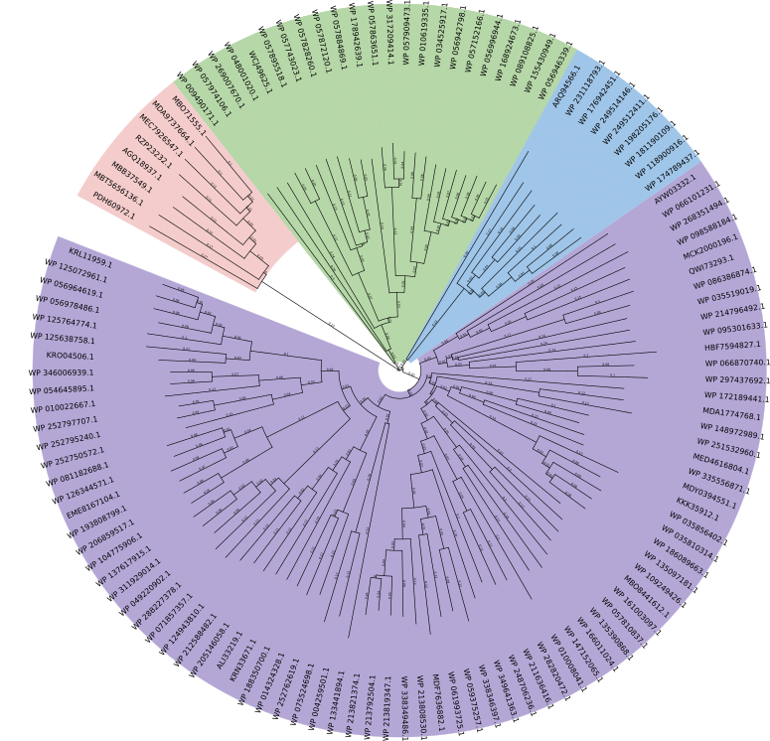
Fig. S1 Phylogenetic tree constructed using MEGA7
Table S1 NCBI accession number, species source, sequence identity with the template enzyme, and specific activity
NCBI accession | Species | Identity | Specific activity (U/g)
AYW03332.1 | Peribacillus psychrosaccharolyticus |  | 210
KRN33671.1 | Weissella halotolerans DSM 20190 | 0.63309 | 0
WP_252762619.1 | Leuconostoc fallax | 0.61871 | 48
WP_252797707.1 | Fructilactobacillus hinvesii | 0.62590 | 64
WP_009490171.1 | Catellicoccus marimammalium | 0.69565 | 0
WP_268351494.1 | Bacillus haynesii | 0.51079 | 221
MBT5656136.1 | Actinomycetota bacterium | 0.74803 | 160

3. Enzyme Activity Assay and Analytical Method
The standard enzyme activity was determined by mixing 0.1 mL purified enzyme solution (final concentration of 0.22 mg/mL) with 2.4 mg 2′-deoxythymidine (final concentration of 2 mM) and 2.6 mg 5-fluorouracil (final concentration of 4 mM) in 5 mL PBS buffer (10 mM, pH 7.0). The reaction mixture was incubated at 45℃ for 20 min at 500 rpm, then heated at 100℃ for 5 min to inactivate the enzyme. After high-speed centrifugation, the supernatant was diluted 10 times with PBS (10 mM, pH 7.0) buffer and filtered with a filter membrane. The residual Thd concentration was quantified using high-performance liquid chromatography (HPLC). One unit (U) of enzyme activity was defined as the amount of enzyme required to consume 1 μmol Thd per minute at 45°C. The specific activity was calculated as the ratio of the total enzyme activity to the mass of enzyme protein used. All assays were performed in triplicate.
HPLC analysis: Reaction products were analyzed on a C18 column using a mobile phase of 95% water and 5% acetonitrile (v/v) at a flow rate of 1 mL/min. The injection volume was 10 μL, and detection was performed at 260 nm. Retention times were approximately 7.9 min for Thd, 4.9 min for thymine, 3.7 min for 5-FUra, and 6.1 min for FdUrd.
Conversion = [n(mol)_{consumed substrate Thd}/n(mol)_{initial substrate Thd}] × 100%.
Yield = [n(mol)_{product 5-FUrd}/n(mol)_{initial substrate Thd}] × 100%.

4.BhNDT Sequence Comparison
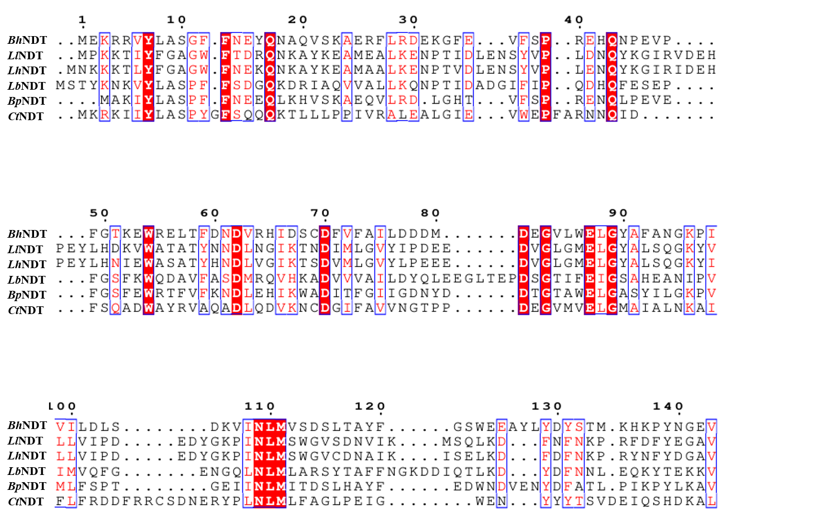
Fig. S2 Sequence alignment of BhNDT with various NDT sequences, performed using MAGE 7 and the ESPript server (https://espript.ibcp.fr/ESPript/ESPript/)

5. Mutagenic Primer Design and Construction
Mutagenic primers were designed based on the BhNDT gene sequence to introduce site-directed mutations. The resulting variants were expressed and purified as described above. Enzyme activity of the mutants was determined using the standard assay with β-thymidine (Thd) as the sugar donor and 5-fluorouracil (5-FUra) as the acceptor base, with the production of 5-fluoro-2′-deoxyuridine (FdUrd) serving as the indicator of catalytic efficiency.
Table S2. Primers used for mutagenesis
 | Primer Sequences (5′–3′) | Relative activity（%）
Q43E | GTGAACACGAAAATCCGGAAGTACCGTTCGGCAC | 0
Q43E | TCCGGATTTTCGTGTTCACGCGGAGAGAACACTTC | 0
Q43K | GTGAACACAAAAATCCGGAAGTACCGTTCGGCAC | 0
Q43K | TCCGGATTTTTGTGTTCACGCGGAGAGAACACTTC | 0
D62N | CGACAACAACGTTCGTCACATCGACTCTTGCGAC | 0
D62N | TGACGAACGTTGTTGTCGAAGGTCAGTTCACGC | 0
D62S | CGACAACAGCGTTCGTCACATCGACTCTTGCGAC | 0
D62S | TGACGAACGCTGTTGTCGAAGGTCAGTTCACGC | 0
D62H | TCGACAACCACGTTCGTCACATCGACTCTTGCGAC | 0
D62H | GACGAACGTGGTTGTCGAAGGTCAGTTCACGC | 0
D81N | GACGACATGAACGAAGGCGTTCTGTGGGAACTGG | 0
D81N | CGCCTTCGTTCATGTCGTCGTCCAAGATTGCGAATA | 0
D81S | GACGACATGAGCGAAGGCGTTCTGTGGGAACTGG | 0
D81S | CGCCTTCGCTCATGTCGTCGTCCAAGATTGCGAATA | 0
D81H | GACGACATGCACGAAGGCGTTCTGTGGGAACTGG | 0
D81H | CGCCTTCGCTCATGTCGTCGTCCAAGATTGCGAATA | 0
E87D | TCTGTGGGACCTGGGCTACGCTTTCGCTAAC | 0
E87D | GCCCAGGTCCCACAGAACGCCTTCATCCATGTC | 0
E88Q | TCTGTGGCAACTGGGCTACGCTTTCGCTAAC | 0
E88Q | GCCCAGTTGCCACAGAACGCCTTCATCCATGTC | 0
E90H | TCTGTGGCACCTGGGCTACGCTTTCGCTAAC | 0
E90H | GCCCAGGTGCCACAGAACGCCTTCATCCATGTC | 0
N109D | AAAGTAATCGACCTGATGGTTAGCGATTCTCTGAC | 0
N109D | CCATCAGGTCGATTACTTTATCGGACAGGTCCAAG | 0
N109H | AAAGTAATCCACCTGATGGTTAGCGATTCTCTGAC | 0
N109H | CCATCAGGTGGATTACTTTATCGGACAGGTCCAAG | 0
F13G | TGGTTTCGGAAACGAATACCAGAACGCTCAGG | 34
F13G | ATTCGTTTCCGAAACCAGAAGCCAGGTATACACG | 34
F13A | TGGTTTCGCAAACGAATACCAGAACGCTCAGG | 54.8
F13A | ATTCGTTTGCGAAACCAGAAGCCAGGTATACACG | 54.8
F13S | TGGTTTCAGCAACGAATACCAGAACGCTCAGG | 50.7
F13S | ATTCGTTGCTGAAACCAGAAGCCAGGTATACACG | 50.7
F49S | AGTACCGAGCGGCACCAAAGAATGGCGTGAACTG | 82
F49S | TGGTGCCGCTCGGTACTTCCGGATTCTGGTGTTC | 82
F49A | AGTACCGGCAGGCACCAAAGAATGGCGTGAACTG | 89.03
F49A | TGGTGCCTGCCGGTACTTCCGGATTCTGGTGTTC | 89.03
F49G | AGTACCGGGAGGCACCAAAGAATGGCGTGAACTG | 83
F49G | TGGTGCCTCCCGGTACTTCCGGATTCTGGTGTTC | 83
W54A | CAAAGAAGCACGTGAACTGACCTTCGACAACG | 111.9
W54A | GTTCACGTGCTTCTTTGGTGCCGAACGGTACTTC | 111.9
W54G | CAAAGAAGGACGTGAACTGACCTTCGACAACG | 99
W54G | GTTCACGTCCTTCTTTGGTGCCGAACGGTACTTC | 99
W54S | ACCAAAGAAAGCCGTGAACTGACCTTCGACAACG | 40.1
W54S | GTTCACGGCTTTCTTTGGTGCCGAACGGTACTTC | 40.1
E56A | AGAATGGCGTGCACTGACCTTCGACAACGATGTTCG | 99.8
E56A | TCAGTGCACGCCATTCTTTGGTGCCGAACGGT | 99.8
E56G | AGAATGGCGTGGACTGACCTTCGACAACGATGTTCG | 79.99
E56G | TCAGTCCACGCCATTCTTTGGTGCCGAACGGT | 79.99
E56K | ATGGCGTAAACTGACCTTCGACAACGATGTTCG | 0
E56K | AGGTCAGTTTACGCCATTCTTTGGTGCCGAAC | 0
E56T | ATGGCGTACACTGACCTTCGACAACGATGTTCG | 151.1
E56T | AGGTCAGTTGTACGCCATTCTTTGGTGCCGAAC | 151.1
E56Q | ATGGCGTCAACTGACCTTCGACAACGATGTTCG | 3.89
E56Q | AGGTCAGTTGACGCCATTCTTTGGTGCCGAAC | 3.89
D60K | GACCTTCAAAAACGATGTTCGTCACATCGACTC | 62.70
D60K | CATCGTTTTTGAAGGTCAGTTCACGCCATTCT | 62.70
D60E | GACCTTCGAAAACGATGTTCGTCACATCGACTC | 79.77
D60E | CATCGTTTTCGAAGGTCAGTTCACGCCATTCT | 79.77
D60N | GACCTTCAACAACGATGTTCGTCACATCGACTC | 70.89
D60N | CATCGTTGTTGAAGGTCAGTTCACGCCATTCT | 70.89
D60Q | GACCTTCCAAAACGATGTTCGTCACATCGACTC | 57.65
D60Q | CATCGTTTTGGAAGGTCAGTTCACGCCATTCT | 57.65
D60A | GACCTTCGCAAACGATGTTCGTCACATCGACTC | 130.1
D60A | CATCGTTTGCGAAGGTCAGTTCACGCCATTCT | 130.1
D60G | GACCTTCGGAAACGATGTTCGTCACATCGACTC | 110.12
D60G | CATCGTTTCCGAAGGTCAGTTCACGCCATTCT | 110.12

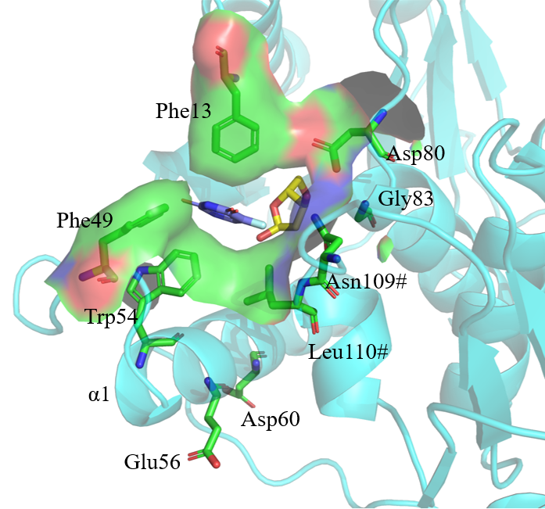
Fig. S3 Screening of mutant amino acids

6. Characterization of BhNDT-M2
Optimum pH
According to the method of enzyme activity determination, 0.1 mL of purified enzyme solution was added to 4.9 mL of different pH (4.6-9.5) buffer (PBS buffer solution, Citrate buffer solution, Gly-NaOH buffer solution) containing 2.4 mg 2'-deoxythymidine and 2.6 mg 5-fluorouracil in a 10 mL centrifuge tube, and reacted at 45 ℃ for 20 min. The activity of the enzyme at different pH was detected, and the enzyme activity at the optimum pH was defined as 100%. pH 4.6-6.0, using 10 mM Citrate buffer solution. The pH was 6.0-8.0 with 10 mM PBS buffer. pH 8.0-9.5, using 10 mM Gly-NaOH buffer solution.
Optimum temperature
According to the method of enzyme activity determination, 0.1 mL purified enzyme solution was added to 4.9 mL PBS buffer (10 mM, pH 7.0) containing 2.4 mg 2'-deoxythymidine and 2.6 mg 5-fluorouracil in a 10 mL centrifuge tube, and incubated at 25-60 ℃ for 20 min. The enzyme activity at different temperatures was detected, and the relative enzyme activity at the optimum temperature was defined as 100%.
pH stability
According to the method of enzyme activity determination, a certain concentration of purified enzyme solution was incubated in PBS buffer of pH 5.0 or pH 10 in a 10 mL centrifuge tube, and 0.1 mL enzyme solution was added to 4.9 mL PBS buffer containing 2.4 mg 2'-deoxythymidine and 2.6 mg 5-fluorouracil every certain time. The enzyme activity of 2'-deoxythymidine was detected, and the relative activity at 0 moment before incubation was defined as 100%.
Thermal stability
According to the method of enzyme activity determination, 0.1 mL pure enzyme solution was incubated at different temperatures (45-70 ℃) for 3 h at pH 7.0, and the incubated pure enzyme solution was added to 4.9 mL PBS buffer containing 2.42 mg 2'-deoxythymidine and 2.6 mg 5-fluorouracil. The reaction was carried out at the optimum temperature and optimum pH for 20 min, and the initial enzyme activity was defined as 100%. T₅₀³ is the temperature at which the enzyme activity is reduced to 50% of the initial enzyme activity.
Determination of kinetic parameters
The enzyme activity of the substrate 2'-deoxythymidine and 5-fluorouracil was determined by reference to the enzyme activity determination method. The final concentration of 2'-deoxythymidine was fixed at 2 mM, and the enzyme activity of NDT to 5-fluorouracil at the final concentration of 1,2,4,6,8,10,15 and 20 mM was determined. The initial rate at different concentrations was calculated, and the Michaelis Menten function in Origin 2024 was used to fit the enzyme kinetic parameters. Similarly, the final concentration of 5-fluorouracil was fixed at 2 mM, and the enzyme activity of NDT at the final concentration of 2'-deoxythymidine at 1,2,4,6,8,10,15,20 mM was determined. The initial rate at different concentrations was calculated, and the Michaelis Menten function in Origin 2024 was used to fit the enzyme kinetic parameters.
The initial reaction rate was defined as the concentration of Thd or 5-FUra consumed per unit time.
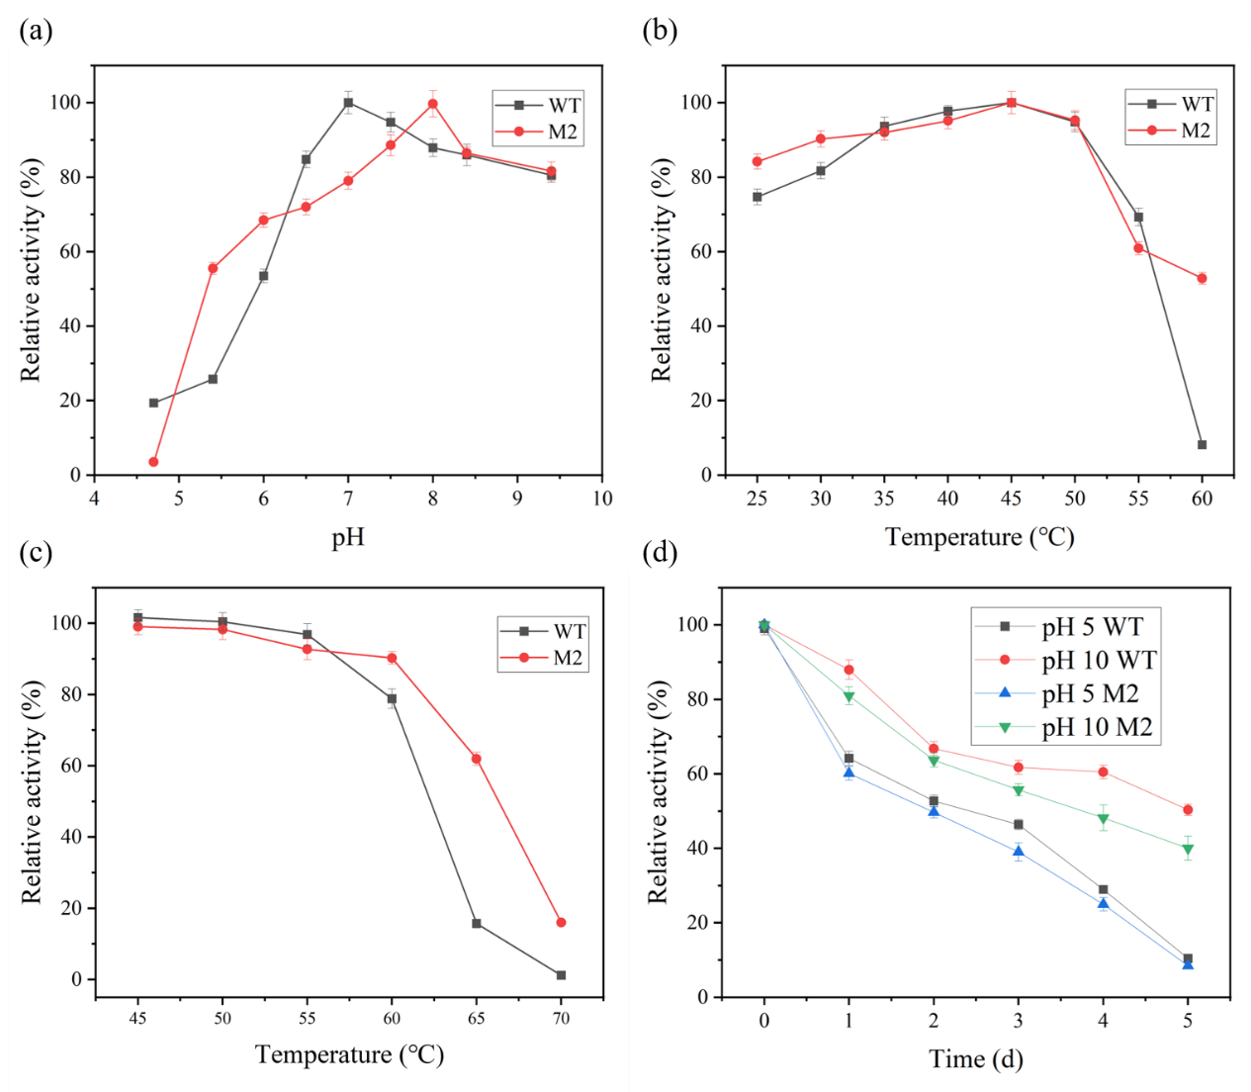
Fig.S4 Using 2′-deoxythymidine as the sugar donor and 5-fluorouracil as the acceptor base, the effects of pH and temperature on the enzymatic activities of wild-type BhNDT and the BhNDT-M2 mutant were evaluated. (a) Optimal pH determination: 100 μL of purified enzyme was added to a reaction mixture containing 2 mM 2′-deoxythymidine and 4 mM 5-fluorouracil at pH values ranging from 4.6 to 9.5, and the reaction was carried out at 45°C for 20 min. (b) Optimal temperature determination: At pH 7.0, 100 μL of purified enzyme was added to a reaction system containing 2 mM 2′-deoxythymidine and 4 mM 5-fluorouracil, and the reaction was conducted at temperatures ranging from 25 to 60°C for 20 min. (c) Thermal stability: The enzyme was pre-incubated at temperatures between 40 and 70 °C for 3 h, after which the residual activity was measured at 45°C and pH 7.0. The temperature at which the enzyme retained 50% of its initial activity was defined as T₅₀. (d) pH stability: The enzyme was incubated at pH 5.0 and pH 10.0 for various time intervals, and the residual activity was subsequently determined at 45°C and pH 7.0

Table S3 Steady-state kinetic parameters of enzyme variants
5-FUra | K_{m}  （mmol/L） | k_{cat}  （s⁻¹） | k_{cat}/K_{m}  （s⁻¹/mM） | V_{max}  （mmol/min）
WT | 1.16614 | 0.118 | 0.101 | 0.0799
BhNDT-M2 | 0.57957 | 0.116 | 0.200 | 0.07863

Thd | K_{m}  （mmol/L） | k_{cat}  （s⁻¹） | k_{cat}/K_{m}  （s⁻¹/mM） | V_{max}  （mmol/min）
WT | 2.7749 | 0.138 | 0.0497 | 0.09338
BhNDT-M2 | 2.82179 | 0.148 | 0.0525 | 0.10009
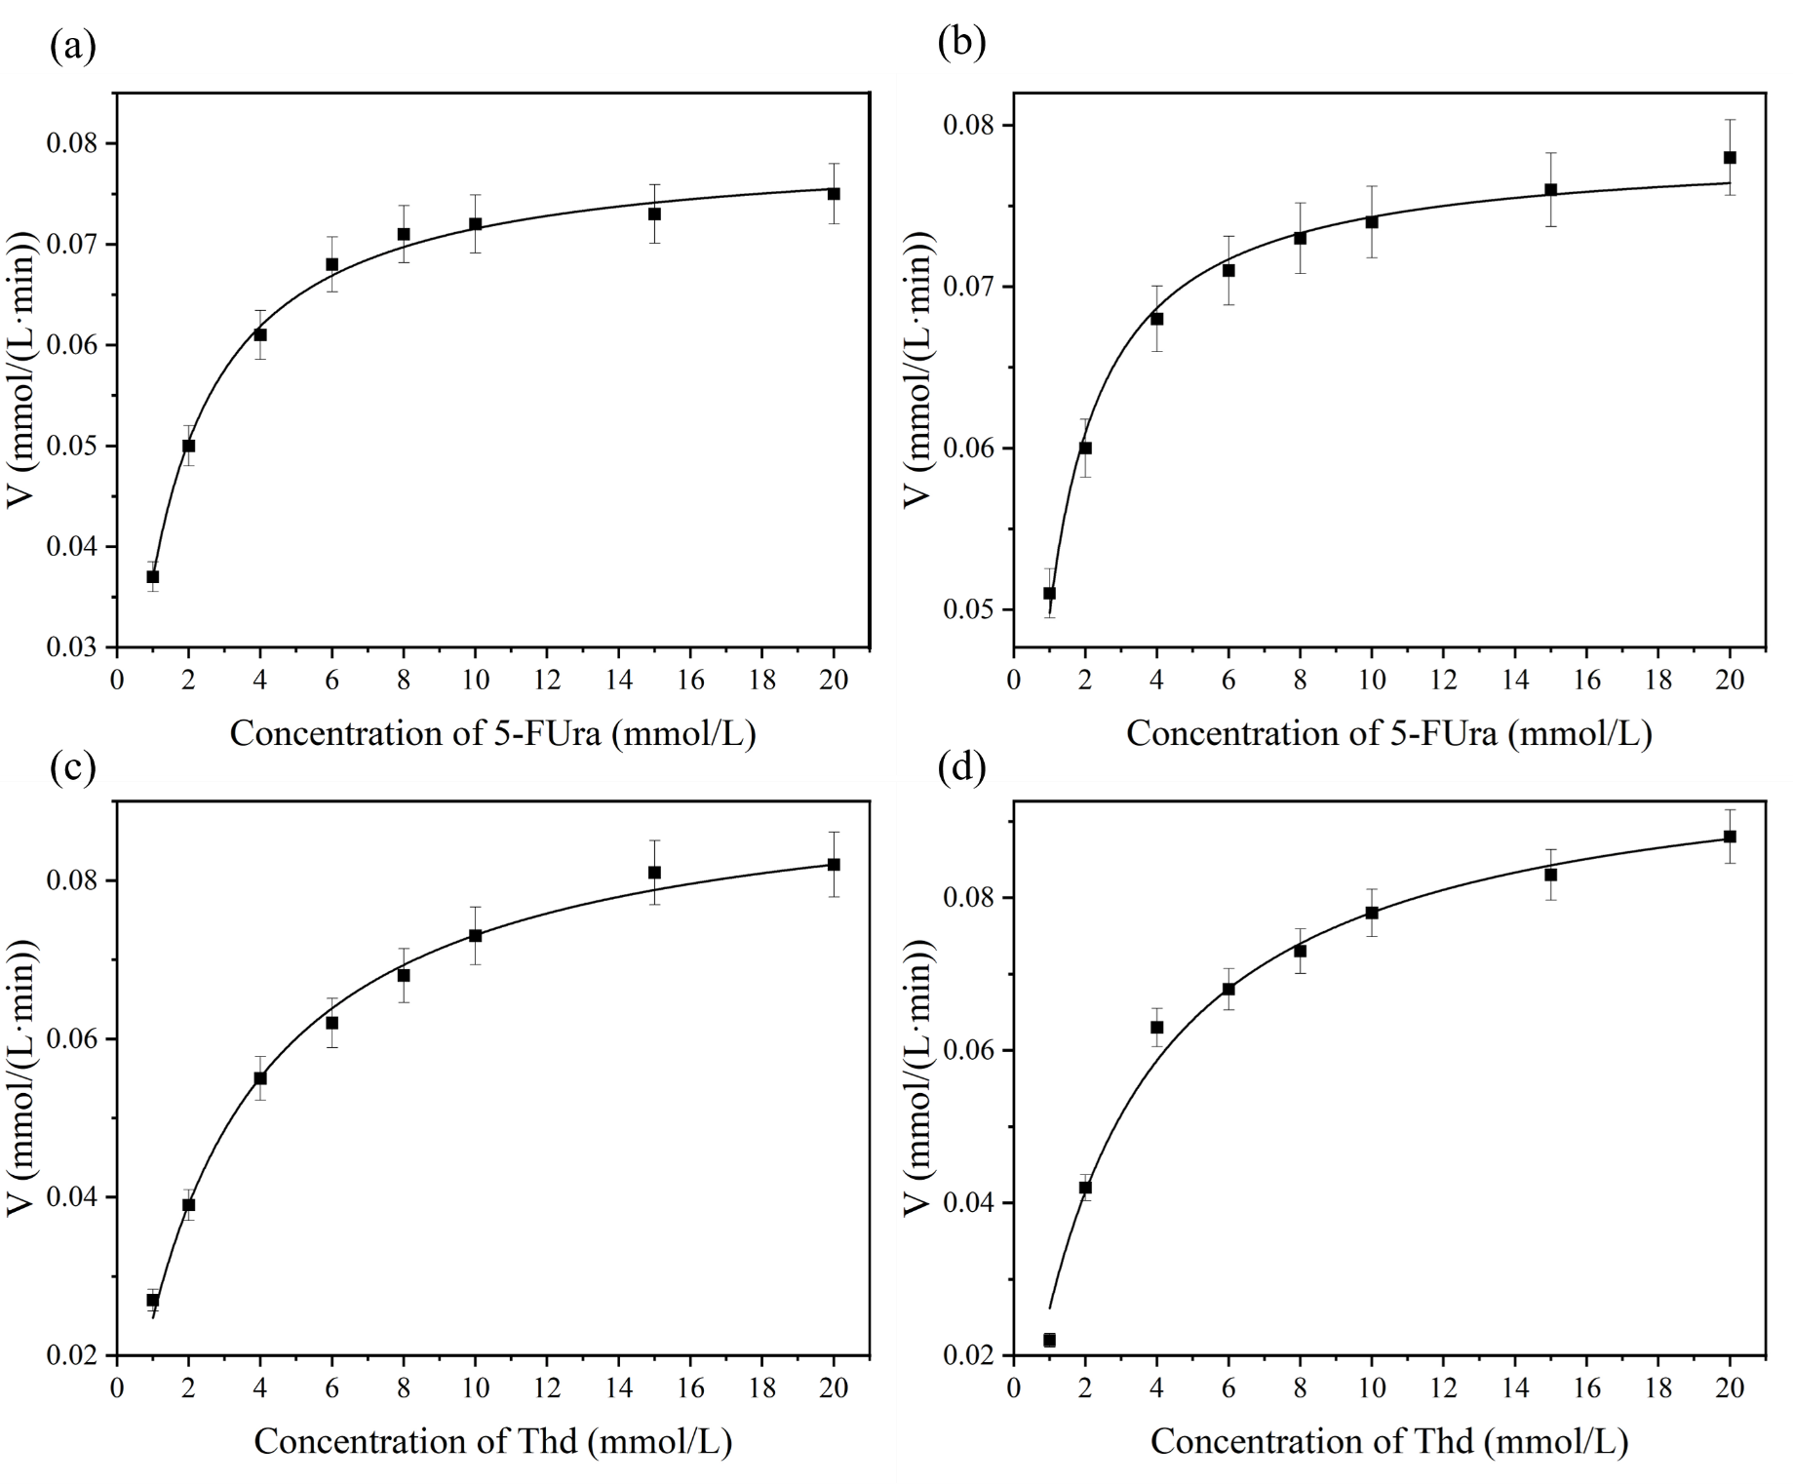
Fig. S5 Determination of kinetic parameters of BhNDT-M2 (b and d) and BhNDT (a and c) at 45°C. Reactions were performed with varying concentrations of 5-FUra (1–20 mM) and a fixed concentration of Thd, and the initial rates were determined based on Thd consumption. Reactions were performed with varying concentrations of Thd (1–20 mM) and a fixed concentration of 5-FUra, and the initial rates were determined based on 5-FUra consumption. Kinetic parameters were obtained by nonlinear fitting using the Michaelis–Menten equation

7. Comparison between Wild Type and Mutant
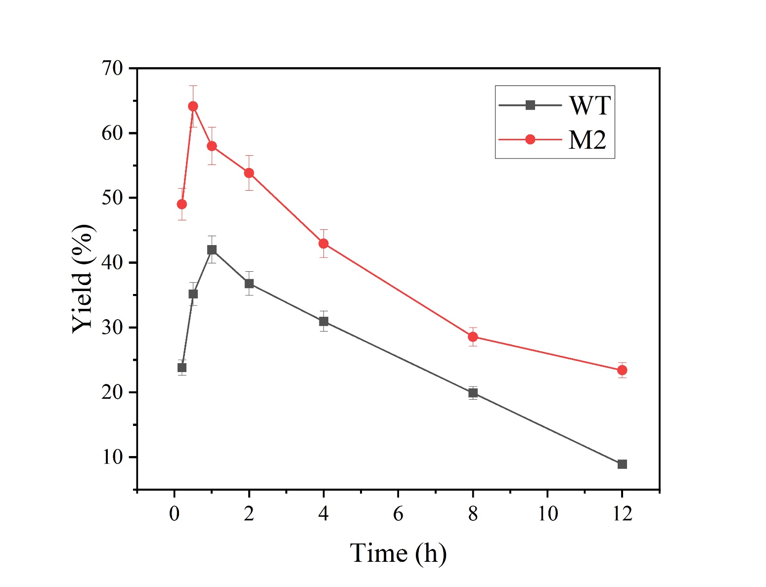
Fig. S6 Reaction process curve for FdUrd synthesis catalyzed by equal amounts of purified BhNDT and purified BhNDT-M2. Reaction conditions: Wild-type: 10 mM PBS, pH 7.0, 45°C, with acceptor and donor concentrations of 20 mM and 40 mM, respectively (1:2 ratio). Mutant: 10 mM PBS, pH 8.0, 45°C, with acceptor and donor concentrations of 20 mM and 40 mM, respectively (1:2 ratio)
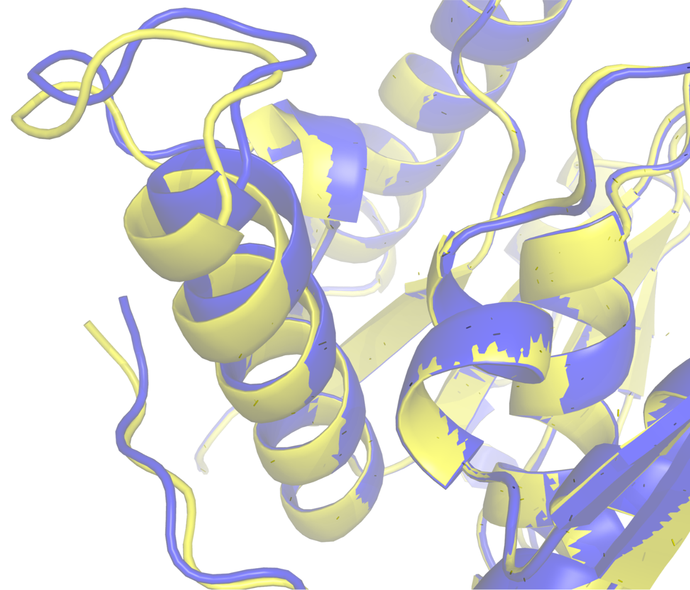
Fig. S7 Predicted protein structural changes by AlphaFold3. Yellow represents BhNDT-M2, and blue represents BhNDT.

8. Caver Web 2.0 Predicts Active Pockets
Caver Web 2.0: https://loschmidt.chemi.muni.cz/caverweb

Cover configuration

starting_point_residue A:7 A:8 A:9 A:10 A:11 A:12 A:13 A:21 A:38 A:39 A:40 A:43 A:49 A:54 A:58 A:62 A:81 A:83 A:84 A:87 B:109 B:110 B:111 B:143 B:144
probe_radius 0.9
shell_depth 4.0
shell_radius 3.0
clustering_threshold 3.5
max_distance 3.0
desired_radius 5.0
visualization_tunnel_sampling_step 0.5
compute_tunnel_residues yes
seed 1
save_dynamics_visualization yes
generate_trajectory yes

9. Distribution of Ionization Residues.

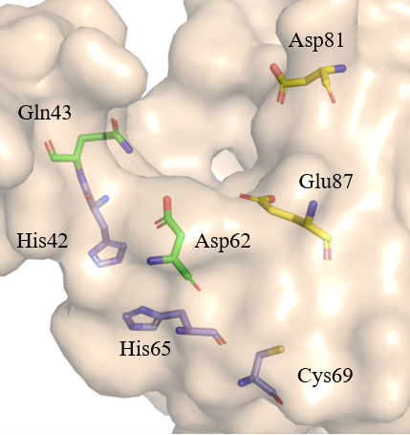
Fig. S8 Distribution of ionization residues

10. Enzyme Immobilization
Table S4 Resin type and manufacturer
Resin | Specification | Producer
ESR-3 | amino resin | Xi 'an Lanxiao Technology New Material Co., Ltd.
ESQ-3 | amino resin | Tianjin Nankai Synthetic Technology Co., Ltd.
LX-1000HA | amino resin | Xi 'an Lanxiao Technology New Material Co., Ltd.
LX-1000HFA | epoxy resin | Xi 'an Lanxiao Technology New Material Co., Ltd.
LX109S | epoxy resin | Xi 'an Lanxiao Technology New Material Co., Ltd.
LKZ-219B | amino resin | Xi 'an Lanxiao Technology New Material Co., Ltd.
LKZ-219A | amino resin | Xi 'an Lanxiao Technology New Material Co., Ltd.
LX-EPHA | amino resin | Xi 'an Lanxiao Technology New Material Co., Ltd.

Table S5 Using 2 mM 2′-deoxythymidine (Thd) and 4 mM 5-fluorouracil (5-FUra) as substrates, reactions were conducted in 5 mL of PBS buffer (10 mM, pH 8.0) for 20 min (Table S4) to compare protein loading capacities and enzymatic activities among the eight immobilized preparations. The protein loading capacity is defined as the ratio of the difference in protein content before and after immobilization to the mass of the carrier
Resin | Protein loading capacity (mg/g_{support}) | Enzyme Activity (U/ g_{support})
ESR-3 | 17 | 46
LKZ-219B | 22 | 52
LKZ-219A | 18 | 46
LX-EPHA | 20 | 48
ESQ-3 | 16.9 | 46
LX-1000HA | 16 | 45
LX-1000HFA | 11 | 41
LX-109S | 7 | 39

11. Optimization of Immobilization Conditions of BhNDT-M2@LKZ-219B

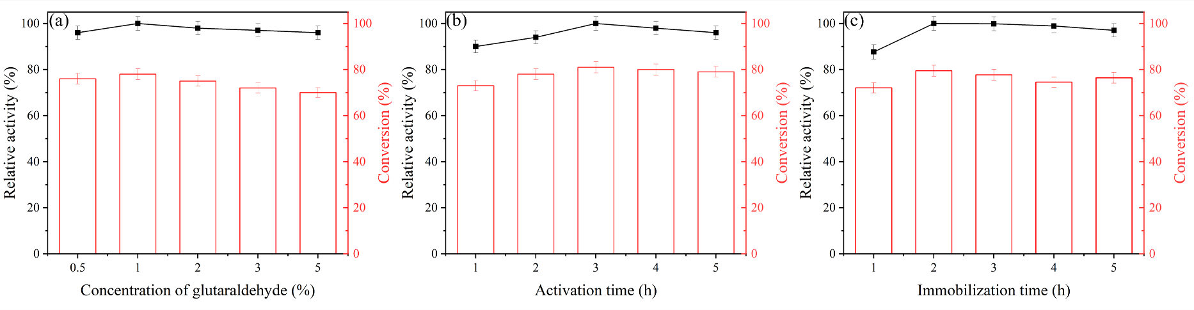
Fig.S9 (a) Optimization of glutaraldehyde concentration: 2 g of pretreated resin was weighed and added with 20 mL PBS buffer (10 mM, pH 8.0), which contained 0.5%, 1%, 2%, 3% and 5% glutaraldehyde solution. Activated at 25°C, 150 rpm for 3 h. After activation, the residual glutaraldehyde was washed with double distilled water and dried. Subsequently, 40 mg of activated resin was taken out, 2 mL of enzyme was added, and shaken in a shaker at 25°C and 100 rpm for 2 h. Finally, the resin was taken out, the protein loading was measured, and the residual enzyme solution was washed away. The activity of immobilized enzyme was evaluated by liquid phase. (b) Optimization of activation time: On the basis of the above, the activation time of 1 h, 2 h, 3 h, 4 h and 5 h was selected, and the enzyme activity of the immobilized enzyme and the conversion rate of 2-deoxythymidine were evaluated by liquid phase. (c) Immobilization time optimization: On the basis of the above, the immobilization time of 1 h, 2 h, 3 h, 4 h and 5 h was selected, and the enzyme activity of the immobilized enzyme and the conversion rate of 2-deoxythymidine were evaluated by liquid phase. Conversion=[n(mol)_{Remaining substrate Thd}/n(mol)_{initial substrate Thd}] ×100%

12. Enzymatic Synthesis of 5-Fluoro-2′-Deoxyuridine
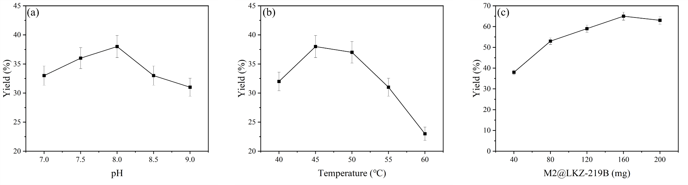
Fig. S10 Using 2′-deoxythymidine (20 mM) as the sugar donor and 5-fluorouracil (40 mM) as the acceptor base, the reaction conditions for the immobilized-enzyme-catalyzed synthesis of 5-fluoro-2′-deoxyuridine were optimized in a 5 mL reaction system. (a) Optimal reaction temperature: With an immobilized enzyme loading of 40 mg at pH 8.0, reactions were carried out at 35, 40, 45, 50, 55, and 60°C for 1 h. (b) Optimal reaction pH: With an immobilized enzyme loading of 40 mg, reactions were conducted at 45°C for 1 h over a pH range of 7.0–9.0. (d) Optimal immobilized enzyme loading: Reactions were performed with immobilized enzyme loadings of 40, 80, 120, 160, and 200 mg at pH 8.0 and 45°C for 1 h

13. Calibration curve
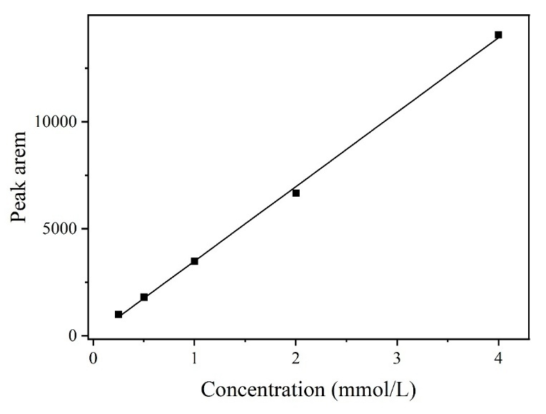
Fig. S11 Concentration of 5-Fluoro-2′-Deoxyuridine
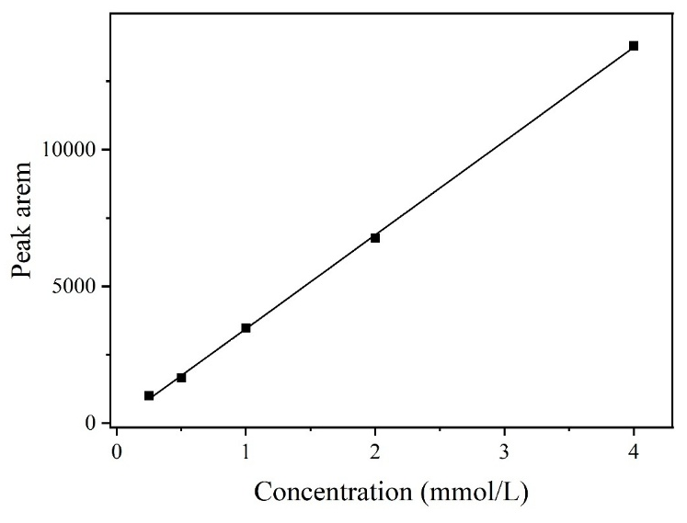
Fig. S12 Concentration of 2′-Deoxythymidine

14. Substrate spectrum expansion.
The chromatogram on the left represents the reaction mixture, while the chromatogram on the right shows the corresponding product standard.
