A Quantitative Approach to Optimise Microcarrier Surface Area for Smarter Adherent Cell Culture

Rayan Metha¹, Jane Toting¹, Sarina Ghobadi¹, Majid Ebrahimi Warkiani^{1,2,3}, Payar Radfar¹, Lin Ding¹*, Rouzbeh Abbassi⁴*
*Corresponding author

¹ Smart MCs PTY LTD, Belrose, NSW 2085
² Department of Mechanical Engineering, American University of Sharjah, UAE
³Advanced Biosciences and Bioengineering Research Center (ABSBERC), American University of Sharjah, UAE
⁴School of Engineering, Macquarie University, Macquarie Park, NSW 2113
*Corresponding authors

- Mathematical Definitions

S1. Intersection over Union (IOU) and Detection Classification
The model outputs the circles detected as triplets of (x, y, diameter) which we must compare to the ground truth set of circles in the same format. To classify a True Positive (TP), we utilised an Intersection over Union (IOU) threshold. For each ground truth circle ($A$) and model-predicted circle ($B$), the IOU is calculated as
$$IOU= \frac{Area(A∩B)}{Area(A∪B)}$$
An IOU value of larger than 0.5 was required to classify a detection as a True Positive

S2. Detection Efficiency Metric (E)
The utility function for the Bayesian Optimisation was a custom efficiency metric ($E$) combining detection fidelity and geometric precision
$$E= F1⋅(1-NAE)$$
where an $E$ value of 1 represents a perfect annotator.

The F1-score is defined as
$$F1= 2⋅\frac{Precision⋅Recall}{Precision+Recall}$$

where Precision and Recall are derived from the True Positives (TP), False Positives (FP) and False Negatives (FN).

The Normalised Average Diameter (NAE) is computed only on the diameters correctly identified circles (TP’s)
$$NAE=\frac{1}{n}\sum_{circles∈TP}{\frac{|d_{predicted}-d_{ground_truth}|}{d_{ground_truth}}}$$
Where $n$ is the number of true positive detections.

- Benchmarking Metrics and Estimations

S3. Evaluation Metrics
Performance was evaluated using the median Absolute Percentage Error (APE) across image classes.

Count Accuracy:
$$APE_{count}=\frac{|Count_{method}-Count_{GT}|}{Count_{GT}}$$
Diameter Accuracy:
$$APE_{diameter}=\frac{|{\overline{d}}_{method}-{\overline{d}}_{GT}|}{{\overline{d}}_{GT}}$$
Coefficient of Variation (CV) Accuracy:
$$APE_{CV}=\frac{|CV_{method}-CV_{GT}|}{CV_{GT}}$$

S4. Manual Benchmark Image Estimates

For the expert manual benchmark, instead of providing a full annotation of each image, we replicated common industry practices for measuring or estimating key population-based metrics. An experienced lab technician firstly produced a total manual count of the particles in each image. Then to derive statistics typically used in routine quality control, the technician randomly selected and manually measured the diameter of 20 distinct particles. This random sample was used to calculate estimates for the population mean diameter and coefficient of variation the given by the formulas

$$\overline{d}=\sum_{i=1}^{20}{d_{i}}$$
and
$$\check{CV}=\frac{s_{d}}{\overline{d}}$$
where
$$s_{d}=\sqrt{\frac{1}{20-1}\sum_{i=1}^{20}{{\left(d_{i}-\overline{d}\right)}^{2}}}$$

- Image Classes
A total of 6 image classes each with 5 images, were used to benchmark the model’s effectiveness using a broad range of images. Classes A-C are of microcarriers, and classes D-F are of cells. These classes differ in colour shape of particles as well as the amount of background noise in the image to benchmark the generalisability of the model.

Class | Descriptors | Example Image
A | Morphology: Highly circular/spherical  Size Variation: Low  Spatial Distribution: High particle clustering and significant overlap (occlusion)  Image Quality: Moderate non-particle background noise, with medium particle-background contrast ratio  Colour Consistency: Homogenous particle colour | 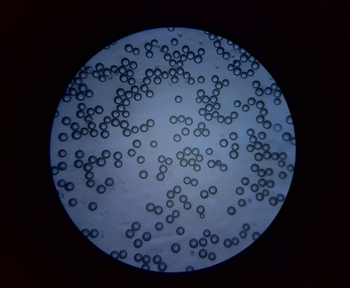
B | Morphology Predominantly non-circular (oval/irregular)  Size Variation: Low  Spatial Distribution: High degree of particle aggregation/clustering  Image Quality: Low background noise, high particle-to-background contrast  Colour Consistency: Homogenous particle colour | 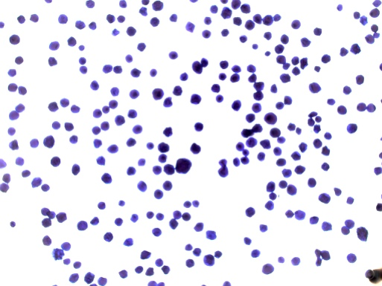
C | Morphology: Highly circular/spherical  Size Variation: Low  Spatial Distribution: Moderate clustering  Image Quality: Minimal non-particle background noise, high particle-to-background contrast. Background is non-homogenous in colour (dark patches)  Colour consistency: Homogenous particle colour (with consistent white circle inside particles) | 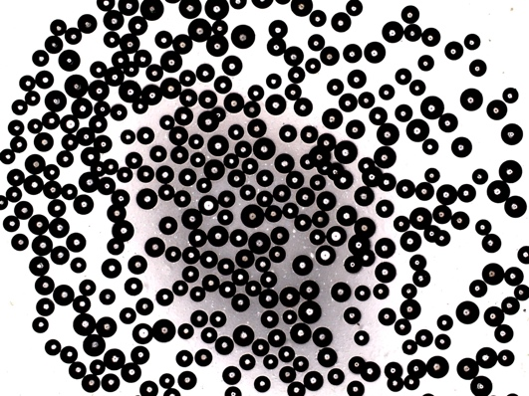
D | Morphology: Highly circular/spherical  Size Variation: Moderate (includes sub-micron/very small particles)  Spatial Distribution: Spread out  Image Quality: High background noise including many non-particle artefacts, low particle-background contrast  Colour consistency: Moderately homogenous particle colour | 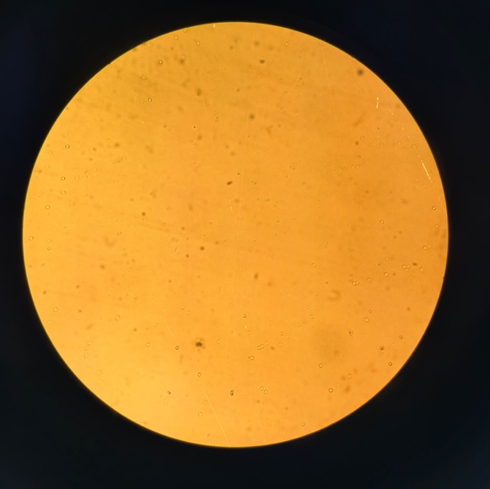
E | Morphology: Highly circular/spherical  Size Variation: Moderate (has many small particles)  Image Quality: High background noise, high particle-background contrast. Includes many non-particle artifacts (transparent particles)  Colour Consistency: Heterogeneous particle colours (multiple classes) | 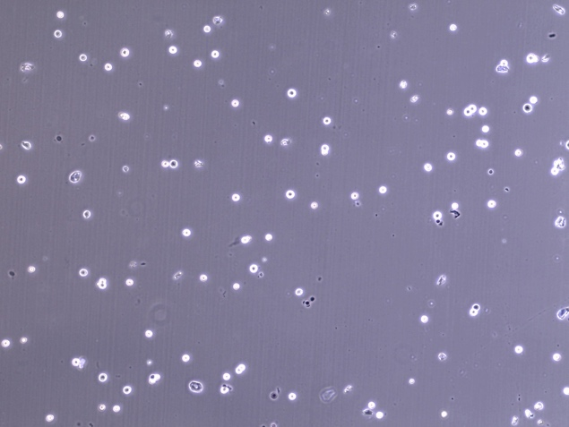
F | Morphology: Moderately circular (slight deviation)  Size Variation: Consistent, broad range (includes small particles)  Image Quality: High background noise, including non-particle artifacts (smudges)  Low particle to background contrast ratio  Colour consistency: Homogenous particle colour | 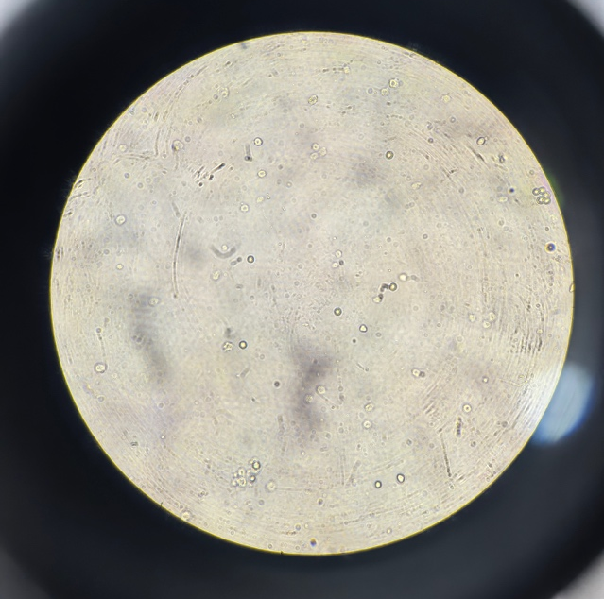
Table 1: Image descriptors per class

- Pipeline Parameters
The full Gradient Hough Transform (GHT) pipeline has a range of parameters that dictate how well it fits towards specific image classes. These are the parameters tuned by the Bayesian optimisation loop.

Pipeline Parameter(s) | Role in Pipeline
“min_diameter” - “max_diameter” | Dictates the range of diameters that the GHT algorithm will accept
“blur_level” | Controls how much the image gets blurred before being put processed through the GHT algorithm  Balanced to reduce noise while retaining important details
“min_intensity_threshold” - “max_intensity_threshold” | Specifies a range of intensity (brightness) that circles must be to be accepted as part of the processing of the GHT
“upper_canny_threshold” | Provides a threshold for edge detection in GHT based on the intensity of edge gradients in the image
“accumulator_threshold” | Threshold on how many votes a circle center (a,b) needs to have before it is accepted in GHT
“min_distance” | Minimum spacing that circles must be apart to be considered as separate
Table 2: A list of the overall parameters and their role in the pipeline

