Cover sheet for supplementary information
Title: Phylogenomic and multi-omics analysis of Agarivorans sp. D1326 uncovers an agarolytic pathway involving rare GH118 β‑agarase

Author: Tao Li, Cong Liu, Chengwei Wu, Boyu Zhang, Ziwei Wang, Yueyue Zhao, Wenbin Gu, Zilin Liu, Fanling Meng, Jingjing Shangguan, Wenbo Zhang, Xueyi Zhu, Yan Wang

Number of pages: 26 (including the cover sheet)

Number of tables: 6

Number of figures: 17

Supplemented methods, tables, and figures
Methods
Genome sequencing and phylogenomic analysis
Genome annotation was conducted using Glimmer version 3.02 for gene identification, and the resultant coding sequences were translated into their corresponding amino acid sequences. These were subsequently employed as queries in BLAST searches against the GenBank, Swiss-Prot, KEGG, Clusters of Orthologous Groups (COG), and Gene Ontology (GO) databases. To evaluate genomic relatedness, publicly available genome sequences of validly published type strains belonging to the family Celerinatantimonadaceae were downloaded from GenBank. The amino acid sequences of 120 ubiquitous single-copy proteins (bac120 marker set) were extracted from these genomes using the Genome Taxonomy Database Toolkit (GTDB-Tk). The selected marker sequences were then concatenated and aligned with MUSCLE under default parameters to ensure alignment accuracy. Finally, a maximum-likelihood phylogenomic tree was reconstructed based on the concatenated amino acid sequences using MEGA version 11.0.13 [25, 27].
Transcriptomic analysis
Total RNA was extracted from the bacterial cells using the CTAB method, followed by genomic DNA removal. Only high-quality RNA samples were used for library construction. The RNA-seq transcriptome library was prepared using the Illumina® Stranded mRNA Prep kit (Ligation-based protocol, San Diego, CA) according to the manufacturer's instructions. The constructed paired-end RNA-seq libraries were sequenced on an Illumina NovaSeq 6000 platform (Illumina Inc., San Diego, CA, USA).
Raw sequencing reads were processed to obtain high-quality clean reads by removing reads containing adapters, reads with an excessive proportion of unknown bases (N), and low-quality reads. For each dataset and employing specific alignment and quantification protocols, differentially expressed genes (DEGs) were identified using the DESeq2. Significantly differentially expressed genes were subsequently assigned to different functional groups through Gene Ontology (GO) enrichment analysis and Kyoto Encyclopedia of Genes and Genomes (KEGG) pathway enrichment analysis.
Proteomic analysis
Protein digestion was performed using filter-aided sample preparation (FASP). Briefly, 200 µg of proteins were diluted to 200 µL with 8 M UA buffer (8 M urea in 0.1 M Tris-HCl, pH 8.5). Reduction was carried out with 50 mM dithiothreitol for 1 h at room temperature, followed by alkylation with 10 mM iodoacetamide in the dark for 30 min. The mixture was transferred to a 30-kDa filter (Millipore, USA) and centrifuged at 12,000 × g for 20 min. The filter was washed three times with 200 µL of 8 M UA buffer and 50 mM Tetraethylammonium Bromide (TEAB), each time centrifuging at 12,000 × g for 20 min at 4 °C. Digestion was performed by adding 140 µL of 50 mM TEAB containing 5 µg trypsin and incubating at 37 °C overnight. Peptides were collected by centrifugation at 12,000 × g for 20 min into a low-binding tube (Thermo Scientific, USA), and the filter was further washed twice with 100 µL of 50 mM TEAB. The combined peptide solution was quantified using the Pierce Quantitative Fluorometric Peptide Assay Kit (Thermo Scientific, USA), desalted with MonoTip C18 (GL, Japan), vacuum-dried, and stored at −80 °C.
For LC–MS/MS analysis, 2 µg of peptides spiked with 1 µL iRT standard (Biognosys, Switzerland) were loaded onto a C18 nano trap column (150 µm × 20 mm, 1.9 µm) and separated on an analytical column (150 µm × 300 mm, 1.9 µm) using a 90-min linear gradient at 600 nL/min. The mobile phases consisted of solvent A (2% acetonitrile, 0.1% formic acid) and solvent B (98% acetonitrile, 0.1% formic acid). The gradient program was: 5–14% B in 19 min, 14–26% B in 40 min, 26–42% B in 20 min, 42–95% B in 1 min, and 95% B held for 10 min.
Mass spectrometry was performed on an Orbitrap Fusion Lumos (Thermo Fisher, USA). Full MS scans (350–1250 m/z) were acquired at 120,000-resolution with an AGC target of 4×10⁵ and max injection time of 50 ms. Subsequently, 20 data-independent acquisition (DIA) scans were performed with variable isolation windows. MS/MS scans were collected at 30,000-resolution, with an AGC target of 5×10⁵, max injection time of 50 ms, and high energy collision dissociation (HCD) collision energy set to 31%.
DIA data were processed using Spectronaut 18 (Biognosys, Switzerland) with direct DIA mode. Searches were conducted against the protein database of Agarivorans sp. D1326 with the following parameters: tryptic digestion with up to two missed cleavages, carbamidomethylation as fixed modification, and oxidation and N-terminal acetylation as variable modifications. Precursor and protein false discovery rates were controlled at 1% using Q-value. Quantification was performed with interference correction and global normalization based on MS² peak areas; the top three peptides were summed to represent protein abundance. Data filtering applied Q-value sparse thresholds; other parameters were set to default.

Tables
Table S1. Primers used in this study
Primer name | Primer sequences
B8F | 5’-AGAGTTTGATCCTGGCTCAG-3’
B1510 | 5’-GGTTACCTTGTTACGACTT-3’

Table S2. Characteristics that differentiate Agarivorans sp. from phylogenetically related species. Strains: 1, Strain D1326^{T} (this study); 2, Pontiella agarivorans sp. nov. NLcol2^{T} [1]; 3, Marinomonas agarivorans sp. nov. [2]; 4, Agarivorans aestuarii sp. nov. [3]; 5, Agarivorans litoreus sp. nov. [4]. +, positive; −, negative; ND, not determined.
Characteristic | 1 | 2 | 3 | 4 | 5
Pigmentation | White | ND | ND | Yellowish white | ND
Growth temperature (ºC):
Range | 8-45 | 10-37 | 15-37 | 10-30 | ND
Optimum | 28 | 31 | 28-30 | 25 | 30
Growth salinity (g/L NaCl):
Range | 10-60 | 10-60 | 10-60 | ND | 0-50
Optimum | 30 | 25-30 | 20-30 | ND | 20
Growth pH:
Range | 5.0-10.0 | 6.0-9.0 | 6.0-9.0 | 5.0-9.0 | ND
Optimum | 7.0 | 8.0 | 7.0-7.5 | 7.0-8.0 | 7.0-8.0
Hydrolysis of:
Gelatin | - | ND | + | ND | ND
Urea | - | ND | ND | ND | ND
Enzyme activity:
β-Galactosidase | + | + | ND | ND | +
Acid production from (API 20CHB):
Glucose | + | + | ND | ND | +
Mannose | + | + | + | + | +
Citrate | - | ND | ND | + | +
Rhamnose | - | - | - | ND | ND
Arabinose | - | - | - | ND | ND
Inositol | - | ND | - | ND | ND
Sorbitol | - | ND | - | + | ND
Sucrose | + | + | ND | + | ND
Melibiose | - | ND | + | ND | ND
Amygdalin | - | ND | ND | ND | ND

Table S3. DDH (blue) and ANI (red) values (%) among the strain D1326, Agarivorans species and representatives of other members in the family Celerinatantimonadaceae.
Strains | ANI (%) |  |  |  |  | DDH (%)
Strains | 1 | 2 | 3 | 4 | 5 | 6 | 7 | 8 | 9 | 10 | 11
1 | 100 | 49.40 | 75.10 | 44.20 | 19.70 | 18.40 | 18.60 | 20.70 | 20.50 | 19.00 | 19.90
2 | 92.86 | 100 | 49.50 | 38.20 | 20.10 | 19.10 | 18.50 | 22.80 | 22.10 | 21.80 | 21.70
3 | 97.09 | 93.03 | 100 | 44.40 | 19.90 | 19.20 | 18.80 | 22.60 | 21.40 | 21.00 | 22.10
4 | 91.90 | 89.94 | 91.71 | 100 | 19.80 | 19.10 | 18.30 | 22.30 | 22.10 | 22.20 | 22.00
5 | 75.89 | 75.83 | 76.02 | 75.89 | 100 | 19.00 | 18.30 | 20.20 | 20.50 | 19.70 | 22.10
6 | 70.12 | 70.16 | 70.04 | 70.15 | 70.13 | 100 | 59.70 | 20.30 | 20.40 | 20.00 | 22.90
7 | 70.18 | 70.10 | 70.14 | 70.12 | 69.86 | 94.76 | 100 | 20.30 | 19.70 | 19.60 | 20.90
8 | 69.32 | 69.42 | 69.47 | 69.39 | 69.32 | 68.41 | 68.38 | 100 | 20.20 | 19.60 | 24.30
9 | 68.29 | 68.25 | 68.14 | 68.43 | 68.18 | 68.34 | 67.78 | 67.85 | 100 | 18.70 | 28.20
10 | 68.17 | 68.34 | 67.88 | 68.08 | 68.02 | 67.81 | 67.80 | 67.72 | 72.36 | 100 | 27.80
11 | 67.99 | 68.31 | 67.99 | 68.07 | 67.56 | 67.69 | 67.80 | 67.14 | 66.97 | 67.08 | 100
ANI threshold for species definition: ≥ 95%; DDH threshold for species definition: ≥ 70%. Strain information：1, D1326 (this study); 2, A. litoreus GJSW-6^{T}; 3, A. albus MKT 106^{T}; 4, A. aestuarii hydD622^{T}; 5, A. gilvus WH0801^{T}; 6, Aliagarivorans marinus AAM1^{T}; 7, Aliagarivorans taiwanensis AAT1^{T}; 8, Alginatibacterium sediminis ALS 81^{T}; 9, Celerinatantimonas diazotrophica S-G2-2^{T}; 10, Celerinatantimonas yamalensis C7^{T}; 11, Alteromonas macleodii ATCC 27126^{T}.

Table S4. Analysis of agarose degradation-related enzymes in Agarivorans sp. D1326
No. | Gene ID | Protein name | Annotation | ªE.C. | ªGH family | ªCBMs | ªCBM family | ^{b}SPs | ªSubstrates | Localization and Scores
1 | gene0015 | Aga15 | β-agarase | 3.2.1.81 | GH16 | 2 | CBM13/CBM6 | Y | Agarose | ^{c}Extracellular(9.65)
2 | gene1448 | Aga1448 | β-agarase | 3.2.1.81 | GH16 | 1 | CBM13 | Y | Agarose | ^{c}Extracellular(9.65)
3 | gene1449 | AHGD1449 | AHG dehydrogenase | ^{e}1.2.1.24 | - | - | - | N | AHG | ^{d}Cytoplasm
4 | gene1452 | AHGC1452 | AHGA cycloisomerase | ^{e}4.2.1.- | - | - | - | N | AHGA | ^{d}Cytoplasm
5 | gene1457 | GOD1457 | L-galactonate-5-dehydrogenase | ^{e}1.1.1.- | - | - | - | N | Galactonate | ^{d}Cytoplasm
6 | gene1459 | Aga1459 | β-agarase | 3.2.1.81 | GH50 | 2 | - | Y | Agarose | ^{d}Outer membrane
7 | gene1462 | NABH1462 | neoagarobiose hydrolase | 3.2.1.59 | GH117 | 0 | - | N | Neoagarobiose | ^{c}Cytoplasmic(8.96)
8 | gene1466 | Aga1466 | β-agarase | 3.2.1.81 | GH50 | 2 | - | Y | Agarose | ^{d}Periplasm
9 | gene1467 | Aga1467 | β-agarase | 3.2.1.81 | GH50 | 2 | - | Y | Agarose | ^{c}Extracellular(9.65)
10 | gene1474 | Aga1474 | β-agarase | 3.2.1.81 | GH50 | 1 | - | N | Agarose | ^{c}Cytoplasmic(8.96)
11 | gene1497 | Agl1497 | α-galactosidase | 3.2.1.22 | GH36 | 0 | - | N | α-Galactan | ^{c}Cytoplasmic(8.96)
12 | gene2799 | Aga2799 | β-agarase | 3.2.1.81 | GH16 | 3 | CBM6 | Y | Agarose | ^{d}Extracellular
13 | gene2820 | Aga2820 | β-agarase | 3.2.1.81 | GH118 | 0 | - | Y | Agarose | ^{c}Extracellular(9.64)
14 | gene1002 | Aga1002 | β-agarase | 3.2.1.81 | GH86 | 3 | CBM6 | N | Agarose | ^{c}Extracellular (9.71)
15 | gene1003 | Cg1003 | β-carrageenase | 3.2.1.81/  3.2.1.178 | GH167 | 1 | CBM13 | Y | Carrageenan | ^{c}Extracellular
16 | gene2205 | Aga2205 | β-agarase | 3.2.1.81 | GH16 | 1 | CBM13 | Y | Agarose | ^{c}Cytoplasmic (4.90)
17 | gene2206 | AHGD2206 | AHG dehydrogenase | ^{e}1.2.1.- | - | - | - | N | AHG | ^{d}Cytoplasm
18 | gene2214 | Aga2214 | β-agarase | 3.2.1.81 | GH16 | 3 | CBM6 | Y | Agarose | ^{d}Extracellular
19 | gene2270 | Por2270 | β-porphyranase | 3.2.1.81/  3.2.1.178 | PL29 | 2 | CBM13/CBM99 | Y | Porphyran | ^{d}Extracellular
20 | gene1341 | Aga1341 | β-agarase | 3.2.1.81/  3.2.1.178 | GH86 | 4 | CBM13/CBM99 | N | Agarose | ^{c}Extracellular(8.44)
21 | gene0552 | Agl552 | α-galactosidase | 3.2.1.22 | GH36 | 0 | - | N | α-Galactan | ^{d}Cytoplasm
22 | gene0553 | Bgl553 | β-galactosidase | 3.2.1.23 | GH2 | 0 | - | N | β-Galactan | ^{c}Outer membrane (9.49)
ªPredicted based on the amino acid sequence encoded by the corresponding gene through the dbCAN3 server [5] or InterPro server. ^{b}Predicted using the SignalP 6.0 server [6], where N indicates no signal peptide was predicted, and Y indicates that a signal peptide was predicted. ^{c}Subcellular localization of proteins predicated using PSORTb v3.0.2 [7]. ^{d}Subcellular localization of proteins predicated the webserver Cell-PLoc [8]. ^{e}Predicted using PANNZER2 [9]. Abbreviations: E.C. corresponds to Enzyme Commission number; GH corresponds to glycoside hydrolase; CBMs corresponds to the number of carbohydrate-binding modules; SPs corresponds to signal peptides; PL corresponds to polysaccharide lyase; AHG corresponds to 3,6-anhydro-alpha-L-galactose. AHGA corresponds to 3,6-anhydro-alpha-L-galactonate.
Table S5. Description of transporter activity related genes
Gene ID | NR descriptionª | Swiss-Prot description^{b} | InterPro entry^{c}
gene2841 | phosphonate C-P lyase system protein PhnK | Putative phosphonates utilization ATP-binding protein PhnK | IPR025867  GTPase MnmE
gene2848 | phosphonate ABC transporter substrate-binding protein | Phosphonates-binding periplasmic protein | IPR001757  P-type ATPase
gene2840 | phosphonate C-P lyase system protein PhnL | Alpha-D-ribose 1-methylphosphonate 5-triphosphate synthase subunit PhnL | IPR000873  AMP-dependent synthetase/ligase domain
gene0828 | phosphonate ABC transporter permease protein phnE | Phosphite transport system permease protein PtxC | IPR001757  P-type ATPase
gene0830 | phosphonate ABC transporter substrate-binding protein | Probable phosphite transport system-binding protein PtxB | IPR001757  P-type ATPase
gene0829 | ABC transporter | Phosphonates import ATP-binding protein PhnC | IPR001757  P-type ATPase
gene2849 | phosphonate ABC transporter ATP-binding protein | Phosphonates import ATP-binding protein PhnC | IPR001757  P-type ATPase
gene0542 | phosphate ABC transporter, permease protein PstA | ABC transporter permease protein | IPR003439  ABC transporter-like, ATP-binding domain
gene0541 | phosphate ABC transporter ATP-binding protein | Phosphate import ATP-binding protein PstB | IPR003439  ABC transporter-like, ATP-binding domain
gene1451 | MFS transporter | Putative metabolite transport protein YwtG | IPR001757  P-type ATPase
gene1464 | MFS transporter | Lactose permease | -
gene1106 | N-acetylglucosamine-specific IIA component | PTS system glucose-specific EIICBA component | PF02378  Phosphotransferase system, EIIC
gene3664 | PTS IIA-like nitrogen-regulatory protein PtsN | Nitrogen regulatory protein | PF02378  Phosphotransferase system, EIIC
ªAnnotation performed using the Non-Redundant (NR) Protein Sequence Database; ^{b}Annotation performed using Swiss-Prot Database; ^{c} Protein family classified using InterPro database.

Table S6. Description of genes encoding key proteins involved in intracellular protein transport and secretory pathways
Gene ID | NR descriptionª | Swiss-Prot description^{b} | InterPro entry^{c}
gene0006 | twin arginine-targeting protein translocase TatB | Sec-independent protein translocase protein TatB | IPR003369  Sec-independent protein translocase protein TatA/B/E
gene0007 | twin-arginine translocation protein TatA | Sec-independent protein translocase protein TatA | IPR003369  Sec-independent protein translocase protein TatA/B/E
gene2354 | preprotein translocase subunit SecB | Protein-export protein SecB | IPR003708  Bacterial protein export chaperone SecB
gene4553 | preprotein translocase subunit SecE | Protein translocase subunit SecE | -
gene3611 | preprotein translocase subunit SecA | Protein translocase subunit SecA | PF07517  SecA DEAD-like domain
ªAnnotation performed using the Non-Redundant (NR) Protein Sequence Database; ^{b}Annotation performed using Swiss-Prot Database; ^{c} Protein family classified using InterPro database.

Figures
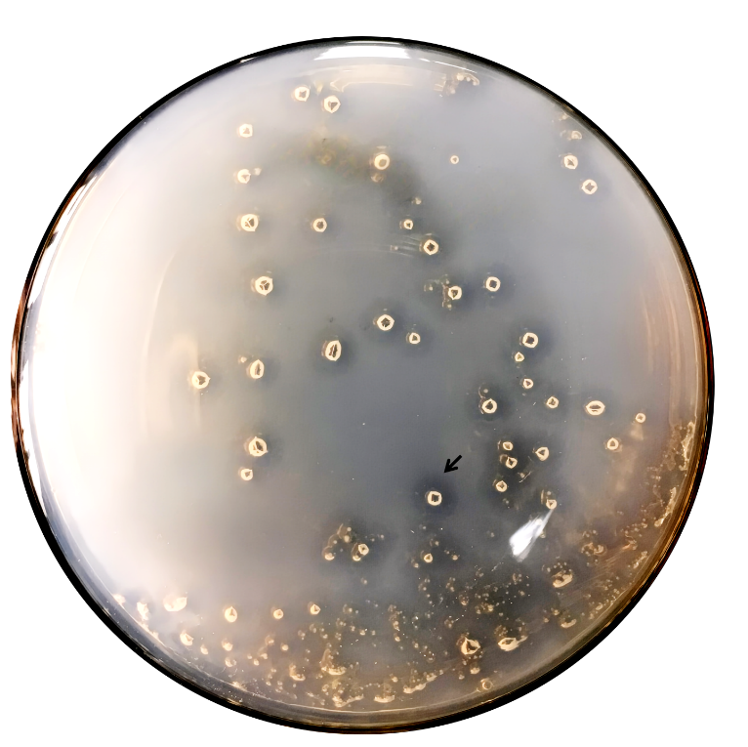
Fig. S1 Agarivorans sp. D1326 colonies on 2216 agar plates. The arrows indicate a clear zone of agar hydrolysis around the colonies, and it was observed that the agar around the colonies has collapsed into small pits.
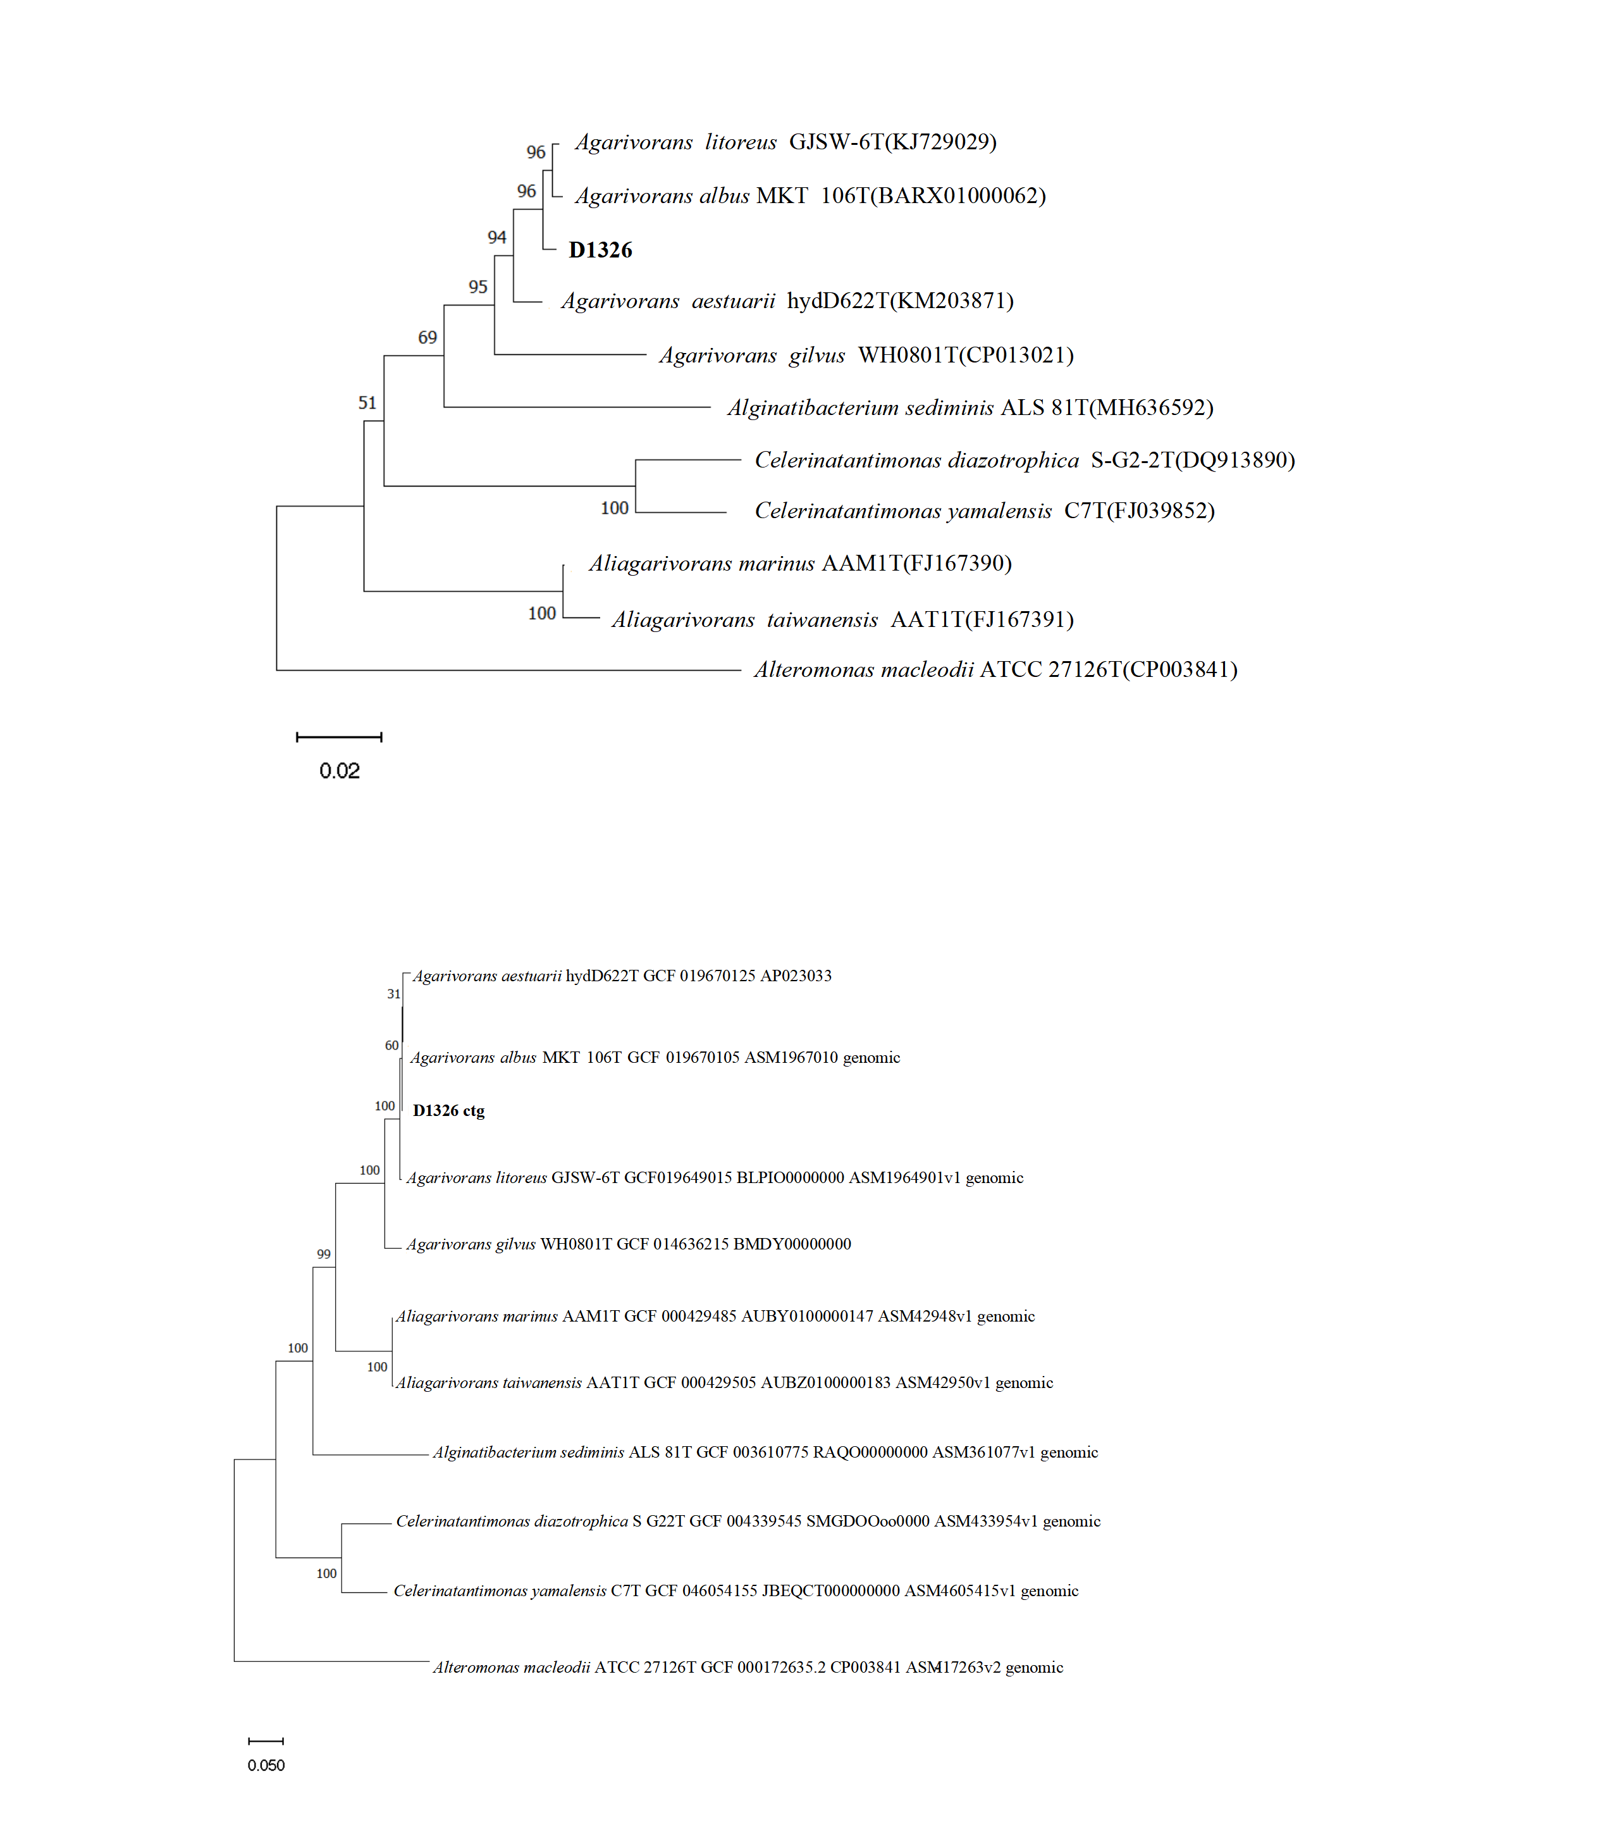
Fig. S2 Phylogenetic analysis based on 16S rRNA. The D1326 strain is shown in bold. GenBank accession numbers for the 16S rRNA sequences of each strain are given in parentheses. The phylogenetic tree was constructed using the maximum-likelihood method with the MEGA 11.0.13 program.
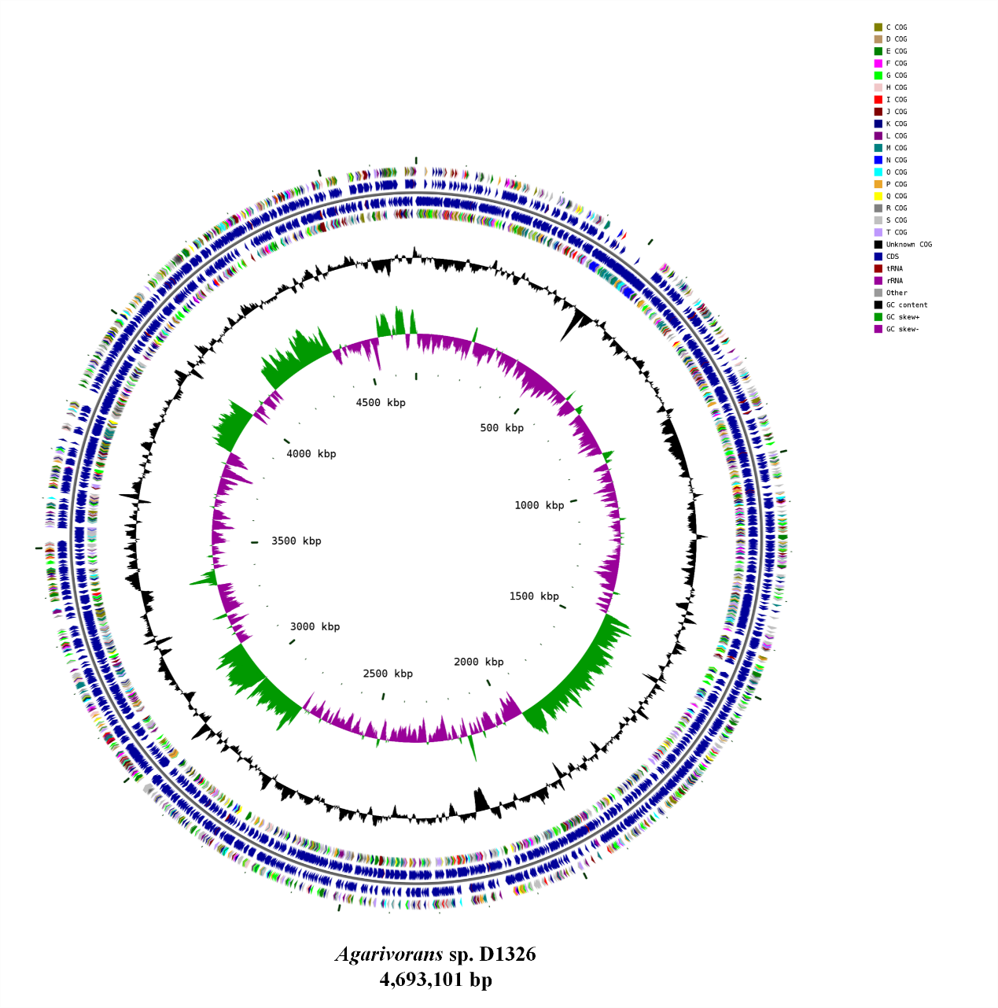
Fig. S3 Genome circular plot of Agarivorans sp. D1326. The circular genome plot of Agarivorans sp. D1326 features several layers: the outermost and fourth circles represent CDS on the positive and negative strands, with colors indicating different COG functional categories. The second and third circles display CDS, tRNA, and rRNA on the positive and negative strands, respectively. The fifth circle illustrates GC content, where the outer section indicates regions with above-average GC content, and the inner section shows below-average GC content, with peak heights reflecting the degree of deviation from the average. The sixth circle presents GC skew values (G-C/G+C), aiding in the identification of leading and lagging strands, as well as replication origins and termini, particularly important for circular genomes. The innermost circle indicates the genome size.
Fig. S4 Phylogenetic tree based on concatenated amino acid sequences of 120 ubiquitous single-copy proteins was constructed by maximum-likelihood methods implemented in the program MEGA 11.0.13

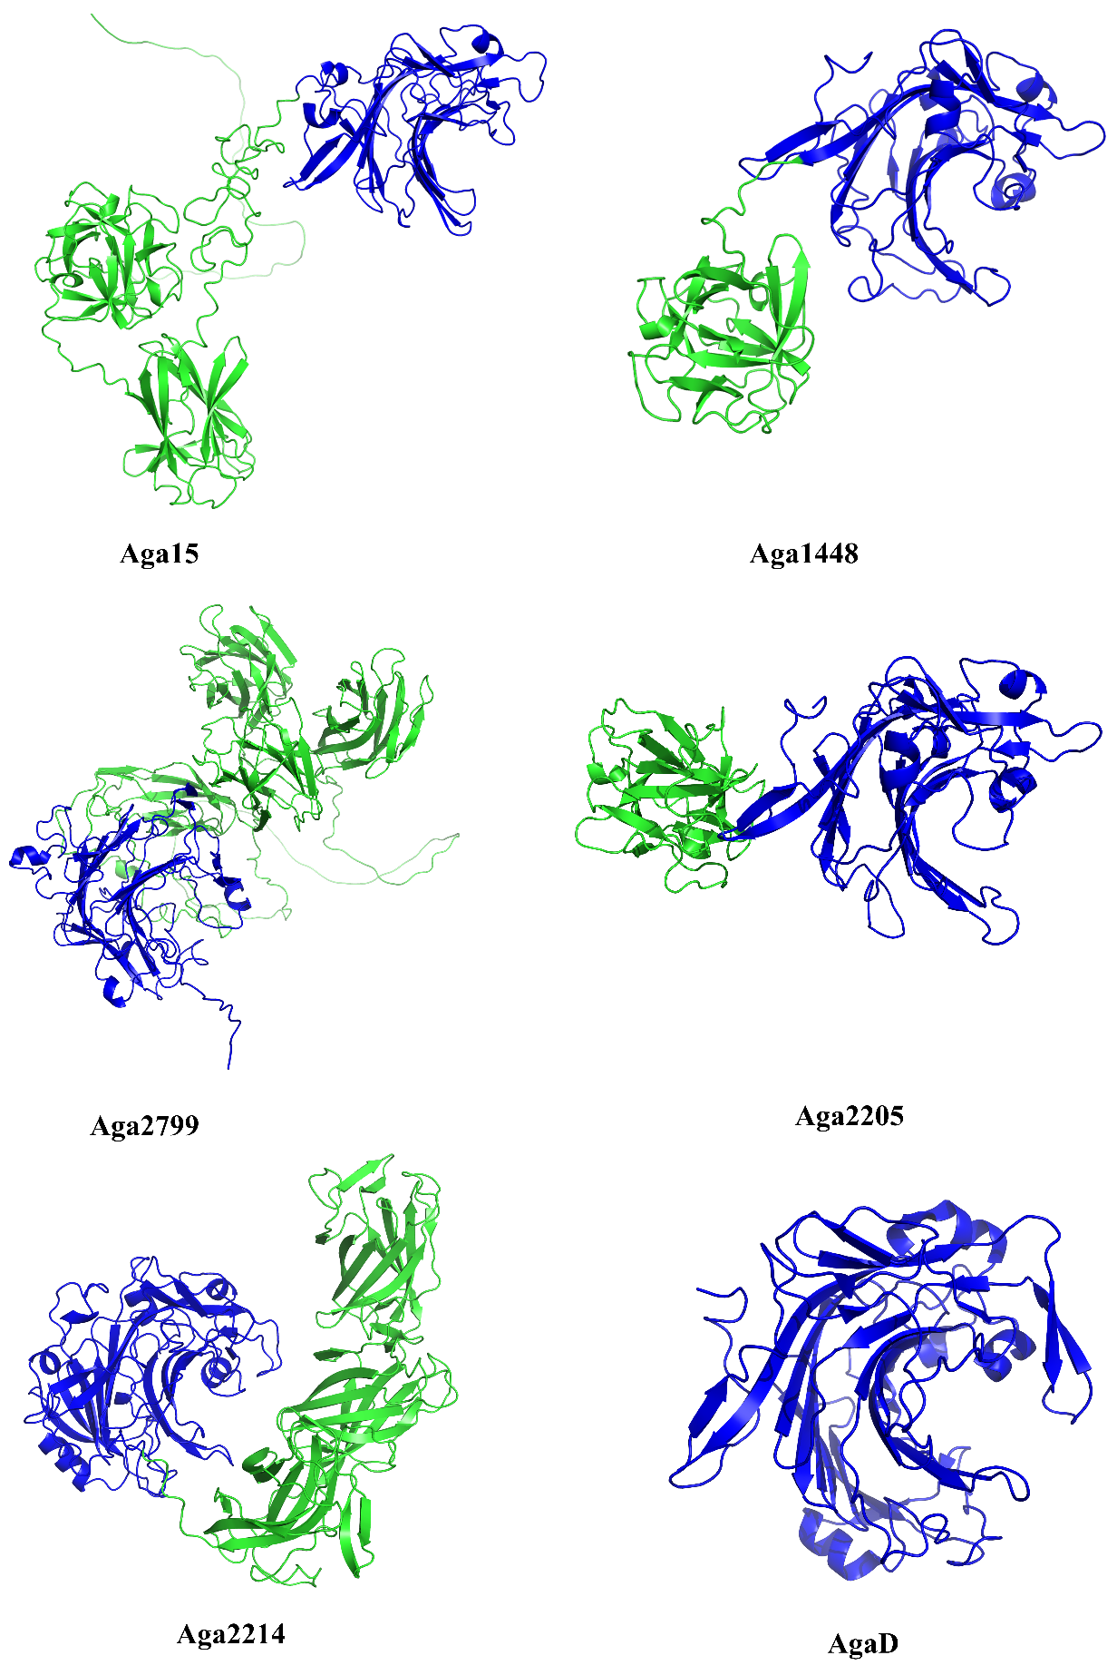
Fig. S5 Structural modeling of GH16 β-agarases. Structure models of Aga15, Aga1448, Aga2799, Aga2205, and Aga2214 from Agarivorans sp. D1326 were predicted by AlphaFold3, while AgaD from Zobellia galactanivorans (PDB: 4ASM) served as reference. Catalytic domains are shown in blue; carbohydrate-binding modules (CBMs) and linker regions in green.
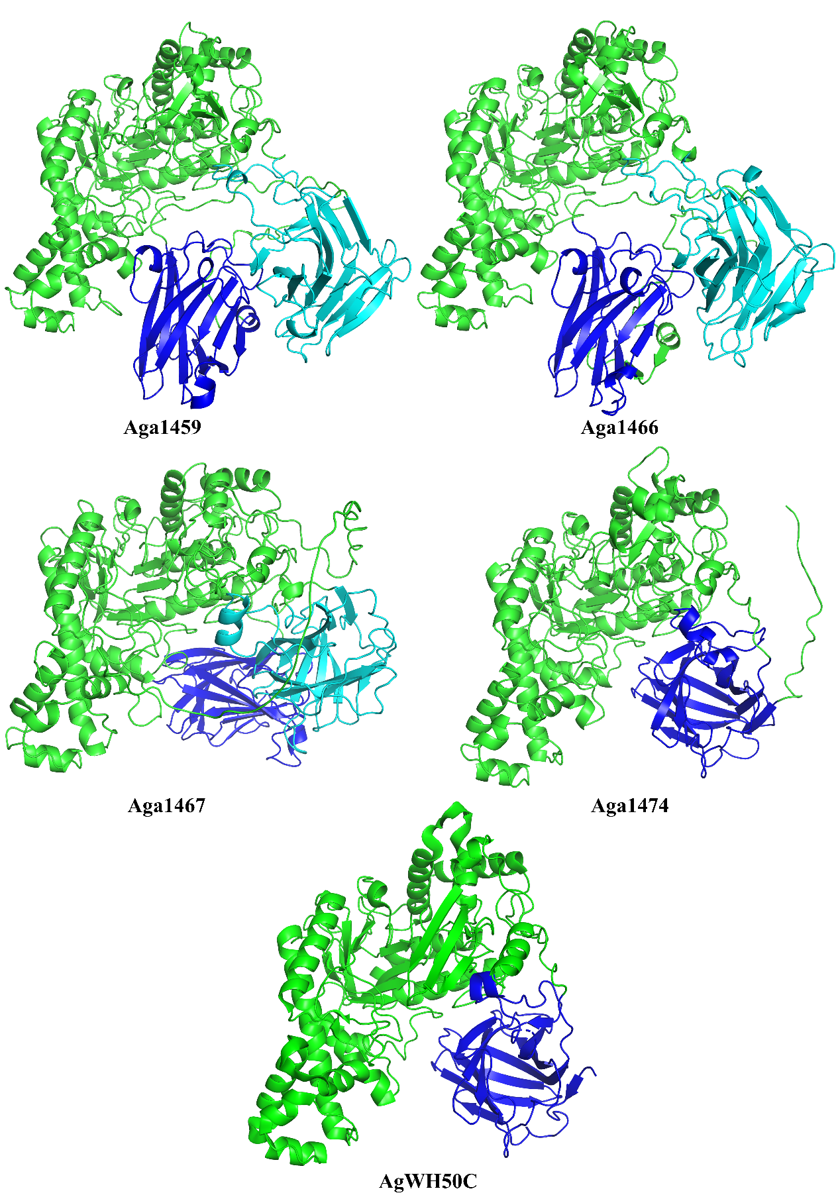
Fig. S6 Structural modeling of GH50 β-agarases. Structure models of Aga1459, Aga1466, Aga1467, and Aga1474 from Agarivorans sp. D1326 were predicted by AlphaFold3, while AgWH50C from Agarivorans gilvus WH0801 (PDB: 5Z6P) served as reference. Catalytic domains are shown in green; carbohydrate-binding modules (CBMs) are colored in blue and cyan.
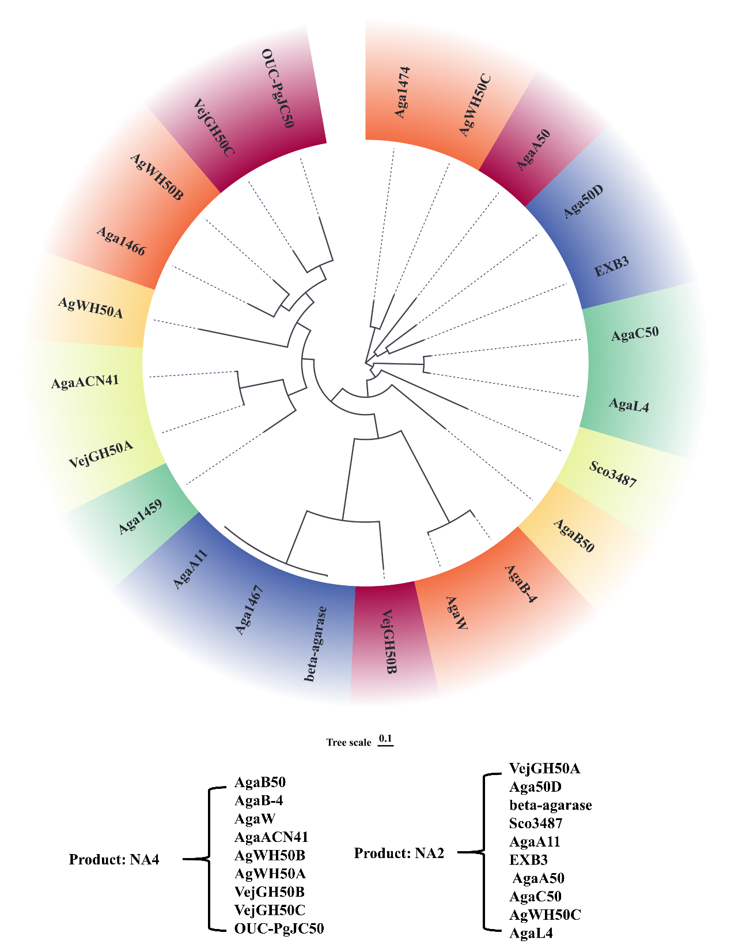
Fig. S7 Phylogenetic tree of GH50 family agarases. Enzymes within this family are categorized into two groups based on their catalytic products from agarose hydrolysis: NA4-type and NA2-type[10, 11]. The agarases from Agarivorans sp. D1326 include Aga1459, Aga1466, Aga1467, and Aga1474. Additional GH50 family members comprise: VejGH50A from Vibrio sp. EJY3 (GenBank accession: WP_014232190.1), Aga50D from Saccharophagus degradans (UniProt ID: Q21HC5), β-agarase from Agarivorans sp. JA-1 (UniProt ID: A1E2A6), Sco3487 from Streptomyces coelicolor A3(2) (UniProt ID: Q9RKF0), AgaA11 from Agarivorans sp. JAMB-A11 (UniProt ID: Q4W8F0), EXB3 from Gilvimarinus chinensis (GenBank accession: WP_020208796.1), AgaA50 (GenBank accession: QZN05586.1) and AgaC50 (GenBank accession: QZN05587.1) from Microbulbifer elongatus PORT2, AgWH50C from Agarivorans gilvus (UniProt ID: A0A023LLI1), AgaL4 from Microbulbifer pacificus LD25 (GenBank accession: AYV64447.1), AgaB50 from Microbulbifer elongatus PORT (GenBank accession: QDQ70821.1), AgaB-4 from Paenibacillus agarexedens BCRC 17346 (UniProt ID: A0A2R4K2K7), AgaW from Cohnella sp. LGH (UniProt ID: A0A0K1RLS9), AgaACN41 from Vibrio sp. strain CN41 (UniProt ID: G3CHF0), AgWH50B (UniProt ID: A0A1S6LKL3) and AgWH50A (GenBank accession: AFP32918.1) from Agarivorans gilvus WH0801, VejGH50B (GenBank accession: WP_014232191.1) and VejGH50C (GenBank accession: WP_014232192.1) from Vibrio sp. EJY3, and OUC-PgJC50 from Photobacterium gaetbulicola (GenBank accession: WP_039465539.1). All GH50 family sequences were aligned using MAFFT, and the phylogenetic tree was reconstructed under the maximum-likelihood criterion with FastTree v2.1.10, employing the Jones-Taylor-Thornton (JTT) and Generalized Time Reversible (CAT) models.

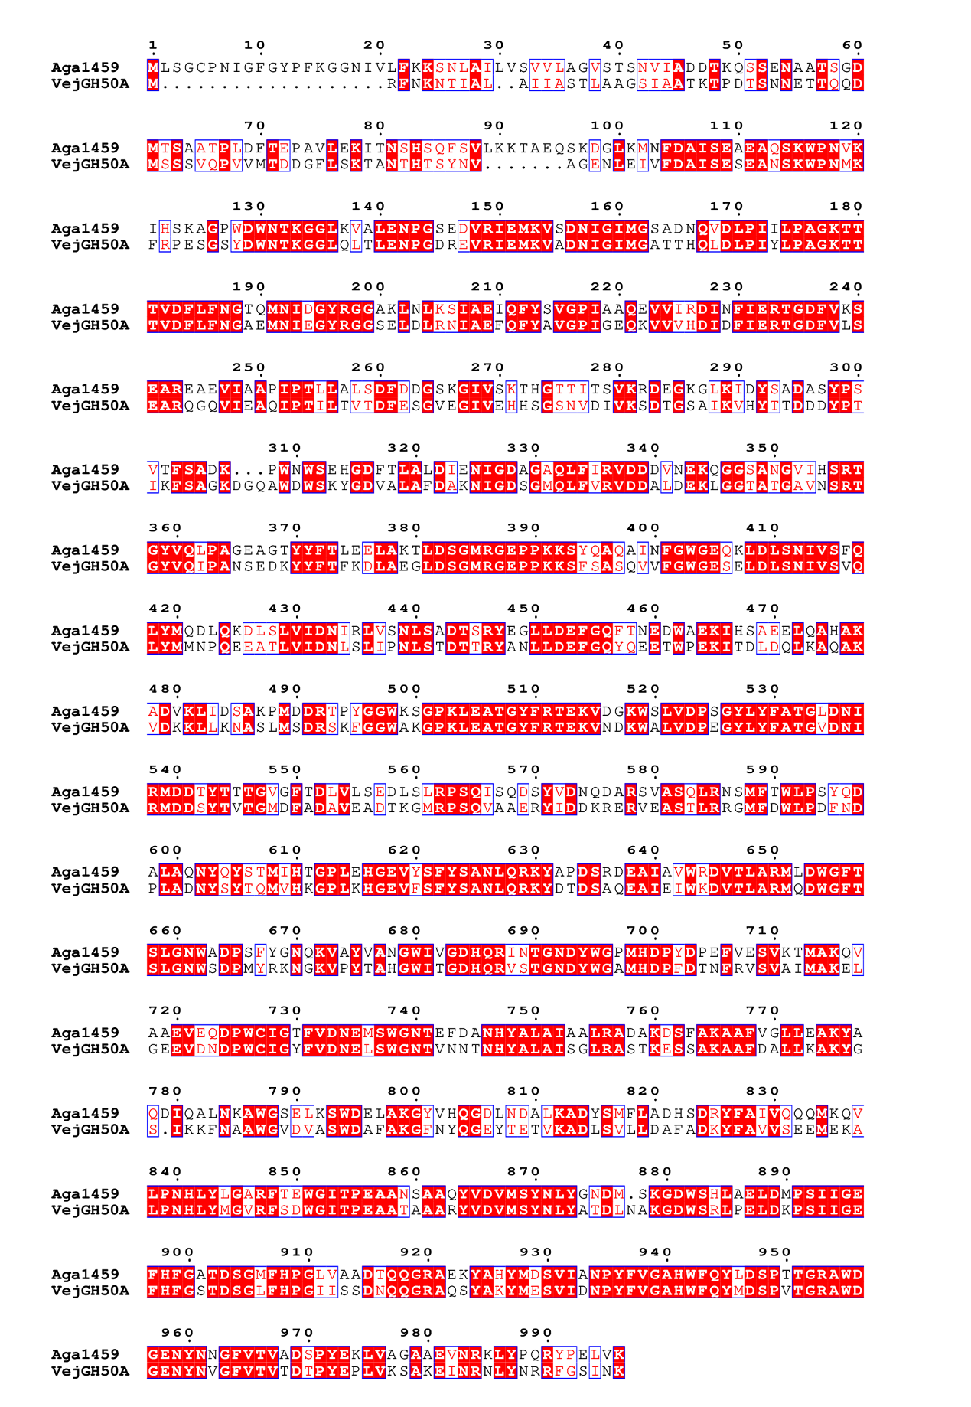
Fig. S8 Amino acid sequence alignment analysis of GH50 β-agarase Aga1459 and VejGH50A derived from Vibrio sp. EJY3
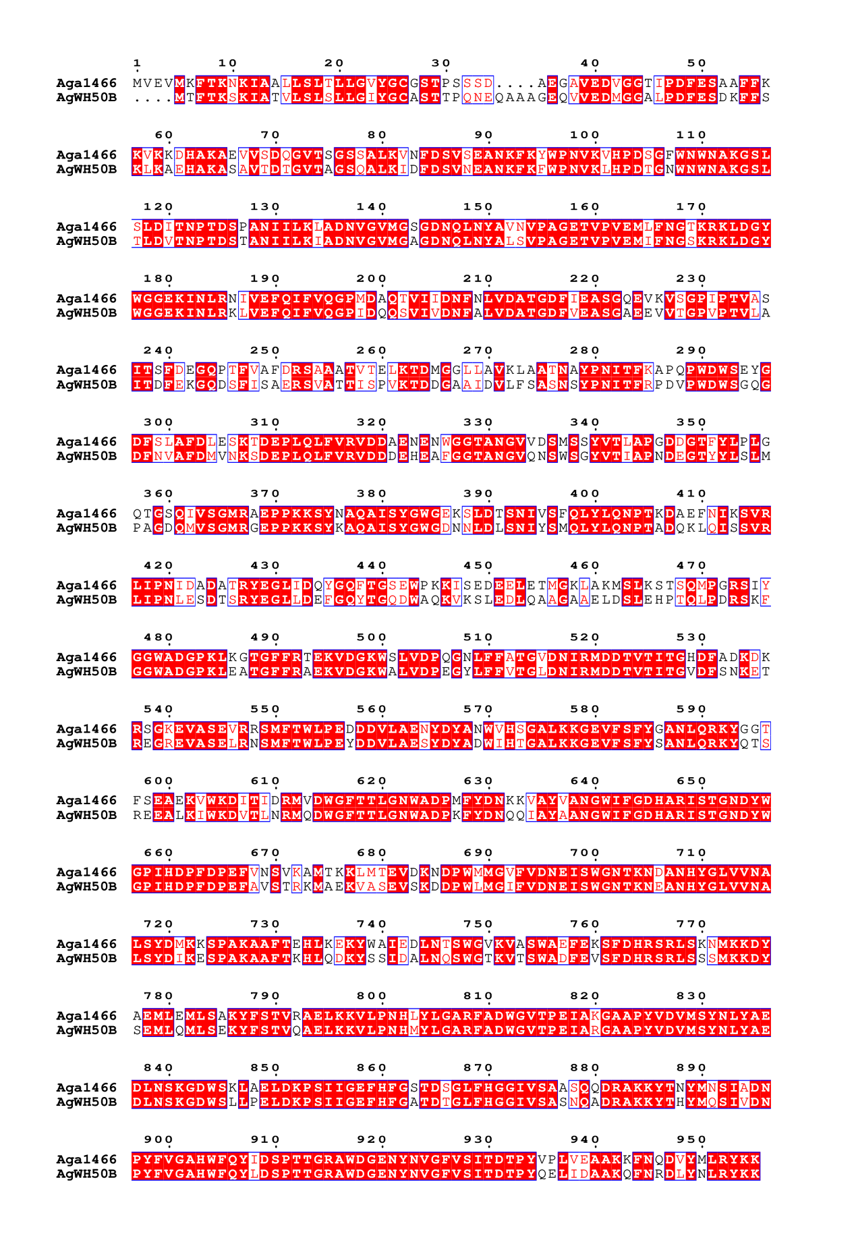
Fig. S9 Amino acid sequence alignment analysis of GH50 β-agarase Aga1466 and AgWH50B derived from Agarivorans gilvus WH0801.

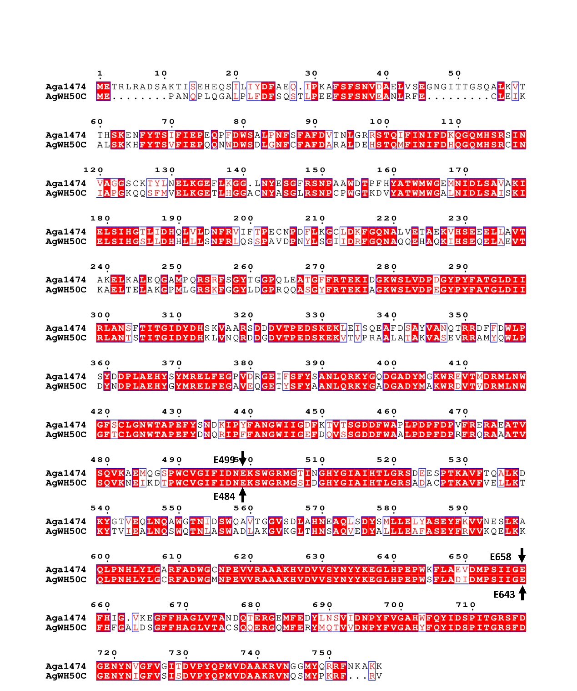
Fig. S10 Amino acid sequence alignment analysis of GH50 β-agarase Aga1474 and AgWH50C derived from Agarivorans gilvus WH0801. Catalytic residues E484 and E643 in AgWH50C [12] correspond to E499 and E658 in Aga1474 based on sequence alignment analysis.

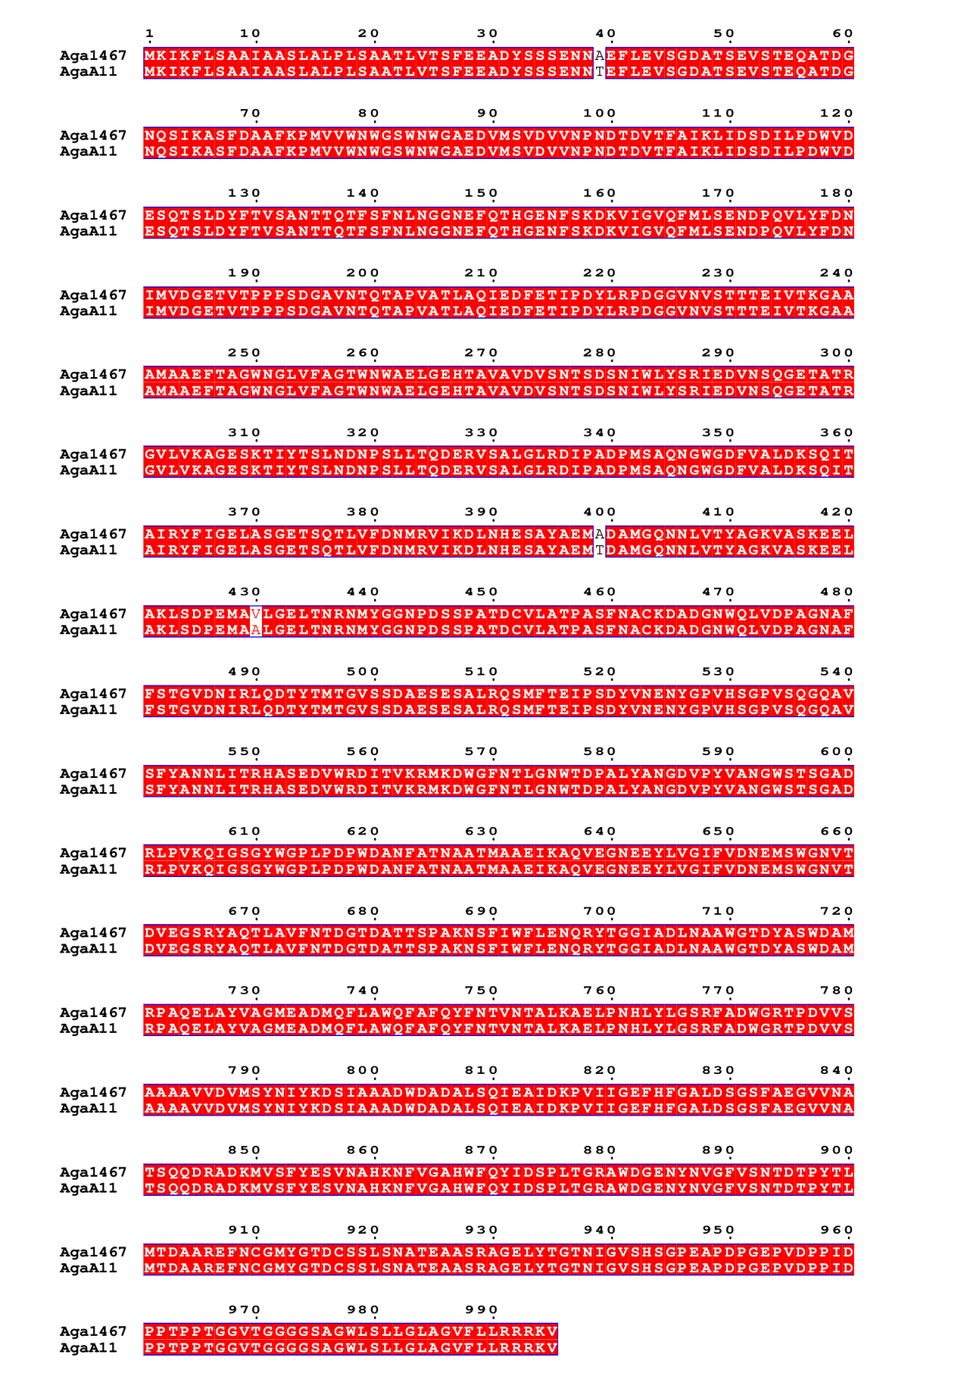
Fig. S11 Amino acid sequence alignment analysis of GH50 β-agarase Aga1467 and AgaA11 derived from Agarivorans sp. JAMB-A11.

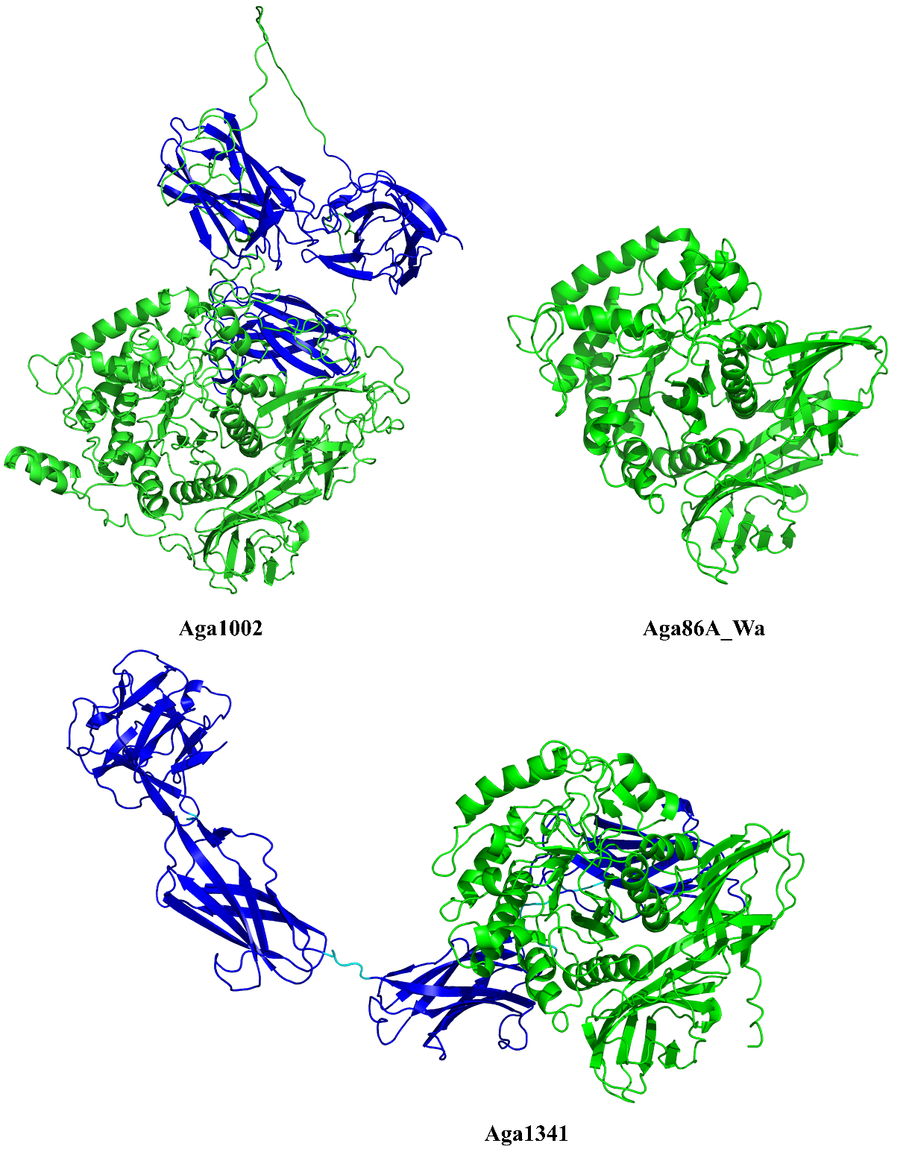
Fig. S12 Structural modeling of GH86 β-agarases. Structure models of Aga1002 and Aga1341 from Agarivorans sp. D1326 were predicted by AlphaFold2, while Aga86A_Wa from W. aestuarii (PDB: 8H97)) served as reference. Catalytic domains are shown in green; carbohydrate-binding modules (CBMs) are colored in blue.

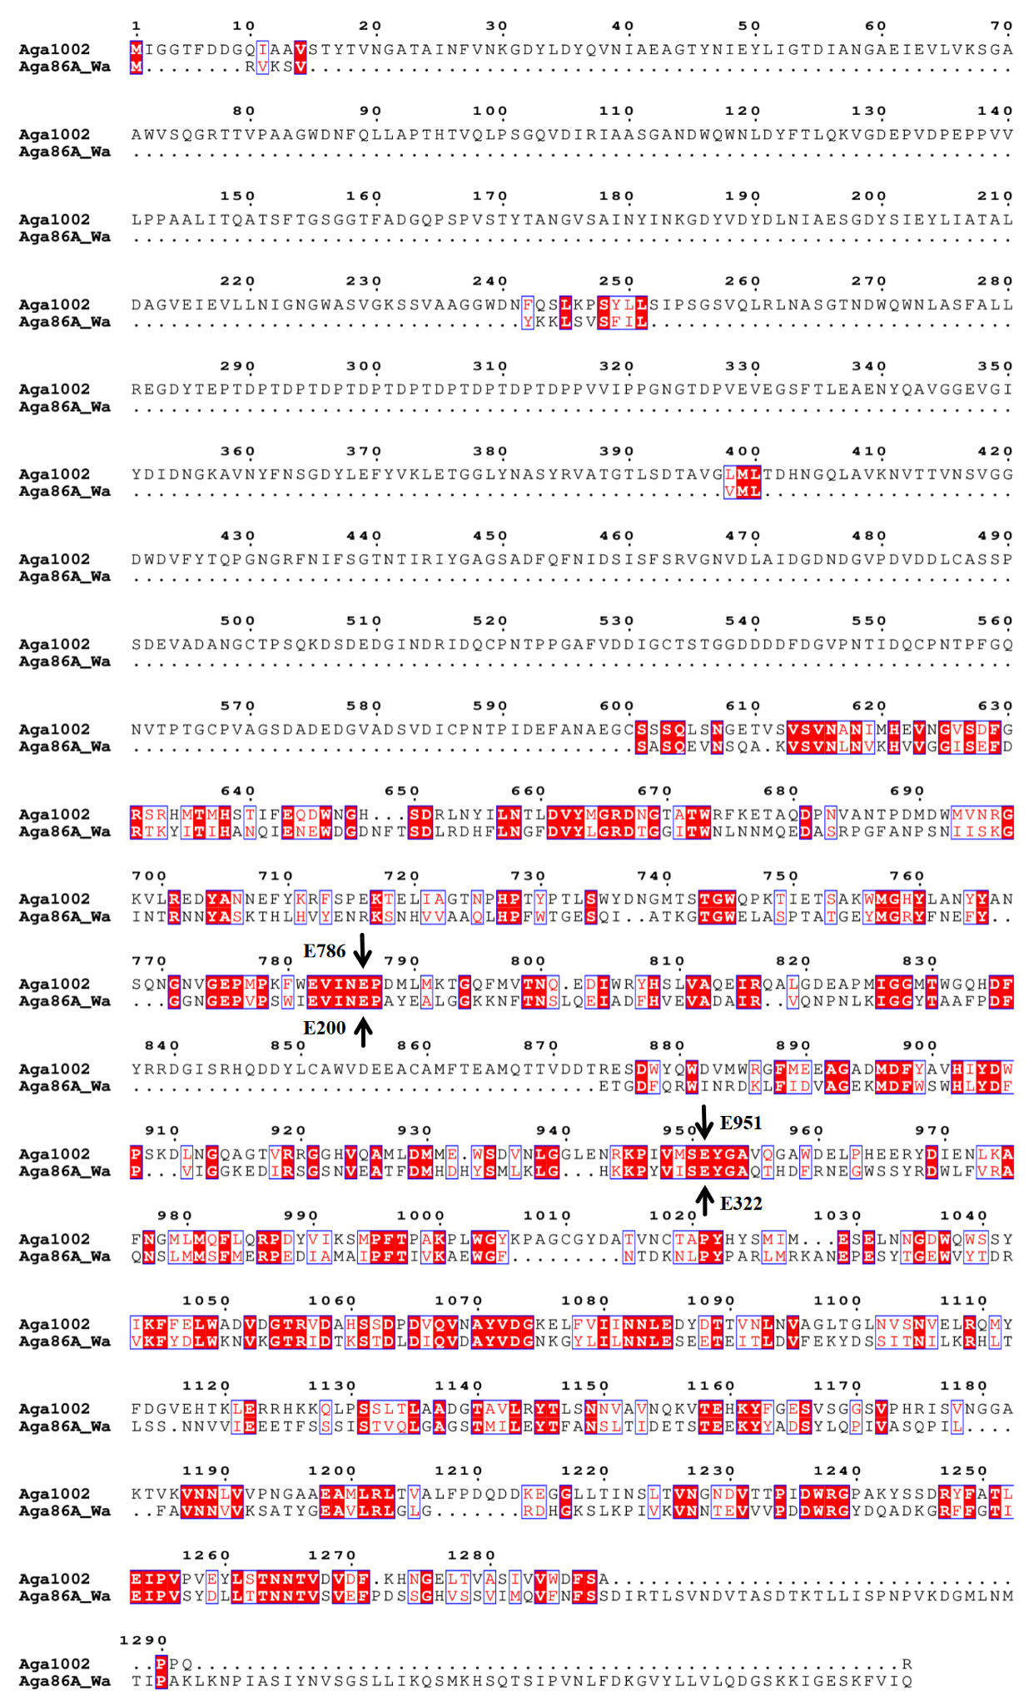
Fig. S13 Protein sequence alignment of Aga1002 from Agarivorans sp. D1326 and Aga86A_Wa from W. aestuarii (UniProtKB: A0A516RTC5). The catalytic residues of Aga86A_Wa are E200 and E322 [13]. The corresponding catalytic residues in Aga1002 are E786 and E951.

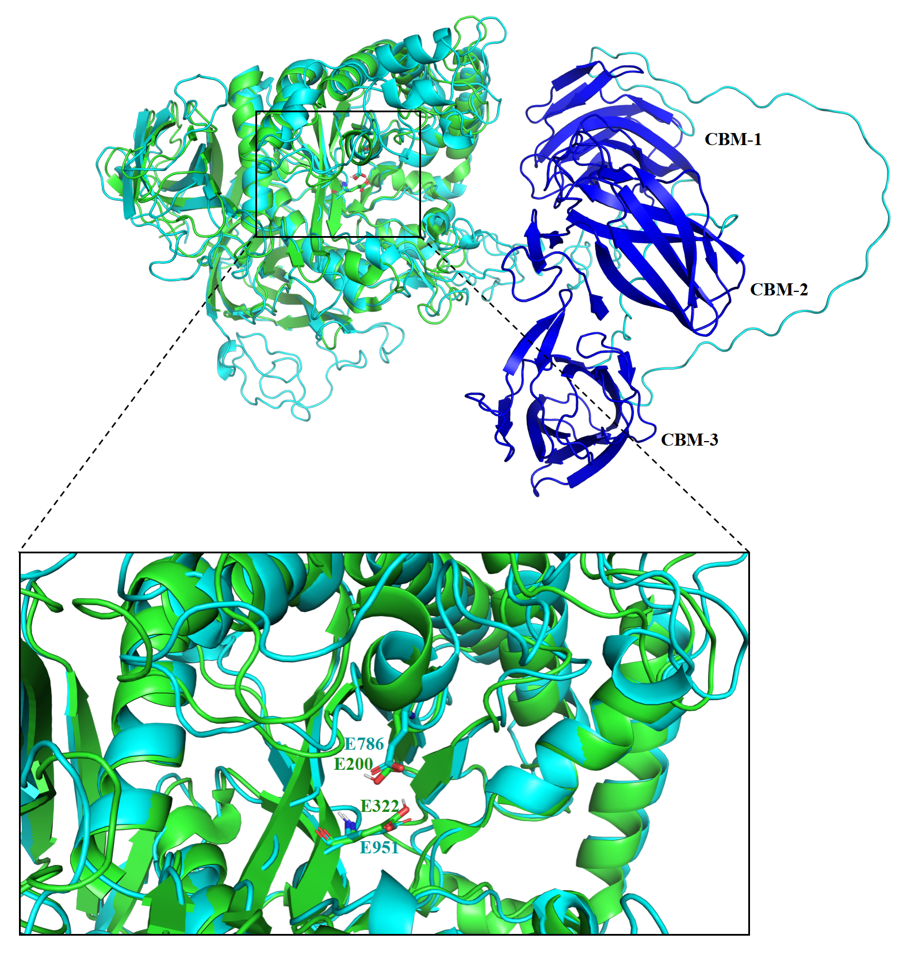
Fig. S14 Structural alignment of GH86 family β-agarases. Green model: Aga86A_Wa from W. aestuarii, structure retrieved from the RCSB Protein Data Bank (PDB: 8H97). Cyan model: Aga1002 from Agarivorans sp. D1326 (this study), modeled using the AlphaFold3 online server. The three dark blue domains represent the carbohydrate-binding module (CBM). Magnified view (boxed region with dashed lines): Close-up of the catalytic center. Residues E200 and E322 are the catalytic residues of Aga86A [13], while E786 and E951 are the predicted catalytic residues of Aga1002

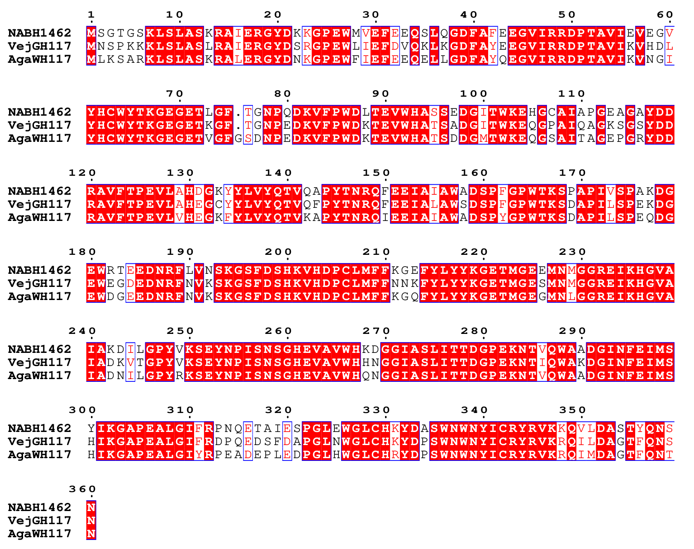
Fig. S15 Protein sequence alignment of three GH117 family NA2 hydrolases. NABH1462 from Agarivorans sp. D1326, VejGH117 from Vibrio sp. Strain EJY3 (GenBank accession No. WP_014232194.1), and AgaWH117 from Agarivorans gilvus WH0801 (UniProtKB accession No. A0A023LKZ7). The sequence alignment was performed using MAFFT (version 7) [14], and visualized using ESPript 3.0 [15].
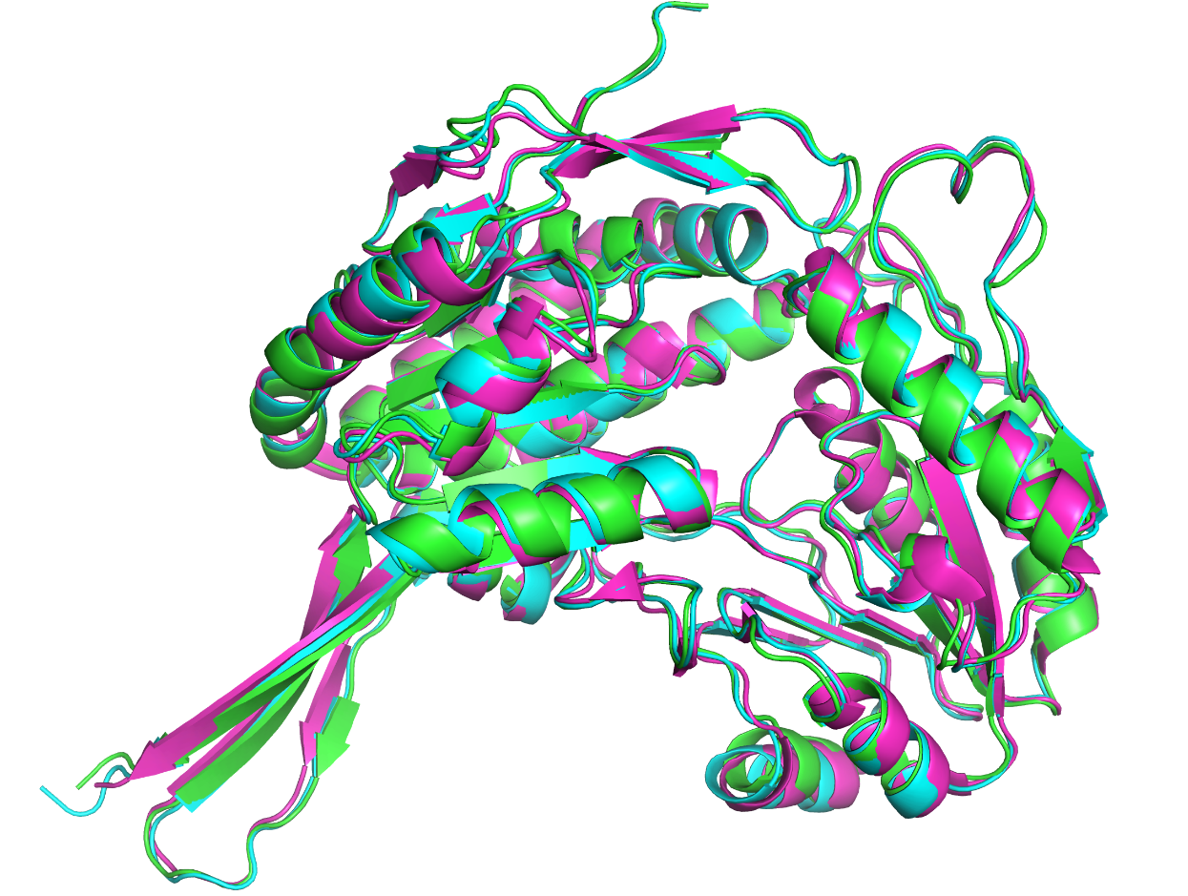
Fig. S16 Structural modeling of AHG dehydrogenase (AHGD). Structure models of AHGD1449 (green) and AHGD2206 (cyan) from Agarivorans sp. D1326 were predicted by AlphaFold3, while VvAHGD from marine bacterium Vibrio variabilis JCM 19239 (PDB: 6J75) served as reference.
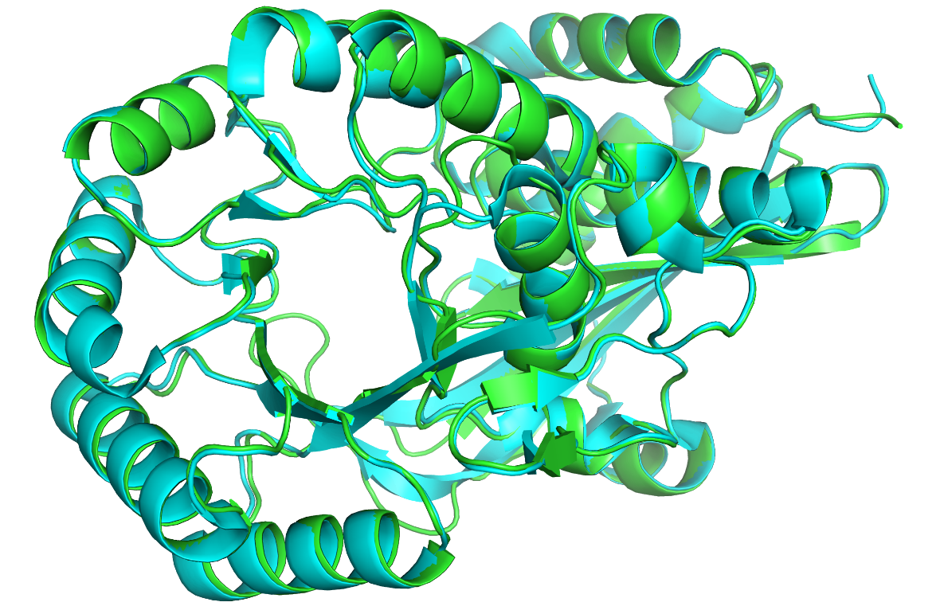
Fig. S17 Structural modeling of AHGA cycloisomerase (AHGC). Structure models of AHGD1552 (green) from Agarivorans sp. D1326 were predicted by AlphaFold3, while VejACI from marine bacterium Vibrio sp. strain EJY3 (PDB: 5XD7) served as reference.

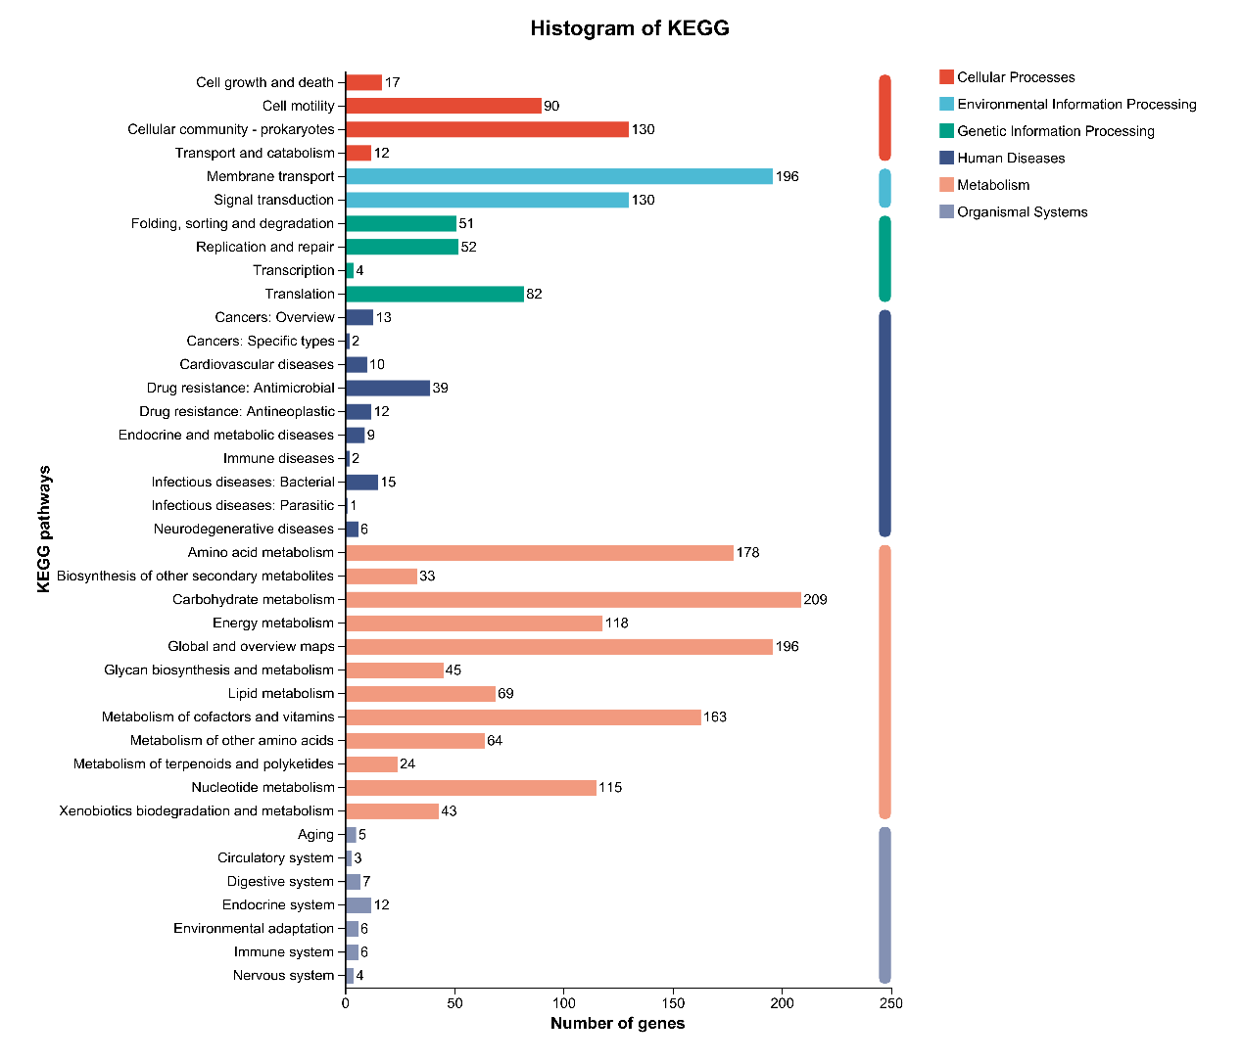
Fig. S18 Histogram of KEGG pathway for Agarivorans sp. D1326

References
1. Liu N, Kivenson V, Peng X, Cui Z, Lankiewicz TS, Gosselin KM, English CJ, Blair EM, O’Malley MA, Valentine DL (2024) Pontiella agarivorans sp. nov., a novel marine anaerobic bacterium capable of degrading macroalgal polysaccharides and fixing nitrogen. Appl Environ Microbiol 90:e00914-23. https://doi.org/10.1128/aem.00914-23
2. Yu W-N, Du Z-Z, Chang Y-Q, Mu D-S, Du Z-J (2020) Marinomonas agarivorans sp. nov., an agar-degrading marine bacterium isolated from red algae. Int J Syst Evol Microbiol 70:100–104. https://doi.org/10.1099/ijsem.0.003723
3. Kim S-G, Pheng S, Lee Y-J, Eom MK, Shin D-H (2016) Agarivorans aestuarii sp. nov., an agar-degrading bacterium isolated from a tidal flat. Int J Syst Evol Microbiol 66:3119–3124. https://doi.org/10.1099/ijsem.0.001155
4. Park S, Park J-M, Jung Y-T, Yoon J-H (2014) Agarivorans litoreus sp. nov., a novel gammaproteobacterium isolated from seawater and emended description of the genus Agarivorans. Antonie van Leeuwenhoek 106:1041–1047. https://doi.org/10.1007/s10482-014-0273-6
5. Zheng J, Ge Q, Yan Y, Zhang X, Huang L, Yin Y (2023) DbCAN3: automated carbohydrate-active enzyme and substrate annotation. Nucleic Acids Res 51:W115–W121. https://doi.org/10.1093/nar/gkad328
6. Nielsen H, Teufel F, Brunak S, von Heijne G (2024) SignalP: The evolution of a web server. In: Lisacek F (ed) Protein Bioinformatics. Springer US, New York, NY, pp 331–367
7. Yu NY, Wagner JR, Laird MR, Melli G, Rey S, Lo R, Dao P, Sahinalp SC, Ester M, Foster LJ, Brinkman FSL (2010) PSORTb 3.0: improved protein subcellular localization prediction with refined localization subcategories and predictive capabilities for all prokaryotes. Bioinformatics 26:1608–1615. https://doi.org/10.1093/bioinformatics/btq249
8. Chou K-C, Shen H-B (2008) Cell-PLoc: a package of web servers for predicting subcellular localization of proteins in various organisms. Nat Protoc 3:153–162. https://doi.org/10.1038/nprot.2007.494
9. Törönen P, Holm L (2022) PANNZER—A practical tool for protein function prediction. Protein Sci 31:118–128. https://doi.org/10.1002/pro.4193
10. Jiang C, Liu Z, Cheng D, Mao X (2020) Agarose degradation for utilization: Enzymes, pathways, metabolic engineering methods and products. Biotechnol Adv 45:107641. https://doi.org/10.1016/j.biotechadv.2020.107641
11. Jiang C, Zhang T, Xu Y, Mao X (2022) Characterization of a GH50 β-agarase: A biotechnological tool for preparing oligosaccharides from agarose and porphyran. J Agric Food Chem 70:9931–9940. https://doi.org/10.1021/acs.jafc.2c02107
12. Zhang P, Zhang J, Zhang L, Sun J, Li Y, Wu L, Zhou J, Xue C, Mao X (2019) Structure-based design of agarase AgWH50C from Agarivorans gilvus WH0801 to enhance thermostability. Appl Microbiol Biotechnol 103:1289–1298. https://doi.org/10.1007/s00253-018-9540-1
13. Zhang Y, Dong S, Chen G, Cao S, Shen J, Mei X, Cui Q, Feng Y, Chang Y, Wang Y, Xue C (2023) Structural characterization on a β-agarase Aga86A_Wa from Wenyingzhuangia aestuarii reveals the prevalent methyl-galactose accommodation capacity of GH86 enzymes at subsite −1. Carbohydr Polym 306:120594. https://doi.org/10.1016/j.carbpol.2023.120594
14. Katoh K, Rozewicki J, Yamada KD (2019) MAFFT online service: multiple sequence alignment, interactive sequence choice and visualization. Brief Bioinform 20:1160–1166. https://doi.org/10.1093/bib/bbx108
15. Gouet P, Courcelle E, Stuart DI, Métoz F (1999) ESPript: analysis of multiple sequence alignments in PostScript. Bioinformatics 15:305–308. https://doi.org/10.1093/bioinformatics/15.4.305

