SUPPLEMENTARY DATA
Disposable Screen-Printed Electrodes Modified with Oxygen-Terminated MoAlB-Derived MBene for Low-Potential Detection of Vortioxetine

Chemicals and reagents
Vortioxetine hydrobromide and other antidepressants (fluoxetine, sertraline, paroxetine, citalopram, venlafaxine; ≥98% purity) were purchased from Sigma-Aldrich (Germany). The precursor MoAlB powder (phase-pure) was obtained from Jilin 11 Technology Co., Ltd. (China). Sodium hydroxide (NaOH; ≥98%) from Aladdin was used for alkaline hydrothermal deintercalation to prepare MBene. Ethanol (≥99.7%) from Sinopharm was used to disperse and prepare the MBene ink. Phosphate-buffered saline (PBS; 0.1 M, pH 7.0) from Sigma-Aldrich served as the electrolyte for electrochemical measurements. The ferri/ferrocyanide redox couple ([Fe(CN)₆]³⁻/[Fe(CN)₆]⁴⁻), made from potassium ferricyanide (≥99%) and potassium ferrocyanide trihydrate (≥99%) from Sigma-Aldrich (Germany), was used as a redox probe in 0.1 M KCl. All solutions were prepared with ultrapure deionized water (resistivity 18.2 MΩ·cm, Milli-Q). Deuterium oxide (D₂O; 99.9 atom% D) from Cambridge was used for isotope experiments. Disposable screen-printed carbon electrodes (SPEs; DRP-110, carbon working electrode) from Metrohm DropSens (Spain) (geometric area of 0.126 cm²) were used for sensor fabrication and testing.
Characterization
The morphology and elemental distribution of MAB and etched MBene were examined by field-emission scanning electron microscopy with EDS mapping (SUPRA55 VP, Carl Zeiss). Transmission electron microscopy images were acquired on a JEM-F200 microscope (JEOL) after dispersing the sample in deionized water and drop-casting it onto carbon-coated copper grids (200 mesh). Powder X-ray diffraction patterns were recorded on a D8 ADVANCE diffractometer (Bruker) over a 2θ range of 5–90° at a scan rate of 10° min⁻¹. Raman spectra were collected using an inVia Reflex spectrometer (Renishaw) with 633 nm laser excitation in the 50–1800 cm⁻¹ range. X-ray photoelectron spectra were measured on a K-Alpha system (Thermo Fisher Scientific). UV–Vis spectra were recorded with a Lambda XLS spectrophotometer (PerkinElmer) in the 200–800 nm range. Nitrogen adsorption–desorption isotherms were measured at 77 K on a Micromeritics ASAP 2020 surface area and porosity analyzer. Samples were degassed under vacuum at 150 °C for 12 h prior to analysis. Specific surface areas were calculated by the Brunauer–Emmett–Teller (BET) method using the linear region at relative pressures of 0.05–0.30, and pore-size distributions were obtained from the desorption branch using the BJH method. Zeta potentials of MAB and MBene dispersions were measured in deionized water after brief sonication using a BeNano 90 Zeta analyzer (Bettersize Instruments Ltd., China) based on electrophoretic light scattering at room temperature, and the reported values are the average of at least three measurements. Static water contact angles were measured by the sessile-drop method using an OCA 15EC optical contact angle goniometer (DataPhysics Instruments GmbH, Germany). A 2 µL droplet of deionized water was deposited onto the surface of coated electrodes at room temperature. The contact angle was recorded with a high-speed camera and averaged across at least 5 positions on each sample. Electrochemical measurements were carried out using a VMP3 potentiostat (BioLogic), and electrochemical impedance spectroscopy (EIS) was recorded in 5 mM [Fe(CN)₆]^{3-/4-} containing 0.1 M KCl at open-circuit potential using a 5 mV AC perturbation over the frequency range 100 kHz to 0.1 Hz. Open-circuit potential (OCP) transients were recorded in 0.1 M PBS under quiescent conditions, and after baseline stabilization, 1 µM VOX was added, and the potential–time response was monitored. In-situ UV–Vis spectroelectrochemistry was carried out in a custom-designed thin-layer electrochemical cell equipped with a quartz optical window (Figure S9). The MBene-modified screen-printed electrode was placed inside the cell containing 0.1 M PBS (pH 7.0) with VOX, and real-time absorbance spectra were recorded simultaneously with the electrochemical scan (10 mV s⁻¹) using a UV–Vis spectrophotometer. The absorbance change at 225 nm was monitored to follow the consumption of vortioxetine during oxidation.

Real-sample preparation and analysis
Urine samples were collected from healthy adult volunteers after informed consent. According to institutional policy, formal ethics committee approval was not required for the collection and use of urine samples in this study. The samples were stored at 4 °C and used within 24 h. Before analysis, urine was diluted 10-fold with 0.1 M PBS (pH 7.0) to reduce matrix effects and bring the analyte concentration within the sensor's working range. Recovery experiments were performed by spiking the diluted urine samples with VOX at 0.11, 0.30, and 0.50 μM, followed by DPV measurement under the optimized conditions. Each concentration level was measured in triplicate, and recovery was calculated as (found/added) × 100. The method afforded recoveries of 96.7–109.1% with RSD values of 1.15–4.95%, confirming acceptable accuracy for VOX determination in diluted urine.

Figure S1 SEM images of pristine MAB (MoAlB) and corresponding EDS maps, showing the compact layered morphology and the distribution of Mo, Al, and B in the precursor phase.
Figure S2 (a) Zeta-potential comparison of MAB and MBene dispersions after alkaline etching, (b) photograph of the MBene dispersion stored at 4 °C and used for electrode fabrication.

Figure S3(a) N₂ adsorption–desorption isotherms and (b) pore-size distribution plots of MAB and etched MBene.

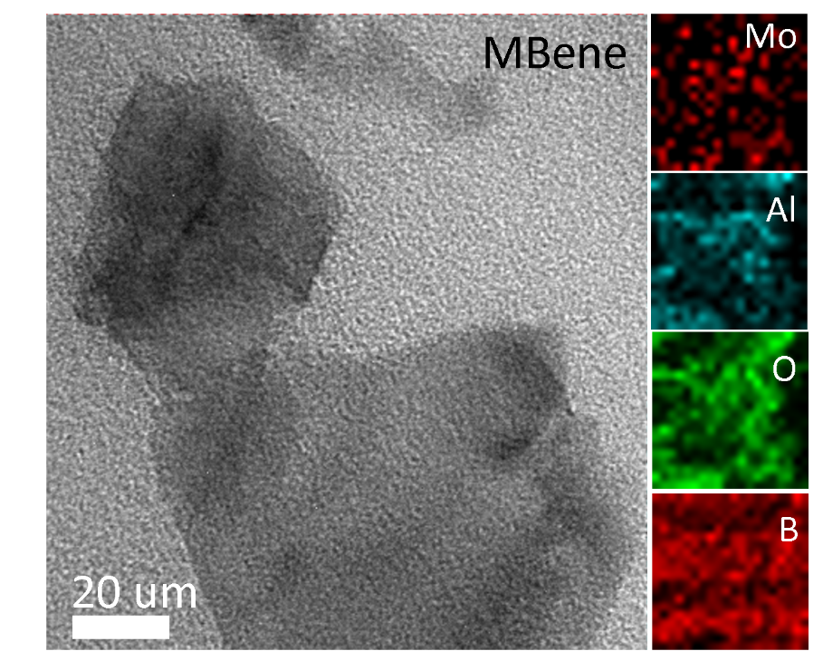
Figure S4 TEM image of etched MBene with corresponding elemental maps confirming the presence of Mo, Al, B, and O in the lamellar product.

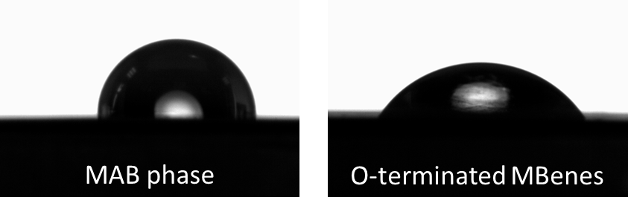

Figure S5 Representative water-contact-angle images of MAB and etched MBene, showing improved wettability after alkaline etching.

Figure S6 Representative Raman spectrum of MBene showing characteristic vibrations of the Mo–B framework within MoAl_{1-x}B.

Figure S7 CV responses of [Fe(CN)₆]³⁻/[Fe(CN)₆]⁴⁻ at MBene/SPE recorded at 50–200 mV s⁻¹. corresponding plots of (b) peak current versus scan rate, (c) log peak current versus log scan rate, (d) peak current versus square root of scan rate, (e) peak-potential separation versus scan rate, and (f) anodic-to-cathodic peak-current ratio versus scan rate.

Figure S8 Apparent electrochemically addressable interfacial coverage (Γ_{app}) of MBene/SPE estimated from the anodic and cathodic responses of the [Fe(CN)₆]³⁻/[Fe(CN)₆]⁴⁻ redox probe under thin-layer conditions.

Figure S9 Open-circuit potential (OCP) transients of bare SPE and MBene/SPE before and after addition of 1 μM VOX. After VOX addition (~70 s), MBene/SPE shows a pronounced positive potential shift, whereas bare SPE and blank controls show only minor changes, supporting stronger interfacial interaction and adsorption-assisted preconcentration of VOX on O-terminated MBene

Figure S10 Schematic illustration of the custom in situ UV–Vis spectroelectrochemical setup used to monitor VOX oxidation on MBene/SPE.

Figure S11 Optimization of analytical parameters for VOX detection at MBene/SPE: dependence of VOX anodic peak current (i_{pa}) and peak potential (E_{pa}) on (a) MBene deposition volume, (b) accumulation potential (Eacc), and (c) accumulation time (tacc).

Figure S12 Total density of states (DOS) for (a) pristine O-terminated MBene and (b) the adsorbed VOX–MBene complex.

Figure S13 (a) Fabrication reproducibility of independently prepared MBene/SPEs, (b) storage stability of MBene/SPE at ambient humidity toward VOX oxidation after up to 100 days of ambient storage.

Figure S14 Peak current (bars) and peak potential (circles) obtained for VOX and representative interferents at identical concentrations on MBene/SPE. VOX remains clearly distinguishable in the mixed-interferent system (VOX + Mix), supporting practical selectivity under equimolar coexistence conditions.

Figure S15 SEM image of MBene/SPE after 10 min pre-incubation in blank urine followed by VOX measurement, showing retention of film morphology and elemental distribution.

Table S1 Direct spike–recovery of VOX in urine using MBene/SPE
Sample | Matrix | VOX added (µM) | Found (µM)* | Recovery (%) | RSD (%)
S1 | Urine | 0.11 | 0.12 | 109.1 | 4.95
S2 | Urine | 0.30 | 0.29 | 96.7 | 1.97
S3 | Urine | 0.50 | 0.50 | 100.0 | 1.15
* Measured values are the mean of three consecutive replicates

