SUPPLEMENTARY FILE

Supplementary Table 1. Search strategy used for obtaining studies

(Tenecteplase OR Metalyse OR TNKase OR "TNK tPA" OR "TNK-tPA" OR Elaxim)
AND
(Alteplase OR Actilyse OR Activase OR Cathflo OR "Tissue plasminogen activator" OR rtPA OR tPA)
AND
("Ischemic stroke" OR "Ischaemic Stroke" OR "Acute Ischemic Stroke" OR "Cerebral Infarction" OR Stroke OR Thrombectomy OR "Posterior circulation" OR vertebrobasilar OR "basilar artery" OR BAO)

Supplementary Table S2. Risk of Bias Summary.
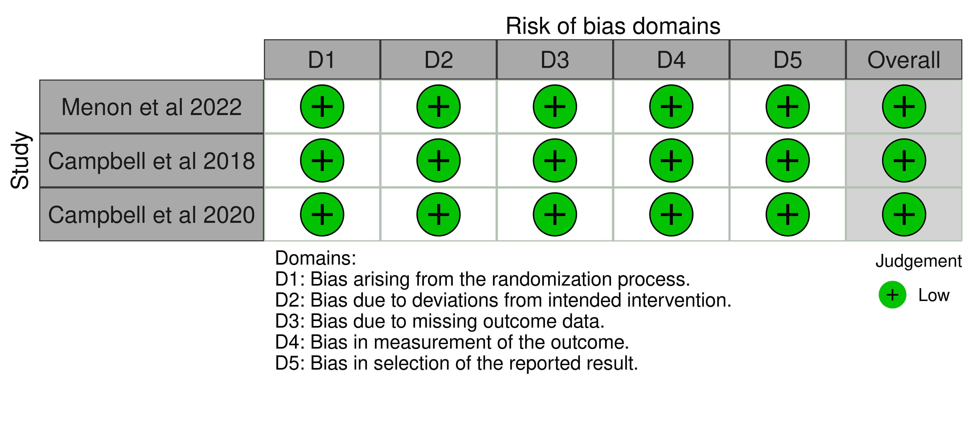

Supplementary Table 3. Risk of Bias for observational studies NOS.
Studies | Selection |  |  |  | Comparability |  | Exposure |  |  | Total Quality score
 | Representativeness of exposed cohort | Selection of non-exposed cohort | Ascertainment of exposure | Outcome not present at start | Control for most important confounders | Control for additional confounders | Assessment of outcome | Follow-up long enough for outcomes | Adequacy of follow-up
Wolman et al 2025 | * | * | * | * | * | - | * | * | - | 7
Karamchandani et. al (2025) | * | * | * | * | * | - | * | * | * | 8
Alemseged et al 2019 | * | * | * | * | * | * | * | * | * | 9

Supplementary Table 4: GRADE summary of findings table for efficacy and safety outcomes
Certainty assessment |  |  |  |  |  |  | Summary of findings
Participants  (studies)  Follow-up | Risk of bias | Inconsistency | Indirectness | Imprecision | Publication bias | Overall certainty of evidence | Study event rates (%) |  | Relative effect  (95% CI) | Anticipated absolute effects
 |  |  |  |  |  |  | With Alteplase | With Tenecteplase | Relative effect  (95% CI) | Risk with Alteplase | Risk difference with Tenecteplase
mRS 0–1 at 90 Days
433  (4 studies) | not serious | not serious | not serious | serious | none | ⨁⨁⨁◯  Moderate | 90/272 (33.1%) | 60/161 (37.3%) | RR 1.19  (0.91 to 1.56) | 90/272 (33.1%) | 63 more per 1,000  (from 30 fewer to 185 more)
mRS 0–2 at 90 Days
587  (5 studies) | not serious | not serious | not serious | serious | none | ⨁⨁⨁◯  Moderate | 170/358 (47.5%) | 123/229 (53.7%) | RR 1.10  (0.89 to 1.37) | 170/358 (47.5%) | 47 more per 1,000  (from 52 fewer to 176 more)
mRS 0–3 at 90 Days (Ambulatory)
279  (2 studies) | not serious | not serious | not serious | serious | none | ⨁⨁⨁◯  Moderate | 74/157 (47.1%) | 74/122 (60.7%) | RR 1.29  (1.03 to 1.60) | 74/157 (47.1%) | 137 more per 1,000  (from 14 more to 283 more)
Mortality at 90 Days (mRS 6)
477  (4 studies) | not serious | not serious | not serious | serious | none | ⨁⨁⨁◯  Moderate | 79/267 (29.6%) | 55/210 (26.2%) | RR 0.88  (0.66 to 1.17) | 79/267 (29.6%) | 36 fewer per 1,000  (from 101 fewer to 50 more)
Symptomatic ICH (sICH)
542  (4 studies) | not serious | not serious | not serious | very serious | none | ⨁⨁◯◯  Low | 11/329 (3.3%) | 7/213 (3.3%) | RR 0.89  (0.36 to 2.22) | 11/329 (3.3%) | 4 fewer per 1,000  (from 21 fewer to 41 more)
Any Intracranial Hemorrhage
296  (2 studies) | not serious | not serious | not serious | serious | none | ⨁⨁⨁◯  Moderate | 22/161 (13.7%) | 19/135 (14.1%) | RR 1.02  (0.59 to 1.78) | 22/161 (13.7%) | 3 more per 1,000  (from 56 fewer to 107 more)
Any Parenchymal Hematoma (PH)
335  (3 studies) | not serious | not serious | not serious | very serious | none | ⨁⨁◯◯  Low | 9/212 (4.2%) | 4/123 (3.3%) | RR 0.76  (0.24 to 2.38) | 9/212 (4.2%) | 10 fewer per 1,000  (from 32 fewer to 59 more)
Early Reperfusion
306  (4 studies) | not serious | not serious | not serious | serious | none | ⨁⨁⨁◯  Moderate | 20/197 (10.2%) | 24/109 (22.0%) | RR 2.18  (1.06 to 4.46) | 20/197 (10.2%) | 120 more per 1,000  (from 6 more to 351 more)
Final Successful Reperfusion
196  (3 studies) | not serious | not serious | not serious | serious | none | ⨁⨁⨁◯  Moderate | 93/106 (87.7%) | 87/90 (96.7%) | RR 1.12  (0.89 to 1.40) | 93/106 (87.7%) | 105 more per 1,000  (from 97 fewer to 351 more)

Supplementary Figure 1. Forest plot assessing post-EVT perfusion outcomes between Tenecteplase and Alteplase.
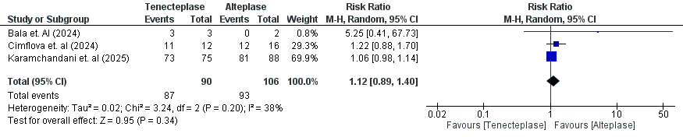
Supplementary Figure 2. Forest plot comparing the incidence of symptomatic intracranial hemorrhage (sICH) for Tenecteplase vs Alteplase.
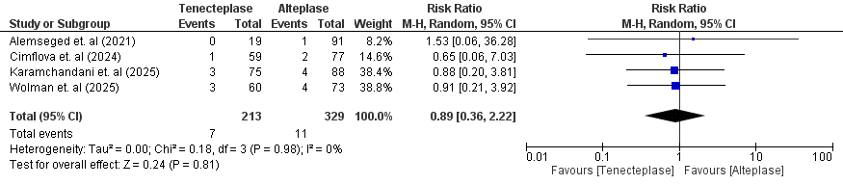
Supplementary Figure 3. Forest plot comparing the incidence of any intracranial hemorrhage (ICH) between the two treatments.
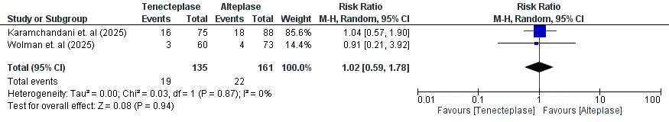
Supplementary Figure 4. Forest plot assessing the occurrence of parenchymal hematoma for Tenecteplase and Alteplase.
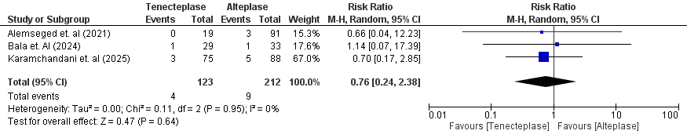
Supplementary Figure 5. Forest plot comparing the 90-day mortality rates between Tenecteplase and Alteplase.
