SUPPLEMENTARY MATERIAL
Comparative Efficacy and Safety of Ticagrelor and Prasugrel in Acute coronary syndrome: A Meta-Analysis of Randomized controlled trials

Supplementary Table S1. Search Strategy
Database | Search Strategy | Results
PubMed | ((((("Percutaneous Coronary Intervention"[Mesh]) OR (Percutaneous Coronary Interventions))  OR Percutaneous Coronary Revascularization) OR (Percutaneous Coronary Revascularizations))  AND (((((("Ticagrelor"[Mesh]) OR (3-(7-((2-((2-(3,4-Difluorophenyl)cyclopropyl)amino)-5-(propylthio)-3H-(1,3)-triazolo(4,5-d)pyrimidin-3-yl)-5-(2-hydroxyethoxy)cyclopentane-1,2-diol))  OR (Brilinta)) OR (AZD-6140)) OR (AZD6140)) OR (AZD 6140)) OR (Brilique)))  AND (((((("Prasugrel Hydrochloride"[Mesh]) OR (Prasugrel HCl)) OR (CS-747)) OR (CS 747))  OR (CS747)) OR (Prasugrel)) OR (Efient)) OR (Effient)) OR (LY 640315))  OR (LY640315)) OR (LY-640315) | 1,005
Web of Science | (((TS=("Percutaneous Coronary Intervention"[Mesh]) OR TS=(Percutaneous Coronary Interventions))  OR TS=(Percutaneous Coronary Revascularization)) OR TS=(Percutaneous Coronary Revascularizations))  AND (((((TS=("Ticagrelor"[Mesh])) OR TS=(Brilique)) OR TS=(AZD 6140))  OR TS=(AZD6140)) OR TS=(AZD-6140)) OR TS=(Brilinta))  OR TS=(3-(7-((2-(3,4-Difluorophenyl)cyclopropyl)amino)-5-(propylthio)-3H-(1,3)-triazolo(4,5-d)pyrimidin-3-yl)-5-(2-hydroxyethoxy)cyclopentane-1,2-diol))  AND ((((((TS=("Prasugrel Hydrochloride"[Mesh])) OR TS=(Prasugrel HCl))  OR TS=(CS-747)) OR TS=(CS 747)) OR TS=(CS747)) OR TS=(Prasugrel))  OR TS=(Efient)) OR TS=(Effient)) OR TS=(LY 640315))  OR TS=(LY640315)) OR TS=(LY-640315)) | 37
Cochrane CENTRAL | ([mh "Acute Coronary Syndrome"] OR [mh "Myocardial Infarction"] OR [mh "Angina, Unstable"] OR "acute coronary syndrome" OR ACS OR STEMI OR NSTEMI OR "unstable angina" OR "myocardial infarction")  AND  ([mh "Percutaneous Coronary Intervention"] OR "percutaneous coronary intervention" OR PCI OR "coronary revascularization" OR angioplasty OR stent*)  AND  ([mh Ticagrelor] OR ticagrelor OR Brilinta OR Brilique OR AZD6140 OR "AZD 6140" OR "AZD-6140")  AND  ([mh "Prasugrel Hydrochloride"] OR prasugrel OR Efient OR Effient OR "prasugrel hydrochloride" OR "CS-747" OR "CS 747" OR CS747 OR LY640315 OR "LY 640315" OR "LY-640315") | 49

Supplementary Table S2. Definitions of major and minor bleeding endpoints across the included trials.
Trial | Major Bleeding Definition | Minor Bleeding Definition
TUXEDO-2 (2026) | Bleeding Academic Research Consortium (BARC) types 3a, 3b, 3c, 4, 5a, and 5b. | N/A
Schüpke et al. (2019) | BARC types 3, 4, or 5 (including overt bleeding with significant hemoglobin drop/transfusion, intracranial, intraocular, CABG-related, and fatal bleeding). | Bleeding classified as BARC type 1 or 2.
Motovska et al. (2018) | Evaluated using both Thrombolysis In Myocardial Infarction (TIMI) criteria ("TIMI major bleeding") and BARC criteria. | Tracked as "all bleeding" minus the events that met the "TIMI major bleeding" threshold.
Welsh et al. (2019) | Severe: Fatal, hemoglobin drop ≥5 g/dL, causing hypotension, requiring surgery, symptomatic intracranial, or requiring ≥4 units of RBCs.  Other non severe major: Disabling, intraocular with vision loss, or requiring 2-3 units of RBCs. | Any bleeding that did not meet the criteria for a major bleed or required only 1 unit of blood transfused.

Supplementary Table S3. Risk of Bias Summary.
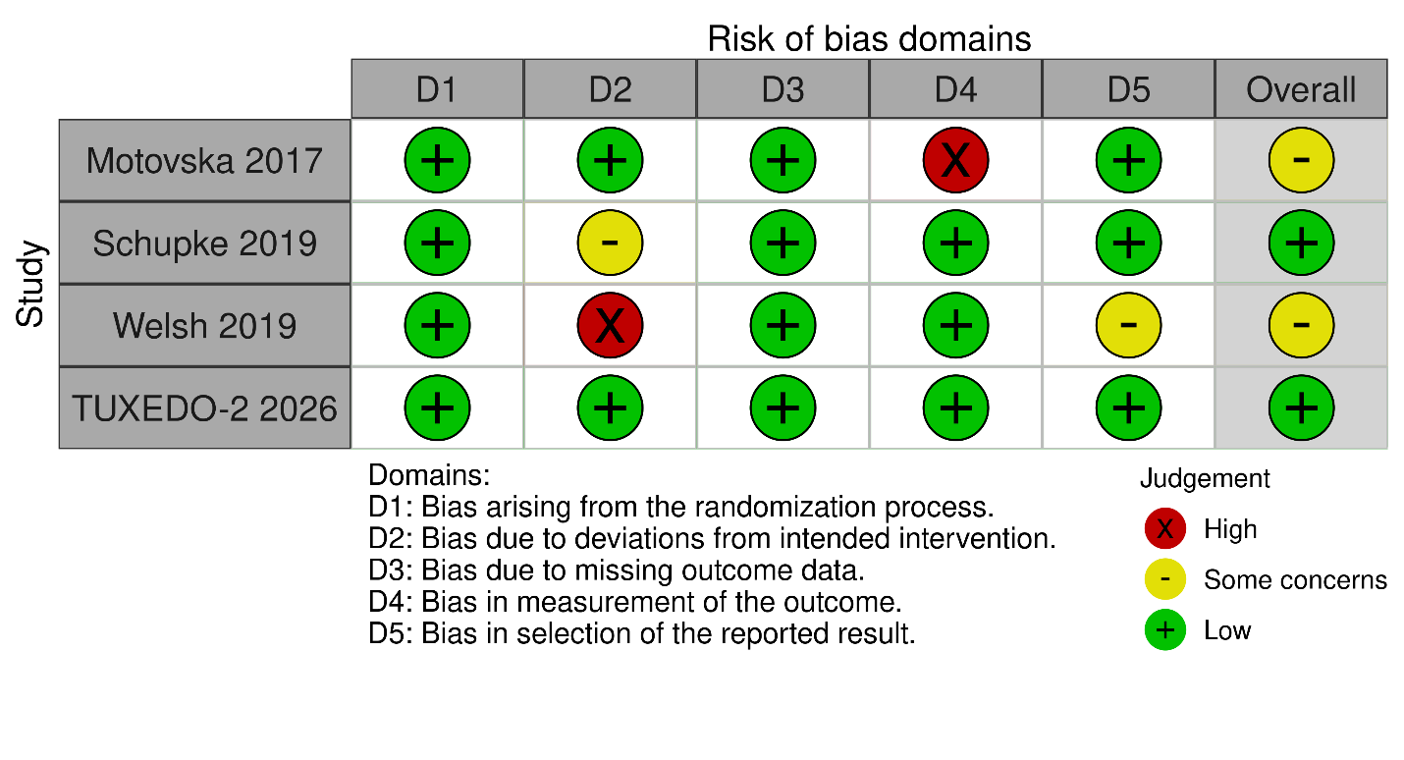

Supplementary Table S4. Regression analysis results for Ticagrelor vs Prasugrel
Study | Motovska (2017) |  | Schupke (2019) |  | Welsh (2019) |  | TUXEDO-2 (2026)
Drug | TICA | PRA | TICA | PRA | TICA | PRA | TICA | PRA
Total Patients (n) | 596 | 634 | 2012 | 2006 | 2188 | 1244 | 901 | 899
Male (n) | 439 | 489 | 1534 | 1528 | 1704 | 1054 | 636 | 660
Age (mean) | 61.8 | 61.8 | 64.5 | 64.6 | NA |  | 60.5 | 60.1
HTN (n) | 305 | 326 | 1178 | 1163 | 962 | 560 | 534 | 550
Smokers (n) | 392 | 406 | 682 | 667 | 945 | 603 | 140 | 146
Diabetes (n) | 124 | 127 | 463 | 429 | 332 | 253 | 896 | 896
Prior PCI (n) | 45 | 42 | 1676 | 1701 | 188 | 148 | 31 | 43
Prior MI (n) | 55 | 47 | 311 | 320 | 817 | 521 | 183 | 204

Supplementary Table S5. Regression analysis results for ACM.
Model | Term | Beta Estimate | SE | CI LL | CI UL | Z-value | P-value
age | Intercept | 0.3619 | 5.8266 | -11.058 | 11.7818 | 0.0621 | 0.9505
 | age (Slope) | -0.0063 | 0.093 | -0.1885 | 0.1759 | -0.068 | 0.9458
male | Intercept | -4.6065 | 2.8694 | -10.2304 | 1.0175 | -1.6054 | 0.1084
 | male (Slope) | 0.06 | 0.0379 | -0.0142 | 0.1343 | 1.5841 | 0.1132
smoking | Intercept | -0.4213 | 0.2754 | -0.9611 | 0.1185 | -1.5296 | 0.1261
 | smoking (Slope) | 0.0096 | 0.0069 | -0.0039 | 0.0231 | 1.3985 | 0.162
diabetes | Intercept | 0.0778 | 0.208 | -0.3298 | 0.4853 | 0.3739 | 0.7085
 | diabetes (Slope) | -0.0031 | 0.0041 | -0.0111 | 0.005 | -0.7496 | 0.4535
htn | Intercept | 1.8131 | 0.9866 | -0.1207 | 3.7468 | 1.8377 | 0.0661
 | htn (Slope) | -0.0342 | 0.0179 | -0.0693 | 0.0008 | -1.913 | 0.0558
prior pci | Intercept | 0.0692 | 0.1687 | -0.2615 | 0.3999 | 0.4099 | 0.6819
 | prior_pci (Slope) | -0.0032 | 0.0032 | -0.0095 | 0.0031 | -0.9992 | 0.3177
prior mi | Intercept | -0.2826 | 0.2472 | -0.7671 | 0.202 | -1.1429 | 0.2531
 | prior_mi (Slope) | 0.0109 | 0.0107 | -0.01 | 0.0318 | 1.0217 | 0.3069

Supplementary Table S6. Regression analysis results for Cardiovascular Death.
Model | Term | Beta Estimate | SE | CI LL | CI UL | Z-value | P-value
age | Intercept | -1.3521 | 4.6339 | -10.4345 | 7.7302 | -0.2918 | 0.7705
 | age (Slope) | 0.0216 | 0.0737 | -0.1229 | 0.166 | 0.2929 | 0.7696
male | Intercept | -4.135 | 3.1327 | -10.2749 | 2.0049 | -1.32 | 0.1868
 | male (Slope) | 0.0547 | 0.0414 | -0.0264 | 0.1357 | 1.3216 | 0.1863
smoking | Intercept | -0.293 | 0.3093 | -0.8992 | 0.3132 | -0.9472 | 0.3435
 | smoking (Slope) | 0.0081 | 0.0078 | -0.0073 | 0.0234 | 1.0306 | 0.3027
diabetes | Intercept | 0.1277 | 0.1774 | -0.22 | 0.4754 | 0.7201 | 0.4715
 | diabetes (Slope) | -0.0033 | 0.0036 | -0.0103 | 0.0037 | -0.9369 | 0.3488
htn | Intercept | 1.4707 | 1.0897 | -0.6651 | 3.6064 | 1.3496 | 0.1771
 | htn (Slope) | -0.0268 | 0.0198 | -0.0656 | 0.012 | -1.3552 | 0.1753
prior_pci | Intercept | 0.053 | 0.1687 | -0.2776 | 0.3835 | 0.3141 | 0.7535
 | prior_pci (Slope) | -0.0013 | 0.0031 | -0.0073 | 0.0047 | -0.415 | 0.6781
prior_mi | Intercept | -0.1972 | 0.2658 | -0.7181 | 0.3237 | -0.742 | 0.4581
 | prior_mi (Slope) | 0.0094 | 0.0113 | -0.0127 | 0.0316 | 0.8351 | 0.4037

Supplementary Table S7. Regression analysis results for Composite Ischemic Event.
Model | Term | Beta Estimate | SE | CI LL | CI UL | Z-value | P-value
age | Intercept | 1.1727 | 7.8588 | -14.2303 | 16.5756 | 0.1492 | 0.8814
 | age (Slope) | -0.0185 | 0.1258 | -0.265 | 0.228 | -0.147 | 0.8831
male | Intercept | -5.5779 | 3.313 | -12.0712 | 0.9154 | -1.6836 | 0.0922
 | male (Slope) | 0.0737 | 0.0437 | -0.012 | 0.1594 | 1.685 | 0.092
htn | Intercept | 2.4408 | 0.7279 | 1.014 | 3.8675 | 3.353 | 0.0008
 | htn (Slope) | -0.0453 | 0.0131 | -0.071 | -0.0196 | -3.4513 | 0.0006
smoking | Intercept | -0.3576 | 0.3966 | -1.1349 | 0.4198 | -0.9016 | 0.3673
 | smoking (Slope) | 0.0096 | 0.0095 | -0.0089 | 0.0282 | 1.0161 | 0.3096
diabetes | Intercept | 0.1466 | 0.2871 | -0.4161 | 0.7094 | 0.5108 | 0.6095
 | diabetes (Slope) | -0.0032 | 0.0054 | -0.0138 | 0.0073 | -0.6031 | 0.5464
prior_pci | Intercept | 0.1605 | 0.2058 | -0.2428 | 0.5637 | 0.7799 | 0.4355
 | prior_pci (Slope) | -0.0052 | 0.0045 | -0.014 | 0.0037 | -1.1442 | 0.2525
prior_mi | Intercept | -0.3387 | 0.3289 | -0.9832 | 0.3059 | -1.0298 | 0.3031
 | prior_mi (Slope) | 0.016 | 0.0136 | -0.0106 | 0.0427 | 1.1786 | 0.2385

Supplementary Table S8. Regression analysis results for Major Bleeding.
Model | Term | Beta Estimate | SE | CI LL | CI UL | Z-value | P-value
age | Intercept | -2.1457 | 6.5457 | -14.9751 | 10.6837 | -0.3278 | 0.7431
 | age (Slope) | 0.0348 | 0.1046 | -0.1702 | 0.2397 | 0.3326 | 0.7394
male | Intercept | -5.228 | 3.2648 | -11.6268 | 1.1709 | -1.6013 | 0.1093
 | male (Slope) | 0.0694 | 0.0436 | -0.016 | 0.1548 | 1.5917 | 0.1114
htn | Intercept | 2.1766 | 1.2749 | -0.3221 | 4.6754 | 1.7073 | 0.0878
 | htn (Slope) | -0.0389 | 0.0224 | -0.0827 | 0.0049 | -1.7402 | 0.0818
smoking | Intercept | -0.5173 | 0.2836 | -1.0732 | 0.0385 | -1.8241 | 0.0681
 | smoking (Slope) | 0.0152 | 0.0083 | -0.001 | 0.0314 | 1.8404 | 0.0657
diabetes | Intercept | 0.1904 | 0.2114 | -0.2239 | 0.6048 | 0.9007 | 0.3677
 | diabetes (Slope) | -0.0045 | 0.0036 | -0.0116 | 0.0027 | -1.2242 | 0.2209
prior_pci | Intercept | 0.0871 | 0.2592 | -0.4209 | 0.5952 | 0.3361 | 0.7368
 | prior_pci (Slope) | -0.0015 | 0.0052 | -0.0117 | 0.0086 | -0.2952 | 0.7678
prior_mi | Intercept | -0.119 | 0.3523 | -0.8095 | 0.5715 | -0.3378 | 0.7355
 | prior_mi (Slope) | 0.0056 | 0.0157 | -0.0252 | 0.0364 | 0.3579 | 0.7204

Supplementary Table S9. Regression analysis results for Minor Bleeding.
Model | Term | Beta Estimate | SE | CI LL | CI UL | Z-value | P-value
age | Intercept | -3.8879 | 7.2634 | -18.124 | 10.3482 | -0.5353 | 0.5925
 | age (Slope) | 0.0606 | 0.1147 | -0.1643 | 0.2855 | 0.5283 | 0.5973
male | Intercept | 4.8132 | 2.1025 | 0.6924 | 8.9341 | 2.2893 | 0.0221
 | male (Slope) | -0.063 | 0.0275 | -0.1169 | -0.0092 | -2.2942 | 0.0218
htn | Intercept | -1.342 | 0.5793 | -2.4773 | -0.2067 | -2.3168 | 0.0205
 | htn (Slope) | 0.0247 | 0.0107 | 0.0038 | 0.0456 | 2.315 | 0.0206
smoking | Intercept | 0.0752 | 0.5333 | -0.9701 | 1.1205 | 0.141 | 0.8879
 | smoking (Slope) | -0.0028 | 0.0112 | -0.0246 | 0.0191 | -0.249 | 0.8034
diabetes | Intercept | -1.3691 | 0.5826 | -2.511 | -0.2272 | -2.3499 | 0.0188
 | diabetes (Slope) | 0.0657 | 0.028 | 0.0109 | 0.1206 | 2.3482 | 0.0189
prior_pci | Intercept | -0.1824 | 0.1328 | -0.4426 | 0.0779 | -1.3731 | 0.1697
 | prior_pci (Slope) | 0.0032 | 0.0022 | -0.0012 | 0.0076 | 1.4325 | 0.152
prior_mi | Intercept | 0.211 | 0.1445 | -0.0722 | 0.4942 | 1.46 | 0.1443
 | prior_mi (Slope) | -0.0112 | 0.0061 | -0.0231 | 0.0008 | -1.8349 | 0.0665

Supplementary Table S10. Regression analysis results for Myocardial Infarction.
Model | Term | Beta Estimate | SE | CI LL | CI UL | Z-value | P-value
age | Intercept | 4.2925 | 8.5143 | -12.3953 | 20.9803 | 0.5041 | 0.6142
 | age (Slope) | -0.0695 | 0.1362 | -0.3364 | 0.1975 | -0.5099 | 0.6101
male | Intercept | -4.9782 | 4.943 | -14.6662 | 4.7099 | -1.0071 | 0.3139
 | male (Slope) | 0.0651 | 0.0654 | -0.063 | 0.1932 | 0.9961 | 0.3192
htn | Intercept | 2.4181 | 1.3536 | -0.2349 | 5.0712 | 1.7864 | 0.074
 | htn (Slope) | -0.0457 | 0.0245 | -0.0937 | 0.0023 | -1.8671 | 0.0619
smoking | Intercept | -0.4197 | 0.4942 | -1.3882 | 0.5489 | -0.8493 | 0.3957
 | smoking (Slope) | 0.0098 | 0.0121 | -0.0139 | 0.0336 | 0.8115 | 0.4171
diabetes | Intercept | 0.0294 | 0.3647 | -0.6854 | 0.7442 | 0.0806 | 0.9357
 | diabetes (Slope) | -0.0018 | 0.0067 | -0.0148 | 0.0113 | -0.2631 | 0.7924
prior_pci | Intercept | 0.1486 | 0.1996 | -0.2425 | 0.5397 | 0.7447 | 0.4564
 | prior_pci (Slope) | -0.0072 | 0.004 | -0.015 | 0.0007 | -1.7938 | 0.0728
prior_mi | Intercept | -0.4507 | 0.4058 | -1.246 | 0.3446 | -1.1107 | 0.2667
 | prior_mi (Slope) | 0.0178 | 0.017 | -0.0154 | 0.0511 | 1.0506 | 0.2935

Supplementary Table S11. Regression analysis results for Stent Thrombosis.
Model | Term | Beta Estimate | SE | CI LL | CI UL | Z-value | P-value
age | Intercept | -7.8069 | 13.7151 | -34.6879 | 19.0741 | -0.5692 | 0.5692
 | age (Slope) | 0.123 | 0.2187 | -0.3056 | 0.5516 | 0.5625 | 0.5738
male | Intercept | -12.072 | 4.485 | -20.8624 | -3.2817 | -2.6917 | 0.0071
 | male (Slope) | 0.1571 | 0.0581 | 0.0433 | 0.2709 | 2.7057 | 0.0068
htn | Intercept | 3.554 | 1.392 | 0.8257 | 6.2823 | 2.5532 | 0.0107
 | htn (Slope) | -0.0676 | 0.0267 | -0.1199 | -0.0153 | -2.5341 | 0.0113
smoking | Intercept | -0.5562 | 0.8457 | -2.2138 | 1.1013 | -0.6577 | 0.5107
 | smoking (Slope) | 0.0117 | 0.0195 | -0.0266 | 0.05 | 0.6001 | 0.5484
diabetes | Intercept | 0.2779 | 0.4017 | -0.5094 | 1.0653 | 0.6919 | 0.489
 | diabetes (Slope) | -0.0103 | 0.0091 | -0.0281 | 0.0075 | -1.1303 | 0.2583
prior_pci | Intercept | -0.0349 | 0.4531 | -0.9229 | 0.8531 | -0.077 | 0.9386
 | prior_pci (Slope) | -0.0022 | 0.0099 | -0.0216 | 0.0172 | -0.2229 | 0.8236
prior_mi | Intercept | -0.8254 | 0.4011 | -1.6116 | -0.0393 | -2.0579 | 0.0396
 | prior_mi (Slope) | 0.0343 | 0.0141 | 0.0066 | 0.0619 | 2.4285 | 0.0152

Supplementary Table S12. Regression analysis results for Stroke.
Model | Term | Beta Estimate | SE | CI LL | CI UL | Z-value | P-value
age | Intercept | 9.7204 | 9.5427 | -8.9829 | 28.4236 | 1.0186 | 0.3084
 | age (Slope) | -0.1529 | 0.1507 | -0.4482 | 0.1424 | -1.0147 | 0.3102
male | Intercept | 1.8862 | 6.3689 | -10.5966 | 14.3689 | 0.2962 | 0.7671
 | male (Slope) | -0.0242 | 0.0836 | -0.1881 | 0.1396 | -0.2901 | 0.7717
htn | Intercept | 0.3501 | 2.0417 | -3.6515 | 4.3517 | 0.1715 | 0.8639
 | htn (Slope) | -0.0057 | 0.0374 | -0.079 | 0.0676 | -0.153 | 0.8784
smoking | Intercept | -0.1695 | 0.6852 | -1.5125 | 1.1735 | -0.2474 | 0.8046
 | smoking (Slope) | 0.0055 | 0.0169 | -0.0277 | 0.0386 | 0.3225 | 0.7471
diabetes | Intercept | -0.1107 | 0.3398 | -0.7766 | 0.5552 | -0.3259 | 0.7445
 | diabetes (Slope) | 0.005 | 0.0086 | -0.0119 | 0.022 | 0.5833 | 0.5597
prior_pci | Intercept | 0.2705 | 0.3479 | -0.4114 | 0.9523 | 0.7775 | 0.4369
 | prior_pci (Slope) | -0.005 | 0.0058 | -0.0164 | 0.0064 | -0.8603 | 0.3896
prior_mi | Intercept | 0.109 | 0.4911 | -0.8536 | 1.0716 | 0.2219 | 0.8244
 | prior_mi (Slope) | -0.0033 | 0.0206 | -0.0436 | 0.0371 | -0.1582 | 0.8743

Supplementary Table S13. GRADE summary of findings table for efficacy and safety outcomes
Certainty assessment |  |  |  |  |  |  |  | Summary of findings
Participants  (studies)  Follow-up | Risk of bias | Inconsistency | Indirectness | Imprecision | Publication bias |  | Overall certainty of evidence | Study event rates (%) |  | Relative effect  (95% CI) | Anticipated absolute effects
 |  |  |  |  |  |  |  | With ticagrelor | With prasugrel | Relative effect  (95% CI) | Risk with ticagrelor | Risk difference with prasugrel
All-cause Mortality
10480  (4 RCTs) | serious | not serious | not serious | serious |  | not assessed | ⨁⨁◯◯  Low | 201/5697 (3.5%) | 169/4783 (3.5%) | RR 0.95  (0.75 to 1.20) | 201/5697 (3.5%) | 2 fewer per 1,000  (from 9 fewer to 7 more)
Major Bleeding/Severe Bleeding
10224  (4 RCTs) | serious | not serious | not serious | serious |  | not assessed | ⨁⨁◯◯  Low | 182/5674 (3.2%) | 156/4550 (3.4%) | RR 0.99  (0.77 to 1.27) | 182/5674 (3.2%) | 0 fewer per 1,000  (from 7 fewer to 9 more)
Cardiovascular Death
10480  (4 RCTs) | serious | not serious | not serious | serious |  | not assessed | ⨁⨁◯◯  Low | 153/5697 (2.7%) | 136/4783 (2.8%) | RR 1.00  (0.80 to 1.26) | 153/5697 (2.7%) | 0 fewer per 1,000  (from 5 fewer to 7 more)
Composite Ischemic Endpoint
10480  (4 RCTs) | serious | very serious | not serious | serious |  | not assessed | ⨁◯◯◯  Very low | 388/5697 (6.8%) | 325/4783 (6.8%) | RR 1.01  (0.73 to 1.41) | 388/5697 (6.8%) | 1 more per 1,000  (from 18 fewer to 28 more)
Myocardial Infarction
10480  (4 RCTs) | serious | serious | not serious | serious |  | not assessed | ⨁◯◯◯  Very low | 197/5697 (3.5%) | 153/4783 (3.2%) | RR 0.94  (0.64 to 1.39) | 197/5697 (3.5%) | 2 fewer per 1,000  (from 12 fewer to 13 more)
Minor Bleeding
8680  (3 RCTs) | serious | serious | not serious | serious |  | not assessed | ⨁◯◯◯  Very low | 545/4796 (11.4%) | 461/3884 (11.9%) | RR 0.95  (0.76 to 1.19) | 545/4796 (11.4%) | 6 fewer per 1,000  (from 27 fewer to 22 more)
Stroke
10480  (4 RCTs) | serious | not serious | not serious | serious |  | not assessed | ⨁⨁◯◯  Low | 44/5697 (0.8%) | 40/4783 (0.8%) | RR 1.04  (0.67 to 1.61) | 44/5697 (0.8%) | 0 fewer per 1,000  (from 3 fewer to 5 more)
Stent Thrombosis
10480  (4 RCTs) | serious | serious | not serious | serious |  | not assessed | ⨁◯◯◯  Very low | 74/5697 (1.3%) | 61/4783 (1.3%) | RR 0.93  (0.52 to 1.65) | 74/5697 (1.3%) | 1 fewer per 1,000  (from 6 fewer to 8 more)
CI: confidence interval; RR: risk ratio

Supplementary Figure S1. Forest plot showing the Minor Bleeding outcomes.
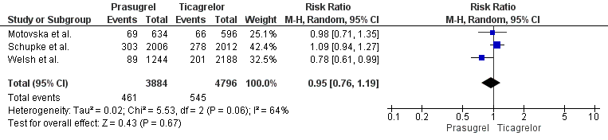
Supplementary Figure S2. Forest plot showing the Myocardial Infarction outcome.
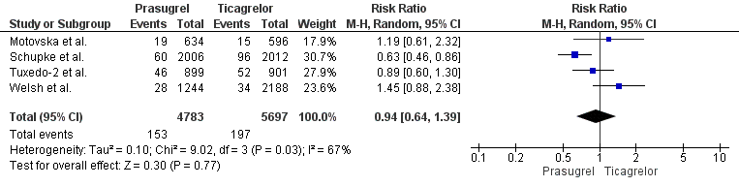

Supplementary Figure S3. Forest plot showing the Stent thrombosis outcome.
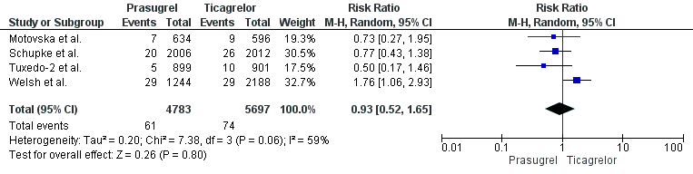

Supplementary Figure S4. Forest plot showing the Stroke outcome.
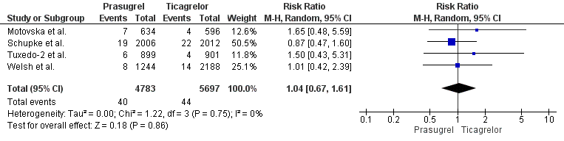

Supplementary Figure S5. Sensitivity analysis of Composite ischemic event (excluding Welsh et al.).
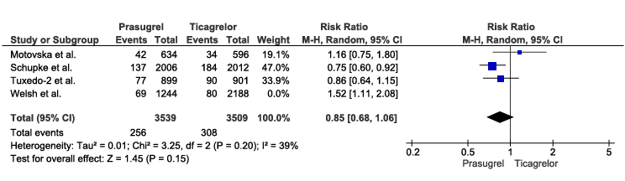

Supplementary Figure S6. Sensitivity analysis of Minor bleeding (excluding Welsh et al.).
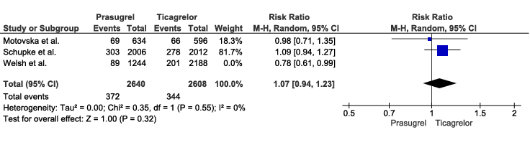

Supplementary Figure S7. Sensitivity analysis of Myocardial Infarction (excluding Schupke et al.).
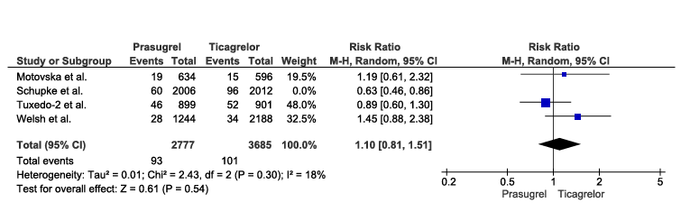

Supplementary Figure S8. Sensitivity analysis of Stroke. (excluding Welsh et al.).
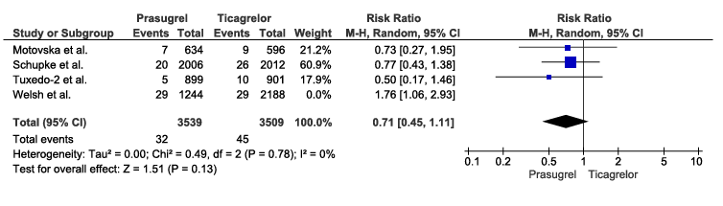
Supplementary Figure S9A. Meta regression of ACOM outcome.
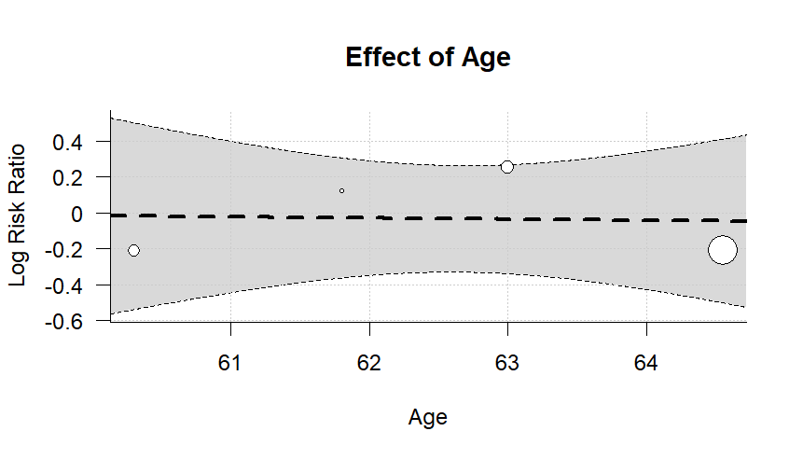

Supplementary Figure S9B.
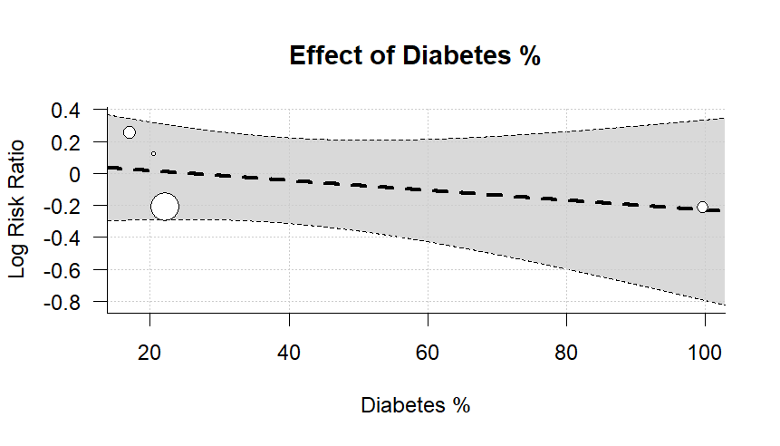

Supplementary Figure S9C.
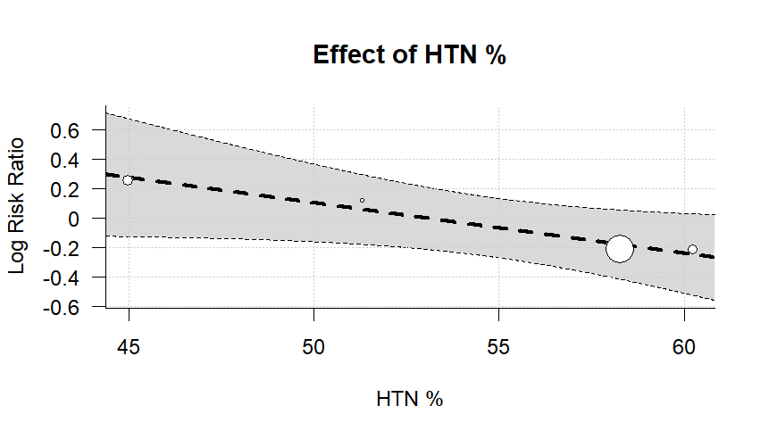

Supplementary Figure S9D.
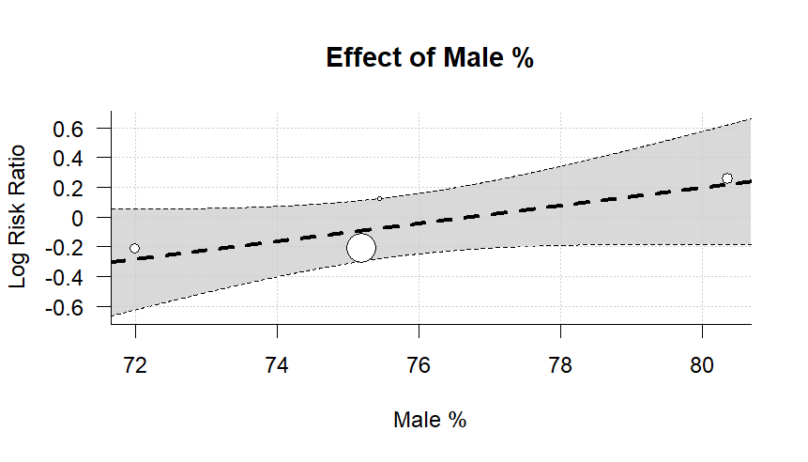

Supplementary Figure S9E.
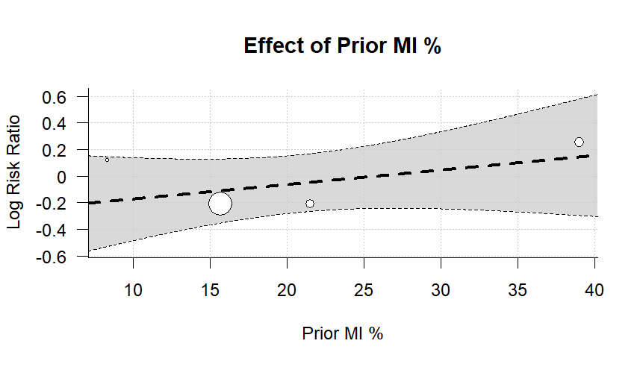

Supplementary Figure S9F.
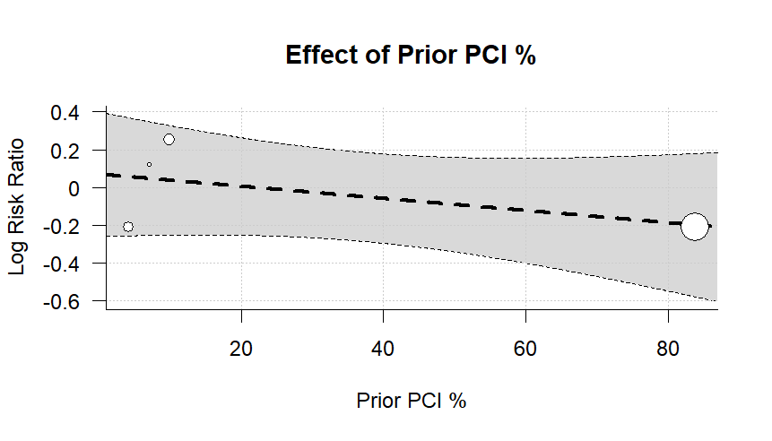

Supplementary Figure S9G.
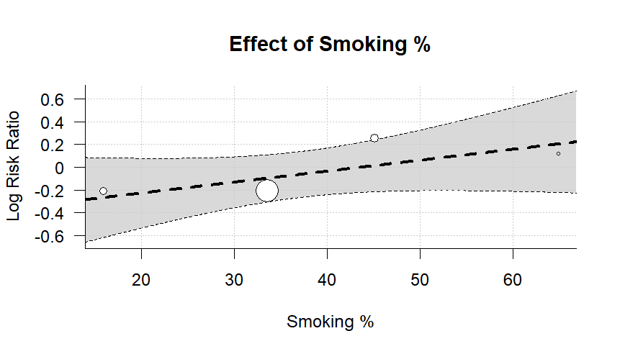

Supplementary Figure S10A. Meta regression of Cardiovascular Death outcome.
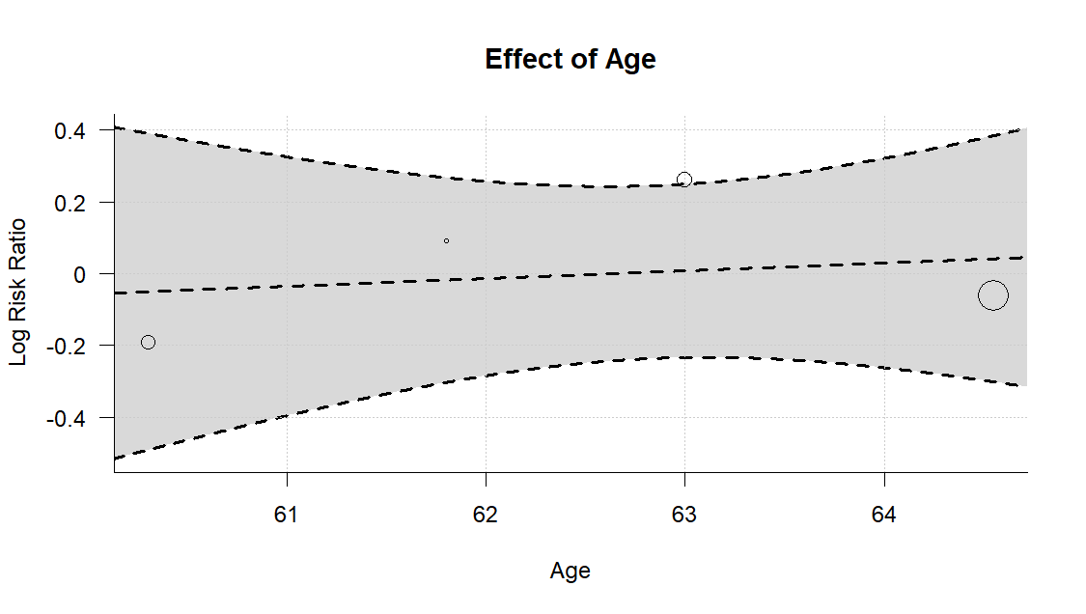
Supplementary Figure S10B.
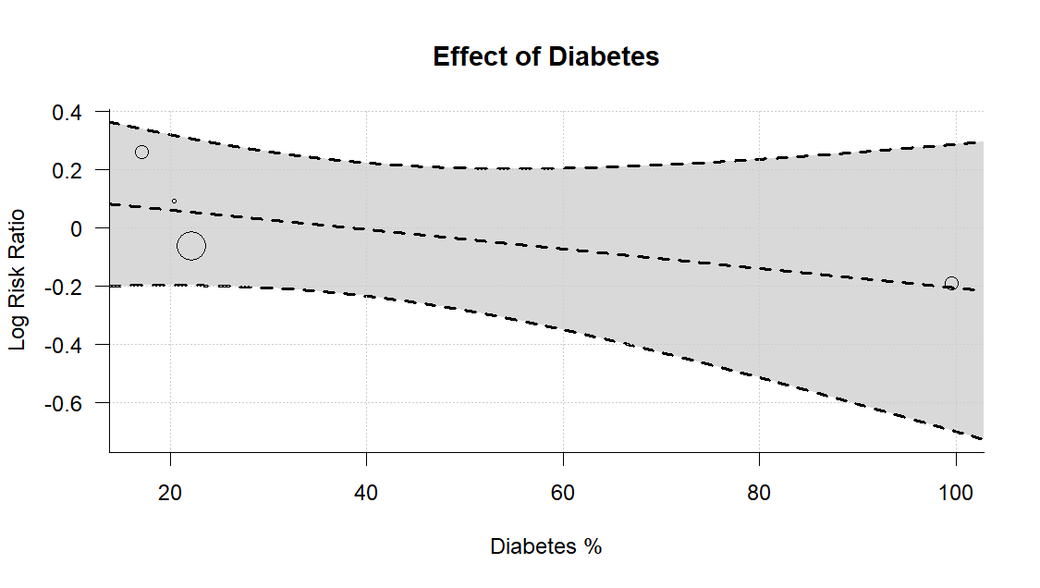
Supplementary Figure S10C.
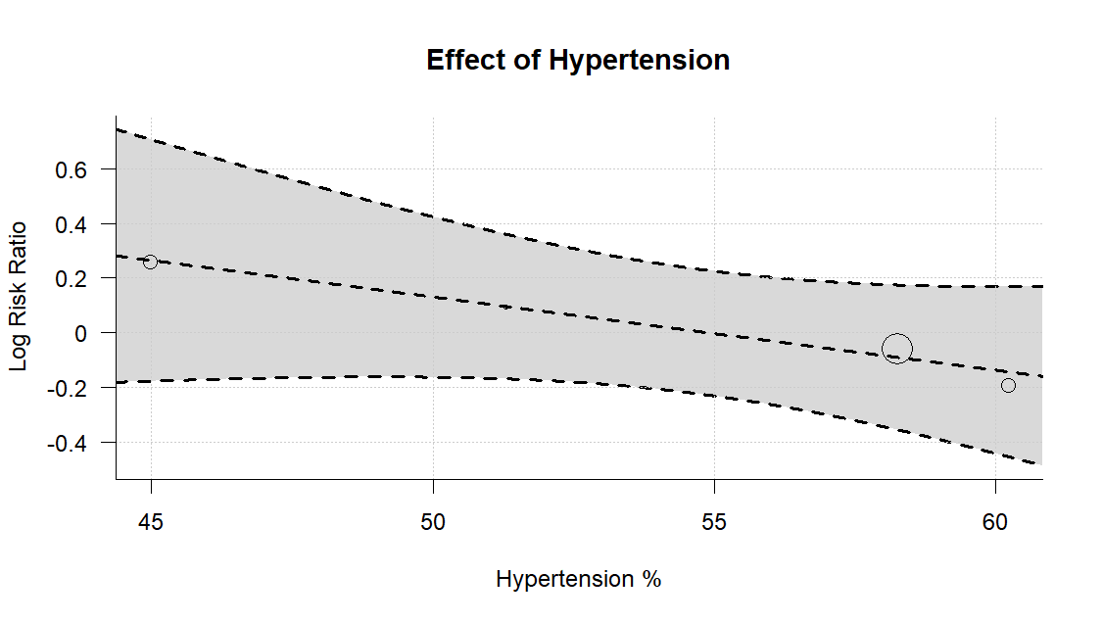

Supplementary Figure S10D.
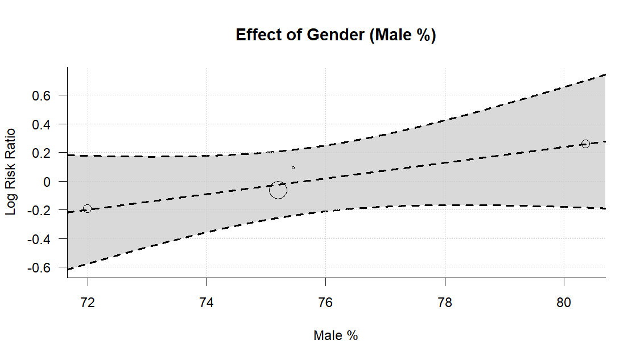

Supplementary Figure S10E.
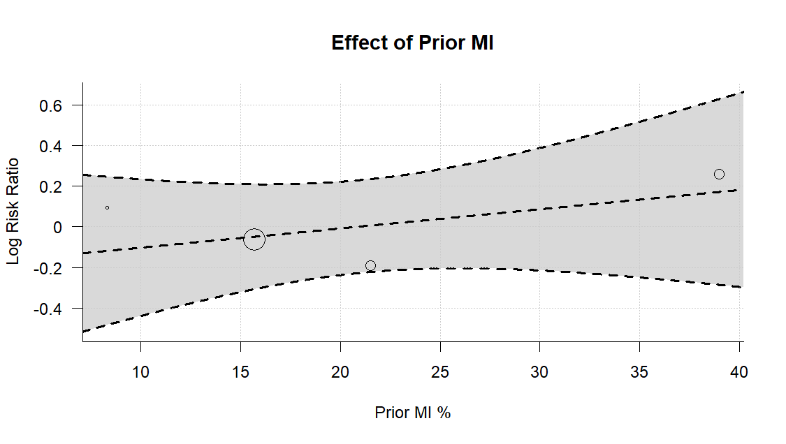

Supplementary Figure S10F.
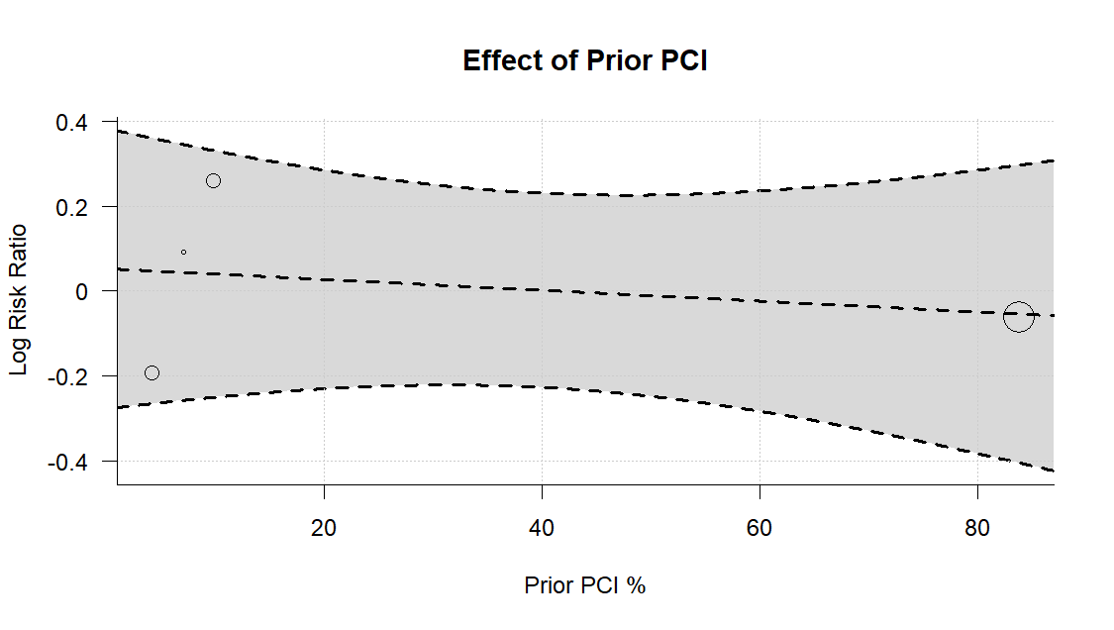

Supplementary Figure S10G.
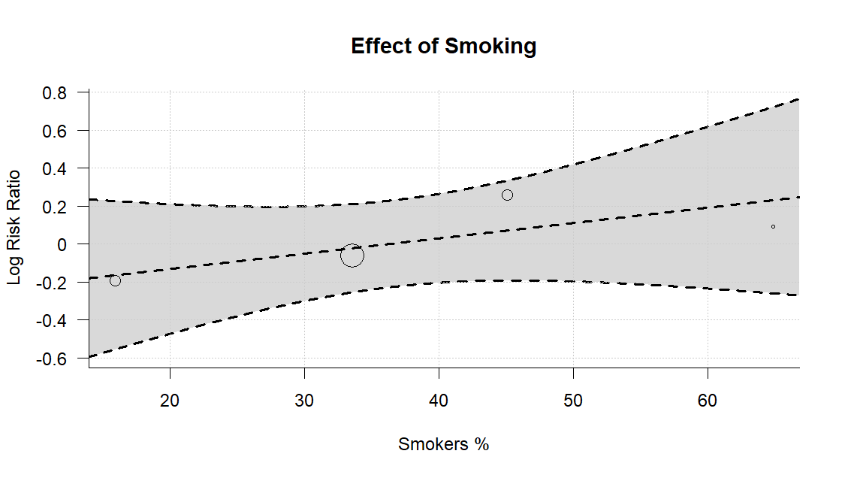

Supplementary Figure S11A. Meta regression of Composite Ischemic Event outcome.
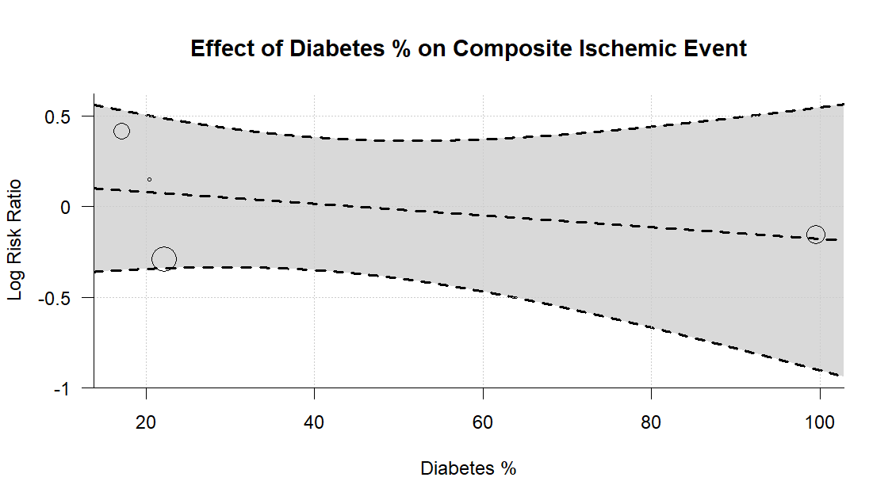
Supplementary Figure S11B.
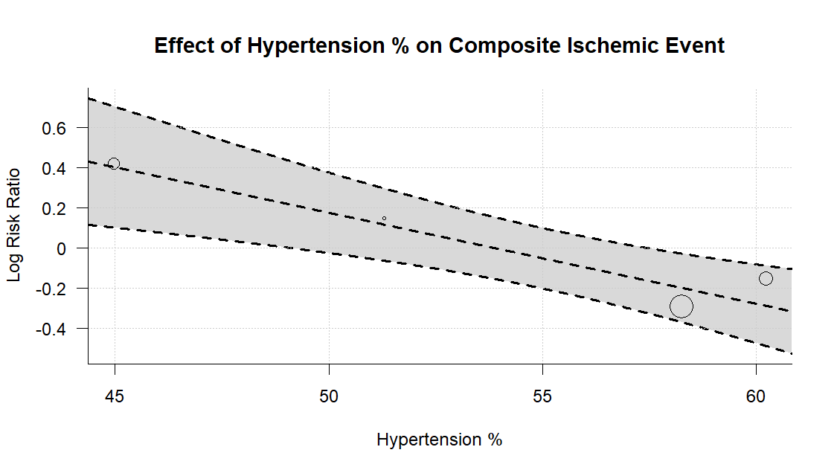
Supplementary Figure S11C.
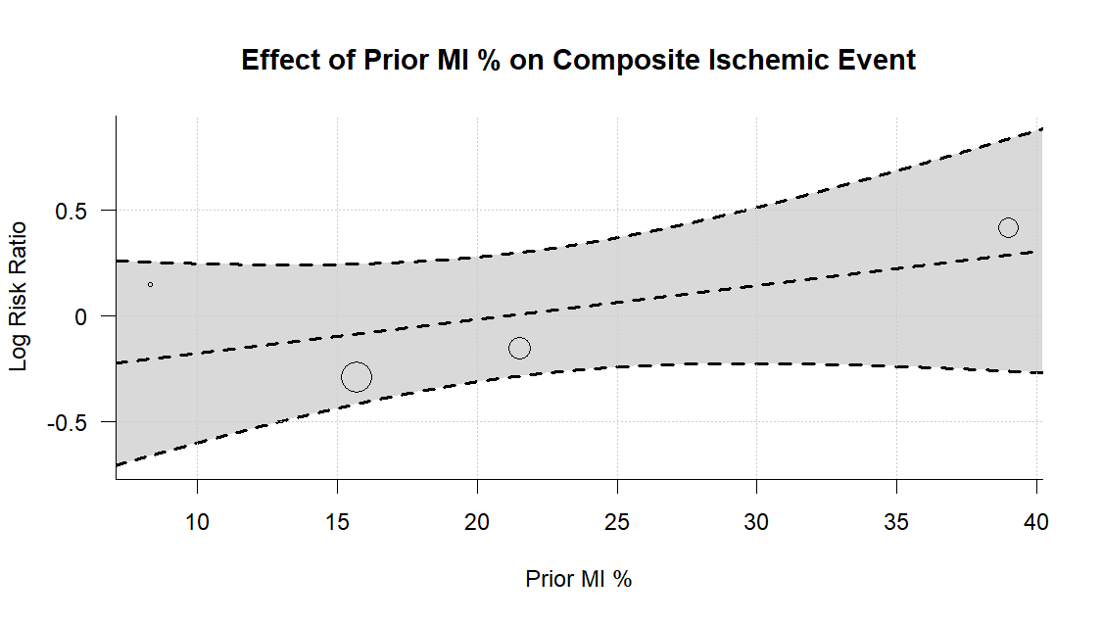

Supplementary Figure S11D.
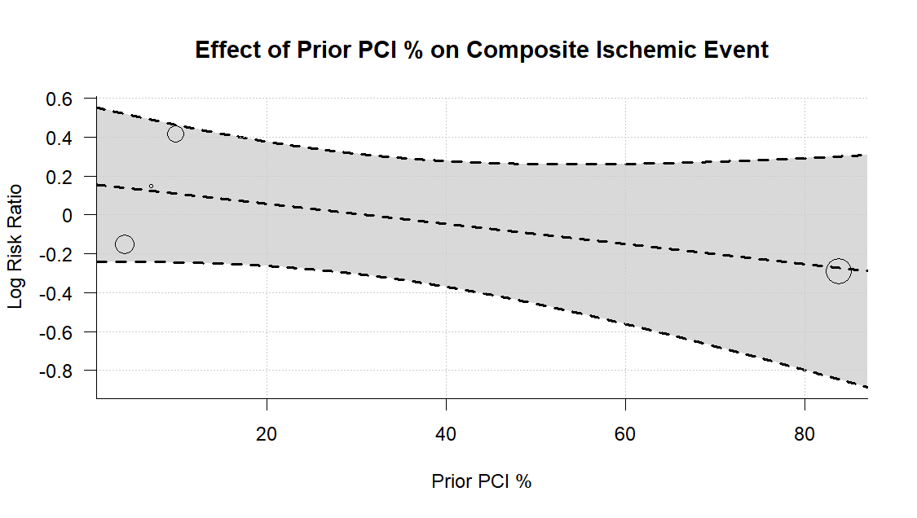

Supplementary Figure S11E.
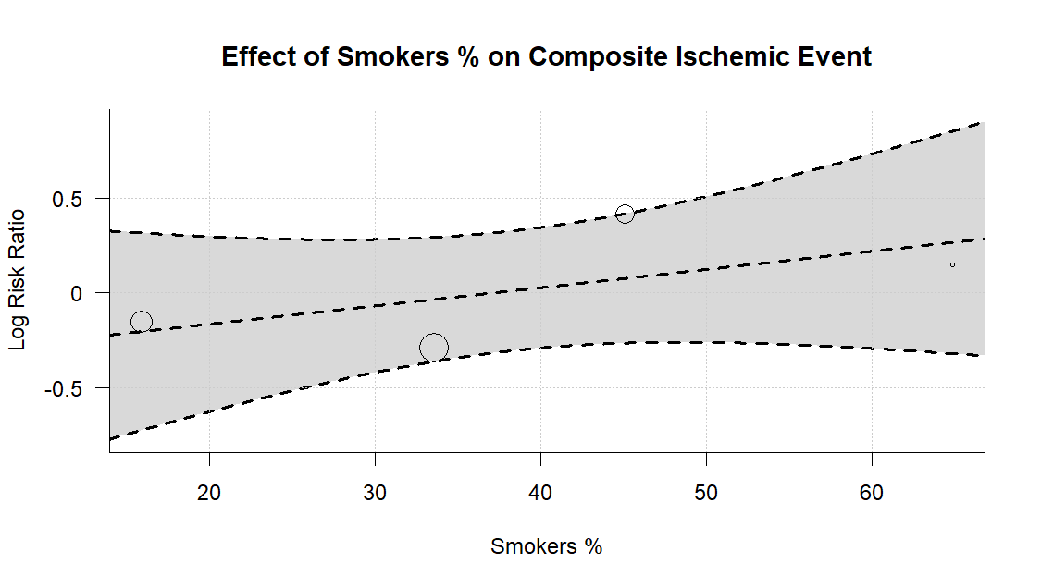

Supplementary Figure S11F.
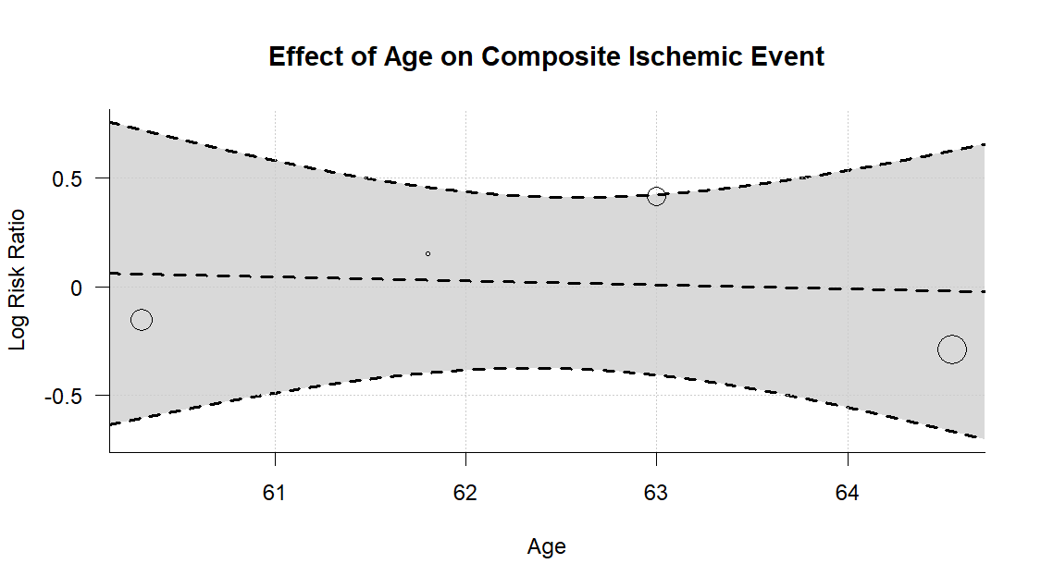

Supplementary Figure S11G.
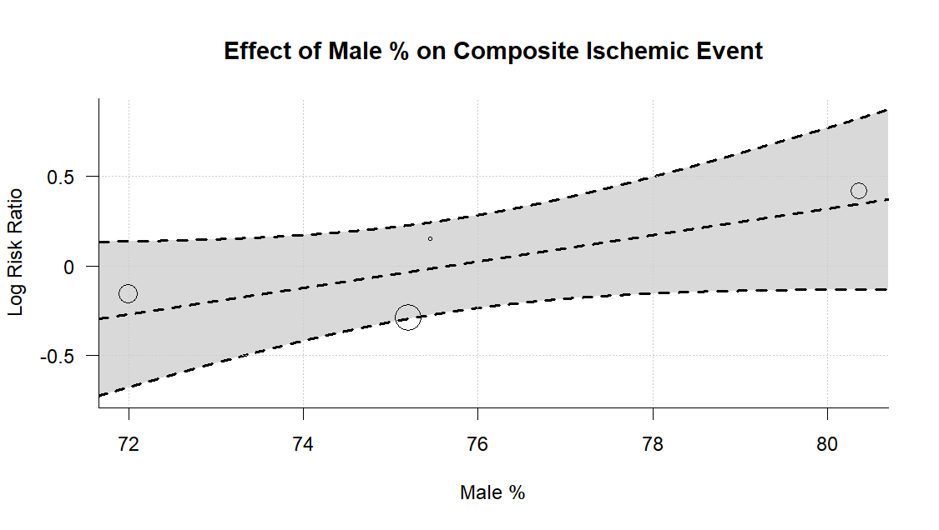

Supplementary Figure S12A. Meta regression of Major Bleeding outcome.
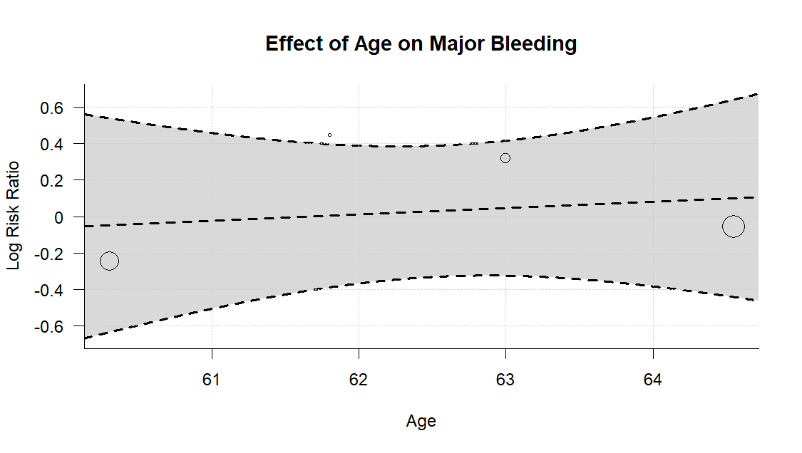
Supplementary Figure S12B.
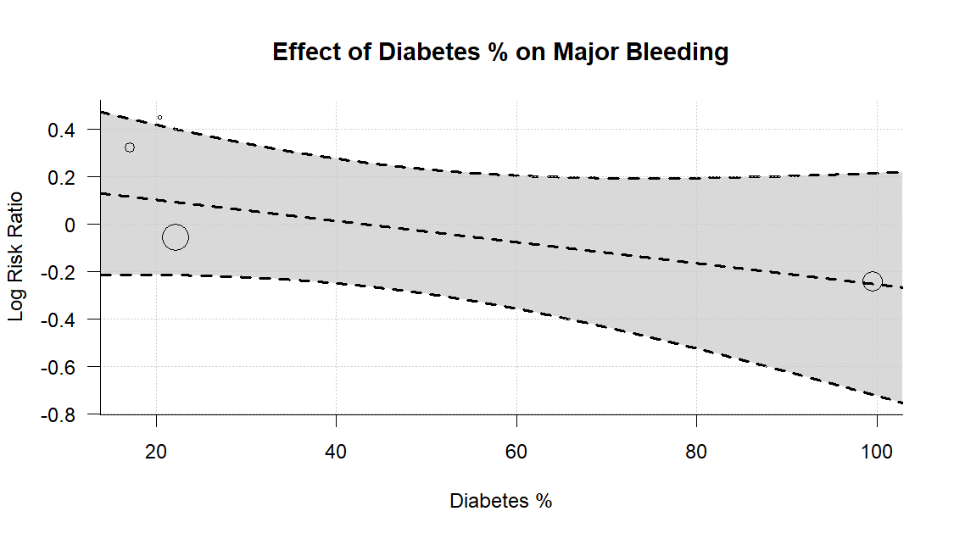
Supplementary Figure S12C.
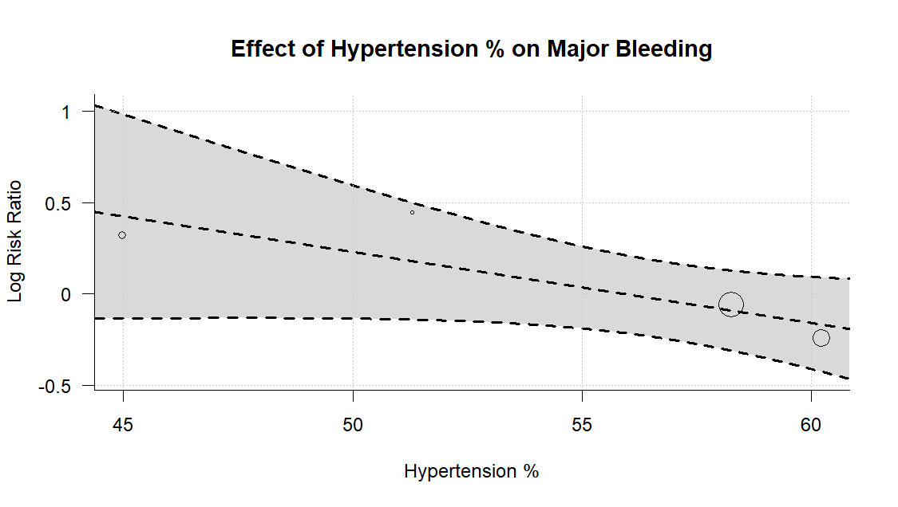

Supplementary Figure S12D.
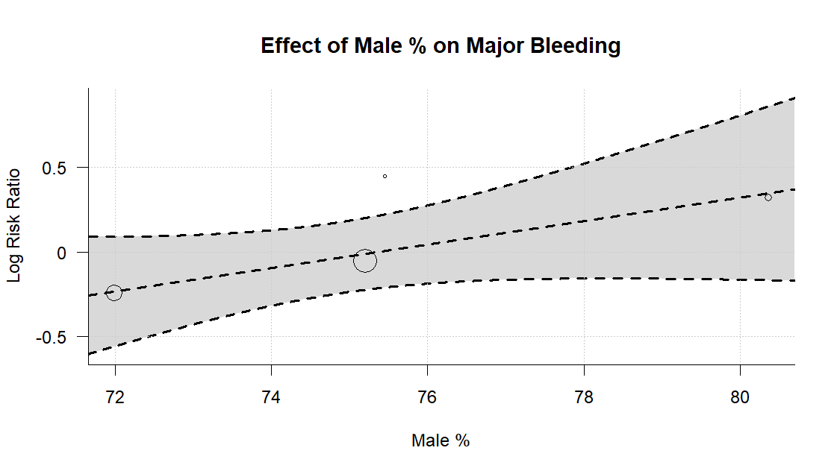

Supplementary Figure S12E.
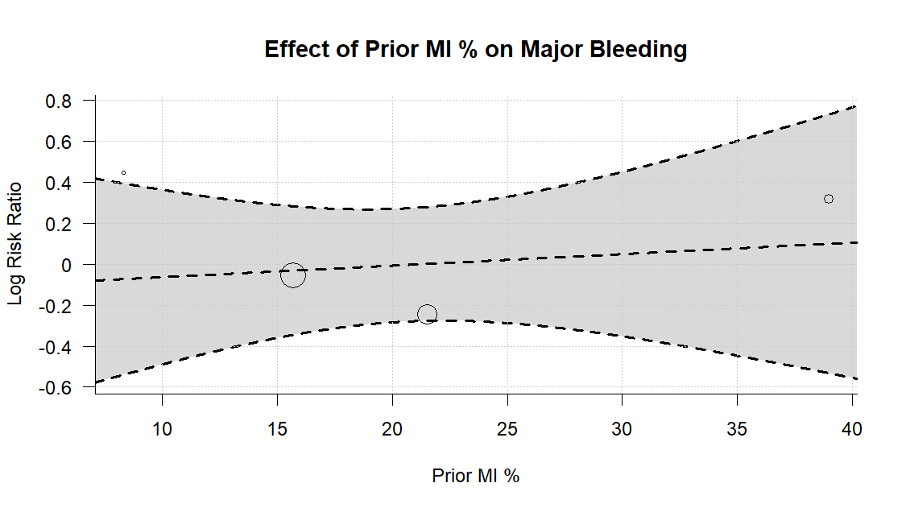

Supplementary Figure S12F.
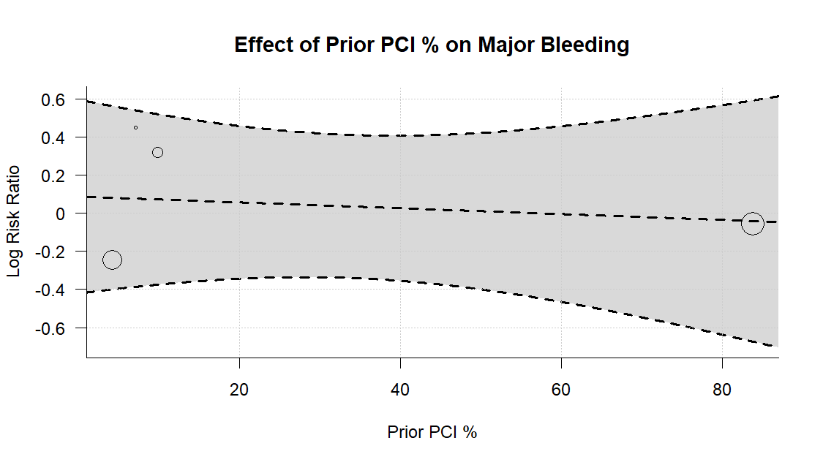

Supplementary Figure S12G.
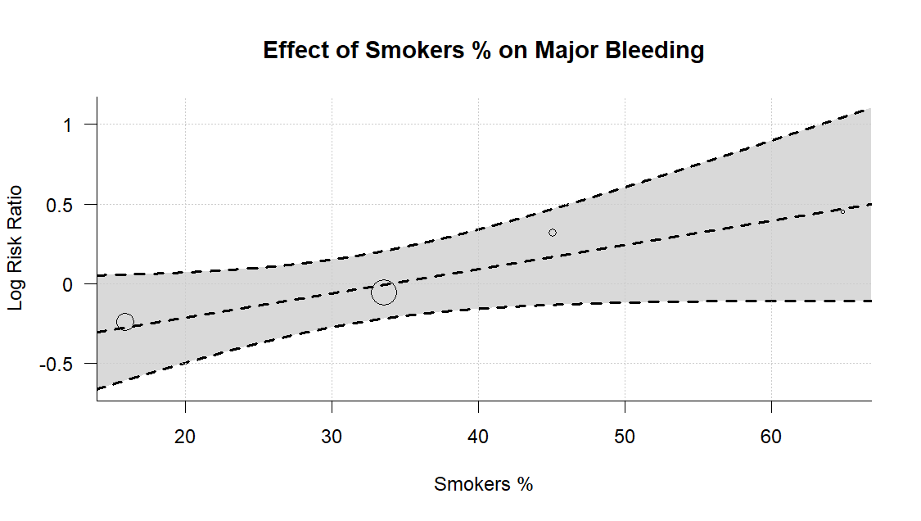

Supplementary Figure S13A. Meta regression Minor Bleeding outcome.
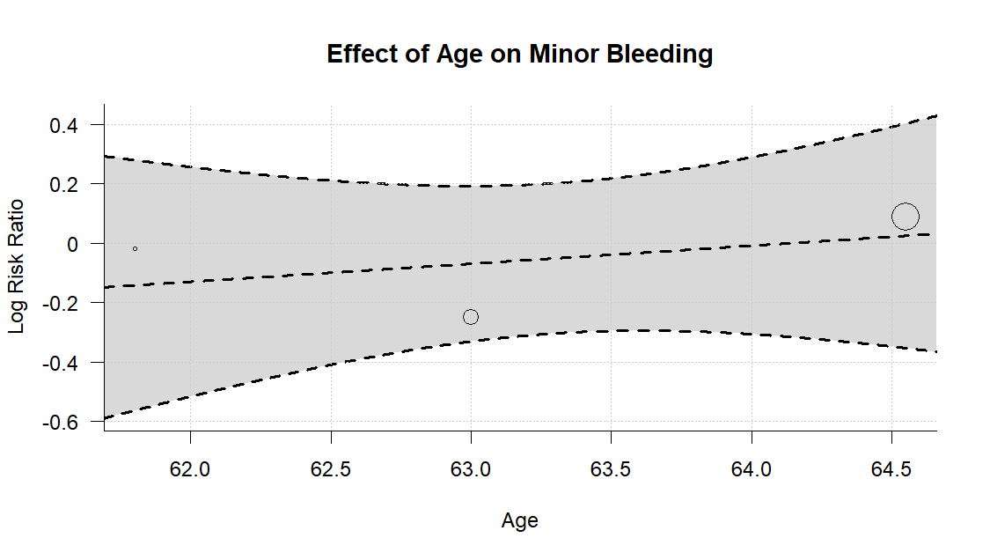
Supplementary Figure S13B.
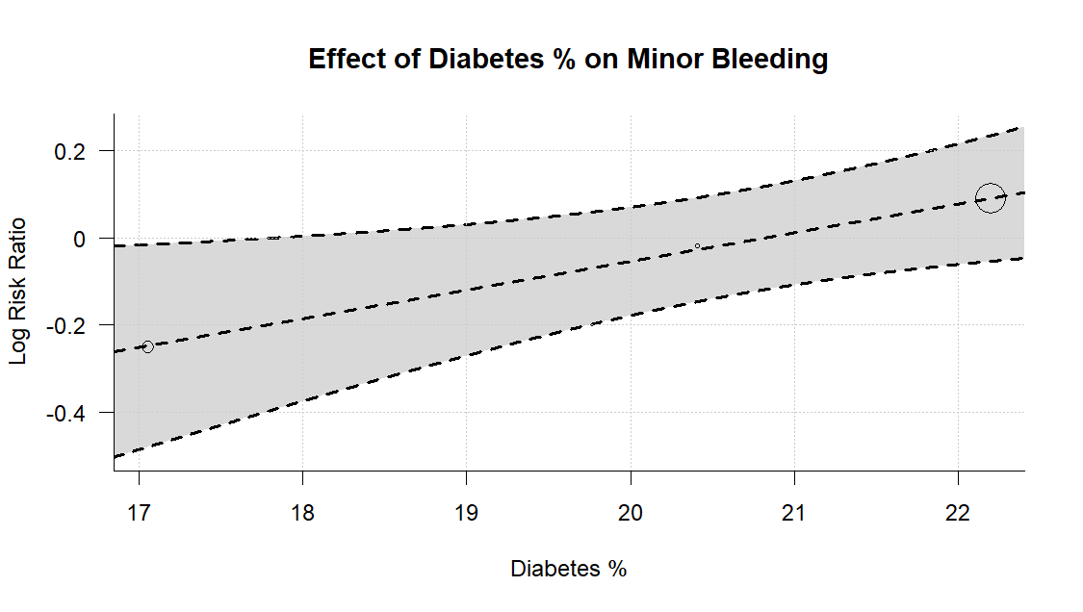
Supplementary Figure S13C.
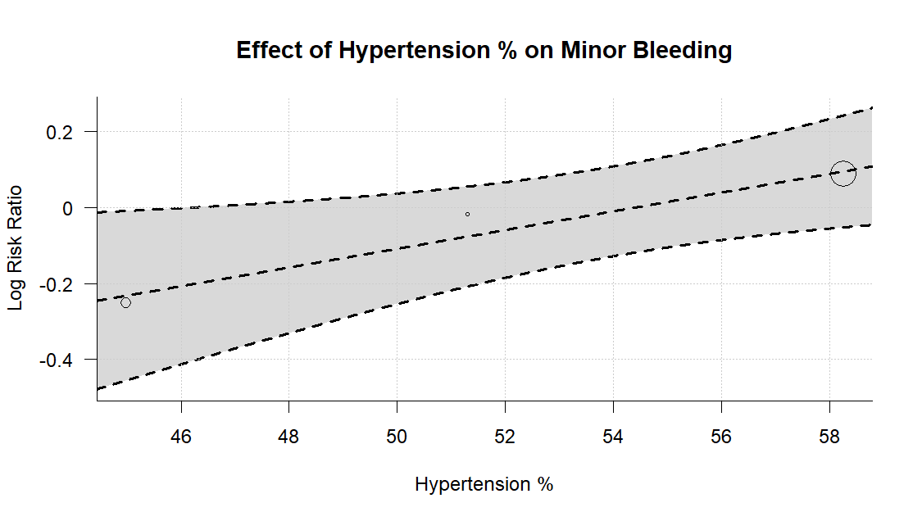

Supplementary Figure S13D.
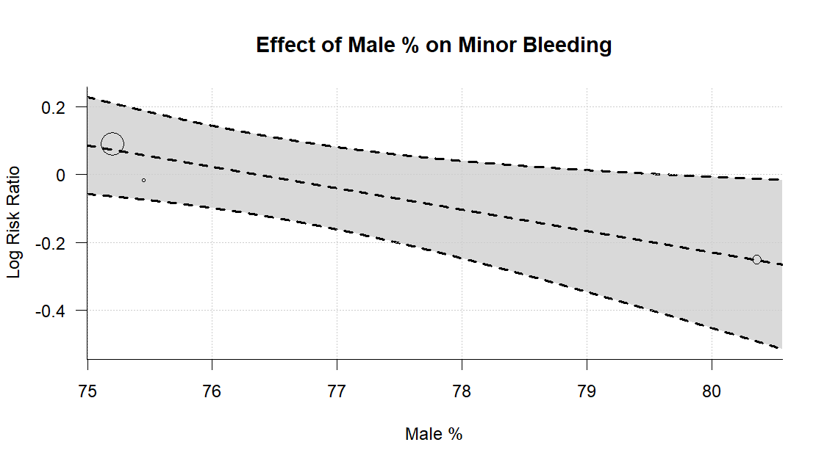

Supplementary Figure S13E.
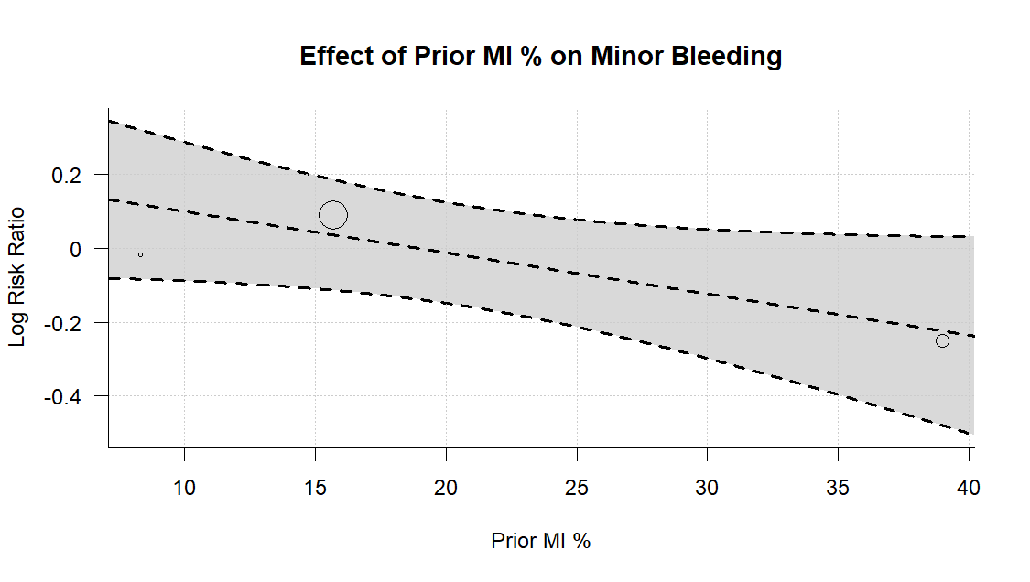

Supplementary Figure S13F.
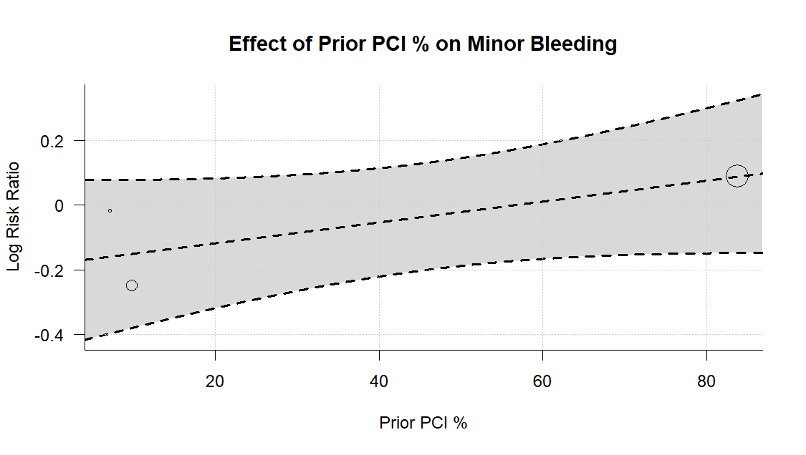

Supplementary Figure S13G.
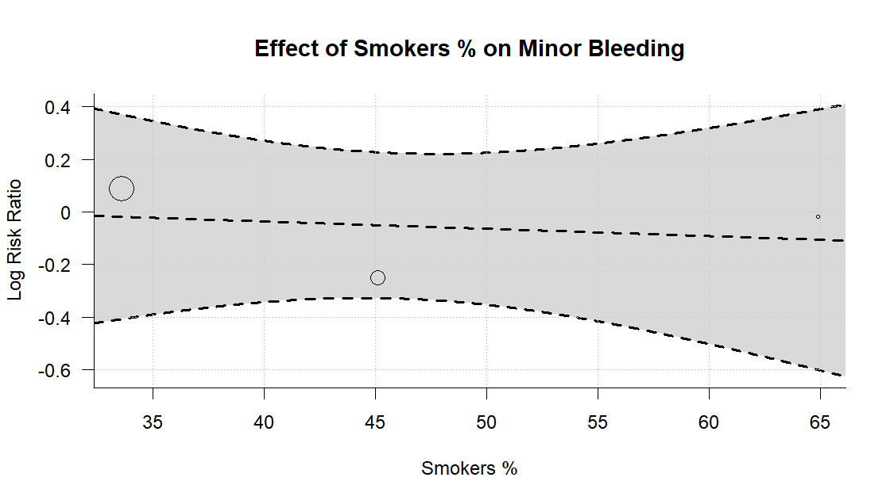

Supplementary Figure S14A. Meta regression of Myocardial Infarction outcome.
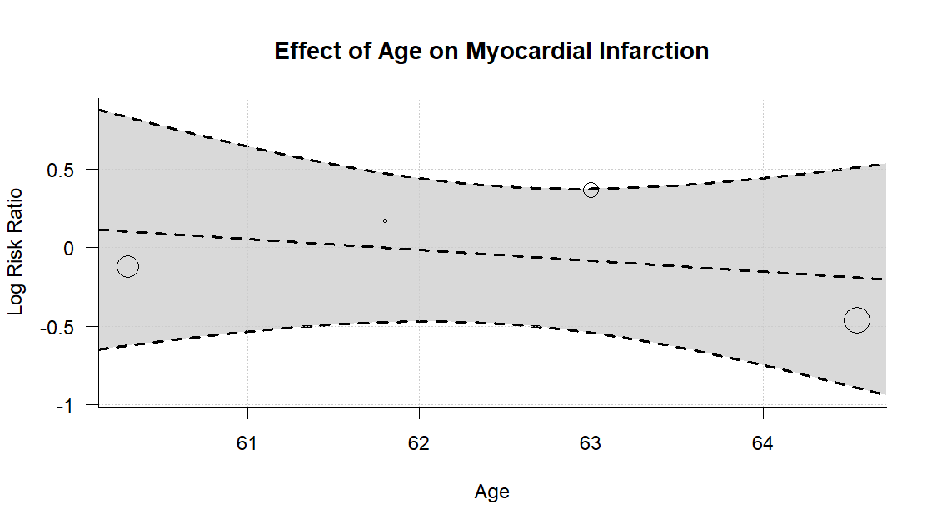
Supplementary Figure S14B.
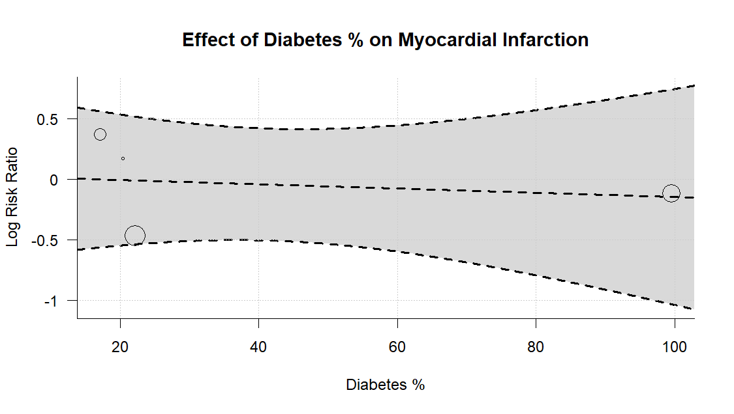
Supplementary Figure S14C.
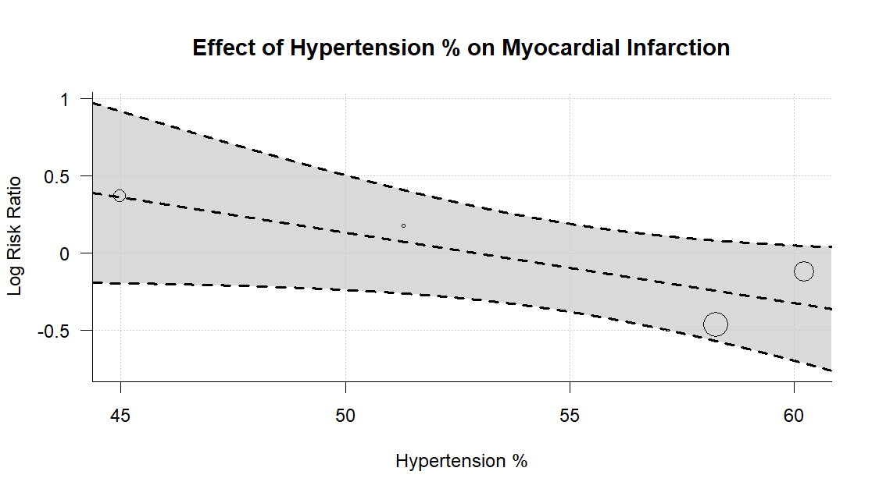

Supplementary Figure S14D.
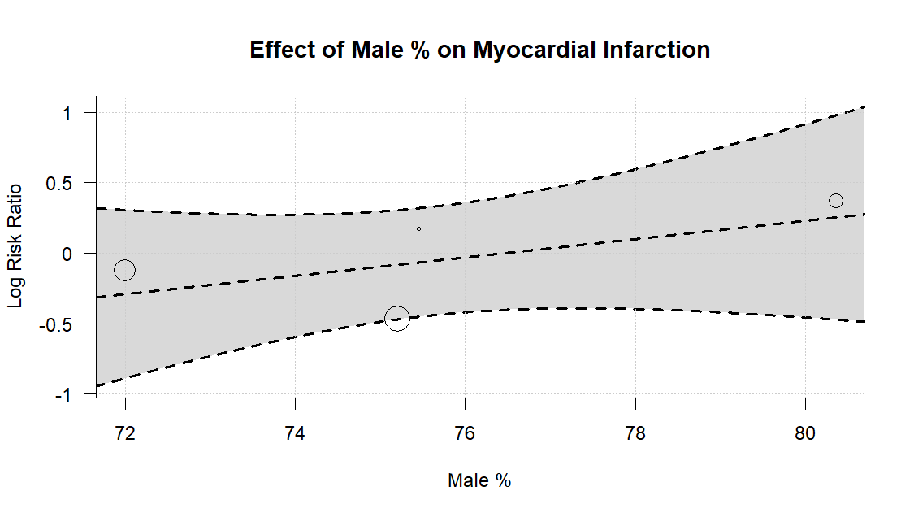

Supplementary Figure S14E.
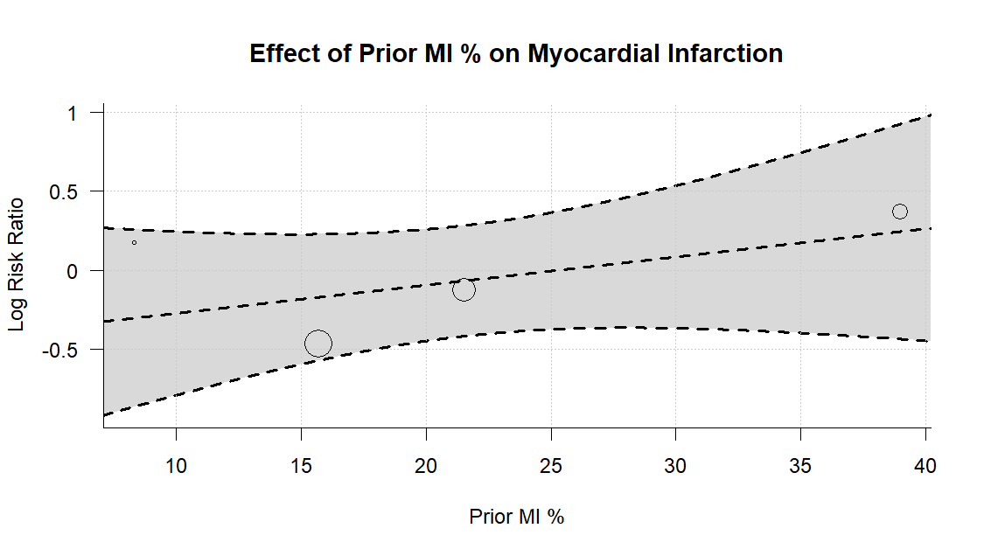

Supplementary Figure S14F.
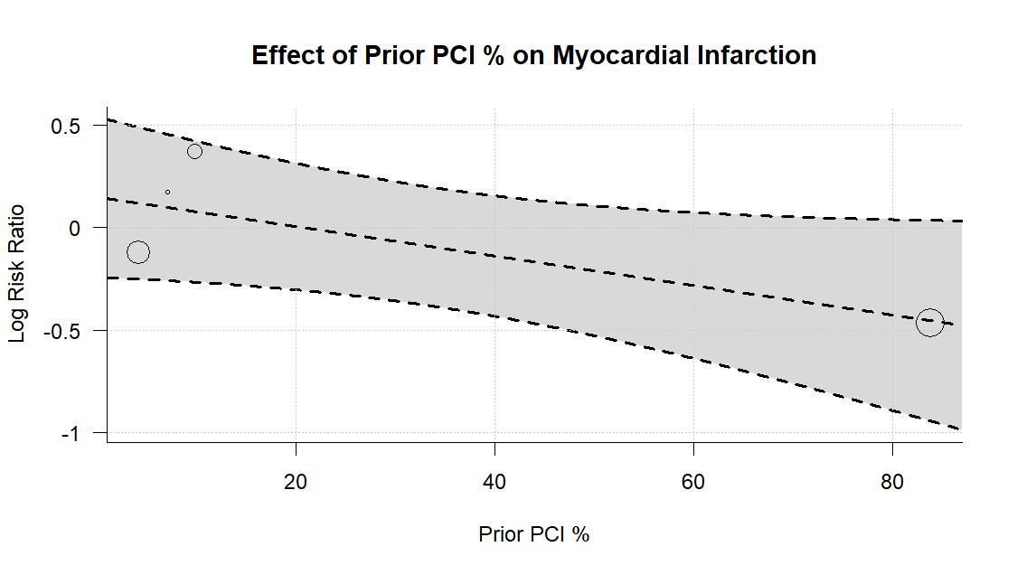

Supplementary Figure S14G.
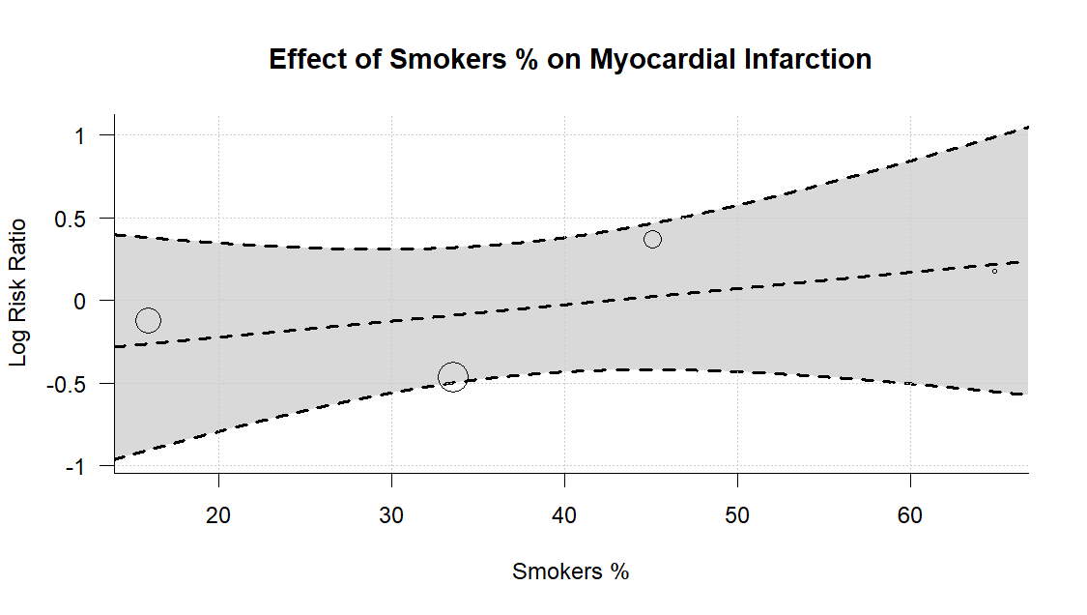

Supplementary Figure S15A. Meta regression of Stent Thrombosis outcome.
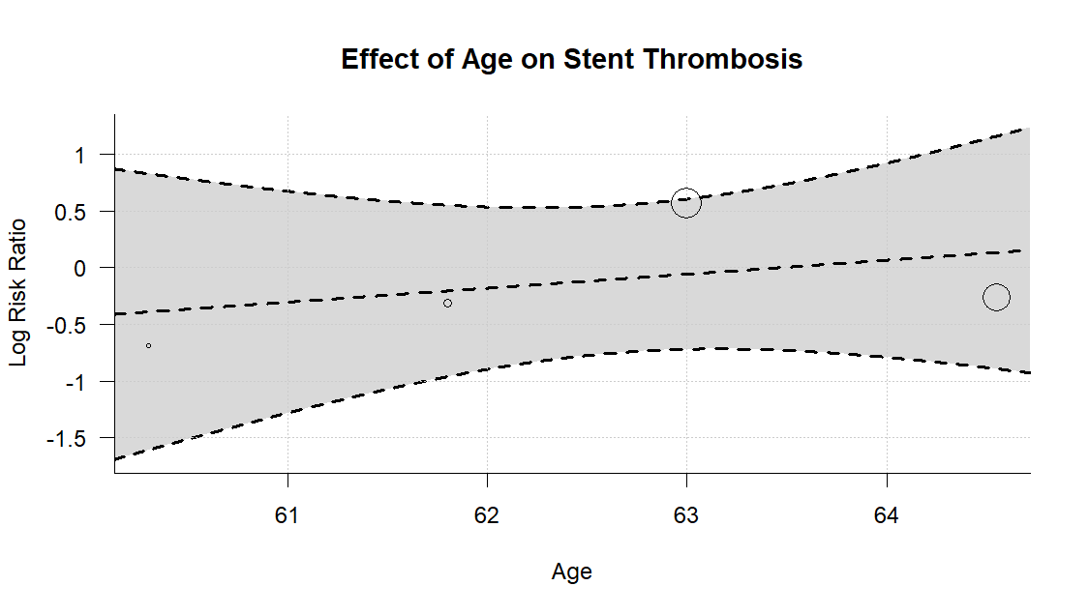
Supplementary Figure S15B.
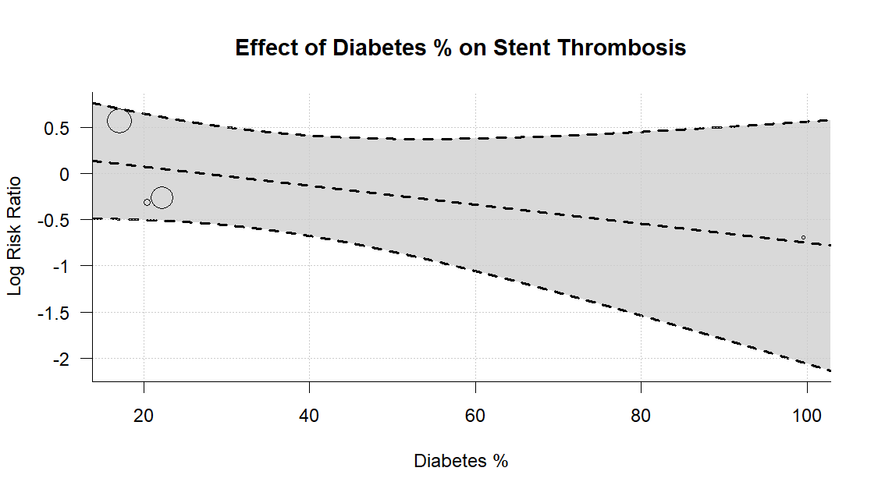
Supplementary Figure S15C.
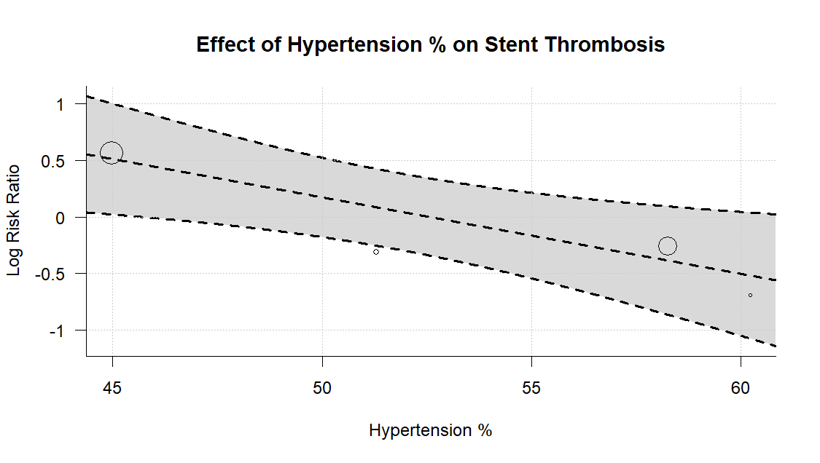

Supplementary Figure S15D.
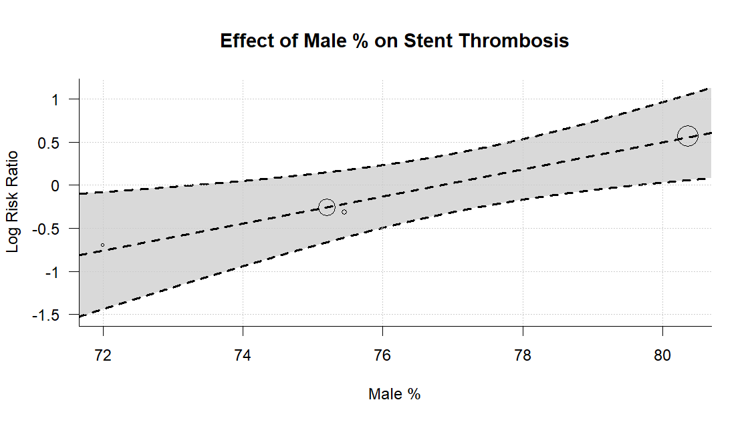

Supplementary Figure S15E.
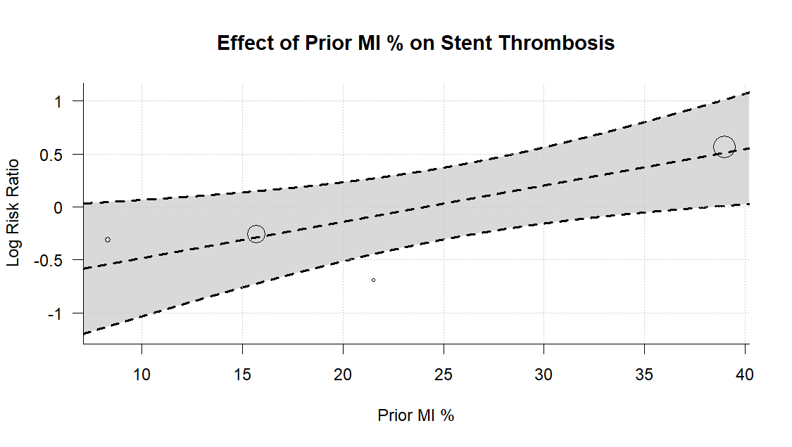

Supplementary Figure S15F.
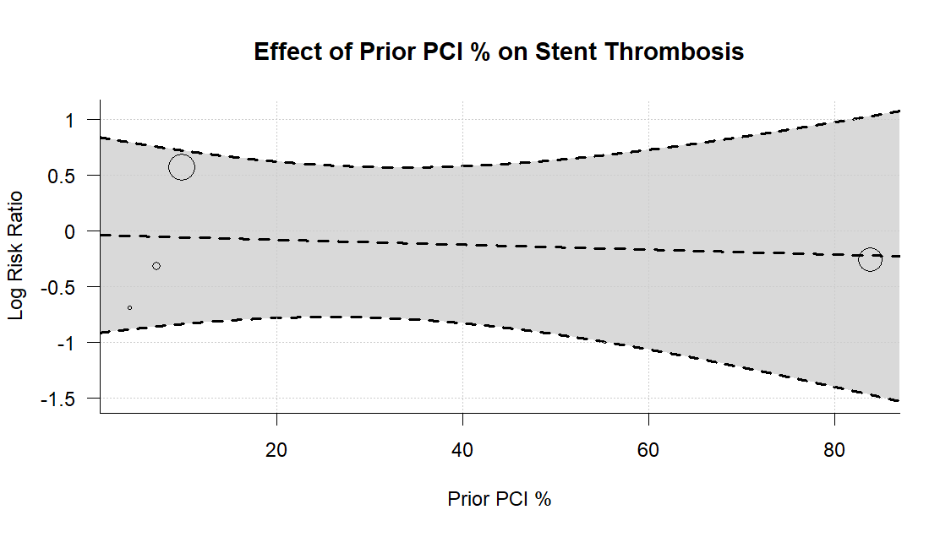

Supplementary Figure S15G.
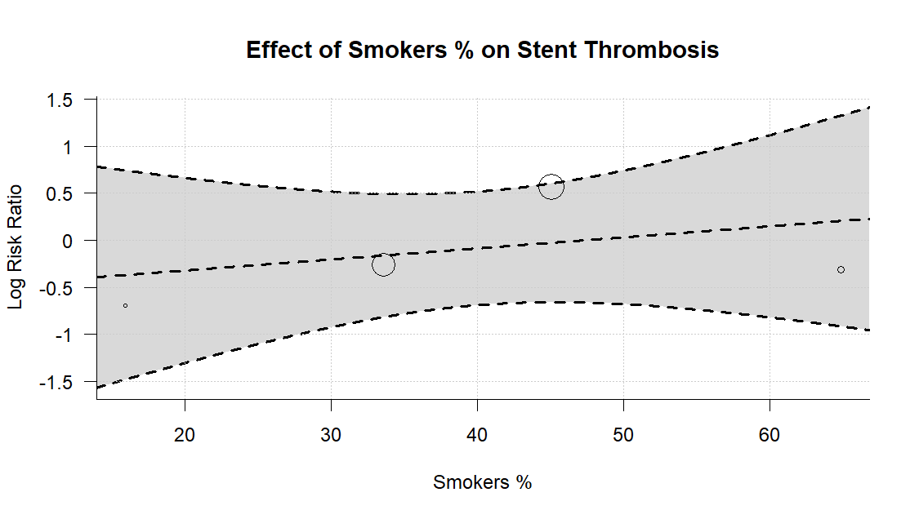

Supplementary Figure S16A. Meta regression of Stroke outcome.
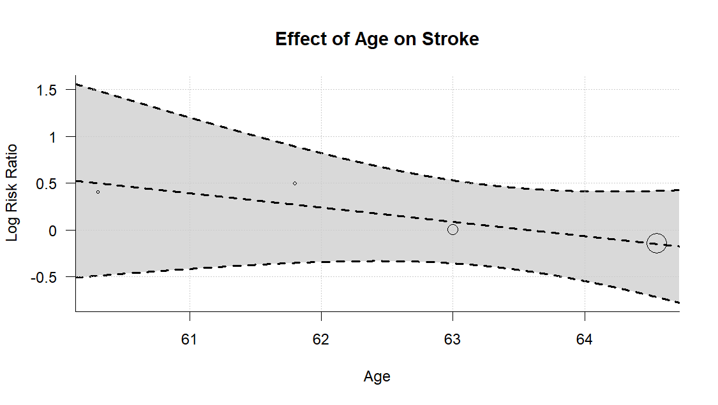
Supplementary Figure S16B.
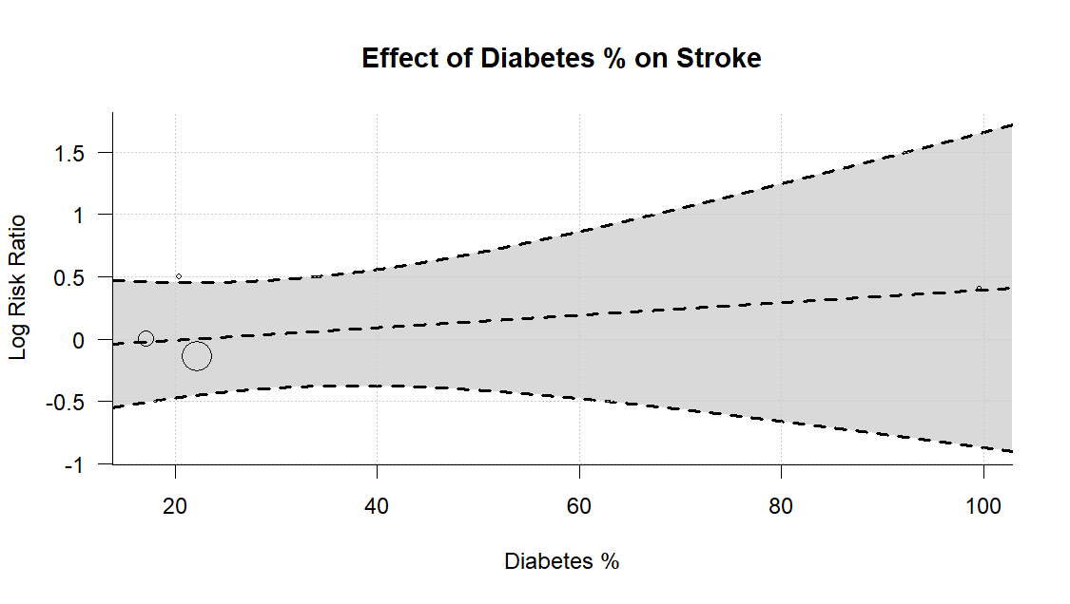
Supplementary Figure S16C.
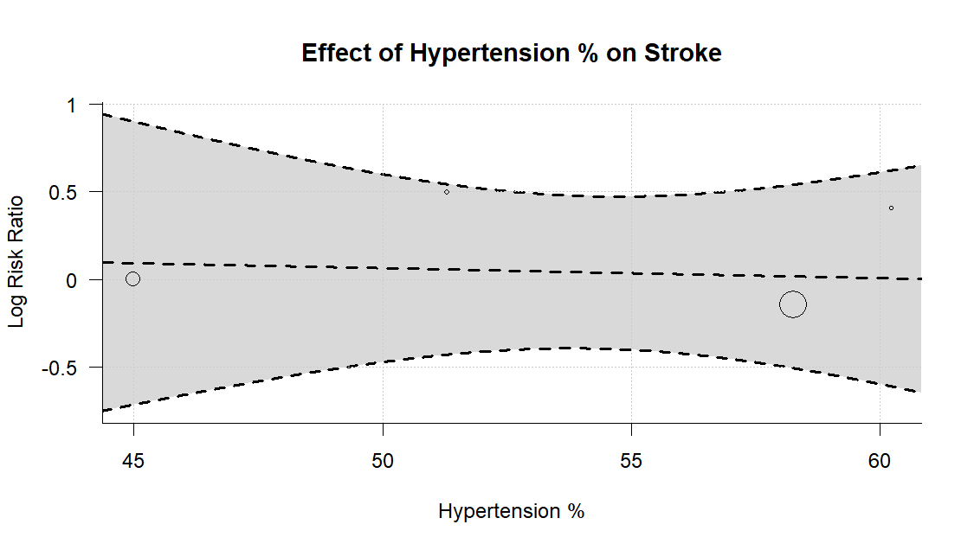

Supplementary Figure S16D.
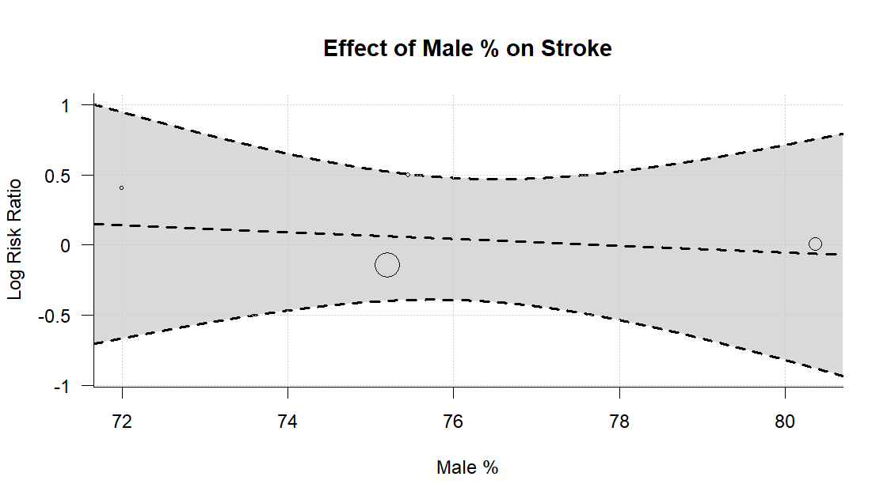

Supplementary Figure S16E.
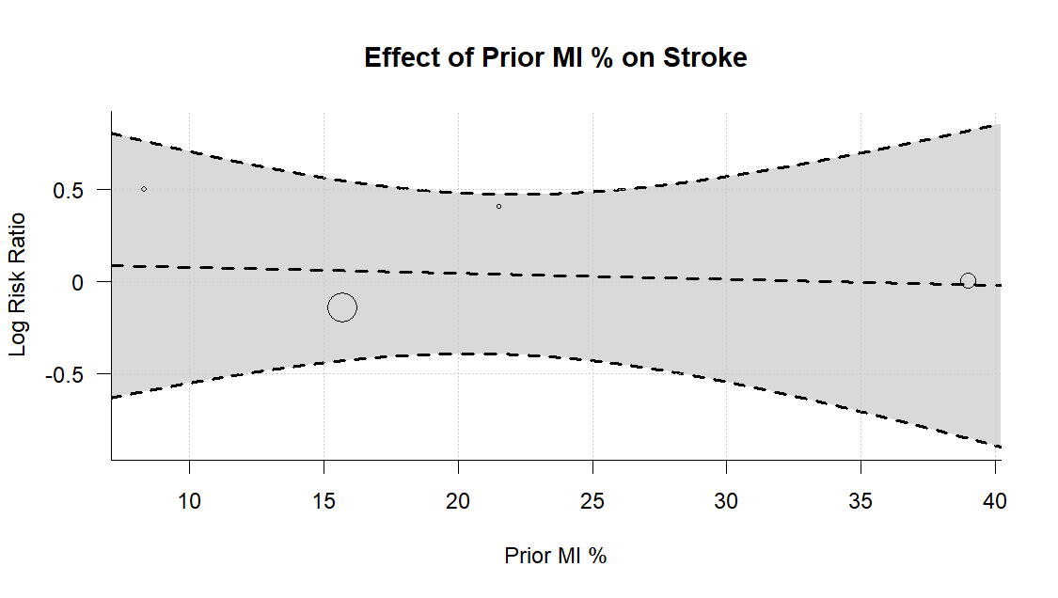

Supplementary Figure S16F.
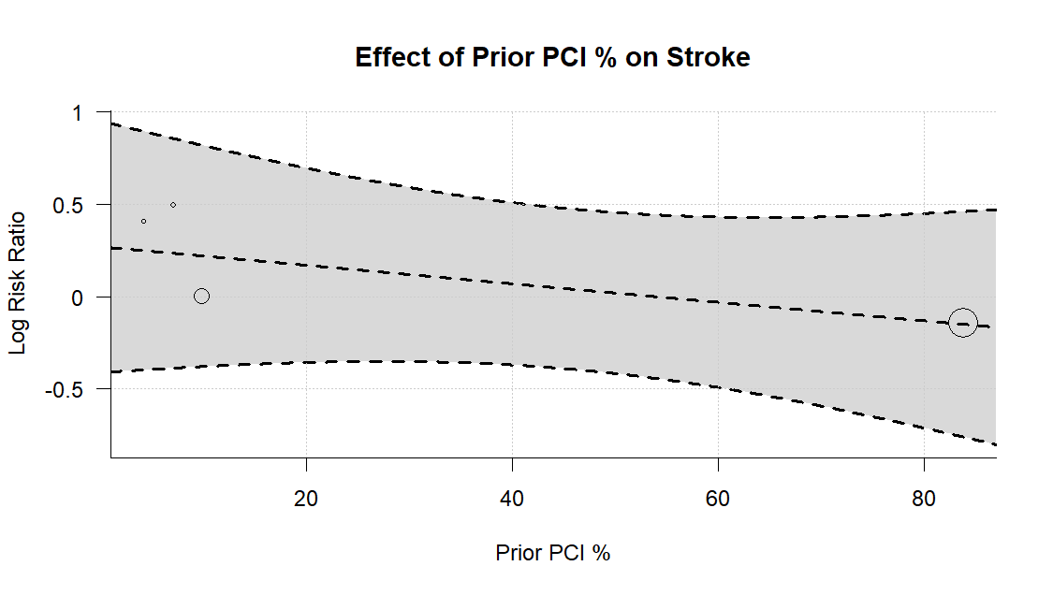

Supplementary Figure S16G.
