Supplementary Information

Tough, Strong, and Ductile Interlocking Hard-Soft Suture Assemblies of Cementitious Composite

Dana Daneshvar^{1,2}, Aimane Najmeddine¹, Shashank Gupta¹, Reza Moini^{1*}
¹ Department of Civil and Environmental Engineering, Princeton University, Princeton, NJ, 08544 USA.
² Institute for Structural Engineering, Vienna University of Technology, Karlsplatz 13/212-2, 1040 Vienna, Austria.

Email: Reza.Moini@princeton.edu

Suture Interface Design
As shown in Figure S1, the suture blade geometry consists of three identical circular shapes. Specifically, seven different lock angles (θ) ranging from 15° to 45° in 5-degree intervals and four different interface gap widths (w) (0, 1, 2, and 3 mm) are considered. Considering the suture geometric features, the polylactic acid (PLA) models are first 3D printed using the Ultimaker S5 device. All samples have a width of 70 mm and a thickness of 15 mm, respectively. The samples are fabricated in a laboratory environment at a temperature of 23 ± 4 °C and a humidity of 49 ± 5%. After fabrication, they are transferred to a sealed chamber maintained at a relative humidity of 95 ± 2% using a saturated potassium sulfate solution. The samples are initially cured in the chamber for 24 hours, demolded, and then kept there for an additional six days. The suture geometry (θ and w) impacts the failure mode. Monolithic sutures (w = 0) exhibit abrupt brittle failure (Supplementary Videos 1, 4, and 7). Composite sutures with a PVS interlayer (w = 1-3) show geometry-dependent behavior, transitioning from delayed brittle failure (Supplementary Videos 5, 8, and 9) to ductile failure (Supplementary. Videos 2, 3, and 6).
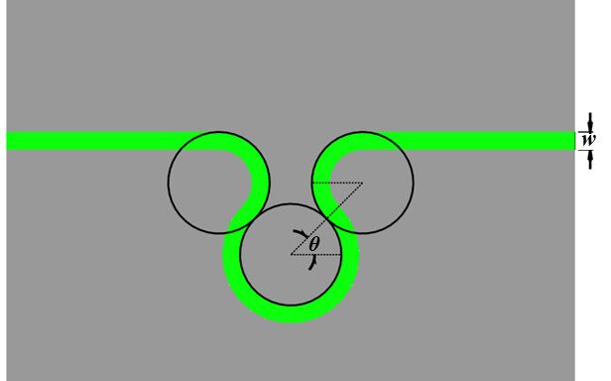
Figure S1. Suture blade and interface geometric features.

Multiple Blades Suture Composite
The impact of the number of suture blades on the mechanical performance of suture composites is investigated. For this study, a suture geometry with a θ=30° and w=3 mm is selected. In addition to a single suture, suture composites with two and three blades are also examined. To accommodate these variations, all samples had a width of 100 mm and a thickness of 15 mm, respectively. As shown in Figure S2A, the initial peak corresponding to PVS debonding remained nearly constant across all cases. However, the post-peak response varied with the number of blades. Specifically, step-wise cracking is observed in multiple-suture samples due to the increased number of blades and interlocking effects. This mechanism helped postpone abrupt failure of cement paste and contributed to enhanced energy dissipation. The work of fracture (WOF) is calculated for all studied cases, as presented in Figure S2B. For the three-blade suture composite, the WOF is determined to be 2135 ± 92 N.mm, which is 1.6 and 2.1 times higher than that of the two-blade and single-blade counterparts, respectively. The energy dissipation performance and mechanical response of four types of samples studied in this research are compared in Figure S3. It can be concluded that engineering the interface through a bio-inspired design, specifically the suture pattern, can remarkably enhance the toughness of the cement paste composite, up to 85 times higher, while also significantly improving its overall mechanical response.
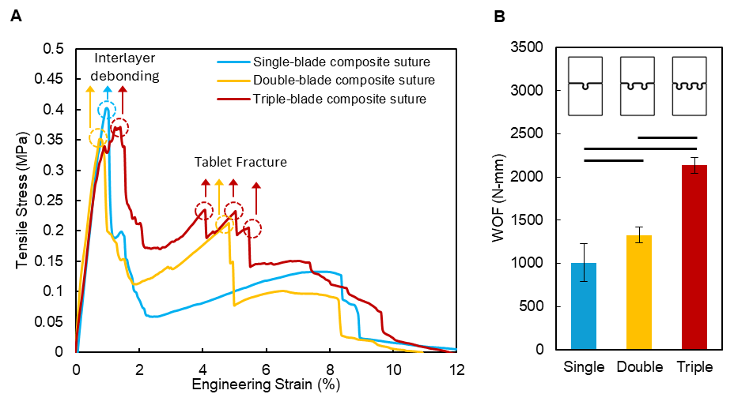
Figure S2. Mechanical response of a selected suture (θ=30°, t=3mm) as a function of the number of blades. (A) Typical stress-strain responses. (B) WOF values. Data is shown as mean ± SD. A solid horizontal line depicts p < 0.05 which indicates the statistically significant difference between the corresponding samples. p-value is obtained from the F-test and T-test.
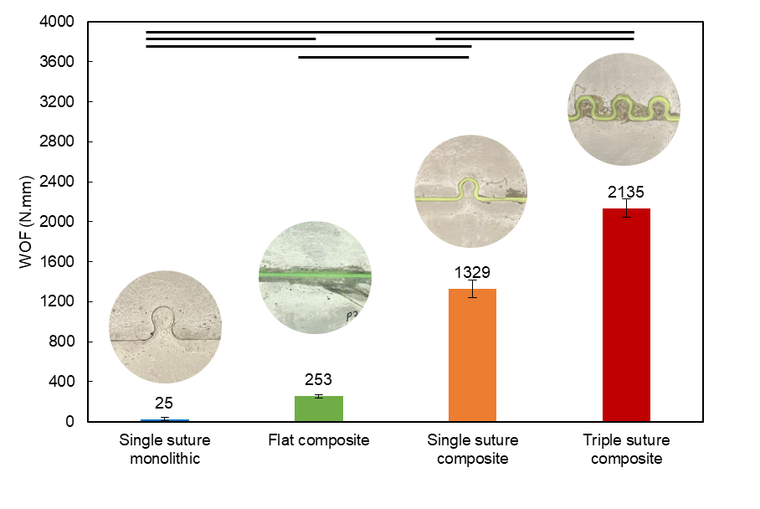
Figure S3. Comparison WOF across samples with different interface. In sutures, θ =30°, and in composite interfaces, w=3 mm. Data is shown as mean ± SD. A solid horizontal line depicts p < 0.05 which indicates the statistically significant difference between the corresponding samples. p-value is obtained from the F-test and T-test.
Characterization of Bulk Cement Paste and PVS Materials
The mechanical response of PVS and cement paste is characterized by conducting uniaxial tension tests on dogbone samples, following ASTM D412-16 and JSCE, as shown in Figure S4A and B, respectively. In contrast to cement paste, PVS demonstrates non-linear stress-strain behavior, undergoing significant deformations before experiencing sudden failure (Figure S4A). The tensile strength and strain-at-failure are measured to be 1.48 ± 0.45 MPa and 427.5 ± 18.9% for PVS, and 0.73 ± 0.21 MPa and 0.28 ± 0.02% for cement paste, respectively. The Work of Fracture (WOF) of PVS and cement paste is evaluated, yielding WOF values of 36.9 ± 0.04 N·mm for PVS and 1352.3 ± 285.4 N·mm for cement paste (Figure S4C).
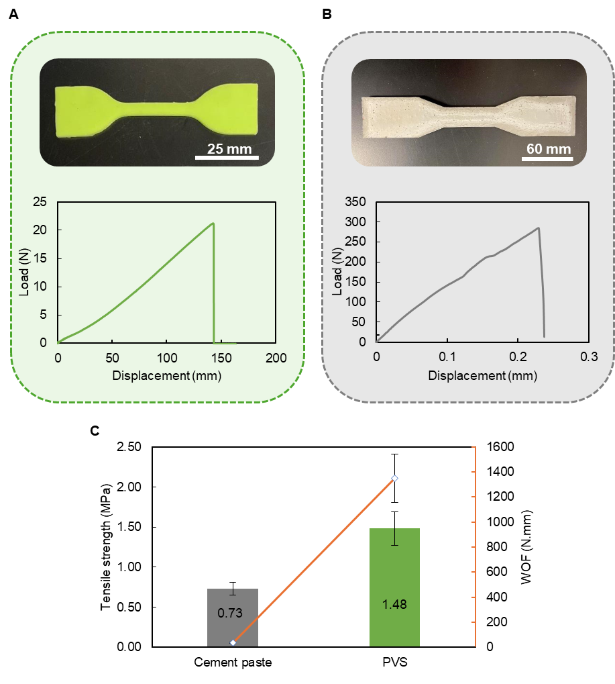
Figure S4. Characterization of individual materials under uniaxial tension test. (A) PVS, (B) Cement paste. (C) Comparison the average values of tensile strength and WOF between cement paste and PVS samples.
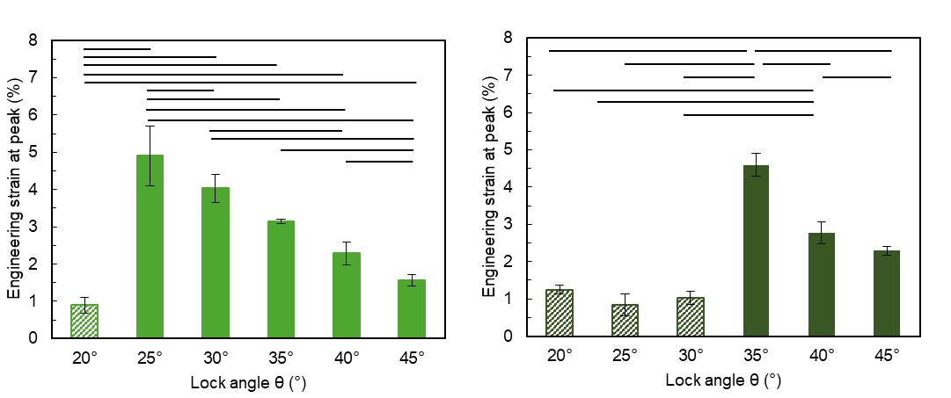
Figure S5. Impacts of θ on the strain at failure (ductility) of the composite sutures with w of (A) 2 mm, and (B) 3 mm. Data is shown as mean ± SD. A solid horizontal line depicts p < 0.05 which indicates the statistically significant difference between the corresponding samples. p-value is obtained from the F-test and T-test. The hatch pattern refers to the first failure (PVS interlayer debonding), while the solid pattern corresponds to cement paste failure, if it occurred.
Interfacial characterization
The interfacial properties were determined using the following experimental methods. The normal cohesive strength was measured using a direct tension test, in which a PVS layer was sandwiched between two rectangular cement paste prisms and loaded perpendicular to the interface (Figure S6A). In contrast, the tangential cohesive strength was determined using an anti-symmetric four-point bending test, as shown in Figure S6D. The Mode-I and Mode-II fracture toughness values were obtained using the Brazil-nut test ¹, as illustrated in Figure S6B-C. The fracture mode is governed by the diametral compression angle, θ, defined as the angle between the applied load and the cement–PVS interface: θ = 0° corresponds to Mode-I loading, while θ = 90° corresponds to Mode-II loading.²
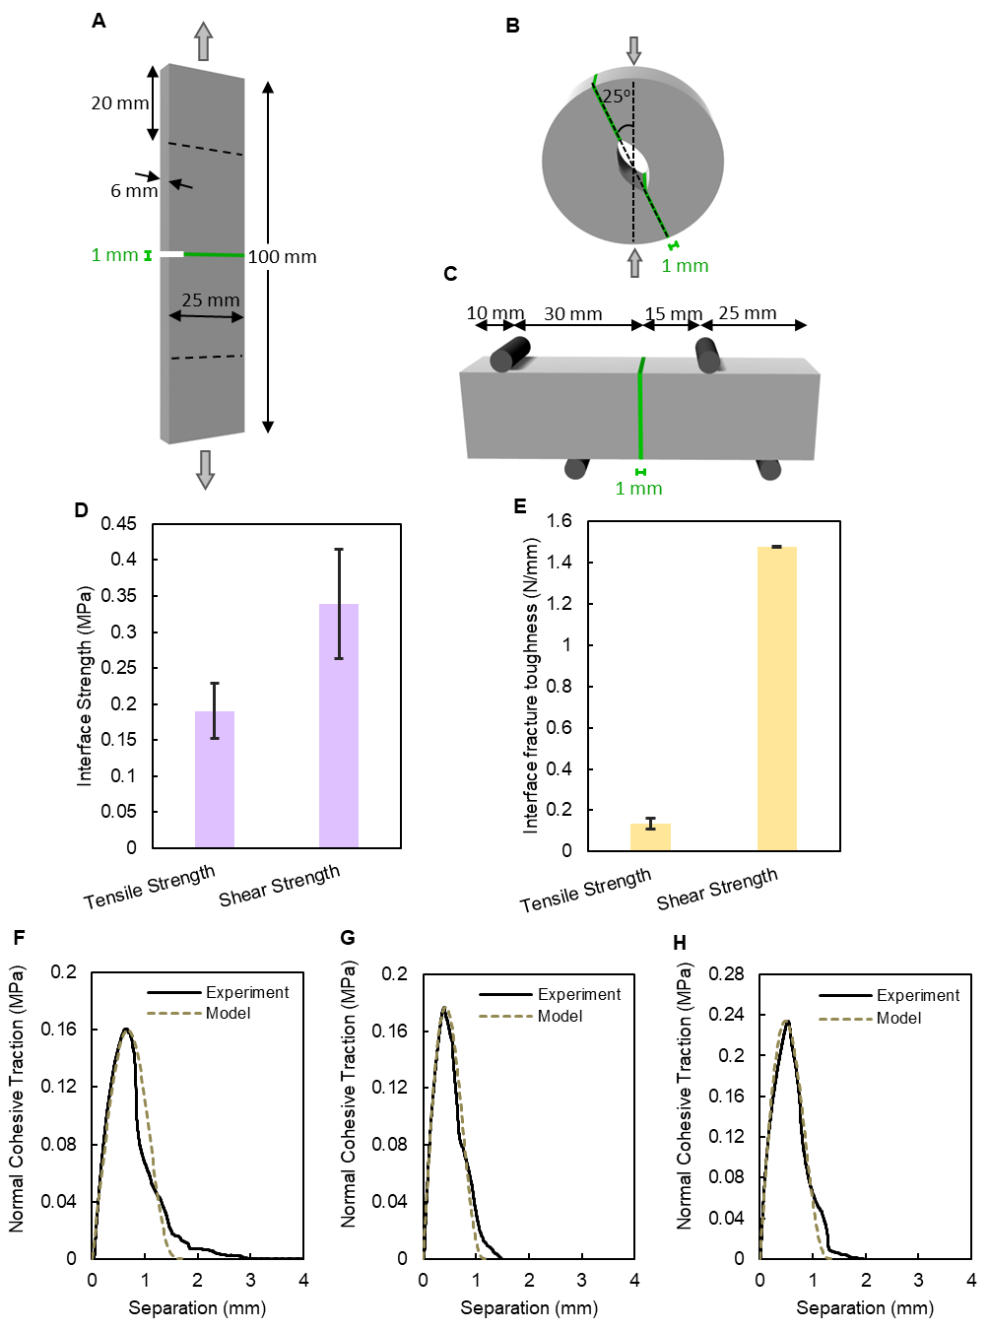
Figure S6. Characterization of cement paste-PVS interfacial properties. (A) Single-edge notch test with notch at the interface, (B) Brazil-nut test, (C) Asymmetric three-point bending test, (D) Bond strength results, (E) Bond fracture toughness results.
Coupled Phase-Field and Cohesive Zone Numerical Framework
Variational Framework for Crack Propagation in Layered Structures
A variational formulation for modeling crack propagation in layered assemblies composed of hard constituents separated by interfacial zones was recently developed by the authors³. The key lines are recalled herein. The framework considers a solid body Ω₀¹ divided into two regions (Ω₀¹ and Ω₀²) by an interface Γ₀, with each region potentially having different constitutive properties (Figure S7A).
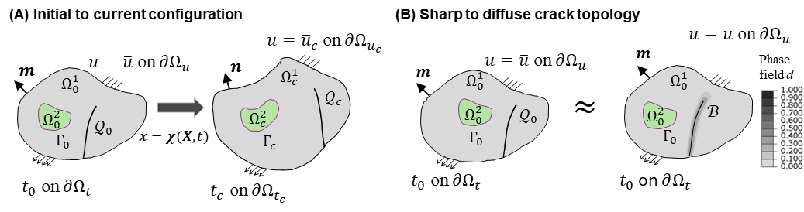
Figure S7. (a) Kinematics of a solid body containing an initial crack Q₀ and an interface Γ₀ separating two regions Ω₀¹ and Ω₀² in the initial and Ω_{c}¹ and Ω_{c}² in the current configurations. (b) Substitution of the sharp crack topology Q₀ with a diffuse representation β having a finite width over which a scalar phase-field variable varies from 0 (intact) to 1 (fractured).
The kinematics involve a motion mapping x = χ(X, t) from the reference to current configuration (Figure S7A), with the displacement field defined as u(X, t) = x − X. The body is subject to body forces b₀ and boundary conditions including applied tractions t₀ and prescribed displacements u. The total potential energy of the layered system with interfaces is composed of three components:
$$Π\left(u\right)= Π^{b^{k}}\left(u\right)+Π^{int}(u)+P(u) (Eq. S1)$$
where $Π^{b^{k}}$ represents the bulk energy contributions where k refers to the number of layers (i.e., material bulk regions) considered, $Π^{int}$ accounts for interface energy, and P represents external work. The bulk contribution incorporates both the strain energy and fracture energy:
$$Π^{b^{k}}\left(u,d\right)=\int_{Ω_{0}^{k}}{Ψ^{k}\left(F,d\right)dV}+\int_{Q_{0}}{G_{c}^{k}dA} (Eq. S2)$$
where $Ψ^{k}\left(F,d\right)$ and $G_{c}^{k}$ are the Helmholtz free energy and the fracture toughness of bulk material k, respectively, and $\int_{Q_{0}}{G_{c}^{k}dA}$ denotes the energy dissipated due to fracture phenomena at the sharp crack Q₀. The interface contribution is characterized by a cohesive potential function $φ^{int}$:
$$Π^{int}\left(Δu\right)=\int_{Γ_{0}}{φ^{int}(Δu)dA} (Eq. S3)$$
here ∆u represents the displacement jump across the interface. The equilibrium of the system is determined through the principle of stationary energy, requiring that the variation of the total potential energy vanishes:
$$δΠ=δΠ^{b^{k}}+δΠ^{int}+δP=0 (Eq. S4)$$
Bulk Material Damage
Rather than modeling the sharp crack Q₀, the phase-field approach to fracture employs a damage field d(X, t) that varies continuously from 0 (intact material) to 1 (complete fracture) over a localized band β (Figure S7B). As such, the energy contribution from Q₀ is regularized through a volumetric approximation of the integral evaluation as follows⁴.
$$\int_{Q_{0}}{G_{c}^{k}dA} ≈\int_{Ω_{0}^{k}}{G_{c}^{k}γ\left(d,∇d\right)dV} (Eq. S5)$$
with the crack surface density function:
$$γ(d,∇d) =\frac{1}{c_{ϕ}}\left(\frac{1}{{l_{c}}^{k}}ϕ(d)+ {l_{c}}^{k}∇d∙∇d\right) (Eq. S6)$$
where $c_{ϕ}=4\int_{0}^{1}{\sqrt{ϕ(y)}dy}$, and $ϕ(d)=d^{2}$ is a quadratic crack geometric function (AT2 formulation). The length scale parameter ${l_{c}}^{k}$ controls the diffuse damage band width, with Griffith theory recovered as ${l_{c}}^{k}$→ 0.
The complete bulk contribution (Eq. 2) becomes:
$${δΠ}^{b^{k}}\left(u,d\right)= \int_{Ω_{0}^{k}}{Ψ^{k}\left(F, d\right)dV} +\int_{Ω_{0}^{k}}{G_{c}^{k}γ\left(d,∇d\right)dV} (Eq. S7)$$
from which, the following variational expressions with respect to displacement and phase field are obtained:
$${δΠ}_{d}^{b^{k}}=\int_{Ω_{0}^{k}}{\frac{{∂Ψ}^{k}\left(F, d\right)}{∂d}δddV}+\int_{Ω_{0}^{k}}{\frac{G_{c}^{k}}{c_{ϕ}{l_{c}}^{k}}{ϕ'}_{(d)}δddV}-\int_{Ω_{0}^{k}}{\frac{2G_{c}^{k}l_{c}}{c_{ϕ}}ΔdδddV} (Eq. S8)$$
where ∆d = ∇ · ∇d is the Laplacian of the phase-field variable.
Interface Dissipation
To account for the interface contribution to overall energy potential, a displacement jump ∆u is defined across the interfacial region Γ₀, with tangential and normal components: ∆u = (∆u_{t}, ∆u_{n})^{T} . The interface potential energy is then written in terms of the displacement jump as:
$$Π^{int}\left(∆u\right)=\int_{Γ_{0}}{G_{c}^{int}\left(∆u\right)dA} (Eq. S9)$$
The interface variation therefore takes the form:
$${δΠ}^{int}={δu}^{T}\int_{Γ_{0}}{{\left(\frac{∂∆u}{∂u}\right)}^{T}TdA} (Eq. S10)$$
where T is the first Piola-Kirchhoff cohesive traction vector, obtained as:
$$T=\frac{∂φ^{int}(∆u)}{∂∆u}={(T_{t}+T_{n})}^{T} (Eq. S11)$$

Constitutive Relationships
This section presents the constitutive relationships corresponding to the bulk and interface components of the coupled phase-field CZM framework³.
Bulk
The constitutive behavior of the bulk is characterized as a linear elastic material through the following intact Helmholtz free-energy:
$$ψ(F)=\frac{1}{2}E:C:E (Eq. S12)$$
where E is the Green-Lagrange strain tensor and C is the elastic stiffness tensor. To capture different behaviors under tension and compression, the deformation gradient is decomposed into volumetric and isochoric parts:
$$F_{iso}={\left(detF\right)}^{-1/3}F$$  $$F_{vol}={(detF)}^{1/3}I$$ | $$(Eq. S13)$$

The strain tensor is similarly decomposed:
$$E_{iso}=\frac{1}{2}\left({F_{iso}}^{T}F_{iso}-I\right)$$  $E_{vol}=\frac{1}{2}\left({F_{vol}}^{T}F_{vol}-I\right)$ | $$(Eq. S14)$$

The degraded elastic strain tensor incorporates damage through:
$$\tilde{E_{d}}= \left\{\begin{aligned}\left(1-d\right)E \\ \left(1-d\right)E+{dE}_{vol}, \end{aligned}\right.\begin{aligned} if\det\left(F\right)≥1 \\ otherwise\end{aligned} (Eq. S15)$$
This formulation ensures that damage only affects the volumetric component under dilation and effectively handles tension-compression asymmetry⁵. The final degraded Helmholtz free energy function is:
$$Ψ(F,d)=\frac{1}{2}\tilde{E_{d}}:C:\tilde{E_{d}} (Eq. S16)$$
The first Piola-Kirchhoff stress tensor is then derived as $P=\frac{∂Ψ}{∂F}$.
Interface
The detailed constitutive description of the interface is provided in³; we recall the key aspects herein. The interface behavior is modeled using the Park-Paulino-Roesler (PPR) potential-based cohesive zone model⁶, which offers advantages over traditional approaches by providing consistent work-of-separation and physically meaningful fracture parameters. The PPR potential is expressed as:
$$φ^{int}=\min\left(G_{n}, G_{t}\right) +\left[Γ_{n}{\left(1-\frac{∆u_{n}}{δ_{n}}\right)}^{r}{\left(\frac{m}{r}+\frac{∆u_{n}}{δ_{n}}\right)}^{m}+\left\langle G_{n}-G_{t}\right\rangle \right]×\left[Γ_{t}{\left(1-\frac{\left|∆u_{t}\right|}{δ_{t}}\right)}^{s}{\left(\frac{n}{s}+\frac{\left|∆u_{t}\right|}{δ_{t}}\right)}^{n}+\left\langle G_{t}-G_{n}\right\rangle \right] (Eq. S17)$$
where $G_{n},$ $G_{t}$ are Mode-I and Mode-II fracture energies, and Γ_{n}, Γ_{t} are energy constants⁶. Furthermore, m and n are exponents of the PPR CZM model given by $m=\frac{r\left(r-1\right)l_{n}^{2}}{1-rl_{n}^{2}}, n=\frac{s\left(s-1\right)l_{t}^{2}}{1-sl_{t}^{2}}$, where r and s are shape parameters that control the softening behavior: r, s < 2 produces concave traction-separation curves, while r, s ≫ 2 yields convex curves typical of quasi-brittle materials, and $l_{t}$ and $l_{n}$ are the initial slope indicators corresponding to the tangential and normal directions, respectively, relating to the final normal and tangential crack openings, $δ_{n}$ and $δ_{t}$ respectively, to the critical normal and tangential crack opening, $δ_{nc}$ and $δ_{tc}$, respectively, through $δ_{nc}=l_{n}δ_{n}$ and $δ_{tc}=l_{t}δ_{t}$. The normal and tangential tractions are derived from the potential (Eq. S17) by taking its derivative with respect to the components of the displacement jump $Δu_{n}$ and $Δu_{t}$:
$$T_{n}=\frac{Γ_{n}}{δ_{n}}\left[m{\left(1-\frac{∆u_{n}}{δ_{n}}\right)}^{r}{\left(\frac{m}{r}+\frac{∆u_{n}}{δ_{n}}\right)}^{m-1}-r{\left(1-\frac{∆u_{n}}{δ_{n}}\right)}^{r-1}{\left(\frac{m}{r}+\frac{∆u_{n}}{δ_{n}}\right)}^{m}\right]×\left[Γ_{t}{\left(1-\frac{\left|∆u_{t}\right|}{δ_{t}}\right)}^{s}{\left(\frac{n}{s}+\frac{\left|∆u_{t}\right|}{δ_{t}}\right)}^{n}+\left\langle G_{t}-G_{n}\right\rangle \right] (Eq. S18)$$

$$T_{t}=\frac{Γ_{t}}{δ_{t}}\left[n{\left(1-\frac{\left|∆u_{t}\right|}{δ_{t}}\right)}^{s}{\left(\frac{n}{s}+\frac{\left|∆u_{t}\right|}{δ_{t}}\right)}^{n-1}-s{\left(1-\frac{\left|∆u_{t}\right|}{δ_{t}}\right)}^{s-1}{\left(\frac{n}{s}+\frac{\left|∆u_{t}\right|}{δ_{t}}\right)}^{n}\right]×\left[Γ_{n}{\left(1-\frac{∆u_{n}}{δ_{n}}\right)}^{r}{\left(\frac{m}{r}+\frac{∆u_{n}}{δ_{n}}\right)}^{m}+\left\langle G_{n}-G_{t}\right\rangle \right]\frac{∆u_{t}}{\left|∆u_{t}\right|} (Eq. S19)$$
The normal and tangential traction-separation curves reach their maximum when the normal and tangential separations reach critical crack opening widths $δ_{nc}$ and $δ_{tc}$, respectively. At these critical points, the maximum tractions correspond to the cohesive strengths:
$T_{n}(δ_{nc} , 0) = σ_{max}$, $T_{t}(0, δ_{tc}) = τ_{max}$
The constitutive relationships described for the bulk and interface components have been incorporated into the finite element (FE) software ABAQUS/Standard⁷ through the utilization of a user-defined element subroutine (UEL)³. In particular, user-defined elements have been developed for four-node isoparametric quadrilateral plane-strain elements for the material bulk, and zero-thickness elements for the interface.
The bulk and interface properties determined through the mechanical characterization tests were used to carry out simulations. Additionally, for both bulk materials (cement paste and PVS), the phase-field length scale $l_{c}$ was given a value of 0.1 mm; consequently, a finite element mesh size of value $l_{c}/4$ was assigned to all bulk finite elements. Note that the Young’s modulus for the PVS elastomer was obtained from the rubber shear modulus which in turn was inferred from the mechanical tensile test of Figure S4 through fitting the Arruda-Boyce 8-chain hyperelastic model on to the corresponding stress-stretch curve. Similarly, the hardened cement paste modulus was obtained from the work of Nguyen et al.⁸ For the PPR CZM parameters, the associated 1D normal traction-separation curve was fit onto the experimentally obtained traction-separation plot from the single-edge notch tensile test (Figure S6F-H). Table S1 and Table S2 summarized all property values used in the simulations. Using this framework, uniaxial tension simulations were performed under the same loading conditions as the experiments for composite sutures with w = 3 mm. Supplementary Videos 10, 11, and 12 show the evolution of the bulk normal stress component (S₂₂) for composite sutures with the lock angle ranging from θ = 15° to θ = 45°. The normal cohesive traction distributions along the PVS-cement interface for the same samples are presented in Supplementary Videos 13, 14, and 15.
Table S1 Bulk material properties
Bulk material | E (MPa) | $$ν$$ | $G_{c}$ (N/mm) | $l_{c}$ (mm)
Hardened Cement Paste | 22000 | 0.22 | 0.0446 | 0.1
PVS Elastomer | 0.39 | 0.49 | 1.4 | 0.1

Table S2 Cement paste-PVS interfacial properties
 | $G_{n}$ (N/mm) | $G_{t}$ (N/mm) | $σ_{max}$ (MPa) | $τ_{max}$ (MPa) | $$r,s$$ | $$l_{n},l_{t}$$
Cement paste-PVS Interface | 0.14 | 1.4 | 0.2 | 0.2 | 4 | 0.4

Supplementary Videos:
Suppl. Video 1: Hard-hard (monolithic) suture interface with lock angle θ=30° & gap, w=0 mm
https://youtu.be/q1ryEoQvTZk

Suppl. Video 2: Hard-soft (composite) suture interface with lock angle θ=15° & gap, w=1 mm
https://youtu.be/xtwA1kSWiIo

Suppl. Video 3: Hard-soft (composite) suture interface with lock angle θ = 15° & gap, w=3 mm https://youtu.be/EQoEbSak8EA

Suppl. Video 4: Hard-hard (monolithic) suture interface with lock angle θ =30° & gap, w=0 mm https://youtu.be/fyHVoZiQZ4o

Suppl. Video 5: Hard-soft (composite) suture interface with lock angle θ =30° & gap, w=1 mm https://youtu.be/tsm9OusowVw

Suppl. Video 6: Hard-soft (composite) suture interface with lock angle θ =30° & gap, w=3 mm https://youtu.be/RbSN7J4q9m4

Suppl. Video 7: Hard-hard (monolithic) suture interface with lock angle θ =45° & gap, w=0 mm
https://youtu.be/FNDObCLXn8U

Suppl. Video 8: Hard-soft (composite) suture interface with lock angle θ =45° & gap, w =1 mm https://youtu.be/OjV-FLEfIus

Suppl. Video 9: Hard-soft (composite) suture interface with lock angle θ =45° & gap, w =3 mm
https://youtu.be/VF0-bgRCSOU

Suppl. Video 10: Numerical Simulation: Normal Stress in bulk of the hard-soft suture composite with lock angle θ = 15° & gap, w=3 mm
https://youtu.be/xTbpJPK62wg

Suppl. Video 11: Numerical Simulation: Normal Stress in bulk of the hard-soft suture composite with lock angle θ = 30° & gap, w=3 mm
https://youtu.be/bwsaHLwNWmc

Suppl. Video 12: Numerical Simulation: Normal Stress in bulk of the hard-soft suture composite with lock angle θ = 45° & gap, w=3 mm
https://youtu.be/B0AAjLCgfko

Suppl. Video 13: Numerical Simulation: Cohesive normal traction at the interface of the hard-soft suture composite with θ =15° and w=3 mm
https://youtu.be/YPNmUqYk3zw

Suppl. Video 14: Numerical Simulation: Cohesive normal traction at the interface of the Hard-soft suture composite with θ =30° and w=3 mm
https://youtu.be/DS_TCHp-HPs

Suppl. Video 15: Numerical Simulation: Cohesive normal traction at the interface of the Hard-soft suture composite with θ =45° and w=3 mm
https://youtu.be/XSo1bqx8TPM

References
1. Wang, J. S. & Suo, Z. Experimental determination of interfacial toughness curves using Brazil-nut-sandwiches. Acta metall, mater 38, 1279–1290 (1990).
2. Atkinson, C., Smelser, R. E. & Sanchez, J. Combined mode fracture via the cracked Brazilian disk test. Int. J. Fract. 18, 279–291 (1982).
3. Najmeddine, A., Gupta, S. & Moini, R. Coupled large deformation phase-field and cohesive zone model for crack propagation in hard-soft multi-materials. J. Mech. Phys. Solids 196, 106016 (2025).
4. Miehe, C., Welschinger, F. & Hofacker, M. A phase ﬁeld model for rate-independent crack propagation: Robust algorithmic implementation based on operator splits. Int. J. Numer. Methods Eng. 199, 2765–2778 (2010).
5. Shahba, A. & Ghosh, S. Coupled phase field finite element model for crack propagation in elastic polycrystalline microstructures. Int. J. Fract. 219, 31–64 (2019).
6. Park, K., Paulino, G. H. & Roesler, J. R. A unified potential-based cohesive model of mixed-mode fracture. J. Mech. Phys. Solids 57, 891–908 (2009).
7. SIMULIA. Abaqus 6.14 Documentation. Dassault Systemes, Providence, RI, USA. (2014).
8. Nguyen, V. T., Lee, S. Y., Yoon, S. & Kim, D. J. A comprehensive study on predicting the elastic modulus and Poisson ratio of hardened cement pastes via micro-scale cement hydration simulations. Case Studies in Construction Materials 20, e03285 (2024).

