Tables and Figures
Spinal Deformities in Hereditary Motor and Sensory Neuropathy with Special Emphasis on Dejerine-Sottas Disease
Alex HJ Cho
Supplement to manuscript

List of Tables
Table 1. HMSN/CMT Subtypes — Genetic Basis and Scoliosis Characteristics
→ Insert after Section 2, paragraph 2 (after "with many cases presenting before the age of 10")

Table 2. Scoliosis Features: DSD/Neuromuscular vs Adolescent Idiopathic Scoliosis
→ Insert in Section 6, after the first paragraph (after "more aggressive natural history")

Table 3. Surgical and Conservative Management Options
→ Insert in Section 12.2, after the preoperative considerations paragraph

Table 4. Recommended Surveillance Protocol
→ Insert in Section 5.6 (replaces existing surveillance table)

List of Figures
Figure 1. Pathogenesis of Scoliosis in DSD (flowchart)
→ Insert in Appendix / at end of Section 3

Figure 2. Clinical Management Algorithm for Scoliosis in DSD (decision tree)
→ Insert in Appendix / at end of Section 9

Citation Note — In-text references for these items
When referring to these in the manuscript body, use the following text:
"...summarised in Table 1 (see Appendix)." or "(Table 1)"
"The recommended management algorithm is shown in Figure 2 (see Appendix)."
If inline placement is required by the target journal, insert each table/figure immediately after the paragraph in which it is first cited.

Table 1
HMSN/CMT Subtypes — Genetic Basis and Scoliosis Characteristics
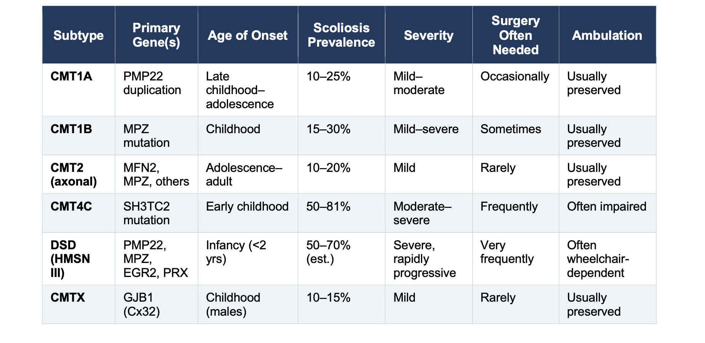

Table 1 Caption: Overview of major hereditary motor and sensory neuropathy (HMSN/CMT) subtypes with their primary genetic mutation, typical age of scoliosis onset, approximate prevalence, severity, and functional impact. Scoliosis prevalence figures are approximate estimates derived from mixed cohort studies.^{[7,8,10,11,12]} DSD = Dejerine-Sottas disease; CMT = Charcot-Marie-Tooth disease; est. = estimate.
Suggested placement: After Section 2, paragraph 2. Call-out in text: "(Table 1)"

Table 2
Scoliosis Features: DSD/Neuromuscular vs Adolescent Idiopathic Scoliosis
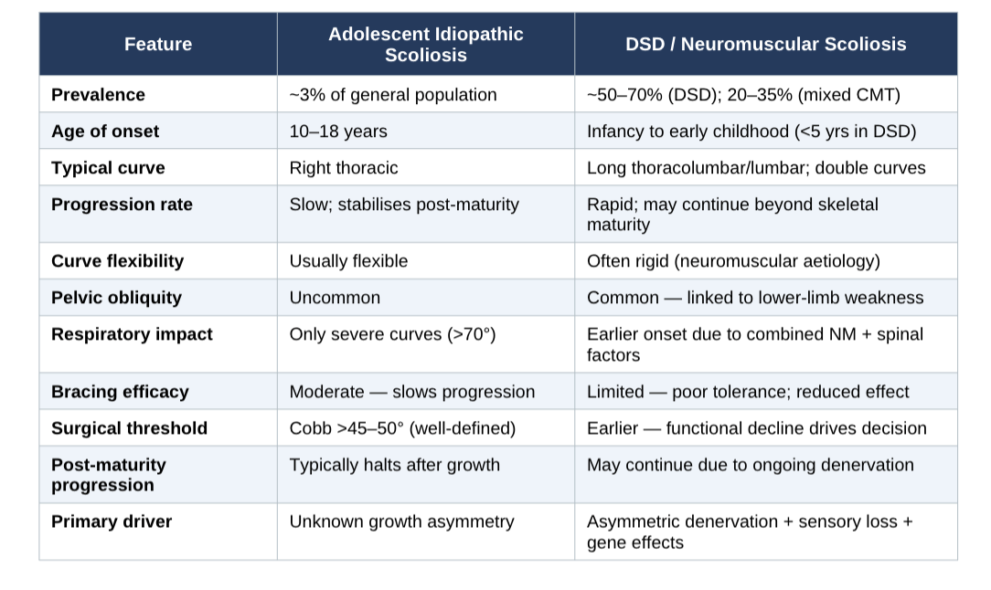

Table 2 Caption: Comparison of key clinical, radiographic, and prognostic features of scoliosis in Dejerine-Sottas disease and neuromuscular (NM) conditions versus adolescent idiopathic scoliosis (AIS). AIS data from Weinstein et al.^{[17]} DSD/NM data from Horacek et al.,^{[7]} Karol and Elerson,^{[10]} Murphy and Mooney,^{[13]} and Plante-Bordeneuve and Said.^{[16]} NM = neuromuscular; DSD = Dejerine-Sottas disease; Cobb = Cobb angle.
Suggested placement: Section 6, after the first paragraph. Call-out: "(Table 2)"

Table 3
Surgical and Conservative Management Options in DSD-Associated Scoliosis
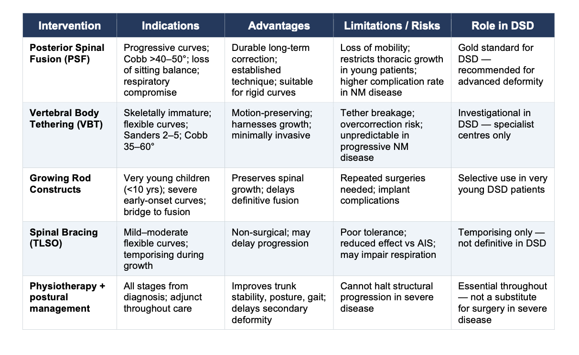

Table 3 Caption: Summary of surgical and principal non-surgical interventions for spinal deformity in Dejerine-Sottas disease and hereditary motor and sensory neuropathies. PSF = posterior spinal fusion; VBT = vertebral body tethering; TLSO = thoracolumbar sacral orthosis; NM = neuromuscular; AIS = adolescent idiopathic scoliosis; DSD = Dejerine-Sottas disease.
Suggested placement: Section 12.2, after the preoperative paragraph. Call-out: "(Table 3)"

Table 4
Recommended Surveillance Protocol — Scoliosis in DSD and Severe HMSN
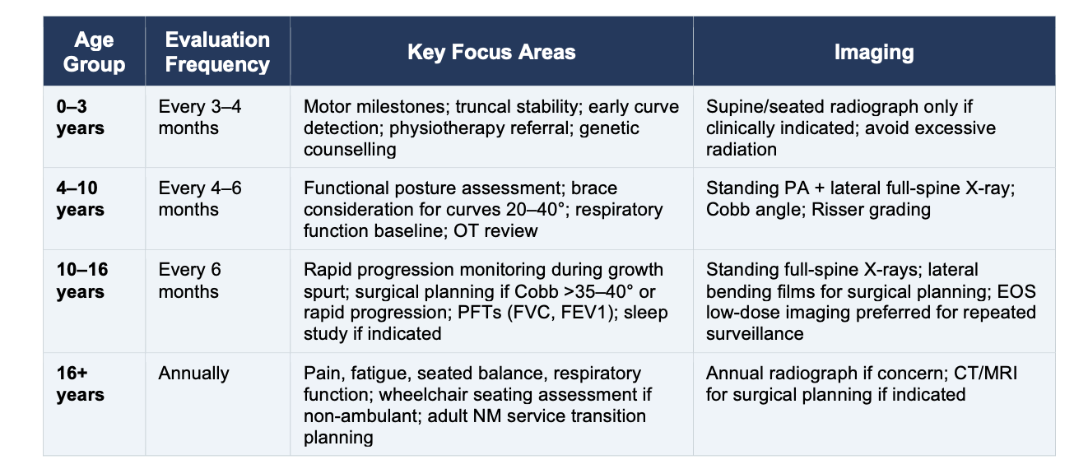

Table 4 Caption: Recommended surveillance framework for scoliosis monitoring in patients with Dejerine-Sottas disease and severe hereditary motor and sensory neuropathies, stratified by age group. PA = posteroanterior; PFTs = pulmonary function tests; FVC = forced vital capacity; FEV1 = forced expiratory volume in 1 second; EOS = low-dose biplanar stereoradiography;^{[15]} OT = occupational therapist; NM = neuromuscular.
Suggested placement: Section 5.6. Call-out: "(Table 4)"

Figure 1
Pathogenesis of Scoliosis in Dejerine-Sottas Disease
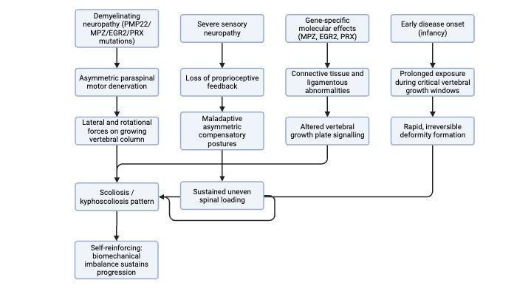

Figure 1 Caption: Multifactorial pathogenesis of scoliosis in Dejerine-Sottas disease. Four convergent pathways — asymmetric paraspinal denervation, proprioceptive loss, gene-specific connective tissue effects, and critical-window growth exposure — interact to produce early-onset, progressive neuromuscular spinal deformity. Once a structural threshold is reached, biomechanical self-reinforcement sustains progression independently of neurological decline. Based on pathophysiological principles described in Murphy and Mooney ^{[13]}, Plante-Bordeneuve and Said ^{[16]}, and Gabreels-Festen.^{[14]}
Suggested placement: End of Section 3 (Pathophysiology), or in the Appendix. Call-out: "The four pathogenic mechanisms are summarised in Figure 1."

Figure 2
Clinical Management Algorithm for Scoliosis in DSD
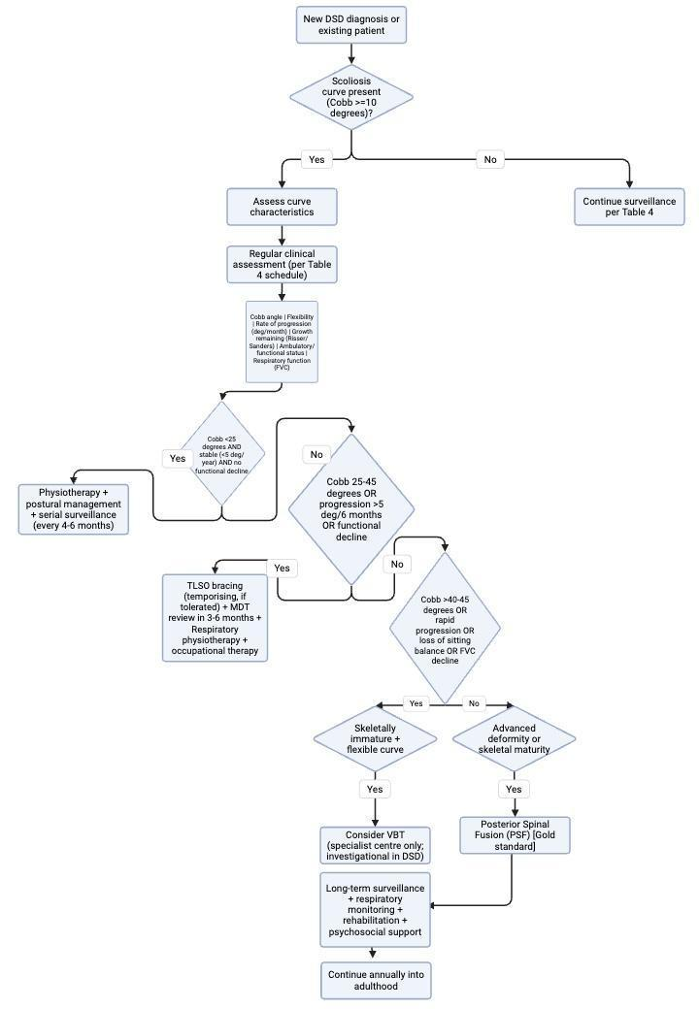

Figure 2 Caption: Proposed clinical management algorithm for scoliosis in Dejerine-Sottas disease and severe hereditary motor and sensory neuropathies. Decisions integrate neurological severity, radiographic assessment, functional status, and remaining growth potential. Surgical thresholds differ from adolescent idiopathic scoliosis: functional decline often precedes or drives intervention before the Cobb angle alone would mandate surgery. MDT = multidisciplinary team; TLSO = thoracolumbar sacral orthosis; VBT = vertebral body tethering; PSF = posterior spinal fusion; FVC = forced vital capacity; FEV1 = forced expiratory volume in 1 second.
Suggested placement: End of Section 9 (Timing of intervention), or in Appendix. Call-out: "The recommended management algorithm is shown in Figure 2."

