Supplementary Methods
REWARD TASK
In GO trials participants made a choice and responded to the stimuli, then waited for the feedback where they lost or earned reward.

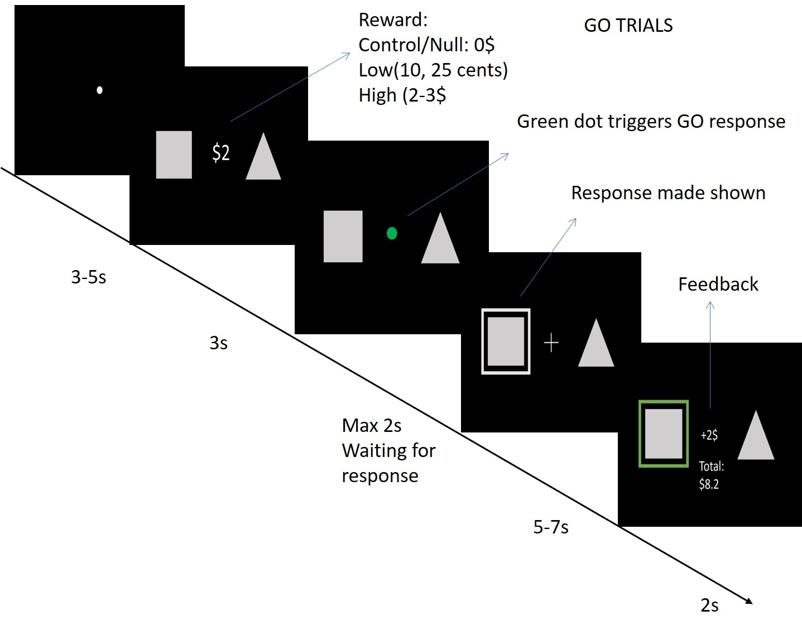

In NOGO trials participants withheld their choice, then waited for the feedback where they lost or earned reward.

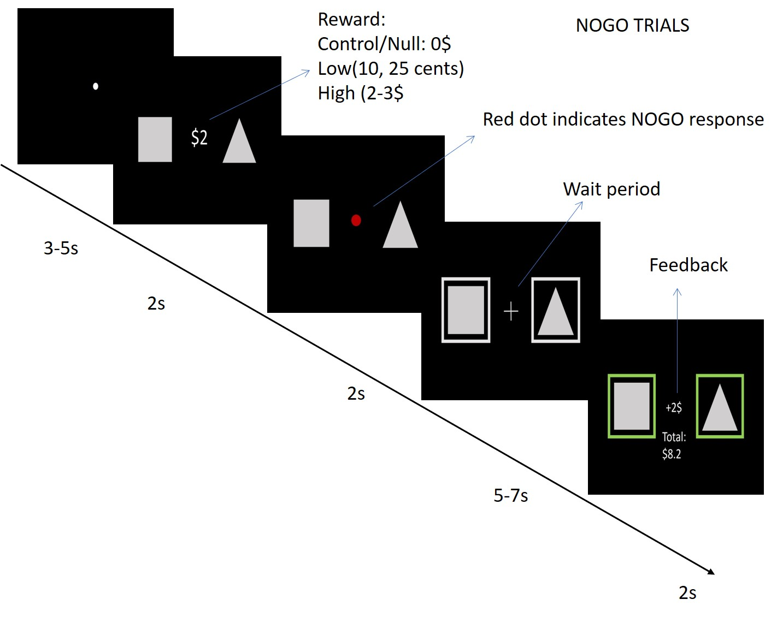

AAN MASKS
Ascending arousal networks in sagittal, coronal and axial views.
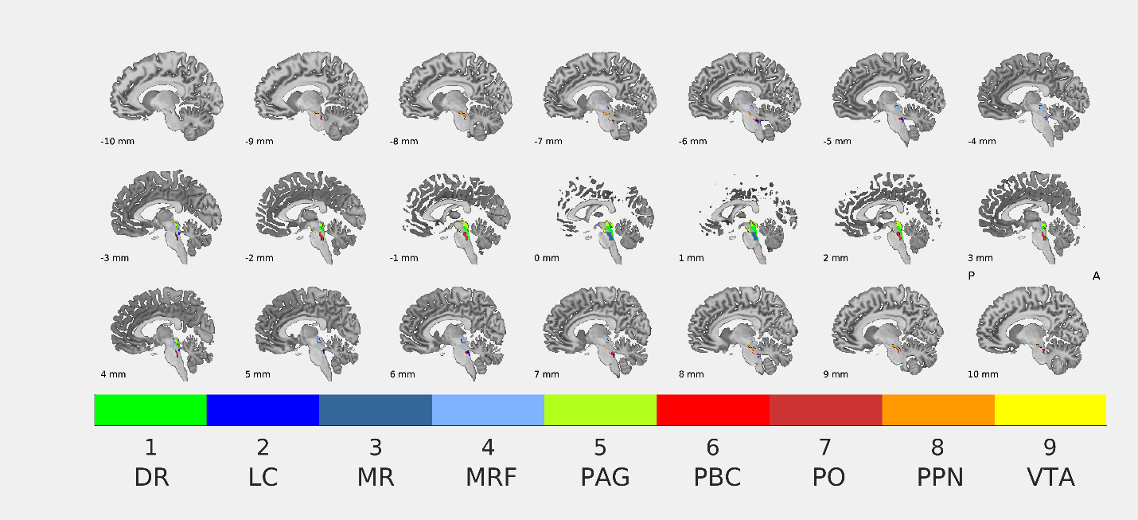

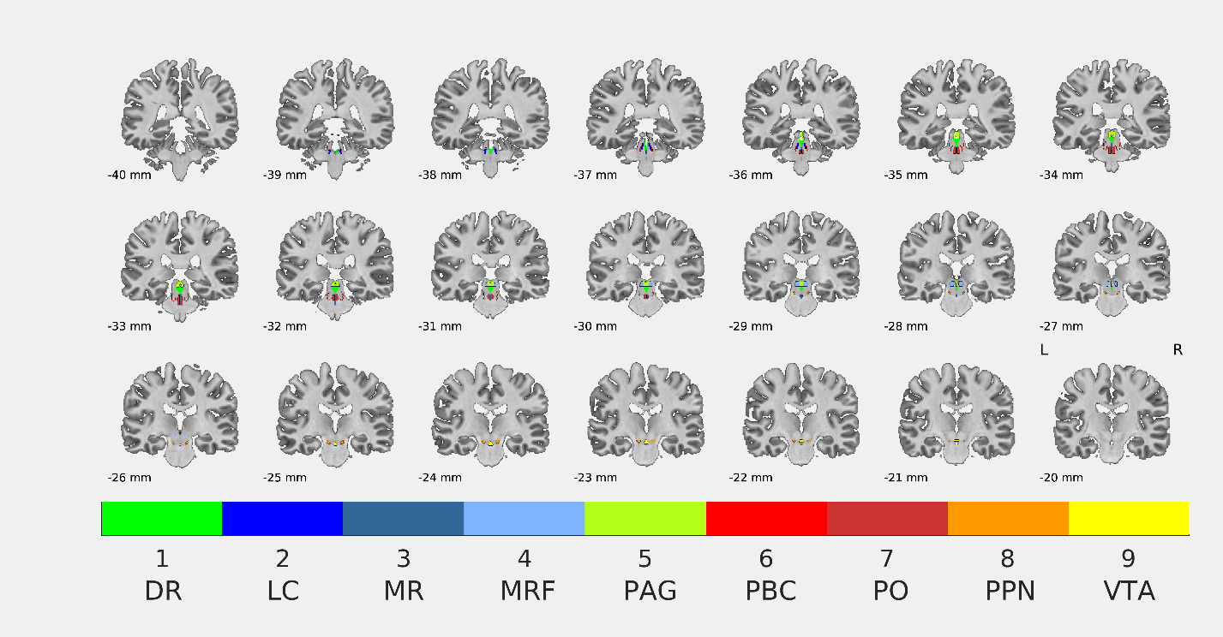
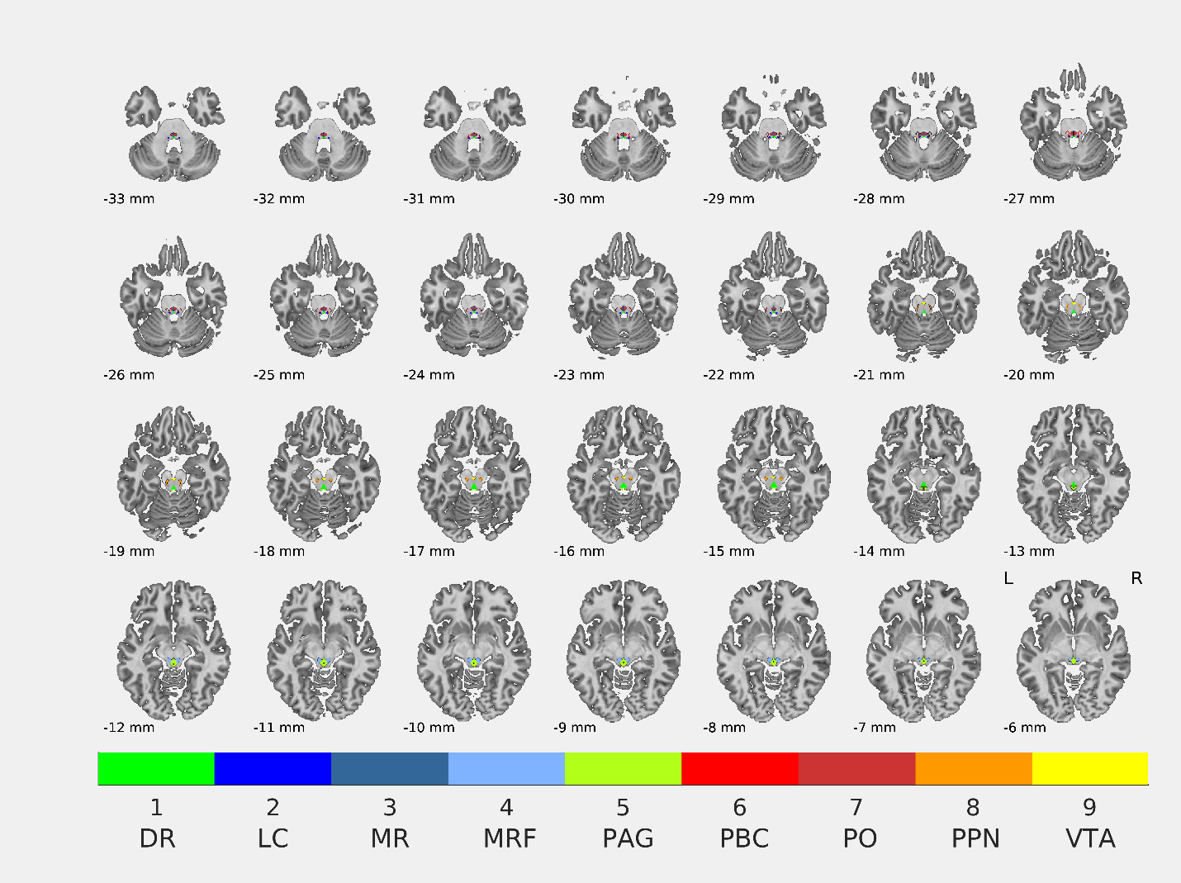

BEHRENS THALAMIC SEEDS
Thalamic seeds and their projections in Behrens et al. (2003) study. A) Projections to the seven different cortical sections of the brain are color coded and overlaid on the Montreal Neurological Institute (MNI) brain template. In clockwise order; B) Axial (z= 1), C) Sagittal (x= -18), and D) Coronal (y= -17) views of the thalamic seeds with the same colors depicting their projections.

