Supplementary Data 3
Cluster corrected blink correlations for Rest-Task contrast
Voxels above or below absolute t-value of 3.54 are shown. Cluster corrected voxels are marked with a thick borderline.
REST-TASK 2TRs before blink
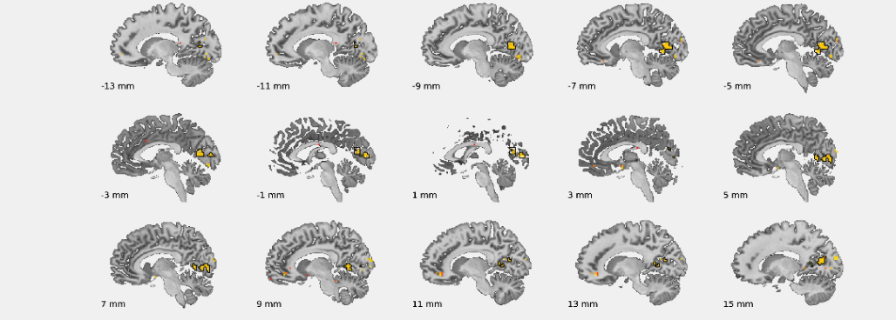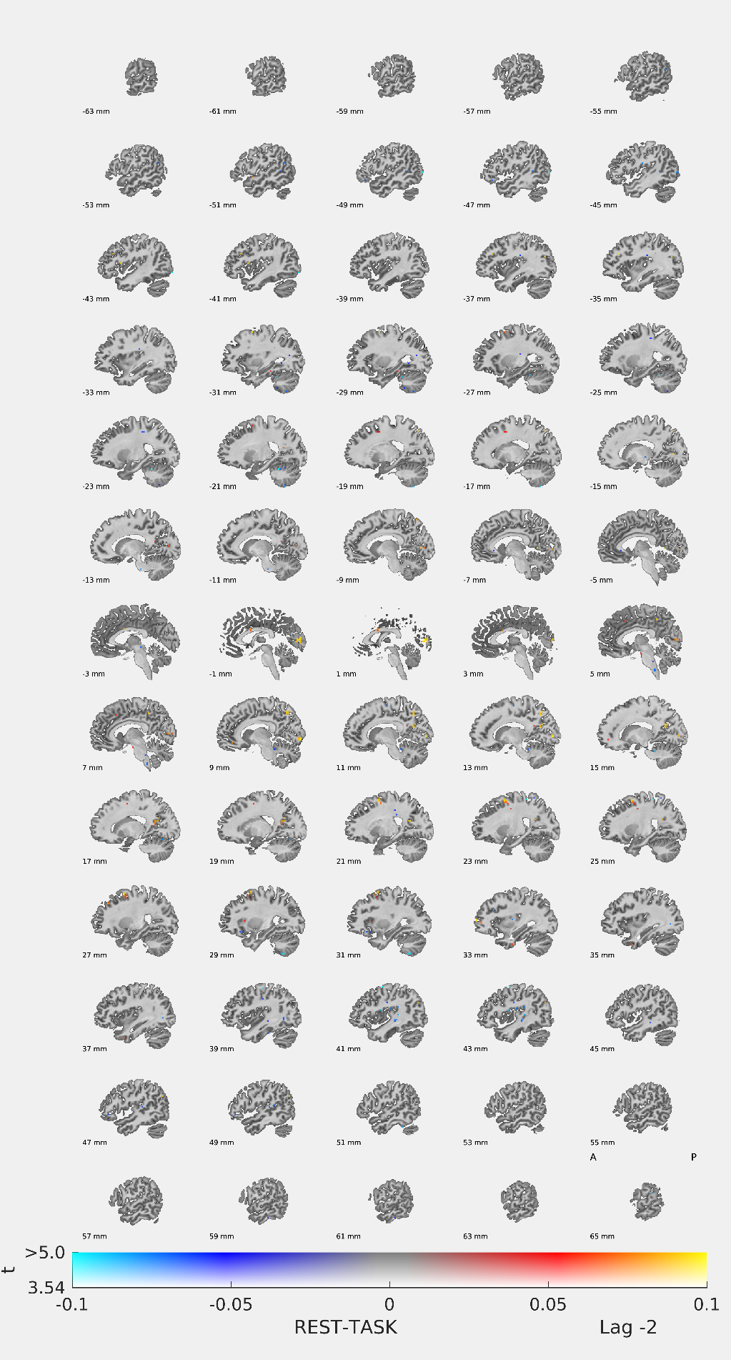
REST-TASK 1TR before blink
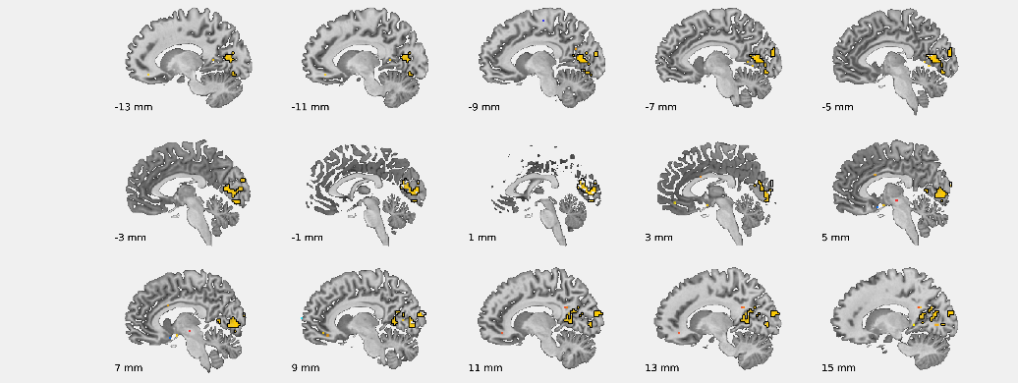

REST-TASK at BLINK
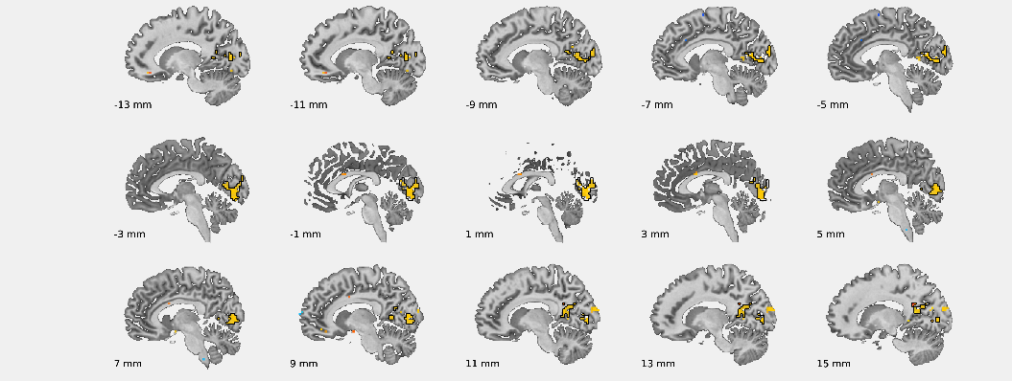

REST-TASK 1TR after blink
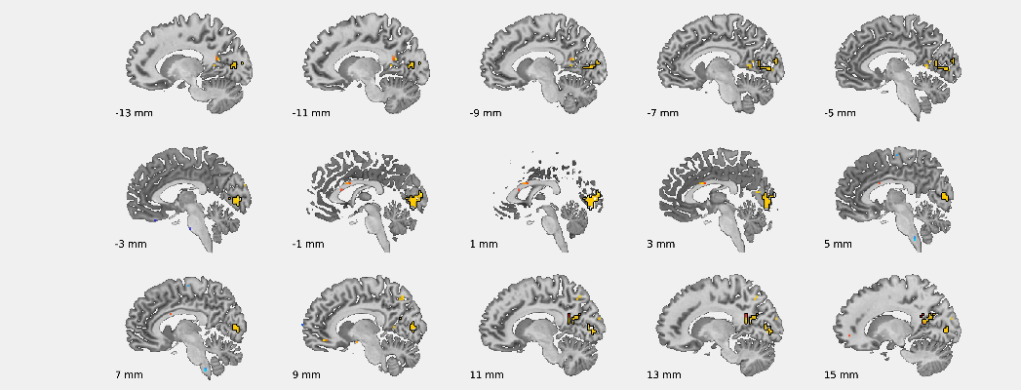

REST-TASK 2TRs after blink

