Supplementary Data 7
AAN across-subject variability plots. Each point represent a value of an individual. Task and Rest shown in different rows.
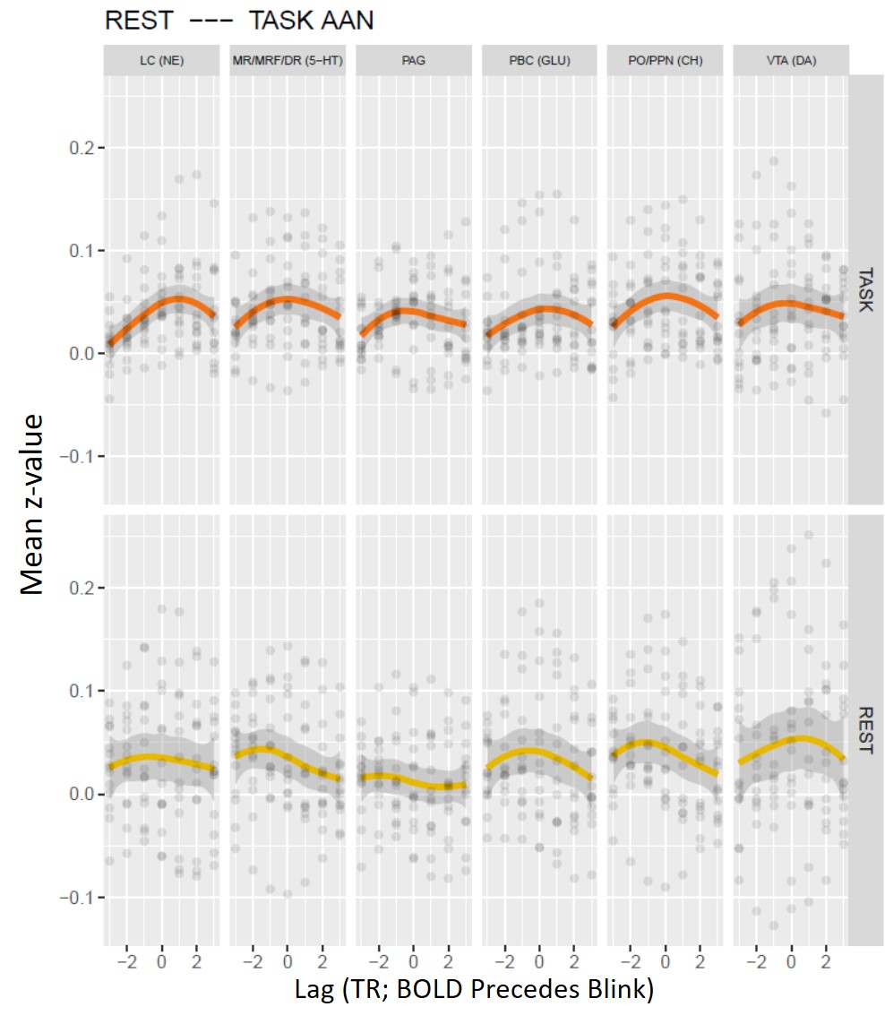

Thalamus across-subject variability
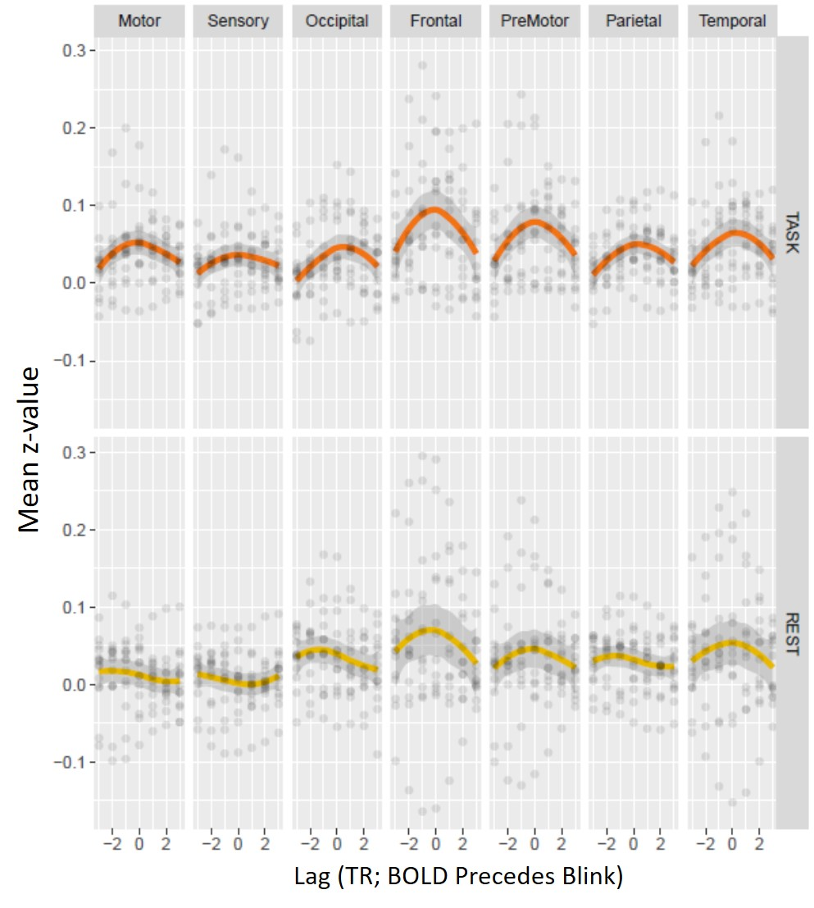

Cerebellum across-subject variability
