Supplementary Data 1
Cluster corrected Task-Blink correlations
Voxels above or below absolute t-value of 3.54 are shown. Cluster corrected voxels are marked with a thick borderline.
TASK 2TR BEFORE BLINK
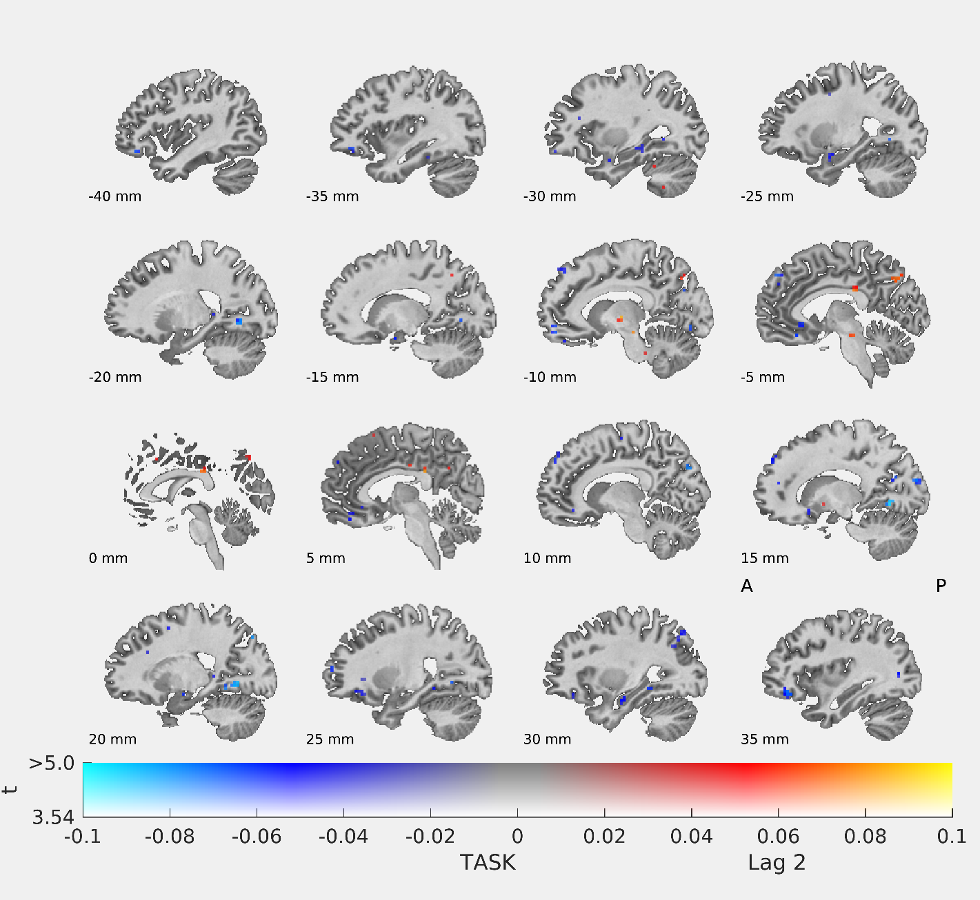

1TR BEFORE BLINK
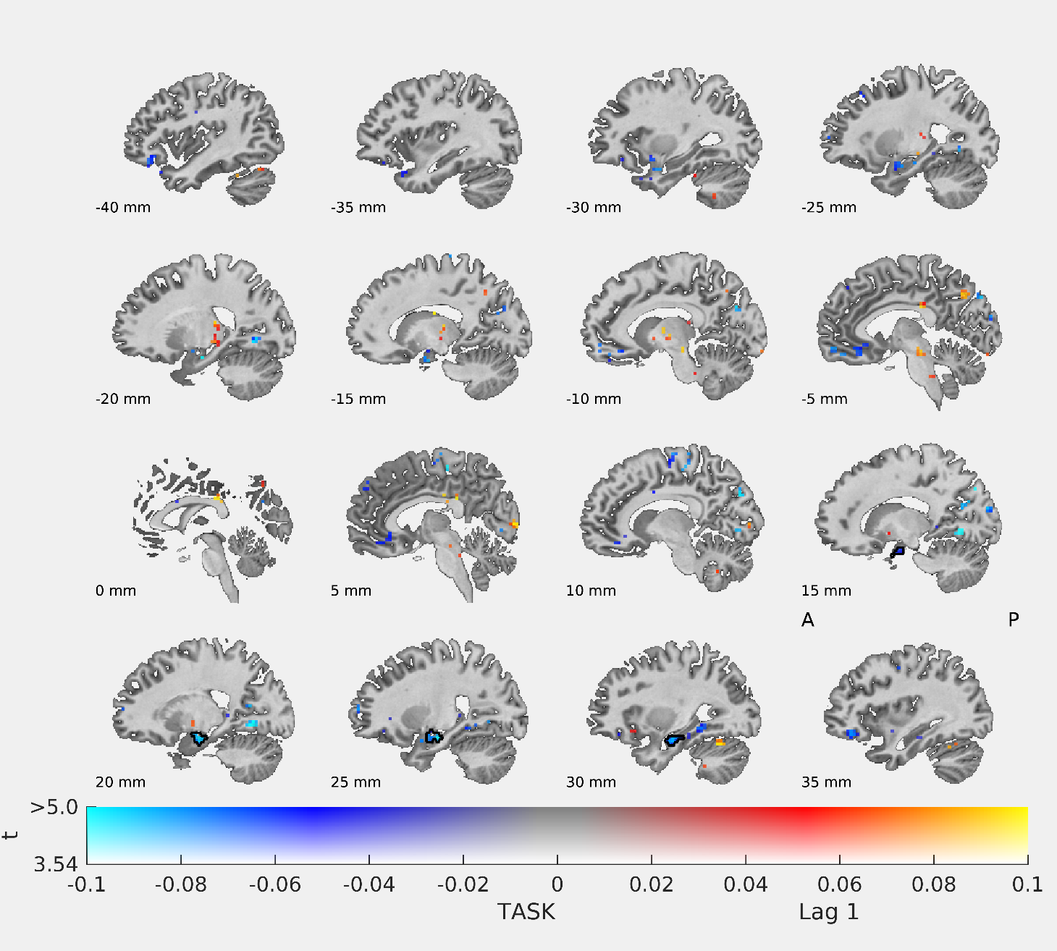

AT BLINK
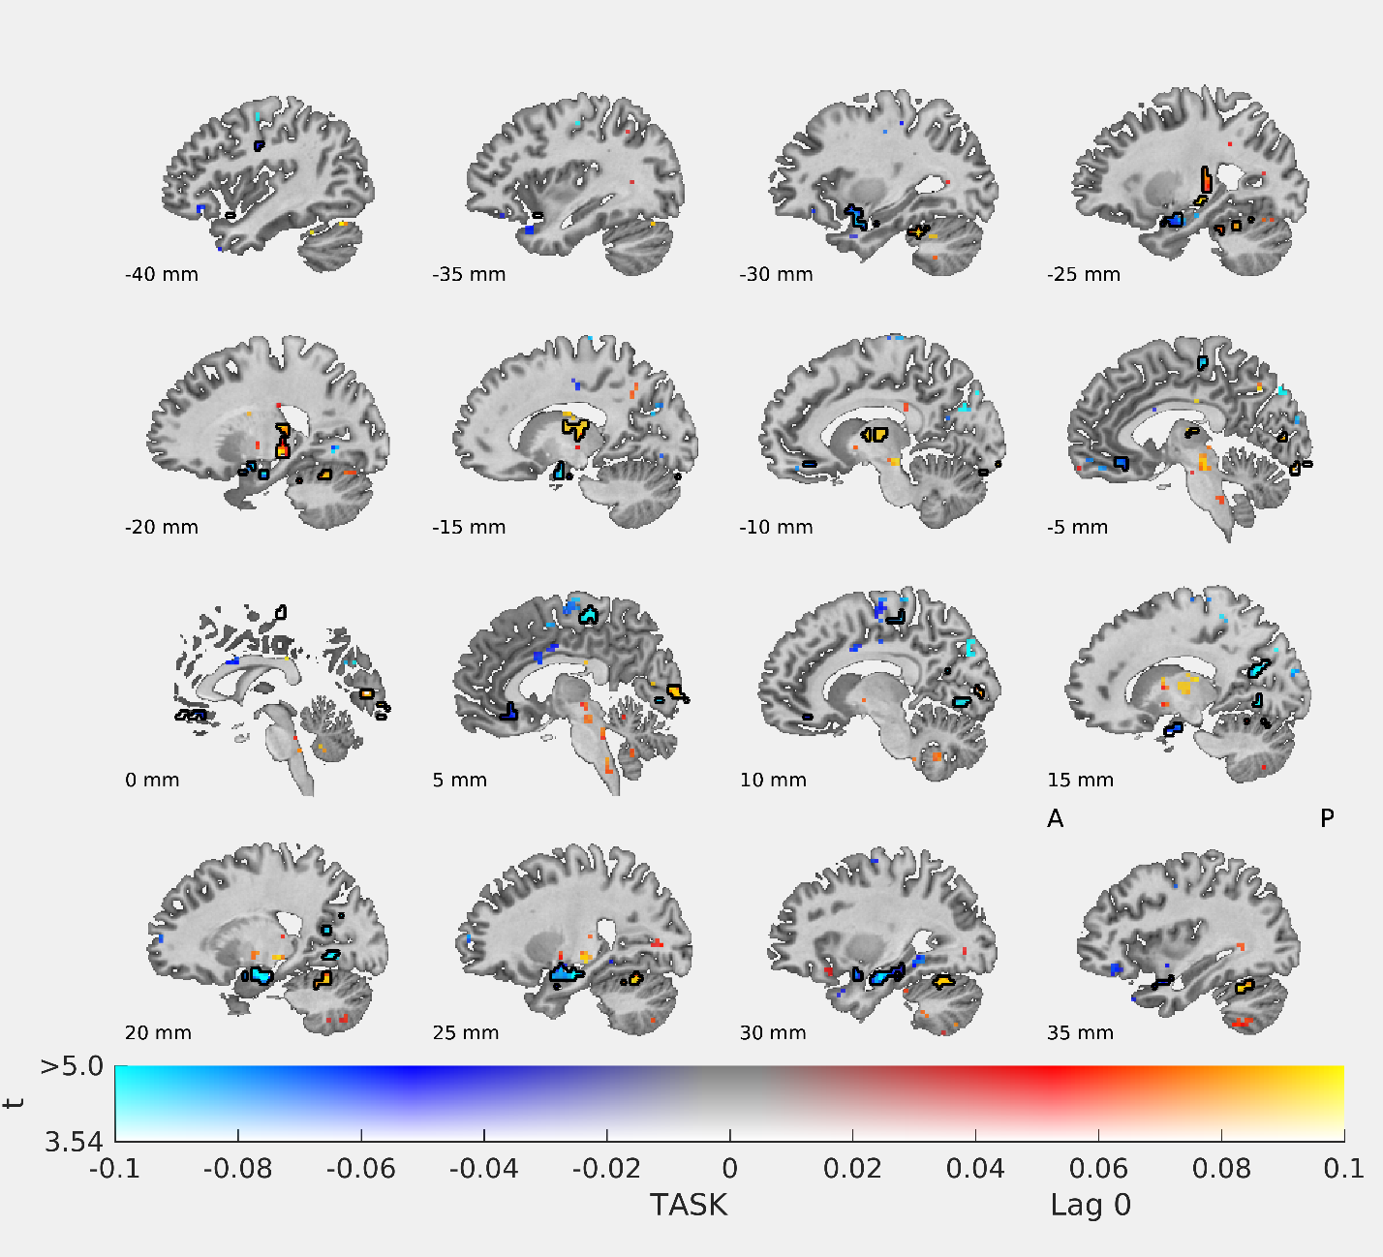

1TR AFTER BLINK
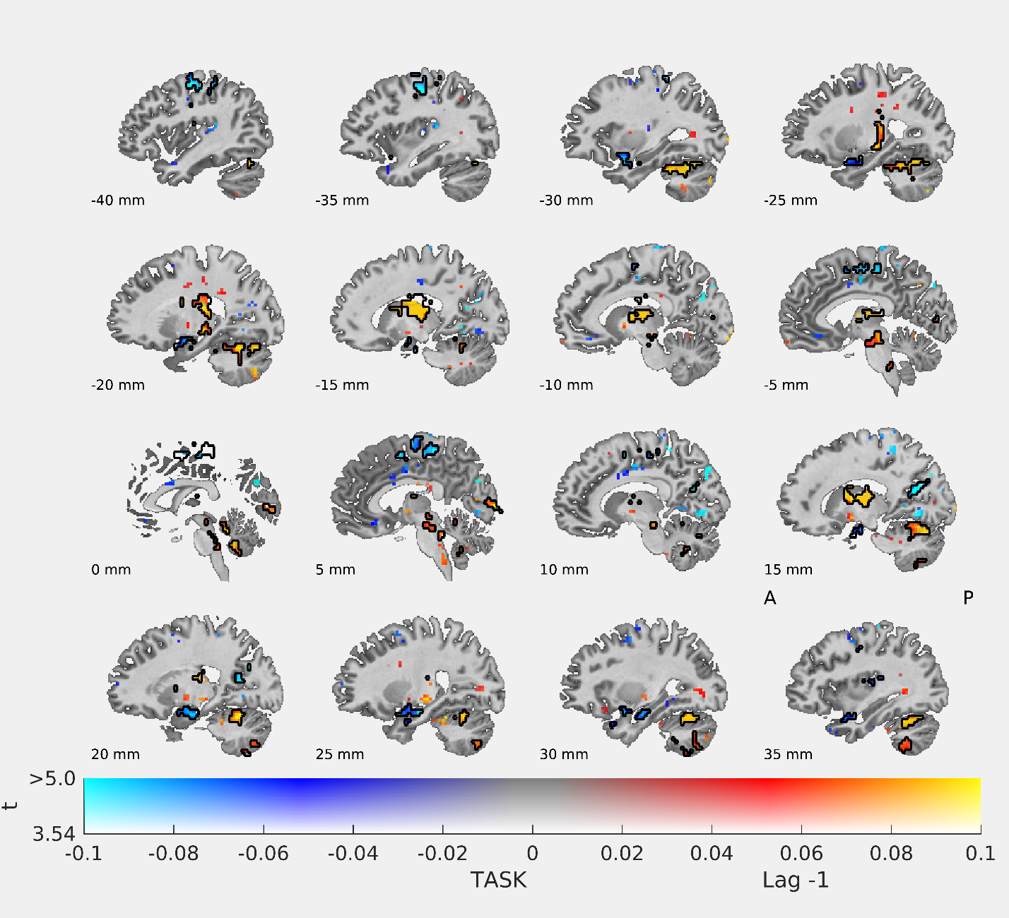

2TR AFTER BLINK
