Discriminators of pseudoprogression and true progression in high-grade gliomas: A systematic review and meta-analysis

Supplementary Material

Supplementary Material A
Search Strategy
1. exp oligodendroglioma/ or oligodendroglioma$.mp. or exp astrocytoma/ or astrocytoma$.mp. or exp glioblastoma/ or glioblastoma$.mp. or GBM.mp. or exp glioma/ or glioma$.mp. or brain tumour$.mp. or brain tumor$.mp. or LGG.mp. or HGG.mp. or exp low-grade-glioma/ or low-grade-glioma.mp. or exp high-grade-glioma/ or high-grade-glioma.mp.
2. pseudoprogression.mp. or pseudo-progression.mp. or treatment-related change$.mp. or treatment related change$.mp. or psPD.mp. or PsP.mp.
3. (progressive supranuclear palsy or primary spontaneous pneumothorax).mp.
4. (1 and 2) not 3

Supplementary Material B1
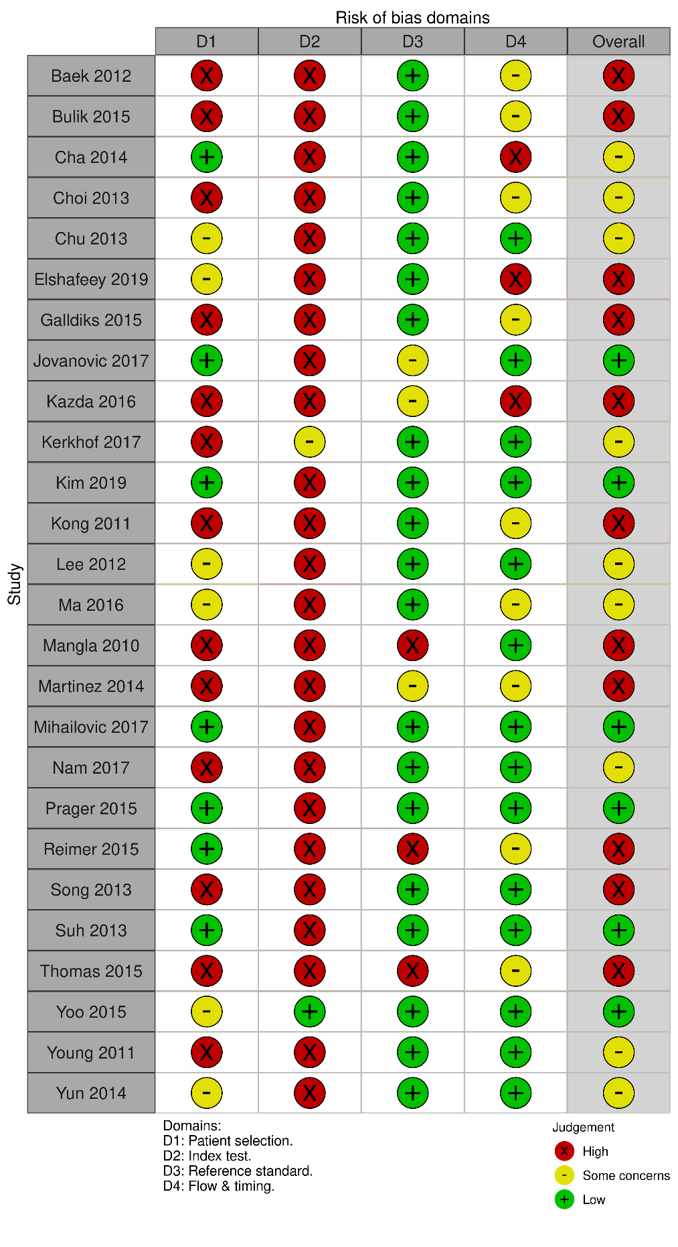
Risk of bias and applicability table assessing the quality of included studies according to the Quality Assessment of Diagnostic Accuracy Studies-2 (QUADAS-2) tool. Martinez et al., Kerkhof et al., Kong et al., Mangla 2010 et al., Song et al., and Thomas et al., were all found to include at least one patient that had received steroid treatment.

Supplementary Material B2
Summary of risk of bias across all studies according to the risk of bias table in Figure 5 assessing the quality of included studies according to the Quality Assessment of Diagnostic Accuracy Studies-2 (QUADAS-2) tool.
